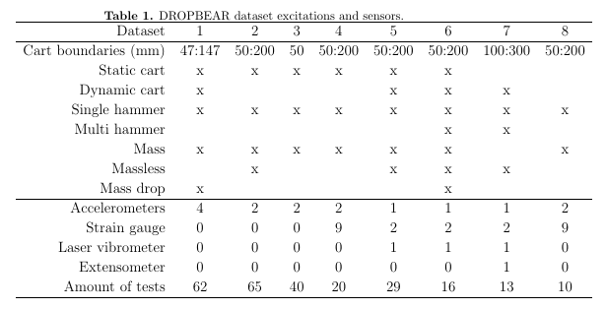

Dataset 1 - 26Jul2018 to 28Aug2018

Dataset 2 - 17Sep2018

Dataset 3 - 3Jan2019

Dataset 4 - 21 Mar 2019

Dataset 5 - 17Sep2019, 19Sep2019, 25Sep2019

Dataset 6 - 29Oct2019

Dataset 7 - 15Jan2020

Dataset 8 - 21May2019