Web-Based Mr. Softy Integrated Business Intelligence Platform

A Capstone Project presented to the College of Information
Technology Education PHINMA University of Iloilo
Iloilo City

Submitted in partial fulfillment of the requirements for the
degree of
Bachelor of Science in Information Technology
Business Analytics Management

Casibual, Dwayne Reigne M.
Jerez, John Rhenwel E.
Losbañes, Gemnuel D.
Palacios, Lance Vincent M.
Ubana, Alyssa Faith T.

March 2026

Abstract
This study focused on the design and development of a Web-Based Mr. Softy Integrated Business Intelligence Platform that was intended to improve the efficiency and accuracy of the business's daily operations. Mr. Softy relied on manual processes for sales recording, inventory monitoring, and employee attendance tracking, which often resulted in delays, inaccuracies, and difficulties in managing business records. To address these challenges, the researchers proposed a centralized web-based system that integrated sales management, inventory management, attendance monitoring, and report generation into a single platform.
The study employed a developmental research design and utilized the Agile Software Development Methodology to guide the system development process. Data were gathered through interviews and observations conducted with the business owner and staff to identify operational problems and system requirements. The system was developed using HTML, CSS, JavaScript, PHP, and MySQL, following a client-server architecture to support efficient data processing and management.
The developed platform enabled automated recording of sales transactions, real-time inventory monitoring, employee attendance tracking, and generation of business reports. The system was designed to reduce manual workloads, minimize human errors, improve data organization, and provide accurate information that supported business decision-making. Furthermore, the platform offered secure access for authorized users and a user-friendly interface that promoted ease of use and operational efficiency.
The study concluded that the implementation of a web-based integrated business management platform enhanced the operational performance of Mr. Softy by providing a more efficient, accurate, and organized approach to managing sales, inventory, and attendance records. Future enhancements may include mobile application support, advanced analytics, online transaction capabilities, and cloud-based deployment to further improve system functionality and business performance.
Keywords: Business Intelligence Platform, Web-Based System, Sales Management, Inventory Management, Attendance Monitoring, Agile Methodology, Business Automation.

Table of Contents
Abstract 2
Table of Contents 3
Chapter I 6
Introduction 6
Background of the Study 6
Statement of the Problem 7
Chapter II 13
REVIEW OF RELATED LITERATURE 14
Foreign Study 14
Point of Sales 14
References: 19
Attendance Monitoring 19
References: 22
Inventory Management 23
References: 27
Business Intelligence 28
References: 31
Local Studies 31
Point of Sales 31
References: 35
Attendance Monitoring 36
References: 39
Inventory Management 39
References: 43
Business Intelligence 44
References: 47
Related Literature 48
Point Of Sale (POS) System 48
Attendance Monitoring System 49
Inventory Management System 50
Business Intelligence 50
Synthesis of Reviewed Literature 51
Chapter III 53
Methodology 53
Research Design 53
System Development Methodology 54
Requirements Analysis 55
System Design 55
Development 56
Testing 56
Deployment (Prototype) 56
Continuous Improvement 56
System Architecture 57
Presentation Layer 57
Application Layer 58
Data Layer 58
User Interaction Flow 59
Data Flow Diagram (LEVEL 0) 59
Data Flow Diagram (LEVEL 1) 61
Flow Chart 64
Wire Frame (Admin) 70
Wire Frame (Cashier) 73
USE CASE DIAGRAM 75
Frontend Technologies 77
Backend Technologies 77
Database Management Tool 78
Development Environment 78
Data Gathering Techniques 79
Interviews 79
Observation 79
Document Analysis 80
Testing Procedures 80
● Unit Testing 80
● Integration Testing 81
● System Testing 81
● User Acceptance Testing (UAT) 81
Evaluation Criteria 81
● Functionality 82
● Usability 82
● Reliability 82
● Security 83
● Efficiency 83
SYSTEM DEVELOPMENT, IMPLEMENTATION, TESTING, EVALUATION, RESULTS, AND DISCUSSION 83
Overview of the Developed System 83
System Implementation 85
Admin Modules 85
Login Module 85
Dashboard Module 87
Inventory Module 88
Sales Module 90
Attendance Module 91
Stores Module 92
Reports Module 93
Attendance Analytics 95
Sales Analytics 95
Smart Insights 96
Smart Business Recommendation 97
Variance Module 98
User Module 99
Testing Result 100
Unit Testing Results 102
Integration Testing Result 104
System Testing Result 106
User Acceptance Testing Result 109
Hardware and Software Requirements 111
CHAPTER V 113
CONCLUSION AND RECOMMENDATIONS 113
INTRODUCTION 113
Summary of Findings 113
Conclusion 114
Recommendation 114
System Improvements 114
Future Research Directions 115
Implementation Strategies 115
Impact of the Study 115
Summary 116

Chapter I

Introduction

Background of the Study
The use of digital technology has become increasingly important in helping businesses manage their daily activities and maintain accurate records. Through the adoption of information systems, businesses can improve the way they handle transactions, store information, and monitor their operations. Business intelligence (BI) applications also help organizations examine business data and use the information to support management decisions [1]. For small and medium-sized enterprises (SMEs), choosing suitable digital solutions can help address operational difficulties and meet the changing needs of the business.
Sales and inventory management are among the business activities that can benefit from computerized systems. Recording transactions and updating stock information manually may take considerable time, especially when business records need to be checked or prepared for reporting. A study examining a Point-of-Sale (POS) system integrated with inventory management reported improvements in transaction processing, data accuracy, and stock reporting [2]. These findings demonstrate how digital tools can assist businesses in handling sales and inventory information in a more organized manner.
Employee attendance is also an important part of daily business management. Employers need reliable records of employees’ working hours to monitor attendance and review time-in and time-out information. However, manual attendance procedures may make recordkeeping more difficult and increase the possibility of recording errors. One study presented an Employee Attendance Monitoring System based on the concept of Enterprise Resource Planning (ERP) [3], while another examined automated attendance monitoring technology [4]. These studies illustrate how computerized methods can assist in maintaining employee attendance records and lessen the effort required for manual monitoring.
For Mr. Softy, sales transactions, employee attendance, and inventory records are essential to its daily business activities. Each area produces information that must be recorded and updated to help authorized personnel monitor business operations. When these activities are handled separately, staff may need to check different records to find the information they need. This can make it more difficult to maintain consistent records and review business information efficiently.
According to the researchers’ initial interviews, consultations, and observations, Mr. Softy relied on manual procedures for several operational tasks. Sales transactions involved recording orders and computing payments, while employee attendance required the monitoring of time-in and time-out records. Product quantities also needed to be checked and updated to keep inventory information current. These responsibilities required staff and administrators to maintain records that could be used to review the business’s daily activities.
The use of these manual procedures created difficulties in managing sales, attendance, inventory, and reports. Recording and computing sales manually could take additional time and lead to errors in transaction records. Attendance information also needed to be organized so that employee time records could be reviewed when necessary. In inventory management, regular stock checking and updating were needed to keep recorded quantities consistent with available products. Furthermore, preparing reports required relevant information to be collected and reviewed, which could add to the workload of the administrator.
Previous studies provide support for using information systems to address similar operational concerns. Research on business intelligence applications discussed how organized business information can help users make decisions [1]. Another study reported benefits from using a POS system integrated with inventory management [2]. Meanwhile, studies on employee attendance monitoring explored computerized and automated approaches to maintaining attendance records [3], [4]. These studies provide a basis for considering digital solutions that can improve recordkeeping and help businesses manage their operational information.
To address the identified needs, this study developed the Web-Based Mr. Softy Integrated Business Intelligence Platform. The proposed system combines sales processing, employee attendance monitoring, inventory management, and report generation in one web-based application. Its functions include recording customer orders, handling checkout and billing, producing receipts, updating product quantities, managing stock requests, recording stock checks, and tracking employee time-in and time-out. It also provides reporting, notification, user management, and store management functions for authorized personnel.
The proposed platform is intended to provide Mr. Softy with a more organized way of handling information related to its daily operations. By bringing sales, attendance, and inventory functions together, the system allows authorized staff to record and access relevant information through a common application. The administrator can also use the available reports to review business activities and monitor operational records. Through these functions, the study aims to lessen reliance on manual procedures, improve record organization, and support the efficient management of Mr. Softy’s business operations.

Reference:
[1] A. Quamar, F. Özcan, D. Miller, R. J. Moore, R. Niehus, and J. Kreulen, “Conversational BI: An ontology-driven conversation system for business intelligence applications,” Proceedings of the VLDB Endowment, vol. 13, no. 12, pp. 3369–3381, 2020, doi: 10.14778/3415478.3415557.
[2] R. Yulia and D. N. D. Seputro, “Digital transformation of inventory management: Evaluating the impact of first in first out-based accurate point of sale system implementation on warehouse operations,” International Journal Administration, Business & Organization, vol. 6, no. 3, pp. 378–393, 2025, doi: 10.61242/ijabo.25.663.
[3] A. Munshi et al., “Employee attendance monitoring system by applying the concept of Enterprise Resource Planning (ERP),” International Journal of Education and Management Engineering, vol. 9, no. 5, pp. 1–9, 2019, doi: 10.5815/ijeme.2019.05.01.
[4] A. S. Nadhan et al., “Smart attendance monitoring technology for Industry 4.0,” Journal of Nanomaterials, vol. 2022, Art. no. 4899768, 2022, doi: 10.1155/2022/4899768.

Statement of the Problem
Mr. Softy relied on manual methods for managing sales transactions, employee attendance, and inventory records. Although these methods were manageable for small-scale operations, they often resulted in inefficiencies such as time-consuming processes, inaccurate record-keeping, data redundancy, and difficulty in retrieving information when needed. These challenges affected the overall productivity and decision-making capabilities of the business.
In addition, the absence of an integrated system caused business information to be stored separately, making it difficult for the owner to effectively monitor daily operations, track inventory levels, manage employee attendance, and generate accurate reports. As the business continued to operate and expand, the need for a computerized and centralized management system became increasingly important.
This study aimed to develop an Integrated Sales, Inventory, and Attendance Management System for Mr. Softy. Specifically, it sought to answer the following questions:
- How were sales transactions automated to improve accuracy, reduce human errors, and streamline the recording of daily sales?
- How was employee attendance monitored and recorded efficiently to ensure accurate attendance tracking and reporting?
- How was inventory managed effectively to maintain accurate stock records and prevent stock shortages or overstocking?
- How did the integration of sales, inventory, and attendance management into a single system improve the efficiency of business operations?
- How did the proposed system provide timely and accurate reports that supported the business owner in making informed decisions?

Objectives of the Study

General Objectives
The primary objective of this study was to design, develop, and implement a web-based Sales, Attendance, and Inventory Management System for Mr. Softy to automate and improve its daily business operations. The proposed system replaced the existing manual processes with a computerized platform that efficiently managed sales transactions, employee attendance records, and inventory information within a single integrated system.
Furthermore, the study sought to provide a more accurate, reliable, and organized method of recording and storing business data, reducing the risk of errors, data loss, and inconsistencies commonly associated with manual record-keeping. Through automation, the system streamlined operational tasks, minimized the time required for data processing, and improved the accessibility of important business information.
The proposed system also enabled the business owner and administrators to monitor sales performance, employee attendance, and inventory levels in real time, allowing them to make informed decisions based on accurate and up-to-date data. By centralizing these essential business functions, the system enhanced productivity, improved workflow efficiency, strengthened data management practices, and supported the overall growth and operational effectiveness of Mr. Softy.

Specific Objectives
Specifically, this study aimed to achieve the following objectives:
- To develop a sales management module that efficiently recorded, processed, and managed daily sales transactions, automatically calculated totals, and securely stored transaction records to enhance the accuracy and reliability of sales operations.
- To create an attendance monitoring module that accurately recorded employee time-in and time-out, enabled real-time attendance tracking, and reduced errors in monitoring employee work hours.
- To design and implement an inventory management module that monitored product availability, automatically updated stock levels based on transactions, and helped prevent inventory-related issues such as stock shortages, overstocking, and inaccurate inventory records.
- To minimize human errors, delays, and inconsistencies associated with manual recording and data management processes through the implementation of a computerized and automated system.
- To provide organized, secure, and easily accessible records of sales, inventory, and employee attendance that supported effective monitoring, reporting, and decision-making by the business owner and administrators.
- To integrate sales management, inventory control, and attendance monitoring into a centralized web-based system that streamlined business operations and improved overall workflow efficiency.
- To develop a user-friendly and intuitive interface that enabled staff and administrators to efficiently perform their tasks with minimal training and difficulty.
- To generate accurate and timely reports on sales performance, inventory status, and employee attendance that assisted management in evaluating business operations and planning future actions.
- To evaluate the developed system in terms of functionality, usability, reliability, efficiency, and security to ensure that it met the operational requirements of the business.

Scope and Delimitation

Scope of the Study
This study focused on the design and development of a web-based Sales, Attendance, and Inventory Management System for Mr. Softy. The proposed system provided a computerized solution that helped improve the efficiency, accuracy, and organization of the business’s daily operations. The system replaced the traditional manual process of recording sales, monitoring inventory, and tracking employee attendance, which was often time-consuming and prone to human error. Through the implementation of the system, the business was able to manage records more effectively and improve overall operational performance.
The proposed system was accessible to authorized users, specifically the administrator and staff members of Mr. Softy. Each user had designated access to the system depending on their assigned role and responsibilities. The administrator was responsible for managing products, monitoring inventory, viewing reports, and overseeing system operations, while staff members were able to record customer orders, process transactions, check stock availability, and log attendance. The use of user authentication and login credentials helped ensure the security and confidentiality of business data stored in the system.
The system included several major features necessary for the daily operations of the business. For sales management, the system allowed users to record customer orders, automatically calculated totals, processed billing, and saved transaction records for future reference. For inventory management, the system monitored product stocks, updated inventory levels whenever sales were made, and helped track the availability of products to avoid shortages or overstocking. In terms of attendance management, the system recorded employee time-in and time-out logs to provide accurate attendance monitoring and maintain organized employee records.
Additionally, the system included a basic reporting feature that generated summaries of sales, attendance, and inventory records. These reports helped the business owner and administrators monitor business performance and make informed decisions based on accurate data. The proposed system was web-based, allowing it to run through a web browser using computers or other compatible devices connected to the internet or a local network. This setup made the system more accessible, convenient, and easier to maintain compared to traditional paper-based methods.
Overall, the study focused on developing a functional and user-friendly management system that improved the workflow of Mr. Softy by automating important business processes. The researchers developed a system that reduced manual workloads, minimized recording errors, improved data organization, and contributed to better business operations and customer service.

Delimitation of the Study
This study was limited only to the development of a web-based Sales, Attendance, and Inventory Management System intended for the internal operations of Mr. Softy. The proposed system focused mainly on managing sales transactions, employee attendance, and inventory monitoring within the business establishment. The study did not cover operations beyond the identified functions and objectives of the system.
The system did not include features related to online shopping, customer accounts, online reservations, online payment processing, delivery services, or integration with third-party applications. Customers did not have direct access to the system since it was intended solely for use by administrators and staff members of the business. The study was also limited to basic report generation and did not include advanced financial management functions such as accounting systems, payroll computation, tax management, or detailed business analytics.
Furthermore, the proposed system did not include mobile application support, artificial intelligence capabilities, automated forecasting, or cloud-based enterprise deployment. The researchers developed the system using the available tools, programming languages, resources, and timeframe allotted for the study. Because of these limitations, some advanced functionalities that were present in commercial business management systems were not implemented in the proposed system. The implementation and testing of the system were conducted only within the business environment of Mr. Softy.
The performance and effectiveness of the system might have varied when applied to larger businesses or different operational setups. Future enhancements, additional modules, and system upgrades beyond the scope identified in this study were not included and were recommended for further development by future researchers.

Significance of the Study
The results of this study provided significant benefits to the business, its employees, customers, and future researchers. The development of a web-based Sales, Attendance, and Inventory Management System for Mr. Softy aimed to improve the efficiency, accuracy, and organization of business operations. Specifically, this study benefited the following:
Mr. Softy Business
The proposed system helped Mr. Softy improve its daily operations by automating sales recording, employee attendance tracking, and inventory management. Through the use of a computerized system, the business reduced manual workloads, minimized recording errors, and organized business data more effectively. The system also improved operational efficiency, saved time, and provided a more reliable method of handling important business information.

Business Owner and Management
The business owner and management benefited from the system through easier access to organized and accurate records related to sales, inventory, and employee attendance. The system provided real-time monitoring and basic reports that supported decision-making and business planning. With accurate and updated information, management monitored business performance more effectively, identified operational issues quickly, and made informed decisions that contributed to the growth and improvement of the business.
Employees
The proposed system helped employees by providing a more convenient and accurate method of recording attendance and managing work-related tasks. The attendance monitoring feature reduced errors in recording work hours and helped ensure that employee attendance records were properly documented. In addition, the system simplified certain operational tasks, making daily work more organized and efficient for staff members.
Customers
Although the system was mainly intended for internal business operations, customers also benefited indirectly from the improved efficiency of the business. Faster transaction processing, more accurate order handling, and better inventory monitoring contributed to improved customer service and smoother business transactions. The system also helped reduce delays and mistakes during customer transactions, leading to a better overall customer experience.
Future Researchers
This study served as a useful reference and guide for future researchers who planned to conduct studies related to sales systems, attendance monitoring systems, inventory management systems, or other business-related information systems. The findings, design, and development process of this study provided valuable insights and additional knowledge that helped future researchers improve or develop similar systems in different business environments.

Definition of Terms
The following terms are operationally and conceptually defined to provide better understanding of the study and the proposed system:
- Authorized User- Refers to an individual who is granted permission to access and use the system based on assigned roles and responsibilities. In this study, authorized users include the administrator and staff members of Mr. Softy.
- Business Intelligence Platform- Refers to a system or technology used to collect, analyze, and present business data in order to support effective decision-making and improve business operations.
- Computerized Management System- Refers to a digital or computer-based system designed to manage, organize, process, and store business information more efficiently compared to manual methods.
- Employee Attendance Tracking- Refers to the process of recording, monitoring, and managing employee attendance, including time-in and time-out records, to ensure accurate documentation of work hours.
- Inventory Management- Refers to the process of monitoring, organizing, and controlling product stocks to maintain accurate inventory records and avoid shortages or overstocking of products.
- Manual System- Refers to a traditional method of handling business operations and records using paper-based processes or manual encoding without the assistance of automated computerized systems.
- Product Inventory- Refers to the collection of products, goods, or items available for sale or use within the business establishment.
- Sales Recording- Refers to the process of documenting and storing sales transactions, including customer orders, purchased products, quantities, and total amounts.
- Stock Monitoring- Refers to the activity of checking, updating, and tracking the quantity and availability of products in the inventory to ensure proper stock management.
- System Administrator- Refers to the authorized person responsible for managing the system, monitoring operations, maintaining records, and controlling user access within the proposed system.
- Web-Based System- Refers to a computerized system that can be accessed through a web browser using an internet connection or local network, allowing users to perform operations online.
- Real-Time Monitoring- Refers to the ability of the system to display updated information immediately as transactions, attendance logs, or inventory changes occur within the system.

Chapter II

REVIEW OF RELATED LITERATURE
This chapter presented the related literature and studies that supported the development of the proposed web-based Sales, Attendance, and Inventory Management System for Mr. Softy. The researchers gathered information from books, journals, articles, online sources, and previous studies related to computerized systems, inventory management, attendance monitoring, and sales management. These related studies and literature provided ideas, concepts, and information that were helpful in understanding how technology improved business operations and management.
Many businesses used computerized systems to make their operations faster, easier, and more accurate. Traditional manual processes in recording sales, monitoring inventory, and tracking employee attendance were often time-consuming and prone to human errors. Because of this, many small and medium-sized businesses adopted digital systems to improve efficiency, organize records properly, and reduce mistakes in handling business data.
Several studies showed that web-based and computerized management systems helped businesses improve transaction processing, inventory monitoring, report generation, and employee management. Sales and inventory systems allowed businesses to monitor products and transactions in real time, while attendance systems helped ensure accurate recording of employee work hours. These systems also helped business owners access organized information that supported better decision-making and business monitoring.
The related literature and studies included in this chapter served as the foundation of the proposed study. They helped the researchers identify the strengths and weaknesses of existing systems and provided guidance in designing and developing the proposed system for Mr. Softy. Furthermore, the gathered information helped the researchers understand the importance of integrating sales, attendance, and inventory management into one centralized web-based system that improved the overall efficiency and productivity of the business.

Foreign Study

Point of Sales
Asrani et al. [5] (2024) discussed the importance of Point of Sale (POS) systems as integrated solutions that combine hardware and software to facilitate business transactions, inventory management, and sales monitoring. The study explained that modern POS systems enable businesses to record sales transactions, track inventory levels, process different payment methods, and generate reports that support decision-making. These features help improve operational efficiency, accuracy, and overall business performance.
The authors further emphasized that POS systems play a significant role in inventory management through real-time stock monitoring, inventory updates, and automated inventory control processes. Such functionalities help businesses maintain accurate inventory records, prevent stock shortages, and improve inventory planning. The study also highlighted the integration capabilities of POS systems, allowing businesses to combine transaction processing with data analysis tools for better business insights.
Moreover, the research examined the feasibility of implementing web-based POS systems for small and medium enterprises (SMEs). The findings revealed that web-based systems provide advantages such as real-time access to information, improved sales tracking, efficient inventory management, and enhanced business monitoring. The study concluded that POS systems contribute to increased efficiency, improved customer service, better inventory control, enhanced security, and more accurate reporting, making them valuable tools for modern business operations.
This study is relevant to the present research because it supports the development of a web-based Sales, Attendance, and Inventory Management System for Mr. Softy. The features and benefits of POS systems discussed in the study demonstrate how computerized systems can improve business processes, data management, and operational efficiency.
According to Rahangdale, Raut, Ingle, and Vaidya [6] (2024), the implementation of a Point of Sale (POS) Inventory Management System significantly improves the efficiency and accuracy of business operations. The study was conducted to develop a computerized system capable of managing sales transactions, inventory records, report generation, and user monitoring. The researchers aimed to address the limitations of traditional manual processes, which are often time-consuming, prone to errors, and difficult to manage as business operations expand.
The system was developed using the Agile Development Cycle, with C# and the .NET Framework as the primary programming tools and MySQL as the database management system. To assess the quality of the developed system, the researchers utilized the ISO 25010 software quality standards. The evaluation results showed that the system effectively streamlined inventory management and sales processing while providing accurate and reliable reports.
The findings revealed that the system improved inventory tracking through real-time updates, reduced data entry errors, enhanced operational efficiency, and provided valuable information to support business decision-making. Furthermore, the system enabled businesses to monitor inventory levels more effectively, minimize stock shortages and overstocking, and improve customer service through faster transaction processing.
The study concluded that a POS Inventory Management System plays a vital role in modern business operations by automating routine processes and improving overall productivity. The researchers emphasized that computerized systems provide businesses with accurate data, real-time monitoring capabilities, and efficient reporting tools that contribute to better operational performance and organizational growth.
This study is relevant to the present research because it demonstrates the effectiveness of integrating sales and inventory management functions into a computerized system. Similar to the proposed Sales, Attendance, and Inventory Management System for Mr. Softy, the study highlights how automation can improve operational efficiency, ensure accurate record management, and support business decision-making through organized and reliable information processing.
Ramadhani, Nindyasari, and Murti [7] (2025) conducted a study entitled “Design and Development of a Web-Based Point of Sale System for Small-Scale Retail Management” in Indonesia. The study aimed to address inventory inaccuracies, sales record discrepancies, and operational inefficiencies caused by manual record-keeping practices in small-scale retail businesses. The researchers developed a web-based Point of Sale (POS) system integrated with inventory management, sales recording, financial monitoring, and reporting functions to improve business operations and customer service.
The study utilized a mixed-methods research approach, combining qualitative and quantitative techniques to identify user requirements and evaluate the effectiveness of the developed system. The system was developed using PHP, MySQL, CodeIgniter, and Bootstrap and followed a prototyping development model with a user-centered design approach. System testing was conducted through functional and black-box testing to ensure that all features performed according to the specified requirements.
The findings revealed that the implementation of the web-based POS system significantly improved the accuracy of inventory records, reduced operational errors, enhanced sales monitoring, and streamlined business processes. The system also provided real-time inventory updates, improved data accessibility, and supported faster and more accurate decision-making. Furthermore, the integration of inventory and sales management functions enabled the business to optimize resource utilization and improve overall operational efficiency.
The researchers concluded that web-based POS systems provide an effective solution for small and medium-sized enterprises (SMEs) by improving inventory control, sales management, and business productivity. The study emphasized that adopting digital technologies can help businesses reduce manual errors, improve service quality, and remain competitive in an increasingly digital business environment.
This study is relevant to the present research because it demonstrates the effectiveness of a web-based system in managing sales transactions and inventory records. Similar to the proposed Sales, Attendance, and Inventory Management System for Mr. Softy, the study highlights the importance of automation in improving operational efficiency, ensuring data accuracy, and providing reliable information for business decision-making. The findings support the development of an integrated management system that can streamline daily operations and enhance overall business performance.
According to Prudente, Crodua, Adrian, Ramirez, and Romero [8] (2026), the integration of Point-of-Sale (POS) and Financial Reporting Systems significantly improves retail performance, operational efficiency, and customer satisfaction. The study aimed to determine how the integration of sales processing and financial reporting contributes to accurate record management, faster transaction processing, improved inventory control, and better business decision-making in retail organizations.
The researchers employed a quantitative-descriptive research design and evaluated the developed system using the System Usability Scale (SUS). The study involved retail managers and finance personnel who assessed the system in terms of functionality, accuracy, reliability, and user acceptability. The results revealed an overall SUS score of 77.17, interpreted as “Good to Excellent Usability,” indicating that the system effectively supported retail operations and financial management.
The findings showed that the integrated POS and Financial Reporting System enhanced transaction speed, improved inventory accuracy, reduced human errors, streamlined report generation, and provided real-time business information. The system also improved decision-making by offering accurate financial reports and performance analytics that enabled managers to monitor sales, inventory levels, and operational performance efficiently. Furthermore, the integration of sales and financial data promoted transparency, consistency, and customer satisfaction through improved service quality and faster transaction processing.
The study concluded that integrated POS and Financial Reporting Systems play a vital role in modern retail management by automating business processes, improving data accuracy, and supporting informed decision-making. The researchers emphasized that digital business solutions contribute to operational efficiency, financial transparency, and overall organizational productivity.
This study is relevant to the present research because it supports the development of a Web-Based Sales, Attendance, and Inventory Management System for Mr. Softy. Similar to the proposed system, the study highlights the importance of integrating sales monitoring, inventory management, and reporting functions into a computerized platform. The findings demonstrate how automation can improve operational efficiency, ensure accurate record management, and provide reliable information for business decision-making
According to Umar, Zwal, Hussaini, and Oluyemisi [9] (2021), Point-of-Sale (POS) systems play a significant role in improving business performance, operational efficiency, and sales management within small-scale businesses. The study entitled “Effect of Point of Sale (POS) on the Growth of Business in Nigeria” was conducted to examine the impact of POS systems on selected supermarkets in Bauchi Metropolis, Nigeria, and to determine the level of POS adoption among small businesses.
The researchers utilized a descriptive research design and gathered data through questionnaires administered to customers and business establishments. The collected data were analyzed using frequency counts and percentage distributions to determine customer perceptions, usage patterns, and the effectiveness of POS systems in business operations.
The findings revealed that POS systems provide businesses with efficient transaction processing, real-time inventory monitoring, and improved sales management. The study emphasized that POS technology enables retailers to access accurate management information, maintain better inventory control, reduce administrative workload, and support effective business decision-making. Furthermore, the results showed that 80% of the respondents agreed that POS systems contribute to increased sales, productivity, and business growth. The study also found that the adoption and usage of POS systems among retail businesses continue to increase due to their convenience and operational benefits.
The researchers concluded that POS systems are valuable technological tools that enhance retail business operations by improving transaction efficiency, supporting inventory management, and increasing organizational productivity. Although challenges such as network failures, power interruptions, and security concerns were identified, the benefits of POS systems were found to outweigh these limitations.
This study is relevant to the present research because it supports the development of a Web-Based Sales, Attendance, and Inventory Management System for Mr. Softy. Similar to the proposed system, the study highlights the importance of automating sales transactions, monitoring inventory accurately, and improving operational efficiency through the use of information technology. The findings demonstrate how POS-based systems can contribute to better business performance, accurate record management, and improved decision-making.

References:
[5] Asrani et al., “Point of Sale Systems and Their Impact on Business Operations, Inventory Management, and Sales Monitoring,” Journal of Emerging Technologies and Innovative Research, vol. 11, no. 4, 2024.
[6] Rahangdale, Raut, Ingle, and Vaidya, “Point of Sale Inventory Management System Using Agile Development Cycle,” International Journal of Scientific Research in Engineering and Management, vol. 8, no. 5, 2024.
[7] Ramadhani, Nindyasari, and Murti, “Design and Development of a Web-Based Point of Sale System for Small-Scale Retail Management,” Jurnal Teknik Informatika dan Sistem Informasi, vol. 10, no. 1, 2025.
[8] Prudente, Crodua, Adrian, Ramirez, and Romero, “Point-of-Sale and Financial Reporting System: Enhancing Retail Performance and Operational Efficiency,” International Journal of Computing and Digital Systems, vol. 15, no. 2, 2026.
[9] Umar, Zwal, Hussaini, and Oluyemisi, “Effect of Point of Sale (POS) on the Growth of Business in Nigeria,” International Journal of Advanced Research in Computer Science and Software Engineering, vol. 11, no. 3, 2021.

Attendance Monitoring
The study conducted by Mohamad Noor, Ibrahim, and Jamaluddin [10] (2023) focused on the development of an Employee Attendance Management System using Flutter technology. The purpose of the study was to provide a cost-effective and efficient attendance monitoring solution for organizations that still rely on manual attendance tracking methods. The researchers developed a mobile application that enables employees to record their attendance digitally while allowing administrators to monitor attendance records through a centralized management dashboard.
The findings revealed that the system improved attendance monitoring efficiency and reduced the administrative burden associated with manual attendance recording. The Flutter-based application provided cross-platform compatibility for Android and iOS devices, making the system accessible and convenient for employees and administrators. The researchers found that the system facilitated real-time attendance monitoring, report generation, and employee record management.
Furthermore, the system enhanced data accuracy and accessibility by maintaining attendance records within a centralized database. The researchers observed that the digital attendance process improved operational efficiency and minimized record-keeping errors commonly associated with traditional attendance methods. User evaluations also indicated a high level of acceptance and satisfaction with the system.
The researchers concluded that mobile-based attendance management systems provide an effective, reliable, and affordable solution for employee attendance monitoring. The study emphasized the importance of digital attendance technologies in improving workforce management and organizational productivity.
This study is relevant to the present research because it highlights employee attendance automation, centralized record management, and real-time reporting. Similar to the proposed Web-Based Sales, Attendance, and Inventory Management System for Mr. Softy, the study demonstrates how digital attendance systems can improve efficiency, accuracy, and administrative effectiveness.
The study conducted by Nazara and Nasien [11] (2024) focused on the development of an Employee Attendance System using the Rapid Application Development (RAD) method integrated with Location-Based Service (LBS) technology. The purpose of the study was to address the limitations of conventional attendance systems and provide a reliable solution for organizations implementing remote, field-based, or flexible work arrangements.
The findings revealed that the system successfully validated employee attendance using GPS-based location verification, ensuring that attendance could only be recorded within authorized locations. The web-based application enabled employees to submit attendance records digitally while administrators monitored attendance information through an integrated management platform. The researchers found that the system effectively improved attendance accuracy and accountability.
Furthermore, the implementation of the RAD methodology accelerated system development and enabled continuous improvements based on user feedback. Performance testing demonstrated that the application efficiently handled multiple simultaneous users while maintaining system responsiveness and reliability. The researchers observed that location verification significantly reduced attendance fraud and strengthened attendance monitoring procedures.
The researchers concluded that integrating location-based services into attendance management systems improves attendance validation, operational efficiency, and workforce accountability. The study recommended the adoption of location-aware attendance systems to support modern organizational requirements.
This study is relevant to the present research because it emphasizes web-based attendance management, GPS verification, and automated record keeping. Similar to the proposed Web-Based Sales, Attendance, and Inventory Management System for Mr. Softy, the study demonstrates how location-based attendance technologies can improve monitoring accuracy, employee accountability, and administrative efficiency.
The study conducted by Srivathsan and Rajesh [12] (2024) focused on the development of Work Track, an automated employee activity tracking and monitoring system designed to improve attendance recording and workforce management. The purpose of the study was to eliminate the inaccuracies and vulnerabilities associated with traditional manual attendance systems while providing organizations with a secure and efficient employee monitoring solution.
The findings revealed that the system significantly improved attendance accuracy through the implementation of digital clock-in and clock-out functionality integrated with GPS and geolocation verification. Employees were able to record attendance using a mobile application, while managers accessed real-time attendance information and performance reports through a centralized dashboard. The researchers found that the system reduced attendance discrepancies and enhanced workforce transparency.
Furthermore, the application incorporated additional features such as scheduling, break management, and activity monitoring, enabling organizations to manage employee operations more effectively. The researchers observed that the system improved data accessibility, streamlined attendance processes, and enhanced managerial decision-making through real-time reporting capabilities.
The researchers concluded that automated employee tracking and attendance systems provide a secure, efficient, and reliable solution for workforce management. The study emphasized the importance of integrating location verification and digital monitoring technologies to improve organizational productivity and accountability.
This study is relevant to the present research because it highlights automated attendance monitoring, employee activity tracking, GPS verification, and real-time reporting. Similar to the proposed Web-Based Sales, Attendance, and Inventory Management System for Mr. Softy, the study demonstrates how digital workforce management systems can improve attendance accuracy, operational efficiency, and administrative control.

References:
[10] Mohamad Noor, Ibrahim, and Jamaluddin, “Development of Employee Attendance Management System Using Flutter,” Journal of Computing Research and Innovation, vol. 8, no. 2, 2023, ISSN 2600-8793.
[11] Nazara and Nasien, “Employee Attendance System Using Rapid Application Development (RAD) and Location-Based Service (LBS),” Journal of Information Systems and Technology Management, 2024, ISSN 2723-7567.
[12] Srivathsan and Rajesh, “Work Track: An Automated Employee Activity Tracking and Monitoring System,” Journal of Computing Research and Engineering Sciences, vol. 7, no. 1, 2024, ISSN 2581-611X.

Inventory Management
The study conducted by Tjia et al. [13] (2025) focused on the development of a web-based inventory system using the Rapid Application Development (RAD) methodology. The primary objective of the study was to improve inventory management processes through automation and digitalization. The researchers designed the system to enable users to submit requests for inventory items electronically while allowing administrators to review and approve requests before releasing the requested items.
The findings revealed that the system significantly improved inventory management by providing real-time stock monitoring, automated record keeping, and a centralized platform for request processing and approval. The implementation of the system reduced delays in inventory transactions, minimized human errors associated with manual record keeping, and improved the accuracy and reliability of inventory data. The study also found that the system enhanced communication between users and administrators and generated reports that supported inventory tracking and decision-making.
Furthermore, the researchers observed that the use of the RAD methodology enabled rapid system development and continuous improvement based on user feedback. The system improved accountability and control over inventory resources by ensuring that all transactions were properly authorized and documented. In addition, security measures limited system access to authorized personnel, thereby protecting inventory records from unauthorized modifications.
The researchers concluded that the web-based inventory system improved operational efficiency, inventory accuracy, accountability, and resource management. The study also emphasized the importance of automated inventory monitoring in preventing stock shortages and overstocking situations. Future enhancements were recommended to further improve the scalability and effectiveness of the system.
This study is relevant to the present research because it highlights the importance of web-based inventory monitoring, automated request processing, approval workflows, and report generation in improving business operations. Similar to the proposed Web-Based Sales, Attendance, and Inventory Management System for Mr. Softy, the study demonstrates how digital inventory systems can improve efficiency, reduce errors, and strengthen inventory control.
The study conducted by Rakhman et al. [14] (2025) focused on the development of a web-based inventory management system with a request and approval workflow. The purpose of the study was to improve inventory control and overcome the limitations of manual inventory management practices. The researchers designed the system to allow users to submit inventory requests electronically while administrators review and approve requests before releasing inventory items.
The findings revealed that the system significantly reduced paperwork and administrative workload by digitizing inventory transactions and records. The approval workflow ensured that inventory withdrawals were properly authorized, thereby reducing the risk of unauthorized use of inventory resources. The study also found that digital record keeping improved data accuracy, accessibility, and transparency in inventory operations.
Furthermore, the system maintained detailed transaction histories that enabled administrators to monitor inventory movement and stock levels in real time. The researchers observed that the system improved accountability among users and administrators because every transaction was properly documented and traceable. The availability of organized and updated inventory data also supported faster and more effective decision-making processes.
The researchers concluded that the inventory management system enhanced operational efficiency, inventory security, and resource management. The study also noted that the system improved user satisfaction by providing a faster and more convenient inventory request process. Continuous system improvement was recommended to accommodate future inventory management requirements and additional functionalities.
This study is relevant to the present research because it emphasizes the value of request-and-approval workflows, inventory monitoring, transaction tracking, and digital record management. Similar to the proposed Web-Based Sales, Attendance, and Inventory Management System for Mr. Softy, the study demonstrates how automated inventory systems can improve accountability, operational efficiency, and inventory security.
The study conducted by Odasco and Saong [15] (2023) examined the implementation of an inventory management system designed to improve the management of non-consumable resources within a university environment. The system was developed to facilitate inventory monitoring, request processing, approval procedures, and transaction recording through an electronic platform.
The findings revealed that the system improved the accuracy of inventory records compared to traditional manual methods. Users were able to submit requests electronically, while administrators reviewed and approved transactions before issuing inventory items. The automated monitoring feature provided real-time updates on inventory availability and status, allowing administrators to manage inventory resources more efficiently.
Furthermore, the study found that the system maintained detailed transaction records that enhanced transparency and accountability. The borrowing and return processes became faster and more organized, reducing delays and improving service delivery. Accurate and updated inventory information also supported better planning, resource allocation, and decision-making within the institution.
The researchers concluded that the inventory management system strengthened inventory control, improved operational efficiency, and enhanced service quality. The study also emphasized the importance of maintaining accurate inventory records and properly documented transactions to ensure responsible resource utilization. Further system development was recommended to address the growing inventory management needs of the institution.
This study is relevant to the present research because it demonstrates how automated inventory monitoring, request processing, approval workflows, and transaction tracking can improve operational efficiency and resource management. Similar to the proposed Web-Based Sales, Attendance, and Inventory Management System for Mr. Softy, the study highlights the benefits of digital inventory systems in maintaining accurate records, improving accountability, and supporting informed decision-making.

The study conducted by Kumar and Patel [16] (2020) examined the implementation of automated request-and-approval mechanisms in enterprise inventory management systems among manufacturing and retail firms in the United Kingdom. The researchers aimed to evaluate how structured approval workflows could improve inventory accuracy, accountability, and operational efficiency. The study was conducted in response to inventory discrepancies, inaccurate records, and unauthorized withdrawals caused by the lack of formal inventory authorization procedures.
The findings revealed that the implementation of automated request-and-approval workflows significantly reduced unauthorized inventory access and improved inventory tracking. Users were required to submit formal inventory requests containing item details, quantities, and purposes before inventory could be released. Designated personnel reviewed and approved requests based on inventory availability and organizational requirements.
Furthermore, the study found that the system generated complete audit trails for all inventory transactions, making it easier for administrators to monitor inventory movement and conduct internal audits. Managers were able to make better inventory decisions by reviewing stock levels before approving requests. The researchers also observed that employees gradually adapted to the approval process and recognized its role in promoting accountability and transparency within the organization.
The researchers concluded that automated request-and-approval mechanisms are essential features of modern inventory management systems because they strengthen inventory control, improve resource utilization, reduce inventory-related errors, and support effective organizational decision-making. The study emphasized that structured approval workflows contribute significantly to inventory security and operational efficiency.
This study is relevant to the present research because it highlights the importance of inventory request approval, transaction monitoring, audit trails, and accountability in inventory management. Similar to the proposed Web-Based Sales, Attendance, and Inventory Management System for Mr. Softy, the study demonstrates how approval-based inventory systems can improve inventory control, transparency, and resource management.
The study conducted by Zhang, Chen, and Liu [17] (2021) investigated the adoption of digital inventory control systems with hierarchical approval workflows in manufacturing enterprises in China. The researchers aimed to determine how approval-based inventory systems could improve inventory accuracy, reduce material waste, and enhance supply chain performance. The study addressed problems associated with manual inventory procedures, including inaccurate inventory records, overstocking, shortages of essential materials, and inefficient procurement planning.
The findings revealed that the implementation of hierarchical approval workflows significantly improved inventory accuracy and reduced unnecessary inventory consumption. Inventory requests were required to pass through different levels of approval depending on the value and importance of the requested items. Supervisors and managers reviewed requests using real-time inventory information before granting approval.
Furthermore, the system incorporated automated notifications and monitoring features that ensured inventory requests were processed within established timeframes. The researchers found that properly documented inventory withdrawals improved accountability and transparency while reducing material waste. The collected inventory request data also provided valuable information for demand forecasting and procurement planning.
The researchers concluded that hierarchical approval systems play an important role in strengthening inventory control, promoting accountability, reducing unnecessary inventory consumption, and improving operational efficiency. The study emphasized that integrating approval mechanisms into digital inventory systems contributes to better organizational performance and resource management.
This study is relevant to the present research because it demonstrates the effectiveness of approval-based inventory control, automated monitoring, and inventory tracking in improving inventory management processes. Similar to the proposed Web-Based Sales, Attendance, and Inventory Management System for Mr. Softy, the study highlights how digital inventory systems can improve inventory accuracy, accountability, and decision-making while ensuring proper authorization of inventory transactions.

References:
[13] Michael William Tjia, David, and Jackri Hendrik, “Web-Based Inventory System Design Using RAD Method,” Journal of Artificial Intelligence and Engineering Applications, 2025, ISSN 2808-4519.
[14] Arif Rakhman, Muhammad Bakhar, and Ida Afriliana, “Inventory Management System with Request and Approval Workflow,” International Journal of Science, Technology & Management, 2025, ISSN 2722-4015.
[15] Beverly T. Odasco and Marilou M. Saong, “Inventory Management System for University Service Delivery,” International Journal of Science, Technology, Engineering and Mathematics, 2023, ISSN 2799-1601 / 2799-161X.
[16] S. Kumar and R. Patel, “Automated Request-and-Approval Mechanisms in Enterprise Inventory Management Systems,” International Journal of Supply Chain Management, vol. 9, no. 4, 2020, ISSN 2051-3771.
[17] Y. Zhang, W. Chen, and H. Liu, “Digital Inventory Control with Hierarchical Approval Systems in Chinese Manufacturing Enterprises,” Journal of Operations and Production Management, vol. 41, no. 6, 2021, ISSN 0144-3577.

Business Intelligence
The adoption of information systems has become increasingly important for small and medium-sized enterprises (SMEs) seeking to improve operational efficiency and maintain competitiveness. According to Salisu et al. [18] (2021), the successful adoption of business information systems is influenced by technological, organizational, environmental, and managerial factors. The study utilized the Technology-Organization-Environment (TOE) Framework and the Information Systems Adoption Model for Small Businesses to identify the key determinants affecting the implementation of information systems within SMEs.
The researchers identified several technological factors that influence system adoption, including relative advantage, compatibility, complexity, trialability, and observability. These factors determine how organizations perceive the benefits and usability of a new system. The study emphasized that businesses are more likely to adopt technological innovations when they provide clear advantages, align with existing business processes, and demonstrate practical value in improving organizational performance.
Furthermore, organizational factors such as management support, organizational size, resource availability, absorptive capacity, and the presence of innovation champions were found to play a significant role in successful system implementation. The study highlighted that strong managerial support and adequate organizational resources are essential in facilitating technology adoption and ensuring the effective utilization of information systems within the organization.
The study also examined environmental factors, including vendor support, competitive pressure, and government support. The findings revealed that external pressures and support mechanisms encourage businesses to adopt information systems to enhance their competitiveness and operational capabilities. In addition, owner-managers’ characteristics, such as innovativeness, information technology knowledge, and positive attitudes toward technology, were identified as critical factors influencing the decision to implement new systems.
The findings of the study are relevant to the present research because they emphasize the importance of organizational readiness, management support, technological compatibility, and user acceptance in the successful implementation of information systems. Similar to the proposed Web-Based Sales, Attendance, and Inventory Management System for Mr. Softy, the study demonstrates that adopting an integrated information system can improve business operations, support decision-making, and enhance overall organizational efficiency. The identified factors may serve as valuable considerations in ensuring the successful implementation and acceptance of the proposed system within the business.
Mavutha et al.[19] (2023) examined the factors influencing the adoption of Business Intelligence (BI) systems among micro-small apparel retailers in KwaZulu-Natal, South Africa. The study aimed to identify the technological, organizational, and environmental factors that affect the adoption of Business Intelligence systems within small businesses. Using the Technology-Organization-Environment (TOE) Framework, the researchers conducted a quantitative cross-sectional survey involving 132 apparel business owners.
The findings revealed that perceived relative advantage, organizational readiness, management support, and organizational data environment positively influence the adoption of Business Intelligence systems. The study emphasized that business owners are more likely to adopt information technologies when they perceive clear benefits, have adequate organizational resources, and receive strong managerial support. Furthermore, the researchers found that information systems contribute to improved decision-making, operational efficiency, and business competitiveness.
The study also identified cost as one of the primary barriers to technology adoption among small businesses. Despite this challenge, many respondents recognized the long-term benefits of adopting information systems and expressed willingness to invest in technological solutions that could improve business performance. The findings suggest that successful implementation of information systems requires not only technological readiness but also organizational commitment and strategic planning.
The study is relevant to the present research because it highlights the importance of adopting information systems within small business environments. Similar to the proposed Web-Based Sales, Attendance, and Inventory Management System for Mr. Softy, the study demonstrates how information technology can enhance operational efficiency, support informed decision-making, and improve overall business performance. The identified factors influencing technology adoption may also serve as valuable considerations in ensuring the successful implementation and acceptance of the proposed system.

Chen [20] (2025) conducted a study entitled Applications of Artificial Intelligence in Small and Medium Scale Business to investigate the adoption, implementation, and impact of Artificial Intelligence (AI) among Small and Medium-Sized Enterprises (SMEs) across 12 countries in North America, Europe, and Asia-Pacific. The study utilized a mixed-methods research design involving 583 survey respondents, 47 semi-structured interviews, and 18 case studies to examine how SMEs use AI technologies to improve business operations and competitiveness.
The findings revealed that 64.7% of SMEs had implemented at least one AI application, particularly in customer service, marketing, and operational functions. The study found that AI implementation significantly improved operational efficiency by 27.3%, customer satisfaction by 24.8%, and cost reduction by 22.4%. Furthermore, the research identified key success factors for technology adoption, including clear problem identification, leadership commitment, data quality, workflow integration, and user training. The study also reported that businesses utilizing digital technologies achieved faster decision-making, increased productivity, and improved overall business performance.
The researchers concluded that technology-driven systems play a significant role in enhancing business operations, improving efficiency, and supporting organizational growth. The study emphasized that the successful implementation of digital solutions enables businesses to streamline processes, manage resources effectively, and make informed decisions.
This study is relevant to the present research because it demonstrates how technology-based systems can improve operational efficiency, data management, and overall business performance. Similarly, the proposed Web-Based Sales, Attendance, and Inventory Management System for Mr. Softy aims to automate manual processes, improve inventory monitoring, manage employee attendance efficiently, and provide accurate sales records to support better decision-making and business operations.
According to Yu [21] (2022), Business Intelligence (BI) and Business Data Analysis (BA) play significant roles in helping organizations transform large volumes of business data into meaningful information for decision-making. The study examined the impact of business intelligence in the era of big data and explored how business intelligence and data analysis technologies contribute to organizational competitiveness and operational effectiveness.
The findings revealed that business intelligence enables organizations to collect, manage, and analyze both structured and unstructured data to support business operations and managerial decision-making. The study showed that BI can be used to analyze consumer behavior, monitor sales trends, evaluate financial performance, optimize business processes, manage customer relationships, and support strategic planning. Furthermore, the research emphasized that business intelligence tools provide organizations with timely and accurate information that improves decision-making and enhances overall business performance.
The study also highlighted that combining business intelligence with business data analysis allows organizations to better understand past business activities, predict future outcomes, and identify the most appropriate strategies for achieving organizational goals. Through data-driven decision-making, businesses can improve operational efficiency, strengthen competitiveness, and respond effectively to changing market conditions.
The researchers concluded that business intelligence serves as a valuable tool for integrating information technology with business operations. By utilizing analytical tools and automated reporting systems, organizations can improve decision-making processes and achieve sustainable growth.
This study is relevant to the present research because it highlights the importance of collecting, processing, and analyzing business data through computerized systems. Similar to the proposed Web-Based Sales, Attendance, and Inventory Management System for Mr. Softy, business intelligence features can provide accurate reports, support monitoring activities, improve operational efficiency, and assist managers in making informed business decisions.

References:
[18] Salisu et al., “Information Systems Adoption in Small and Medium-Sized Enterprises (SMEs),” International Journal of Academic Research in Business and Social Sciences, 2021, ISSN 2331-1975.
[19] Mavutha et al., “Factors Influencing the Adoption of Business Intelligence Systems Among Micro-Small Apparel Retailers,” International Journal of Economics and Business Administration, 2023, ISSN 2147-4478.
[20] Chen, “Applications of Artificial Intelligence in Small and Medium Scale Business,” International Journal of Research and Innovation in Social Science, 2025, ISSN 2709-023X.
[21] Yu, “Business Intelligence in the Era of Big Data,” International Journal of Data and Network Science, 2022, ISSN 2352-5428.

Local Studies

Point of Sales
The study conducted by Tronqued [22] (2026) examined the utilization of Point-of-Sale (POS) systems among selected start-up cafés in Tabaco City, Albay. Using a qualitative descriptive research design, the study gathered data from café owners, managers, and staff to determine the features, benefits, challenges, and utilization of POS systems in daily business operations.
The findings revealed that POS systems were primarily used for basic transaction functions such as order processing, billing, receipt generation, and sales recording. These features helped improve transaction accuracy, reduce waiting time, automate reporting, and support real-time monitoring of business activities. The study also found that inventory management, sales analytics, and customer relationship management features were available but were not fully utilized by many café operators due to limited technical knowledge, inadequate training, and operational constraints.
Furthermore, the study identified several benefits of POS systems, including improved operational efficiency, reduced human errors, enhanced customer service, better sales monitoring, and increased transparency in transactions. However, challenges such as unstable internet connectivity, system downtime, maintenance costs, limited integration capabilities, and insufficient employee training affected the effective utilization of advanced POS features.
The researchers concluded that while POS systems significantly improve business operations, many small enterprises still utilize only the basic functions of the technology. The study recommended providing additional training, improving technological infrastructure, and maximizing advanced POS features to enhance business competitiveness and operational sustainability.
This study is relevant to the present research because it highlights the importance of automated sales processing, inventory monitoring, reporting, and employee management in improving business efficiency. Similar to the proposed Web-Based Sales, Attendance, and Inventory Management System for Mr. Softy, the study demonstrates how integrated digital systems can reduce manual work, improve record accuracy, and support better decision-making for small business operations.
Divina et al. [23] (2025) developed a web-based Point-of-Sale (POS) and Inventory Management System for a small food enterprise known as “Pastil sa Tabi.” The study aimed to automate sales transactions, inventory monitoring, and forecasting processes to address inefficiencies associated with manual record-keeping. The system was developed using PHP, MySQL, HTML, CSS, and JavaScript following the Waterfall Software Development Life Cycle (SDLC) model. It integrated transaction processing, inventory management, sales forecasting, and predictive analytics to improve operational efficiency and support data-driven decision-making.
The researchers evaluated the system using the ISO/IEC 25010 software quality standards with fifty (50) respondents composed of end-users and technical experts. The results showed that the system received high ratings in terms of functionality, usability, reliability, effectiveness, and security. The implementation of real-time inventory monitoring, sales reporting, and forecasting features enabled the business to improve inventory control, reduce shortages and waste, and make informed decisions regarding stock replenishment and resource allocation.
Furthermore, the study concluded that integrating POS, inventory management, and predictive analytics into a single platform significantly enhanced business productivity, operational accuracy, and customer service. The researchers emphasized that adopting automated systems can help small businesses improve efficiency, sustainability, and profitability through better management of sales and inventory data.
This study is relevant to the present research because it demonstrates how a web-based POS and Inventory Management System can streamline business operations and improve data management. Similar to the proposed Sales, Attendance, and Inventory Management System for Mr. Softy, the study highlights the importance of automation in enhancing operational efficiency, maintaining accurate records, and supporting effective decision-making. The findings serve as a basis for developing a system that integrates sales monitoring, inventory control, and employee management into a centralized platform.
Moreno et al. [24] (2025) examined the challenges and perceptions of micro and small enterprises in Tacurong City regarding the adoption and use of Point of Sale (POS) systems. The study found that most businesses utilized legacy POS systems and generally experienced only minimal challenges in operating the technology. However, operational issues such as power interruptions, network reliability, and maintenance costs were identified as common concerns among users.
The findings revealed that business owners and managers had a positive perception of POS systems, particularly in terms of perceived usefulness and ease of use. Respondents believed that POS systems improved business performance, increased productivity, enhanced operational efficiency, and simplified daily business activities. The study further showed that operational challenges significantly influenced users' perceptions of POS systems, indicating that fewer operational difficulties resulted in a more favorable attitude toward system adoption.
The study is relevant to the present research because it highlights the importance of computerized systems in improving business operations. Similar to the proposed Web-Based Sales, Attendance, and Inventory Management System for Mr. Softy, the study demonstrates how digital technologies can enhance efficiency, streamline transactions, improve inventory monitoring, and support business decision-making. The findings provide evidence that technology-based management systems contribute to better organizational performance and can encourage businesses to adopt more advanced and integrated solutions.
According to Mangmang [25] (2018), Point-of-Sale (POS) systems serve as effective tools in managing sales transactions, inventory monitoring, and business profitability within retail establishments. The study entitled “Development and Implementation of Point of Sale System (POS): Profitability Measurement for Retail Business” was conducted to develop and implement an enhanced POS system with notification features for overdue payments and out-of-stock items. The primary objective of the study was to improve business operations through automation and better monitoring of retail transactions.
The researcher utilized a developmental-evaluative research design and developed the system using Microsoft Visual Studio 2012 and Microsoft SQL Server 2005. The software was evaluated based on the ISO/IEC 25010:2011 software quality standards, specifically focusing on effectiveness, usability, satisfaction, and performance efficiency. The owner and cashier of the retail business served as respondents in evaluating both the existing and developed systems.
The findings revealed that the developed POS system significantly improved business operations by providing efficient monitoring of inventory levels, overdue customer payments, and stock availability. The implementation of notification features enabled users to track out-of-stock items and overdue accounts more effectively, reducing manual monitoring efforts and improving decision-making. The results further showed that the developed system achieved higher levels of satisfaction, effectiveness, and performance efficiency compared to the existing manual system.
The study concluded that adopting technological innovations such as POS systems can greatly improve retail business operations, increase efficiency, enhance inventory management, and support profitability. Furthermore, the researcher emphasized that businesses handling credit transactions can benefit from automated monitoring features that help ensure timely payments and better financial management.
This study is relevant to the present research because it supports the development of a Web-Based Sales, Attendance, and Inventory Management System for Mr. Softy. Similar to the proposed system, the study highlights the importance of automating sales transactions and inventory monitoring to improve operational efficiency and business performance. The findings demonstrate how computerized systems can provide accurate records, efficient monitoring, and reliable information that support better business management and decision-making.
According to Canlas et al. [26] (2021), Point-of-Sale (POS) systems significantly influence the supply chain performance of retail businesses by improving inventory monitoring, transaction processing, customer service, and business reporting. The study was conducted among selected retail establishments in Tuguegarao City, Cagayan, to examine the influence of POS technologies on supply chain performance. Using a descriptive-correlational research design, the researchers gathered data from employees working in procurement, inventory management, finance, information technology, and marketing departments of retail businesses utilizing POS systems.
The study evaluated three major POS components: Rapid Scan Systems, Cloud-Based Communication Systems, and Electronic Funds Transfer at Point of Sale (EFTPOS). The findings revealed that Rapid Scan Systems improved transaction speed, reduced customer waiting time, minimized data processing errors, and enhanced inventory tracking. Cloud-Based Communication Systems enabled businesses to generate performance reports, monitor inventory levels, identify purchasing patterns, and support data-driven decision-making. Meanwhile, EFTPOS provided secure and convenient cashless transactions that improved customer convenience and operational efficiency.
The results further showed that POS systems contributed to high supply chain performance by reducing operational costs, increasing customer satisfaction, improving service speed, enhancing supplier relationships, increasing sales, and strengthening competitive advantage. The study also found that cloud-based communication systems had a significant relationship with supply chain responsiveness, service speed, and customer satisfaction, demonstrating the importance of real-time information access in business operations.
The researchers concluded that POS systems play a vital role in improving retail business performance through automation, real-time data processing, efficient inventory management, and enhanced customer service. The adoption of POS technologies allows businesses to streamline operations, improve decision-making, and increase overall organizational efficiency.
This study is relevant to the present research because it supports the development of a Web-Based Sales, Attendance, and Inventory Management System for Mr. Softy. Similar to the proposed system, the study highlights the importance of integrating sales transactions, inventory monitoring, and business reporting into a computerized platform. The findings demonstrate how automation and real-time information management can improve operational efficiency, support informed decision-making, and enhance overall business performance.

References:
[22] K. B. Tronqued, “Point of Sale System Used by the Start-Up Cafés in Tabaco City, Albay,” Journal of Interdisciplinary Perspectives, vol. 4, no. 5, May 2026, ISSN 2984-8385.
[23] J. Divina, A. Olan, N. C. Perez, R. Acepcion, M. Sarmiento, and G. Cabututan, “Data-Driven Point-of-Sale and Inventory System for Pastil sa Tabi: Integrating Sales Forecasting Algorithms and Predictive Analytics,” International Journal of Research and Innovation in Applied Science (IJRIAS), vol. 10, no. 10, Nov. 2025, ISSN 2454-6194.
[24] J. G. Moreno, J. A. M. Juanitas, F. M. L. Montales, and E. S. Bauzon, “Challenges and Perception on the Adoption of Point-of-Sale System among Micro and Small Enterprises in Tacurong City,” Psychology and Education: A Multidisciplinary Journal, vol. 35, no. 5, 2025, ISSN 2822-4353.
[25] G. B. Mangmang, “Development and Implementation of Point of Sale System (POS): Profitability Measurement for Retail Business,” Journal of Educational and Human Resource Development, vol. 6, pp. 220–226, 2018, ISSN 2545-9759.
[26] J. M. Canlas, L. Collado, P. Magundayao, P. J. Sy, and G. Tumbali, “The Influence of Point of Sale System in the Supply Chain Performance of the Retail Sector,” Accountancy, Business and Hospitality Research Bulletin, 2021, ISSN 2704-3959.

Attendance Monitoring
The study conducted by Domingo and Ladia [27] (2024) focused on the development of QSUM-eASys, a Face Recognition Attendance and Web-Based Attendance Monitoring System for Quirino State University Maddela Campus. The purpose of the study was to address the limitations of the institution’s existing biometric attendance device, which only generated raw attendance summaries that were insufficient for payroll processing and formal record keeping. The researchers developed a web-based system that integrated attendance data from a facial recognition device and transformed it into a centralized and reportable format for attendance processing officers.
The findings revealed that the system effectively improved attendance monitoring by providing accurate tracking of employee time-in and time-out records. The web-based platform centralized attendance information, allowing authorized personnel to access, monitor, and manage attendance records efficiently. The researchers found that the system streamlined attendance processing and provided reliable reports that could be directly utilized for payroll registry preparation during each payroll cutoff period.
Furthermore, the system enhanced security and accountability by incorporating measures that prevented fraudulent attendance recording and unauthorized manipulation of attendance records. The researchers observed that the system improved administrative efficiency and reduced the workload associated with manual attendance consolidation and report preparation.
The researchers concluded that the face recognition attendance and monitoring system provides an effective solution for employee attendance management, payroll support, and attendance record monitoring. The study emphasized the importance of integrating attendance technologies with web-based reporting systems to improve operational efficiency and data reliability.
This study is relevant to the present research because it highlights employee attendance monitoring, facial recognition technology, web-based record management, and payroll integration. Similar to the proposed Web-Based Sales, Attendance, and Inventory Management System for Mr. Softy, the study demonstrates how automated attendance systems can improve accuracy, accountability, operational efficiency, and employee management.
According to Calo et al. [28] (2021), the development of an In-Classroom Faculty Attendance Monitoring System using Ultra High Frequency (UHF) Radio Frequency Identification (RFID) with image cross-verification significantly improved the efficiency and reliability of attendance monitoring. The study was conducted to address the limitations of traditional attendance monitoring systems that only record daily time-in and time-out logs and are unable to verify actual attendance within the workplace.
The researchers developed a system composed of a UHF-RFID reader, camera module, Raspberry Pi device, and a web-based attendance monitoring application connected to a MySQL database. The system automatically recorded attendance by detecting RFID-enabled identification cards within a two-meter range and generated attendance reports through a web-based platform. Additionally, image capture was utilized as a verification mechanism to minimize fraudulent attendance practices.
The findings revealed that the system provided accurate attendance monitoring, improved data reliability, reduced manual monitoring tasks, and received positive evaluations in terms of functionality and usability. The study concluded that automated attendance monitoring systems can enhance attendance management efficiency while providing dependable and real-time attendance information.
This study is relevant to the present study because it demonstrates how automated attendance monitoring technologies can improve attendance recording, monitoring, and reporting processes. The findings support the integration of attendance monitoring features in business management systems to promote accountability, operational efficiency, and accurate employee attendance tracking.
According to Reynoso and Torres [29] (2020), the development of Tempus, a facial recognition technology-based attendance monitoring system, significantly improved the efficiency and accuracy of attendance management. The study aimed to replace traditional attendance monitoring methods by integrating facial recognition technology, Internet of Things (IoT) capabilities, and mobile platform support into a single automated system.
The researchers developed Tempus using Raspberry Pi 3 as the primary hardware component, Haar Cascade for facial detection, and Local Binary Pattern Histogram (LBPH) for facial recognition. The system was designed to record attendance automatically, manage schedules, generate reports, and provide real-time notifications to users through a mobile application. In addition, the system allowed administrators to monitor attendance records, manage user accounts, and customize attendance settings according to organizational requirements.
The findings revealed that the system achieved excellent ratings in terms of functionality, usability, accuracy, efficiency, and reliability. The integrated computer vision technology, real-time attendance monitoring, mobile support, and user-friendly interface contributed to the effectiveness of the system. Furthermore, the facial recognition component demonstrated an average accuracy rate of 83 percent in real-time attendance identification.
The study concluded that automated attendance monitoring systems enhance attendance management by providing accurate attendance records, real-time reporting, and efficient information dissemination. The integration of smart technologies also improves monitoring processes and supports decision-making within organizations.
This study is relevant to the present study because it demonstrates how automated attendance monitoring systems can improve employee attendance tracking, report generation, and attendance management. Although the present study does not utilize facial recognition technology, the findings support the implementation of attendance monitoring features to promote operational efficiency, accountability, and accurate attendance recording in business establishments such as Mr. Softy.
According to Fernandez et al. [30] (2025), the development of a Facial and Geofencing-Based Attendance Tracking System significantly improved attendance monitoring, personnel accountability, and record accuracy among deployed personnel. The study was conducted for the Cagayan de Oro City Police Office (COCPO), Philippines, to address issues associated with manual attendance recording, inaccurate records, and proxy attendance practices.
The researchers developed a mobile and web-based attendance tracking system that integrated facial recognition and geofencing technologies. The system required personnel to verify their identity through facial recognition and confirm their location within a designated geofence before attendance could be recorded. Attendance information was then transmitted to a centralized database where administrators could monitor records and generate reports through a web dashboard.
The findings revealed that the system achieved a facial recognition accuracy of 99 percent under optimal conditions and a geofencing accuracy of 92.18 percent in open environments. Furthermore, the system obtained a System Usability Scale (SUS) score of 85.56, indicating a high level of usability and user acceptance. The researchers concluded that the system enhanced transparency, accountability, and efficiency while reducing errors associated with traditional attendance monitoring methods.
This study is relevant to the present study because it demonstrates the effectiveness of automated attendance monitoring systems in improving attendance recording, monitoring, and report generation. Although the proposed system for Mr. Softy does not utilize facial recognition and geofencing technologies, the findings support the implementation of computerized attendance monitoring features to ensure accurate employee attendance tracking, improve operational efficiency, and strengthen workforce accountability.

References:
[27] Fernandez et al., “Facial and Geofencing-Based Attendance Tracking System for Deployed Personnel,” Mindanao Journal of Science and Technology, vol. 23, no. 2, 2025.
[27] A. Reynoso and M. Torres, “Tempus – A Facial Recognition Technology in Attendance Monitoring,” Philippine Social Science Journal, vol. 3, no. 2, Special Issue, 2020, ISSN 2672-3107.
[29] Calo et al., “In-Classroom Faculty Attendance Monitoring System Based on Ultra High Frequency (UHF) RFID with Captured Image Cross-Verification Mechanism,” Indian Journal of Science and Technology, vol. 14, no. 45, 2021, ISSN 0974-6846.
[30] R. Cortez, J. L. Meneses, and J. Tan Jr., “Design and Development of Laboratory Inventory Management System (LIMS),” Research Publication of Manuel S. Enverga University Foundation, 2024, ISSN 1908-7349 / 3208-2985.

Inventory Management
The study conducted by Anade, Calibo, Noveda, Yu, and Verecio [31] (2023) developed a Supply Inventory Management System for Leyte Normal University. The researchers sought to address common problems associated with manual inventory management, including inaccurate records, delays in updating information, and difficulties in monitoring inventory movement.
The findings revealed that the system improved inventory monitoring and reporting through the use of a centralized database accessible to authorized personnel. Users were able to record transactions, update inventory information, and generate reports efficiently. The implementation of automation improved the accuracy and reliability of inventory records while reducing paperwork and minimizing human errors.
Furthermore, the study found that real-time monitoring enabled administrators to track inventory levels and movement more effectively. Digital transaction recording improved transparency and accountability because inventory activities became traceable and easier to audit. The system also helped identify inventory shortages and supported inventory replenishment planning. Users reported that the computerized system was more convenient and efficient than traditional manual methods.
The researchers concluded that the system enhanced inventory control, operational efficiency, transparency, and resource management. The study also emphasized the importance of technology adoption in modern inventory management practices and highlighted the role of accurate inventory data in supporting effective decision-making.
This study is relevant to the present research because it demonstrates how automated inventory monitoring, transaction recording, and report generation can improve business operations. Similar to the proposed Web-Based Sales, Attendance, and Inventory Management System for Mr. Softy, the study shows how digital inventory solutions can improve inventory accuracy, operational efficiency, and resource management.
The study conducted by Dela Cruz and Santos [32] (2021) focused on the development of a web-based inventory management system for a state university in Laguna, Philippines. The researchers aimed to improve inventory control and address problems associated with manual inventory processes, particularly inventory discrepancies caused by undocumented withdrawals and inaccurate stock records.
The findings revealed that the system successfully implemented a request-and-approval workflow that required users to submit item requests before supplies could be released. Inventory officers reviewed and approved requests based on stock availability, while all transactions were digitally recorded for monitoring and auditing purposes. The system also provided real-time inventory tracking, enabling administrators to monitor inventory movement and stock levels more effectively.
Furthermore, the study found that the implementation of the system resulted in a significant reduction in inventory discrepancies and improved accountability among users. Digital records simplified inventory tracking, supported procurement planning, and improved transparency within inventory operations. The researchers observed that the request-and-approval process strengthened inventory control by ensuring that all inventory transactions were properly authorized and documented.
The researchers concluded that integrating a request-and-approval workflow into an inventory management system improves transparency, inventory accuracy, accountability, and resource management. The study emphasized the value of digital inventory monitoring in maintaining accurate inventory records and supporting effective operational management.
This study is highly relevant to the present research because it highlights the importance of web-based inventory monitoring, approval workflows, and transaction tracking. Similar to the proposed Web-Based Sales, Attendance, and Inventory Management System for Mr. Softy, the study demonstrates how automated inventory processes can improve inventory control, accountability, and operational efficiency.
The study conducted by Odasco and Saong [33] (2023) analyzed the University of Baguio Requisition, Procurement, and Inventory System (UBRPIS) and its effectiveness in supporting inventory management operations. The researchers aimed to evaluate the system's contribution to inventory control and service delivery within the university. The study examined employees' familiarity with the system and identified its strengths and limitations in managing inventory resources.
The findings revealed that the automated system streamlined inventory recording, monitoring, and updating of records. Employees reported that the system made inventory-related tasks more efficient, organized, and easier to manage. The researchers found that automation reduced delays commonly associated with manual inventory processes while improving the accuracy and accessibility of inventory information.
Furthermore, the study showed that the system enabled administrators to monitor inventory movement and stock availability more effectively. The integration of barcode technology improved inventory tracking and monitoring, while properly documented transactions increased accountability and transparency. The researchers also identified operational challenges and recommended additional system enhancements and user training to maximize system utilization.
The researchers concluded that automated inventory systems play an important role in improving efficiency, transparency, accountability, and inventory control. The study emphasized that effective inventory management contributes to better service delivery, informed decision-making, and proper resource allocation within organizations.
This study is relevant to the present research because it demonstrates the effectiveness of automated inventory monitoring, transaction recording, and inventory tracking technologies in improving organizational operations. Similar to the proposed Web-Based Sales, Attendance, and Inventory Management System for Mr. Softy, the study highlights how digital inventory systems can improve inventory accuracy, operational efficiency, and resource management.
The study conducted by Reyes, Fontanilla, and Magno [34] (2020) examined the inventory and procurement practices of selected local government units (LGUs) in the Visayas region of the Philippines. The researchers identified several challenges associated with manual inventory and procurement processes, including delays in request processing, misplaced documents, weak request tracking, inconsistent record-keeping, and limited visibility regarding the status of submitted requests.
The findings revealed that the computerized inventory and procurement management system successfully digitized the request-and-approval workflow. Authorized users were able to submit supply requests electronically, while approving officers reviewed requests through a centralized dashboard containing real-time inventory information. The system also provided automatic notifications that reduced the need for manual follow-ups and improved communication between users and administrators.
Furthermore, the study found that digital transaction recording improved inventory monitoring, reporting, transparency, and accountability. Administrators were able to track inventory movement more effectively and generate reports for auditing and decision-making purposes. The pilot implementation demonstrated a significant reduction in processing time, with requests being completed in less than 24 hours compared to several days under the manual process. Inventory accuracy and operational efficiency also improved due to better documentation and tracking mechanisms.
The researchers concluded that computerized request-and-approval systems enhance efficiency, strengthen governance, reduce operational delays, and improve inventory and procurement management. The study emphasized the importance of digital systems in maintaining accurate records and supporting transparent resource management.
This study is highly relevant to the present research because it highlights the benefits of request-and-approval workflows, inventory monitoring, transaction tracking, and automated reporting. Similar to the proposed Web-Based Sales, Attendance, and Inventory Management System for Mr. Softy, the study demonstrates how digital inventory systems can improve operational efficiency, accountability, transparency, and inventory control.

References:
[31] M. A. M. Anade, C. T. C. Calibo, J. P. Noveda, W. R. Yu, and R. L. Verecio, “Leyte Normal University: Supply Inventory Management System,” International Journal of Innovative Science and Research Technology, 2023, ISSN 2456-2165.
[32] B. T. Odasco and M. M. Saong, “Analysis of the Inventory Management System Towards Enhanced University Service Delivery,” International Journal of Science, Technology, Engineering and Mathematics, 2023, ISSN 2799-1601 / 2799-161X.
[33] A. B. Dela Cruz and M. R. Santos, “Web-Based Inventory Management System with Request-and-Approval Workflow,” International Journal of Computing and Information Sciences, vol. 9, no. 1, 2021, ISSN 2244-7091.
[34] F. G. Reyes, D. R. Fontanilla, and A. L. Magno, “Computerized Inventory and Procurement Management for Local Government Units,” Philippine Public Administration Review, vol. 4, no. 2, 2020, ISSN 2546-0765.

Business Intelligence
The study conducted by Paulino [35] (2022) examined the influence of Business Intelligence (BI) generated through Business Analytics (BA) on organizational performance within the Philippine retail industry. Using Partial Least Squares Structural Equation Modeling (PLS-SEM), the study analyzed the relationship between business analytics capabilities, business intelligence, and organizational performance among retail organizations.
The findings revealed that business analytics significantly contributes to the generation of business intelligence, which in turn enhances organizational performance. The study showed that BI improves marketing performance, financial performance, and business process efficiency by providing managers with accurate, timely, and relevant information for decision-making. Furthermore, the research emphasized that organizations utilizing business intelligence tools are more capable of monitoring business operations, identifying trends, and implementing data-driven strategies.
The study concluded that business intelligence serves as an essential resource for organizations seeking to improve competitiveness and operational effectiveness. Through the use of analytical tools and information systems, businesses can gain valuable insights that support strategic planning and organizational growth.
This study is relevant to the present research because it highlights the importance of utilizing computerized systems to collect, process, and analyze business data. Similar to the proposed Web-Based Sales, Attendance, and Inventory Management System for Mr. Softy, business intelligence capabilities can provide accurate reports, improve monitoring processes, and support informed managerial decision-making.
The study conducted by Tanpoco and Magnaye [36] (2025) examined the factors influencing the success of business analytics initiatives in Philippine manufacturing companies. The researchers investigated how data quality, user skills, and leadership support contribute to the effectiveness of business analytics systems in improving organizational performance. The study involved 401 respondents from five manufacturing companies in the Philippines and utilized structural equation modeling and multiple regression analysis to evaluate the relationships among the identified variables.
The findings revealed that data quality, user skills, and leadership support significantly influence business analytics success. The study showed that accurate, complete, and relevant data enhance the effectiveness of analytics initiatives by providing reliable information for decision-making. Likewise, employees with strong technical, statistical, and analytical skills were found to be more capable of utilizing analytics tools and interpreting business data effectively. Furthermore, leadership support emerged as the strongest predictor of business analytics success, emphasizing the importance of resource allocation, communication, collaboration, and employee development in achieving positive analytics outcomes.
Furthermore, the researchers emphasized that business analytics enables organizations to improve operational efficiency, reduce costs, optimize business processes, and enhance employee productivity through data-driven decision-making. The study highlighted that organizations can achieve better performance when management supports the implementation of analytics systems and ensures the availability of high-quality data and skilled personnel.
The researchers concluded that leadership support, data quality, and user competencies are essential factors in achieving successful business analytics implementation. The study recommended investing in data management practices, employee training programs, and organizational support mechanisms to maximize the benefits of analytics technologies and improve overall business performance.
This study is relevant to the present research because it highlights the importance of utilizing business analytics and data-driven systems to support organizational operations and managerial decision-making. Similar to the proposed Web-Based Mr. Softy Integrated Business Intelligence Platform, the integration of reporting, monitoring, and analytical features can help managers analyze sales, inventory, and operational data, improve business efficiency, and make informed decisions based on accurate and timely information.
The study conducted by Silaya and Baldovino [37] (2025) examined the relationship between business analytics and organizational functions among small and medium enterprises (SMEs) in Quezon Province, Philippines. The researchers investigated how descriptive, predictive, and prescriptive analytics contribute to business planning, operational management, performance monitoring, and strategic decision-making. Using a quantitative research approach, the study evaluated the extent to which analytics practices support organizational effectiveness.
The findings revealed that business analytics significantly improves organizational functions by providing valuable insights derived from business data. The study showed that analytics tools assist managers in monitoring business performance, identifying trends, forecasting future outcomes, and making evidence-based decisions. The researchers found that organizations that utilize business analytics are more capable of improving operational efficiency, resource allocation, and strategic planning.
Additionally, the study emphasized that data-driven decision-making enhances the ability of SMEs to respond to changing business environments and maintain competitiveness. The use of analytics technologies enabled organizations to transform raw business data into meaningful information that supports organizational growth and sustainability.
The researchers concluded that business analytics serves as an important component of modern business management. The study recommended that SMEs adopt analytics tools and information systems to improve decision-making processes and strengthen overall business performance.
This study is relevant to the present research because it highlights the importance of collecting, analyzing, and utilizing business data to support managerial decisions. Similar to the proposed Web-Based Sales, Attendance, and Inventory Management System for Mr. Softy, the integration of reporting and analytics features can help monitor sales, inventory levels, and employee attendance while providing useful information for improving business operations and productivity.
The study conducted by Simon and Suarez [38] (2022) examined the factors influencing the adoption of Business Intelligence and Analytics (BI&A) applications among Micro, Small, and Medium Enterprises (MSMEs) in the Philippines. Using the Technology-Organization-Environment (TOE) framework and Personal Innovativeness in Information Technology (PIIT), the researchers investigated the technological, organizational, environmental, and individual factors affecting the intention of MSMEs to adopt BI&A solutions. Data were collected from 202 MSME owners and managers from the manufacturing, wholesale and retail, and accommodation and food service sectors in the National Capital Region and Region IV-A.
The findings revealed that perceived relative advantage, top management support, competitive pressure, and innovativeness positively influence the intention of MSMEs to adopt BI&A applications. The study showed that organizations are more likely to adopt business intelligence technologies when they recognize the benefits of data-driven decision-making, receive support from management, and operate in competitive business environments.
Furthermore, the researchers emphasized that BI&A technologies enable businesses to transform organizational data into useful information for strategic planning, operational monitoring, and business decision-making. The study highlighted that business intelligence tools help organizations improve competitiveness, evaluate business performance, and enhance operational effectiveness through data analysis and reporting capabilities.
The researchers concluded that Business Intelligence and Analytics applications play a significant role in helping Philippine MSMEs improve decision-making processes and achieve business growth. The study recommended increasing awareness and adoption of BI&A technologies to support innovation and organizational development.
This study is relevant to the present research because it highlights the importance of utilizing information systems and analytical tools to support business operations and managerial decision-making. Similar to the proposed Web-Based Sales, Attendance, and Inventory Management System for Mr. Softy, the integration of reporting and monitoring features can help managers analyze sales, inventory, and attendance data, improve operational efficiency, and make informed business decisions.

References:
[35] Paulino, “Business Intelligence Generated Through Business Analytics and Organizational Performance in the Philippine Retail Industry,” Journal of Business and Retail Management Research, 2022, ISSN 2299-7326.
[36] Tanpoco and Magnaye, “Factors Influencing the Success of Business Analytics Initiatives in Philippine Manufacturing Companies,” DLSU Business & Economics Review, 2025, ISSN 2304-1013 (Online), 2304-1269 (CD-ROM), 2414-6722 (Print).
[37] Silaya and Baldovino, “Business Analytics and Organizational Functions Among Small and Medium Enterprises in Quezon Province,” International Journal of Data and Network Science, 2025, ISSN 2352-5428.
[38] Simon and Suarez, “Factors Influencing the Adoption of Business Intelligence and Analytics (BI&A) Applications Among Philippine MSMEs,” Journal of Open Innovation: Technology, Market, and Complexity, 2022, ISSN 2213-2307.

Related Literature

Point Of Sale (POS) System
Point-of-Sale (POS) systems have become one of the most important technologies used by businesses to improve operational efficiency and accuracy in transaction processing. A POS system is a combination of hardware and software that enables businesses to process sales transactions, monitor inventory, generate reports, and manage customer information. Unlike traditional manual transaction methods, POS systems automate business processes, reducing the possibility of human errors and improving the speed of service delivery.
According to Asrani et al. (2024), POS systems integrate various business functions such as sales processing, inventory management, payment handling, and report generation into a single platform. Their study emphasized that web-based POS systems provide real-time access to business data, allowing managers to monitor sales performance and inventory levels from any location. This capability supports faster and more informed decision-making, which is essential in maintaining business competitiveness.
Similarly, Rahangdale et al. (2024) developed a POS Inventory Management System to address the inefficiencies of manual record-keeping. Their findings revealed that the computerized system improved inventory tracking, reduced data-entry errors, and enhanced overall business productivity. The researchers emphasized that automation enables businesses to maintain accurate inventory records and generate reliable reports that support operational planning.
Ramadhani, Nindyasari, and Murti (2025) further highlighted the effectiveness of integrating sales and inventory management within a web-based POS platform. Their study demonstrated that automation significantly improved inventory accuracy, reduced operational delays, and streamlined business processes. The integration of multiple business functions into a centralized system allowed managers to monitor business activities efficiently and make timely decisions.
These studies collectively indicate that POS systems are valuable tools for improving transaction accuracy, inventory control, and overall business performance. Their findings support the proposed Web-Based Sales, Attendance, and Inventory Management System for Mr. Softy because the sales module of the proposed system aims to automate transactions, maintain accurate sales records, and provide management with reliable reports for decision-making.

Attendance Monitoring System
Attendance monitoring plays a significant role in workforce management because it directly affects employee productivity, accountability, and payroll computation. Traditional attendance methods such as manual logbooks and attendance sheets often result in inaccurate records, delayed reporting, and opportunities for attendance fraud. As a result, many organizations have adopted computerized attendance monitoring systems to improve efficiency and reliability.
Mohamad Noor, Ibrahim, and Jamaluddin (2023) developed an Employee Attendance Management System using Flutter technology to provide a digital solution for attendance recording. Their study revealed that the system improved attendance accuracy, reduced administrative workload, and enabled real-time attendance monitoring through a centralized database. The researchers concluded that mobile-based attendance systems provide organizations with a more convenient and reliable method of managing employee attendance.
Likewise, Nazara and Nasien (2024) developed an attendance system integrated with Location-Based Service (LBS) technology. Their findings showed that GPS verification significantly improved attendance validation by ensuring that employees could only record attendance within authorized locations. This feature reduced attendance fraud and strengthened employee accountability.
On the local level, Domingo and Ladia (2024) developed QSUM-eASys, a web-based attendance monitoring system integrated with facial recognition technology. The system effectively tracked employee attendance, generated payroll-ready reports, and improved administrative efficiency through centralized attendance management. Similarly, Reynoso and Torres (2020) developed Tempus, a facial recognition-based attendance system integrated with Internet of Things (IoT) technology. The system achieved high ratings in terms of functionality, usability, and reliability, proving the effectiveness of automated attendance monitoring solutions.
These studies demonstrate that attendance monitoring systems contribute significantly to improving attendance accuracy, reducing administrative tasks, and enhancing employee accountability. For the proposed Mr. Softy system, the attendance monitoring module will help management track employee attendance efficiently while maintaining accurate attendance records and supporting workforce management.

Inventory Management System
Inventory management is one of the most critical functions in business operations because it ensures that products are available when needed while preventing stock shortages and overstocking. Poor inventory management can lead to financial losses, operational delays, and reduced customer satisfaction. For this reason, businesses increasingly rely on computerized inventory management systems to improve inventory control and resource utilization.
Tjia, David, and Hendrik (2025) developed a web-based inventory management system using the Rapid Application Development (RAD) methodology. Their study found that the system improved inventory monitoring, automated record-keeping, and enhanced inventory control through real-time stock updates. The researchers emphasized that computerized inventory systems help organizations maintain accurate records while reducing human errors associated with manual inventory management.
Similarly, Rakhman, Bakhar, and Afriliana (2025) developed an inventory management system with a request-and-approval workflow. Their findings showed that the system strengthened inventory control by ensuring that all inventory withdrawals were properly authorized. The researchers concluded that approval-based inventory systems improve accountability, transparency, and resource management.
Locally, Anade et al. (2023) developed a Supply Inventory Management System for Leyte Normal University. Their study revealed that automation improved inventory accuracy, transparency, and operational efficiency through real-time monitoring and report generation. Cortez, Meneses, and Tan Jr. (2024) also developed a Laboratory Inventory Management System that enhanced inventory tracking, record accuracy, and resource management through centralized data storage and automated monitoring.
The reviewed studies demonstrate that inventory management systems are essential for maintaining accurate inventory records, monitoring stock movement, and supporting operational efficiency. These findings justify the inclusion of an inventory management module in the proposed Mr. Softy system to ensure effective inventory control and accurate stock monitoring.

Business Intelligence
Business Intelligence (BI) refers to the technologies and processes used to collect, analyze, and transform business data into meaningful information that supports decision-making. In today's business environment, organizations generate large amounts of data through sales transactions, inventory records, customer interactions, and employee activities. BI tools help organizations analyze this data and convert it into valuable insights that improve organizational performance.
Paulino (2022) examined the influence of Business Intelligence generated through Business Analytics on organizational performance in the Philippine retail industry. The study revealed that BI improves marketing performance, financial performance, and business process efficiency by providing accurate and timely information for decision-making. The researcher emphasized that organizations using BI tools are better equipped to identify trends, monitor performance, and implement data-driven strategies.
Similarly, Mavutha et al. (2023) investigated the adoption of Business Intelligence systems among small businesses and found that BI technologies contribute to improved operational efficiency, organizational performance, and business competitiveness. The study highlighted the importance of management support, organizational readiness, and technological capability in successfully implementing BI systems.
Furthermore, Silaya and Baldovino (2025) found that business analytics significantly improves organizational functions by helping managers monitor performance, identify trends, forecast outcomes, and make evidence-based decisions. Their study emphasized that data-driven decision-making enables businesses to respond effectively to changing market conditions and maintain competitiveness.
These studies indicate that Business Intelligence plays an essential role in supporting managerial decision-making and improving business performance. In the proposed Mr. Softy system, reporting and analytics features will serve as Business Intelligence tools by providing managers with accurate sales, attendance, and inventory information needed for effective decision-making.

Synthesis of Reviewed Literature
The reviewed literature and studies provide substantial evidence that information systems have become essential tools for improving operational efficiency, data management, and decision-making in modern organizations. The concepts and studies related to Point-of-Sale (POS) Systems, Attendance Monitoring Systems, Inventory Management Systems, Business Intelligence, and Web-Based Information Systems collectively emphasize the importance of automation in addressing the limitations of traditional manual processes. These technologies enable organizations to streamline business operations, improve record accuracy, reduce administrative workload, and generate reliable information that supports managerial decision-making.
The reviewed studies on Point-of-Sale systems consistently demonstrated the effectiveness of computerized sales processing in improving business operations. Studies conducted by Asrani et al. (2024), Rahangdale et al. (2024), Ramadhani et al. (2025), and other local researchers revealed that POS systems improve transaction accuracy, inventory monitoring, financial reporting, and customer service. These systems provide real-time access to business information, allowing managers to monitor sales performance, track inventory movement, and make timely decisions. The findings suggest that integrating sales and inventory management functions into a centralized platform significantly enhances productivity, operational efficiency, and business performance.
Similarly, the reviewed studies on Attendance Monitoring Systems highlighted the advantages of automating employee attendance recording and monitoring processes. The studies conducted by Mohamad Noor et al. (2023), Nazara and Nasien (2024), Domingo and Ladia (2024), Reynoso and Torres (2020), and other researchers demonstrated that attendance monitoring systems improve attendance accuracy, reduce fraudulent attendance practices, enhance workforce accountability, and simplify attendance management. The integration of technologies such as web-based applications, GPS verification, RFID, facial recognition, and IoT further strengthened attendance validation and monitoring capabilities. These studies indicate that automated attendance systems contribute significantly to efficient workforce management and organizational productivity.
The reviewed Inventory Management System studies also revealed the importance of automation in inventory control and resource management. The studies conducted by Tjia et al. (2025), Rakhman et al. (2025), Anade et al. (2023), Cortez et al. (2024), and other researchers showed that computerized inventory systems improve inventory accuracy, minimize stock discrepancies, reduce losses, and support efficient monitoring of inventory movement. Real-time inventory updates, automated reporting, and approval-based workflows were identified as important features that enhance accountability and transparency. These findings demonstrate that inventory management systems play a crucial role in maintaining adequate stock levels, preventing inventory-related problems, and improving organizational efficiency.
Furthermore, the reviewed Business Intelligence studies emphasized the growing importance of data-driven decision-making in business operations. The studies of Paulino (2022), Mavutha et al. (2023), and Silaya and Baldovino (2025) revealed that Business Intelligence and Business Analytics enable organizations to transform raw data into meaningful information that supports planning, performance evaluation, forecasting, and strategic decision-making. The studies consistently showed that organizations utilizing analytical and reporting tools are better equipped to identify business trends, monitor operational performance, allocate resources effectively, and improve competitiveness. These findings highlight the value of integrating reporting and analytics features into business information systems.
A common theme identified across all reviewed studies is the positive impact of automation on organizational performance. Regardless of the specific business function being addressed, the studies consistently reported improvements in efficiency, accuracy, transparency, accountability, and decision-making. The findings suggest that integrating digital technologies into business operations reduces reliance on manual processes and enables organizations to manage information more effectively.
Despite the numerous benefits identified in the reviewed studies, most existing systems focus on a single organizational function such as sales management, attendance monitoring, inventory control, or business analytics. Only a limited number of studies explored the integration of multiple business processes into a unified platform. This indicates a research gap in the development of comprehensive systems capable of managing several operational functions simultaneously.
Therefore, the present study seeks to address this gap through the development of a Web-Based Sales, Attendance, and Inventory Management System for Mr. Softy. Unlike existing systems that focus on individual functions, the proposed system integrates sales processing, attendance monitoring, inventory management, and reporting features into a centralized web-based platform. Through this integration, the system aims to improve operational efficiency, ensure accurate record management, strengthen employee accountability, enhance inventory control, and provide reliable information for managerial decision-making. Ultimately, the proposed system is expected to contribute to the overall productivity, effectiveness, and growth of the organization.

Chapter III

Methodology

Research Design
This study used a developmental research design in creating a Web-Based Mr. Softy Integrated Business Intelligence Platform. This research design was suitable because the study focused on the design, development, and evaluation of a system that would help improve the business operations of Mr. Softy. The system was intended to solve problems related to manual inventory checking, manual sales recording, and manual attendance tracking.
The researchers first gathered information about the current process and identified the problems experienced by the business. After identifying the system requirements, the researchers designed and developed the web-based platform using appropriate programming languages, web technologies, and database management tools. The developed system included features for inventory management, sales monitoring, attendance tracking, and report generation.
After the development process, the system was tested and evaluated based on functionality, usability, efficiency, and reliability to determine whether it met the needs of the business. The evaluation results were also used to improve the system and ensure that it provided a more efficient and accurate way of managing the operations of Mr. Softy.

System Development Methodology
This study utilized the Agile Software Development Methodology in the development of the Web-Based Mr. Softy Integrated Business Intelligence Platform. Agile was a widely used software development approach that emphasized flexibility, collaboration, continuous improvement, and rapid delivery of functional system components. This methodology was suitable for the study because it allowed the developers to adapt to changing requirements and incorporate user feedback throughout the development process, ensuring that the final system effectively addressed the needs of the business.
Unlike traditional development methodologies that followed a rigid sequence of phases, Agile promoted an iterative and incremental approach. The system was developed through a series of short development cycles called sprints. Each sprint focused on the design, development, testing, and evaluation of specific system features. This approach enabled the researchers to identify and resolve issues early, improve system functionality continuously, and ensure that project objectives were achieved efficiently
The development process consisted of the following phases:
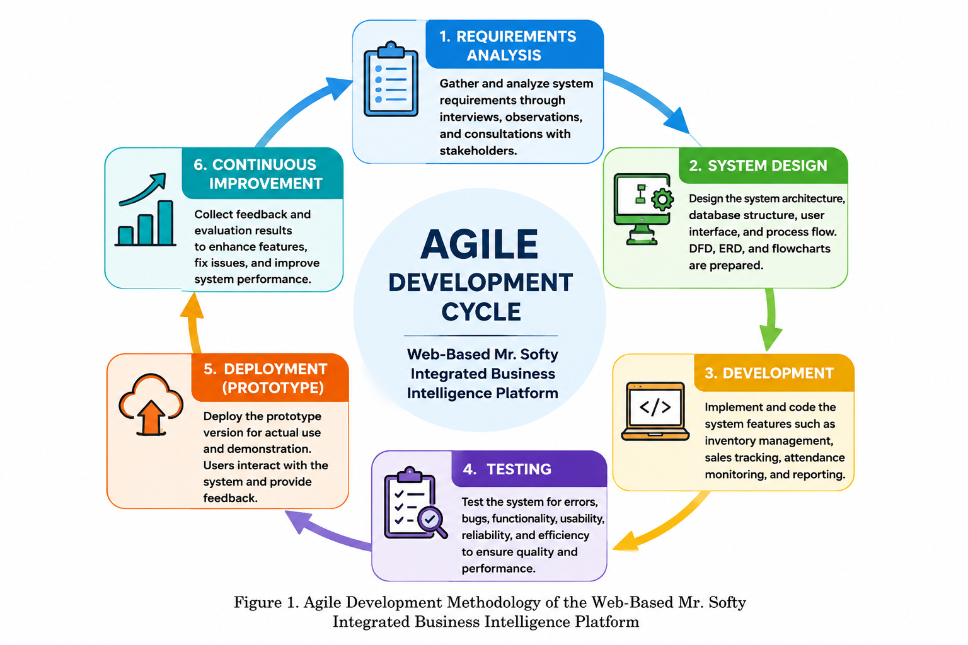

Requirements Analysis
In this phase, the researchers gathered and analyzed all information necessary for the development of the proposed system. Data gathering techniques such as interviews, observations, and consultations with the business owner, administrator, and staff were conducted to understand the current business processes and identify existing problems. The researchers examined how sales transactions, inventory monitoring, and employee attendance were managed. The collected data were analyzed to determine the functional and non-functional requirements of the system, ensuring that the proposed platform addressed the needs of the business and improved operational efficiency.

System Design
After identifying the system requirements, the researchers will proceed with designing the overall structure and functionality of the system. This phase involves creating the user interface design, database architecture, system modules, and process workflows. The researchers will also develop diagrams such as Data Flow Diagrams (DFD), Entity Relationship Diagrams (ERD), flowcharts, and use case diagrams to visualize how data moves within the system and how users interact with it. The design phase serves as the blueprint for the development process and ensures that all system requirements are properly represented.

Development
During this phase, the researchers converted the approved system design into a working application through coding and programming. Appropriate programming languages, frameworks, and database management systems were utilized to develop the platform. Core features such as sales transaction processing, inventory management, employee attendance monitoring, user account management, report generation, and system security were implemented. The researchers followed the design specifications to ensure that the developed system met the identified requirements and business objectives.

Testing
Once the development process was completed, the system underwent a series of testing procedures to identify and correct errors, bugs, and system defects. Functional testing was performed to verify that each feature operated according to its intended purpose. Usability testing assessed the ease of use and user-friendliness of the system, while reliability and performance testing evaluated system stability and efficiency. Any issues discovered during testing were documented and resolved to ensure the quality and effectiveness of the system before deployment.

Deployment (Prototype)
Once the development process was completed, the system underwent a series of testing procedures to identify and correct errors, bugs, and system defects. Functional testing was performed to verify that each feature operated according to its intended purpose. Usability testing assessed the ease of use and user-friendliness of the system, while reliability and performance testing evaluated system stability and efficiency. Any issues discovered during testing were documented and resolved to ensure the quality and effectiveness of the system before deployment.

Continuous Improvement
The final phase focused on enhancing and refining the system based on the feedback and evaluation results gathered during deployment. Suggestions, concerns, and recommendations from users were carefully reviewed to identify areas for improvement. Necessary modifications, feature enhancements, bug fixes, and performance optimizations were implemented to increase system efficiency, accuracy, usability, and reliability. This iterative process helped ensure that the proposed platform continued to meet the evolving needs of the business and provided long-term value to its users.

System Architecture
The Mr. Softy Web-Based Integrated Business Intelligence Platform followed a client-server architecture. In this type of architecture, the client side allowed users to access and interact with the system through a web browser, while the server side was responsible for processing requests, handling business logic, managing the database, and generating reports and analytics.
The client sent requests such as recording sales, checking inventory, or monitoring attendance to the server. The server then processed the data and stored it in the database before sending the results back to the user interface. This architecture helped the system provide faster data processing, centralized data management, and secure access for multiple users at the same time.
The client-server architecture was suitable for the study because it supported real-time data access, easier system maintenance, and improved scalability. It also allowed the researchers to manage and update the system efficiently without affecting the users’ access to the platform.
The architecture consisted of the following components:

Presentation Layer
The presentation layer served as the interface between the users and the application. It was responsible for displaying information, receiving user input, and providing access to the different features of the system through a user-friendly web interface.
Authorized users were able to access the system using desktop computers, laptops, tablets, or smartphones through a modern web browser.
The major interface components included:
- Login Page
- Administrator Dashboard
- Sales Management
- Inventory Management
- Attendance Monitoring
- Product and Toppings Management
- Stock Request Management
- Stock Check Logs
- Reports
- User Management

Application Layer
The application layer contained the business logic responsible for processing user requests, validating user inputs, executing business rules, and managing communication between the presentation layer and the database.
Its primary responsibilities included:
- User Authentication
- Sales Transaction Processing
- Inventory Monitoring and Updates
- Employee Attendance Recording
- Product and Toppings Management
- Stock Request Processing
- Stock Check Management
- Report Generation
- Dashboard Management
The application server acted as the intermediary between the presentation layer and the database server, ensuring that all transactions and user requests were processed accurately and efficiently.

Data Layer
The data layer stored all business information in a centralized relational database using MySQL. It was responsible for maintaining data integrity, enforcing relationships among database tables, and supporting efficient storage and retrieval of business records.
The stored information included:
- User Accounts
- Employee Information
- Products
- Toppings
- Inventory Records
- Sales Transactions
- Order Details
- Attendance Records
- Stock Requests
- Stock Check Logs
- Generated Reports
The implemented architecture ensured secure communication between the application server and the database while restricting unauthorized access through user authentication and role-based access control. This architectural approach contributed to the reliability, security, and efficiency of the Web-Based Mr. Softy Integrated Business Intelligence Platform by providing accurate data processing and centralized management of business operations.

User Interaction Flow

Data Flow Diagram (LEVEL 0)
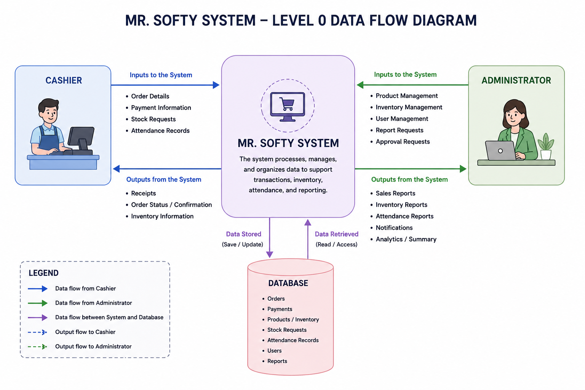
The Level 0 Data Flow Diagram (DFD) of the Web-Based Mr. Softy Integrated Business Intelligence Platform provided a high-level overview of how data flowed between the system, its users, and the database. It illustrated the interactions among the Cashier, Administrator, Web-Based Mr. Softy Integrated Business Intelligence Platform, and the Database, showing how information was entered, processed, stored, and retrieved to support daily business operations.
The Cashier served as one of the primary external entities of the system. The cashier inputted essential information such as customer order details, payment information, stock requests, and attendance records into the system. These data were processed by the Mr. Softy System to facilitate transaction processing, inventory monitoring, and attendance tracking. After processing, the system generated outputs including receipts, order confirmations, and inventory information, which were provided to the cashier to support customer service and operational tasks.
The Administrator was responsible for managing and overseeing the overall operation of the system. The administrator submitted product management updates, inventory management information, user management tasks, report requests, and approval requests to the system. In return, the system provided outputs such as sales reports, inventory reports, attendance reports, notifications, and analytical summaries. These outputs assisted the administrator in monitoring business performance, making informed decisions, and ensuring efficient store operations.
At the center of the diagram was the Mr. Softy System, which acted as the main processing unit. It received data from both the cashier and administrator, processed the information, and performed various functions related to sales transactions, inventory management, attendance monitoring, reporting, and record management. The system ensured that all business activities were organized and accurately recorded.
The Database functioned as the central repository of information. It stored important records such as orders, payments, products and inventory data, stock requests, attendance records, user information, and reports. The system continuously interacted with the database by saving, updating, and retrieving data whenever necessary. This centralized storage ensured data consistency, security, and accessibility across all system functions.
Overall, the Level 0 Data Flow Diagram demonstrated how the Mr. Softy System integrated sales processing, inventory management, attendance tracking, reporting, and administrative functions into a unified computerized platform. By enabling seamless data flow between users and the database, the system enhanced operational efficiency, improved record accuracy, supported effective decision-making, and reduced the limitations associated with manual business processes.

Data Flow Diagram (LEVEL 1)

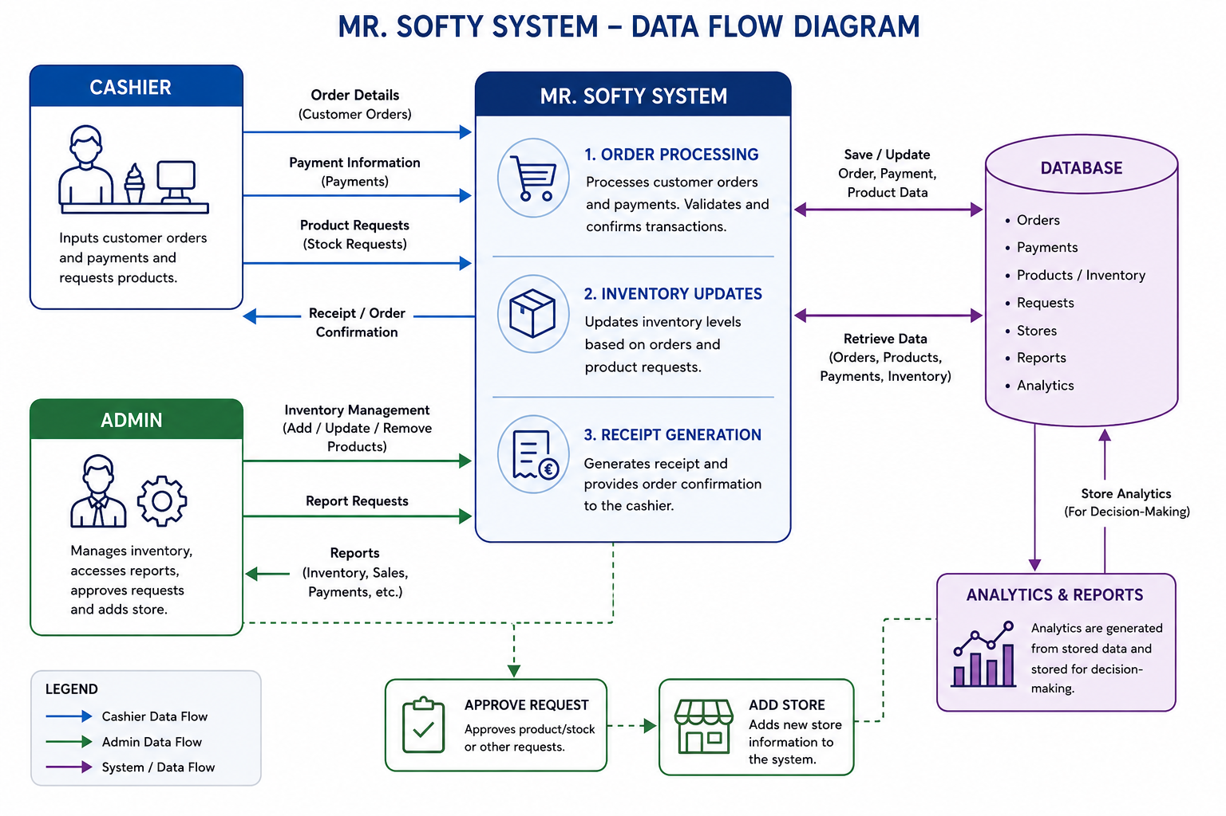

The Level 1 Data Flow Diagram (DFD) of the Web-Based Mr. Softy Integrated Business Intelligence Platform provided a detailed representation of how data flowed between the system's users, processes, and database. It broke down the major functions of the system into specific processes, showing how information was collected, processed, stored, and utilized to support daily business operations. The primary external entities involved in the system were the Cashier and the Administrator, while the database served as the central repository of information.
The first process, Order Processing, handled customer transactions entered by the cashier. The cashier submitted order details, payment information, and product requests through the system. The Order Processing module validated the information, calculated transaction totals, confirmed payments, and recorded customer purchases. Once the transaction was successfully completed, the system generated an order confirmation and sent the corresponding transaction data to the database for storage.
The second process, Inventory Updates, managed inventory-related activities. After each successful transaction, the system automatically updated inventory records by deducting the quantity of products sold from the available stock. Product requests submitted by the cashier were also recorded and processed within this module. The Inventory Updates process retrieved existing inventory data from the database and saved any modifications to ensure that stock information remained accurate and up to date. This process helped prevent stock shortages, inventory discrepancies, and manual errors in inventory monitoring.
The third process, Receipt Generation, was responsible for producing transaction receipts and order confirmations. After the order had been processed and payment had been verified, the system generated a receipt containing transaction details such as purchased items, quantities, prices, total amount, and payment information. The receipt was then provided to the cashier for distribution to the customer. This process ensured proper documentation of every transaction and served as proof of purchase.
The Database acted as the central data storage component of the system. It stored and maintained important records, including customer orders, payment transactions, inventory data, product information, stock requests, store information, reports, and analytics. The database continuously exchanged information with the system processes by receiving newly generated records and providing existing data whenever retrieval was required. This centralized storage ensured data consistency, security, and accessibility throughout the system.
The Administrator played a crucial role in managing system operations. The administrator submitted inventory management requests, such as adding, updating, or removing products from the inventory database. The administrator could also request reports, monitor sales and inventory activities, approve stock requests, and manage store information. Through these functions, the administrator ensured that inventory levels were properly maintained and business operations ran smoothly.
The Approve Request function allowed the administrator to review and authorize stock or product requests submitted through the system. Once approved, the corresponding updates were recorded in the database and reflected in inventory records. This process helped maintain proper inventory control and ensured that stock requests followed the organization's approval procedures.
The Add Store function enabled administrators to register and manage store information within the system. Store details were saved in the database and became available for reporting, monitoring, and operational management purposes. This function supported businesses operating in multiple locations by maintaining organized store records.
The Analytics and Reports module generated meaningful information from the data stored in the database. Sales records, payment transactions, inventory levels, and operational data were analyzed to produce reports and performance indicators. These reports provided administrators with valuable insights that supported decision-making, business planning, inventory forecasting, and performance evaluation. The generated analytics were stored in the database for future reference and reporting purposes.
Overall, the Level 1 Data Flow Diagram illustrated how the Mr. Softy System integrated transaction processing, inventory management, reporting, request approval, and store management into a unified computerized platform. By automating these processes and maintaining a centralized database, the system improved operational efficiency, data accuracy, inventory control, and managerial decision-making while reducing manual work and processing errors.

Flow Chart
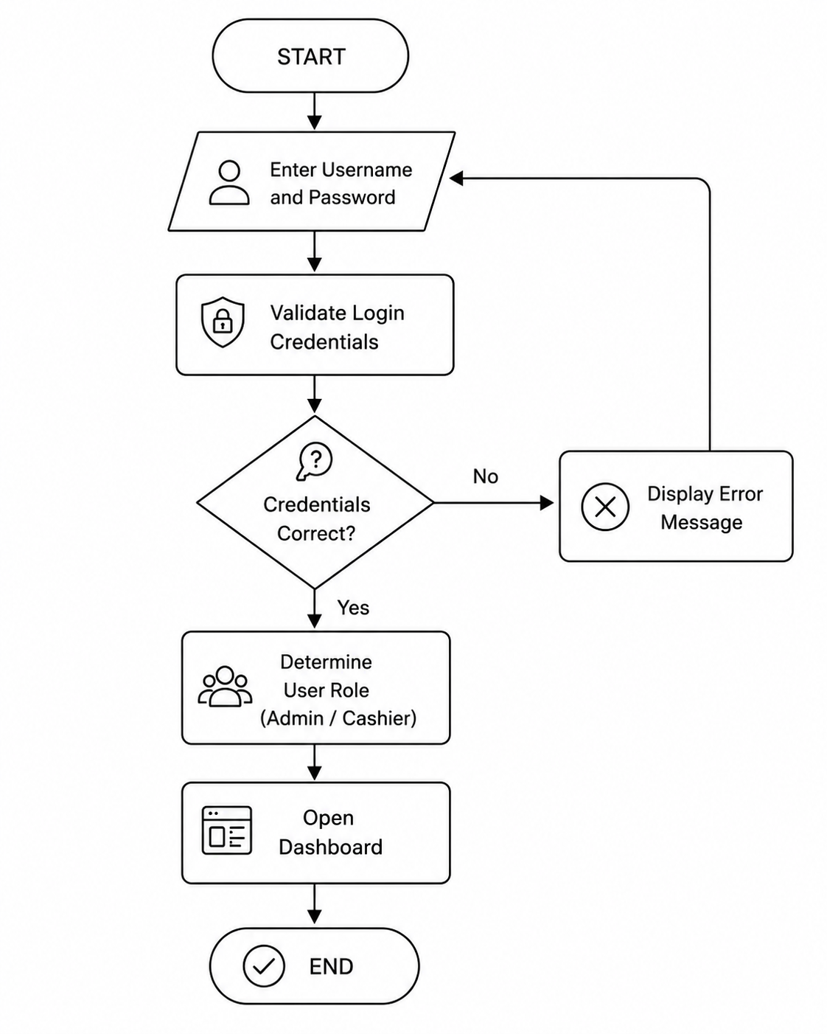
This figure presented the Login Process Flowchart of the Web-Based Mr. Softy Integrated Business Intelligence Platform. This flowchart illustrated the sequence of activities performed when a user attempted to access the system. It served as a security mechanism that ensured only authorized users could access the system's features and data.
The process started when the user opened the system and entered their username and password in the login interface. These credentials were then submitted to the system for verification. The system validated the entered information by comparing it with the user records stored in the database.
After the validation process, the system evaluated whether the provided credentials were correct. If the username or password did not match any existing record in the database, the system displayed an error message informing the user that the login attempt had failed. The user was then redirected back to the login page and prompted to enter the correct credentials before attempting to log in again. This step helped prevent unauthorized access and ensured that only legitimate users could proceed.
On the other hand, if the entered credentials were valid, the system identified the role assigned to the user. The system supported role-based access control, wherein different users had different permissions and functionalities depending on their designated role. For example, an Administrator was granted access to system management functions such as inventory monitoring, user management, stock requests, attendance records, and report generation, while a Cashier was provided access only to sales transactions and other cashier-related functions.
Once the user's role had been successfully determined, the system granted access and redirected the user to the appropriate dashboard. The dashboard served as the main interface where users could perform their assigned tasks and interact with the system's modules. After the dashboard was displayed, the login process was considered complete, and the user could begin utilizing the system according to their privileges.
The login process was an essential component of the system because it enhanced security, protected sensitive business information, and ensured that users could only access functions relevant to their responsibilities. Through credential validation and role-based authorization, the system maintained data integrity and prevented unauthorized operations within the proposed system.
Entity Relationship Diagram
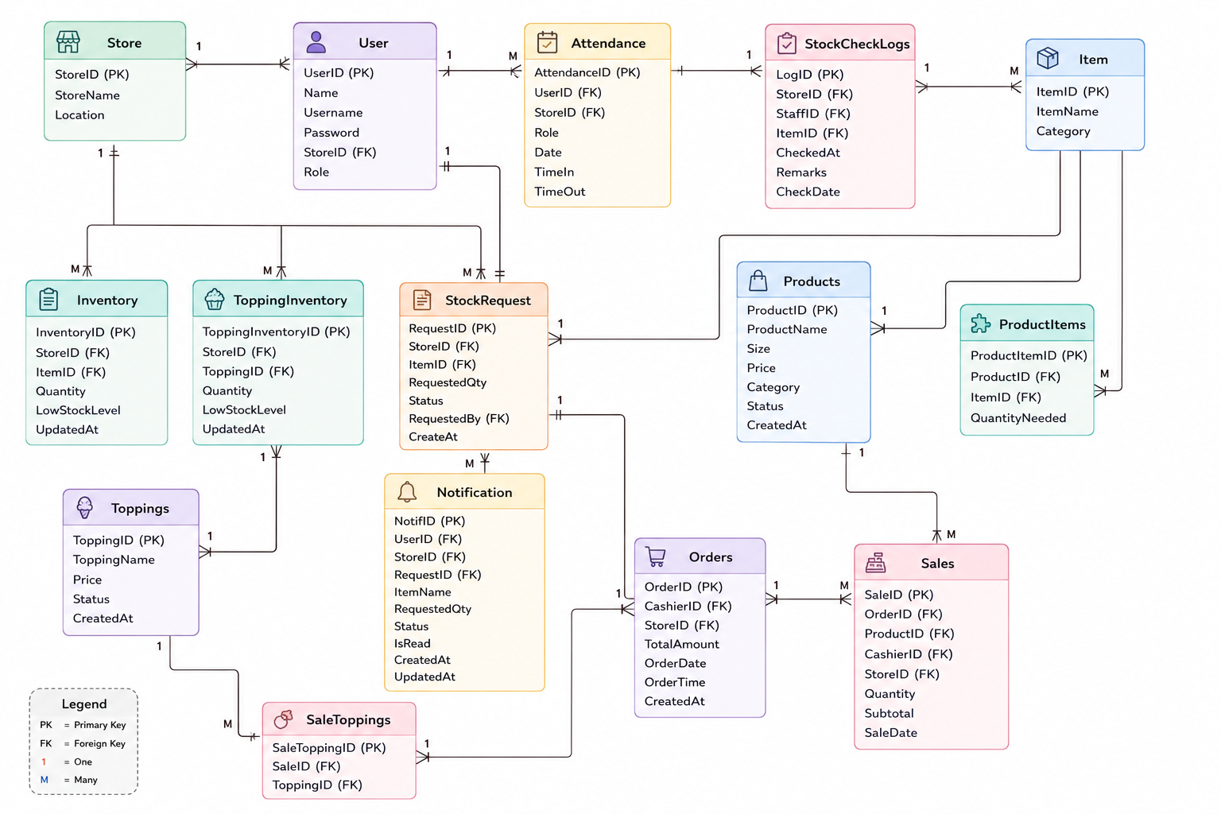

The figure illustrated the database structure of the proposed Point of Sale (POS), Inventory, and Employee Management System. It showed how different entities interacted with one another to support daily business operations, including sales processing, inventory monitoring, stock requests, attendance tracking, and product management.
At the center of the system was the Store entity, which served as the primary reference for users, inventory records, sales transactions, stock requests, attendance records, and topping inventories. Each store could have multiple users, inventory items, sales, and operational records.
The User entity stored information about system users such as cashiers and administrators. Users were associated with a specific store and could perform various functions including processing sales, requesting stocks, receiving notifications, and recording attendance.
The Products entity contained information about menu items offered by the business. Since each product could require multiple inventory items, the ProductItems entity served as a bridge table that defined the ingredients and quantities needed for each product. This established a many-to-many relationship between products and inventory items.
The Inventory entity managed the stock levels of raw materials and supplies used in product preparation. It tracked available quantities, low-stock thresholds, and inventory updates. Similarly, the Toppings and ToppingInventory entities managed available toppings and their corresponding stock quantities for each store.
Sales transactions were handled through the Orders and Sales entities. An order represented a customer's purchase, while sales records contained the individual products included in that order. Additional toppings selected by customers were recorded through the SaleToppings entity, which linked toppings to specific sales transactions.
To ensure proper inventory management, the StockRequest entity recorded requests for additional stock items made by staff members. These requests generated corresponding entries in the Notification entity, allowing administrators to monitor and approve stock replenishment requests.
The StockCheckLogs entity maintained records of inventory inspections conducted by staff, including the date, time, and remarks regarding stock conditions. Meanwhile, the Attendance entity recorded employee attendance information such as time-in and time-out logs.
Overall, the ERD demonstrated how the system integrated sales, inventory control, employee management, stock monitoring, and notification processes into a centralized database structure, ensuring efficient and accurate business operations.

Database Design

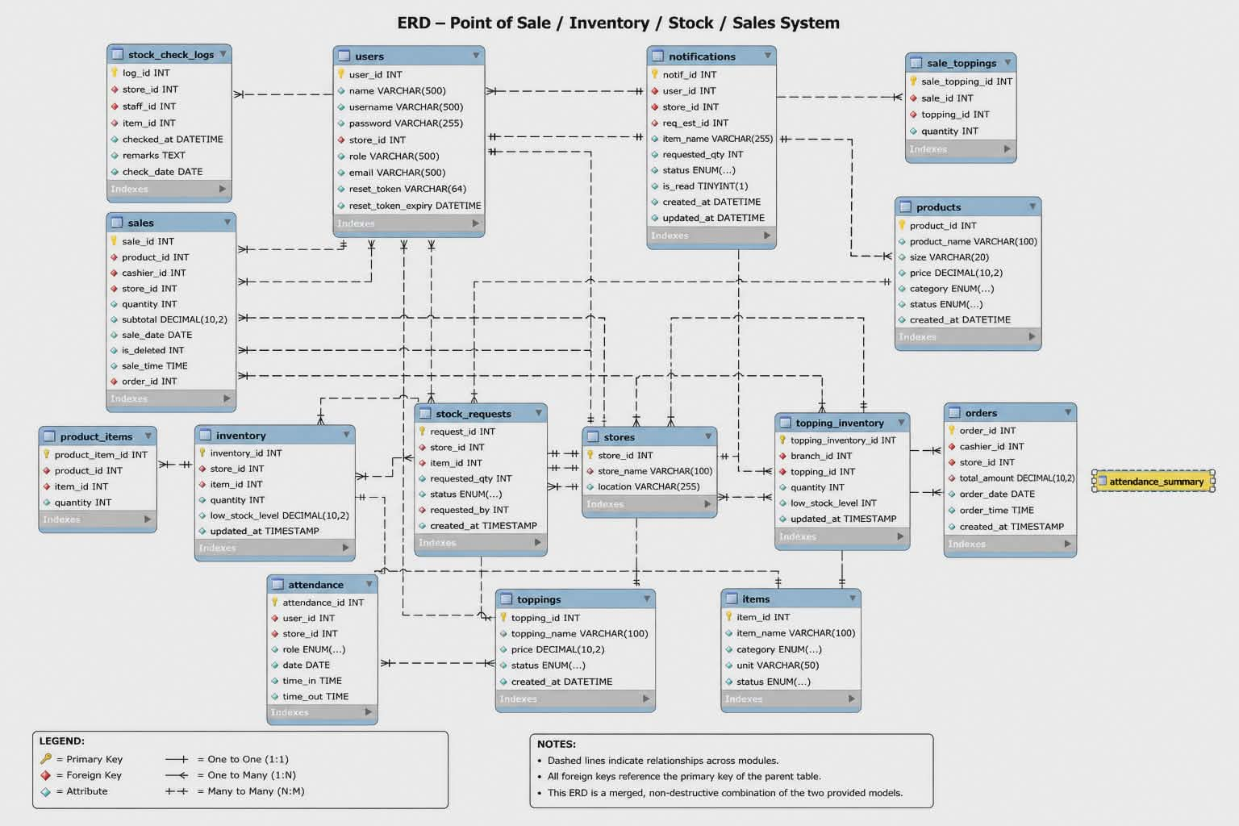
The database design presented the structure of the Web-Based Mr. Softy Integrated Business Intelligence Platform. It was composed of several interconnected tables that worked together to store, manage, and process business transactions, inventory records, employee attendance, and administrative activities. The design followed a relational database model where each table represented a specific entity and relationships were established through primary and foreign keys to ensure data integrity and consistency.
At the center of the database was the users table, which stored information about system users such as administrators and cashiers. This table contained login credentials, user roles, and contact information, allowing the system to implement role-based access control. The users table was connected to several modules including sales, attendance, stock requests, notifications, and stock check logs.
The products table contained information about the products being sold, including product names, sizes, prices, categories, and status. Since products were composed of different ingredients or materials, the product_items table served as a bridge between products and inventory items. This relationship allowed the system to determine which inventory items were consumed whenever a product was sold.
The items table stored the list of raw materials and inventory supplies used in the business. These items were monitored through the inventory table, which recorded the available quantity of each item per store, the low-stock threshold, and the last update date. This enabled the system to automatically monitor inventory levels and identify items that required replenishment.
To support multiple store branches, the store table contained branch information such as store name and location. Many operational tables, including inventory, sales, stock requests, attendance, and notifications, referenced the store table to identify where a transaction or activity occurred.
The orders table recorded customer orders and served as the main transaction record during sales operations. Related to this, the sales table stored detailed sales information such as product sold, cashier assigned, quantity purchased, subtotal amount, sale date, and sale time. This table provided the basis for generating sales reports and monitoring business performance.
To accommodate customizable products, the system included a toppings table that stored available toppings and their corresponding prices. The sale_toppings table acted as a junction table that linked sales transactions with selected toppings. Meanwhile, the topping_inventory table managed the stock levels of topping ingredients for each branch, ensuring that topping availability was accurately monitored.
Inventory management was further supported by the stock_requests table. This table recorded requests for additional inventory items whenever stock levels became insufficient. Each request contained information about the requested item, quantity, requesting user, status, and creation date. To keep users informed, the notifications table stored system-generated notifications related to stock requests and inventory concerns.
The system also included the stock_check_logs table, which recorded inventory inspection activities performed by staff members. This table stored information about the employee who conducted the stock check, the item inspected, the store involved, and remarks regarding the inspection. These logs helped maintain inventory accuracy and accountability.
For workforce management, the attendance table recorded employee attendance information, including time-in, time-out, date, assigned role, and store location. This allowed administrators to monitor employee attendance and working hours efficiently. The attendance_summary view provided a summarized representation of attendance records, making it easier to generate attendance reports and analyze employee performance.
Overall, the database design integrated sales processing, inventory monitoring, stock management, attendance tracking, and administrative functions into a single relational database structure. Through the use of well-defined relationships and normalized tables, the design ensured efficient data storage, minimized redundancy, maintained data integrity, and supported the operational requirements of the proposed system.

Wire Frame (Admin)
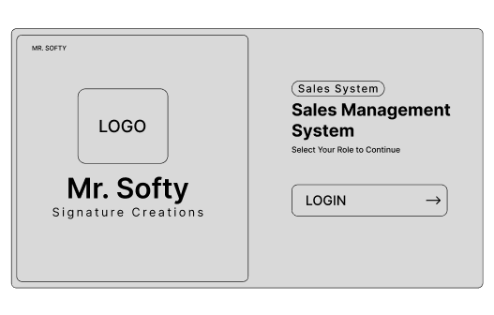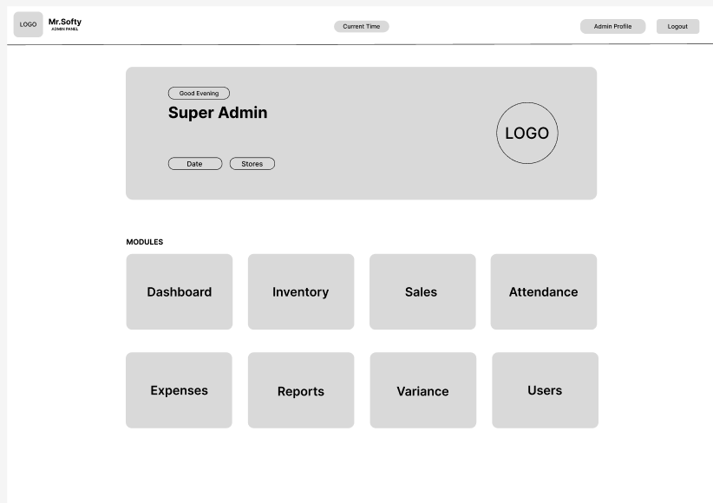

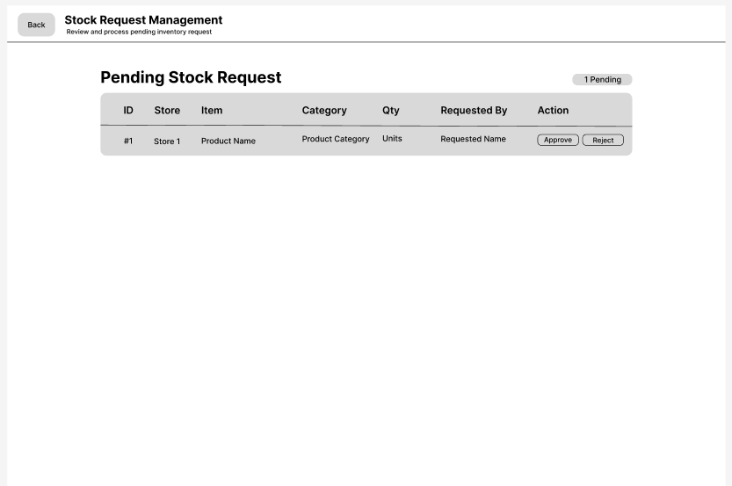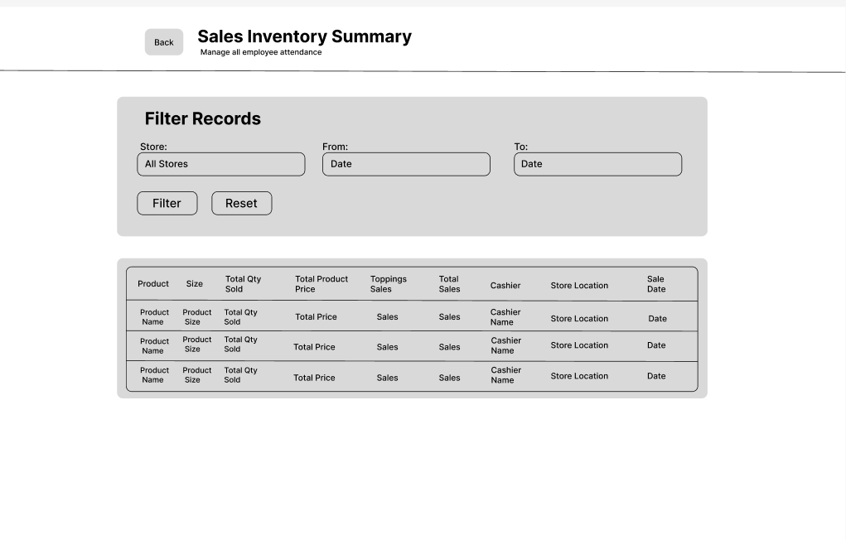

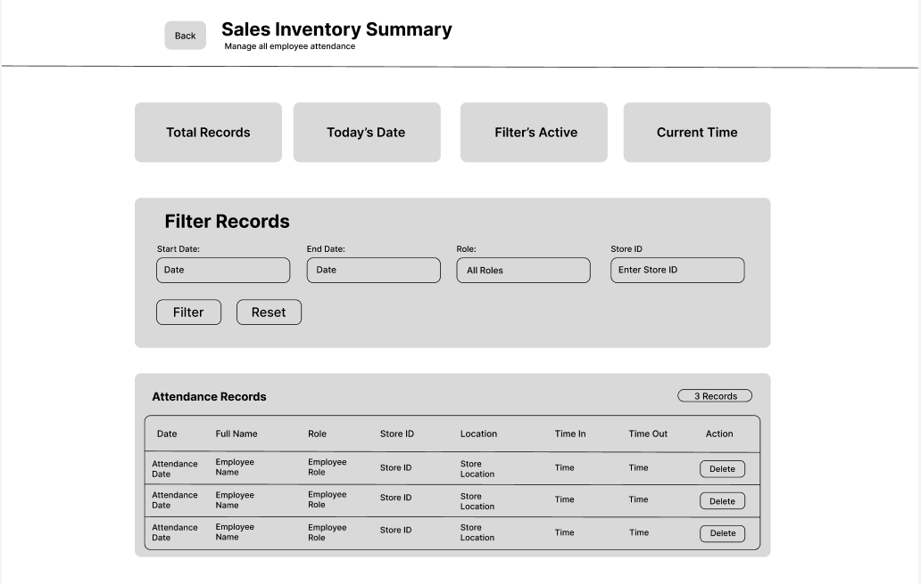
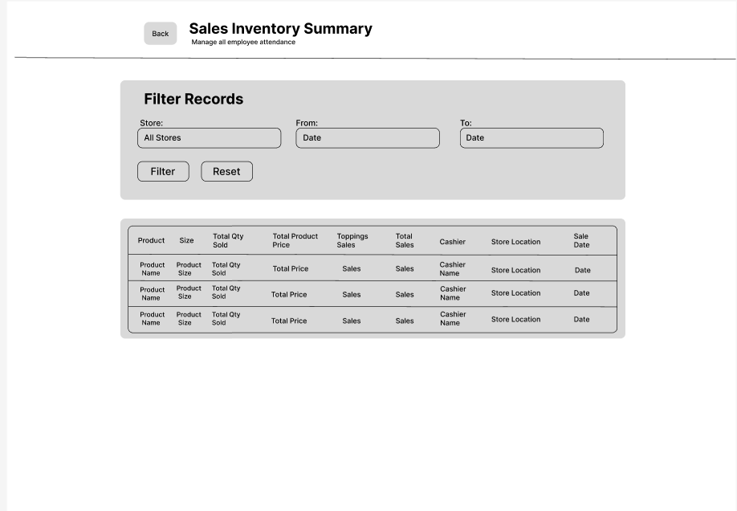
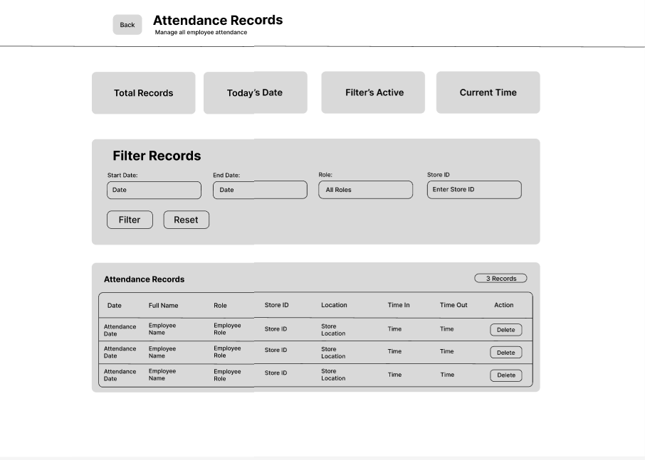
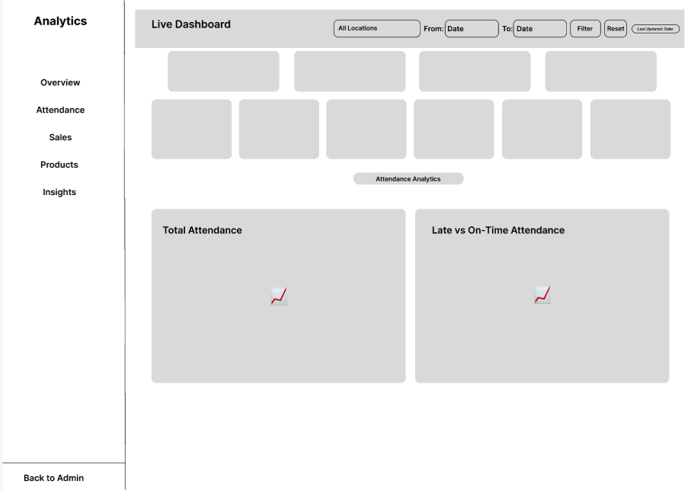
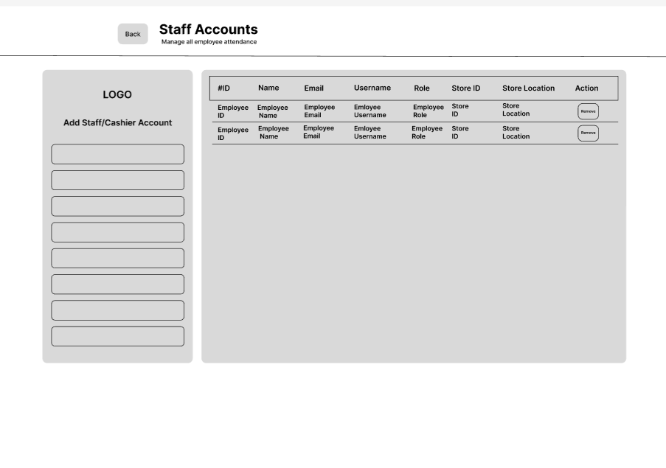
The figures presented the user interface of the Web-Based Mr. Softy Integrated Business Intelligence Platform. The interfaces included the Login Page, Admin Dashboard, Stock Request Management, Sales Inventory Summary, Attendance Records, Analytics Dashboard, and Staff Accounts. Each interface was designed with a simple and user-friendly layout to allow administrators to easily access and manage the system's core functions.
The developed system enabled administrators to monitor sales transactions, manage inventory and stock requests, track employee attendance, generate reports, analyze business performance through dashboards, and manage staff accounts within a single platform. By integrating these essential business operations into one system, the application improved efficiency, minimized manual errors, and provided organized records that supported faster and more informed decision-making.

Wire Frame (Cashier)

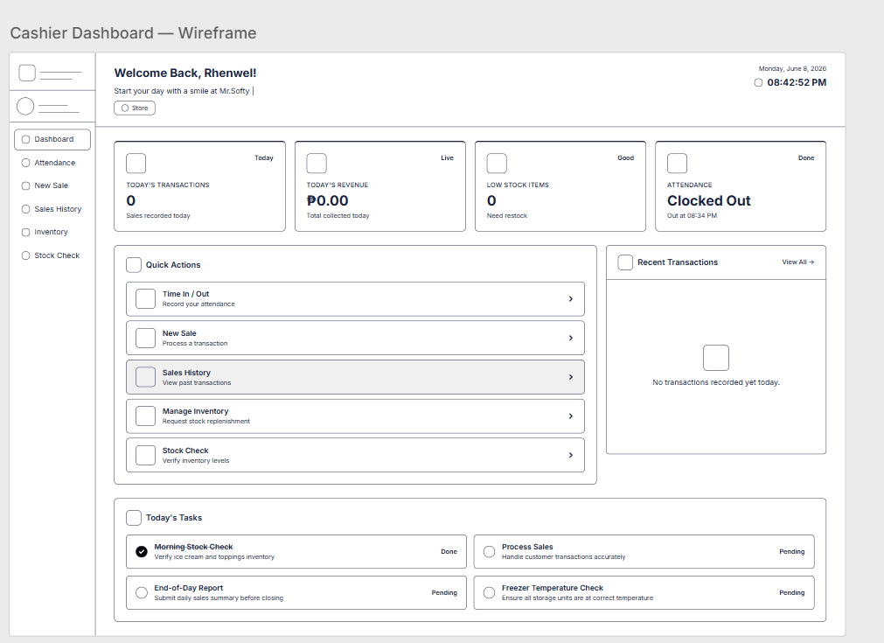
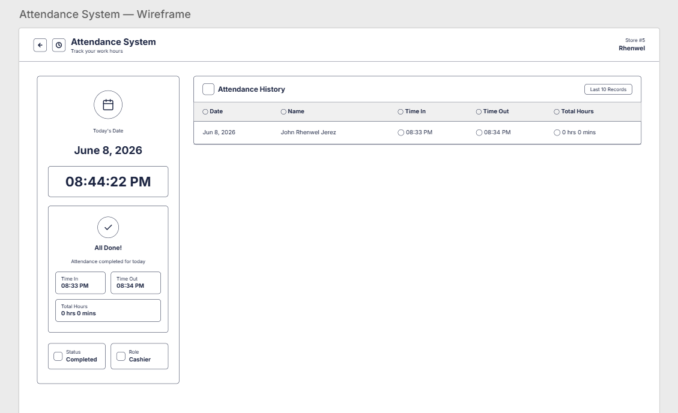

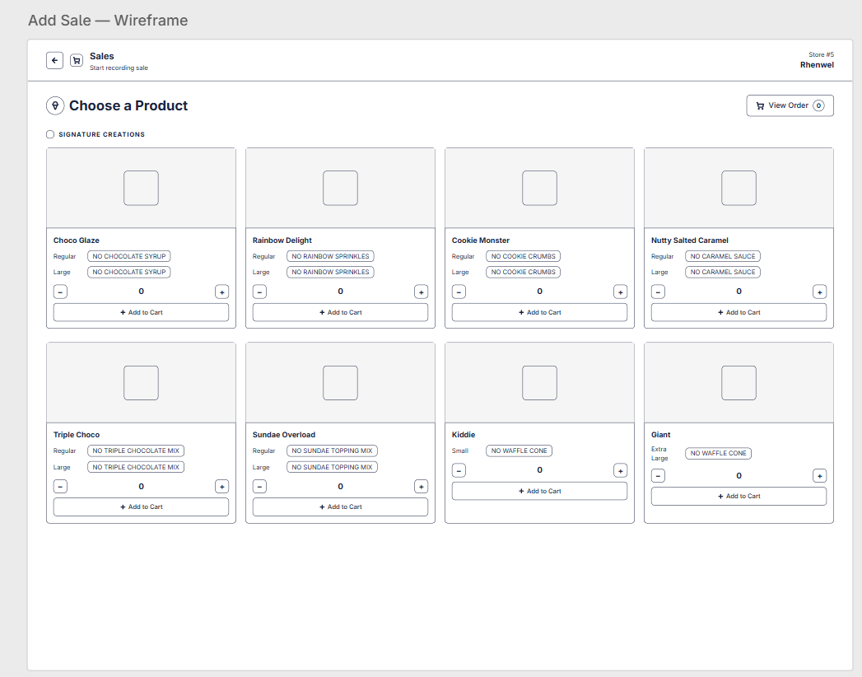

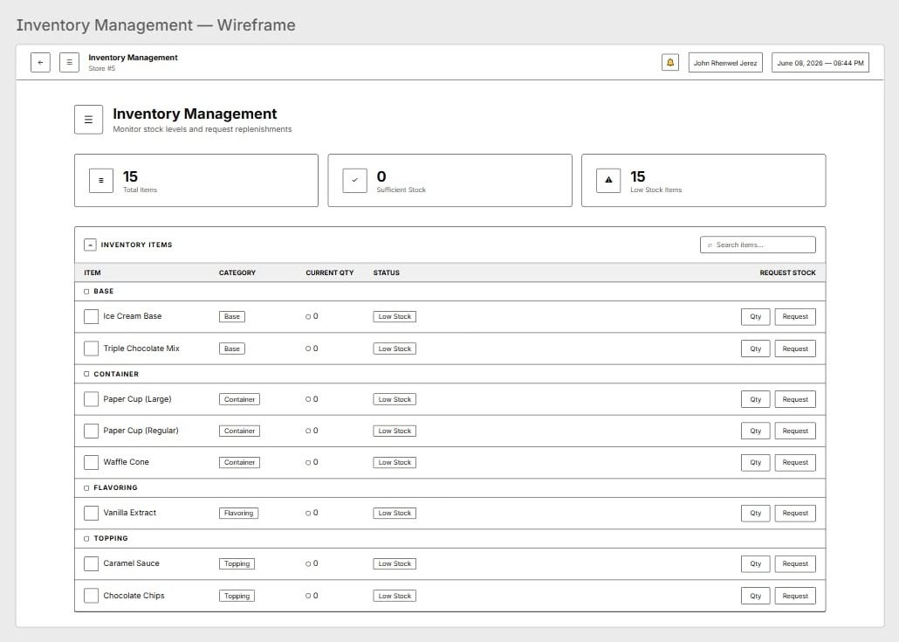
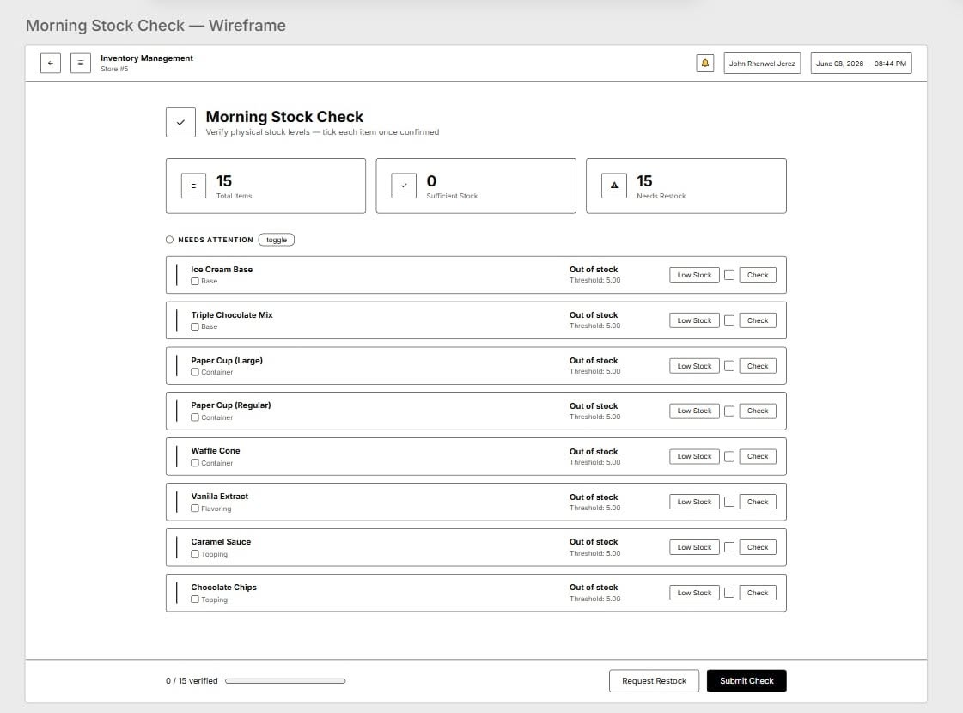

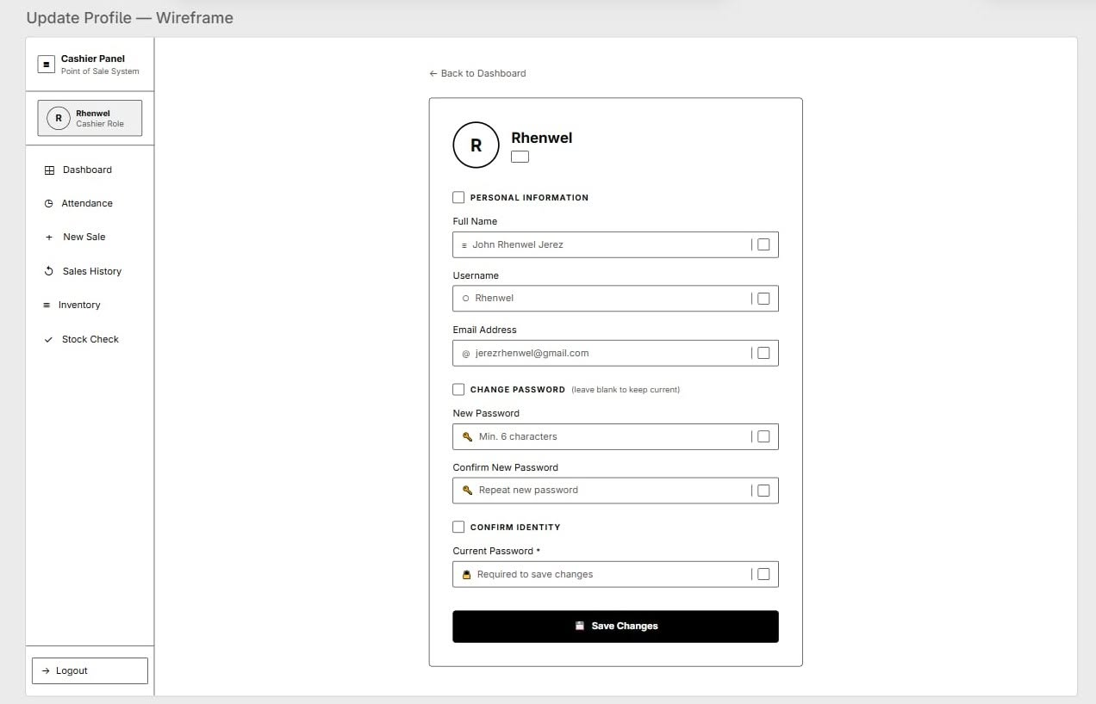

The figures presented the cashier interface of the Web-Based Mr. Softy Integrated Business Intelligence Platform. It included the Cashier Dashboard, Attendance System, Add Sale, Inventory Management, Morning Stock Check, and Update Profile pages. These interfaces were designed to provide cashiers with an organized and user-friendly environment for performing their daily tasks. Through the dashboard, cashiers could quickly access essential functions such as recording attendance, processing sales transactions, managing inventory, conducting stock checks, and viewing recent activities.
The system also allowed cashiers to monitor inventory levels, submit stock replenishment requests, record daily sales, and update their personal account information. Additionally, the attendance and stock check modules helped ensure accurate employee timekeeping and inventory monitoring before daily operations began. By integrating these functions into a single platform, the system streamlined cashier operations, reduced manual record-keeping, improved accuracy, and enhanced the overall efficiency of Mr. Softy's business processes.

USE CASE DIAGRAM
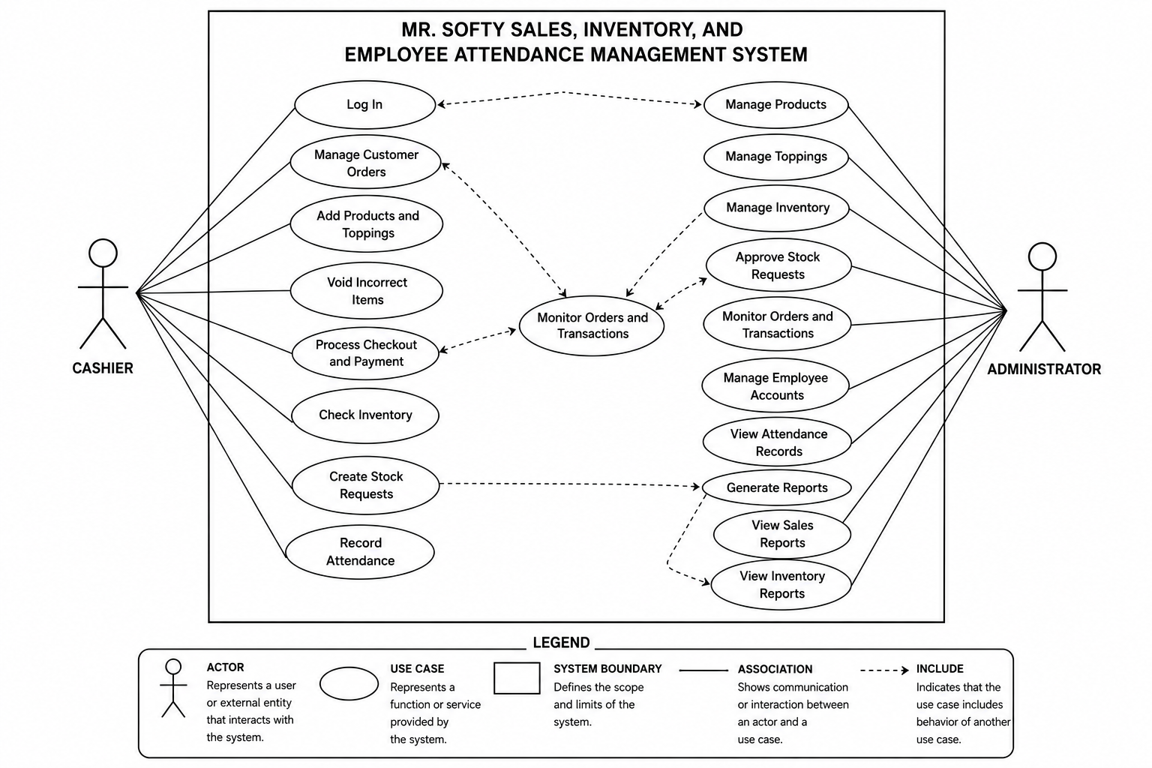

The Use Case Diagram illustrated the interactions between the users and the proposed Web-Based Mr. Softy Integrated Business Intelligence Platform. It identified the different functions of the system and showed how each user interacted with those functions. The diagram helped define the scope of the system and served as a guide during the system development process.
The system had two primary actors: the Cashier and the Administrator. These actors were located outside the system boundary because they represented the users who interacted with the system.
The Cashier was responsible for handling daily business operations. The cashier could log in to the system, manage customer orders, add products and toppings, void incorrect items, process customer payments, check inventory availability, create stock requests, and record employee attendance. These functions helped ensure that sales transactions were processed efficiently and that inventory information remained updated.
On the other hand, the Administrator had higher-level management responsibilities. The administrator could manage products, toppings, and inventory records, approve stock requests submitted by the cashier, monitor orders and transactions, manage employee accounts, view attendance records, generate reports, and review sales and inventory reports. These functions allowed the administrator to supervise business operations and make informed decisions based on system-generated data.
The diagram also showed the relationships between use cases through the use of «include» and «extend» relationships. The «include» relationship indicated that one use case required the functionality of another use case as part of its process. For example, generating reports could include viewing sales reports and inventory reports. Meanwhile, the «extend» relationship indicated optional or additional functionality that could occur under specific conditions, such as voiding incorrect items while managing customer orders.
The system boundary represented the scope of the proposed system and contained all the use cases that the system could perform. The actors interacted with these use cases through association relationships, which were represented by solid lines connecting the actors to the use cases.
Overall, the Use Case Diagram provided a visual representation of the functional requirements of the proposed system. It helped the researchers, developers, and stakeholders understand how users interacted with the system and ensured that all necessary features were identified before the implementation phase began.

Tools and Technologies Used
The development of the proposed system utilized various software tools and technologies to ensure efficient system design, implementation, and database management. These technologies were selected based on their reliability, accessibility, and compatibility with web-based applications.

Frontend Technologies
HTML (HyperText Markup Language)
HTML served as the foundation of the system's user interface. It was used to structure and organize the content displayed on web pages, including forms, buttons, tables, navigation menus, and other interactive elements. Through HTML, users were able to interact with the system to perform tasks such as managing orders, viewing inventory, recording attendance, and generating reports.
CSS (Cascading Style Sheets)
CSS was utilized to enhance the visual appearance and layout of the system. It controlled the design aspects of the application, including colors, fonts, spacing, alignment, and responsiveness. By using CSS, the system provided a more user-friendly and professional interface that improved usability and user experience for both cashiers and administrators.
JavaScript
JavaScript was used to add interactivity and dynamic functionality to the system. It enabled features such as form validation, real-time calculations, automatic updates, confirmation messages, and responsive user interactions without requiring the page to reload. This improved the efficiency and responsiveness of the application.

Backend Technologies
PHP (Hypertext Preprocessor)
PHP served as the server-side scripting language responsible for processing user requests and managing system operations. It handled data transactions between the user interface and the database, including user authentication, order processing, inventory updates, attendance recording, and report generation. PHP enabled the system to execute business logic securely and efficiently.
MySQL
MySQL was the relational database management system used to store, organize, and manage the system's data. It maintained records related to products, toppings, inventory, sales transactions, stock requests, employee attendance, and user accounts. MySQL ensured data consistency, security, and efficient retrieval of information required by the system.

Database Management Tool
MySQL Workbench
MySQL Workbench was utilized as the database design and administration tool for the project. It assisted developers in creating and managing the database structure through Entity-Relationship Diagrams (ERDs), designing tables, defining relationships, executing SQL queries, and monitoring database performance. The tool helped ensure that the database was properly organized and optimized for the system's requirements.

Development Environment
Visual Studio Code (VS Code)
Visual Studio Code was the primary Integrated Development Environment (IDE) used during system development. It provided a lightweight yet powerful coding environment with features such as syntax highlighting, code completion, debugging tools, and extension support for PHP, HTML, CSS, JavaScript, and MySQL. These features improved development efficiency, code quality, and project management.
Summary
The combination of HTML, CSS, JavaScript, PHP, MySQL, MySQL Workbench, and Visual Studio Code provided a complete development environment for building the proposed system. These technologies worked together to deliver a secure, efficient, and user-friendly web-based application capable of supporting the daily operations of Mr. Softy.

Data Gathering Techniques
To gather the necessary information for the development of the proposed Point-of-Sale, Inventory Management, and Attendance Monitoring System, the researchers employed several data gathering techniques. These techniques were used to understand the current operational processes, identify existing problems, and determine the system requirements needed to address the business's needs effectively.

Interviews
The researchers conducted interviews with the business owner, administrator, and staff members who are directly involved in the daily operations of the business. The interviews aimed to collect detailed information regarding the current procedures for sales transactions, inventory management, employee attendance monitoring, and report generation.
Through face-to-face discussions, the researchers were able to identify the challenges and limitations of the existing manual system, such as errors in record-keeping, delays in report preparation, difficulties in inventory tracking, and inefficiencies in attendance monitoring. The interview process also provided an opportunity for the respondents to share their suggestions and expectations for the proposed computerized system.
Furthermore, the information gathered through interviews served as a primary source in determining the functional and non-functional requirements of the system. By obtaining insights directly from the users, the researchers ensured that the proposed system would address actual operational problems and supported the business's daily activities more effectively.

Observation
Observation was utilized to examine and understand the actual workflow and operational procedures of the business in its natural setting. The researchers observed how sales transactions were processed, how inventory records were maintained, how employee attendance was monitored, and how daily reports were prepared and managed.
This technique allowed the researchers to witness firsthand the sequence of activities performed by employees and administrators during business operations. Through observation, the researchers identified inefficiencies, repetitive tasks, and areas where human errors commonly occurred. It also enabled the researchers to verify and validate the information obtained during the interviews.
Additionally, observation provided valuable insights into user behavior, system requirements, and operational challenges that may not have been fully expressed during interviews. By closely examining the actual business processes, the researchers gained a comprehensive understanding of the organization's workflow, which contributed significantly to the design and development of a system that aligns with the business's operational needs and objectives.

Document Analysis
The researchers also reviewed existing business documents and records, including sales receipts, inventory logs, attendance records, stock request forms, and manual reports. These documents served as supporting sources of information that helped the researchers understand the structure, format, and content of the data currently being used by the business.
Through document analysis, the researchers identified the types of information that needed to be stored, processed, and generated by the proposed system. This technique also helped ensure that the computerized system would maintain consistency with existing business records while improving accuracy, accessibility, and efficiency in data management.

Testing Procedures
To ensure the quality, reliability, and effectiveness of the proposed Inventory, Sales, and Attendance Monitoring System, the researchers conducted several levels of testing throughout the development process. These testing procedures helped identify and resolve errors, verify system functionality, and ensure that the system met the requirements of the business.

Unit Testing
Unit Testing was performed to evaluate individual modules or components of the system separately. Each feature, such as login authentication, inventory management, sales transaction processing, attendance recording, and report generation, was tested independently to ensure that it functioned correctly according to the specified requirements. This testing helped identify coding errors and defects at an early stage of development, making them easier and less costly to fix.

Integration Testing
After the individual modules had been tested, Integration Testing was conducted to verify that the different components of the system worked together properly. The researchers examined the interaction between modules, such as the connection between sales transactions and inventory updates, attendance records and report generation, and user accounts and system access controls. This testing ensured that data flowed accurately between modules and that there were no communication issues within the system.

System Testing
System Testing was performed on the fully integrated system to evaluate its overall functionality, performance, security, and reliability. The researchers tested the complete platform in an environment that closely resembled actual business operations. This process verified that all system features functioned as intended and met the established requirements. The testing also assessed the system's ability to handle multiple transactions, maintain data accuracy, and provide stable performance during regular use.

User Acceptance Testing (UAT)
User Acceptance Testing was conducted by allowing the business owner, administrator, and selected users to evaluate the system based on actual business tasks and operations. Users interacted with the system and provided feedback regarding its usability, efficiency, functionality, and overall performance. The purpose of this testing was to determine whether the system met the expectations and needs of the users. Any suggestions, concerns, or issues identified during this phase were reviewed and addressed before the final implementation of the system.

Evaluation Criteria
The researchers evaluated the developed system using software quality criteria to determine its effectiveness, performance, and acceptance by users. The evaluation focused on functionality, usability, reliability, security, and efficiency to ensure that the system met the operational requirements of the business and provided a satisfactory user experience.
The proposed Inventory, Sales, and Attendance Monitoring System was evaluated based on several quality criteria to determine its effectiveness, performance, and suitability for business operations. These criteria served as the basis for assessing whether the system successfully met the needs and expectations of its users.

Functionality
Functionality refers to the system's ability to perform its intended tasks accurately and efficiently. The researchers evaluated whether all features and modules, including sales transaction processing, inventory management, attendance monitoring, report generation, and user account management, functioned according to the specified requirements. The system was expected to produce correct outputs, process data accurately, and support the daily operations of the business without errors.

Usability
Usability measured how easy and convenient the system was for users to learn, operate, and navigate. The researchers assessed whether the user interface was clear, organized, and user-friendly for cashiers, administrators, and other authorized users. Factors such as ease of navigation, accessibility of features, clarity of instructions, and overall user experience were considered. A highly usable system allowed users to complete tasks efficiently with minimal training and effort.

Reliability
Reliability evaluated the system's ability to perform consistently and accurately over time. The researchers examined whether the system could operate continuously without frequent failures, crashes, or unexpected errors. The system was expected to maintain data integrity, process transactions correctly, and provide dependable performance during normal business operations. A reliable system ensured that users could trust the platform to perform its functions whenever needed.

Security
Security focused on protecting the system and its data from unauthorized access, misuse, and potential threats. The researchers evaluated the effectiveness of user authentication, access controls, data validation, and error-handling mechanisms implemented within the system. The system was expected to ensure that sensitive information, such as employee records, sales data, and inventory information, was properly secured and accessible only to authorized users. Input validation was also assessed to prevent invalid or harmful data from entering the system.

Efficiency
Efficiency refers to the system's ability to perform tasks quickly while utilizing resources effectively. The researchers assessed the speed of transaction processing, report generation, data retrieval, and inventory updates. The system was expected to respond promptly to user actions and maintain smooth performance even when handling multiple operations. Efficient resource utilization helped improve productivity and supported the daily workflow of the business.

Chapter VI

SYSTEM DEVELOPMENT, IMPLEMENTATION, TESTING, EVALUATION, RESULTS, AND DISCUSSION

Overview of the Developed System
The Web-Based Mr. Softy Integrated Business Intelligence Platform is a web-based application developed to automate and improve the daily business operations of Mr. Softy. The system integrates sales management, employee attendance monitoring, inventory management, and business reporting into a single platform. It enables business owners and authorized staff to efficiently record transactions, monitor inventory levels, track employee attendance, and generate reports that support operational and managerial decision-making.
Unlike the previous manual process of recording sales, attendance, and inventory using paper-based records, the developed system centralizes business information in a secure database. The application minimizes human errors, eliminates redundant record-keeping, and provides real-time access to business data. It also generates reports and dashboards that help the business owner monitor daily sales performance, inventory status, employee attendance, and stock movement, allowing for faster and more informed decision-making.
The system was developed to provide Mr. Softy with an affordable and user-friendly business intelligence platform that improves operational efficiency, enhances record management, and supports business growth. By integrating multiple business processes into a single web-based application, the system simplifies daily operations while ensuring that important business information is organized, accurate, and easily accessible.
The major objectives of the developed system are as follows:
- Automate the recording and management of sales transactions.
- Monitor and record employee attendance accurately.
- Manage inventory by tracking product availability and stock movement.
- Generate sales, inventory, and attendance reports for business monitoring.
- Reduce manual recording errors through a centralized database.
- Support business owners in making informed decisions through organized reports and real-time business information.
The development of the Web-Based Mr. Softy Integrated Business Intelligence Platform followed modern software engineering principles by incorporating a responsive user interface, secure user authentication, centralized database management, role-based access control, and reliable data processing. These features ensure that authorized users can securely access the system while maintaining the accuracy, integrity, and confidentiality of business information.
The completed system consists of several integrated modules that work together to capture, process, store, and manage business data. These modules include user authentication, sales management, inventory management, attendance monitoring, stock request management, stock checking, report generation, and the administrator dashboard. Together, these modules provide a comprehensive solution that streamlines Mr. Softy's daily operations and improves overall business management.

System Implementation
This phase involved the development of the Web-Based Mr. Softy Integrated Business Intelligence Platform for sales, attendance, and inventory management. The system was developed using HTML, CSS, JavaScript, PHP, and MySQL. It included modules for recording sales transactions, monitoring employee attendance, managing inventory, processing stock requests, and generating reports. The implemented system centralized the storage and management of business records and provided role-based access for administrators and staff.

Admin Modules

Login Module
The Login Module served as the primary access point of the Mr. Softy Integrated Business Intelligence Platform. It was implemented to authenticate administrators before granting access to the system and its administrative functions. The module provided a secure and organized interface where administrators could enter their registered email address and password to access the system. This authentication process helped restrict system access to authorized administrators and protected the information and functions managed within the application.
As shown in Figure 4.1, the login interface displayed the Mr. Softy logo and branding at the upper portion of the form, followed by the Admin Login heading and a short instruction indicating that users needed to enter their credentials to continue. The interface provided separate input fields for the administrator's email and password. It also included a Forgot Password? option to assist users who needed to recover their account credentials. After entering the required information, the administrator could select the Sign In button to proceed with authentication. A Back option was also provided to return to the previous page.
The Login Module was designed with a simple and user-friendly interface to provide administrators with a straightforward method of accessing the system. By requiring valid login credentials before entering the administrative interface, the module supported controlled access to the different functions of the Mr. Softy system.
Image 4.1 presents the Login Interface of the Web-Based Mr. Softy Integrated Business Intelligence Platform.

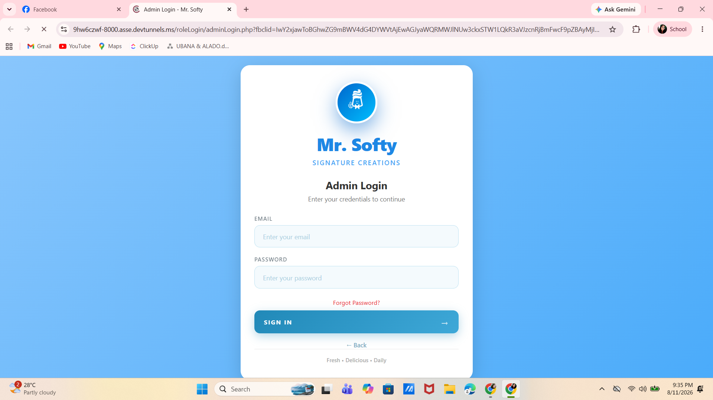
As shown in Image 4.1, the Login Interface provides the required fields for the administrator's email and password together with the Sign In, Forgot Password, and Back options. The interface provides the initial authentication screen through which authorized administrators access the system.

Dashboard Module
The Dashboard Module served as the primary interface of the Mr. Softy System after the administrator successfully logged into the application. It provided the administrator with a centralized starting point for accessing the major functions of the system. The dashboard displayed the current administrator account, system time, current date, selected store coverage, and the available modules, allowing the administrator to easily navigate and manage the different operations of Mr. Softy.
The dashboard presented eight major modules: Dashboard, Inventory, Sales, Attendance, Stores, Reports, Variance, and Users. Each module was represented by a dedicated section with an icon, module name, and short description indicating its purpose. The Inventory module provided access to store stocks and stock requests, while the Sales module focused on revenue information. The Attendance module provided access to staff records, the Stores module was used to manage branches, and the Reports module provided access to daily reports. The Variance module was intended for monitoring stock alerts, while the Users module provided access to staff accounts. The dashboard also displayed the administrator's role as Super Admin, indicating that the account had full access to the available stores and reports.
Image 4.2 presents the Dashboard Module of the Mr. Softy Integrated Business Intelligence Platform. 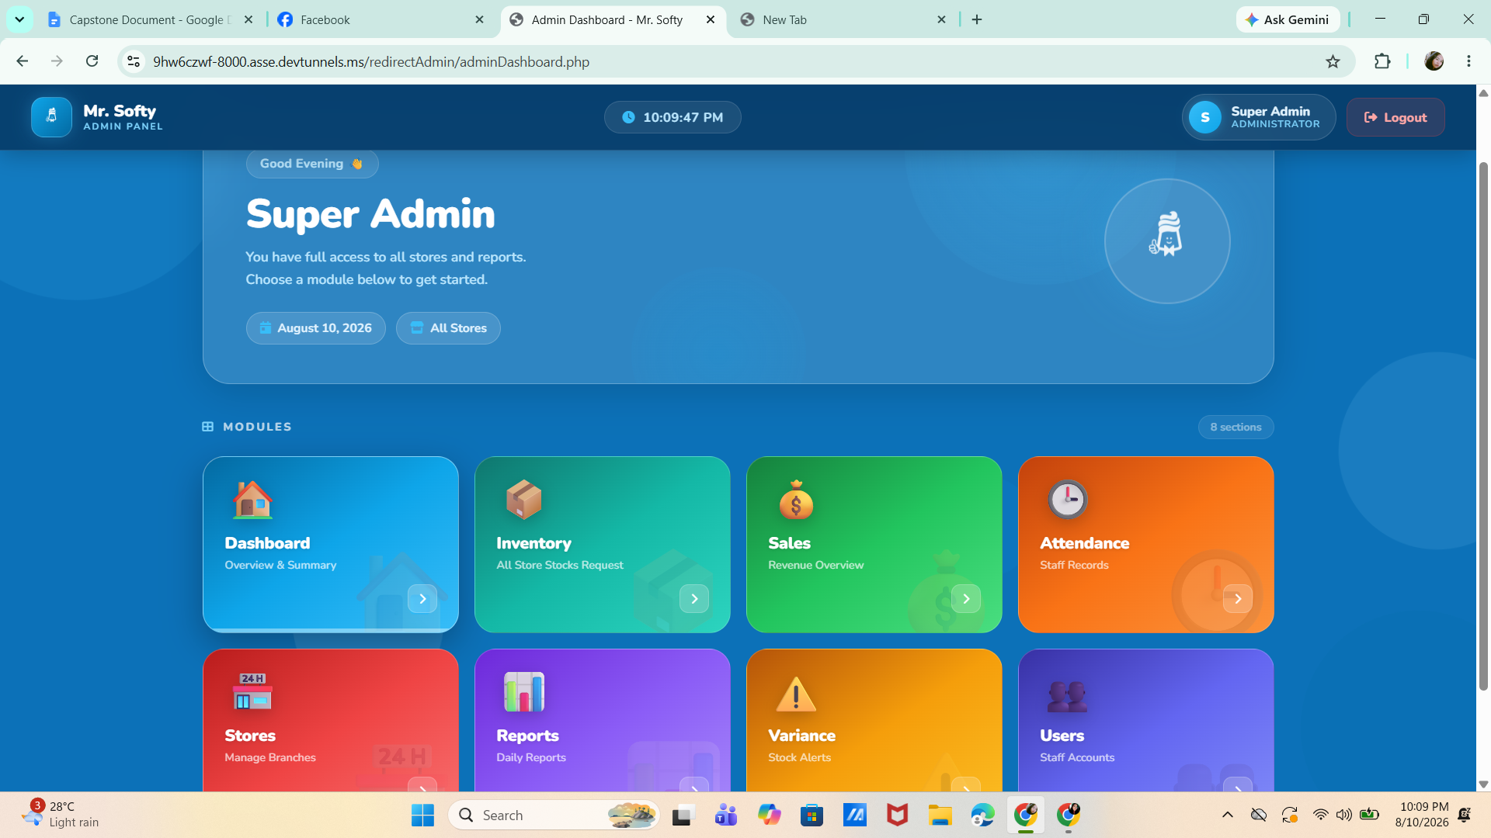
As shown in Image 4.2 the Administrator Dashboard provided an organized interface containing the system header, administrator account information, current date and time, store selection, and eight available system modules. The module cards allowed the administrator to directly access the different functions of the system. This centralized dashboard provided a convenient and organized way for the administrator to navigate the system and manage the sales, inventory, attendance, store, reporting, variance, and user-related operations of Mr. Softy.

Inventory Module
The Inventory Module was developed to manage and monitor stock requests within the Mr. Softy System. It provided the administrator with a centralized interface for reviewing and processing inventory requests submitted by authorized staff. The module was designed to help the administrator monitor requests and ensure that inventory-related concerns were properly handled.
As shown in Image 4.3, the Inventory Module displayed the Stock Request Management interface with a Pending Stock Requests section. The page included a back button for returning to the previous interface and a module heading that indicated its purpose of reviewing and processing pending inventory requests. In the displayed screen, no pending stock requests were available at the time, as indicated by the message “No pending stock requests at this time.” This allowed the administrator to immediately determine whether there were inventory requests requiring action.

Image 4.3 presents the Inventory Module of the Mr. Softy Integrated Business Intelligence Platform.

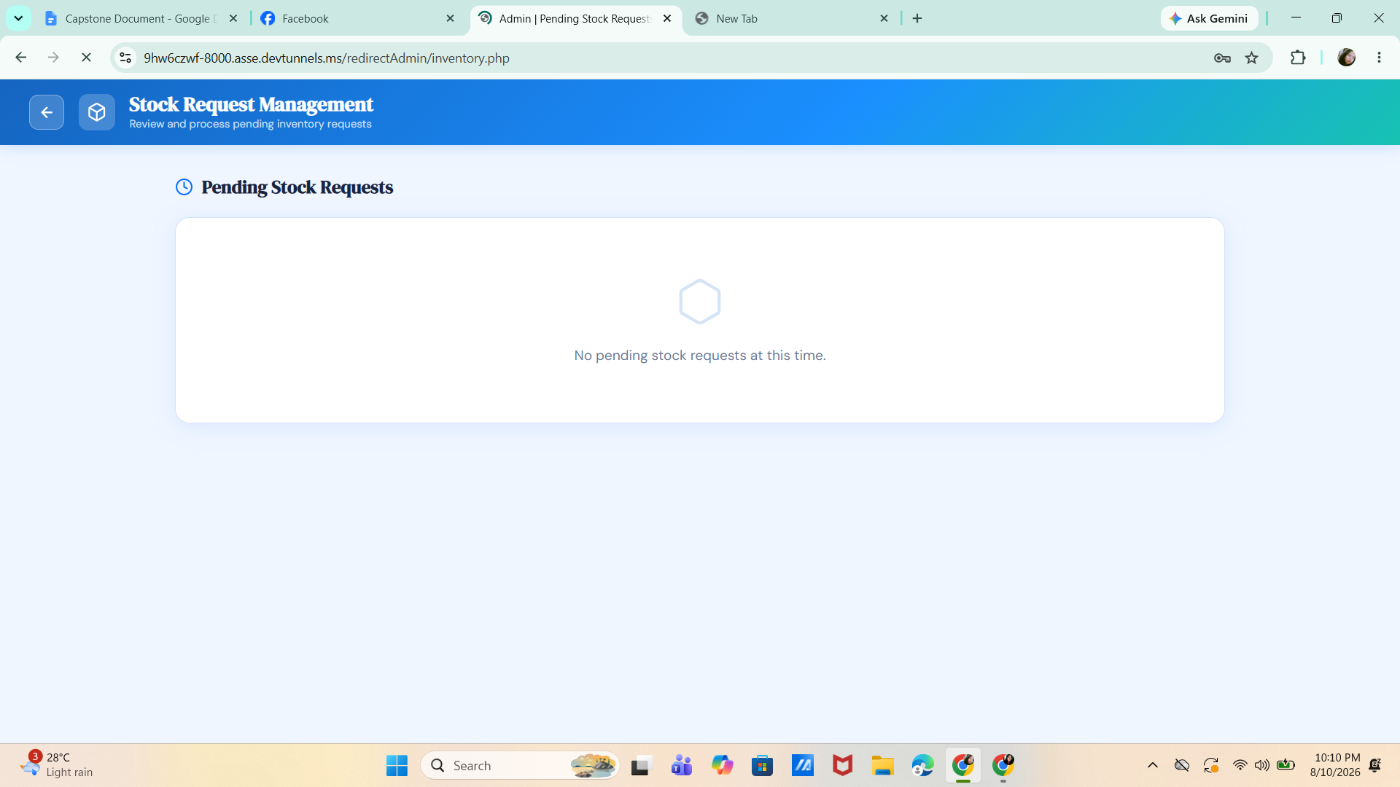

The module provided a simple and organized interface for monitoring stock requests. When requests were available, the administrator could review and process them through this section. The absence of pending requests indicated that there were currently no outstanding inventory requests requiring administrative action. This feature helped maintain an organized stock request process and supported the administrator in monitoring inventory-related activities within the system.

Sales Module
The Sales Module was developed to provide the administrator with an organized view of sales transactions recorded in the Mr. Softy System. It allowed the administrator to review sales records based on the selected store and a specified date range. This module supported the monitoring of transactions by providing filtering options that helped the administrator locate sales information according to specific reporting requirements.
Image 4.4 presents the Sales Module of the Mr. Softy Integrated Business Intelligence Platform.
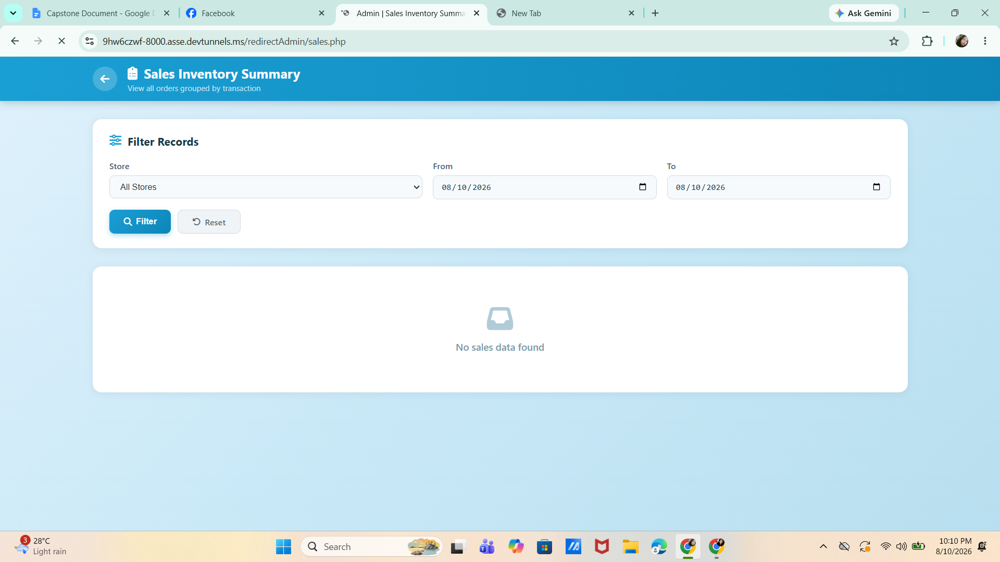
As shown in Image 4.4, the Sales Module displayed the Sales Inventory Summary interface, which was designed to show orders grouped by transaction. The Filter Records section contained a Store selection field, From and To date fields, a Filter button, and a Reset button. The administrator could select All Stores or a specific store and define the desired date range to retrieve corresponding sales records. In the displayed screen, the selected date range was August 10, 2026, while the system indicated “No sales data found.”
The filtering function provided the administrator with a convenient way to narrow down sales records based on store and date. The results section displayed the retrieved sales information after the filter was applied. When no transactions matched the selected criteria, the system displayed a notification indicating that no sales data was available. This helped the administrator easily determine the availability of sales records for a particular store and reporting period.

Attendance Module
The Attendance Module was developed to provide the administrator with a centralized interface for monitoring and managing employee attendance records. It displayed important attendance information, including the total number of records, the current date, the status of active filters, and the current system time. The module also allowed the administrator to filter attendance records according to a specific date range and store, making it easier to locate and review employee attendance information.
Image 4.5 presents the Attendance Module of the Mr. Softy Integrated Business Intelligence Platform.
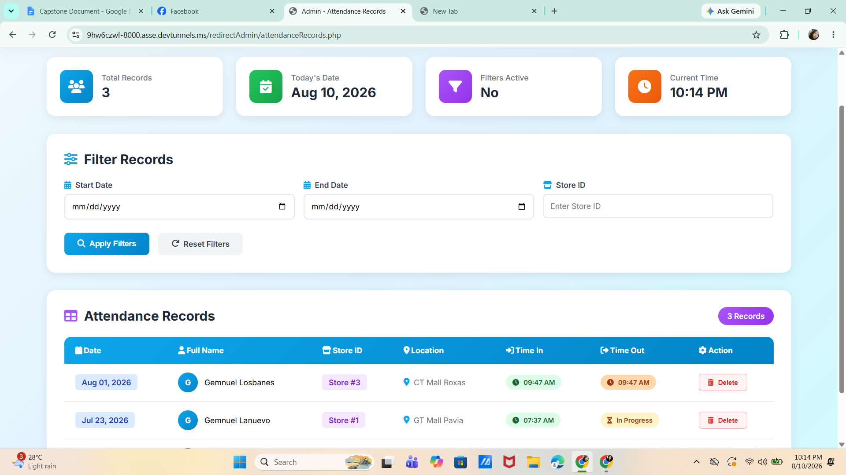

The Attendance Module contained four summary cards showing Total Records, Today's Date, Filters Active, and Current Time. The Filter Records section provided fields for the Start Date, End Date, and Store ID, together with Apply Filters and Reset Filters buttons. Below the filtering section, the Attendance Records table displayed the recorded attendance information, including the Date, Full Name, Store ID, Location, Time In, Time Out, and Action columns.
The displayed records showed the attendance details of employees assigned to different stores. The table included completed and ongoing attendance records, with the Time In and Time Out columns indicating the employee's attendance status. A Delete button was also provided under the Action column for managing individual attendance records. The filtering and record management features helped the administrator monitor employee attendance and review records based on specific dates and store locations.

Stores Module

The Stores Module was developed to allow the administrator to manage the different Mr. Softy branch locations registered in the system. It provided a centralized interface where the administrator could add new stores or branches and maintain existing store information. This module helped organize the branch records and made store-related information easier to manage within the system.
Image 4.6 presents the Stores Module of the Mr. Softy System.

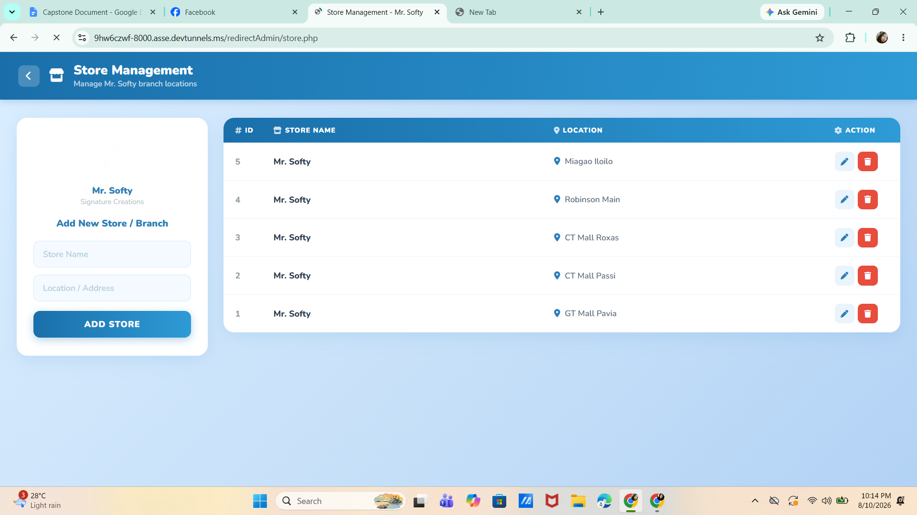
As shown in Image 4.6, the Stores Module displayed the Store Management interface with an Add New Store / Branch section on the left side. This section contained fields for the Store Name and Location / Address, together with an Add Store button for registering a new branch. On the right side, the system displayed a table containing the existing store records, including the ID, Store Name, Location, and Action columns.
The displayed records showed five Mr. Softy branches located at GT Mall Pavia, CT Mall Passi, CT Mall Roxas, Robinson Main, and Miaagao Iloilo. Each store record included an Edit button and a Delete button, allowing the administrator to update or remove store information when necessary. Through these functions, the Stores Module supported the centralized management of Mr. Softy branch locations and helped maintain accurate store records within the system.

Reports Module
The Reports Module was developed to provide the administrator with an analytical view of the operational data recorded in the Mr. Softy System. It presented summarized information related to attendance and sales, allowing the administrator to monitor business activities within a selected location and date range. The module also provided visual analytics that helped present attendance trends and employee attendance status in an organized manner.
Image 4.7 presents the Reports Module of the Mr. Softy System.

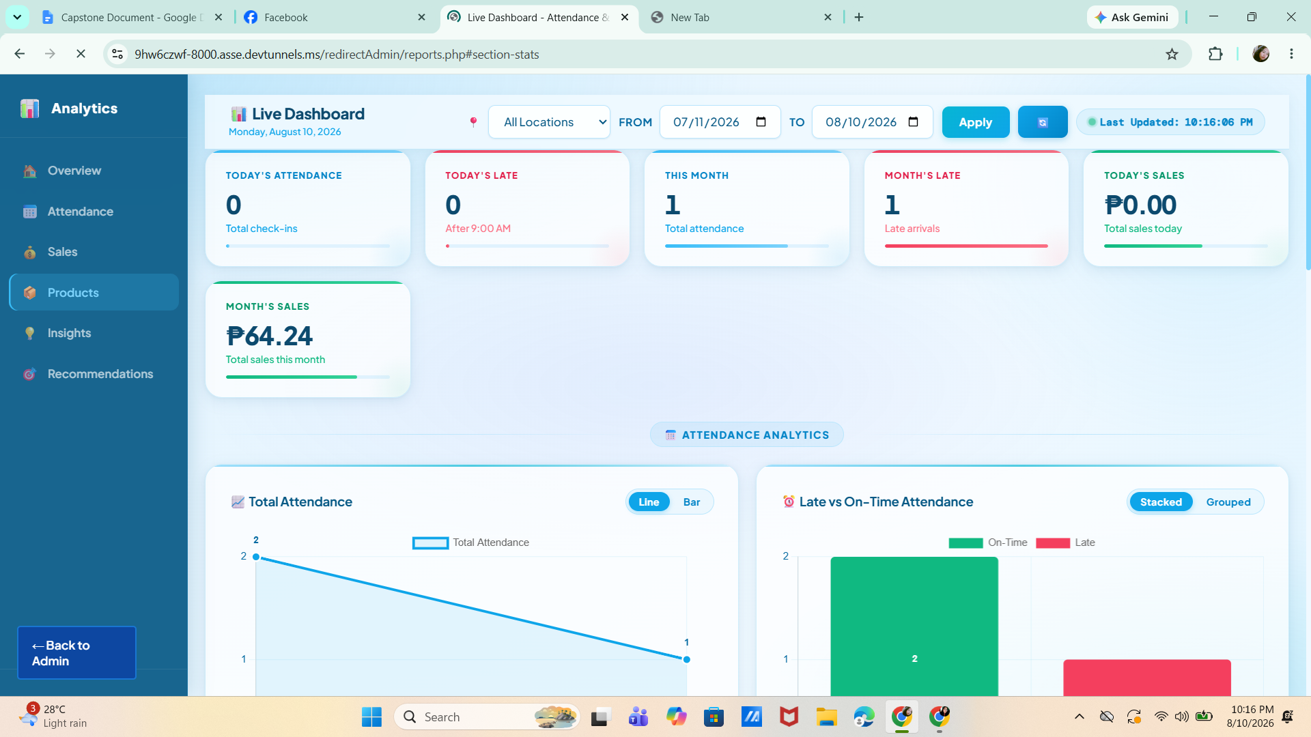

As shown in Image 4.7, the Reports Module displayed a Live Dashboard with a location selection field and From and To date filters. The administrator could select All Locations or a specific location and apply a desired date range. The dashboard presented summary cards for Today's Attendance, Today's Late, This Month, Month's Late, Today's Sales, and Month's Sales. Based on the displayed information, the system recorded 0 check-ins for the current day, 0 late arrivals for the day, 1 total attendance for the month, 1 late arrival for the month, ₱0.00 in today's sales, and ₱64.24 in total sales for the month.
The module also contained an Attendance Analytics section with graphical representations of attendance information. The Total Attendance chart provided a visual comparison of attendance records, with options to display the data using a line or bar chart. The Late vs On-Time Attendance chart presented the comparison between on-time and late attendance, with options for stacked or grouped visualization. These features provided the administrator with a clearer view of attendance patterns and sales performance based on the selected reporting period.
This module has five subsection this includes the following:

Attendance Analytics
The Attendance Analytics section was developed to provide the administrator with a visual representation of employee attendance records. It presented attendance information through graphical charts, allowing the administrator to monitor the number of attendance records and compare on-time and late arrivals within the selected date range.
Image 4.6.1 presents the Attendance Analytics section of the Mr. Softy System.
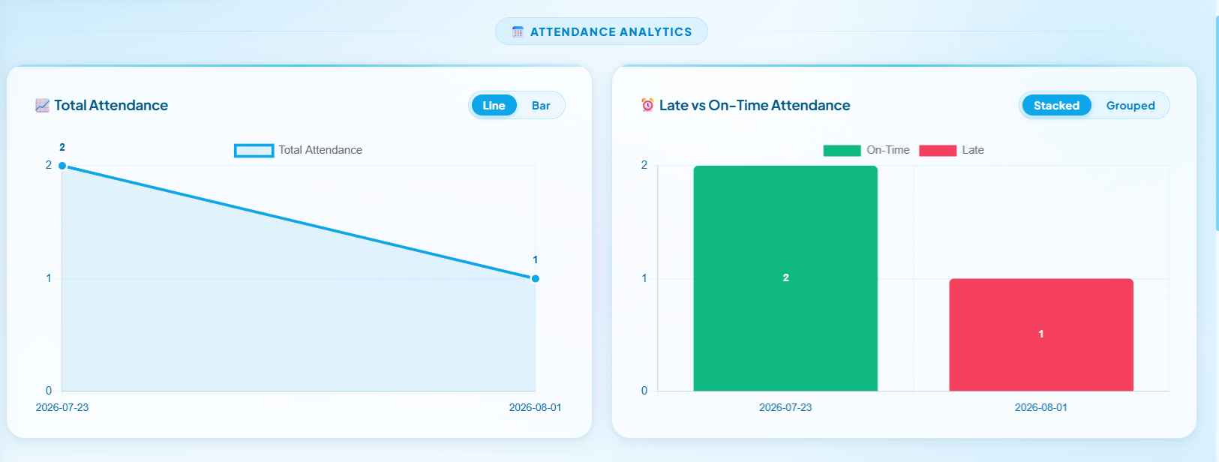
As shown in Image 4.6.1 the section contained two graphical presentations: Total Attendance and Late vs On-Time Attendance. The Total Attendance chart displayed attendance records over time and provided options to view the data using either a Line or Bar chart. The Late vs On-Time Attendance chart compared on-time and late attendance records and provided Stacked and Grouped viewing options. Based on the displayed records, the system showed two attendance records on July 23, 2026, and one attendance record on August 1, 2026.
These visualizations allowed the administrator to easily identify attendance patterns and monitor employee punctuality. The comparison between on-time and late arrivals also helped the administrator determine whether attendance issues were occurring within the selected reporting period.

Sales Analytics
The Sales Analytics section was developed to provide the administrator with a visual representation of sales performance and product quantities sold. It presented sales information over a selected period and identified the products with the highest quantities sold. This section helped the administrator monitor sales trends and determine which products were performing well.
Image 4.6.2 presents the Sales Analytics section of the Mr. Softy System.
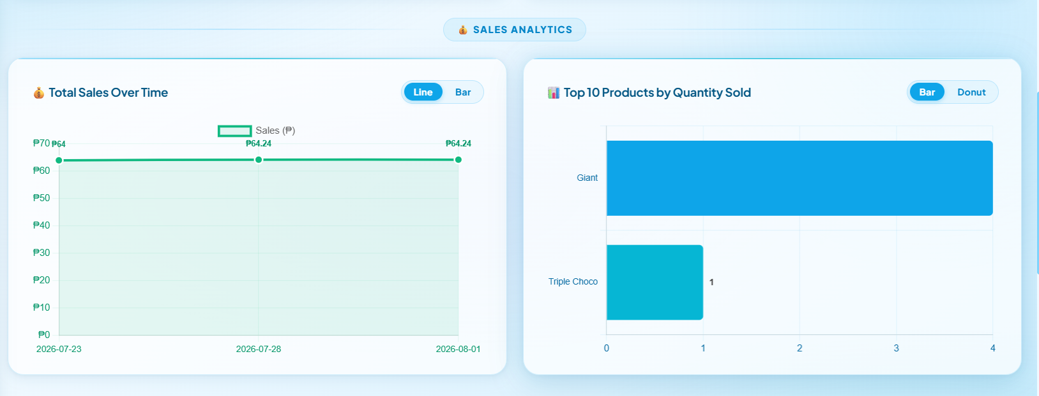
As shown in Image 4.6.2, the section contained the Total Sales Over Time and Top 10 Products by Quantity Sold charts. The Total Sales Over Time chart displayed sales amounts across different dates and provided Line and Bar chart options. The displayed records showed sales of ₱64.24 on July 23, July 28, and August 1, 2026. The Top 10 Products by Quantity Sold chart presented the products according to their quantity sold and provided Bar and Donut visualization options. In the displayed data, Giant had the highest quantity sold with four units, while Triple Choco had one unit sold.
The Sales Analytics section helped the administrator evaluate sales performance and identify the products with higher demand. The graphical presentation made it easier to compare sales results and product quantities within the selected reporting period.

Smart Insights
The Smart Insights section was developed to summarize important findings generated from the sales and attendance data recorded in the system. It presented key business information in a structured table, allowing the administrator to quickly identify significant performance indicators without manually reviewing individual records.

Image 4.6.3 presents the Smart Insights section of the Mr. Softy System.
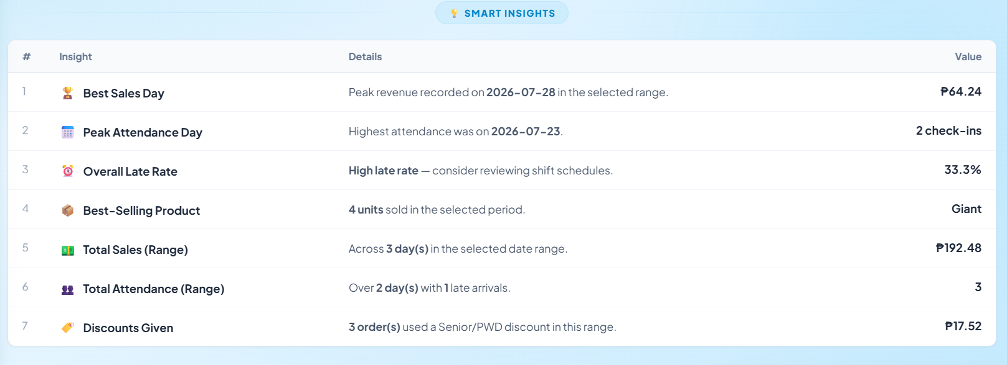
The Smart Insights table contained the Insight, Details, and Value columns. The displayed insights included Best Sales Day, Peak Attendance Day, Overall Late Rate, Best-Selling Product, Total Sales (Range), Total Attendance (Range), and Discounts Given. The system identified July 28, 2026, as the best sales day with ₱64.24, while July 23, 2026, had the highest attendance with 2 check-ins. The displayed overall late rate was 33.3%, and Giant was identified as the best-selling product with four units sold.
The section also summarized total sales of ₱192.48 across the selected three-day period and recorded three total attendance records over two days with one late arrival. It also showed that ₱17.52 was given through Senior/PWD discounts across three orders. These insights provided the administrator with a concise summary of important business information that could support operational monitoring and decision-making.

Smart Business Recommendation
The Smart Business Recommendations section was developed to provide the administrator with system-generated recommendations based on the identified sales and attendance conditions. It presented specific observations and suggested actions that could help improve business operations and address areas that required attention.
Image 4.6.4 presents the Smart Business Recommendations section of the Mr. Softy System.
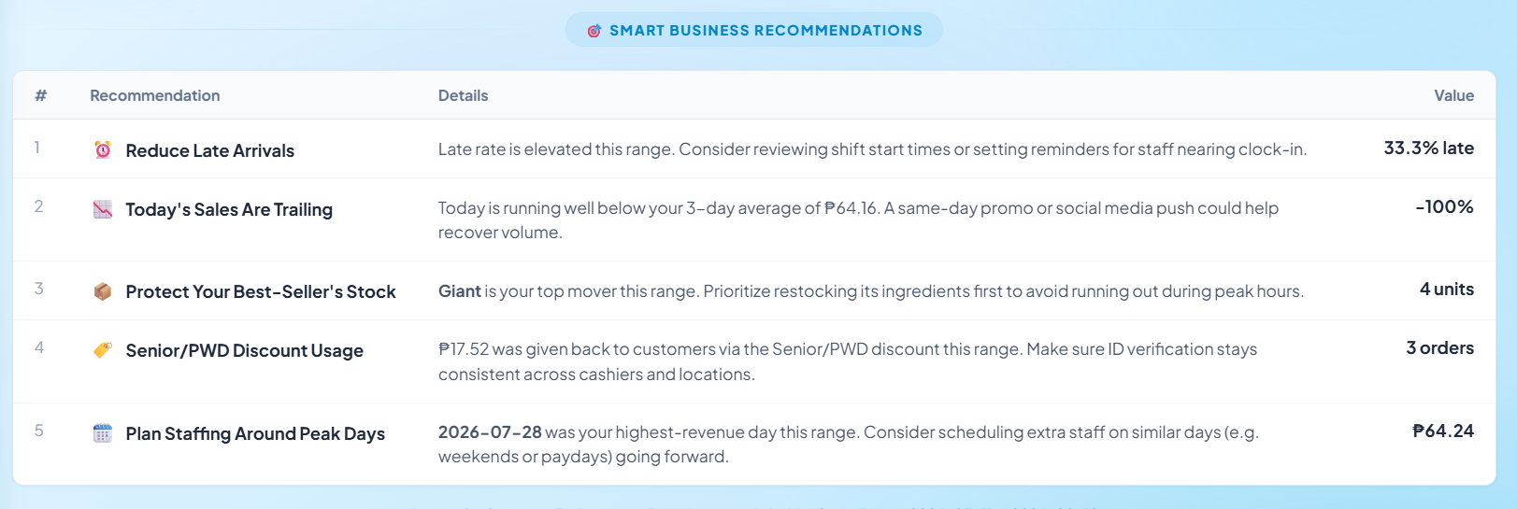
The section displayed recommendations together with their corresponding details and values. The recommendations included Reduce Late Arrivals, Today's Sales Are Trailing, Protect Your Best-Seller's Stock, Senior/PWD Discount Usage, and Plan Staffing Around Peak Days. The system recommended reviewing shift start times or setting reminders because the displayed late rate was 33.3%. It also indicated that the day's sales were below the three-day average and suggested using a same-day promotion or social media activity to help recover sales.
The system further recommended prioritizing the restocking of Giant ingredients because it was identified as the top-selling product with four units sold. It also highlighted the use of Senior/PWD discounts, which amounted to ₱17.52 across three orders, and recommended maintaining consistent identification verification. Lastly, the system suggested planning additional staffing around peak sales days, particularly based on the highest-revenue date of July 28, 2026, which recorded ₱64.24. These recommendations provided the administrator with actionable information for improving attendance management, sales performance, inventory preparation, and staffing decisions.

Variance Module

The Variance Module is designed to monitor and track stock discrepancies across all Mr. Softy stores. It provides the administrator with an overview of the expected inventory, actual inventory, sales consumed, and unaccounted losses within a selected date range. The module also displays the total number of stores, total consumed items, sales consumed, and unaccounted losses to help the administrator quickly assess the overall inventory status.

Image 4.8 presents the Reports Module of the Mr. Softy System.

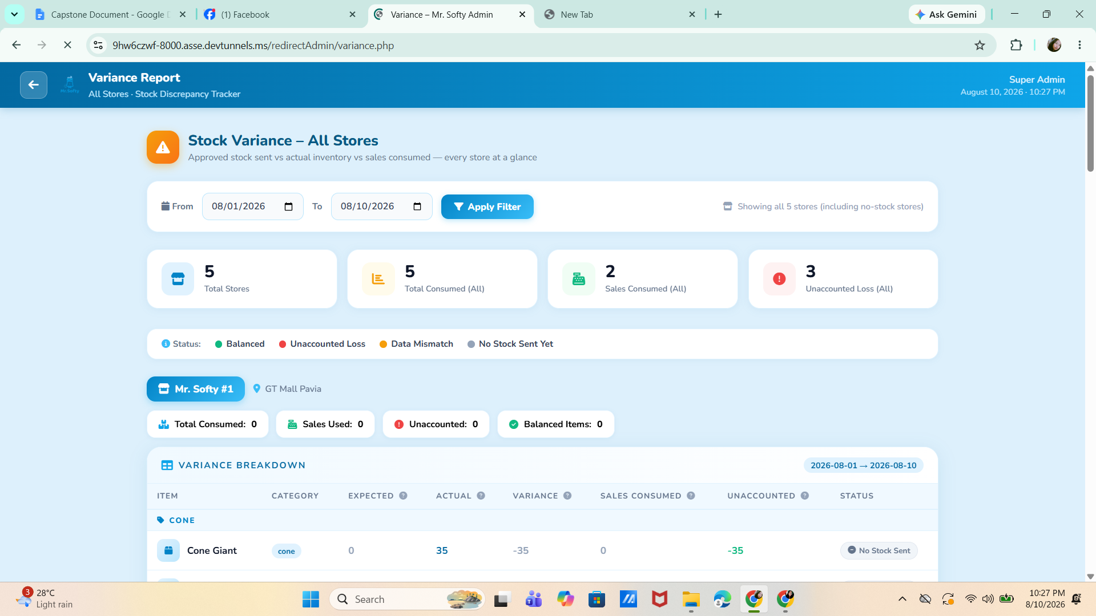

The module includes a date filter that allows the administrator to select a specific period for reviewing stock variance. It also provides a Variance Breakdown that displays the item, category, expected quantity, actual quantity, variance, sales consumed, unaccounted quantity, and status. The status indicators help the administrator identify whether inventory is balanced, has an unaccounted loss, contains a data mismatch, or has no stock sent yet. This allows the

User Module
The Users Module is designed to manage the staff and cashier accounts of the Mr. Softy system. It allows the administrator to create employee accounts by entering the staff member’s full name, username, email, password, and confirmation password, as well as assigning the account to a specific store location. This provides the administrator with a centralized way of creating and organizing employee access to the system.

Image 4.9 presents the Reports Module of the Mr. Softy System.

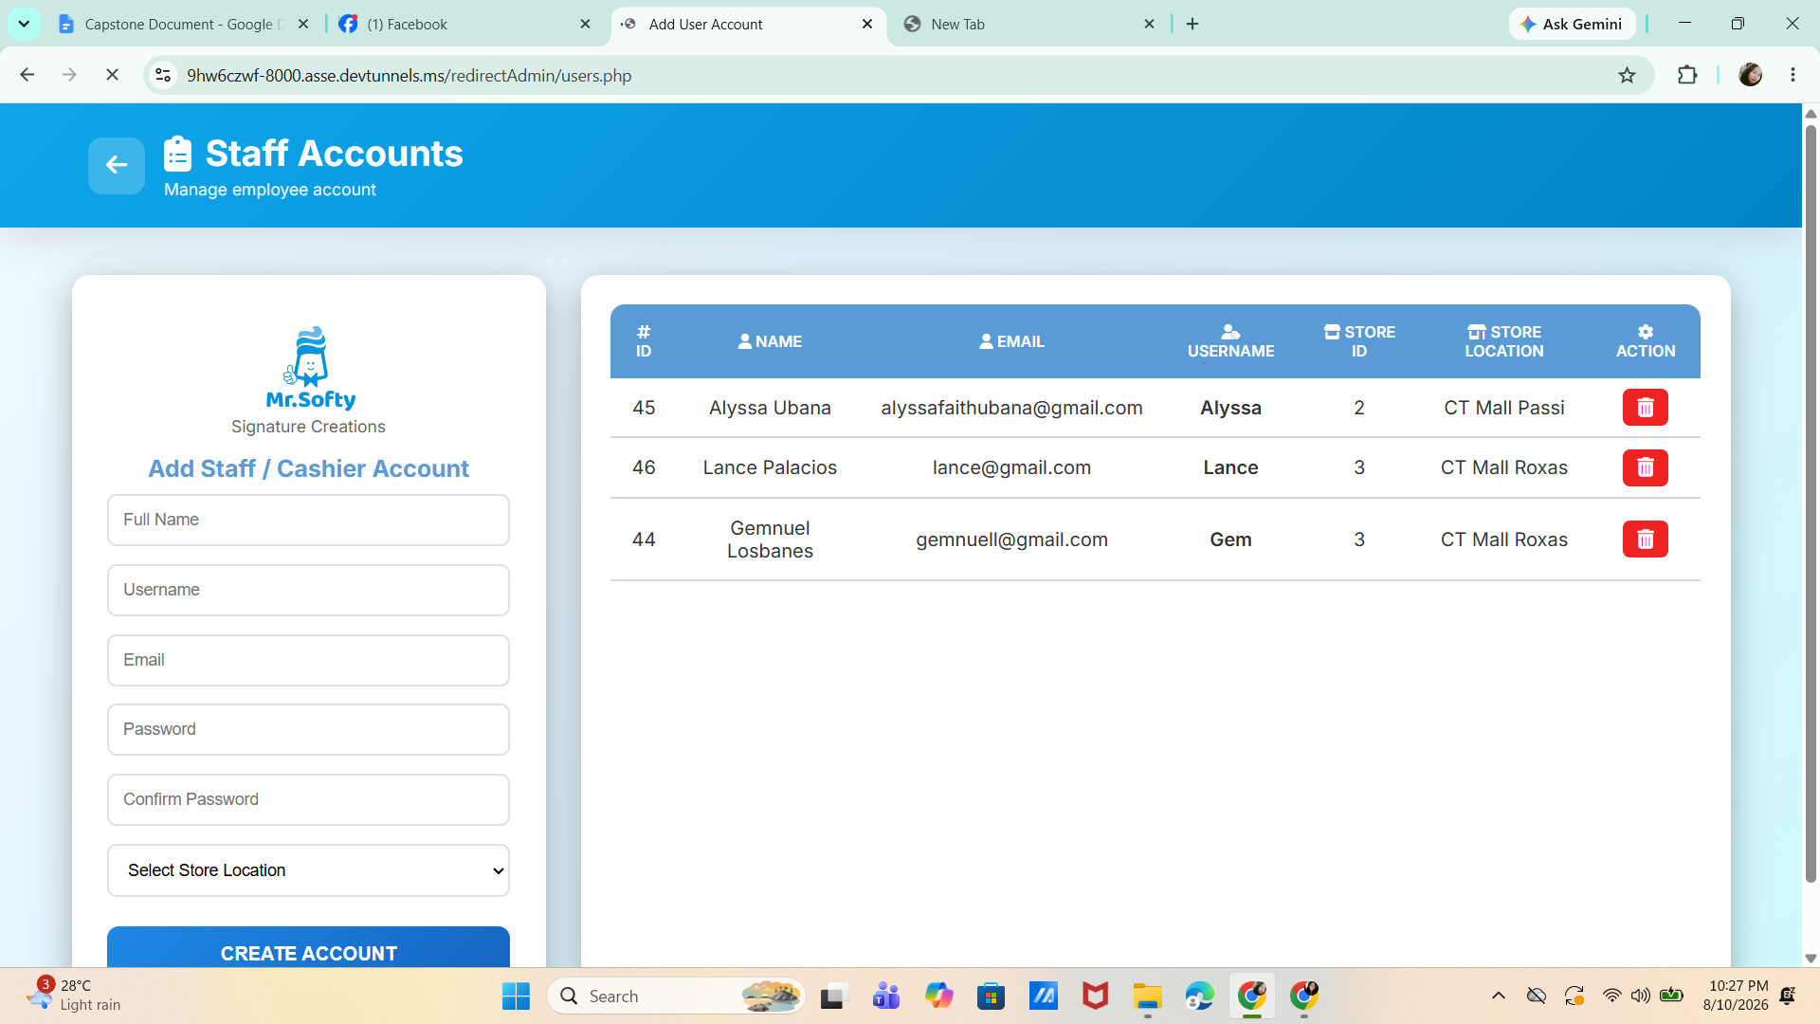

The module also displays the existing staff accounts in a table containing the employee’s ID, name, email, username, store ID, and store location. The administrator can review the registered accounts and use the delete action to remove an employee account when necessary. This helps maintain organized user records and ensures that staff accounts are properly associated with their assigned Mr. Softy store.

Testing Result
Testing was conducted throughout the development and refinement of the Web-Based Mr. Softy Integrated Business Intelligence Platform to examine the operation of its implemented functions. The testing activities involved functional checking by the development team and repeated system reviews to verify whether the implemented modules performed according to their intended operations. The results and observations obtained during these activities were used to identify required modifications and verify the implementation of subsequent revisions.
The development team conducted functional checks on the implemented modules, including user authentication, dashboard functions, inventory management, sales transactions, attendance monitoring, store management, report generation, variance monitoring, and user account management. The individual functions were checked according to their intended operations, and identified issues or required modifications were addressed during the development process.
System reviews were also conducted at different stages of development. During these reviews, the implemented functions were examined to determine whether they corresponded to the operational requirements of Mr. Softy. Feedback and requested modifications were incorporated into subsequent versions of the system and were subsequently checked again.
The testing process therefore consisted of repeated checking, revision, and rechecking of the implemented functions. The observations obtained during the testing and review activities served as a basis for refining the system before completion.

Table 4.1 Summary of Testing Activities

Testing Type | Performed By | Focus on Testing | Result/Observation
Unit Testing | Development Team | Individual System functions | Functions were checked and revised when necessary.
Integration Testing | Development Team | Interaction between related modules | Related functions were checked after integration and modification.
System Testing | Development Team | Complete system operation | Major implemented functions were checked during system operation.
User Acceptance Testing | Intended User/ Client | Alignment with operational requirements | Feedback and requested modifications were incorporated into subsequent system revisions.

The testing activities summarized in Table 4.1 were conducted at different stages of system development. The findings from these activities were used to identify necessary modifications and verify the corresponding revisions.

Unit Testing Results
Unit testing was conducted by the development team to examine the individual functions and modules of the Web-Based Mr. Softy Integrated Business Intelligence Platform. The testing focused on verifying whether each implemented function performed its intended operation based on the specified system requirements.
The proponents conducted functional checks on individual features, including user authentication, dashboard information display, inventory management, sales transaction recording, attendance logging, store management, report generation, variance monitoring, and user account management. Each function was examined separately during development to identify operational issues and required modifications.
When an issue or additional requirement was identified during the development and review process, the affected function was modified and checked again. This repeated testing and revision process was performed to verify the behavior of the updated functions before proceeding with further system refinement.
Table 4.2 Unit Testing Results of the Mr. Softy System

Module/Function | Test Performed | Expected Result | Observed Result | Status
User Authentication | Enter valid login credentials | Authorized user is logged in | User was successfully logged in | Passed
Dashboard | Access the dashboard after login | Dashboard information and navigation options are displayed | Dashboard information and navigation options were displayed | Passed
Inventory Management | Add or update inventory information | Inventory information is saved and updated | Inventory information was saved and updated | Passed
Sales Management | Record a sales transaction | Sales transaction is saved and reflected in the system | Sales transaction was successfully recorded | Passed
Attendance Management | Record employee time-in or time-out | Attendance record is saved | Attendance record was successfully recorded | PassedPassed
Store Management | Add or update store information | Store information is saved and displayed | Store information was saved and displayed | Passed
Report Generation | Generate a system report | Requested report is generated | Report was successfully generated | Passed
Variance Management | Record or review inventory variance | Variance information is recorded and displayed | Variance information was recorded and displayed | Passed
User Management | Add or update an authorized user | User information is saved and updated | User information was successfully saved and updated | Passed

The unit testing results presented in Table 4.2 show the observed behavior of the selected individual system functions based on their corresponding test cases. The tested functions produced the expected results during the conducted checks. Functions requiring modification during development were revised and subsequently checked again.

Integration Testing Result
Integration testing was conducted to examine the interaction of the interconnected modules of the Web-Based Mr. Softy Integrated Business Intelligence Platform. The testing focused on determining whether related system functions operated appropriately when used together and whether information processed in one module was properly reflected in other related modules.
The development team checked the integration of functions involving sales transactions, inventory records, attendance records, store information, reports, variance records, and user accounts. The interactions among these functions were examined during system development to identify issues that could occur when information was processed across related modules.
The role-based access controls were also checked during the integration testing process to determine whether the available functions corresponded to the permissions assigned to each user role. Authorized accounts were used to examine whether users could access the functions required for their assigned responsibilities and whether restricted functions remained inaccessible.
When issues or additional requirements were identified during development and review, the affected functions were modified and subsequently checked again. This iterative process allowed the proponents to verify the interaction of the revised functions with the other related components of the system.
Table 4.3 Integration Testing Results of the Mr. Softy System

Integrated Function | Test Performed | Expected Result | Observed Result | Status
Sales and Inventory | Record a sales transaction and check inventory | Inventory quantity is updated based on the recorded transaction | Inventory information was updated based on the recorded transaction | Passed
Sales and Reports | Record a sales transaction and generate a report | Recorded transaction is reflected in the corresponding report | Sales transaction was reflected in the generated report | Passed
Attendance and Users | Record attendance using an authorized account | Attendance record is associated with the appropriate user | Attendance record was recorded for the authorized user | Passed
Stores and Inventory | Select a store and access its inventory information | Inventory information corresponds to the selected store | Inventory information was displayed according to the selected store | Passed
Inventory and Variance | Review inventory records and record variance | Variance information corresponds to the inventory records | Variance information was recorded based on the inventory records | Passed
Users and Role-Based Access | Access system functions using different authorized roles | Functions are available according to the assigned role | Access was provided according to the assigned user role | Passed

The integration testing results presented in Table 4.3 show the observed interaction among selected related system functions. The tested integrations produced the expected behavior during the conducted checks. Functions affected by modifications during development were subsequently checked again to verify their interaction with related system components.

System Testing Result
System testing was conducted to examine the Web-Based Mr. Softy Integrated Business Intelligence Platform as a complete and integrated application. The testing focused on the operation of the major system functions and their ability to support the intended workflow of Mr. Softy. The development team performed functional checks of the system during its development and refinement.
The testing covered the major implemented functions of the system, including user authentication, dashboard functions, inventory management, sales transactions, attendance monitoring, store management, report generation, variance monitoring, and user management. The functions were checked according to their intended operations during normal system use.
The system was also reviewed during different stages of development. During these reviews, the implemented functions were examined to identify minor modifications and additional requirements. The requested changes were incorporated into subsequent versions of the system, after which the affected functions were checked again.
The repeated testing and review process provided a basis for identifying and addressing functional modifications during system development. The final system was subsequently presented for review after the requested revisions had been incorporated.
Table 4.4 System Testing Results of the Mr. Softy System

Module/Function | Test Performed | Expected Result | Observed Result | Status
User Authentication | Log in using an authorized account | Authorized user is granted access to the system | Authorized user was granted access | Passed
Dashboard | View the dashboard after successful login | Relevant system information and navigation options are displayed | Relevant dashboard information and navigation options were displayed | Passed
Inventory Management | Add, update, and view inventory information | Inventory information is saved and displayed accordingly | Inventory information was saved and displayed accordingly | Passed
Sales Management | Create and complete a sales transaction | Sales transaction is recorded and reflected in the system | Sales transaction was successfully recorded and reflected in the system | Passed
Attendance management | Record employee attendance | Attendance information is recorded | Attendance information was successfully recorded | Passed
Store Management | Add and update store information | Store information is saved and displayed accordingly | Store information was saved and displayed accordingly | Passed
Reports | Generate and view system reports | Requested report is generated and displayed | Requested report was successfully generated and displayed | Passed
Variance Management | Record and review inventory variance | Variance information is recorded and displayed | Variance information was recorded and displayed | Passed
User Management | Manage user accounts using an authorized account | Permitted user management functions are accessible | Permitted user management functions were accessible | Passed

The system testing activities provided the development team with observations regarding the overall operation of the Web-Based Mr. Softy Integrated Business Intelligence Platform and its major functions. Findings and requested modifications identified during system testing and review were incorporated into subsequent system revisions and subjected to further checking.

User Acceptance Testing Result
User Acceptance Testing (UAT) was conducted through reviews of the Web-Based Mr. Softy Integrated Business Intelligence Platform during the development and refinement stages. The reviews focused on determining whether the implemented functions corresponded to the operational requirements and workflow of Mr. Softy.
During the review process, the intended users examined the implemented system functions and provided feedback regarding additional requirements and minor modifications. The development team incorporated the requested changes into subsequent versions of the system. The revised functions were then presented for further checking.
The review process covered the implemented functions relevant to the operations of Mr. Softy, including sales management, inventory management, attendance monitoring, store management, reporting, variance monitoring, and user access. The review also provided an opportunity to identify functions that required modification or additional implementation.
After the requested revisions were incorporated, the updated system was presented for subsequent review. The system was considered acceptable based on the implemented requirements and the feedback obtained during the review process.
Table 4.6 User Acceptance Testing Results of the Mr. Softy System

Area Reviewed | Test Performed | Expected Result | Observed Result | Status
Sales Management | Review sales transaction functions | Sales functions correspond to the operational requirements | The implemented sales functions were reviewed and accepted | Passed
Inventory Management | Review inventory-related functions | Inventory functions correspond to the operational requirements | The implemented inventory functions were reviewed and accepted | Passed
Attendance Management | Review attendance functions | Attendance functions support the intended employee monitoring process | The implemented attendance functions were reviewed and accepted | Passed
Store Management | Review store-related functions | Store functions correspond to the operational requirements | The implemented store functions were reviewed and accepted | Passed
Reports | Review report generation functions | Reports provide the required system information | The implemented report functions were reviewed and accepted | Passed
Variance Management | Review variance functions | Variance functions support the monitoring of inventory differences | The implemented variance functions were reviewed and accepted | Passed
User Management | Review user account and access functions | User functions correspond to the assigned access requirements | The implemented user management functions were reviewed and accepted | Passed

The User Acceptance Testing results presented in Table 4.6 document the observations obtained during the review of the implemented Mr. Softy system. The feedback and requested modifications were considered during the refinement of the system. The final review indicated that the implemented functions corresponded to the identified operational requirements of the system.

Hardware and Software Requirements
The successful implementation of the Web-Based Mr. Softy Integrated Business Intelligence Platform required appropriate hardware and software resources. These specifications ensured that the application operated efficiently during sales transaction processing, inventory management, employee attendance monitoring, report generation, and database management.
Hardware Requirements
Table 4.1 presents the recommended hardware specifications for the developed system.
Component | Minimum Specification | Recommended Specification
Processor | Intel Core i3 | Intel Core i5 or higher
Memory (RAM) | 4 GB | 8 GB or higher
Storage | 256 GB SSD | 512 GB SSD or higher
Monitor | 1366x768 Resolution | Full HD Display
Internet Connection | 10 Mbps | 50 Mbps or higher
Keyboard and Mouse | Standard USB Keyboard and Mouse | Wireless or USB Keyboard Mouse
Printer(Optional) | Inkjet Printer | Thermal Receipt Printer
The recommended hardware configuration provided sufficient processing capability for managing sales transactions, monitoring employee attendance, updating inventory records, and generating business reports without significant delays. These specifications also ensured the smooth execution of the application during daily business operations.
Software Requirements
Table 4.2 presents the software requirements used in the development and implementation of the system.
Software | Purpose
Windows 10/11 | Operating System
Visual Studio Code | Source Code Editor
PHP | Backend Development
HTML, CSS, and JavaScript | Frontend Development
MySQL | Database Management System
XAMPP | Local Web Server and Database Server
Google Chrome | Web Browser
Git | Version Control
The selected software tools were chosen based on their reliability, compatibility, ease of use, and widespread adoption in modern web application development. These technologies supported the development of a secure, efficient, and user-friendly business management system capable of handling the sales, inventory, attendance, and reporting requirements of Mr. Softy.

CHAPTER V

CONCLUSION AND RECOMMENDATIONS

INTRODUCTION
This chapter presents the summary of the findings, conclusions, and recommendations of the study entitled "Web-Based Mr. Softy Integrated Business Intelligence Platform" It summarizes the key results obtained during the development, implementation, and evaluation of the proposed system. The chapter also determines whether the objectives of the study were successfully achieved based on the findings. Finally, it provides recommendations for future improvements and enhancements that can further increase the system's efficiency, functionality, and overall effectiveness in supporting the daily business operations of Mr. Softy.

Summary of Findings
The development and evaluation of the Web-Based Mr. Softy Integrated Business Intelligence Platform yielded significant results that aligned with the objectives of the study:
- The system successfully automated the recording and management of sales transactions, reducing the time required for processing orders and minimizing errors associated with manual record-keeping.
- The attendance monitoring module effectively recorded employees' time-in and time-out, providing accurate attendance records and making it easier for the administrator to monitor employee attendance.
- The inventory management module enabled real-time monitoring of product and topping stocks, helping prevent stock shortages and ensuring that inventory records remained accurate and up to date.
- The system generated organized sales and inventory reports that provided useful information for the business owner, supporting better decision-making and improving the overall management of daily business operations.
- User evaluation results indicated that the system is user-friendly, easy to navigate, and effective in improving the efficiency, accuracy, and organization of Mr. Softy's sales, attendance, and inventory management processes.

Conclusion
The Web-Based Mr. Softy Integrated Business Intelligence Platform proved to be a practical and effective solution for improving the daily operations of Mr. Softy. By automating the recording of sales transactions, employee attendance, and inventory monitoring, the system reduced the reliance on manual processes, minimized recording errors, and improved the accuracy and organization of business records. The generated reports also provided the business owner with valuable information for monitoring sales performance and inventory status, supporting better decision-making.
The study successfully addressed the identified problems related to manual record-keeping and achieved the research objectives by developing a user-friendly, efficient, and reliable web-based system. Based on the evaluation results, the system enhanced operational efficiency, improved data management, and contributed to more effective business operations. Therefore, the research questions were answered positively, confirming that the proposed system is a suitable solution for managing Mr. Softy's sales, attendance, and inventory processes.

Recommendation
To further improve the functionality and effectiveness of the Web-Based Mr. Softy Integrated Business Intelligence Platform, the following recommendations are proposed:

System Improvements
- Integrate an automated low-stock notification feature to alert the administrator when inventory levels reach a minimum threshold, helping prevent stock shortages.
- Implement barcode or QR code scanning to speed up order processing and inventory management.
- Enhance system security by adding two-factor authentication and regular password updates to better protect user accounts and business data.
- Expand the reporting module by allowing reports to be exported in multiple formats, such as PDF, Excel, and CSV, for easier documentation and record-keeping.

Future Research Directions
- Develop a mobile version of the system to allow administrators and staff to access sales, attendance, and inventory records anytime and anywhere.
- Explore the integration of customer management and loyalty features to improve customer service and encourage repeat purchases.
- Conduct further studies to evaluate the long-term impact of the system on the operational efficiency and productivity of small businesses.

Implementation Strategies
- Business owners should provide proper training to employees before implementing the system to ensure accurate and consistent use of its features.
- Regular data backup and system maintenance should be performed to protect business information and ensure continuous system operation.
- The system should be updated periodically to improve its performance, fix identified issues, and introduce new features based on user feedback and business needs.

Impact of the Study
The Web-Based Mr. Softy Integrated Business Intelligence Platform contributes to the field of Information Technology by demonstrating how a web-based information system can improve the efficiency, accuracy, and organization of daily business operations in small enterprises. The system was developed to address the challenges associated with manual sales recording, employee attendance monitoring, and inventory management. By integrating these business processes into a centralized platform, the system helps reduce repetitive tasks, minimize human errors, and maintain organized records that can be accessed and managed by authorized personnel. It also provides a more convenient way to monitor business activities and generate reports that support informed decision-making.
The implementation of the system provides several benefits to the business owner and authorized staff of Mr. Softy. Through automated sales recording, transactions can be documented and monitored more efficiently, reducing the need for manual computation and recordkeeping. The attendance monitoring feature allows employee time-in and time-out records to be stored systematically, making it easier to review attendance information. Meanwhile, the inventory management feature helps monitor product ingredients, toppings, and other stock items, allowing authorized personnel to check stock availability, record stock checks, and submit stock requests when necessary. These functions help improve the coordination of daily operations and provide more reliable information for business monitoring.
Furthermore, the system supports better data management by storing sales, attendance, and inventory records in a centralized database. This reduces the possibility of records becoming misplaced, duplicated, or difficult to retrieve. The generated reports also allow the administrator to review relevant business information in a more organized manner. With access to updated records, the business owner and administrator can identify operational concerns, monitor business performance, and make decisions based on available information. Although the system does not provide advanced forecasting or automated predictions, it serves as a practical tool for organizing business data and supporting routine management activities.
From an Information Technology perspective, the project demonstrates the practical application of web development, database management, and information system integration in addressing real-world business problems. It provides an example of how technologies such as web-based interfaces, server-side processing, and relational databases can be used to develop a system that meets the operational needs of a small enterprise. The project may also serve as a reference for future researchers and IT students who intend to develop similar systems for businesses that still rely on manual processes.
Despite its potential benefits, the system has certain limitations. It was designed specifically to address the operational requirements of Mr. Softy; therefore, other businesses may require modifications to accommodate their own workflows and management practices. Its accessibility and performance may also depend on the availability of a reliable internet connection and the proper maintenance of the system and its database, depending on the deployment environment. In addition, the accuracy of the reports depends on the correctness and completeness of the information entered by authorized users. Regular system maintenance, appropriate user training, and responsible data management are therefore important to ensure its continued effectiveness.
Overall, the Web-Based Mr. Softy Integrated Business Intelligence Platform demonstrates the value of adopting information technology to improve business operations. By bringing sales recording, attendance monitoring, inventory management, and report generation into one platform, the system provides a more organized and efficient approach to managing daily activities. While its implementation is limited to the specific needs of Mr. Softy, the project highlights the potential of web-based information systems to help small enterprises improve recordkeeping, reduce manual workload, and support more informed business decisions.

Summary
In summary, the Web-Based Mr. Softy Integrated Business Intelligence Platform represented the application of software development principles in addressing the operational challenges encountered by a small business. The study focused on developing a centralized web-based system that integrated sales recording, employee attendance monitoring, inventory management, and report generation into a single platform. It aimed to provide a more organized and efficient way of handling daily business activities and to reduce the difficulties associated with manual recordkeeping and monitoring.
The developed system provided features that supported the recording and monitoring of sales transactions, the management of employee time-in and time-out records, and the monitoring of available inventory. It also included functions for managing products and toppings, processing orders and payments, handling stock requests, and generating reports for administrative use. By bringing these functions together, the system provided authorized users with a more convenient way to access and manage business information. The centralized database also helped organize records, making relevant information easier to retrieve and review when needed.
Furthermore, the study demonstrated the importance of information technology in improving the management of business operations. The integration of sales, attendance, and inventory functions provided a systematic approach to handling business records and supported the monitoring of daily activities. The availability of organized records and reports could assist the administrator in reviewing business performance, identifying operational concerns, and making decisions based on recorded information. However, the effectiveness of the system remained dependent on the accuracy of the data entered, proper system maintenance, and the availability of the resources required for its operation.
The study also served as a potential reference for future researchers and developers who planned to create similar web-based business management systems. The system's design and development could provide guidance for projects involving point-of-sale operations, inventory monitoring, employee attendance, and centralized data management. Future studies could further improve the system by exploring additional features, enhancing its accessibility, strengthening data security, and adapting its functions to the needs of other businesses.
Overall, the Web-Based Mr. Softy Integrated Business Intelligence Platform demonstrated how a centralized information system could support the digital transformation of small and medium-sized enterprises (SMEs). Through the integration of essential business functions, the project provided a practical approach to organizing records, reducing reliance on manual processes, and supporting daily operational management. The study highlighted the value of developing information systems that respond to actual business needs and contribute to more systematic and informed business operations.

