**.NET Application Programming**

**Project Status and Design Report**

|  |  |  |
| --- | --- | --- |
| **Topic:** | Milestone 6 | |
| **Date:** | 4/28/18 | |
| **Revision:** | 6.0 | |
| **Team:** | 1. William Bierer | |
| 2. Stuart Reeder | |
| **Weekly Team Status Summary:** | |  |  |  |  | | --- | --- | --- | --- | | **User Story** | **Team**  **Member** | **Hours**  **Worked** | **Hours Remaining** | | As a developer, I need logging to be determine where the app is breaking | *Stuart Reeder* | *3* | *0* | | As a developer, I need a RESTful Web API to handle data on Net-Sweeper Wins | *William Bierer* | *5* | *0* | |  |  |  |  | |  |  |  |  | |  |  |  |  | |  |  |  |  | |  |  |  |  | |  |  |  |  | |  |  |  |  | |  |  |  |  | |  |  |  |  | |  |  |  |  | | |
| **GIT URL:** | https://github.com/wbierer/CST-247_Bierer_Reeder | |
|  |  | |
| **Peer Review:** | *Yes* | We acknowledge that our team has reviewed this Report and we agree to the approach we are all taking. |

**Planning Documentation**

**Agile Scrum Product Backlog:**

|  |  |  |  |
| --- | --- | --- | --- |
| ID | Feature | User Story | Priority |
| S7 | JavaScript Timer | As a user, I need to see how much time has elapsed since I've started playing | 1 |
| S7 | Bomb Counter | As a user, I need to see how many bombs are left on the board so that I can be more strategic. | 2 |
| S8 | Highscore Page | As a user, I need to be able to see the highscores of other user so that I can compete agaisnt them and improve myself. | 3 |
| S8 | Flag Cells W/ Right Click | As a user, I need to be able to flag a cell with right click so that I can easily keep track of where bombs are located on the board. | 4 |
|  |  |  |  |
|  |  |  |  |
|  |  |  |  |
|  |  |  |  |

**Agile Scrum Sprint Backlog:**

|  |  |  |  |  |  |
| --- | --- | --- | --- | --- | --- |
|  |  |  |  |  |  |
| User Story ID | User Story | Task | Assigned To | EST. Time | Actual Time |
| 1 | As a developer, I need logging to be determine where the app is breaking | Add Logger | Stuart Reeder | 1 | 2 |
|  |  | Implement Logger in Game Controller | Stuart Reeder | 1 | 1 |
| 2 | As a developer, I need a RESTful Web API to handle data on Net-Sweeper Wins | Finish WinsAPI | William Bierer | 3 | 5 |
|  |  |  |  |  |  |
|  |  |  |  |  |  |

**Agile Scrum Burn Down Chart:**

**Agile Retrospective Results:**

We were able to finish off the school year on a strong note by finishing the RESTful Web API for wins and implementing our logger into our GameController. In hindsight, we should have communicated our schedules better so that we can better utilize the principles of SCRUM. We also should have checked our code to our Git Repository more often.

|  |
| --- |
| **What Went Well** |
| We were able to finish the WebAPI |
| We were able to implement a logger into the GameController |

|  |  |  |
| --- | --- | --- |
| **What Did Not Go Well** | **Action Plan** | **Due Date** |
| We Should have communicated our schedules throughout the year to manage our time better. |  |  |
|  |  |  |

**Design Documentation**

**Install Instructions:**

*Acquire the project code from either zip package or the git repository. Install onto your version of Microsoft Visual Studios. Set up the Database using the DDL Script. Run the project through visual studios server on your localhost.*

**General Technical Approach:**

* Minesweeper Web application
  + Login/Registration system
    - Registration includes: First Name, Last Name, Sex, Date of Birth, State, Email, Username, and Password
    - Cannot play minesweeper unless user is logged in
  + Home page will have game board on it
    - User can play the game
    - User can save game states
    - User can load a game state to continue their progress.
  + Minesweeper Game Board
    - Game Board Web setup
    - Minesweeper Game logic
    - Win and Lose Logic
    - Set up via AJAX for no full screen refreshes

**Key Technical Design Decisions:**

* Registration Requires: First and Last name, Username, Password, Email, Sex, Age, and State.
* AJAX will be used to have partial page updates so the entire page won’t refresh when the user makes a move.
* Bootstrap plus custom stylesheets will be used to make the site look professional
* Be able to play Minesweeper multiple times while logged in.
* Have our board( and potentially a timer on our page) use AJAX.

**Known Bugs:**

* Loading games can sometimes cause you to be unable to win
* Does not work on mobile
* Only one user can play at a time (Game Engine not in the Session)

**ER Diagram:**

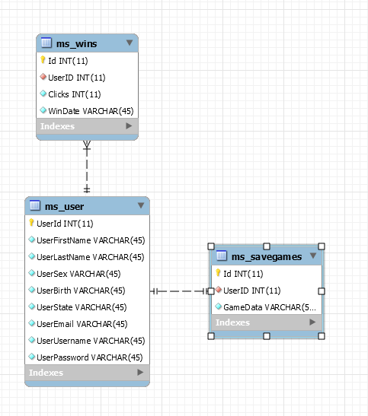

**DDL Scripts:**

*DDL Script found in the Git Repository*

***Sitemap Diagram:***

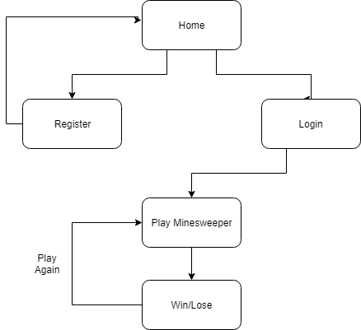

**Flow Charts:**

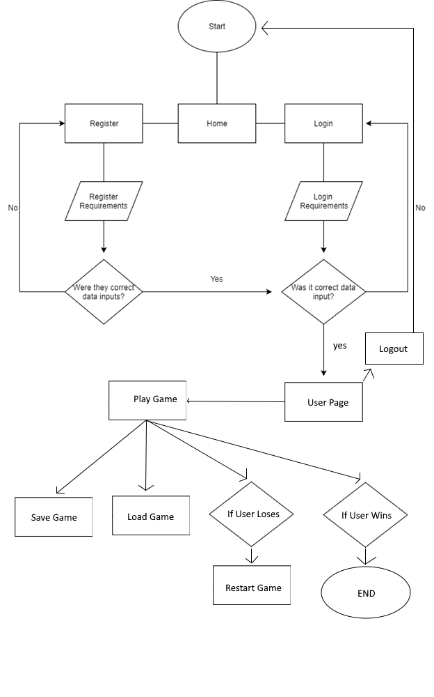

**User Interface Diagrams:**

Home Page

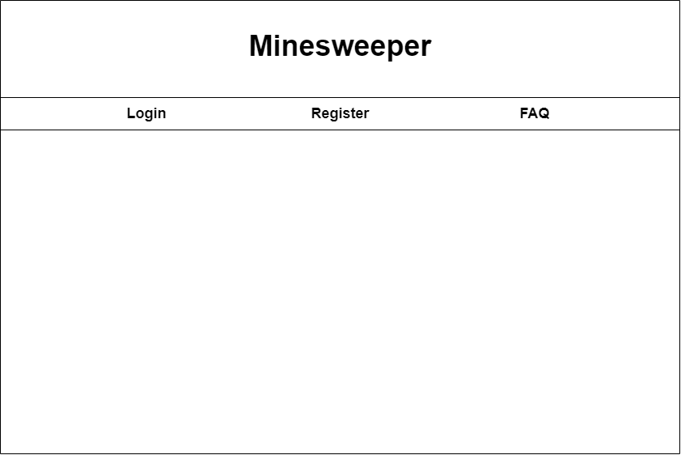

Register Page

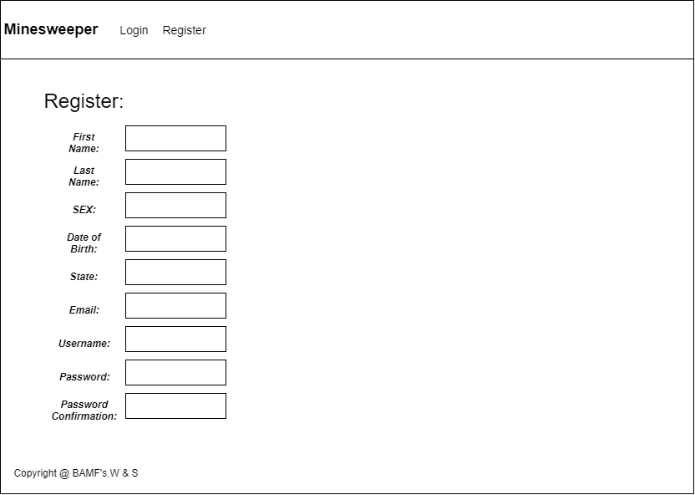

Login Page

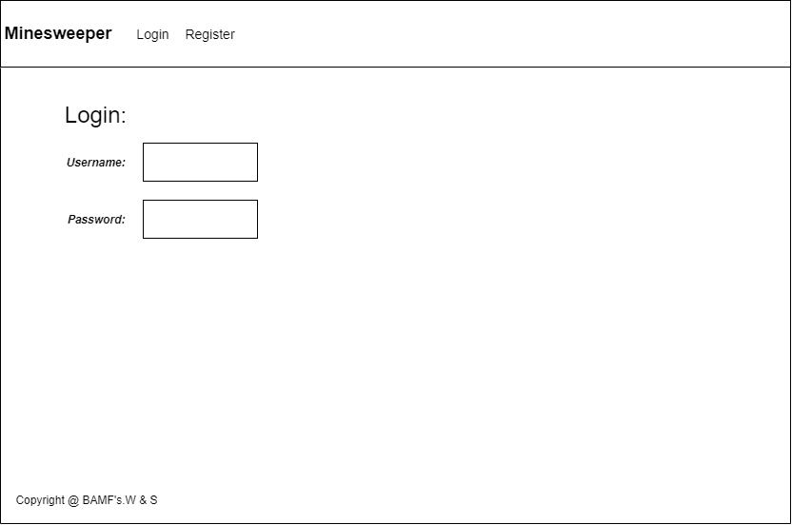

Minesweeper Board Page

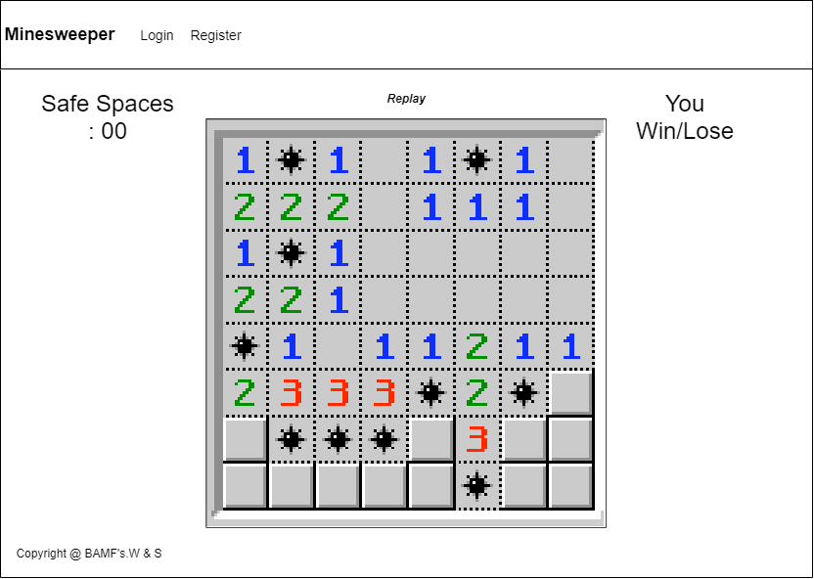

**Class Diagrams:**

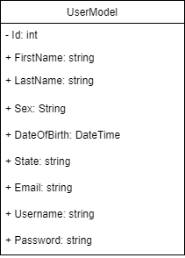

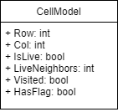

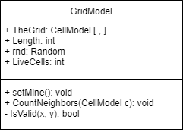

**Controller Diagrams:**

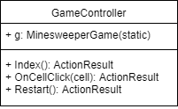

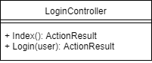

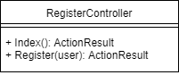

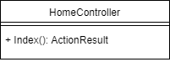

**Service Diagrams:**

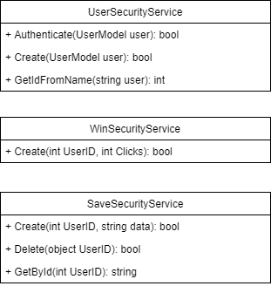

**DAO Diagrams**

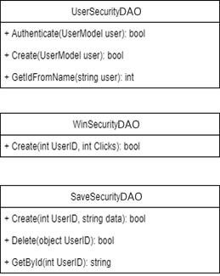

**Logging Diagrams**

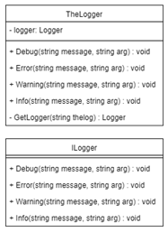

**Web API Design**

**WinsAPI:**

*A RESTful Web API that gets wins data from the core Net-Sweeper application and returns this data in JSON format.*

|  |
| --- |
| **API:** GET /api/wins |
| **Returns:** application/json |
| **Description:** *Returns all wins in JSON format* |
| **Example:**  {  "Id": "1",  "UserID": "1",  "Clicks": "13"  "WinDate": "Apr 23 2018 3:35PM"  }  {  "Id": "2",  "UserID": "4",  "Clicks": "19"  "WinDate": "Apr 23 2018 6:38PM"  }  {  "Id": "3",  "UserID": "7",  "Clicks": "8"  "WinDate": "Apr 24 2018 9:54AM"  }  *Continued…* |

|  |
| --- |
| **API:** GET /api/wins/11 |
| **Returns:** application/json |
| **Description:** *Returns the win that has id 11 in JSON format* |
| **Example:**  {  "Id": "11",  "UserID": "15",  "Clicks": "19"  "WinDate": "Apr 26 2018 12:18PM"  } |