World Dominion: The Last Sanctuary
A Mixed-Reality Survival Strategy Game

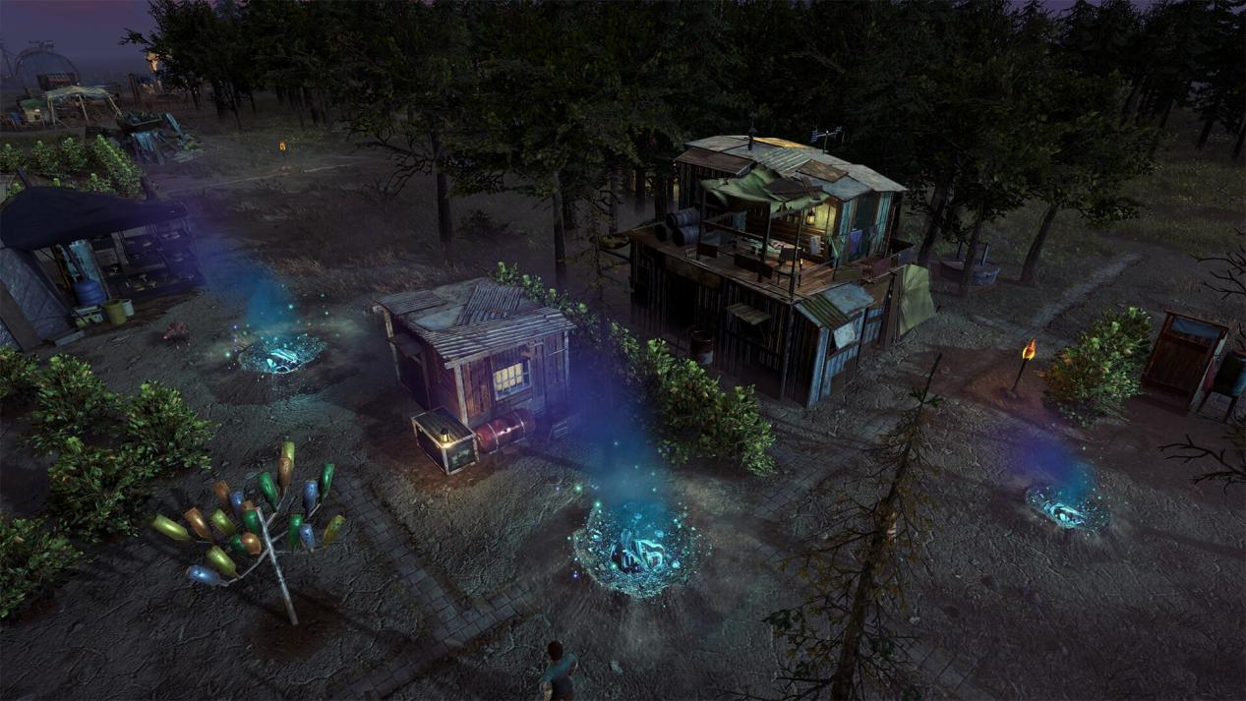

One world destroyed. A handful of survivors. One guardian to guide them.
Proposed competition: Meta VR Start Developer Competition 2026
Category: Gaming — New Experience
Target platform: Meta Quest, with Mixed Reality as the intended experience
Game genre: Survival Strategy / Tactical Rescue / World Restoration / God-Eye Simulation
Primary interaction: Hands-first, seated gameplay
Project status: Concept approved for prototyping; implementation and final storyline pending team discussion

1. Executive summary
The Last Sanctuary is a hands-first mixed-reality survival strategy game in which players assume the role of a powerful but limited guardian overseeing the last remnants of a civilization devastated by an invasion from another dimension.
The player views the world from a God-eye perspective, with the battlefield presented as a miniature living environment on a real or virtual table.
Unlike conventional survival games where the player controls a single character, The Last Sanctuary allows players to influence the survival of an entire community.
Players guide survivors, deploy defenders, repair broken supply networks, recover lost knowledge, manage scarce resources, and gradually reclaim regions controlled by hostile forces.
Every mission contributes to the world's recovery. Destroyed structures are reconstructed, inaccessible areas become explorable, survivors develop new capabilities, and the small sanctuary eventually grows into a civilization capable of fighting back.
The long-term campaign culminates in an invasion of the enemy's home dimension, where the player discovers that the rules governing their own world no longer apply.
The first playable version focuses on a single settlement rescue mission, establishing the game's survival mechanics, hand interactions, reconstruction system, and progression foundation.
The project is intentionally designed to scale from a small hackathon prototype into a larger survival strategy experience.
2. Vision and central identity
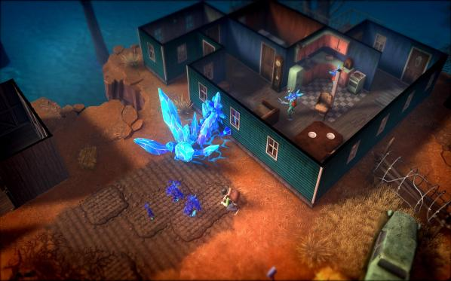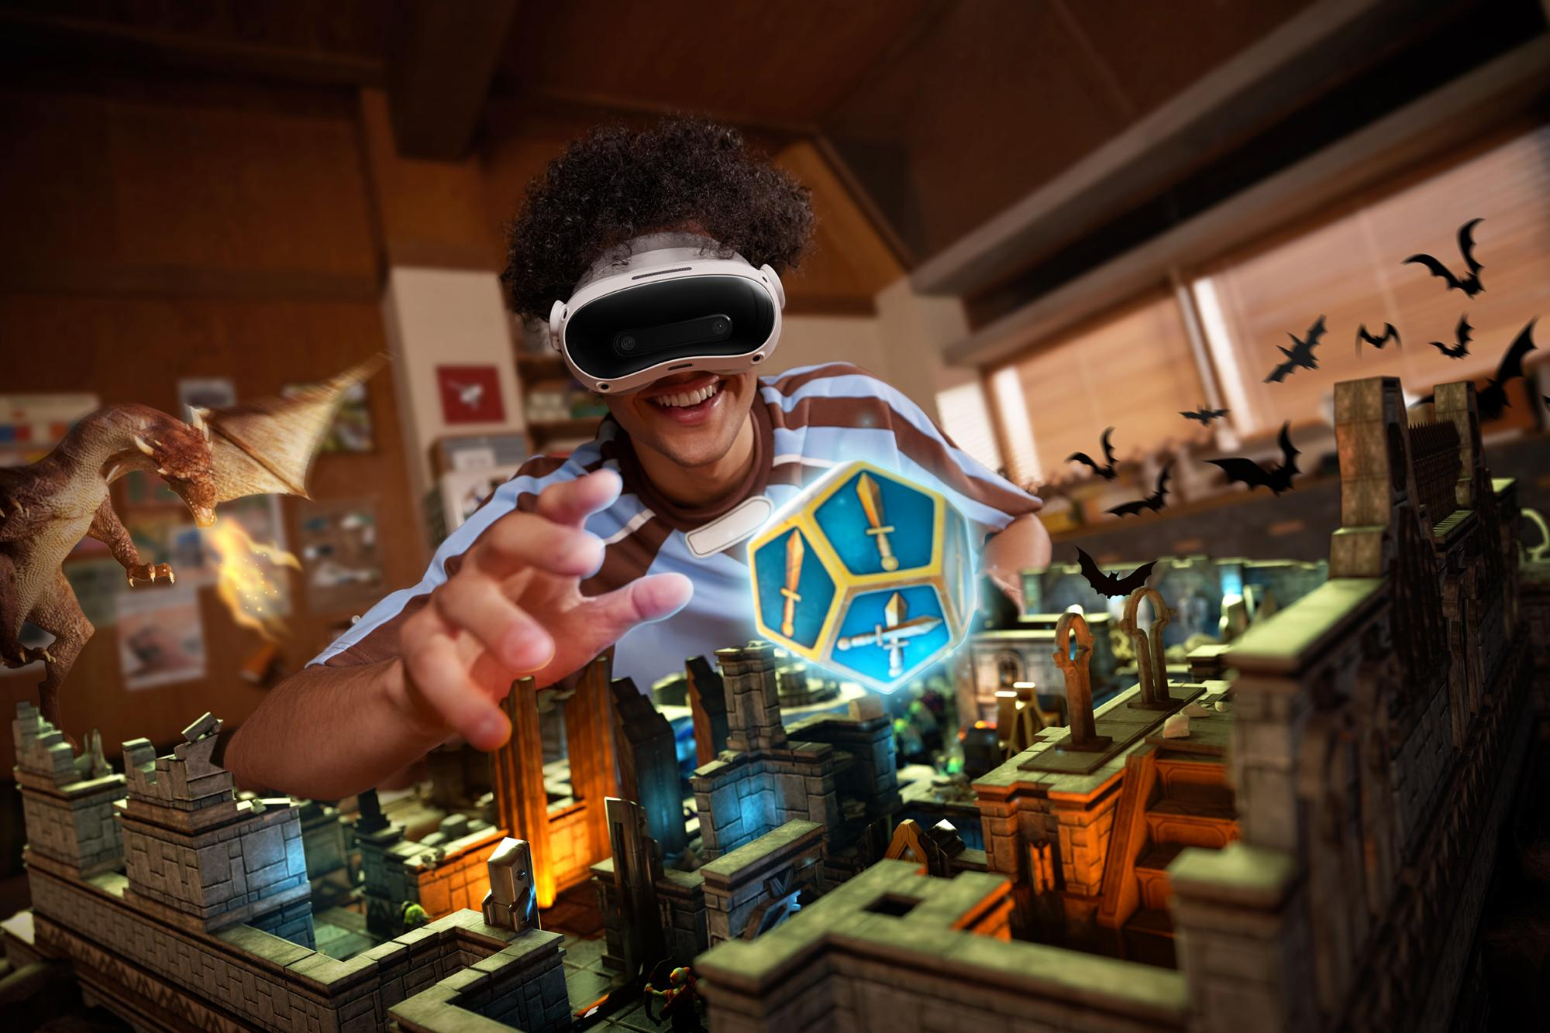
A world struggling to survive A guardian who influences their fate

Our primary goal is to create an experience where the player feels responsible for the survival and recovery of a miniature civilization.
This is not primarily a village-building game.
Settlements, buildings, and characters represent the tools through which survival, strategic decision-making, and world restoration take place.
The village or sanctuary is the starting point of a much larger game world.

Design pillars
Survival has consequences
Survivors, energy, defensive positions, and access to resources matter. The player must make decisions under pressure rather than simply follow predetermined commands.
The player is part of the world
Hands are not just replacements for mouse buttons. The player's physical actions influence supply networks, reconstruction, squad positioning, and protection.
Recovery is visible and meaningful
Rebuilding changes both the environment and gameplay. A restored structure can unlock new routes, abilities, resources, knowledge, or strategic options.
The world expands with progress
Players begin with limited access and gradually reach new regions through missions, exploration, and successful survival.
The rules evolve across worlds
The ultimate campaign introduces the enemy dimension, where familiar powers and environmental laws may work differently.

3. Proposed storyline and universe
Working narrative - subject to creative development

The fall
Long before the game begins, humanity developed a thriving civilization supported by a network of advanced energy structures.
Its cities were connected through powerful relays, allowing energy, knowledge, and resources to flow between regions.
Then came the invasion.
A hostile civilization from an unknown dimension entered through unstable gateways, overwhelming humanity's defenses and corrupting large portions of the world.
Cities fell. Supply networks collapsed. Communications ceased. Many settlements were abandoned.
The survivors retreated to isolated sanctuaries, using the few remaining sources of energy to defend themselves.

The awakening
The player is an ancient guardian whose influence over the world has nearly disappeared.
One settlement manages to reactivate a surviving Sanctuary Core, restoring a limited connection to the guardian.
The player can now interact with the world once again—but only within the small area sustained by the Core.
The guardian's initial influence is weak, meaning the survivors must still fight, repair, and rebuild for themselves.

The resistance
As the player rescues survivors and restores energy networks, more of the destroyed world becomes accessible.
What begins as a desperate rescue operation develops into an organized resistance.
Recovered structures reveal forgotten technologies and historical records, eventually exposing the origin of the invaders.

The dimensional war
After reclaiming their home world, the survivors discover a path into the invaders' dimension.
But crossing the gateway changes everything.
The guardian's powers are weakened or transformed, the environment obeys unfamiliar laws, and the enemy civilization has its own supernatural protector.
The survivors must adapt, establish footholds, and learn to survive in a world that was never theirs.
Narrative objective: The game begins with saving a few lives and eventually asks whether the survivors can overcome the same hostile world they once feared.
The precise nature of the guardian, the invaders, and the ending should remain open for team discussion. We should avoid locking expensive story-dependent mechanics before the basic gameplay is tested.

4. What makes the game different?
The project's differentiator is not simply that it uses VR or features miniature armies.
It combines a living miniature world with tactical survival decisions, physical interactions, persistent reconstruction, and a gradually expanding strategy campaign.
Conventional strategy or survival game | The Last Sanctuary
Player issues commands through traditional UI | Player interacts with a spatial miniature world using hands
Building restoration mainly changes stats or appearance | Restoration changes the environment, character behavior, and accessible gameplay
Units are often anonymous combat resources | Survivors have identifiable roles and visible reactions
The player's presence is outside the simulation | The guardian is an acknowledged force within the game's world
Progression focuses primarily on expansion | Progression combines survival, rescue, restoration, and territorial recovery
New levels primarily change map and enemy difficulty | Future dimensions can alter environmental rules and available powers
We should not claim these individual features are unprecedented. The opportunity for originality lies in how they work together, particularly in the hands-first rescue and restoration loop.
5. Core gameplay loop

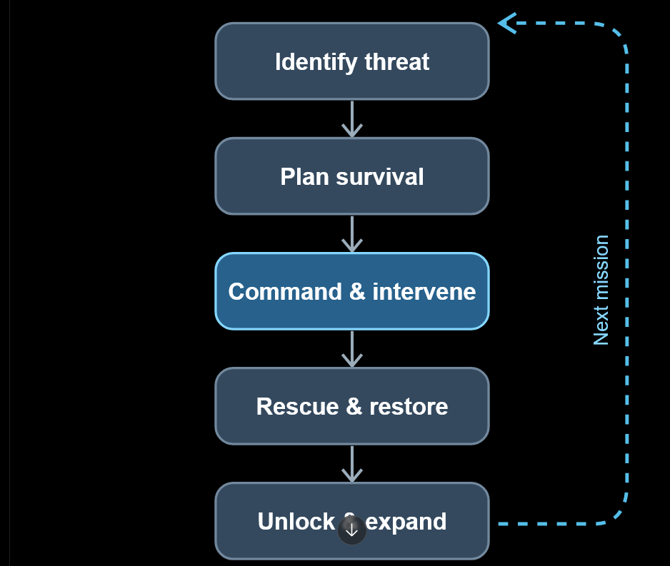
Proposed repeating gameplay loop. Each completed objective improves the survivors' chances of succeeding in the next mission.

The player repeatedly assesses threats, decides how to use limited resources, gives commands through hand interactions, and attempts to complete objectives.
Successful missions provide reconstruction materials, rescued survivors, technology, or access to new territory.
Those rewards influence the player's strategic options during future missions.

Proposed mission types
Mission | Objective | Challenge
Survivor Rescue | Extract stranded survivors | Limited time and dangerous routes
Supply Recovery | Recover essential energy or materials | Enemy patrols and limited capacity
Relay Restoration | Reconnect isolated regions | Broken infrastructure and defensive pressure
Settlement Defense | Protect critical structures | Incoming enemy waves
Reconnaissance | Reveal unexplored areas | Restricted visibility and limited scouting
Strategic Capture | Secure an enemy-controlled location | Enemy defenses and supply management
Dimensional Expedition | Establish a foothold in another world | Altered physics and restricted guardian powers
The first three mission types can share technical systems. That is important because we want variety without having to build an entirely new game mechanic for every objective.

6. Characters and factions
Visual direction: stylized, readable, low-poly fantasy/sci-fi survivors with original silhouettes and personalities.
The initial blue-versus-red distinction was only a conceptual tool. The final design should use clearly differentiated factions with original identities, uniforms, equipment, and visual languages.
For now, working terms are Survivors and Invaders.

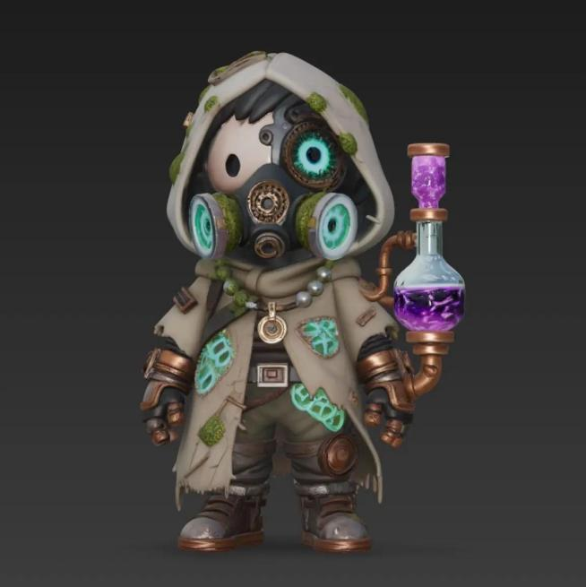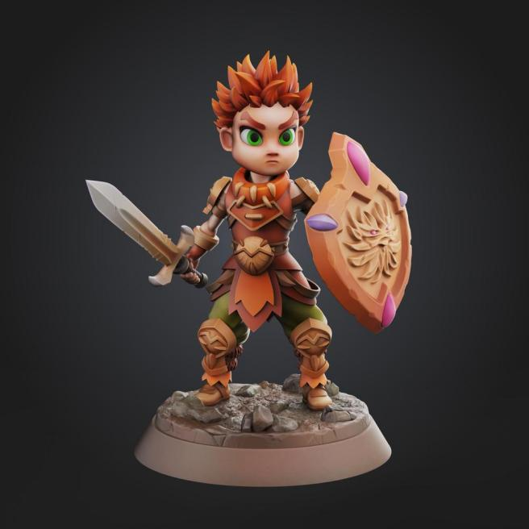
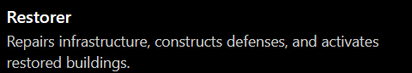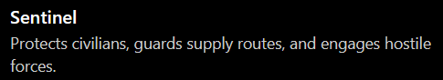
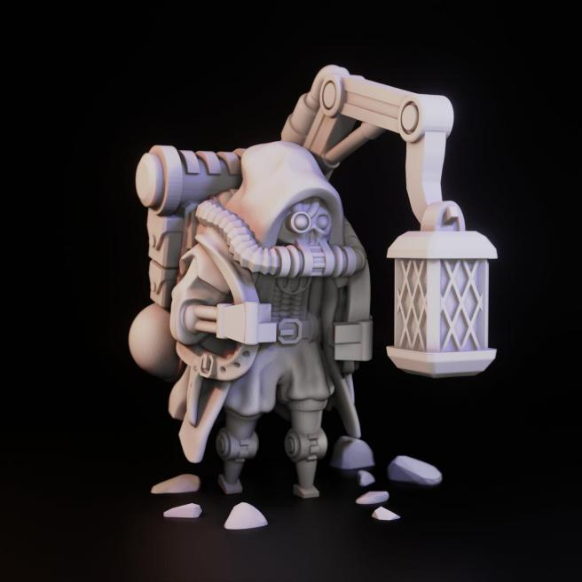
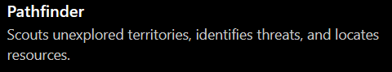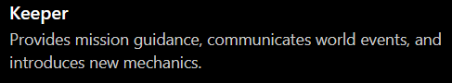
Other future roles could include Rangers, Medics, Engineers, Transporters, Researchers, and specialized dimensional explorers.

Character behavior
The survivors should feel like members of a living society rather than lifeless tokens.
They might carry materials, repair structures, defend one another, celebrate successful rescues, or react to nearby danger.
However, the first build should use scripted or state-machine behaviors instead of complex conversational AI.
First prototype: One Keeper, one Restorer, two Sentinels, and two or three civilians, with simple animations and readable behavior.

Enemy design
The Invaders should differ in silhouette, behavior, and combat style—not merely in color.
For example, their troops could resemble biomechanical entities powered by unstable dimensional energy. Their structures could look grown or assembled from unfamiliar materials rather than conventional architecture.
The exact aesthetic is not decided.
This leaves space for the later reveal that the invading civilization has its own hierarchy, technology, and guardian.

7. Hand-based interactions
Hands-first controls are a central design requirement, not an optional enhancement.
The competition requires the entire experience to be usable without pairing controllers. It also favors seated interactions within approximately a two-foot-diameter area.
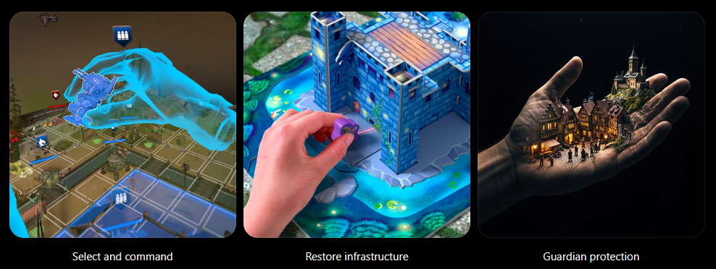

Action | Proposed interaction | Priority
Select a unit | Pinch or gaze-assisted selection | Essential
Command movement | Select unit, point to valid destination, confirm | Essential
Repair relay | Grab energy component and place into highlighted socket | Essential
Resize battlefield | Two-hand scaling or dedicated adjustment handle | Essential
Shield vulnerable units | Equip power, position palm, activate | Stretch goal
Inspect structures | Point and pinch for contextual information | Stretch goal
Manipulate terrain | Grab, lift, rotate, or reconnect spatial objects | Future
Meta's Interaction SDK provides components for grab, poke, ray, and scale interactions. The current SDK also supports gaze-based interactions; these can help with targeting without abandoning hands-first controls.

Meta Horizon OS Developers+1
We should favor predictable interactions over elaborate gesture combinations. Each action needs clear visual feedback, an easy way to cancel, and an alternative when a small target is difficult to reach.

8. Survival systems and resource management
We should be careful not to mistake complexity for strategy.
A fully simulated survival economy with food, water, energy, morale, research, ammunition, health, shelter, and population is unnecessary for the first prototype.
I recommend starting with three interconnected resources.
Survivors
Represent the population and available workforce. Rescuing more survivors improves future capabilities; losing them increases the cost of survival.
Sanctuary Energy
Powers restoration, defensive systems, and limited guardian interventions. Spending it on one action leaves less available for another.
Recovery Materials
Materials collected during missions and used to rebuild structures, repair equipment, and improve infrastructure.
This economy creates simple but meaningful decisions.
For example, the player could spend energy to shield a group of survivors or preserve that energy to reconnect a relay. The player must evaluate the threat and choose.
Later versions can introduce specialized resources, research systems, environmental hazards, and settlement sustainability.
- Infrastructure and progressive reconstruction
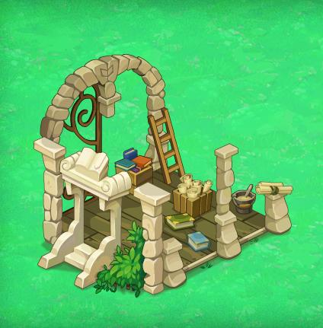

The reconstruction system is one of the project's main long-term progression features.
Structures are not created from nothing. Most already existed before the invasion and now remain damaged, inaccessible, or partially operational.
Completing missions provides opportunities to repair and reactivate them.

Proposed reconstruction stages
Stage | Visual condition | Gameplay impact
0% — Destroyed | Rubble, broken components, no activity | Inaccessible
25% — Stabilized | Debris removed, supports repaired | Limited access or information
50% — Functional | Core systems restored, characters begin using it | Basic functionality
75% — Reinforced | Most structures rebuilt | Improved functionality
100% — Restored | Fully operational structure | Complete ability or bonus
These are design targets, not a promise to create five detailed models for each structure during the hackathon.

Example: The Archive
The Archive preserves knowledge from before the invasion.
At 25% restoration, players discover a record identifying nearby danger zones.
At 50%, the Pathfinders gain improved reconnaissance capabilities.
At 75%, players unlock information about enemy infrastructure.
At 100%, the Archive provides advanced technology or reveals a new region.
Other structures may use different progression systems. A defensive tower might provide no usable defensive benefit until fully repaired, while a workshop might become partially functional much earlier.

Why reconstruction matters
The player should be able to look down at the world and instantly recognize the difference between where they started and what they have achieved.
A growing, recovering civilization is itself a reward.
It is also a natural reason for players to return in later sessions.

10. Miniature battlefield and table adaptation
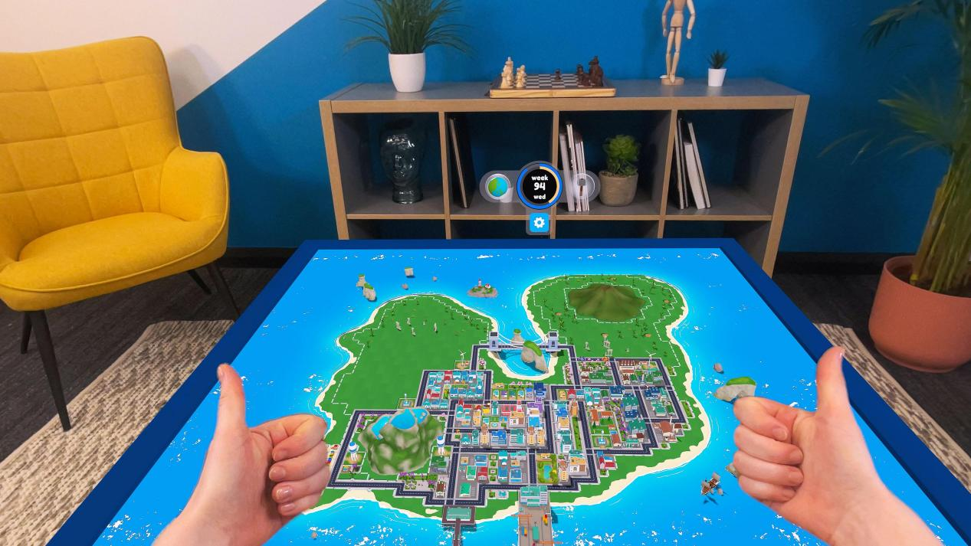

The intended experience places a miniature game world on a physical table using mixed-reality passthrough.
The player can look around the scene naturally while interacting with the miniature environment from above.

Placement strategy
Recommended implementation sequence
- Manual positioning: Spawn the battlefield in front of the seated player and let them reposition it.
- Manual resizing: Allow the player to scale the complete scene while preserving proportions.
- Surface detection: Use Meta's mixed-reality tools to identify a suitable table or flat surface.
- Adaptive placement: Fit the map inside the available surface with appropriate margins and readable controls.
This sequencing matters because automatic tabletop detection should not become a dependency for the entire game.
The game must remain usable if the player has an irregular table, insufficient scene data, or a room layout we haven't tested.
A virtual tabletop mode is also a useful fallback.
Meta provides MR Utility Kit samples and room understanding resources that can help implement the later placement stages.

11. Hackathon MVP: Operation First Light
Recommended first playable milestone
Target playtime: approximately 5–7 minutes
The first version will demonstrate one complete survival mission with a clear beginning, challenge, player decision, and victory sequence.
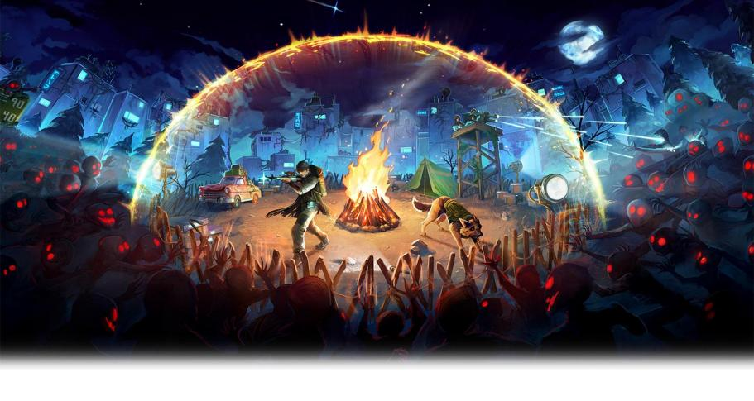

Mission premise
A small group of survivors is trapped beyond a destroyed energy relay. Hostile invaders patrol the surrounding area.
The Sanctuary Core has enough energy to support only a limited rescue operation.
The player must guide a defense squad, secure the relay, restore its connection, and escort the survivors to safety.

Mission sequence
Time | Gameplay event | Player's role
0:00–0:45 | The Keeper explains the emergency through short visual prompts | Learn to select and command
0:45–1:45 | Blue defenders advance toward the broken relay | Choose a safe route
1:45–2:45 | Enemy patrol threatens the Restorer | Position defenders, optionally protect the squad
2:45–3:45 | The damaged relay is reached | Physically insert an energy component
3:45–4:45 | Survivors are escorted back while the enemy responds | Command defense and extraction
4:45–5:45 | Survivors return and resources are recovered | Complete the rescue
5:45–6:30 | The Archive begins rebuilding; another region is revealed | Experience progression and future possibilities
The specific times are targets, not a requirement to force every player through a fixed-length cutscene.

Strategic decision
The player should have at least one real choice: take a shorter, dangerous route that consumes less energy, or use a safer route that requires restoring an extra connection.
This prevents the mission from becoming nothing more than a scripted sequence.

Success and failure
Success: A sufficient number of survivors reach safety and the relay is restored.
Failure: Critical survivors are lost, the rescue timer expires, or the Sanctuary Core's essential system is destroyed.
Failure should trigger a fast restart, not a lengthy punishment or forced replay of the introduction.

MVP success criteria
- A complete rescue mission can be finished using tracked hands
- The player can issue squad movement commands reliably
- Enemy units provide a meaningful tactical challenge
- A relay can be physically restored
- A structure visibly changes after mission completion
- The experience is understandable with minimal instructions
- The project works in the XR Simulator and can be packaged for Quest
Development acceptance checks 0/7
These are internal project targets. A passing internal checklist does not establish competition eligibility or confirm actual Quest performance.

12. Technical implementation plan
Our preferred initial stack is Unity with C#, Meta XR SDKs, and a lightweight custom gameplay architecture.
Proposed system architecture
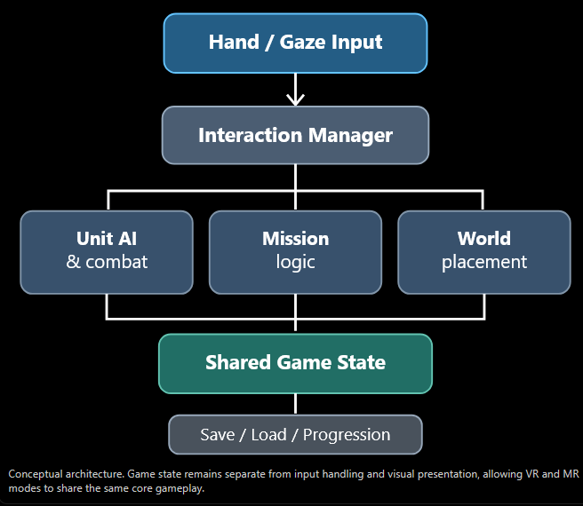

Software stack
Component | Recommended technology
Engine | Unity with C#
XR input | Meta XR Interaction SDK
Gaze assistance | Meta gaze interactions, where supported
Mixed reality | Meta Passthrough and MR Utility Kit
Character movement | Unity AI Navigation / NavMesh
Enemy behavior | Simple finite-state machines
Character animation | Unity Animator
Level creation | Unity primitives and low-poly assets
Modeling | Blender
Audio | Unity Audio
Progression | Local structured save data
Version control | Git and GitHub
Testing | Unity Play Mode, XR Simulator, physical Quest if available
We should keep the project modular enough that unit AI, mission logic, and reconstruction can operate independently of the VR/MR interaction layer.
That is important for debugging on a laptop and for scaling the game later.

Suggested Unity modules
Module | Responsibility
GameManager | Overall game state, pause, win/loss conditions
MissionManager | Objectives, timers, and mission completion
UnitController | Movement, squad selection, commands
EnemyAI | Patrol, detect, pursue, attack
InteractionManager | Hand-selection and contextual interactions
ResourceManager | Energy, materials, survivor counts
ReconstructionManager | Building progression and state changes
WorldManager | Region visibility and accessibility
TabletopManager | Map placement, scaling, orientation
SaveManager | Persistent progression
These are proposed responsibilities rather than a requirement to implement ten elaborate systems immediately. Some can be combined for the MVP.

13. Team structure and responsibilities
Role | Responsibilities | Core deliverable
XR / Unity Lead | Scene setup, Meta SDK, hand tracking, tabletop placement | Reliable interactions and build
Gameplay Programmer | Unit movement, enemy AI, missions, resources | Playable rescue loop
3D / Level Designer | Environment, character assets, ruined/restored states, animations | Cohesive miniature world
Integration / QA / Presentation | UI, audio, testing, bug tracking, Devpost, trailer | Stable submission and demo

14. Long-term vision and future scope
This is the project's largest strategic opportunity: the hackathon build is the first chapter of an expandable survival universe.
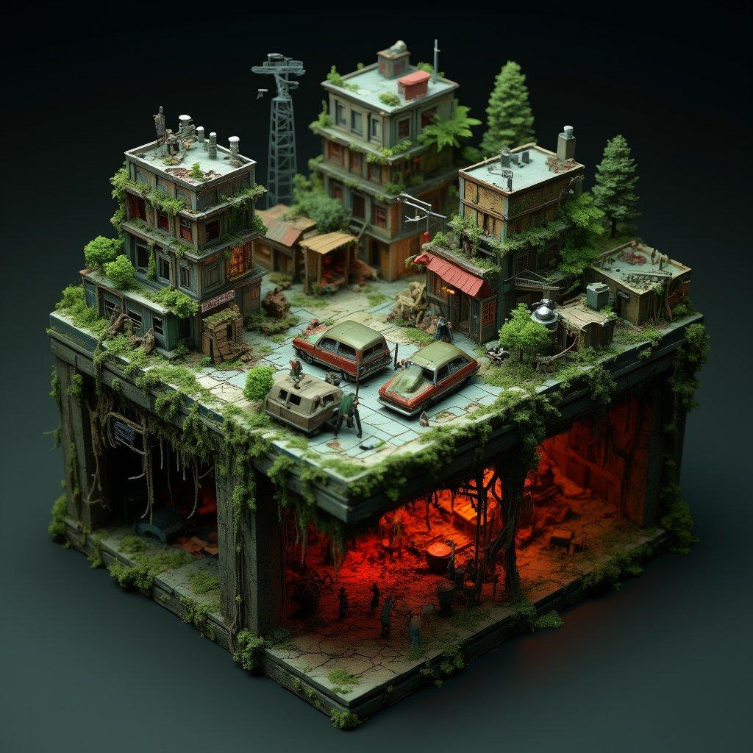
The future scope should not be presented as functionality that already exists. It is a proposed roadmap of increasingly ambitious releases, contingent on testing, user feedback, and resources.
PHASE I — HACKATHON
The Last Sanctuary
One endangered settlement, a rescue operation, a repairable supply relay, simple enemy threats, and visible recovery.
Goal: prove the core experience works and is enjoyable.
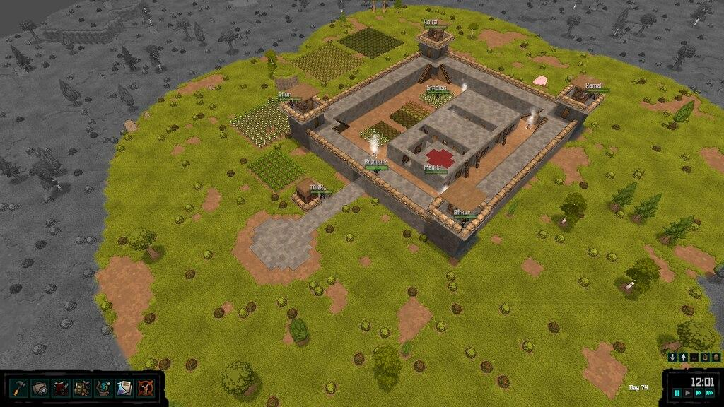
PHASE II — SURVIVAL SYSTEMS
A Living Sanctuary
Multiple mission types, specialized survivors, deeper resource management, structural upgrades, base defense, and persistent save progression.
Goal: create replayability and meaningful survival decisions.
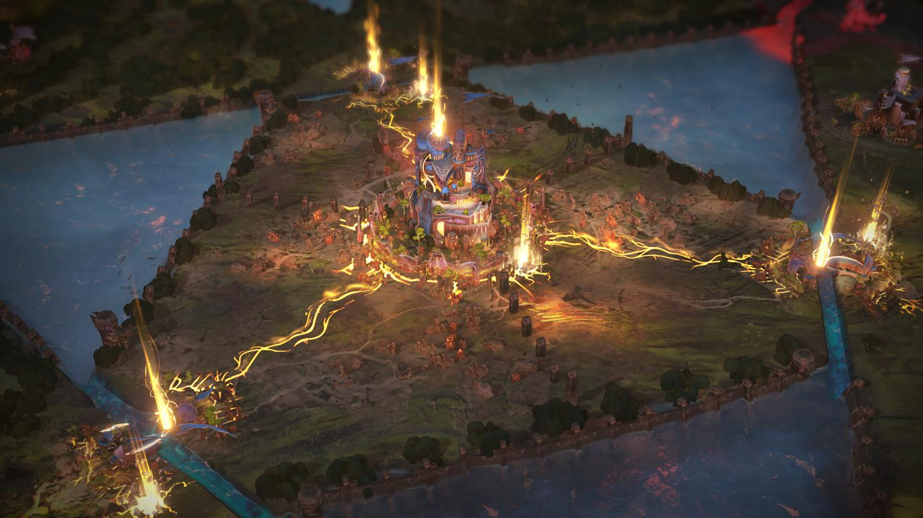
PHASE III — WORLD EXPANSION
Reclaiming the Fallen World
Multiple regions, connected supply networks, outposts, regional missions, exploration, rescue campaigns, and persistent territorial control.
Goal: expand the experience from settlement survival to strategic world recovery.
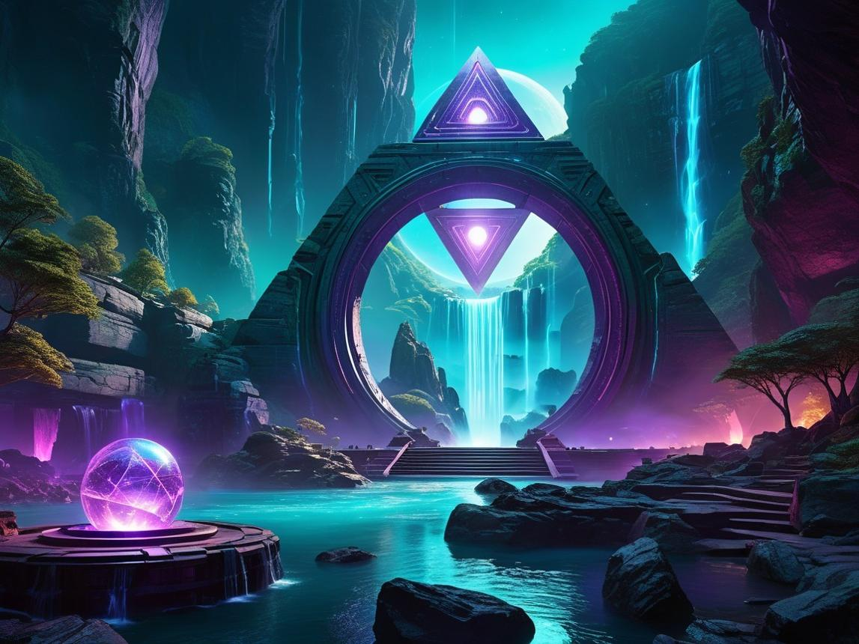
PHASE IV — DIMENSIONAL EXPANSION
Beyond the Gateway
The player enters the invaders' home dimension, encountering altered resources, unfamiliar physics, weakened guardian powers, new enemies, and a rival guardian.
Goal: introduce genuinely different strategic rules rather than reskinning the original world.
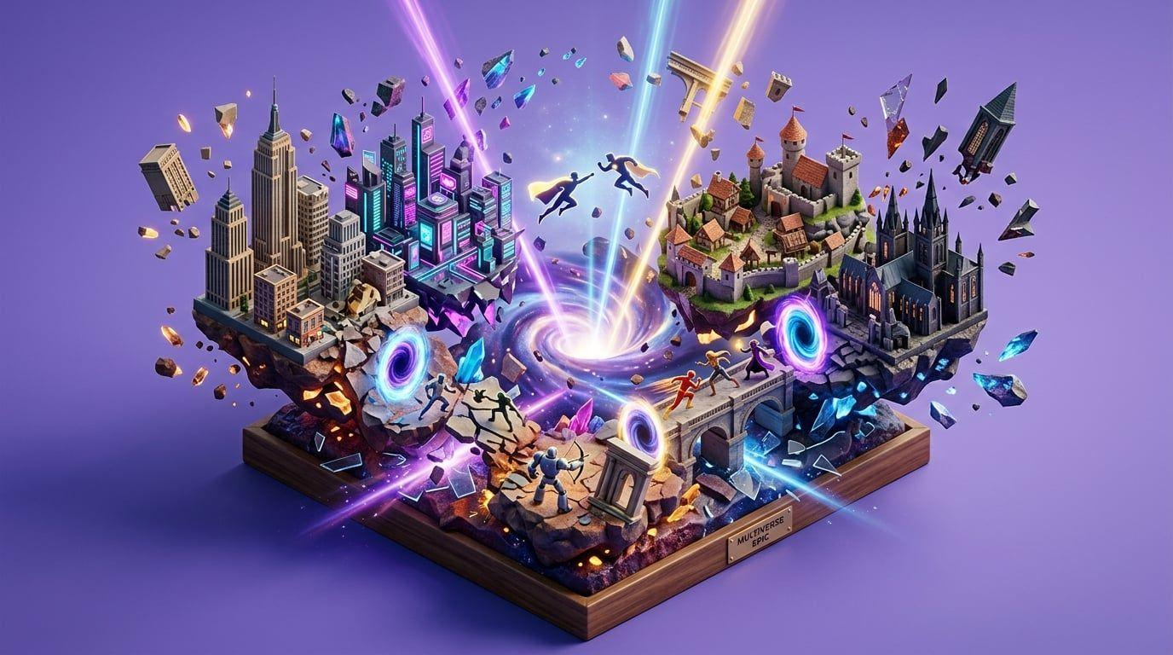
PHASE V — FULL CAMPAIGN
The War of Two Worlds
A complete narrative campaign with advanced defensive systems, evolving enemy strategies, player decisions affecting multiple regions, and a conclusion to the dimensional conflict.
Goal: transform the prototype into a standalone commercial-scale strategy game.

15. Potential advanced mechanics
These features should be evaluated individually after the MVP rather than added to the initial build.
Feature | Gameplay opportunity | Potential
Persistent rebuilding | Players return to see the world recover | High
Adaptive enemy strategy | Enemies respond to player tactics and supply lines | High
Environmental survival | Weather and hazards affect decisions | High
Specialized character roles | More strategic squad combinations | High
Dynamic world events | Emergencies and resource opportunities | High
Technology restoration | Lost knowledge unlocks new abilities | High
Alternate dimension physics | New strategic rules across worlds | High
Co-op guardians | Multiple players coordinate over a shared miniature world | Medium–High
Procedural regions | More exploration and repeatability | Medium
Voice interaction with characters | Natural mission communication | Experimental
Persistent tabletop anchors | Return to a miniature world in the same physical location | Medium–High

Example: The enemy dimension
This is a particularly important selling point, but it needs careful design.
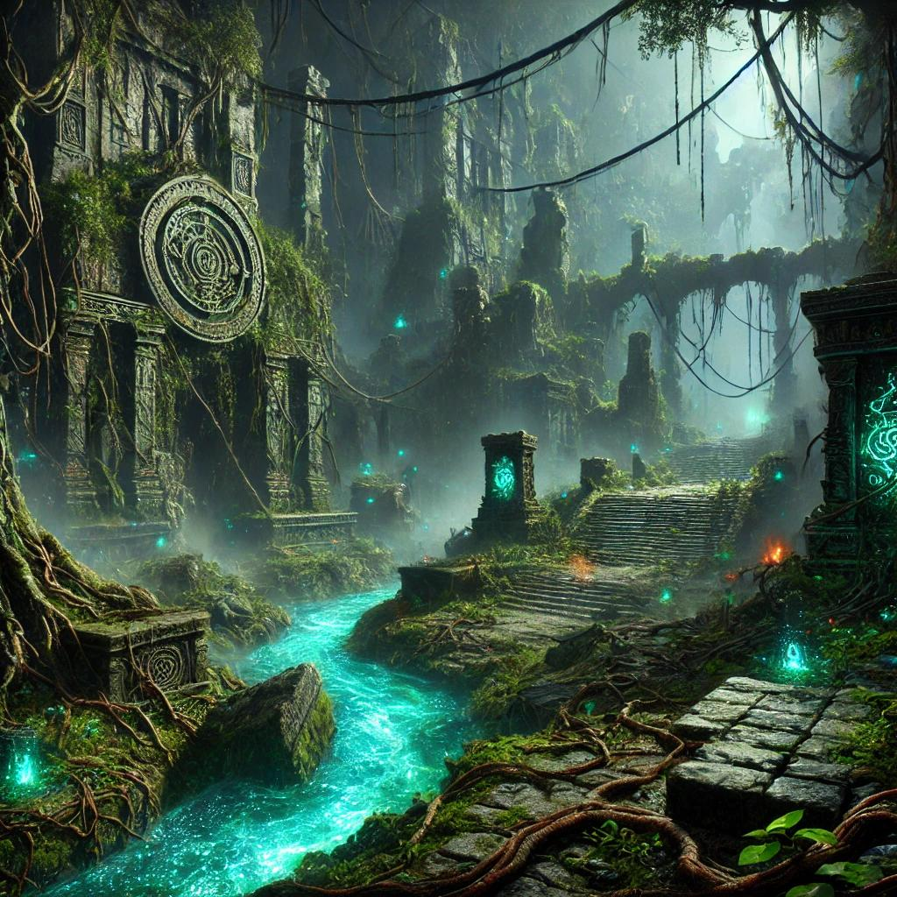
Human world
Energy restores structures. Water sustains settlements. Guardian powers protect survivors.

Invader world
Familiar energy becomes unstable, environmental hazards change, and the guardian must adapt.
Possible mechanics include:
- Fire creating frozen barriers rather than burning obstacles.
- Certain liquids damaging structures instead of replenishing resources.
- Restoration requiring enemy-world materials.
- Guardian shielding becoming unreliable in hostile regions.
- Supply routes becoming vulnerable to dimensional distortion.
- The enemy guardian modifying terrain or protecting its own troops.
The player should always retain understandable controls. The challenge should come from changes in the world's behavior, not from deliberately making hand tracking feel incorrect.
Long-term development should also consider the narrative consequence of invading an enemy world: the survivors may face choices that complicate their original role as victims defending themselves.
That could give the campaign more depth than a straightforward victory-through-conquest story.

16. Hackathon alignment and judging strategy
The Meta VR Start Developer Competition evaluates projects using four equally weighted criteria.
Pasted markdown.md
Criterion | How our project addresses it | What must be demonstrated
Innovation & Creativity (25%) | Physical guardian interactions, spatial strategy, living miniature world | A mechanic that genuinely benefits from XR
Experience Design (25%) | Seated gameplay, short missions, contextual guidance, intuitive hand interactions | A player can understand and complete the experience naturally
Technical Implementation (25%) | Quest hand tracking, scene management, AI, optional MR placement | Stable operation and reliable input on target hardware
Polish & Presentation (25%) | Cohesive characters, satisfying reconstruction, visual feedback, spatial audio | A complete, attractive, understandable playable demo

Competition opportunities
Our primary category is Best New Gaming Experience, which awards $100,000 to the winner and $50,000 to the runner-up under the official rules.
The project could also align with the following $25,000 special awards:
- Best First Five Minutes: A memorable opening rescue with immediate payoff.
- Best Reason to Come Back: Persistent reconstruction, progression, and territory expansion.
- Boldest Original Concept: Physical interactions that make meaningful use of XR presence.
These are potential award alignments, not predictions that the project will win. Each entry is limited to one prize.

Essential submission requirements
The team must ensure:
- All relevant participants meet the competition's eligibility and developer-account requirements, and the submitting representative is a Meta VR Start member.
- The game works fully with hands, without requiring controllers.
- The submission is an accessible Meta Quest-compatible build in the required Competition release channel.
- The team provides a public gameplay demonstration video shorter than three minutes.
- The Devpost submission includes the project description, implementation details, future plans, and a target launch date if not published.
- Submission is complete before November 18, 2026, 12:00 PM Pacific Time.
These requirements are based on the official rules.

