Mastering Chrome Extension Management: A Comprehensive Guide

Generated from Session: Extension Session 8/4/2025, 4:48:44 PM

Created: 2025-08-11 18:19:56

Estimated Read Time: 5 minutes

Tags: Chrome Extensions, Browser Extension Management, Web Browsers, Google Chrome, Developer Tools

Introduction

Welcome to a deep dive into the world of Chrome extension management! This guide is designed to equip you with the knowledge you need to navigate, utilize, and master the Chrome extension interface, ensuring an optimized browsing experience.

Main Content

### Visual Elements in Chrome Extension Interface  
  
The Chrome extension interface is replete with visual elements designed for efficient extension management. At the header section, you will find a search bar labeled 'Search extensions' and a toggle switch for 'Developer mode.' The interface also features several buttons for operations such as 'Load unpacked,' 'Pack extension,' and 'Update.' Each listed extension comes with 'Details' and 'Remove' buttons, and some even have toggle switches for enabling or disabling.  
  
The sidebar hosts options labeled 'My extensions' and 'Keyboard shortcuts.' Lastly, the interface displays extension names, version numbers, IDs, and brief descriptions or additional options like 'Inspect views' and 'service worker.'  
  
### Layout & Structure  
  
The layout and structure of the interface are intuitively designed for ease of navigation. The left sidebar contains navigation items for managing extensions and exploring keyboard shortcuts, along with links to additional resources and the Chrome Web Store.  
  
The main section, on the other hand, displays a list of installed extensions under 'All Extensions.' Each extension is presented in a card-like format with relevant controls and information.  
  
### Functionality of Chrome Extension Interface  
  
The Chrome extension interface offers a plethora of functional features. It allows users to load, pack, and update Chrome extensions. You can toggle developer mode on or off for advanced extension management features, enable or disable individual extensions using the toggle switches, and access details or remove extensions with corresponding buttons.  
  
### User Experience  
  
In terms of user experience, the interface is user-friendly and intuitive. Users can search for specific extensions using the search bar, manage installed extensions easily through intuitive controls, access details about each extension, and engage with developer options if needed. Navigation is also made easy with options to learn about keyboard shortcuts or explore new extensions via the Chrome Web Store link.

Conclusion

In essence, the Chrome extension interface is a robust toolset for managing existing extensions and facilitating the addition of new ones. Its clean and organized layout coupled with a range of functional features, ensures a seamless and optimized browsing experience.

Generated Header Image

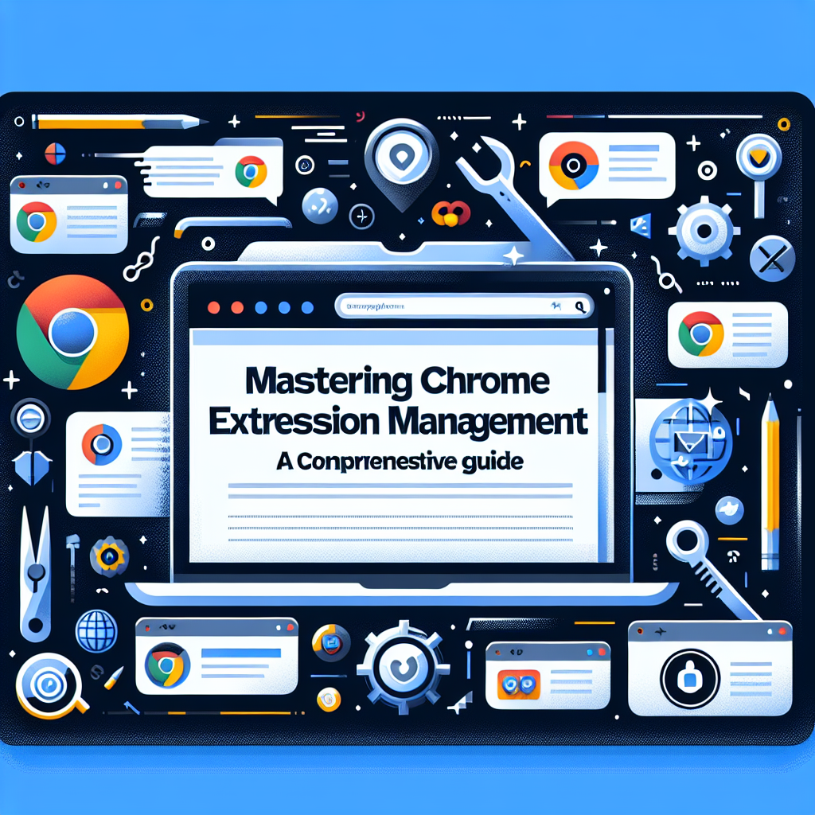

Alt Text: Header image