Script for video for the function- for general public.

Hope you an understand. We would like to a white female presentation and voice if possible

Scene 1

I am sick. 



Diabetics, hernia , headache, kidney problems, liver problems- different people, different diseases.

Medicity, medical colleges, hospital, clinic where should I go? images of hospitals

Modern, surgeon, ayurveda, naturopathy whom I select? Images 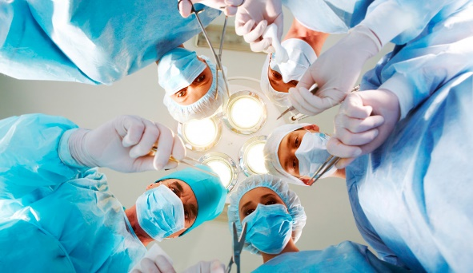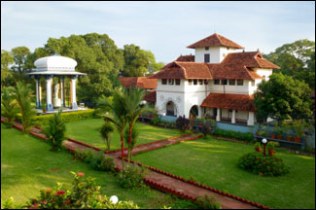

In Kochi, Bangalore, UK, USA here or abroad?- images

Post your case in [www.doctorbudy.com-](http://www.doctorbudy.com-) screen shots or videos of of doctorbudy- typing a name, symptom etc

Real time counselors helps you through chat (use our screen)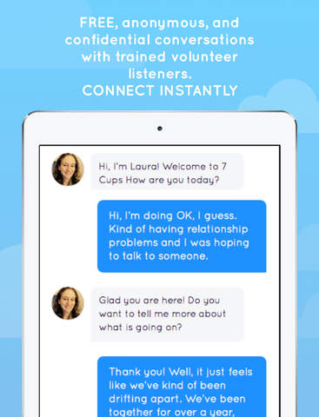

Submit.

 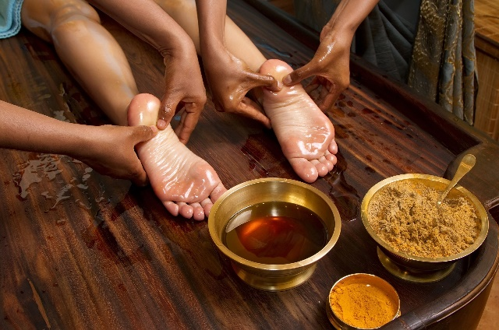 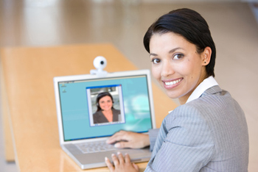

Reply coming from various doctors and hospitals –Variuos treatment plans for various budgets Our service have this and that, wellknown doctors, clean interiors, keyhole, open surgery, etc, approximate expenses, success rate, 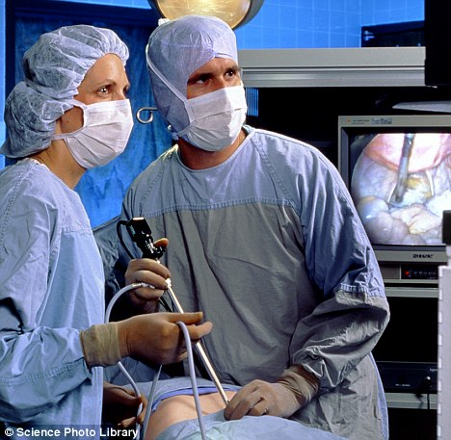 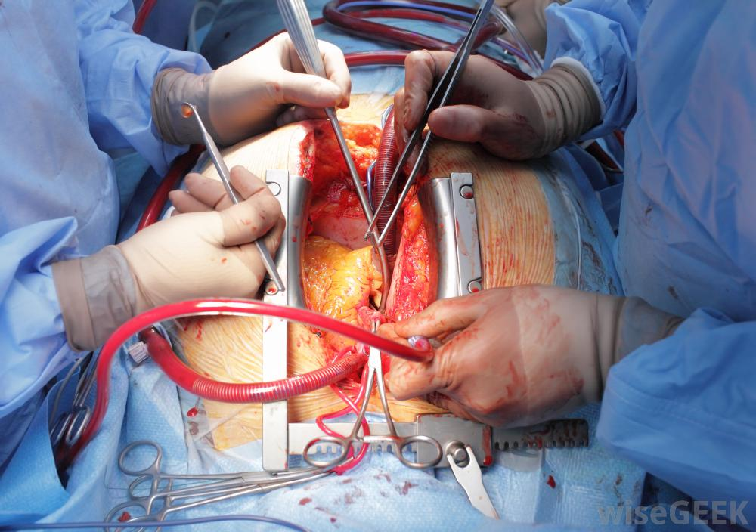

Well informed decisions, plan your dental implant during your vacation, price reduction and priority as a doctor buddy client, 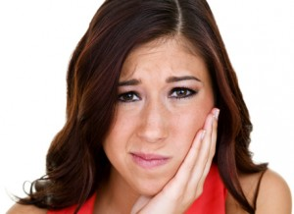 in a tourist spot, morning treatment session evening in the beach

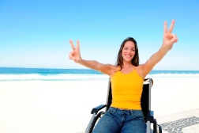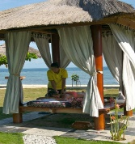

Or telemedicine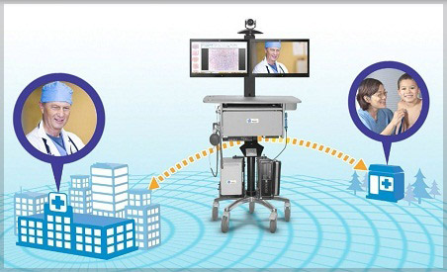

 permanent health file can be updated and edit forward to any doctor at any time.