|  |  |  |  |  |
| --- | --- | --- | --- | --- |
| **SN** | Item Description | **Qty.** | **Price** | **Total** |
| 1 | Payment for the Executive Legislative Leadership and Tours program package, Courtesy Visit to the Worshipful Mayor of Southwark and the rest of the events for the week from the 30th October – 5th November 2023 | 1 | £7000.00 | **£7000.00** |
|  |  |  |  |  |
|  |  |  |  |  |
|  | **Total** |  |  | **£7000.00** |

**The Clerk**

**County Assembly of Kisumu**

**P. O. Box 2738'40100**

**Kisumu**

No: 001

Date: 27/10/2023

**INVOICE**

**POUNDS ACCOUNT DETAILS FOR TRANSFER:**

**Bank Name: Revolut Bank UK**

**Beneficiary: Cater and Merger Consult Ltd**

**Account Number: 68529538**

**IBAN: GB41 REVO 0099 6953 1277 74**

**BIC: REVOGB21**

**Intermediary BIC: CHASGB2L**

**Beneficiary address: Allia Future Business Centre, London Road, PE2 8AN, Peterborough, United Kingdom**

**Bank/Payment institution: Revolut Ltd**

**Bank/Payment institution address: 7 Westferry Circus, E14 4HD, London, United Kingdom**

Yours Faithfully,

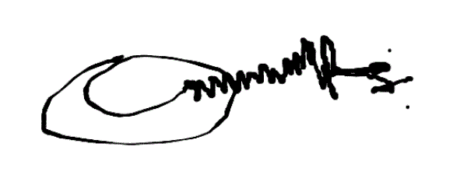

Godson Azu

CEO

CaterandMerger Consult Ltd, UK.