**INDUSTRIAL TRAINING FUND**

**MODEL SKILLS TRAINING CENTRE, ABUJA**

**COMPUTER SOFTWARE ENGINEERING DEPARTMENT**

**SCIENTIFIC PROGRAMMING LANGUAGE USING OBJECT ORIENTED JAVA**

**(CSE 202)**

NID EXAMINATION – PRACTICAL PAPER

##### 3 HOURS

**MARCH, 2022**

### Instructions to Candidates

1. You have 10 minutes to read through the question paper before the commencement of the test. No work is to be carried out during this period.
2. This practical examination consists of **two (2)** stages.
3. The total duration of the practical paper is **3 hours**.
4. Read the instructions and study the diagram carefully before you begin.
5. Observe standard programming procedure and convention.
6. Write your name and ID number on the top right corner of each sheet.
7. Return this question paper at the end of the assessment.

###### 

###### Model Skills Training Centre, Abuja

***This question paper consists of 4 printed pages.***

***(Excluding this cover page)***

**Course Title:** Programming Using Java **Course** **Code**: CSE 202

**Objective:** Build a Java Swing Application **Duration:** 3 Hours

program as per specifications.

**Equipment and tools list:**

Description Quantity

1. A PC installed with the following 1

* Java Development Kit (JDK)
* Java Netbeans IDE
* Microsoft Access

**Diagram:**

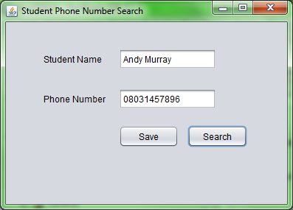

**Figure 1**

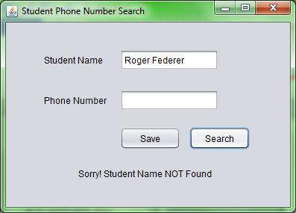

Sorry, Phone Number NOT Found!

Only show this when the Phone Number is not found.

**Figure 2**

**Application Specifications:**

* Create a “**Phone Number Search**” Application.
* User enters Student Name in the “txtName” text field.
* The application will search through the database for the corresponding Phone Number for that Student Name.
* If the Student Name is NOT found, the “lblErrMessage” label will display the message “**Sorry, Phone Number NOT Found!**” (See Figure 2).
* If the Student Name is found, the “txtPhoneNo” will display the Phone Number from the database accordingly.
* Create a database with the following records. (see Table 1)

|  |  |
| --- | --- |
| **Student Name** | **Phone Number** |
| Kemi Ayodele | 08012345678 |
| Yusuf Mohammed | 07023456789 |
| Akai George | 09034567891 |
| Nwanchukwu Ugoma | 08145678923 |
| Amina Salisu | 07056789123 |

**Table 1**

**STAGE ONE:**

1. Create a GUI as shown in **Figure 1** in Java Frame using Java Swing Components. The detailed specification are given below:
2. JFrame Settings
   * 1. The size of the JFrame: **height** = 300 pixels, **width** = 400 pixels
     2. **Title** of the JFrame is “Students Phone Number Search”
3. JComponents

Create and display the following JComponents with its corresponding variable name.

* + 1. JLabel
    2. JLabel
    3. JTextField - “txtName”
    4. JTextField - “txtPhoneNo”
    5. JButton - “btnSavePhoneNo”
    6. JButton - “btnGetPhoneNo”
    7. JLabel - “lblErrMessage”

1. Use the IDE to position all the above components as shown in **Figure 1**.

**STAGE TWO:**

1. Programming
2. Create a database connection and connect to the created Microsoft Access database which stores a table “**tblPhoneNo**” containing 5 rows with corresponding **Student Name** and **Phone Number**.

**Check:** Application is able to connect to database.

1. Create a query to search the Phone Number for the given Student Name.
2. On the “**Search**” button click, user can retrieve the Student’s Phone Number from the database if the Student’s Name is found in the database.

If the Student’s Name cannot be found, “**Sorry,** **Phone Number NOT Found!**” is displayed.

1. Create a query to add new student record to the database.
2. On the “**Save**” button click, warning messages "**Please enter Student Name**" or "**Please enter Phone Number**" is displayed if the "**txtName**" or the "**txtPhoneNo**" field is left blank.

If student record is saved, an Alert message box pops up to inform user that "**Student record saved**".

If student record with same Phone Number already exists, an Alert message box pops up to inform user that "Phone Number already exists!"

1. Use Error trapping techniques for program validation.
2. Compile and execute the program with suitable tools and demonstrate the output to the invigilator.
3. Save the project solution folder as “YourName_NIDjavaExam” and submit the question paper.

*** End ***