**THE DESIGN AND IMPLEMENTATION OF A PERSONNEL MANAGEMENT SYSTEM FOR THE NATIONAL BUREAU OF STATISTICS**

**BY**

**KELVIN KELECHI IBEH**

**NOU193113816**

**A RESEARCH PROJECT SUBMITTED TO FACULTY OF SCIENCES, NATIONAL OPEN UNIVERSITY OF NIGERIA IN PARTIAL FULFILMENT OF THE REQUIREMENTS FOR THE AWARD OF B.SC IN COMPUTER SCIENCE.**

**FACULTY OF SCIENCE**

**NATIONAL OPEN UNIVERSITY OF NIGERIA,**

**MARCH 2024**

**DECLARATION**

I hereby declare that this project is my work and has not been presented in any form for another qualification at any other university or institution. The information derived from the published or unpublished works of others has been duly acknowledged in this work

**CERTIFICATION**

This is to certify that this project research conducted on the “the Design and Implementation of a Personnel Management System for the National Bureau of Statistics” by, it has been read, recommended and approved in its present form as meeting the partial requirement of the Faculty of Science, National Open University of Nigeria, for the award of BSC in Computer Science.

…………………………. …………………………

**Engr Ale Felix Date**

(Project Supervisor)

………………………… …………………………. **Mrs Patience Abimbola Adeniyi Date**

(Centre Director)

…………………………. ………………………….

**Prof. Kolawole .M. Lawal Date**

(Den, Faculty of Science)

………………………… …………………………

**External Examiner**  **Date**

**ACKNOWLEDGEMENT**

I would like to express my profound gratitude to the people who have helped me most throughout the entire program, I am grateful to all my facilitators for their non-stop support and most especially my project supervisor Engr Ale Felix.

I wish to express the joy of having a supportive family. Am sincerely grateful to my parents and siblings for their personal support and attention which inspired me to accomplish this.

A special thanks goes to my friends and colleges who helped me complete this program, they all exchanged their own interesting ideas and thoughts and made it possible to complete my program with accurate information.

**DEDICATION**

I dedicate this study to my Parents, siblings and relatives for giving me the foundation and teaching me never to give up on my dreams.

**TABLE OF CONTENTS**

**CHAPTER ONE**

**INTRODUCTION**

1.1 Background of the Study ……………………………………………….................................1

1.2 Statement of the Problem ……………………………………………...................................4

1.3 Objectives of the Study ………………………………………………………………………5

1.4 Significance of the Study …………………………………………………………………….6

1.6 Scope of the Study…………………………………………………………………………...6

1.7 Limitation …………………………………………………………………………………...7

1.8 Definition of Term …………………………………………………………………………8

**CHAPTER TWO**

**LITERATURE REVIEW**

2.0 Introduction ………………………………………………………………………………12

2.1 Conceptual Framework …………………………………………………………………..12

2.2 Theoretical Framework …………………………………………………………………..16

2.3 Empirical Review …………………………………………………………………………21

2.4 Appraisal of the Study and Summary of Gaps …………………………………………28

**CHAPTER THREE**

**RESEARCH METHODOLOGY**

3.0 Introduction ………………………………………………………………………………….32

3.1 Choice of Methodology ……………………………………………………………………..32

3.2 Waterfall Model …………………………………………………………………………….36

3.3 Requirements Gathering ……………………………………………………………………40

3.4 Analysis ……………………………………………………………………………………55

**CHAPTER FOUR**

**DATA ANALYSIS AND PRESENTATION**

4.1 Introduction ……………………………………………………………………………..66

4.2 Data Analysis and Presentation …………………………………………………………68

**CHAPTER FIVE**

**SUMMARY, CONCLUSION AND RECOMMENDATIONS**

5.1 Summary ……………………………………………………………………………….73

5.2 Conclusion ……………………………………………………………………………..73

5.3. Recommendations ………………………………….…………………………………74

Appendix I…………………………………………………………………………………75

Appendix II (Questionnaire) ………………………………………..................................76

Appendix III (Source Code) ……………………………………………………………….79

**ABSTRACT**

*This study focused on the Design and Implementation of a Personnel Management System for the National Bureau of Statistics. Four objectives and four research questions each were established, raised and formulated. The study adopted waterfall model of methodology. Waterfall approach was first SDLC Model to be used widely in Software Engineering to ensure success of the project. In "The Waterfall" approach, the whole process of software development is divided into separate phases. The researcher will use HTML, CSS and Java script for the front end, the researcher will also use python, and MySQL database for the back end to achieve the above functionality. ERD or model was utilized in the study, it is used to represent or show the relationship between the entities or data objects that are stored in a database, the second method of data analysis used in the study was the use of questionnaire; a total of One hundred and Fifty (150) samples but only one hundred and thirty (130) were involved. The instruments used were a structural questionnaire and achievement test administered for the samples respectively. The study shows that 54 (41.54%) of the respondent were female while 76 (58.5%) were male. The study shows that 43 (33.1%) are single, 65 (50%) are married, 12 (9.2%) are divorced and 10(7.7%) are widow. The study show that 43 (33.1%) are single, 65 (50%) are married, 12 (9.2%) are divorced and 10(7.7%) are widow. The study shows that 65 (50%) of the respondents were aged within 20-25 years old, 10 (7.7%) were aged within 26-30 years old, 22 (16.9%) were aged within 31-35 while 33(25.4%) are aged within 36 and above. the researcher used Yamane sample size to determine the sample. The reference format is APA format of referencing.The study concluded that the development of a PMS was carried out to reduce the stress of paper based method in managing the organizational process with the use of computerized software and good product design which arrive at archiving most of the user requirements. The study recommended that this system is recommended for modification and addition for other programs to computerize the administration department as a whole. The system is recommended as an effective tool for proper management of personnel information.*

***Keywords****:* Design, Implementation, Personnel Management System

**CHAPTER ONE**

**INTRODUCTION**

* 1. **Background of the Study**

Personnel Information System is a computer based system for the maintenance of the service registers of individuals in an organization. A personnel management system is a set of procedures and applied technology that human resources workers use to track and organize data about the employees within a business or organization (Jayel 2018). Public and private organizations generate staff records. Staff records play an imperative role in providing the information needed by organizations to manage and pay their staff members, plan their workforce requirements and monitor staff performance.Ultimately, any organization’s development and sustainability will depend on sound and effective human resource management, and the approaches it chooses to follow will be derived in part from an analysis of the information contained in staff records. The goal of staff records management is to ensure that a complete and comprehensive employment history of each employee is readily available for as long as it is needed, and that the information contained in staff records supports the management, deployment, payment and development of staff. Other key objectives of staff records management are to support transparency and organizational accountability and to enable accurate audits by creating and protecting human resource records as reliable evidence (Griffin and Hoyle, 2014).

The state offices for all the staff in each particular state and local government area offices for staff posted to the local government area where applicable. There are also operational departmental records for staff at the headquarters and states head offices. This, however, led to duplication, fragmentation and inconsistencies in records of staff. Whereas, a firm's information system should be unified, there should be no contradictions, no overlaps, and no gaps. Information needed by many departments should be collected by one source, stored and made available to any section of the organization that needs it (Unamka and Ewurum 2014). Therefore, the Data are inaccurate and thus unreliable as a basis for decision making. Unamka and Ewurum (2015) say, "Unless a manager has the correct information at the right time, he is unlikely to make the right decision". Since the data are inaccurate and unreliable, the information generated therein is of low quality and decisions taken likely to be wrong in confirmation to; "The higher the quality of the information, the better the result of the decision Eating" (Unamka and Ewurum 2014).

According to Cain et al (2017) organizations need to keep staff information for long periods. For example, retention periods of 70 years or longer for staff files are common in many countries. Thus, staff databases need to store data about individuals for decades – far longer periods that is typical for most database applications. The development of personnel management dates back to the period of World War I around the year 1915 and more recently to the human relations movement of 1935 – 1950.

According to Hicks and Gullet (2012), "An information system may be defined as an organized way of sending, receiving and recording messages". Traditionally, personnel record for federal public servants of any organization in a country like ours are held in three places namely: Open and secret register of the organization at the headquarters for all the staff of the organization in the nation.

For instant, the name of a deceased local government area staff may continue to be appearing in the register or nominal roll of the organization at the quarters years after the staff demise, whereas his/her name has been removed from the state register or nominal roll list. Secondly, there are cases where officers obtained additional qualification beside the ones they were employed with, but these qualifications are not accredited to them at the headquarters whereas they have them at their states office files. Another case is where a couple of staff were employed at the same time, place on the same grade level and step and posted to different states, but few years later, the officers started earning different amount of money as salaries because of one manipulation or the other. Thus data gathering and updating are subject to delay or worse when files are lost. Though the existing manual system of recording information is useful, however, with the development of PERSONNEL INFORMATION SYSTEM (PIS) software, personnel records will be simultaneously integrated and rationalized. It should then be seen as a route to eradicating all the problems of manual method of handling records through the creation of a single system that would provide accurate information to all in a time and cost efficient manner.

According to Unamka and Ewurum (2015), "Information that is useful in business should be accurate and timely". With Personnel Information System (PIS), the details pertaining to personnel postings, qualifications, departmental test passed, training attended, family details, etc are stored in this system. With the help of nice friendly graphical interface, retrieval of information is possible based on any individual or on collective information grouped by certain categories. These categories could be designation, retirement time, length of service, place of work or location, etc. Thus the issue of ghost workers, hiding of files, falsification of records, and other vices that are often associated with manual system will be things of the past.

**1.2 Statement of the Problem**

Despite the effective role that personnel management plays in an organization, for the past four decades, manual personnel data management system has been used with large number of works opportunities, the human workforce is increasing, thus, there is a need of a system which can handle the data of such a large number of personnel. Manual handling of personnel information poses a number of challenges. This is evident in procedures such as leave management where an employee is required to fill in a form which may take several weeks or months to be approved. The use of paper work in handling some of these processes could lead to human error, papers may end up in the wrong hands and not forgetting the fact that this is time consuming. A number of current systems lack employee self-service meaning employees are not able to access and manage their personal information directly without having to go through their HR departments or their managers.

Manual method of personnel management results in incomplete service records of staff which undermines the personnel management function that depends upon the information gathered from the earliest stages of employee's career. For instance, additional qualifications obtained after the initial one presented on employment may not be used to place an employee adequately due to lack of updating data or information. Further, management needs adequate information to resolve disciplinary cases fairly, otherwise there may be costly delay in obtaining decision for there is a dictum which says, " justices delayed is justices denied or unfair decisions may be made in order not to deny justices. Besides, a great deal of staff time may be wasted tracking down missing documents

Another challenge is that multi-national companies will have all the personnel information stored at the headquarters of the company making it difficult to access the personnel information from remote places when needed at short notice. The project is aimed at setting up an personnel information system about the status of the employee, the educational background and the work experience in order to help monitor the performance and achievements of the employee through a password protected system.

**1.3 Objectives of the study**

The main aim of this project is to design and implement a personnel management system for National Bureau of Statistics Abuja. To achieve the stated objective, the following specific objectives were laid out:

* To identify the various problems towards handling Personnel Management System in National Bureau of Statistics
* To identify and eliminate the major problems encountered through the use of manual method of processing personnel Management like falsification of records, ghost workers among others.
* To develop an integrated and rationalized Personnel Management System in National Bureau of Statistics
* To suggest other measures that will help in eradicating the problem associated with manual method of handling personnel Management matters.

**1.4 Significance of the Study**

This work could be useful for personnel managers or officers in an organization as well as those involved in research work on personnel management. This research work would let us know that the success of an organization largely depends on the assessment and appraisal of individuals and company employee’s potential, performance and how well the organization can strive to equip all its workers.

Findings from the study will be of immeasurable importance to the Nigerian government personnel management in Nigeria. It will serve as a manual that will guide them on how to about on personnel management.

The study will add to the body of existing knowledge in personnel management, it will serve as a base line for future study and will help managers equip themselves in the current studies of personnel management.

**1.5 Scope and Limitations of the Study**

This study focuses on designing and implementation of personnel management system, a case study of NationalBureau of Statistics. Evaluating Personnel management as a tool in the growth and development of Nigerian economy seems too broad for the time frame of this research work therefore; the scope of this work was confined towards National Bureau of Statistics.

This research was not an exception to the usual problems associated with research in Nigeria. The researcher:

1. Could be face with the problem of finance as the researcher may not have enough funds to visit necessary nations to access necessary materials, collate date and receive responses from stakeholders.
2. The availability of required data has continued to be a problem of Nigerian researchers as those data are not readily available and where available, are not well assembled for immediate use.
3. Time constraint for the completion of the research also is an issue for a project as this.
4. Access to Personal Files of Staff: It was not easy to have access to personal files of staff. A lot of persuasion and conviction was applied before the management could grant permission for us to have access to the staff files, where we extracted the form, format we used as a model in this project.

However, these limitations have been put in perspective to ensure that the outcome of this research shall not in any way be vitiated.

**1.6 Organization of the Study**

The project consists of five chapters. Chapter one entails the introduction to the study and hypothesis was derived. The chapter two contains the literature review; past and existing literature was discussed. Chapter three entails the research methodology; the design and sample. The chapter four is the data analysis and presentation of data. Chapter five entails the summary, recommendations and suggestion of further studies. All authors were cited in the references, appendices were attached.

**1.7 Definition of Terms**

**Personnel management system** is a set of procedures and applied technology that human resources workers use to track and organize data about the employees within a business or organization (Jayel 2018).

**Personnel Information System** is a computer based system for the maintenance of the service registers of individuals in an organization

**Application**: An application is the executable file and all related files that a program needs to function which serve common purposes. The word is sometimes used synonymously with program

**Client**: Is anything that requires the service of something else. Example, in Object Pascal, a client is any code that uses one or more features of an object or unit. In windows, a client is the code that makes use of windows Application Program Interface (API).

Is a database system, in which a workstation connected to a server can request for data from the server. The client workstation can process data locally and write it back to the server.

**Component**:

The element of visual basic application ionized on the component palette in the visual basic programming environment. Component including forms are object one can manipulate. It is always self-contained and provides access to its features through properties.

**Data Access Component:**

Data objects are based within a visual basic program to manipulate database as well as the tables and indexes within the database. The data objects are the representations (in program code) of the physical database, data tables, fields, indexes and so on.

**Database:**

A collection of operational data of organization stored in related tables.

**Data Control Component**:

Data control component means a visual basic component that enables a developer to create the interface of a database application.

**End User:**

This is a member of an application's intended audience synonymous with user but emphasized the fact that the programmer is not the user. According to Delphi document, end user is referred to as the users of application developed in a programming environment such as Delphi.

**Exception, Exception-Handler**:

An exception is an event or condition that if it occurs, breaks the normal flow of execution. Code assigned to resolve the situation in run-time environment that raises the exception and/or restores the environment to a stable state is called exception handler.

**Fields**:

These are rows of information that stores data of particular records.

**File:**

This is a group of related records.

**Information:**

This is a processed data/facts obtained by assembling them into meaningful form.

**Program**: Set of coded instructions written in any of the programming languages to perform a specific task.

**Software**:

This is a procedure in machine-readable instruction called program that directs the activities of the computer.

**SQL**

Structured Query Language (SQL) is a relational database language used to define, manipulate, search, and retrieve data in database.

**REFERENCES**

Cain et al (2017). “Data processing Volume 1, Principles and Practice”. London, M&E Hand Books Pitman Publishing coy 7th Edition

Griffin and Hoyle (2014).“Applied Social and Behavioral Research, Guideline for thesis writing”. Enugu, John Jacob‟s Classic

Hicks H.(2012). “An Introduction to Database System”. Addison-Wesley Publishing Company

Jayel J. (2018). “Computer Science 4th Edition”. London, DP Publication Ltd. Alderine Place.

Unamka and Ewurum (2015). Beginning ASP.NET 1.0 with Visual Basic.NET. Wrox Press Limited.

**CHAPTER TWO**

**LITERATURE REVIEW**

**2.1. INTRODUCTION**.

The review of literature in this study will be represented under the following sub headings.

Conceptual review

Theoretical framework

Empirical studies

Summary of literature

**2.1 CONCEPTUAL REVIEW**

**2.1.1 Personnel Management (PM):**

Web finance (2011) defines personnel Management as administrative discipline of hiring and developing employees so that they become more valuable to the organization. It enumerated the functions of personnel management to include

* Conducting job analysis
* Planning personnel needs
* Orienting and training
* Determining and managing wages and salaries. Providing benefits and incentives.
* Appraising Performance
* Resolving disputes
* Communicating with all employees at all levels.
* Selecting the right people for the job

Unamka and Ewurum (2012) say "Personnel management is concerned with obtaining and effectively utilizing human resources so as to achieve the objective of the organization".

They went further to enunciate that the extent to which this program is employed depends on the form of the organization and the nature of business it does. Brech (2012) defines personnel management as "That Concerned with the development and deployment of people within an organization so that the objective of the organization will be achieved and adopted with the changing circumstances or condition".

Graham (2011) defines it as "A series of management activities which procures personnel for the organization to ensure effective performance towards organizational growth".

Personnel management can also be defined as the planning, organizing, directing and controlling of the procurement, development, compensation, integration, maintenance and separation of human resources to the end that individuals, organizational and societal objectives are accomplished (Flippo, 2011).

Malcolm Tatum (2011) States "In all organization there should be someone concerned with the welfare and performance of persons who are a part of the operation. When an individual or a team of individuals takes on this task of seeing to programs and setting polices that impact everyone associated with the company, they are engaged in the process of personnel management sometimes referred to as human resource (HR) management".

Harbison (2011;1) says, "Human resources constitute ultimate basis for the wealth of nations since they accumulate and exploit natural resources, build social economic and political organizations".

Stahi (2012) defines it as "The totality of concerns with human resources of organization". Graham (2010) says, "The purpose of personnel management is to ensure that employees of an organization are used in such a way that the employer obtains the greatest possible benefit from their abilities and the employees obtain both material and psychological reward from their work". Ikeagwu (2011) gave two functions and activities surfaces of personnel management, namely, management function and operational functions. According to him, management functions deal with the personnel management involvement in formulating and implementing of organization's policies, while operational function deal with the techniques and procedures for procuring employees and securing their compliance for execution of the stated policies for the realization of organizations goals.

Eze (2010) concluded by saying "Personnel management performs a reconciling function in an organization; reconciling organization's interests with that of the employee's interest which are of course complementary". Therefore personnel management is hiring of a person into an organization, studying his behaviour in the work situation, his interest and his relationship with other workers and the organization.

**2.1.2 Information System (IS):**

Information system (IS) exists today all around us, and perhaps we don't even think about them or see them. The goal of the first information system was to give managers critical information tailored according to the need and presented when they are needed (O'Brien 2011).

Boddy et al (2001) defines an information system as a set of people, procedures and resources that collects data which it transforms and disseminate. Likewise an information system (IS) can be defined as a consistent, coordinated set of components acting together towards the production, distribution or processing of information (Ratzan, 2001).

Baynon - Davies (2002) says, "Information System development is the science and art of designing and making information systems that support the activity of particular organization".

There are two general types of models in information system development the linear and the iterative (Baynon - Davies 2002). This assertion is collaborated by Reynold (2011) when he says "The linear is a traditional model sometimes also called the waterfall approach, goes from the conception analysis, design construction, implementation and maintenance as sequence without any rework".

He opined that it is effective in developing an IS but requirement have to be well understood. Kroenke (2012) described information system as an open system that produces information using input processing and output cycles. The minimal information system consists of three element; people, procedures and data. I.e. people follow procedure to manipulate data and produce information. Sanders (2011) in analyzing information system states that an information system is a group of integrated elements, people, procedures and equipment working together to support decision- making and operations within an organization. Atuenyi (2011) says that here are four broad categories of information systems namely:

Operation system (OP): Designed to process data generated by the day - today business transaction of a firm.

Management information system (MIS): it supports the planning and decision-making activities of many managers.

Decision support system (DSS): This is a system designed to help reach a decision by summarizing or comparing data from either or both the internal and external sources to solve unstructured problems.

Expert Systems (ES): These are made up of the combined subject knowledge of the human experts. According to Modum (2011) "An expert system is a term applied to a process whereby a computer system tries to imitate the work of an expert in that field". Hicks and Gullet (2011) in Unamka and Ewurum (2011) say "An information system may be defined as an organized way of sending, receiving and recording messages" while Adamii (2001) defines information system as "A set of interrelated components that collects, stores and process data from various sources to provide information necessary to support and improve the day-to-day operations in a business"

**2.2 THEORETICAL FRAMEWORK**

**2.2.1 Implementation Technologies**

To implement any web-based application a web server is required. A web server is a piece of software that manages web pages and makes them available to the ‘client’ browser – via a local network or over the Internet. The web server can be accessed remotely or locally. There are many web servers available such as Apache, Internet Information Services IIS, and Netscape Web Server and so on.

By typing a URL (Uniform Resource Locator) into the address box of the browser the communication between a browser and a web server is started. Each conversation consists of two pieces:

* a request for information from the browser software and
* a response from the server addressed by the URL. The principle of communication between a client and a server is composed of successions of requests and responses. Server-Side Dynamic Web Page

In the server-side model, when a user types a page request such as an ASP, PHP or ASP.NET page, the web server locates the page and invokes the appropriate servicing program. The servicing program is not part of the Web server but it is an independent executable program running on the Web server. The servicing program, processes any user input, determines the action that must be taken, interacts with any external sources and finally produces an HTML document and terminates. The Web server then sends the HTML document back to the user’s browser where it is displayed. The page is thus generated dynamically upon request. The six steps involved in developing a server side dynamic web page are

1. A web author writes a set of instructions for creating HTML, and saves these instructions within a file such as a .php or .asp or .aspx file

2. Sometime later, a user types a page request into their browser, and the request is passed from the browser to the web server

1. The web server locates the file of instructions and invokes the appropriate servicing program 1. The servicing program follows the instructions in order to create a stream of HTML

1. The web server sends the newly created HTML stream back across the network to the browser

1. The browser processes the HTML and displays the page

Figure 2.1 shows the steps involved in creating a server-side dynamic web page

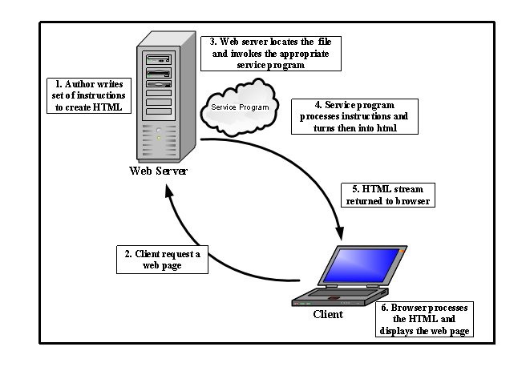

*Figure 2.1 HR S. Olutora personnel management cycle (2011)*

**2.2.2 ASP.NET**

ASP.NET is a server-side technology for creating dynamic web pages and interactive web applications. It uses any full-fledged programming languages supported by .NET such as C#, VB.NET and Java. VB.NET is the programming language used for the implementation of this application.

ASP.NET is a library of classes designed to handle HTTP requests. In addition to a class library, it also includes several IIS components for managing requests such as the ISAPI DLL named aspnet_isapi.dll and a worker process named aspnet_wp.exe.

An ASP.NET page is an HTML page that contains server-side scripts that are processed by a web server before being sent to the user’s browser. It relies on a module attached to the web server. The ASP.NET module is aspnet_isapi.dll. ASP.NET installs new mappings in IIS, redirecting file requests for aspx, ascx and so on to aspnet_isapi.dll. From there, aspnet_isapi.dll directs the request to the aspnet_wp.exe.

ASP.NET runs as a process of its own, aspnet_wp.exe, unlike classic ASP which runs in the same memory space as the IIS. It simply uses IIS to receive requests and then to send out the responses. Therefore, the ASP.NET process can be created or destroyed without affecting IIS at all. This worker process manages the ASP.NET pipeline, the route through which requests flow within ASP.NET

**2.2.3 MySQL**

MySQL is a software package that enables the creation, maintenance and management of database. MySQL is a Structured Query Language (SQL) based, client/server relational database. Each of these terms describes a fundamental part of the architecture of MySQL Server.

**Database**: A database is a storage place for data. The user runs an application that accesses data from the database and presents it to the user in an understandable format.

**Relational Database:** There are different ways to organize data in a database but relational databases are one of the most effective. Relational database systems are an application of mathematical set theory to the problem of effectively organizing data. In a relational database, data is collected into tables (called relations in relational theory).

**Structured Query Language (SQL):** There are several different languages that can be used to manipulate relational databases. The most common of the languages is SQL. The American National Standards Institute (ANSI) and the International Standards Organization (ISO) have defined standards for SQL. Data within a database can be retrieved via SQL that is based on Relational Algebra.

**Client/Server**: In a client/server system, the server is a relatively large computer in a central location that manages a resource used by many people. When individuals need to use the resource, they connect over the network from their computers, clients, to the server.

**MySQL’s** specific design goals were speed, robustness and ease of use. To improve the performance, MySQL was made as a multithreaded database engine. A multithreaded application performs many tasks at the same time as if multiple instances of that application were running simultaneously. Multithreaded applications have a lower overhead cost, when compared with multi processed databases.

In being multithreaded, MySQL has many advantages. A separate thread handles each incoming connection with an extra thread that is always running to manage the connections. Multiple clients can perform read operations simultaneously, but while writing, only the clients that need access to the data being updated are held. Even though the threads share the same process space, they execute individually. Because of this separation, multiprocessor machines can spread the thread across many CPUs as long as the host operating system supports multiple CPUs. Multithreading is the key feature to support MySQL’s performance design goals and this is the core feature around which MySQL is built. MySQL has other features but the most attracting features are cost and performance.

**2.3 EMPIRICAL STUDIES**

**2.3.1 Management Information System (MIS):**

The field of management information System (MIS) addresses the effective use of human and computer resources to realize important business objectives. MIS Professionals are responsible for developing information to all levels of decision - making in a business organization. (Adamu 2001). Lucey (2011) defines management information system as the combination of human and computer based resources that result in the collection, storage, retrieval, communication and use of data for the purpose of efficient management of operations and for business planning.

Modum (2011) Says "MIS has always existed from the time there were managers requiring information that enable them to plan, control and run the operation of their organization. What is new are the added new advantages and dimensions that the computer has provided to the manager in the exercise of his traditional function".

Information Management System involves collection and storage of accurate information to enable the managements of large institutions takes effective decisions at short notice on the future of the institutions. This kind of computerized system makes it possible to know of any given time where the money is going and how the institution is faring or changing for better (Modum 2011). On his on part Q'Leary (2011) states that management information system is a feature of all large organization nowadays.

Kanter and Davis in Bhatnagar and Ramani (2011) state, "Management Information System (MIS) is an integrated man-machine system that provides information to support the planning and control function of managers in an organization".

Nwaocha (2001) says "Management Information System (MIS) is a special kind of information system that helps managers to take decisions. It is tailored to provide special information to individual manager for long term and strategic decision making".

This information can relate to internal and external intelligence and it can assist with planning, staffing, organizing, directing and controlling (Adamu 2001). The use of MIS helps to produce the information that organizations need to improve decision making, problem solving, controlling operations and creating new products or services (Nwaocha 2001). On the complexness of MIS, Modum, (2011) says, "MIS is a complex system, its formulation usually takes time and money and demands a great deal of detailed and meticulous preparation if it is going to be an effective support instrument for company management decision". The overall purpose of management information system is to provide the right information to the right managers or decision makers at the right time (Adamu 2001).

In support of Adamu's assertion, Nkuma-Udah(2001) says, "In information management, it is important to note that the value of information is variable. Some information are always valuable, such as investment account balance; other information has a defined period of time when it is valuable, such as plane departure and arrival information; and still other information (data) has value only periodically such as business intelligence. Nevertheless, all information has a life cycle during which it is identified, captured, organized, controlled, utilized, and eventually archived or stored".

**Database:**

When an organization has a centrally controlled integrated collection of logically structured data, the organization is said to have a database (Modum, 2011). In supporting Modum's view, Clifton (2011) defines database as a collection of data supporting the operation of an organization.

Dean (2011) says, "Database is a generalized integrated collection of data which is structured on natural data relationship so that it provides all necessary access paths to each unit of data in order to fulfill the differing needs of all users". Lucey (2011) defines database as a file of data structured in such a way that it may serve a number of applications without its structure being dictated by any one ofthose applications. The concept is that programs are written around the database rather than files being structured to meet the need of particular program. Meet and

Fairthere (2011) emphasized that in a database all the data is defined together rather than each file being defined separately. Bhatnagar and Ramani (2011) say, "A collection of data files constitute a database and can be defined as an organized collection of operational data used by the application system in an organization". Modum (2011) Says "Data bank or database is therefore a collection of structured data with minimum duplication that are constructed and stored to enable the retrieval of information used in common by the various subsystems of the organization".

O' Leary and Leary (2011) list the following: sharing information, security, fewer files, and data integrity as advantages datable has over the traditional file processing method.

Modum (2011) gave the advantages of an electronic database as;

• It provides for mass storage of all the organization relevant data in a structured manner in such a way as to eliminate redundancy. It equally makes access to the data easy by providing prompt response to user request.

• It allows multiple users to access the database at a time and at the same time protects the data from physical harm and unauthorized access.

Vossen (2011) collaborates this assertion by enumerating the problems that result from the use of the file system to organize data as;

• High redundancy between files; this is a result from the fact that the information are replicated in different places, and these replications are not controlled by a central monitor.

• Inconsistencies might result from the possibilities that a program makeschanges on the file without these changes being made at the same time by all other programs that use the file.

• There exists inflexibility against changes in the application if actions or events arise in the course of time. These can be realized at a substantial expense of time.

• The work of many programmers involved is characterized by low productivity since program maintenance is expensive if the structure of an existing file has to be modified during its lifetime, and then all applications program have to be modified during its lifetimes correspondingly. The problem of adopting and maintaining standards (with respect to coding, data formats, etc), which is important for exchanging data or for migration to a new operating system.

Bhatnagar and Ramani (2011) says "A database is defined by describing the characteristics of the data items in each file. A data item (field) is characterized by its name, type and width". And Modum (2011) concluded by saying that "Database can grow and change and is built up stage by stage depending on the type and nature of activities performed within the organization"

Therefore, database is a collection of structural data with the structured data being independent of any particular application.

**2.1 Database Management System (DBMS):**

Database management system (DBMS) is a complex software system which constructs, expands and maintains the database. It also provides a link or interface between the user and the data in the database (Lucey 2011).

Bhatnagar and Ramani (2011) say "Data Base Management System (DBMS) overcomes most of a convention system. Data redundancy and data inconsistency are minimized by maintaining an integrated database and providing access to all the application programs, depending on their requirements". Modum (2011) defines Data Base Management System as "A collection of programs that enable you to store, modify and extract information from a database".

Just like a human being manages, controls, and supervises the manual organizational records and files stored in the file cabinets so do we have a manager or a supervisor that manages the electronic database. But in contrast to the manual system where a human being does all the functions, in the computer based system, the management is achieved through a complex software system which construct, expands and maintains the database. It is this complex software which is called Database management System (DBMS) (Modum 2011).

According to Bhatnagar and Ramani (2011), “DBMS sometimes just called a database manager is a program that lets one or more computer users create and access data in a database".

Nwaocha (2011; 2) says, "A Database Management System (DBMS) can be defined as a set of software programs that controls the organization, storage, management, and retrieval of data in a database".

However, DBMS are categorized according to their data structures and types. The most typical DBMS are relational, hierarchical and object-oriented database management systems (RDBMS).

**Data processing systems (DPS):**

Stair (2011) States, "Data processing involves converting facts into useful information. It is also the gathering and processing, storing and retrieval of data to yield output which is information. These processing activities include solving, updating, merging, calculating, rearranging and deleting to arrive at a desirable output, therefore information is processed data".

Adamu (2001) Says "Information is a data that has been processed and presented in a useful format that will enable an individual to gain knowledge in order to be able to make a decision".

He opined that the act of producing data does not itself produce information. Information is data that have been interpreted and understood by the recipient of the message. Adams (2011) Says "Information is power just as much as wealth is, therefore, the need to store it and be able to retrieve it becomes essential. For information to be transmitted the following elements are important bit, characters, field, records and record structures".

Lucey (2011) noted that any change in the data they process or function, they perform usually requires the intervention of information system specialist such assystem analysts and programmers. Some data processing systems have to cope with huge volumes and a wide range of data types and output formats. Transaction processing is necessary to ensure that day-to-day activities of the Organization are processed, recorded and acted upon.

Files are maintained which provided the current data for transactions and which also serve as a basis for operational and tactical control and for answering inquiries (Modum 201; 10). .

Clifton (2011) Says "Transaction processing can be subdivided into current activity processing, report processing, and inquiry processing". While Nwaocha (2001) Says, "Transaction processing System (TPS) is an information system that supports business in the delivery of various business transactions. TPS transforms large number of inputs to output using simple processing logic and operation".

**2.4 SUMMARY OF LITERATURE REVIEW:**

Personnel Management (PM) is all about effective utilization of human resources (employees) in an organization so that the objectives of the organization are achieved. These objectives can only be achieved when there is adequate information system concerning the resources. According to Sander (2111), information system is a group of integrated elements: people, procedures, and equipment working together to support decision-making and operations within an organization. However, this information system has to be managed. According to Modum (2011), Management Information System (MIS) has always existed from the time there were managers requiring information that enable them to plan, control and run the operations of their organization by the use of computers. This computerized system that involves collection and storage of accurate information makes it possible to know at any given time where money is going and how the institution is faring or changing for better.

The overall purpose of Management Information System (MIS) is to provide the right information at the right time (Adamu 2001). Therefore, there is need for an organization to have a centrally integrated collection of logically structured data called Database (Modum 2011). Whereas, Database Management System (DBMS) is a complex software system which constructs, expands and maintains the database. It also provides a link or interface between the user and the data in the database (Lucey 2011).

In organization, data are constantly emanating from various departments. These data have to be processed to yield information which managers require. According to Stair (2011), Data Processing involves converting facts into useful information. It is also the gathering and processing, storing and retrieval of data to yield output called information. These processing activities include solving, updating, merging, calculating, rearranging and deleting to arrive at a desirable output called information.

**REFERENCES**

Adamu E. (2001). “Micro Computer For Management Design Making”. Published by Prentice Hall, Englewood Cliffs N.J 07632 4th Edition.

Adamii D. (2001). “Human Resources Management”. United Kingdom, Macdonald and Evans Ltd.

AtuenyiG. (2011). “Element of Personnel Management”. In Business Management Topics, E.U.L. Imaga and U.J.F. Ewurum (eds). Enugu, Okeke Publishers.

Bhatnagar and Ramani (2011). “What is Personnel Management?” wise GEEK Conjecture Corporation.

Boddy et al (2001). “Programmers Guide, Microsoft Visual basic Programming System for Windows Version 3.0”. Microsoft press.

Brech F.(2012). “Information System For Management” Eagle Wood Cliffs, New Jersy.

Davies R. (2002). “Software Reliability, Principles and Practices”. John Wilky and Ons.

Eze A. (2010). “Advanced Information Storage and Retrieval”. National Open Uniersity of Nigeria. Lagos, 14/16 Ahmadu Bello Way Victoria Island.

Flippo V.(2011).“Peter Norton Windows 3.0 Power Programming”. Techniques business Books.as

Gullet T. (2012). “Computing Essential, Annual Edition”, 1996-1997”. McGraw Hall Companies Inc.

Harbison A. (2011). “Student Guide to Information Technology”. B/N Newners Publishers 2nd Edition. London, Lianasre House Hill Oxford

Hicks and Gullet (2011). “An Introduction to Computer Information Science”. The Scare Crow Press Inc. Metuchen, New Jersey.

IkeagwuV. (2011). “Computers and Information Management, A Primer ForPractingManahers”. New Delhi, Prentice Hall of India Private Ltd.

Kroenke J. (2012). “A Guide to Structure programming”. Tula, McGram Hill Publishing Company 30th Edition.

Malcolm Tatum (2011). “Public Personnel Administration”. New York, Harper and Row Publishers.

Modum L. (2011). “Fundamentals of Computer in Business. A System Approach”. 2nd Edition.

NwaochaK. (2001). “Management Information Systems, Analysis and Design”. Enugu, Fourth Dimension Publishing Co. Ltd.

Nkuma-Udah (2001). “Software Engineering Methodologies”. National Open University of Nigeria. Lagos, 14/16 Ahmadu Bello Way Victoria Island

O'Brien H. (2011).“Advanced System Analysis and Design”. National Open University Nigeria. Lagos, 14/16 Ahmadu Bello Way victoria Island.

Q'LearyH. (2011). “Data Models, Database Language and Datebase Management Systems”. Addison Wesley Publishing Company

Ramani D. (2011). Alternative Employment Structure in Information Systems: A Conceptual Analysis. In Proceedings of the 1995 ACM SIGCPR conference on Supporting teams, groups, and learning inside and outside the IS function reinventing IS, Nashville, United States, April 1995. ACM Press New York, NY, 181 - 193

Ratzan, B. (2001).A cure for contingent costs: companies that already use the Web as a tool for product buying are now using it to manage contract workers, Workforce Management .

Reynold N. (2011). Security models for web-based applications, Communications of the ACM. Volume 44 Issue 2. ACM Press New York, NY, 38 – 44.

Sander A. (2012). The ASP Column: ATL Server Versus ASP.NET, The Microsoft Journal for Developers, MSDN Magazine

Stair D. (2011). Computer Software Engineers, Occupational Outlook Handbook, 2006-07 Edition

Vossen F. (2011). An adapted excerpt from the U.S. Department of Labor report Futurework: Trends and challenges for work in the 21st century, Occupational Outlook Quarterly Online

Web finance (2011). Edition. Computer Systems Design and Related Services, Career Guide to Industries (CGI).

**CHAPTER THREE**

**RESEARCH METHODOLOGY**

**3.0 Introduction**

This chapter discussed the research procedures namely: Choice of methodology, requirement gathering, functional requirements, analysis, design, and choice of methodology.

**3.1 Choice of Methodology**

Various methods and techniques used to present the research beautifully is called research methodology. The procedures enhance the research process and it exposes the way research is carried out. It helps to explain the methods used in research and presents the idea to the audience in an elegant manner that depends mainly on the researcher. Various methods are used in the research to explain ideas in any project work. However, the selection of the method purely depends on the researcher if the type adheres to his preferred requirements. A researcher has to be satisfied with the methods in his topic.

Research methods are classified based on different criteria. There are:

* General category
* Nature of the study
* The purpose of the study
* Research design.

Also, there are interviews and case studies based on research methodology. In some researches, more than two methods are combined while in some, very few methods are taken into account for the study.

**3.1.1 Based on General Category**

* Quantitative Research

As the name suggests, quantitative refers to the numbers where data is collected based on numbers, and a summary is taken from these numbers. Graphs help to quantify the results in quantitative research.

* Qualitative Research

Qualitative refers to the non- numerical elements in the research. When the information or data cannot be grasped in terms of numbers, qualitative research comes for the rescue. Though not reliable as much as quantitative, qualitative research helps to form a better summary in terms of theories in the data.

**3.1.2 Based on the nature of the research**

* Descriptive Research

Facts are considered in descriptive methods and surveys and case studies are done to clarify the facts. These help to determine and explain with examples, the facts, and they are not rejected. Many variables can be used in descriptive research to explain the facts.

* Analytical Research

Analytical research uses the facts that have been confirmed already to form the basis for the research and critical evaluation of the material is carried out in this method. Analytical methods make use of quantitative methods as well.

**3.1.3 Based on the purpose of the study**

* Applied Research

Applied research is action research where only one domain is considered and mostly the facts are generalized. Variables are considered constant and forecasting is done so that the methods can be found out easily in applied research. The technical language is used in the research and the summary is based on technical facts.

* Fundamental Research

Fundamental research is the basic or pure research done to find out an element or a theory that has never been in the world yet. Several domains are connected and the aim is to find out how traditional things can be changed or something new can be developed. The summary is purely in common language and logical findings are applied in the research.

**3.1.4 Based on research design,**

* Exploratory Research

Exploratory studies are based on the theories and their explanation and it does not provide any conclusion for the research topic. The structure is not proper and the methods offer a flexible and investigative approach for the study. The hypothesis is not tested and the result will not be of much help to the outside world. The findings will be topic related that helps in improving the research more.

* Conclusive Research

Conclusive Research aims at providing an answer to the research topic and has a proper design in the methodology. A well-designed structure helps in formulating and solving the hypotheses and give the results. The results will be generic and help the outside world. Researchers will have an inner pleasure to solve the problems and to help society in general.

* Surveys

Not least considered, but Surveys play a main role in the research methodology. It helps to collect a vast amount of real-time data and helps in the research process. It is done at a low cost and can be done faster than any other method. Surveys can be done in both quantitative and qualitative methods. Always, quantitative surveys must be considered above qualitative surveys as they provide numerical outputs and the data is real. Surveys are mainly used in the business to know the demand for a product in the market and to forecast the production based on the results from the survey.

* Case Studies

Case studies are another method of research methodology where different cases are considered and the proper one for the research is selected. Case studies help to form an idea of the research and helps in the foundation of the research. Various facts and theories can be considered from the case studies that help to form proper reviews about the research topic. Researchers can either make the topic general or specific according to the literature reviews from the studies. A proper understanding of the research can be made from the case study.

Also, we have focus groups and research interviews to understand the research methods in a well-defined manner. Structured and unstructured methods can be followed by various methods.

Research methodology is the specific procedures or techniques used to identify select, process and analyze information about a topic. The methodology section allows the reader to critically evaluate study’s overall validity and reliability. There are diverse forms of methodology, but I (The researcher) chose the waterfall model.

The waterfall model is a breakdown of project activities into linear sequential phases, where each phase depends on the derivable of the previous one and corresponds to a specialization of tasks. The approach is typical for certain areas of design.

The main aim of the research methodology is to allow departmental control; each phase must be completed fully before the next phase can begin. It is used when there are no uncertain requirements.

**3.2 Waterfall Model**

The Waterfall Model was the first Process Model to be introduced. It is also referred to as a linear-sequential life cycle model. It is very simple to understand and use. In a waterfall model, each phase must be completed before the next phase can begin and there is no overlapping in the phases.

The Waterfall model is the earliest SDLC approach that was used for software development.

The waterfall Model illustrates the software development process in a linear sequential flow. This means that any phase in the development process begins only if the previous phase is complete. In this waterfall model, the phases do not overlap.

Waterfall approach was first SDLC Model to be used widely in Software Engineering to ensure success of the project. In "The Waterfall" approach, the whole process of software development is divided into separate phases. In this Waterfall model, typically, the outcome of one phase acts as the input for the next phase sequentially.

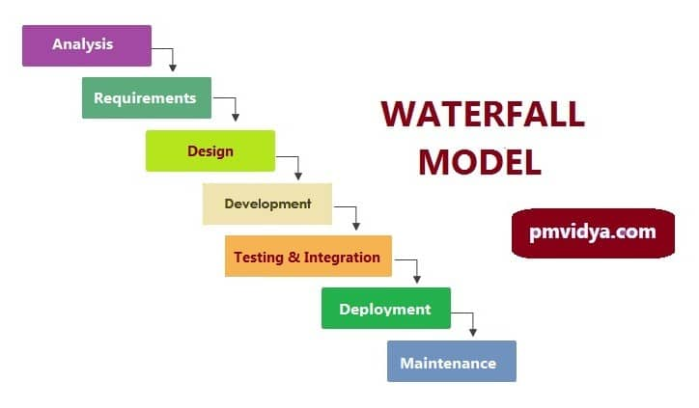

*Figure 3.1: water fall model. Source: pmvidya.com*

* **Analysis phase**

This is the basic, initial phase is the inception of an idea for a solution that improves an existing solution or develops an entirely new one. It helps define the magnitude of the project to plan resources. The surveyor thus, thought of the idea of developing a personnel management system.

* **Requirement/Planning Phase**

In this phase, requirements are gathered to formulate a design plan for the software application solution. This phase entails a thorough analysis to assess user needs, feasibility, development, improvements, and more. It is very important to include documentation to refine requirements and keep a record of the solution’s development. This phase involves the creation of the personnel management system which defines technical and functional requirements.

The aim of this phase is to understand the exact requirements of the customer and to document them properly. Both the customer and the software developer work together so as to document all the functions, performance, and interfacing requirement of the software. It describes the "what" of the system to be produced and not "how." In this phase, a large document called Software Requirement Specification (SRS) document is created which contained a detailed description of what the system will do in the common language.

* **Design Phase**

This phase is focused on the design aspect of personnel management system application solution in terms of the selected technical and functional requirements and the results of the thorough analysis of the software’s viability. The requirement specifications from first phase are studied in this phase and the system design is prepared. This system design helps in specifying hardware and system requirements and helps in defining the overall system architecture.

This phase aims to transform the requirements gathered in the SRS into a suitable form which permits further coding in a programming language. It defines the overall software architecture together with high level and detailed design. All this work is documented as a Software Design Document (SDD).

* **Development Phase**

This phase is the “meat” of the software development process. In this phase, the researcher solely focused on building a prototype of the solution to perform a code review and ultimately create the solution itself. The researcher works on transforming software specifications into a working and reliable solution. During this phase, design is implemented. If the SDD is complete, the implementation or coding phase proceeds smoothly, because all the information needed by software developers is contained in the SDD. During testing, the code is thoroughly examined and modified. Small modules are tested in isolation initially. After that these modules are tested by writing some overhead code to check the interaction between these modules and the flow of intermediate output.

* **Testing Phase**

This crucial phase tests the software to ensure that everything works as it intended. In the testing phase, the researcher will be able to detect defects, bugs, and errors in the software solution and ultimately have a quality product that meets business expectations. Quality Assurance (QA) specialists perform a series of tests to evaluate the status of the solution. This phase is highly crucial as the quality of the end product is determined by the effectiveness of the testing carried out. The better output will lead to satisfied customers, lower maintenance costs, and accurate results. Unit testing determines the efficiency of individual modules. However, in this phase, the modules are tested for their interactions with each other and with the system. The testing team tests the complete application and identifies any defects in the application. These defects are fixed by the developers and the testing team tests the fixes to ensure that the defect is fixed.They also perform regression testing of the application to see if any new defects were introduced.

Testers with banking domain knowledge were also hired for the project so that they could test the application based on the domain perspective.Security testing teams were assigned to test the security of the banking application.

* **Release Phase**

Once the personnel management system is fully developed and tested, it moves to the release phase. In this phase, the personnel management system goes live and is released to the end user for actual use of the product. In essence, the software is fully operational in a live environment where end users utilize it. Once the functional and non-functional testing is done; the product is deployed in the customer environment or released into the market.

The team builds and installs the application on the servers which were procured for the banking application.Some of the high-level activities include installing the OS on the servers, installing security patches, hardening the servers, installing web servers and application servers, installing the database etc.

* **Maintenance Phase**

This post-release phase is tasked with keeping the developed personnel management system software completely operational, updating it to meet quality standards, and enhancing it throughout its life to ensure it continues to attract and retain users. During the maintenance phase, the team ensures that the application is running smoothly on the servers without any downtime.

Issues that are reported after going live are fixed by the team and tested by the testing team. The customer is regularly using the product during the maintenance phase, discovering bugs, inadequate features and other errors that occurred during production. The production team applies these fixes as necessary until the customer is satisfied.

**3.3 Requirements Gathering**

The researcher visited the Nigerian bureau of statistics to gather information for data analysis, the information was gathered using direct observation and interviews so as to gather information to enable the researcher create the software on personnel management system. Thus, for this project, the following requirements and specifications were obtained using interview and observation technique.

**i. Cloud-based**

Most personnel management systems are cloud-based. The software is hosted by the vendor, and corporate access to the application and data is available through a web browser or mobile device. Alternatively, vendors offer these personnel software that's installed and managed on premises within the enterprise, typically by IT. Both options have advantages, but cloud-based is the preferred model.

**ii. Core management system**

A key component of personnel management software which is the core management module, is to stores information about employees and is often the hub for functionality that's applicable to the whole management system, such as security and reporting. When evaluating the core management functionality, validate the following points:

* one centralized database rather than multiple databases, which can happen when the software is built through acquisitions;
* all the necessary employee information can be entered, such as employee name, address, emergency contacts, salary, job and department;
* ability to create custom fields to track information specific to the organization;
* role-based security, which simplifies the assignment of access rights to employees;
* future-dated and back-dated changes are entered;
* system is configured to meet all government compliance requirements and the required data extracted; and
* non-employee data, such as contractor information, can be entered.

**iii. Time and attendance**

personnel management software typically provides features to track absences and capture working hours on a timesheet. Ensure that the system can accommodate corporate policies and practices. Validate that the system can do the following:

* provide the ability to configure all the absence types used by the company;
* define which absence types apply to which employee populations;
* produce schedules and timesheets that display and capture required information;
* make timekeeping simple for employees using a mobile device or browser;
* provide exception reporting to highlight missed shifts, missed clock-outs and overtime;
* specify statutory holidays by country and region and configure eligibility requirements; and
* provide approval workflows and reminders for absence requests and completed timesheets.

**iv. Recruiting**

Often referred to as an applicant tracking system, the recruiting module covers the lifecycle of finding and hiring new employees. Most personnel management systems require this functionality, though it's not always as advanced as the systems from vendors who specialize in this area. Key HR software features to consider include the following:

* job library that contains a job description and key information about the job, such as salary, job family, job level and salary range;
* configurable requisition and offer-approval workflow;
* easy process to post open positions to multiple sites and job boards;
* reports, tags and custom groups to track candidates;
* support for multiple offer templates to meet the unique needs of the company;
* support for the entire offer process, including sending offers, candidate signature and returning a signed offer electronically;
* support for advanced digital signatures like those offered through DocuSign;
* ability to add attachments to offers; and
* easy-to-send regular communications to passive candidates.

**v. Onboarding**

An onboarding module can enhance the onboarding process for new hires and provide a positive first impression. At a minimum, new hires use the onboarding module to complete forms and review policies. Consider the following features when developing a personnel management system requirements checklist:

* simple process to move new hires from recruiting to onboarding and avoid rekeying data;
* customized landing page that includes adding company information, videos and organizational charts;
* employees able to complete and sign forms and policies;
* before their first day, new hires able to access and complete all the necessary paperwork; and
* task lists for everyone involved in the onboarding process.

**vi. Performance management**

Many vendors have added features to support informal feedback options, while continuing to provide functionality for a traditional performance review management process. Regardless of the performance management approach, consider the following points when evaluating management software features:

* configurable form to capture required data from employees and managers;
* configurable workflows so the process and approvals align with the company's process;
* concurrent filling of forms, which reduces the amount of ping-ponging required to complete the review process;
* reports and dashboards to track progress and analyze results;
* 360-degree feedback; and
* integration with compensation and succession.

**vii. Employee benefits**

Incorporating a feature that captures employee benefits information can save significant time during the onboarding process and open enrollment. Based on company requirements, confirm that these capabilities can do the following:

* configure multiple plan options;
* upload data to insurance providers rather than rekeying the data;
* when applicable, allow employees to choose their coverage based on the options presented and provide costing; and
* push data to payroll to avoid rekeying data.

**viii. Reporting and dashboards**

While reviewing these personnel management software features, you need to allocate sufficient time for reporting and dashboards. Too often, those capabilities are left until the end of a demo. Consider the following:

* enough standard reports available to meet most needs;
* dashboards that include charts and graphs to provide actionable insights;
* ability to create custom reports and dashboards without too much complexity;
* scheduling reports and dashboards emailed to specific employees on a regular basis; and
* restricted access to data using role-based permissions.

**ix. Learning and development**

Incorporating an LMS and learning experience platform (LXP) can streamline the administrative tasks of scheduling and running courses, provide online courses and reinforce a corporate learning culture. Consider the following features when exploring an LMS and LXP:

* support for online and instructor-led training;
* ability to combine courses, articles and videos into a curriculum;
* integration with third parties that license online courses;
* detailed reporting and dashboards; and
* auto-assign courses based on predefined rules.

**x. Self-service portals**

A significant benefit of using personnel management software is the ability to securely share information with employees and managers. Consider the following self-service features:

* employee self-service that allows employees to view and update personal information;
* manager self-service to view and update direct report information;
* role-based permissions to control access to sensitive data; and
* approval process that ensures all employee- and manager-initiated changes are acceptable.

**xi. Integration options**

The ability to integrate the HR system with other software used within the enterprise can be very valuable. IT systems, for example, might benefit from knowing about new hires and terminations. These two options are typically available:

* custom integrations, which allow data to be pulled programmatically from the HR software; and
* partner integrations, which offer prebuilt integration with specific third-party applications.

**xii. Data management**

Data can be edited and audited with HR software's built-in tools. The following HR software features may be available:

* data import when multiple changes are required at once;
* quick entry to list multiple employees and a subset of fields requiring an update; and
* error checking to ensure data is cleanly entered and valid.

**xiii. Payroll**

The data between HR and the payroll department is closely tied and warrants consideration, regardless of whether payroll reports to HR or finance. Many HR systems offer a payroll module in addition to prebuilt integrations with the major payroll providers. Consider the following payroll features:

* tight integration with core HR to avoid rekeying data;
* support for multiple currencies;
* enough payroll codes to meet current and future needs;
* employee access to pay statements and other tax-related forms;
* integration with the time and attendance module and benefits module;
* simple data validation tools to ensure data is correct before being submitted; and
* payroll comparison to highlight significant changes from one pay cycle to the next.

**xiv. Succession planning**

Adding a succession planning module to a personnel management system can help identify and prepare rising stars within the company for senior roles. But since time and cost are involved to implement and license this module, be sure there's a companywide commitment to succession planning. Consider the following capabilities when evaluating a succession planning feature:

* integration with performance management and core HR;
* easier to use than spreadsheets and emails; and
* ability to incorporate job data, such as job grades, job families and job descriptions.

**xv. Compensation**

Although just a once or twice a year process, compensation planning is critical to get right, and the often-used spreadsheet can be problematic. A compensation module can provide the following benefits:

* eligibility rules to determine which employees will be part of the compensation process;
* budgets that can restrict managers from overspending;
* workflows and approval processes;
* data security and control to protect sensitive data;
* comprehensive reporting to understand who will receive a pay increase and how budgets are being spent; and
* performance management ratings that default to a recommended salary increase.

**3.1.3 Functional requirements**

The functional requirement defined a function of a system or its component, where a function is described as a specification of behaivour between inputs and outputs. Based on the requirements gathered from the interview with some ICT staffs of the national bureau of statistics in Abuja, the functional requirements for a personnel management system include:

**Document Management**

* Automatic Tax Document Generation
* Company Policies and Employee Handbook
* Document Access Control
* Document Repository
* Document Search and Sharing
* Document Updates and Printing

**Applicant Tracking and Recruiting**

* Talent Pool Search
* Recruitment Pipeline
* Automated Job Posting
* Interview Management
* Employee Referral
* Creation of Career Pages
* Career Portal

**Employee Onboarding and Administration**

* Automated Email Notifications
* Background Screening
* Compliance Reporting
* Hiring and Management of Contingent Workers
* Digital Signatures
* Employee Branch Transfer
* Employee Lifecycle Tracking
* Employee Withholding Certificate
* Job Applications Dashboard
* Offer Letter Creation
* Onboarding Checklist
* Web-Based Forms
* Termination Reason

**Performance Management**

* Skills Matrix
* Pre-Built Competency Templates
* Performance Measurement
* Multiple Appraisal Cycle
* Goal Monitoring Dashboard
* Goal Management
* Feedback Reports
* Employee Coaching
* Development Plans
* Competency Management
* Appraisal Reports
* 360 Degree Feedback

**Staff Benefits Management**

* Eligibility Calculation
* Actionable Recommendations
* Assessment Surveys
* Automated Evidence of Insurability
* Benefits Administration
* Benefits Analytics
* Benefits Statements
* Broker Assistance
* Employee Profile Access
* Life Event Management
* Penalty Alerts
* Rule-Based Eligibility

**Compensation Management**

* Automated Rules in Compensation Management
* Automatic Payroll Update
* Budget Allocation
* Compensation Dashboard
* Compensation Grid
* Compensation Packages
* Compensation Planning
* Compensation Plan View
* Compensation Reports
* Compensation Survey Management
* Reward Letters

**Time and Attendance Management**

* Absence Management
* Blackout Dates
* Calendar View
* Expense Management
* Leave Request Analysis Dashboard
* Overtime Tracking and Alerts
* Time-Off Approvals
* Timesheet Reports
* Timesheets Management
* Time-Tracking Methods

**Learning and Professional Development**

* Training Scheduling and Tracking
* Real-Time Alerts
* Learning Plans
* Learning Channel
* Leadership Development
* Course Dashboard
* Course Communities
* Course Catalog
* Course Sharing
* Course Builder
* Automatic Assignment
* Assessments

**Employee Engagement**

* Artificial Intelligence in Survey Analysis
* Employee Comments Analysis
* Heatmap
* Survey Generation and Distribution

**Employee Self Service**

* Benefits Election and Enrollment
* Expense Requests
* Internal Job Submission
* Leave Requests
* Pay Stub Access
* Personal Details

**Payroll Management**

* Advance Salary Processing
* Automated Tax Filing
* Custom Earning Codes
* Lifetime Accounts
* Multiple Payment Options
* Overtime Pay
* Pay Previews
* Payroll Reporting
* Pay Stubs Creation
* Workers’ Compensation

**Succession Management**

* Succession Planning
* Talent Insights Dashboard
* Talent Matrix
* Talent Pool
* Nine Box Grid
* Talent Reviews View

**Reporting and Dashboard**

* AI-Based Dashboard View
* Charts and Visualizations
* Custom Filters
* Custom Reports
* Dashboard Builder
* Pre-Built Dashboard
* Pre-Built Reports
* Report Export
* Report Scheduling

**Workforce Management**

* Budget Planning
* Color-Coded View
* Mobile Scheduling
* Project Tracking
* Task Management
* Workforce Forecasting
* Workforce Modelling
* Workforce Scheduling
* Workforce Scheduling Alerts

The researcher will use HTML, CSS and Java script for the front end, the researcher will also use python, and MySQL database for the back end to achieve the above functionality.

**3.4 Analysis**

The proposed system is a computerized system called computerized personnel management system. It keeps track of personnel data right from the time as application is received from a proposed. Employees (Applicant) once that is done, the applicant is immediately stored in the database. The applicant number is used as a key reference. After an interview is conducted all the successful applicant will be transferred to the employee file and also given a new number called the identification number. The number was meant to be known by the staff concern and personnel affairs division. The system is structured in such a way that once you enter the database number, the number will first of all go to database to check for the existence of such a number, if it is there, the computer will display the messages “RECORD ALREADY EXIST PRESS KEY TO CONTINUE”. Thereby avoiding duplication of the database. They system will ask if there is any error. If “yes” the computer will look back to the beginning of the fields and allows the operator a chance of entering all the records, the system then go out of the input screen to the menu for another option to be chosen. Depending of the nature of work, the needs might rise for some staff to be sent for further studies or training and such staff must be monitored. Such data must be stored in a separate file so as to know who is on further study, date of commencement, completion etc.

**3.4.1 Use Case**

This use case diagram is a graphic depiction of the interactions among the elements of employee management system. It represents the methodology used in system analysis to identify, clarify and organize system requirements of employee management system. The main actors of employee management system in this use case diagram are: Super Admin, System User, Employee, Managers, who perform the different type of use cases such as Manage Login, Manage Employee, Manage Salary, Manage Leaves, Manage Experiences, Manage User ands and full Employee Management System Operations.

The relationships between and among the actors and the use cases of employee management system includes:

* **Super Admin Entity:** use cases of super admin are Manage Employee, Manage Salary, Manage Leaves, Manage Experiences, Manage Login, Manage Users and full Employee Management System Operations.
* **System User Entity:** use cases of super admin are Manage Employee, Manage Salary, Manage Leaves, Manage Experiences, Manage Login.
* **Employee Entity:** use cases of employee are Apply Leaves, Check Salary, Check attendance.
* **Managers Entity:** use cases of managers are check leaves, approve leaves, check timesheet, approve timesheet.

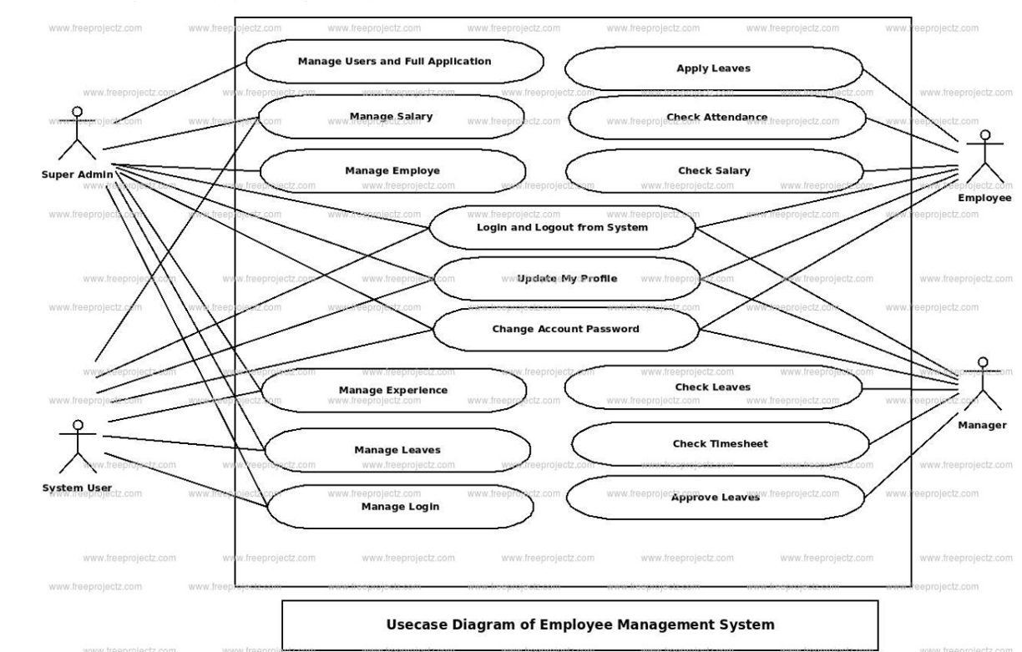

*Figure 3.2 use case diagram of employee management system*

**ii. Entity relationship diagram (ERD)**

The ER (Entity Relationship) diagram represents the model of employee management system entity. The entity relationship diagram of employee management system shows al the visual instrument of database tables and the relations between salary, employee, experience, attendance etc. it use structure data to define the relationships between structured data groups of employee management system of functionalities. ERD is simply the diagram or model that is used to represent or show the relationship between the entities or data objects that are stored in a database.

**Employee Entity:** attributes of employee are employee_id, employee_name, employee_mobile, employee_email, employee_username, employee_password, employee_address.

**Salary Entity:** attributes of salary are salary_id, salary_employee_id, salary_amount, salary_total, salary_type, salary_description.

**Leaves Entity:** attributes of leaves are leaves_id, leaves_employee_id, leaves_type, leaves_status, leaves_to, leaves_from, leaves_description.

**Experience Entity:** attributes of experiences are experience_id, experience_employee_id, experience_year, experience_type, experience_description.

**Login Entity:** attributes of login are login_id, login_user, login_role_id, login_username, login_password, login_lastlogin.

**Attendance Entity:** attributes of attendance are attendance_id, attendance_employee_id, attendance_students_id, attendance_type, attendance_description.

The entity relationship model (ERM) for this study is represented as;

= **Relationship**

= **Entity**

The relationship for the study is personnel management while the entity is Design and implementation. Thus, an ERD represents the conceptual structure of a problem domain being modeled. ERDs are widely used in database design and systems analysis to capture requirements of a system or a problem domain. In particular, when used for data modeling, the ERD assists the database designer in identifying both the data and the rules that are represented and used in a database. ERDs are readily translated into relational database schemas.

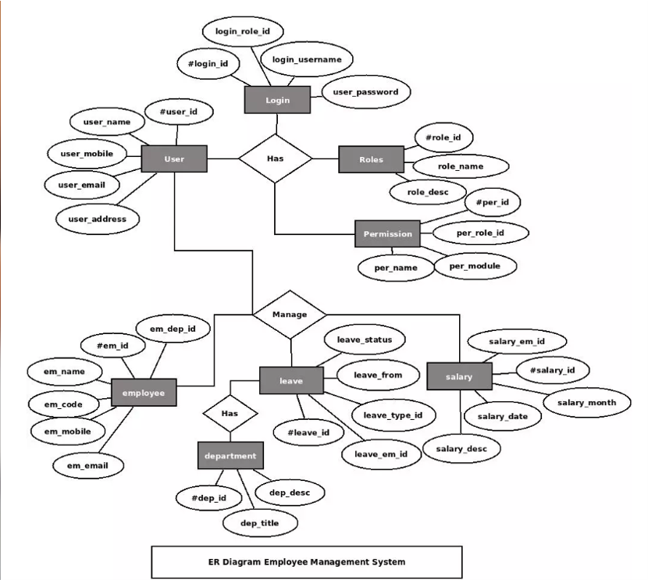

*Figure 3.3 Data flow of Personnel Management System*

**iii. Data flow diagram**

The data flow diagram or (DFD) for Employee Management System is one of diagrams used to trace down the flow of information within the system. It carries out one of the preparatory steps when developing the employee management system in form of DFD level 0, 1 and 2. Each of these levels elaborates the flow of data that enters and exits the project.

The Data Flow Diagram (DFD) represents the flow of data and its transformation within employee system. The input, processing, and output are used to represent and define the overall flow of the system. You will find out how the system react with the user and handles data that the system receives using DFD diagram.

Here’s the DFD for Employee Management System which elaborates the flow of data through data flow diagram level 0, 1 and 2. It has the complete explanation of data flow diagram details.

**Level 0 DFD for Employee Management System**

The Level 0 DFD for Employee Management System (known as context diagram) represents the abstract view of the project. Itposses the single process and external parties that depicts the overall structure as a whole. This level shows the main process with incoming/outgoing indicators showing input and output data.

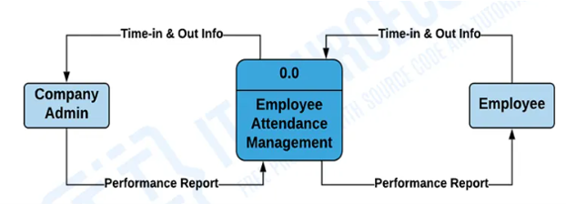

*Figure 3.4 Data flow diagram level 0 Personnel management system*

**Level 1 DFD for Employee Management System**

The Level 1 DFD for Employee Management System provides a broader overview of the context diagram. It widens the processes from the context diagram and determines the sub processes that complete the employee management system. A level 1 DFD can be thought of as a “detonated view” of the context diagram. The Employee Management System DFD Level 1 requires information such as record of employees, time-in and out, leave and performance reports. These information serves as the basis for the company admin to manage their employees. These records are used in processes and were stored in the data store that you will see in the next level.

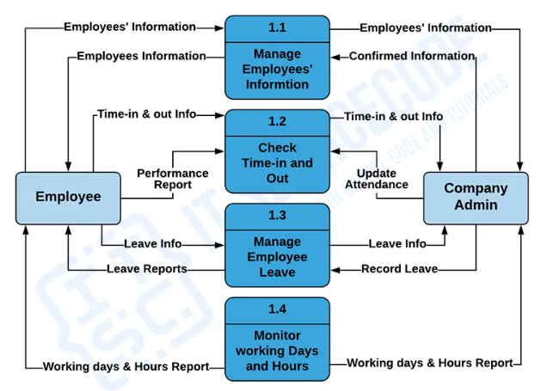

*Data flow diagram level 1 Personnel management system*

**DFD Level 2 for Employee Management System**

The DFD level 2 for Employee Management System tells the ideas on where does the data inputs goes and inputs comes within the project. It shows not only the detailed processes of system, but also gives you precise destination of the data that flows in it. This suppose that DFD Level 2 is the highest abstraction of employee system data flow diagram.

Considered as the highest abstraction, DFD level 2 gives the wider knowledge of Employee System data flow. It reveals the sub-task and databases involved in the project. This level is more informative than the other levels.

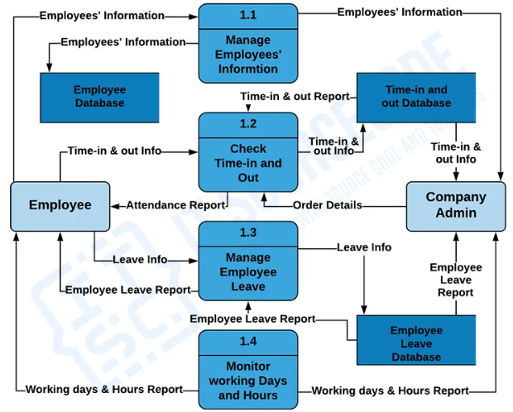

*Figure 3.6 Data flow diagram level 2 Personnel management system*

**i. Story board**

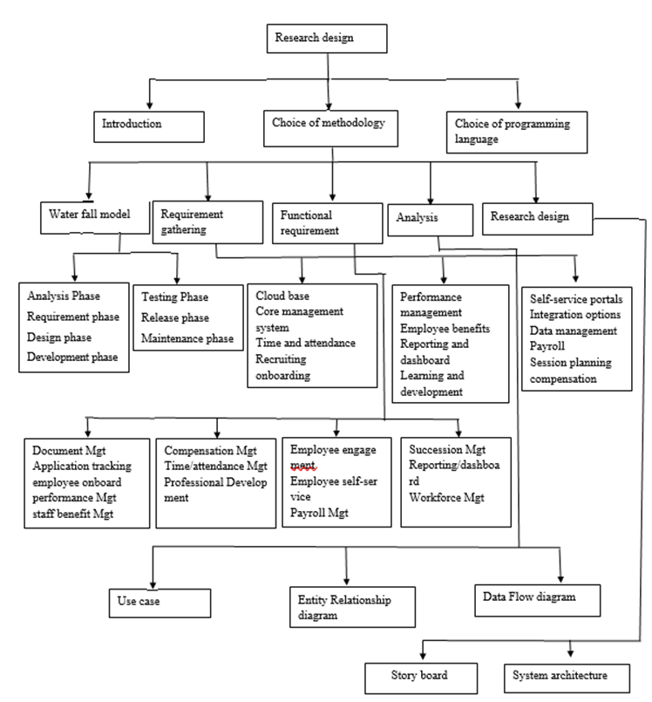

*Figure 3.7 story boarding of a personnel management system*

**ii. System architecture**

All details in the data base of the personnel management system will be backed up in the cloud. To be successful, a cloud service provider has to target a preferably large customer group to leverage economies of scale. Therefore, an application offered as a service in the cloud is often configurable regarding non-functional qualities, such as location or availability. Since many of these qualities depend on the resources on which the service ishosted, a large number of computing environments has to be managed by the service provider.

**3.2 Choice of Programming Language**

Html, CSS and Java Script will be use for the front end to give the Web pages interactive elements that engage a user, the waterfall model method as chose because it is less costly to change scope and requirements, it is easier to test and debug during a smaller iteration, it generates working software quickly and early during the software life cycle. I'll use python and MySQL database for the back end.