1. Step

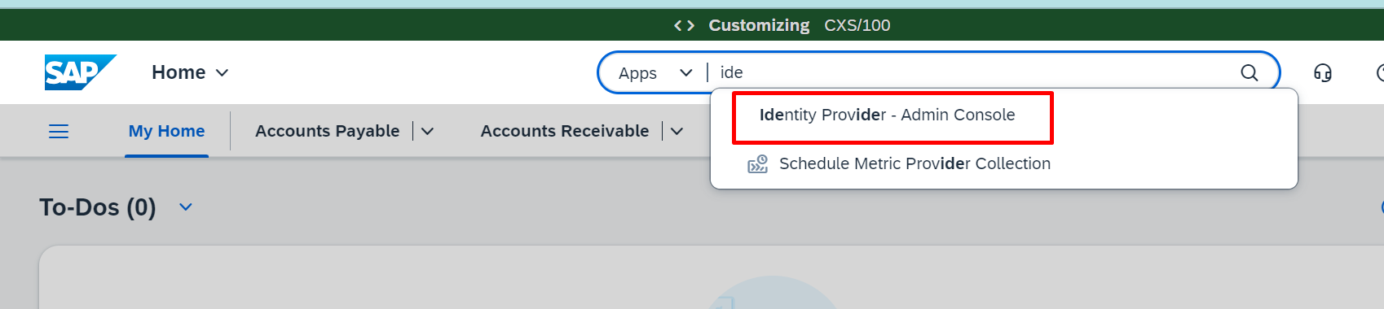

1. Step

Add detail --- create ---- Maintain business role ----Add business role --- Selected All and save --- save

3) Step

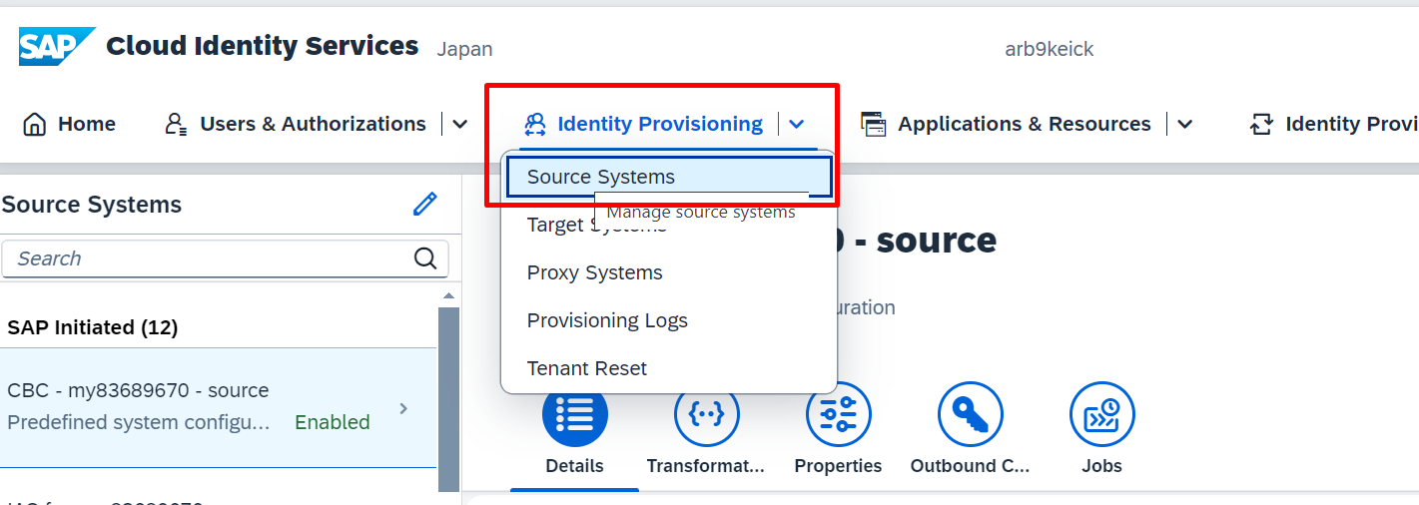

After this search the system ID and Click on job and generated all the the job

Role crestion

**Business Role Templates – selected all the role and**

TR movement ---

