Dushant Kumar

Date Of Interview 28082021 Band II SAP MM

Communication: Good

SAP Knowledge: Poor , cannot be considered for SAP MM Consultant role Not worked on SAP since Feb 2019.

Experience: Experience with Indian Army (Defense)SAP Implementation Project. But no exposure to SAP.

Attitude: Good

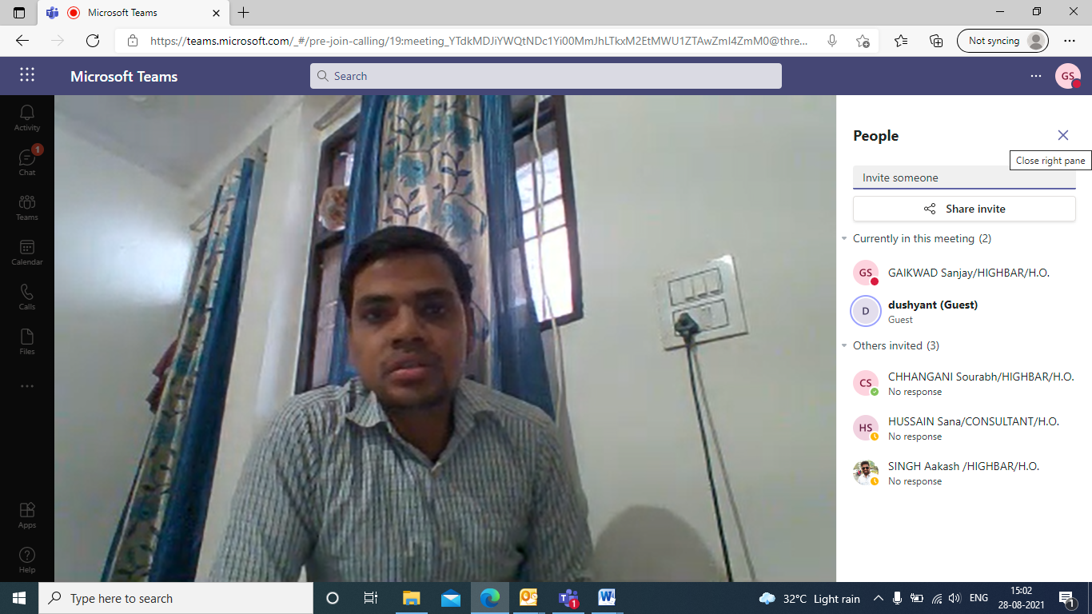

L and T