1. Requisition can be submitted by employee with band IV & above only

Logged in with [manisha.tambade@highbartech.com](mailto:manisha.tambade@highbartech.com) and found following Landing Page

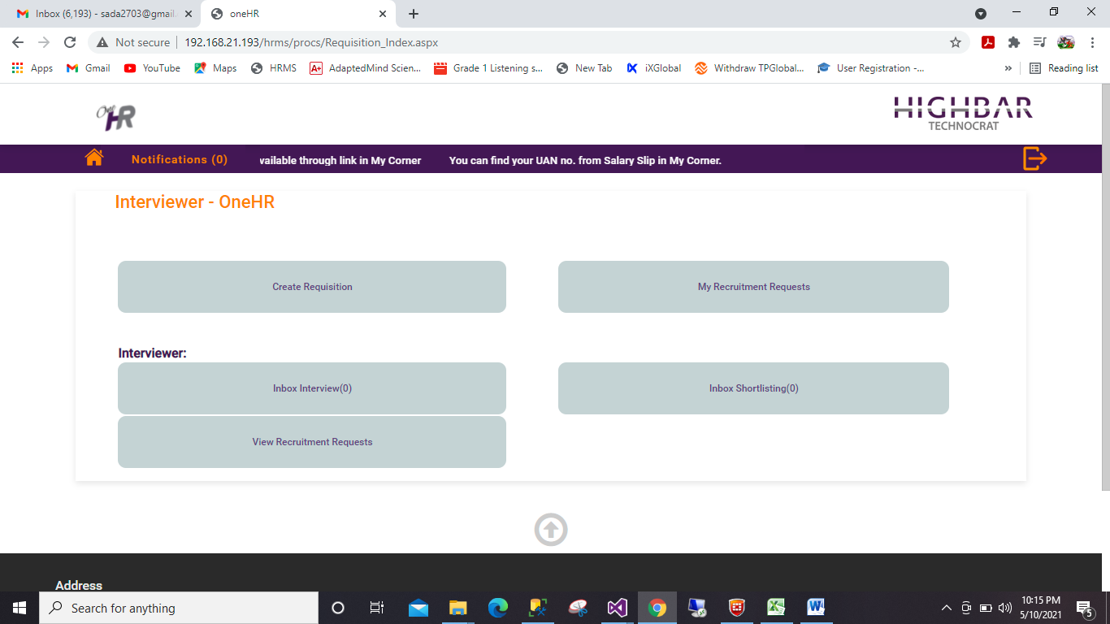

Why Create Requisition & My recruitment requests being displayed for an Employee with Band III?

Why Index page heading is Interviewer – OneHR?

Landing page Heading should always be Recruitment – OneHR only.

1. Create Requisition.

Logged in with [raj.patel@highbartech.com](mailto:raj.patel@highbartech.com). Following are my observations;

1. Requisition number getting displayed as soon as I clicked on Create Requisition, which is wrong. Requisition number should get generated only after Save as Draft or Submit.
2. On click of JD in Popup there is a column View JD but no button to click

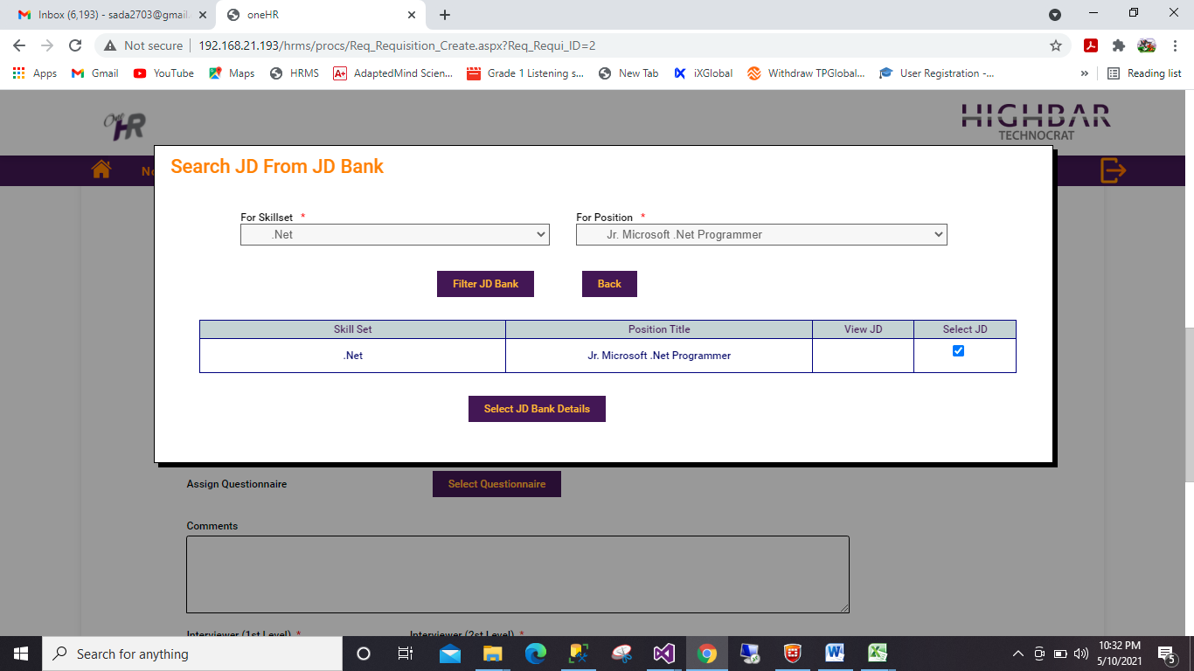

1. In Select Questionnaire – When clicked on Filter questionnaire not giving any records to select. It seems there are not Questionnaires for the selected options. Then in this case it should give a Message saying “No Questionnaires for the selected combination. Please contact Administrator.”

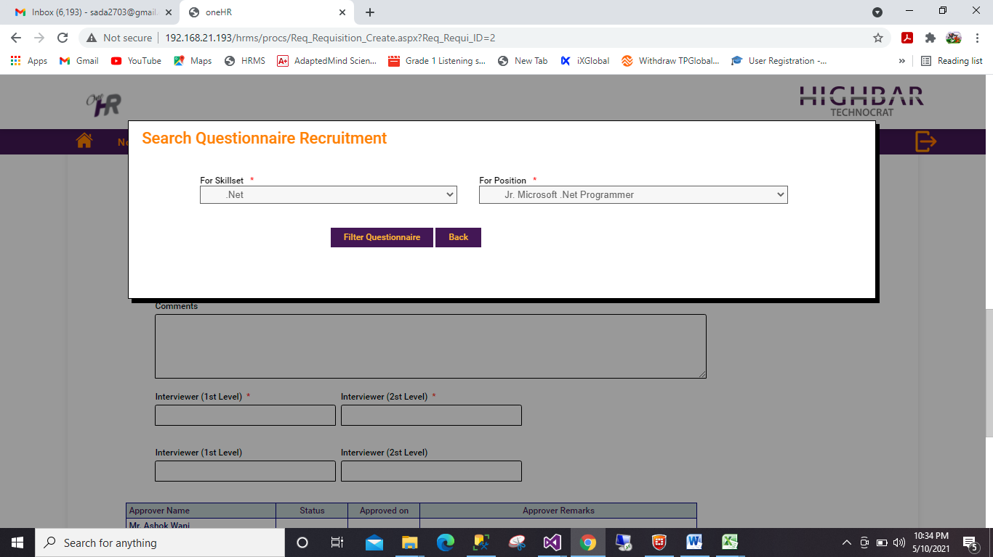

Requisition mail to Approver: No Of Position should come below Band

1. Send For correction:

Logged in with [ashok.wani@highbartech.com](mailto:ashok.wani@highbartech.com) and clicked on send back for correction.

In mail remove following part;

 of Mr. Raj Patel as per the details below

Also No Of Position should come below Band.

1. Recruiter Head Action: HR assigned it to recruiter. Changes in the mail as follows;

**Email to requisitioner:**

Body 1st line should be as follows;

This is to inform you that HR has assigned below said requisition to the recruiter.

Also No Of Position should come below Band.

**Email to Recruiter:**

Subject Should be: Request for REQ/05-2021/000002 of Mr. Raj Patel

Body should be :

Mr. Raj Patel has applied for new requisition as per the details below and is approved by following. Please start recruitment process.

Also No Of Position should come below Band.

I had assigned this Requisition to Priya Wagh and when I clicked on a link & Logged in by Ashok.wani still it opened me the recruiter page.

It should not show recruiter page to anybody else other than the Recruiter to whom the requisition is assigned.

1. After all approvals requisition should show Requisition Status as Approved. Change heading Requisition status to Approval Status and newly added field to be displayed as requisition Status.

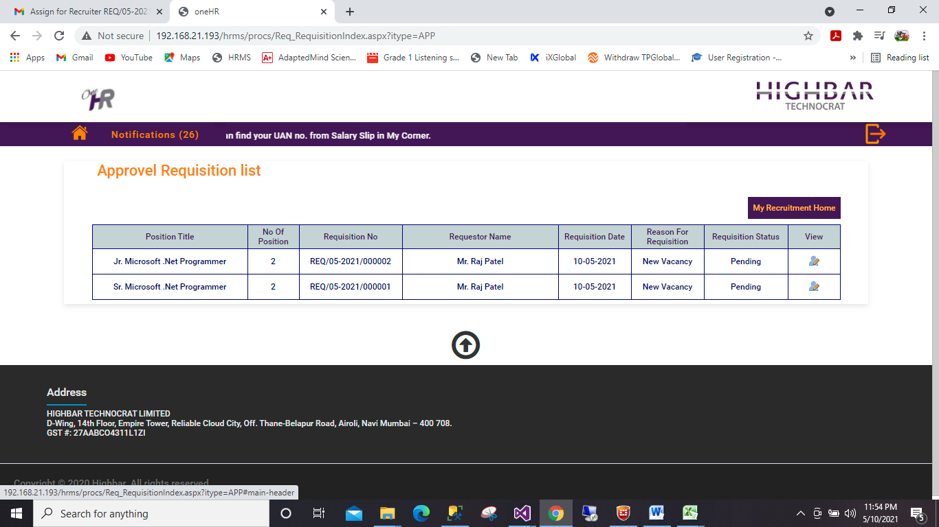

1. Recruiter Login;
2. Create Candidate:

* Selection status for Harshad dhande is rejected still I could not find this candidate in my new requisition request
* The grid on candidate page should not show following fields;

Shortlisting Status

Selection Status

Instead of this show following fields;

Age

Salary

Experience

* Referred By field should editable only when CV Source is Referral Program.
* Message for referred by is wrong: It should be Please enter referred by.
* I entered name in referred by which was not there in the list still it got saved & didn’t gave me error. See candidate Mr. ABC.
* Comments should not be mandatory.
* Mobile no. length should be 50 at least and should allow alphanumeric characters.
* Other files: Nomenclature is wrong. Use **Candidate Id_Filename**
* Created candidate should be editable all the time to recruiters. Even the resume upload & other file upload buttons should also be enabled.
* Search Candidate is not working at all.

1. Inbox:

* Recruitment Status is blank

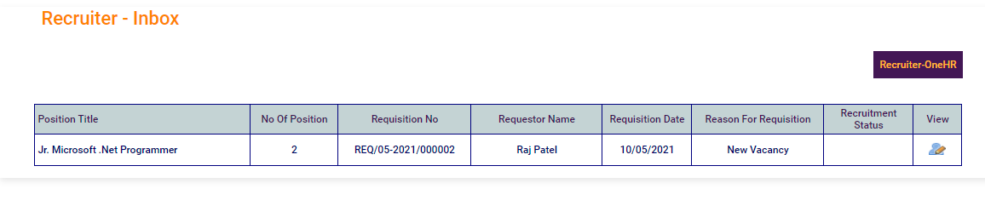

* Send for short listing details:

From & To Experience is not allowing to type more than 2 digits

* Search is not working at all. Seems no work / coding is done for search.
* On Click of Send for Shortlisting no Confirmation Box appeared.
* On Send for Shortlisting mail triggered without basics. Mail Should be as follows

Subject: Shortlist Candidates against request for REQ/05-2021/000002 of Mr. Raj Patel

Body:

Dear (Name of Interviewer),

|  |
| --- |
| Mr. Raj Patel has applied for new requisition as per the details below. Please shortlist candidates |
|  |
| |  |  |  | | --- | --- | --- | | Position Title : | .Net-Jr. Microsoft .Net Programmer |  | | Department : | Technology & Innovation | | | Designation : | Consultant |  | | Band : | III |  | 2 | | NoOfPosition : | 2 |  |  | | Remarks : | Please recruit on priority | |  | |

Link for Interviewer as follows;

Please click here to Shortlist.

There is no Link for Interviewer. Link should open the page for shortlisting directly. Take help of Bharat & do it.

1. Schedule Interview Inbox

* Recruitment status is empty

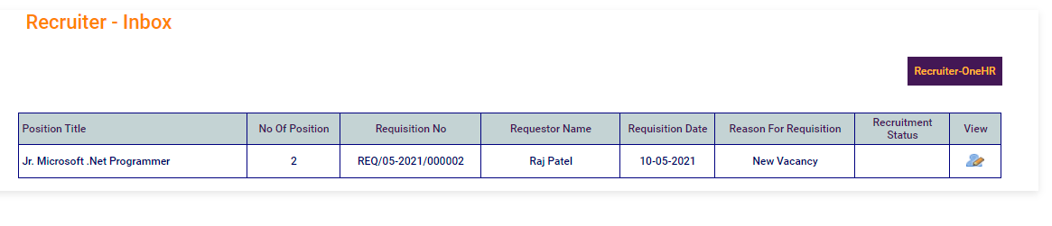

* Change name of the Button **Closed** to close
* Email on Schedule interview should be as follows;

Subject: Interview scheduled for a Candidate against request for REQ/05-2021/000002 of Mr. Raj Patel

Body:

Dear (Interviewer Name),

Interview for the below candidate is scheduled. Please find the details below;

|  |  |  |
| --- | --- | --- |
| Candidate Name : | Mr. ABC |  |
| Interview Round : | 1st Round | |
| Interview Date : | 12/05/2021 |  |
| Interview Time : | 08:00 | |

Link for Interviewer should be as follows;

Please click here to submit Interview Feedback.

There is no Link for Interviewer. Link should open the Interview page directly. Take help of Bharat & do it.

1. View Recruitment Request:

* Recruitment Status is Empty
* There is a check box on the page. When I clicked on this checkbox Candidate Information got vanished from the page and send for shortlisting details appeared.
* Both these tabs should appear till the requisition is in Pending status.(as per discussed I have added button)

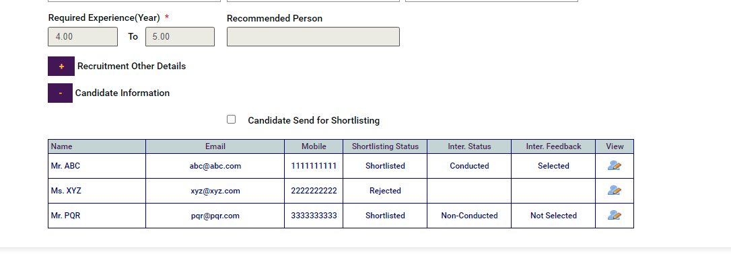

* Rejected spelling in Inter. Feedback is wrong

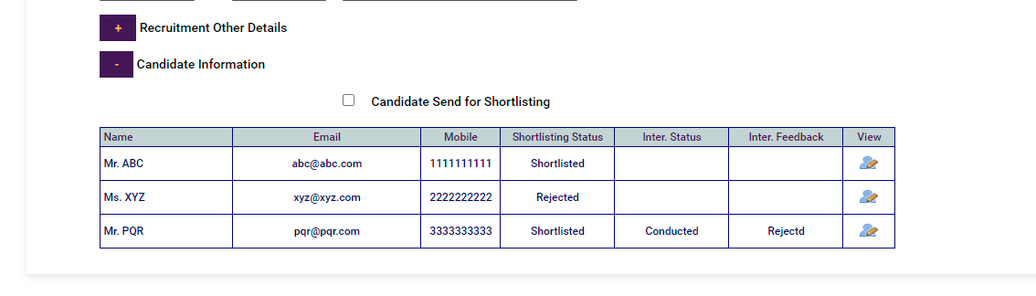

* After Finalized view is as follows

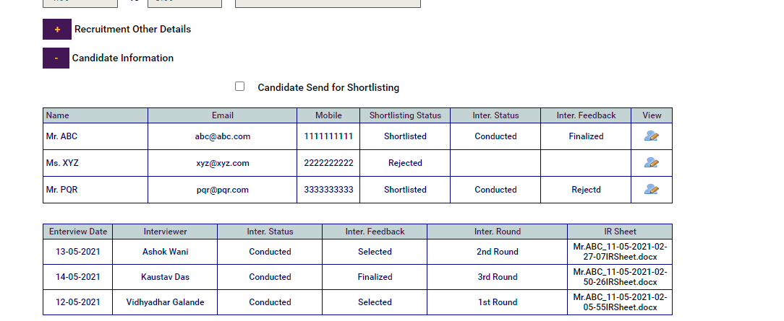

* I entered joining date, Negotiation status, offer status & status update & saved. But again when I clicked on the view all these fields are non-editable. These fields should be non- editable only when I select Joining on Time / Not Joining. Otherwise these fields should be editable for recruiter.
* And the position should be considered fulfilled only when status is Joining on Time.
* On click of Save with the status Joining on Time a mail with link would go to the candidate. Email draft for the same will be shared tomorrow.

1. Re-schedule Inbox:

* I had sent candidate Mr PQR to re schedule interview. There it appeared 1st round correctly but Interviewer name displayed is of 2nd level. I told 2nd level interviewer name should appear only for Level 2 & above only.
* Mail on reschedule interview should be as follows;

Subject: Interview scheduled for a Candidate against request for REQ/05-2021/000002 of Mr. Raj Patel

Body:

Dear (Interviewer Name),

Interview for the below candidate is scheduled. Please find the details below;

|  |  |  |
| --- | --- | --- |
| Candidate Name : | Mr. PQR |  |
| Interview Round : | 1st Round | |
| Interview Date : | 12/05/2021 |  |
| Interview Time : | 08:00 | |

Link for Interviewer should be as follows;

Please click here to submit Interview Feedback.

There is no Link for Interviewer. Link should open the Interview page directly. Take help of Bharat & do it.

1. Interviewer Login:
2. Shortlisting Inbox:

* Requisition Status is missing

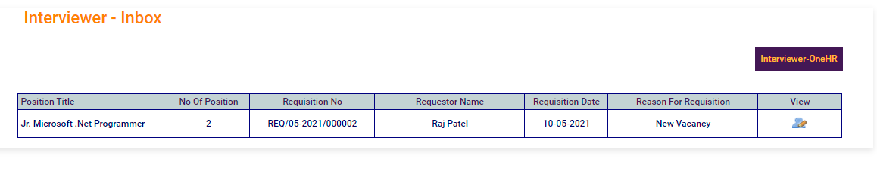

* Recruitment Details Tab alignment issue.

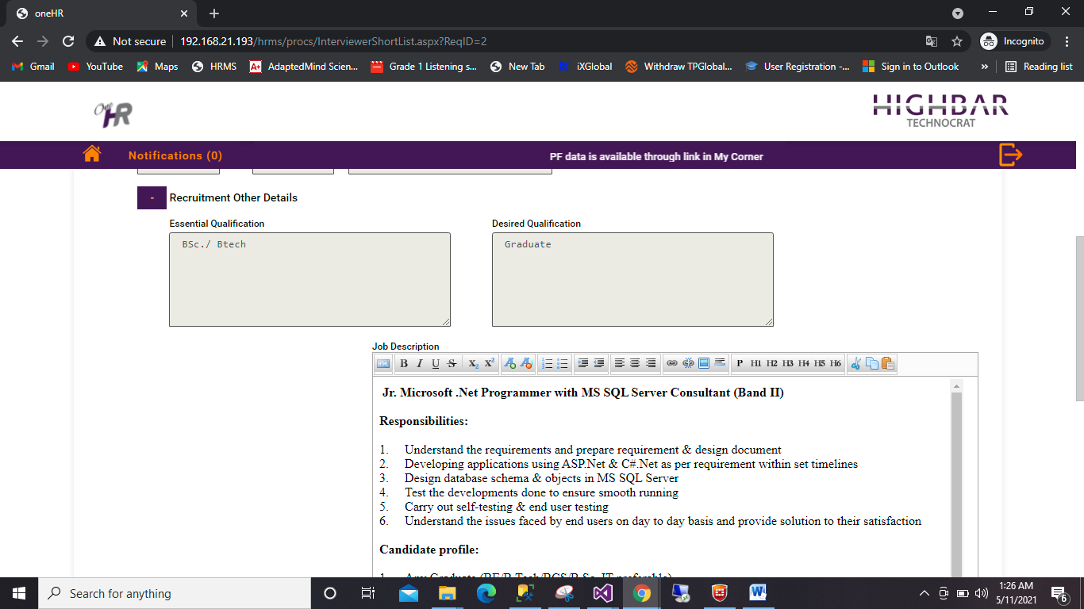

* Maintainscrollposition is missing
* Mail on submit shortlisting is even without basic details. Mail Should be as follows;

Subject: Schedule Interviews for shortlisted Candidates against request for REQ/05-2021/000002 of Mr. Raj Patel

Body:

Dear (Name of Recruiter),

|  |
| --- |
| Mr. Raj Patel has applied for new requisition as per the details below. Please Schedule Interviews for shortlisted  Candidates |
|  |
| |  |  |  | | --- | --- | --- | | Position Title : | .Net-Jr. Microsoft .Net Programmer |  | | Department : | Technology & Innovation | | | Designation : | Consultant |  | | Band : | II |  | 2 | | NoOfPosition : | 2 |  |  | | Remarks : | Please recruit on priority | |  | |

Link for Recruiter should be as follows;

Please click here to Schedule Interviews.

There is no Link for recruiter. Link should open the page of schedule Interview screen directly. Take help of Bharat & do it.

1. View Recruitment request:

* Requisition status is missing



* Shortlisted Candidate details are missing in the view.

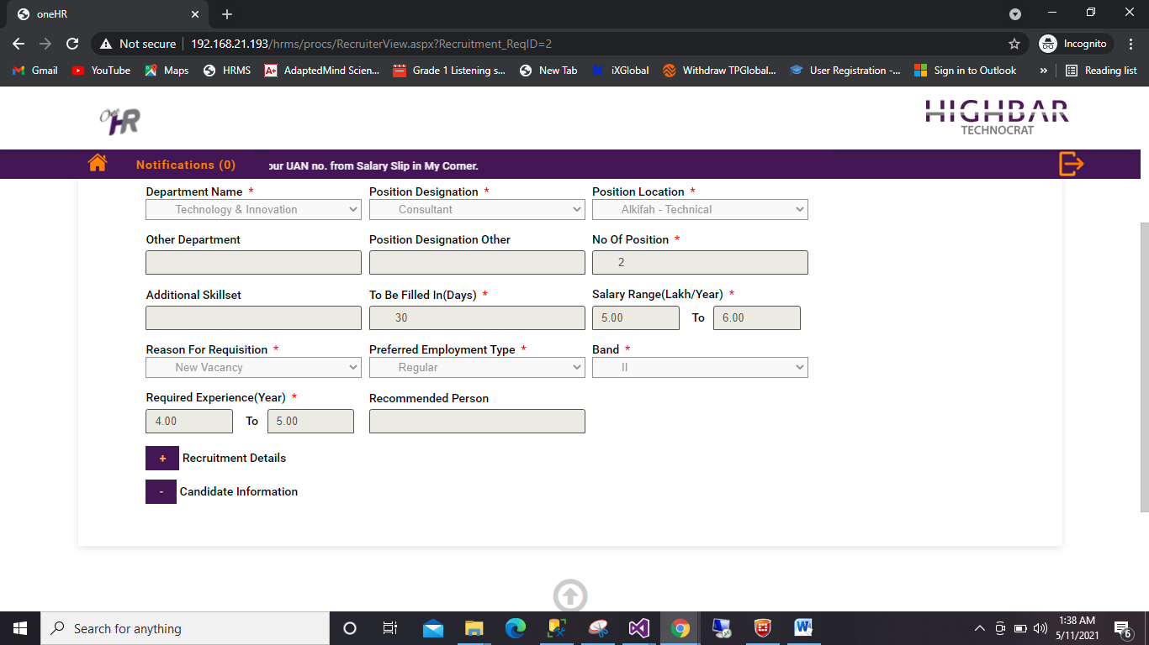

* Candidate Information appeared after Interviewer submitted feedback / rescheduled Interviews.

1. Inbox Interview:

* Spelling of Interview date is wrong

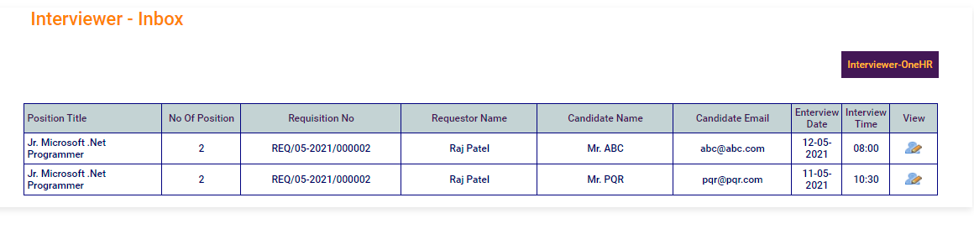

* Column Candidate Email is not required in the grid.
* Column sizes should be proper.
* Interview Status: Status should be Not-Conducted
* I selected Not- Conducted for PQR candidate and clicked on Send reschedule request. Send reschedule request fired a mail which was completely wrong. Mail should be as follows;

Subject: Re-schedule Interview for the Candidate against request for REQ/05-2021/000002 of Mr. Raj Patel

Body:

Dear (recruiter name),

Please re-schedule interview for the below candidate;

Candidate name: Mr. PQR

Interview Round: 1st round

Interview Status: Non-Conducted

Interviewer Remarks: Remarks of Interviewer.

Link for Recruiter should be as follows;

Please click here to re-Schedule Interview.

There is no Link for recruiter. Link should open the page of re-schedule Interview screen directly. Take help of Bharat & do it.

* I selected Conducted & selected & check schedule next round and clicked on Send reschedule request. Send reschedule request fired a mail which was completely wrong. Mail should be as follows;

Subject: Schedule Next round of Interview for the Candidate against request for REQ/05-2021/000002 of Mr. Raj Patel

Body:

Dear (recruiter name),

Please schedule next round of interview for the below candidate;

Candidate name: Mr. PQR

Interview Round: 1st round

Interview Status: Conducted

Interview feedback: Selected

Interviewer Remarks: Remarks of Interviewer.

Link for Recruiter should be as follows;

Please click here to Schedule Interview.

There is no Link for recruiter. Link should open the page of schedule Interview screen directly. Take help of Bharat & do it.

* I selected Conducted & Rejected and clicked on Submit feedback. Submit feedback fired a mail. Mail should be as follows;

Subject: Candidate Rejected against request for REQ/05-2021/000002 of Mr. Raj Patel

Body:

Dear (recruiter name),

Following candidate is rejected. Please send few more profiles for shortlisting.

Candidate name: Mr. PQR

Interview Round: 1st round

Interview Status: Conducted

Interview feedback: rejected

Interviewer Remarks: Not as per requirement.

* I selected Conducted & Finalized and clicked on Submit feedback. Submit feedback fired a mail. Mail should be as follows;

Subject: Candidate Finalized against request for REQ/05-2021/000002 of Mr. Raj Patel

Body:

Dear (recruiter name),

Following candidate is finalized. Please start hiring process for the same.

Candidate name: Mr. ABC

Interview Round: 3rd round

Interview Status: Conducted

Interview feedback: Finalized

Interviewer Remarks: Please start hiring process.

Link for Recruiter should be as follows;

Please click here to submit Hiring Progress.

There is no Link for recruiter. Link should open the page of schedule Interview screen directly. Take help of Bharat & do it.