**STEPS TO HOST APPLICATION**

1. Create folder named “HRMS” on D: drive
2. Copy following folders in “HRMS” folder;
3. hrms
4. hrmsadmin
5. logon
6. open IIS on your machine & create following Application Pools;
7. hrms

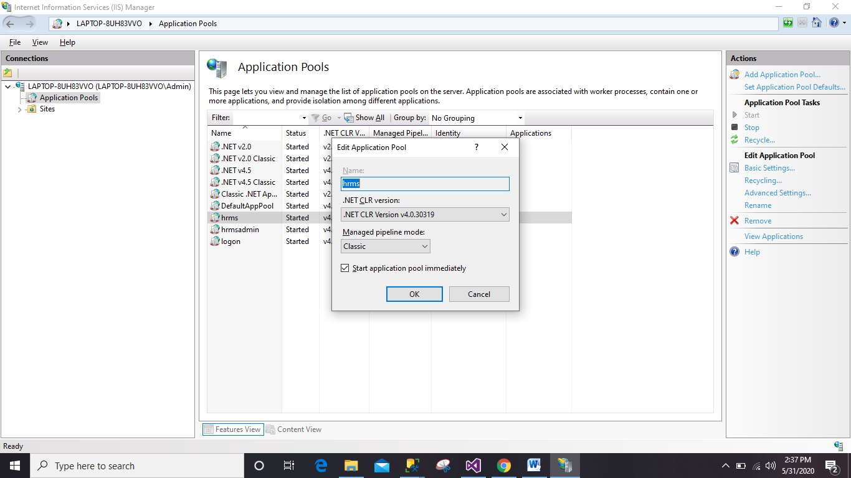

1. hrmsadmin

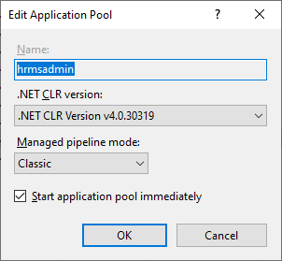

1. logon

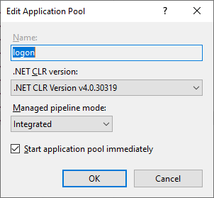

1. Steps to Host website “**logon**”
2. Right click “Default Web Site” and click on “**Add Application**”.

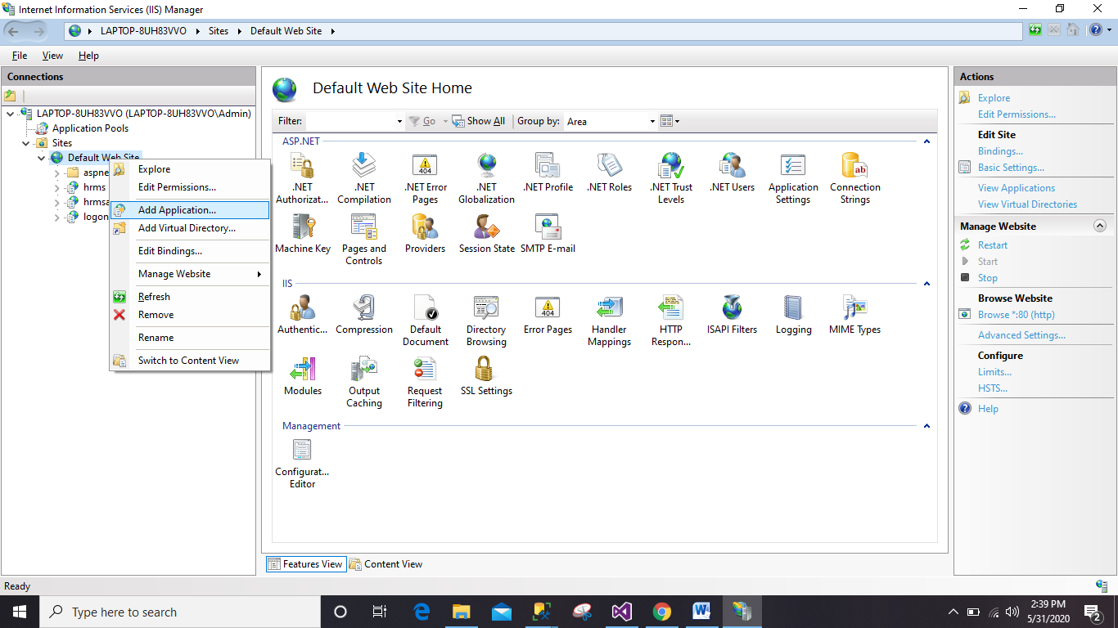

1. Enter the details as shown below and say ok;

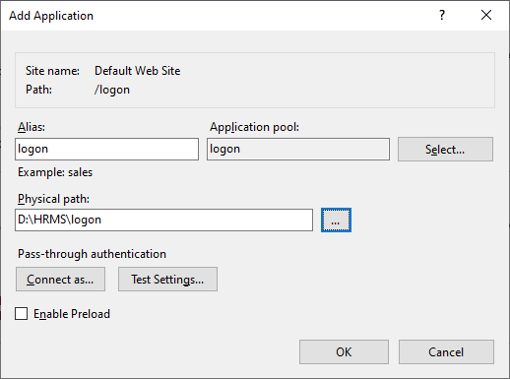

1. Double Click “**Authentication**” and set status as shown below;

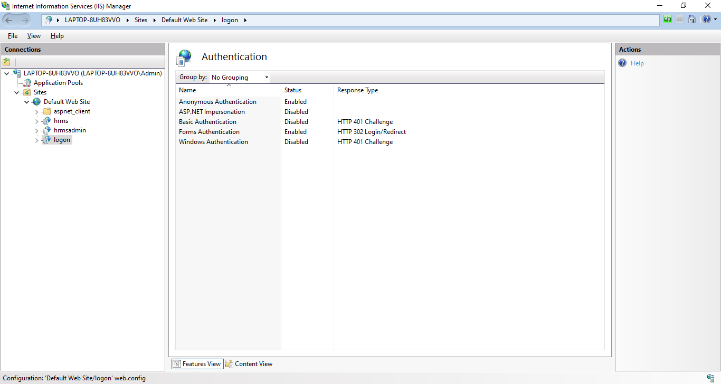

1. Steps to Host website “**hrms**”
2. Right click “Default Web Site” and click on “**Add Application**”.



1. Enter the details as shown below and say ok;

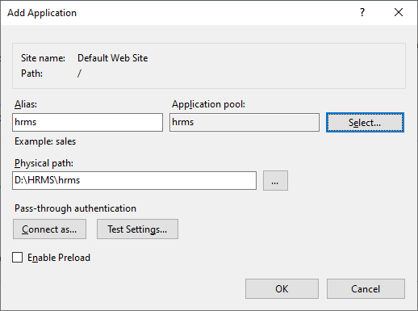

1. Double Click “**Authentication**” and set status as shown below;

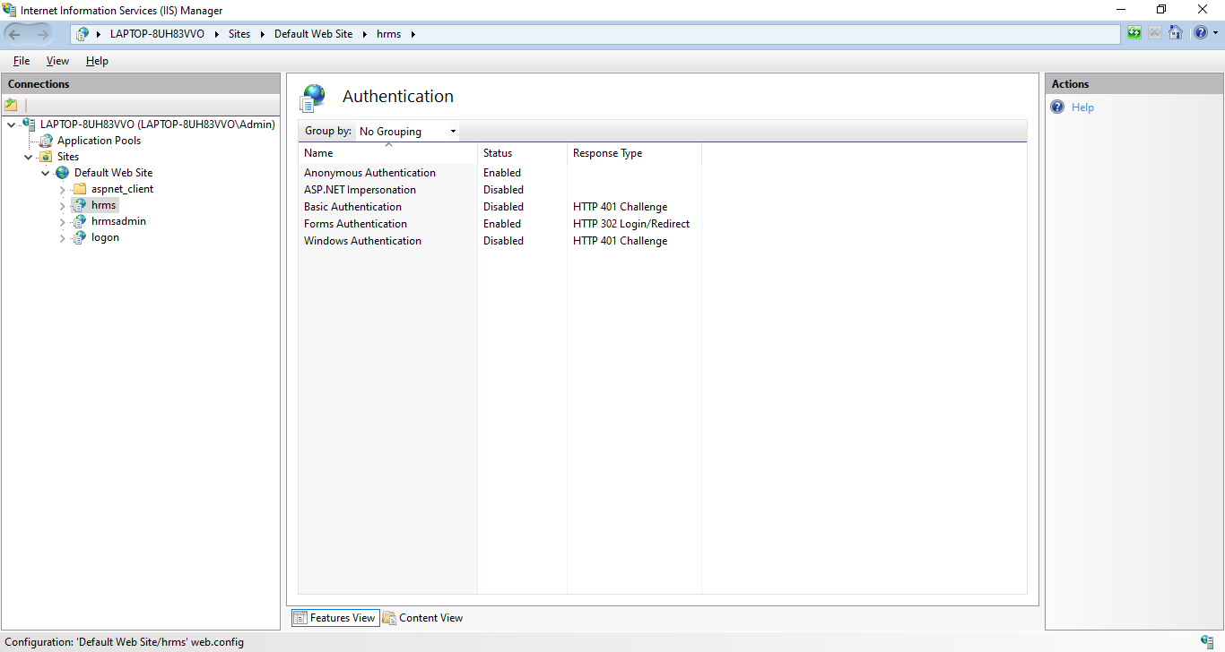

1. Steps to Host website “**hrmsadmin**”
2. Right click “Default Web Site” and click on “**Add Application**”.



1. Enter the details as shown below and say ok;

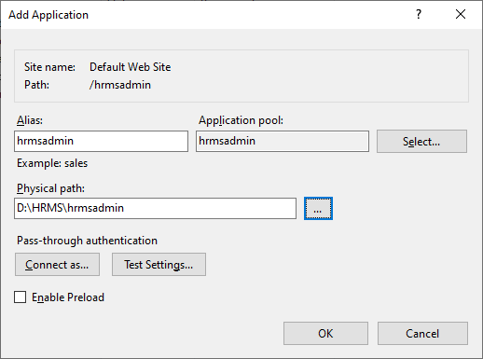

1. Double Click “**Authentication**” and set status as shown below;

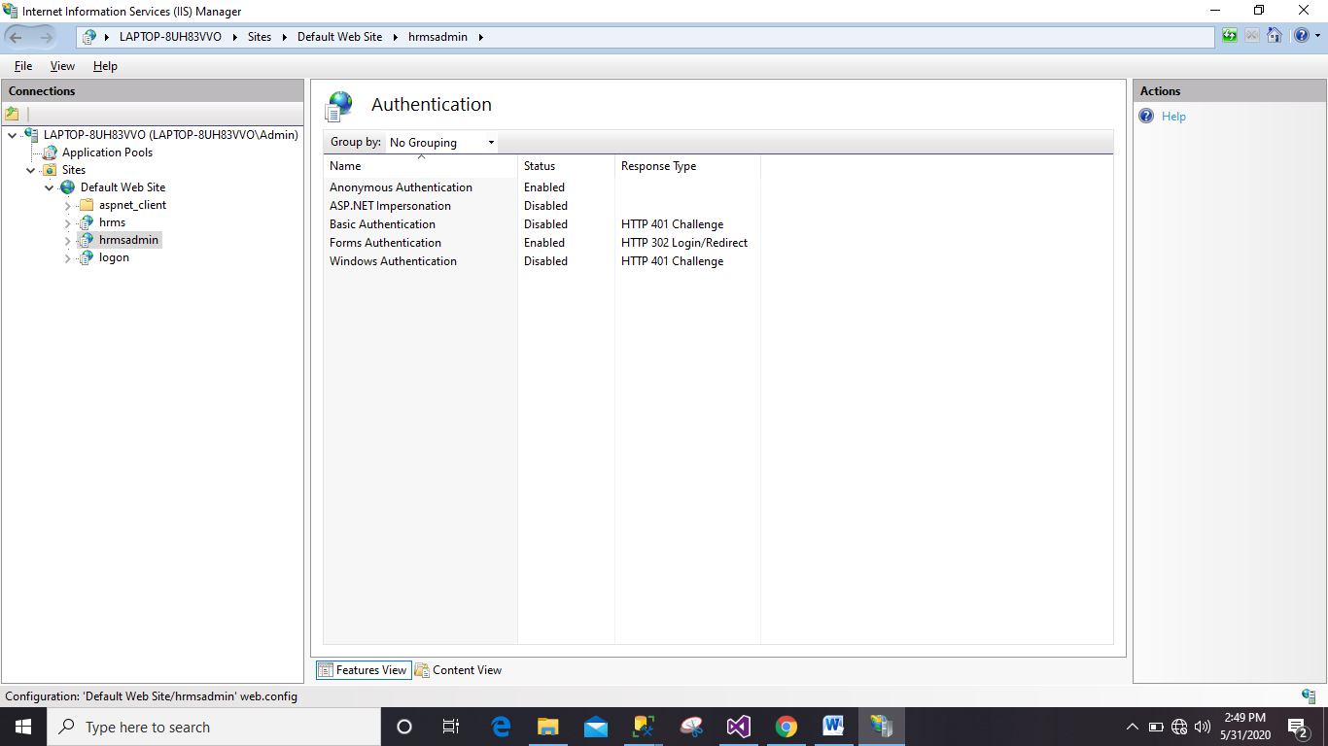

1. URL to open “**HRMS**”

<http://localhost/hrms/login.aspx>