**STEPS TO CONFIGURE IIS ON YOUR MACHINE**

Go to **Programs & Features** & Click on -> **Turn Windows Feature On or Off**

In that click check boxes for **Internet Information Services** As shown below.

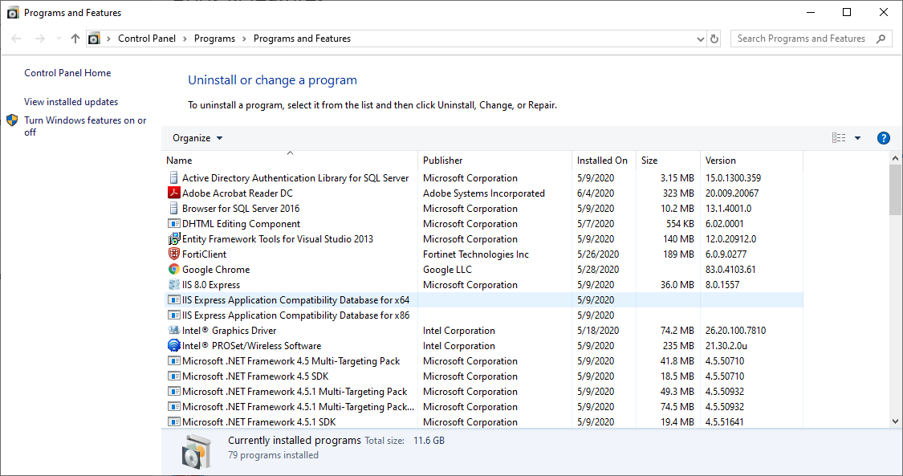

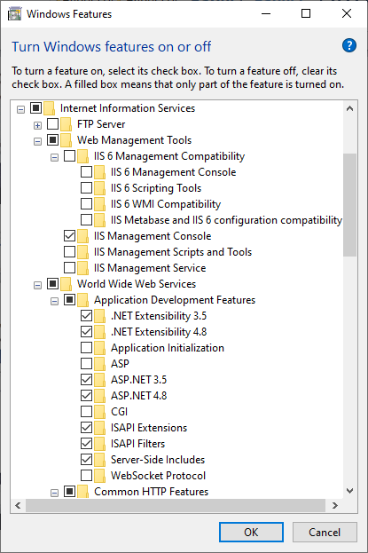

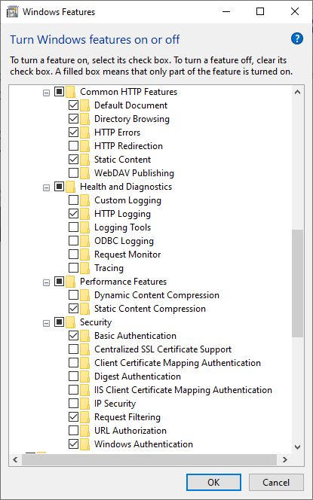

THEN PRESS OK TO CONFIGURE IIS ON YOUR MACHINE.