Lab 04 – Error handling.

PART I
Using the provided files BankAccount.java, BankManager.java, implement the following examples:
- Create Custom Exceptions:
  - InsufficientFundsException
  - InvalidAmountException
  - AccountNotFoundException
- Wrap the existing methods with proper throw statements - negative amount? InvalidAmountException. Not enough balance? InsufficientFundsException. Account not found in the manager? AccountNotFoundException.
- In Main: call a series of operations (some valid, some intentionally broken) inside try/catch blocks and handle each exception type differently — don't just catch Exception for everything.
- Add a finally block somewhere meaningful that logs every transaction attempt to the console regardless of outcome.
- Comment each method (10-25 words).

PART II
Context: You work as a freelancing web developer and you must implement a backend system for an online shop. Each order is placed programmatically and therețs no place for errors – everything must be bulletproof!
Requirements:
- Model a Product (name, price, stock quantity) and an Order class
- Create a custom exception hierarchy:
  - ShopException – the base class and the sub-classes:
    - OutOfStockException
    - InvalidOrderException - (e.g. quantity <= 0).
    - ProductNotFoundException
- Build an OrderProcessor class that validates and processes orders, throwing the right exception at the right moment.
- In Main: simulate at least 6 orders - a mix of valid and broken ones. Each exception type should be caught and handled differently (e.g. out of stock prints a restock suggestion, invalid order prints what was wrong)
- At the end, print a summary: how many orders succeeded, how many failed and why.

More on Java error handling
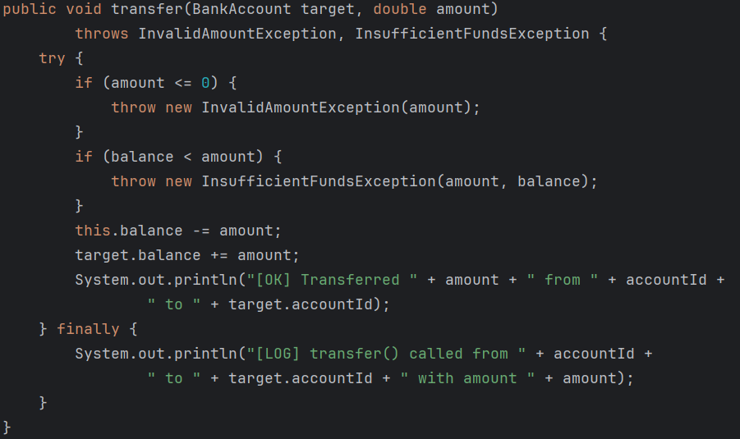
1. try/catch/finally block example

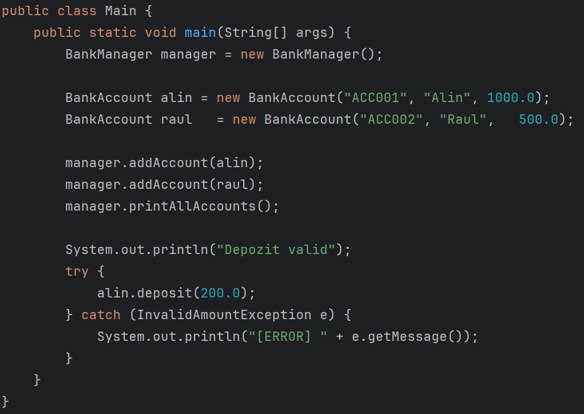
2. Catching errors in Main.
N.B.: UPLOAD ONLY THE JAVA FILES AND THE OUTPUT FILES.

