Lab 03 – More on Polymorphism & Abstract Interfaces

PART I
- Create StreetLight: Extends SmartDevice. It consumes 0.5 kWh per hour. If it's OFF, consumption is 0.
- Create IndustrialMachine: Extends SmartDevice. It consumes 15 kWh per hour, but if it has been running for more than 10 hours, consumption increases by 20% due to heat inefficiency.
- Personalize: Add a String location attribute to SmartDevice and ensure toString() displays the ID, Location, and Current Status.

PART II
Context: The Mayor’s office needs a system to calculate how much money the city collects (Taxes) versus how much it spends (Maintenance). The city charges different rates for different services. You need to create a billing system using multiple interfaces.
Requirements:
Interface Taxable:
  - double VAT_RATE ;
  - calculateCityTax();
- Interface Maintainable:
  - boolean needsUrgentService();
  - double getMaintenanceCost();
  - void performService();
- Class PublicTransport:
Implements Taxable and Maintainable.
Attributes:
  - String lineId
  - double totalKilometers
  - double ticketRevenue
Logic: * Tax: The city takes 10% of its ticketRevenue as tax.
Maintenance: A bus needs urgent service if totalKilometers > 5000.
Cost: Maintenance costs 2.5 RON per kilometer driven up until totalKilometers == 3000km. Then it goes up to 5 RON per kilometer.
Perform Service: Sets totalKilometers back to 0.
- Class CommercialBuilding:
Implements Taxable.
Attributes
  - String address
  - double squareFootage
  - boolean isIndustrial
Logic: * Tax: If isIndustrial, tax is squareFootage * 10. If not, it's squareFootage *
Maintenance: This class does not implement Maintainable (the owner pays for it, not the city). It only implements Taxable.
- Class CityAuditor – the logic controller
Attributes
  - private List<Taxable> taxableItems = new ArrayList<>();
  - private List<Maintainable> maintenanceItems = new ArrayList<>();
Methods
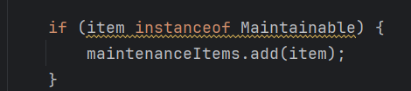
  - public void registerAsset(Taxable item) – add the item in it’s specific category. Make use of the instanceof keyword.
1. Example of instanceof

  - public double calculateTotalTaxRevenue() – total revenue from Taxable items.
  - public void runMaintenanceReport() – print all Maintainable items, only if they are Urgent. Also print the cost alongside the item.
- In the Main Function:
  - Instantiate 3 Buses (one with > 5000km, two with < 5000km).
  - Instantiate 2 Buildings.
  - Add them to a CityAuditor.
  - Print the Total Tax Revenue.
  - Run the Maintenance Report to see which buses need fixing.

PART III
Use the Comparable interface and Java Collections to handle data like a pro.
- Modify SmartDevice: Make it implement Comparable<SmartDevice>.
https://docs.oracle.com/javase/8/docs/api/java/lang/Comparable.html#method.summary
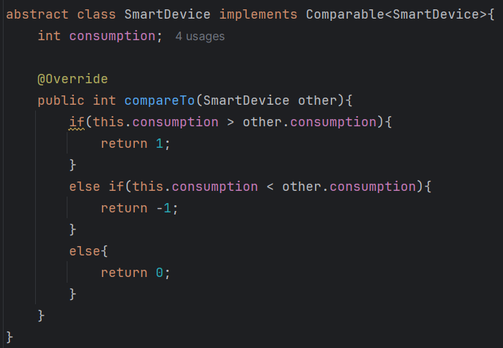
- Logic: Implement the compareTo method so that devices are sorted by their energy consumption (high to low).
2. Comparable<> Example

- The "Emergency" Filter:
- Create a CityManager class.
- Add a method getHighConsumptionDevices(double threshold) that returns a list of only those devices consuming more than the threshold.
- In Main:
- Create a list of 6 various devices (Lights, Machines, etc.).
- Use Collections.sort(myList).
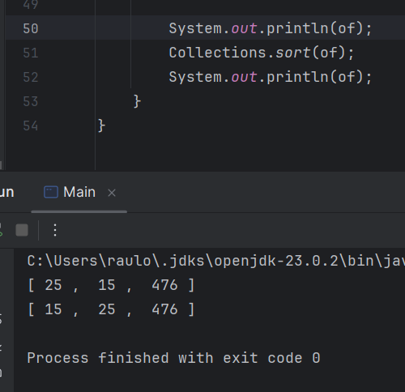
- Display the sorted list to show which device is costing the city the most money.
3. Example of sorting

N.B.: UPLOAD ONLY THE JAVA FILES AND THE OUTPUT FILES.

