Lab 02 – Inheritance & Polymorphism

PART I
Analyze the provided code files (Vehicle.java, Car.java, Truck.java):
- Override the calculateFuelNeeded() method:
  - Car – if the air conditioning is on, fuel consumption increases by 10%
  - Truck – for each ton of cargo, fuel consumption increases by 5%
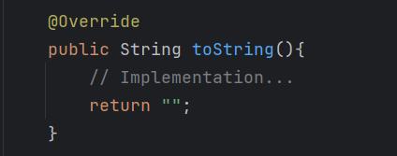
(HINT: In Java, we have so-called compiler annotations that inform the compiler about the role of a method within the broader application context. For overriding, we use the @Override annotation (Figure 1). These annotations are not mandatory, but they demonstrate professionalism and warn the developer when a mistake is made.)
1. @Override tag.

- Override the predefined toString() method in Vehicle, Car, and Truck. All classes must display: Vehicle type, License plate number, Brand, Estimated consumption for 100 km

(HINT: Every class defined in Java is a subclass of the Object class. The Object class contains a toString() method used to easily display object values. For example, if we want to view the values in an Array, we can call toString() and print it to the console. Instead of going through a complex process of determining the values, capacity, and other details of an object, we can use this method to directly display all desired information (see Figure 2). In this exercise, we want to override this method to display the details of vehicle, car, and truck objects.)
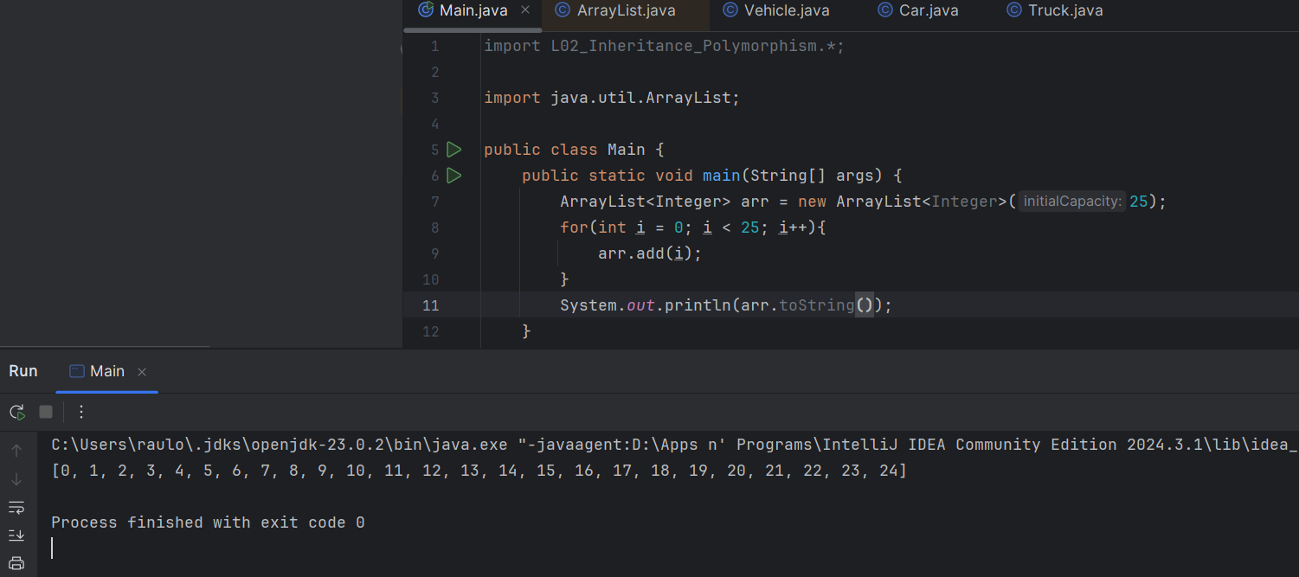
- In your Main function:
2. toString()
  - Instantiate 2 Car objects and 2 Truck objects.
  - Add them to a List<Vehicle>.
  - Calculate the total trip cost for 350 km and display using toString() the most expensive vehicle for that distance.
  - Search online for the current diesel price (RON) and use that value.
- Add comments above each method explaining its functionality (10–25 words).

PART II
Context: A digital media company has contacted you to create a system for managing media files.
All media files contain:
- A title
- A duration (in minutes)
- A base cost per minute
Each media type calculates the final cost differently.
Requirements:
- Create the MediaContent base class
- Attributes:
  - title
  - duration
  - costPerMinute
- Methods:
  - calculateStreamingCost()
  - getDetails()
- Create sublasses:
- Movie – contains a boolean field isPremium. If isPremium is true, the cost increases by 20%.
- SeriesEpisode – contains an int seasonNumber. If seasonNumber > 3, the cost increases by 15%.
- Documentary – contains an int seasonNumber. If seasonNumber > 3, the cost increases by 15%.
- ALL subclasses must override calculateStreamingCost() and toString().

- Create the StreamingManager class:
- Attributes:
  - List<MediaContent> contents;
  - boolean isLoaded;
- Methods:
  - addContent(MediaContent content) – adds media content
  - printAllContent() – displays all content
  - calculateTotalPlatformRevenue() – calculates total platform revenue
  - printMostExpensiveContent() – displays the most expensive media content
- In the main function:
- Create at least 5 media objects.
- Add them to the manager.
- Display the total revenue and the most expensive media content.
N.B.: UPLOAD ONLY THE JAVA FILES AND THE OUTPUT FILES.

