Lab 05 – Trees. Trees representation.
Create a general tree in C/C++ which simulates the hierarchy of folders and files of a computer drive. Imagine we have intalled an SSD (Solid State Drive) in a computer, with only one partition (C:/) which represents the root of the tree. The rest of the folders and files will be child nodes of this root.
Requirements:
|_ C:/ - Root node.
|_ System – files required by the operating system.
|_ Photos – photos folder.
|_ selfie.png
|_ party.jpeg
|_ Documents – folder with diverse documents.
|_ Scanned – sub-folder with scanned docs.
|_ scanned_ID.pdf
|_ birth_certificate.pdf
|_ important.zip
|_ undergrad_doc.docx
|_ Downloads – downloads folder with files form the internet.
|_ friend_photos.zip
|_ The_Art_Of_The_Deal.pdf
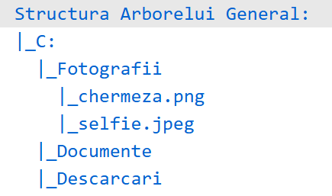
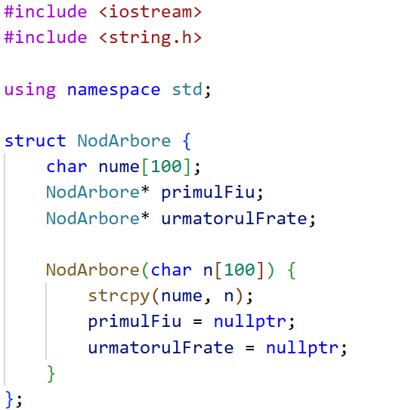
After you created the structure, add the files/folders and respect the hierarchy. In the end, create a function which traverses the whole tree and prints everything on the screen.
2. Example of console output. (Romanian text)
1. Struct example with the folders hierarchy,

Probleme Leetcode recomandate (OPȚIONAL)
94. Binary Tree Inorder Traversal
101. Symmetric Tree
96. Unique Binary Search Trees
104. Maximum Depth of Binary Tree
112. Path Sum
114. Flatten Binary Tree to Linked List

All these files and folders will be implemented as strings, such as every value of one node will be just an array of chars which represents the name of the file/folder. You may not implement a complementary ADT to use as a value for the nodes.

