**EDI**

Definition of 'Value-Added Network - VAN'

A private network used by a company primarily for routing, storing and delivering electronic data interchange (EDI) messages. A value-added network (VAN) also provides other services such as message encryption, retransmission and support. VANs may be operated by large companies for efficient supply chain management with their suppliers, or by industry consortiums and telecom providers.  
  
A **Value-added Network** (VAN) is a hosted service offering that acts as an intermediary between business partners sharing standards based or proprietary data via shared Business Processes. The offered service is referred to as "Value-added Network Service".

## Technical Definition

**VANS** traditionally transmitted data formatted as Electronic Data Interchange but increasingly they also transmit data formatted as XML or in more specific "binary" formats. VANs usually service a given vertical or industry and provide "Value Added Network Services" ("VAN Services" or VANSs) such as data transformation between formats (EDI-to-XML, EDI-to-EDI, etc.).

At one extreme, a VAN hosts only horizontal Business-to-business application integration services, hosting general-purpose integration services for any process or industry. At the other extreme a VAN also hosts process-specific or industry-specific integration, for example supply chain ordering or data synchronization services.

A VAN not only transports (receives, stores and forwards) messages but also adds [audit information](http://en.wikipedia.org/wiki/Audit) to them and modifies the data in the process of automatic error detection and correction or conversion between communications protocols.

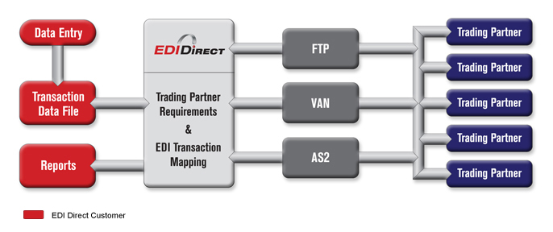

**What is EDI?**

What is Electronic Data Interchange (EDI)? The purpose of this article is to provide a layperson's understanding of the electronic data interchange process. An overview of EDI benefits and drawbacks is included.

The electronic data interchange process is the computer-to-computer exchange of business documents between companies. EDI replaces the faxing and mailing of paper documents.

EDI documents use specific computer record formats that are based on widely accepted standards. However, each company will use the flexibility allowed by the standards in a unique way that fits their business needs.

EDI is used in a variety of industries. Over 160,000 companies have made the switch to EDI to improve their efficiencies. Many of these companies require all of their partners to also use EDI.

**Overview of EDI benefits and drawbacks**

The EDI process provides many benefits. Computer-to-computer exchange of information is much less expensive than handling paper documents. Studies have shown that manually processing a paper-based order can cost $70 or more while processing an EDI order costs less than one dollar.

* Much less labor time is required
* Fewer errors occur because computer systems process the documents rather than processing by hand
* Business transactions flow faster.

Faster transactions support reduction in inventory levels, better use of warehouse space, fewer out-of-stock occurrences and lower freight costs through fewer emergency expedites.

Paper purchase orders can take up to 10 days from the time the buyer prepares the order to when the supplier ships it. EDI orders can take as little as one day.

One drawback to EDI is that companies must ensure that they have the resources in place to make an EDI program work; however, the need for buying and hiring these resources or outsourcing them may be offset by the increased efficiency that EDI provides.

**EDI example**

Here is an example of how the electronic data interchange process works. A buyer prepares an order in his or her purchasing system and has it approved.

Next, the EDI order is translated into an EDI document format called an 850 purchase order.

The EDI 850 purchase order is then securely transmitted to the supplier either via the internet or through a VAN (Value Added Network).

If the purchase order is sent using a VAN, then the buyer’s VAN interconnects with the supplier’s VAN. The VANs make sure that EDI transactions are sent securely and reliably. The supplier’s VAN ensures that the supplier receives the order.

The supplier’s computer system then processes the order.

Data security and control are maintained throughout the transmission process using passwords, user identification and encryption. Both the buyer’s and the supplier’s EDI applications edit and check the documents for accuracy.

**EDI requirements**

Each trading partner has unique EDI requirements. These will include the specific kinds of EDI documents to be processed, such as the 850 purchase order used in the example above, 856 advance ship notices and 810 invoices.

Almost any business document that one company wants to exchange with another company can be sent via EDI. However each EDI document must be exchanged with the partner in exactly the format they specify.

Many partners will have an [EDI implementation](http://www.covalentworks.com/edi-solution-implementation-process.asp) guide or kit that explains their specific requirements. Maps are required to translate the EDI documents from the trading partner’s format into the format that is useable by the receiving party.

Meeting all of an EDI trading partner's EDI requirements is called being EDI compliant.

**What you need to be EDI compliant**

EDI compliance involves either buying or outsourcing the following components:

1. Software for communications
2. VAN service for EDI transmission
3. Mailboxing of EDI transactions
4. Mapping and translation software
5. Installing upgrades to software as needed
6. Mapping labor
7. Testing with EDI trading partners
8. Upgrades for new versions required by trading partners

EDI VAN, FTP, or AS/2 Internet communications will be required by various partners. A server or PC, communication devices and peripherals will be needed as well as secured office space, monitored security, backups and redundant power.

Additional software will be needed if integration of the EDI transactions with back office systems is desired. Personnel must be trained in how to use the software and communication devices. Maps will then need to be developed, tested and maintained.