Electronic payment system
Need For Electronic Tokens (eCash and Electronic Cheques)
Most Ecommerce applications are based on the Credit Card. Internet users will log on to different sites giving their credit card nos. along with some additional information such as Birth Date, a Pre defined Password / Email ID. But these features do not provide the facility of Cash. Accepted, that even villages today are going for credit cards, but it cannot replace the flexibility of Cash. The liquidity aspects of cash cannot be replaced by plastic money. Consider the foll. Statistics.
In USA, there is 300 billion Dollars worth of notes and currency in circulation. Deposits by cheque are growing at the rate of 6 % and that by cash is growing at the rate of 8 %. This alarming statistic clearly indicates that cash transactions are not out. Infact a credible alternative to cash has to be found out for the Electronic media. Two potential options are available eCash and Electronic Signatures.
eCash IN ACTION
eCash is based on cryptographic systems called Digital Signatures. This method involves a pair of numeric keys (very large integers or numbers) that work in tandem: one for locking (or encoding) and the other for unlocking (decoding). Messages encoded with one numeric key can only be decoded with the other numeric key and none other. The encoding key is kept private and the decoding key is made public.
By supplying all customers (buyers and sellers) with its public key, a bank enables customers to decode any message (or currency) encoded with the bank’s private key. If decoding by a customer yields a recognizable message, the customer can be fairly confident that only the bank could have encoded it. These digital signatures are as secure as the mathematics involved and have proved Over the past two decades to be more resistant to forgery than handwritten signatures.
Before eCash can be used to buy products or services, it must be procured from a Currency server.
PURCHASING eCash FROM CURRENCY SERVER
eCash can be purchased from an On – Line currency server in 2 steps namely, Establishing an account and maintaining enough money in the account to back the purchase.
How Actually eCash will work
- The user of eCash has to have an Account with a bank ready to offer eCash.
- The user will apply for eCash in the denomination and amount the he desires. In exchange of money debited from the customer’s account, the bank uses its private key to digitally sign the note for the amount requested and transmits the note back to the customer. The network currency server in effect is issuing a "bank note" with a serial number and a dollar amount.
- Since the bank is digitally signing it, the bank is committing itself.
- The user has the eCash available. He can sign the eCash and give it to anybody.
- When the eCash software generates a note, it masks the original number or "blinds" the note. The blinding carried out makes it impossible for anyone to link Payment to Payer.
- A central bank also maintains a database of Spent notes.
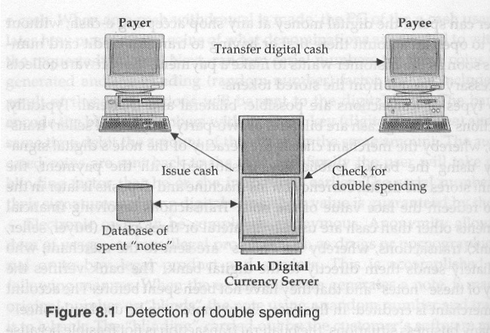
DISADVANTAGES AND LEGAL ISSUES OF eCash
- eCash cannot be broken into smaller denominations.
- The concept of maintaining a database of spent notes is very expensive.
- Accessing Database of spent notes is also very time consuming.
- Transaction based taxes account for a significant portion of state and local government revenue. If eCash becomes successful, then people will use it to buy things like cars and houses, which would not have been possible with actual cash. (One can’t physically carry so much of real cash)
- Currency fluctuation is another issue related to eCash.
Ex- Union Bank of India, Indian Overseas Bank

Electronic Cheques
Electronic cheques are another form of Electronic tokens. They are designed to accommodate the many individuals and entities that might prefer to pay on credit or through some mechanism other than cash.
Once registered, a buyer can then contact sellers of goods and services. To complete a transaction, the buyer sends a check to the seller for a certain amount of money. These checks may be sent using Email or other Transport methods. When deposited, the cheque authorises the transfer of account balances from the account against which the cheque was drawn to the account to which the cheque was deposited.
This method has been deliberately designed to work in the manner conventional cheques work
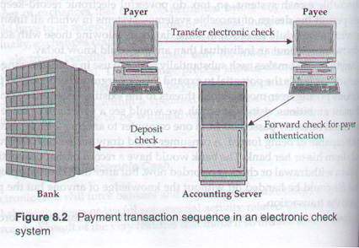
Advantages of Electronic cheques
- Similar to traditional cheques. This eliminates the need for customer education
- Since Electronic cheques use conventional encryption than Public and private keys as in eCash, Electronic cheques are much faster.
- The risk is taken care of by the accounting server, which will guarantee that the cheque would be honoured.
GIRO
What is GIRO?
GIRO was set up in 1987 as an electronic direct debit mechanism used by billing organisations (BOs) as a low cost means to collect payments. GIRO ia a tripartite mechansim between billing organisations, customers and the bank. The authorization for direct debit is a contractual relationship between a consumer and a BO; banks are the intermediaries in this tripartite relationship, and help to effect authorised GIRO deductions. Today, GIRO is widely used for consumers to pay bills to government agencies and private sector BOs. GIRO is especially useful for payments which are regular in nature and of a fixed quantum.
GIRO is the short form of General Interbank Recurring Order. You can set up a GIRO arrangement by requesting for your bank to make on time payment to the billing organization by the due date.
GIRO is a convenient mode of payment for all regular bill payments like telephone bills, income tax, utility bills, season parking fees, credit card bills and many more. No more worries about missing a payment, paying penalty fees or waiting in line to make payment. Simply maintain sufficient funds in the designated DBS/POSB bank account(s) for deduction on the payment dates.
GIRO Application via iBanking
- Select "Payments", "GIRO: Manage GIRO Arrangements" and “Add GIRO Arrangement”.
- Under "From Account", choose your preferred account for this payment.
- Under "To Billing Organisation", select the name of the Billing Organisation.
- Under "Bill Reference No.", please key in your bill reference number for the Billing Organisation. For the explanatory guide on "Bill Reference No", please click "View More Info".
- Under "Payment Limit", please key in "0" unless you would like to set a limit.
- Click "Submit".
- Check your information again before you click "Confirm" and your application is complete!

