

**Main Manuscript for**

***Rocky Mountain subalpine forests now burning more than any time in recent millennia***

Philip E. Higuera, Bryan N. Shuman, Kyra D. Wolf

*Philip E. Higuera.

**Email:**  [philip.higuera@umontana.edu](mailto:philip.higuera@umontana.edu)

**Author Contributions:** PEH and BNS conceived and designed the study, and PEH and KDW analyzed the data. PEH wrote the first draft of the paper with input from BNS. All authors contributed to the final version of the paper.

**Competing Interest Statement:** The authors have no completing interests.

**Classification:** Biological Sciences – Ecology; Physical Sciences – Earth, Atmospheric, and Planetary Sciences

**Keywords:** climate change,fire ecology, paleoecology, Rocky Mountains, wildfires

**This PDF file includes:**

Main Text

Figures – 1-2

Tables - 1

**Abstract**

The 2020 fire season punctuated a decades-long trend of increased fire activity across the western United States, nearly doubling the total area burned in the central Rocky Mountains since 1984. Understanding the causes and implications of such extreme fire seasons, particularly in subalpine forests that have historically burned infrequently, requires a long-term perspective not afforded by observational records. We place 21st-century fire activity in subalpine forests in the context of climate and fire history spanning the past 2000 years using a unique network of 20 paleo-fire records. After extensive burning in 2020, the 21st century fire rotation period is now 117 yr, reflecting nearly double the average rate of burning over the past 2000 yr. More strikingly, contemporary rates of burning are now 22% higher than the maximum rate reconstructed over the past two millennia, during the early Medieval Climate Anomaly (770-870 CE), when Northern Hemisphere temperatures were c. 0.3° C above the 20th-century average. With 21st-century temperatures now exceeding those during the MCA, the extreme 2020 fire season illustrates how subalpine forest fire activity is responding to a warming climate, now exceeding the range of variability that shaped these ecosystems for millennia.

**Significance Statement**

Climate change is increasing wildfire activity across the western United States, with unprecedented rates of burning expected in many Western forests by mid-century. Here we use a unique network of fire-history records to show that after the extreme 2020 fire season, Rocky Mountain subalpine forests are now burning more than at any point in the past 2000 years, exceeding variability experienced in response to past climate extremes. Increasingly warm, dry conditions in the 21st century are enabling the exceptional rates of burning, including 2020, consistent with long-standing links between climate and fire in subalpine forests. Continued warming will reinforce newly emerging fire regimes, with significant implications for ecosystems and society.

**Main Text**

**Introduction**

The 2020 fire season punctuated a trend of increasing wildfire activity throughout the 21st century across the western United States (“the West”). This trend is well linked to increasingly fire-conducive climate conditions (1) and anthropogenic climate change (2), and it is coming with devastating human impacts (3).

Across different ecosystems and regions of the West, the causes of increasing fire activity vary (4-6), and thus so too do potential management and policy solutions (7, 8). Over a century of policies have limited Indigenous fire stewardship and emphasized fire suppression, leading to significant fire deficits in low- and mid-elevation forests that historically burned frequently in low-intensity surface fires (9, 10)(9, 10). This differs from high-elevation subalpine forests, where fire history records show that large, stand-replacing fires typically burned once every one to several centuries over recent millennia (11-17). Continued 21st-century warming in these high-elevation forests is predicted to increase fire activity beyond the historical range of variability (18, 19). Detecting if and when such changes emerge, however, and understanding the magnitude of ongoing change, requires placing contemporary burning in the context of the past.

Here we use a unique network of paleo-fire records spanning the past 2000 years to test the hypothesis that 21st-century climate change has led to unprecedented fire activity in Rocky Mountain subalpine forests. These high-elevation forests are useful sentinels of climate-change impacts because their typically cool, moist climate limits frequent fire, and they have historically experienced less land-use change and fire suppression than lower-elevation forests. To place late-20th and 21st-century wildfire activity in a millennial-scale context, we draw on existing tree-ring and lake-sediment records of fire history from subalpine forests in a c. 30,000 km2 region in the central Rocky Mountains of Colorado and Wyoming (Fig. 1A), similar in size to the Greater Yellowstone Ecosystem.

**Results and Discussion**

Area burned across all ecosystems in the central Rocky Mountains increased significantly since 1984 (ρ = 0.40, p = 0.015), a trend strongly correlated with average May-September vapor pressure deficit (VPD; ρ = 0.75, p < 0.001; Fig. 1B). VPD reflects atmospheric demand for water and is well-linked to increased fire activity because of its influence on fuel aridity (1, 2, 6). The vast extent (95%) of burning since 1984 occurred in the 21st century, with 2020 alone accounting for 44% of area burned over this period (Fig. 1B, Table 1). Within the subalpine forests of our focal study area, defined by the dense network of fire history records (inset box, Fig. 1A), the 2020 wildfires were even more pronounced, accounting for 72% of the total area burned since 1984 (Table 1; Fig. S1).

While the majority of area burned in subalpine forests typically occurs in years with extreme climate conditions (16, 20, 21) – like the 1988 Yellowstone Fires and the 2020 fires in our study area – such conditions are occurring more frequently in the 21st century (Fig. 1B, S1). In our focal study area, just five years account for 99% of the total area burned since 1984, with shortening gaps between extreme years: 2002, 2012, 2016, 2018, and 2020 (Fig. S1). This trend foreshadows continuing increases in wildfire activity and extreme fire seasons with higher aridity in coming decades (22)(20), as projected across Rocky Mountain forests (18, 19).

The extensive fire activity during the 21st century is unprecedented in the past two millennia in our focal study area (Fig. 2). To directly compare recent burning to paleo-fire records, we summarized contemporary fire activity using fire rotation periods (FRP), defined as the time required to burn an area equal in size to the area of interest, in this case, the total area of subalpine forests in our focal study area. By sampling across this large area, we substitute space for time to characterize contemporary FRPs. During the 21st-century (2000-2020), the FRP in our focal study area was 117 yr. The FRP from 1984-2020, incorporating the last 16 years of the 20th century with little fire activity, was 204 yr (Table 1), within the historical range of variability defined by tree-ring and lake-sediment records (Fig. 2C). Integrating published tree-ring reconstructed FRPs from eight sub-regions in our focal study area (11, 15, 17, 21), the median FRP (95% CI) was 267 yr (11, 15, 17, 23)(217-420) from c. 1600-1860, and 312 yr (215-338) from c. 1860 to the mid-20th century (Figs. 2C, S2). Similarly, in the subalpine forest watersheds where lake sediments record fire history over the past two millennia, 44% experienced a fire event within any given century on average, analogous to a FRP of 230 yr (Fig. 2A, C). Therefore, the 21st-century FRP of 117 yr, largely due to the 2020 fire season, represents nearly a doubling of the average rate of burning over the past 2000 years.

The 21st-century FRP also exceeds the maximum rate of burning reconstructed over the past 2000 years. Modest warming during the early Medieval Climate Anomaly (MCA, 770-870 CE) coincided with the maximum of 67% of sites recording fire events within a century, corresponding to a FRP of 150 yr (Fig. 2C). The 21st-century FRP of 117 yr represents 22% more burning per century than the early-MCA maximum (Fig. 2C). Fire activity over the past two millennia also broadly tracked paleo-temperatures across North America (24) and the Northern Hemisphere (25)(22) (Fig. 2B, C), consistent with links between climate and fire seen in the contemporary record (Fig. 1B; S1). Although we cannot directly compare area burned statistics from the paleo-fire records to the size of contemporary wildfires, burning during the early MCA was concentrated within a subset of sites (Sites 2-13 in Fig. (12)2A) (12) spanning an area similar in size to the extent of the major 2020 wildfires (Fig. 1A).

Subalpine forest fire regimes are unlikely to return to the late-Holocene range of variability in this century (Figs. 2C, S2C). It would take two decades with no additional burning following 2020 to return the 21st-century FRP (i.e., 2000-2040) in our focal study area to the late-Holocene average of 230 yr. Even returning to the 1984-2020 rate of burning for the next three decades would keep the 21st-century FRP near the late-Holocene limit of 150 yr (Fig. 2C, S2C). The 2020 fire season thus marks the emergence of 21st-century fire regimes with distinctly higher rates of burning not just from the late 20th century, but relative to the past two millennia.

The primary importance of climate in enabling widespread burning, in the past and present, does not mean that non-climatic factors are unimportant for fire activity at smaller scales. Extreme winds over hourly and daily time scales drove extraordinary growth of individual fires in 2020, with Colorado’s East Troublesome Fire crossing the fuel-barren Continental Divide. The 2020 fires also burned forests with extensive insect-caused tree morality, and while this likely altered stand-level fire behavior(26), it does not explain the West-wide pattern of increased burning in recent decades (23). Further, while fire suppression and prior land uses have altered fire regimes in lower-elevation forests, long fire-free intervals (Fig. 2C) and less intensive forest management minimize these impacts in subalpine forests. Instead, the increasing magnitude and frequency of extreme moisture deficits in the 21st century (Fig. 1B), rather than increased fuel abundance, lacks precedent in recent millennia and has driven the 21st-century shift in fire activity.

(28)(29, 30)(12)A continuation of the observed 21st-century rate of burning will likely alter these subalpine forest ecosystems, due the combination of stand-replacing fire and postfire climate conditions more stressful for tree regeneration (24, 25). While many subalpine forests have displayed remarkable resilience to wildfire for millennia (14, 16), contemporary observations (26) and paleoecological reconstructions (27) suggest that more frequent, severe burning and more stressful post-fire climate will increasingly undermine forest resilience to wildfire. The widespread burning during the MCA, for example, transformed some closed-canopy forests near treeline into lower-density ribbon forests, a structure that persists today (27). Extensive burning during the early MCA also reduced landscape connectivity of late-successional forests, likely explaining why elevated burning was not sustained even as warming persisted for several centuries (Fig. 2C) (12). Such decreased forest density could eventually create a negative feedback with fire activity, but this is unlikely in upcoming decades. Even at the 2010-2020 rate of burning, it would take six additional decades to burn an area equal to all subalpine forests in the focal study area. Area burned will likely continue to increase for decades before fuel limitations, other ecosystem changes, or long gaps between extreme fire years could reduce subalpine forest burning to late-Holocene levels.

Rates of burning now nearly twice the late-Holocene average, and exceeding maxima of the MCA, underscore the high sensitivity of regional fire regimes to climate change. From the paleoecological perspective, unprecedented burning in the 21st century is not surprising, given that Northern Hemisphere temperatures have now risen c. 0.5 °C above the MCA maximum (Fig. 2B). Our findings are also consistent with the predicted development of novel fire regimes across the Rocky Mountains by the early- to mid-21st century (18, 19). The emergence of unprecedented burning by 2020 suggests that the central Rocky Mountains are following a trajectory consistent with the warmer and drier climate scenarios used in projections of future fire activity. Only by returning to the 1984-2020 average rate of burning would 21st-century fire regimes in our focal study area realign with the highest rates of burning over the past 2000 years, an unlikely scenario under even the most modest climate-change projections (18, 19).

As the 21st-century rate of burning moves beyond the range of late-Holocene variability, planning across all scales – from individuals to utility companies, municipalities to the federal government – can no longer be reasonably based on expectations from the past. The 2020 fire season serves as an example of how increasingly fire-conducive climate conditions have made Rocky Mountain subalpine forests more flammable now than at any point in recent decades or millennia, a trend expected to continue with climate warming.

**Materials and Methods**

We characterized contemporary fire activity and climate in the central Rocky Mountains within Bailey’s M331H and M331I ecosections (Fig. 1A). Fire perimeters were obtained from the Monitoring Trends in Burn Severity program (MTBS, www.MTBS.gov) for wildfires from 1984-2018 (as 2019 fire were not yet available) and from the National Interagency Fire Center (www.data-nifc.opendata.arcgis.com) for wildfires from 2019 and 2020. To be consistent with fire-size cut off in the MTBS dataset, we only used fires > 405 ha (1000 acres) from 2019 and 2020. Annual average May-September vapor pressure deficit (VPD) for the study region was obtained from gridMET (32)(28) (www.climatologylab.org/gridmet). We used Spearman rank correlation to assess trends in area burned and VPD, and to compare these two time series.

To explicitly compare contemporary burning to fire activity reconstructed over the past 2000 yr, we further defined a focal study area, reflecting subalpine forests represented by the network of paleo-fire records. The focal study area was defined as the area of subalpine vegetation within the ecosections noted above, within the area from 39.75-41.70° N latitude and 105.0-107.8° W longitude (Fig. 1A). Subalpine vegetation classes were derived from LANDFIRE’s Environmental Site Potential product (www.landfire.gov; Fig.S3). In defining the spatial extent of our focal study area, we balanced the need to capture enough area to characterize fire regimes over recent decades, while still reflecting the forest types represented by the network of paleo-fire records. We used the fire rotation period (FRP) to characterize the rate of contemporary subalpine forest burning, defined as the amount of time it takes to burn an area equal in size to our focal study area: time period considered / (total area burned / size of study area).

We characterized fire history over the past several centuries using four published tree-ring reconstructions from subalpine forests from within the focal study area. Each study provides FRP estimates for varying study areas, totaling six in Rocky Mountain National Park (11, 17), one in the Park Range in northern Colorado (21) and one in the Medicine Bow Mountains in southern Wyoming (15) (Fig. 1A). Past fire extent was reconstructed using dendrochronology to date forest age classes and identify precise fire years with fire scars. Three of the four studies (11, 15, 21) estimated FRPs for two distinct time periods, generally c. 1600s through mid-1800s, and from the mid-1800s through the early- to mid-1900s. We calculated FRP statistics for the fourth study to approximate these time periods (1654-1863 and 1864-2000), based on data presented in Table 4 by Sibold et al. (29). The precise cut-off dates among studies vary, based on the oldest fires confidently reconstructed and the timing of fires in the 1800s. To generate a pooled estimate of the FRP representing the focal study area, we calculated the median FRP from among the eight FRP estimates within two time periods: c. 1650-1870, and 1870-2000. We estimated the 95% confidence intervals around the median FRP from 1000 bootstrapped samples.

We characterized fire history over the past 2000 yr using a network of 20 published fire reconstructions based on distinct peaks in macroscopic charcoal in high-resolution lake-sediment records (12-14, 16, 30, 31). All records come from small (< 10 ha) lakes surrounded by subalpine forests dominated by lodgepole pine (*Pinus contorta* var. *latifolia*) at lower elevations and Engelmann spruce (*Picea engelmannii*) and subalpine fir (*Abies lasiocarpa*) at higher elevations. Chronologies were based on 210Pb- and 14C dates, and macroscopic charcoal (> 150 μm) was sampled contiguously, yielding an average c. 5-20 yr/sample in each record. Distinct charcoal peaks were identified using the *CharAnalysis* program and interpreted as fire events, representing one or more fires within c. 1-3 km of the lake within the sample interval. We used the fire history reconstructions presented in the original publications, 19 of which were developed by the authors of the current study.

We summarized regional paleo-fire activity from the lake-sediment records by calculating the percent of sites with fire events within overlapping 100-yr periods, and smoothed this time series using locally weighted regression with a 10-yr window. To compare fire activity across our paleo-fire network to FRP statistics from tree-ring and contemporary records, we calculated a paleo FRP following Calder et al. (12), defined as the amount of time it takes to record a total number of fire events equal to the number of sites recording. At the 100-yr time intervals used to calculate the percent of sites burned, the paleo FRP is defined as: 100 yr / % sites burned.

**Acknowledgments**

We thank T. Hudiburg, K. McLauchlan, and S. Dobrowski for comments. This work was funded by NSF grants DEB-1655121 and OISE-0966472 to PEH, and DEB-1655189 and BCS-0845129 to BNS. We thank the numerous people involved in field and lab work associated with the original publications utilized here, as well as the federal agencies granting research permits to perform this work.

**References**

1. P. E. Higuera, J. T. Abatzoglou, Record-setting climate enabled the extraordinary 2020 fire season in the western United States. *Global Change Biology* **27**, 1-2 (2021).

2. J. T. Abatzoglou, A. P. Williams, Impact of anthropogenic climate change on wildfire across western US forests. *Proceedings of the National Academy of Sciences* 10.1073/pnas.1607171113, 201607171 (2016).

3. D. M. J. S. Bowman *et al.*, Human exposure and sensitivity to globally extreme wildfire events. *Nature Ecology & Evolution* **1**, 0058 (2017).

4. J. K. Balch *et al.*, Human-started wildfires expand the fire niche across the United States. *Proceedings of the National Academy of Sciences* **114**, 2946-2951 (2017).

5. P. F. Hessburg *et al.*, Climate, environment, and disturbance history govern resilience of Western North American Forests. *Frontiers in Ecology and Evolution* **7**, 239 (2019).

6. S. A. Parks, J. T. Abatzoglou, Warmer and Drier Fire Seasons Contribute to Increases in Area Burned at High Severity in Western US Forests From 1985 to 2017. *Geophysical Research Letters* **47**, e2020GL089858 (2020).

7. T. Schoennagel *et al.*, Adapt to more wildfire in western North American forests as climate changes. *Proceedings of the National Academy of Sciences* **114**, 4582-4590 (2017).

8. D. B. McWethy *et al.*, Rethinking resilience to wildfire. *Nature Sustainability* **2**, 797-804 (2019).

9. S. A. Parks *et al.*, Wildland fire deficit and surplus in the western United States, 1984–2012. *Ecosphere* **6**, 1-13 (2015).

10. P. F. Hessburg *et al.*, Tamm review: management of mixed-severity fire regime forests in Oregon, Washington, and Northern California. *Forest Ecology and Management* **366**, 221-250 (2016).

11. A. Buechling, W. L. Baker, A fire history from tree rings in a high-elevation forest of Rocky Mountain National Park. *Canadian Journal of Forest Research* **34**, 1259-1273 (2004).

12. W. J. Calder, D. Parker, C. J. Stopka, G. Jiménez-Moreno, B. N. Shuman, Medieval warming initiated exceptionally large wildfire outbreaks in the Rocky Mountains. *Proceedings of the National Academy of Sciences* **112**, 13261-13266 (2015).

13. P. V. Dunnette *et al.*, Biogeochemical impacts of wildfires over four millennia in a Rocky Mountain subalpine watershed. *New Phytologist* **203**, 900-912 (2014).

14. P. E. Higuera, C. E. Briles, C. Whitlock, Fire-regime complacency and sensitivity to centennial-through millennial-scale climate change in Rocky Mountain subalpine forests, Colorado, USA. *Journal of Ecology* **102**, 1429-1441 (2014).

15. K. Kipfmueller, W. L. Baker, A fire history of a subalpine forest in south-eastern Wyoming, USA. *Journal of Biogeography* **27**, 71-85 (2000).

16. T. A. Minckley, R. K. Shriver, B. Shuman, Resilience and regime change in a southern Rocky Mountain ecosystem during the past 17 000 years. *Ecological Monographs* **82**, 49-68 (2012).

17. J. S. Sibold, T. T. Veblen, M. E. Gonzalez, Spatial and temporal variation in historic fire regimes in subalpine forests across the Colorado Front Range in Rocky Mountain National Park, Colorado, USA. *Journal of Biogeography* **33**, 631-647 (2006).

18. A. L. Westerling, M. G. Turner, E. A. H. Smithwick, W. H. Romme, M. G. Ryan, Continued warming could transform Greater Yellowstone fire regimes by mid-21st century. *Proceedings of the National Academy of Sciences* **108**, 13165-13170 (2011).

19. J. S. Littell, D. McKenzie, H. Y. Wan, S. A. Cushman, Climate Change and Future Wildfire in the Western United States: An Ecological Approach to Nonstationarity. *Earth's Future* **6**, 1097-1111 (2018).

20. D. L. Ficklin, K. A. Novick, Historic and projected changes in vapor pressure deficit suggest a continental-scale drying of the United States atmosphere. *Journal of Geophysical Research: Atmospheres* **122**, 2061-2079 (2017).

21. E. Howe, W. L. Baker, Landscape Heterogeneity and Disturbance Interactions in a Subalpine Watershed in Northern Colorado, USA. *Annals of the Association of American Geographers* **93**, 797-813 (2003).

22. M. E. Mann *et al.*, Global Signatures and Dynamical Origins of the Little Ice Age and Medieval Climate Anomaly. *Science* **326**, 1256-1260 (2009).

23. S. J. Hart, T. Schoennagel, T. T. Veblen, T. B. Chapman, Area burned in the western United States is unaffected by recent mountain pine beetle outbreaks. *Proc Natl Acad Sci U S A* **112**, 4375-4380 (2015).

24. J. D. Coop *et al.*, Wildfire-Driven Forest Conversion in Western North American Landscapes. *Bioscience* **70**, 659-673 (2020).

25. R. A. Andrus, B. J. Harvey, K. C. Rodman, S. J. Hart, T. T. Veblen, Moisture availability limits subalpine tree establishment. *Ecology* **99**, 567-575 (2018).

26. M. G. Turner, K. H. Braziunas, W. D. Hansen, B. J. Harvey, Short-interval severe fire erodes the resilience of subalpine lodgepole pine forests. *Proceedings of the National Academy of Sciences* 10.1073/pnas.1902841116, 201902841 (2019).

27. W. J. Calder, B. Shuman, Extensive wildfires, climate change, and an abrupt state change in subalpine ribbon forests, Colorado. *Ecology* **98**, 2585-2600 (2017).

28. J. T. Abatzoglou, Development of gridded surface meteorological data for ecological applications and modelling. *International Journal of Climatology* **33**, 121-131 (2013).

29. J. S. Sibold, T. T. Veblen, Relationships of subalpine forest fires in the Colorado Front Range with interannual and multidecadal-scale climatic variation. *Journal of Biogeography* **33**, 833-842 (2006).

30. M. A. Caffrey, J. P. Doerner, A 7000-Year Record of Environmental Change, Bear Lake, Rocky Mountain National Park, USA. *Physical Geography* **33**, 438-456 (2012).

31. G. Jimenez-Moreno, R. S. Anderson, V. Atudorei, J. L. Toney, A high-resolution record of climate, vegetation, and fire in the mixed conifer forest of northern Colorado, USA. *Geological Society of America Bulletin* **123**, 240-254 (2010).

**Figures and Tables**

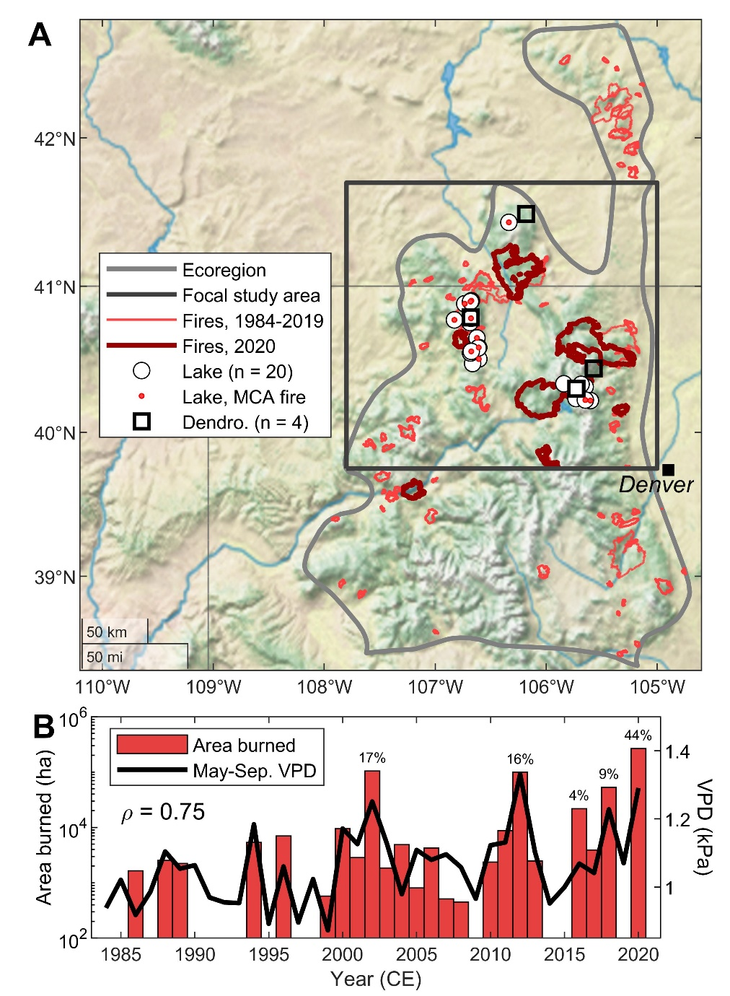

**Figure 1. Wildfire and climate in the central Rocky Mountains.** (A) Central Rocky Mountains (“Ecoregion”) and focal study area, with fire perimeters from 1984-2019 (thin, light-red lines) and 2020 (thick, dark-red lines). The 20 lakes with published paleo-fire records are shown with white circles; lakes recording fire events during the early Medieval Climate Anomaly, c. 770-870 CE, are shown in red. The general locations of published tree-ring-based stand-age and fire-scar records used to reconstruct fire extent are shown with white squares; the geographic extent represented by each study exceeds the extent of the symbols. (B) Ecoregion-wide area burned for fire perimeters displayed in (A) and average May-September vapor pressure deficit (VDP). Percentages above red bars are the proportion of total area burned (from 1984-2020) contributed by the given year.

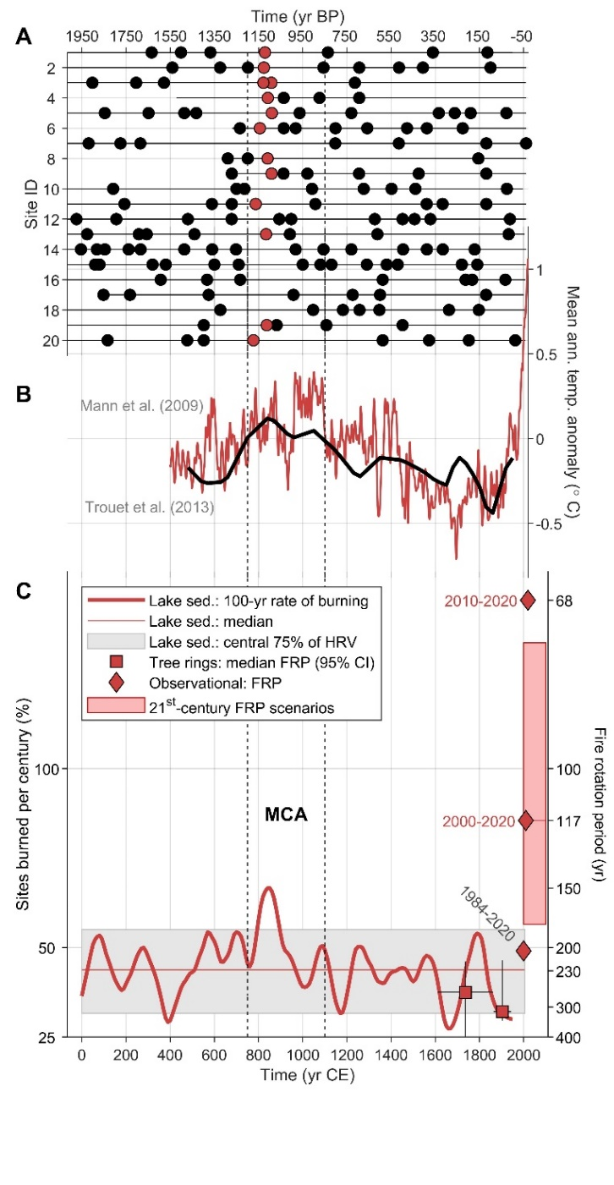

**Figure 2. Subalpine forest fire history.** (A) Fire events (circles) from the 20 sites in Fig. 1A, ordered from north to south (1-20). Black horizontal lines indicate when lakes were recording; red circles highlight the century with maximum burning. (B) Northern Hemisphere (red, 10-yr) and North America (black, 30-yr) mean annual temperature reconstructions, with the Medieval Climate Anomaly (MCA) highlighted by dashed vertical lines; Mann et al. (2009) data extended from 2006 with data from the Climate Research Unit. (C) Paleo-fire history from lake sediments (percent sites burned per century, left axis, and paleo fire rotation period [FRP], right axis) from (A), with median (red line) and the central 75% of the historical range of variability (HRV, grey rectangle; median tree-ring-derived FRP for c. 1611-1863 and 1864 1944 CE (red squares), calculated from eight FRP values (11, 15, 17, 21) with 95% bootstrapped confidence interval; contemporary FRP values for subalpine forests within the focal study area (red diamonds); and 21st-century FRP scenarios, assuming continued rates of burning between the 1984-2020 rate (FRP of 204 yr) and the 2010-2020 rate (FRP of 68 yr; see also Fig. S2).

**Table 1. Contemporary area burned statistics and fire rotation period calculations for the focal study area, for different time periods from 1984-2000.**

|  |  |  |  |
| --- | --- | --- | --- |
|  | **Entire study region (7,817,464 ha)** | **Subalpine forest in focal study area**  **(1,395,870 ha)** | |
| **Time period (CE)** | **Area burned (ha)**  **(% of total)** | **Area burned (ha)**  **(% of total)** | **Fire rotation period (yr)** |
| 1984-2019 | 340,216 (56%) | 71,953 (28%) | 698 |
| **1984-2020** | **606,263 (100%)** | **252,811 (100%)** | **204** |
| 2000-2019 | 320,939 (53%) | 70,175 (28%) | 398 |
| **2000-2020** | **586,985 (97%)** | **251,033 (99%)** | **117** |
| 2010-2020 | 457,340 (75%) | 227,356 (90%) | 68 |
| 2020 | 266,046 (44%) | 180,858 (72%) | -- |