

**Supplementary Information for**

***Rocky Mountain subalpine forests now burning more than any time in recent millennia***

Philip E. Higuera, Bryan N. Shuman, Kyra D. Wolf

\*Philip Higuera

Email: [philip.higuera@umontana.edu](mailto:philip.higuera@umontana.edu)

**This PDF file includes:**

Figures S1 to S3

SI References

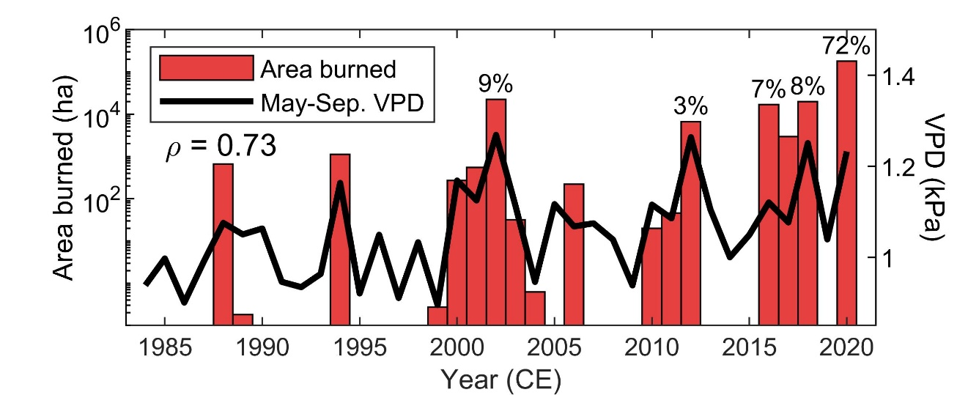

**Figure S1.** **Wildfire and climate in the focal study area.** Subalpine forest area burned within the focal study area (defined in Fig. 1A), and average May-September vapor pressure deficit (VDP) from Grand Lake, Colorado. Percentages above red bars are the proportion of total area burned (from 1984-2020) contributed by the given year. The area burned and VPD time series have a Spearman rank correlation (ρ) of 0.73 (p < 0.001).

**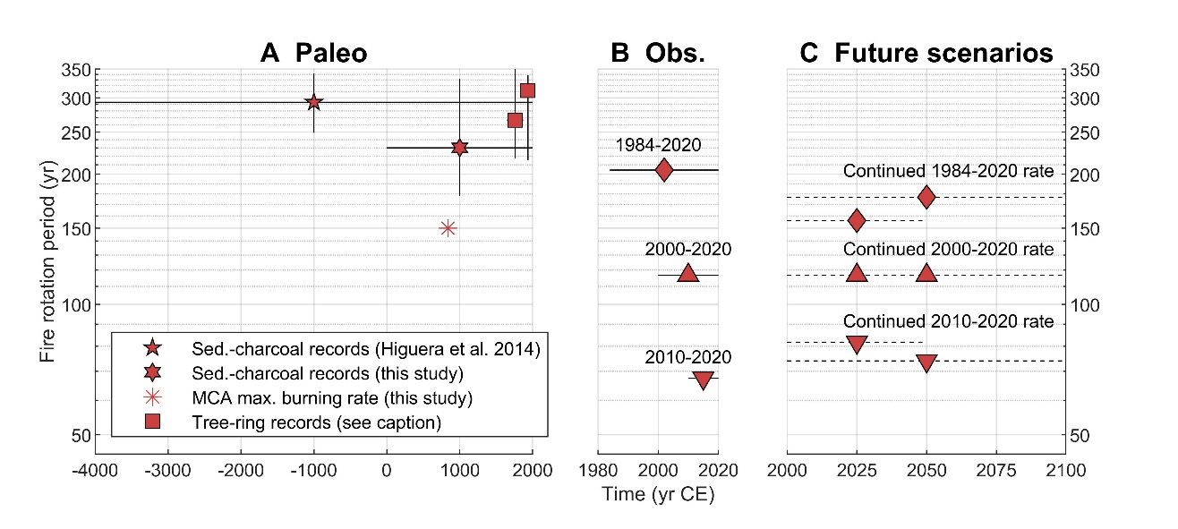**

**Figure S2.** **Historical and contemporary fire rotation periods, and hypothetical future scenarios for subalpine forests in the focal study area.** (A) Fire rotation periods (FRP) from sediment-charcoal and tree-ring records from subalpine forest watersheds within the focal study area. Sediment-charcoal records are the mean and bootstrapped 95% confidence (1) or the central 80% of all 100-yr estimates (Fig. 2C, this study). Tree-ring-based reconstructions (2-5) are the median and the bootstrapped 95% confidence interval from published FRP or fire extent statistics from eight watersheds (as in Fig. 2C; see Materials and Methods). (B) Contemporary observations are from 1984-2020, 2000-2020, and 2010-2020. (C) Future scenarios for 2000-2050 and 2000-2100 use the observed area burned from 2000-2020, and then assume a continued rate of burning equivalent to the three time periods in (B). For all panels, horizontal lines reflect the time period covered by each FRP statistic.

**C:\Users\philip.higuera.UM\Box\1_phiguera\1_working\Manuscripts\Manuscripts_in_review\BreakingPaleoRecords\Figures\Fig_S3.tif**

**Figure S3.** **Subalpine forest vegetation within the focal study area.** Focal study area (map extent), as in Figure 1A, with subalpine forests, as defined by the LANDFIRE environmental site potential (ESP) product. LANDFIRE ESP is a 30-m resolution product representing the vegetation that could occupy a site based on the biophysical setting (www.landfire.gov). Subalpine forest vegetation was defined by combining the following ESP classes, within the broader vegetation classifications of upland forest, upland woodland, and wetland forest: Rocky Mountain Dry-Mesic Spruce-Fir Forest and Woodland; Rocky Mountain Mesic-Wet Spruce-Fir Forest and Woodland; Rocky Mountain Lodgepole Pine Forest. The 20 lakes with published paleo-fire records are shown with white circles; lakes recording fire events during the early Medieval Climate Anomaly, c. 770-870 CE, are shown in red. The general locations of published tree-ring-based stand-age and fire-scar records used to reconstruct fire extent are shown with white squares.

**SI References**

1. P. E. Higuera, C. E. Briles, C. Whitlock, Fire-regime complacency and sensitivity to centennial-through millennial-scale climate change in Rocky Mountain subalpine forests, Colorado, USA. *Journal of Ecology* **102**, 1429-1441 (2014).

2. A. Buechling, W. L. Baker, A fire history from tree rings in a high-elevation forest of Rocky Mountain National Park. *Canadian Journal of Forest Research* **34**, 1259-1273 (2004).

3. E. Howe, W. L. Baker, Landscape Heterogeneity and Disturbance Interactions in a Subalpine Watershed in Northern Colorado, USA. *Annals of the Association of American Geographers* **93**, 797-813 (2003).

4. K. Kipfmueller, W. L. Baker, A fire history of a subalpine forest in south-eastern Wyoming, USA. *Journal of Biogeography* **27**, 71-85 (2000).

5. J. S. Sibold, T. T. Veblen, M. E. Gonzalez, Spatial and temporal variation in historic fire regimes in subalpine forests across the Colorado Front Range in Rocky Mountain National Park, Colorado, USA. *Journal of Biogeography* **33**, 631-647 (2006).