15 April, 2021

Dear editor,

Thank you for handling the review of our manuscript entitled *Rocky Mountain subalpine forests now burning more than any time in recent millennia*. We found the comments and suggestions from the two reviews very helpful for improving the manuscript. Through the online manuscript portal, we have uploaded a revised version of the manuscript, with track changes, and a point-by-point response to all reviewer comments. In addition to the revisions requested by the reviewers, we also updated the statistics in the paper to include area burned data from 2019 (previously not included, due to a lack of MTBS data at the time). Thus, the statistics on contemporary fire activity have are updated throughout, which do not change any of the main findings from analyses. We also added an additional supplementary figure.

The manuscript is not under consideration elsewhere, and we declare no conflicts of interest. Thank you for your time and consideration.

Sincerely,

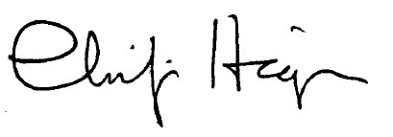

Philip Higuera

Associate Professor of Fire Ecology, Dept. of Ecosystem and Conservation Sciences

University of Montana

Missoula, MT 59812, USA  
[philip.higuera@umontana.edu](mailto:philip.higuera@umontana.edu)