**FIRST FTC Robot Guide**

**for Beginners**

**By Team 18225 - High Definition**

Contents

**1.0 Overview 1**

**2.0 Sample Robot Structure 1**

**3.0 Control Hub 2**

**4.0 Driver Station 3**

**5.0 Drivetrain 6**

**6.0 Arm 8**

**7.0 Sensors 8**

**8.0 Let’s Start Building! 9**

**9.0 Purchasing Parts 10**

**Appendix 11**

# 1.0 Overview

When building a robot, you have a lot of options, especially in the realm of complexity. That said, be aware that FIRST FTC does have some rules and limitations in terms of choosing parts/devices.

This document is mainly to help FTC beginners in building a simple, runnable robot with a one control hub + one phone system.

The robot size must be within 18”x18”x18”.

# 2.0 Sample Robot Structure

Our sample robot is built with the following subsystems:

* Control Hub (robot controller)
* Drive Station (driver remote control)
* Drivetrain (chassis)
* Arm (collect items/objects),
* Sensor (detect objects and distance)

The control hub and driver station can be purchased and used directly. For the drivetrain, teams can build their own or buy a commercial kit. Regardless of whether a team is rookie or experienced, the individual subsystems such as the arm described in this document, will be designed and built by the team. There are also several sensor options such as color sensors, ultrasonic distance sensors, and touch sensors that are available for purchase and use.

# 3.0 Control Hub

Control Hub and Extension Hub are the robot's core controlling devices. The executable software code is installed inside of the Control Hub. This hub is used to receive game players’ commands, retrieve sensor’s sampling data, calculate/analyze data, and output the control command to motors and servos.

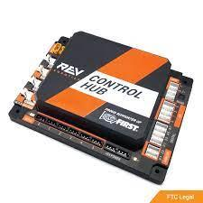 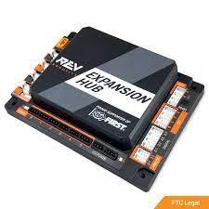

The Control Hub provides an array of USB ports and communicates directly with the driver station via WiFi. It also carries 4 motor ports, 6 servo ports, 8 digital input/output ports, 4 analog input ports, 4 independent I2C ports, and 1 Internal 9-axis IMU (gyroscope). Additionally, it has 2 RS485 ports which allows it to connect to additional expansion hubs if needed. Adding a second expansion hub will allow the robot to control more motors and servos, and use more sensors, not required for the sample robot. Both the Control and the Expansion Hub also carry a power input/output port.

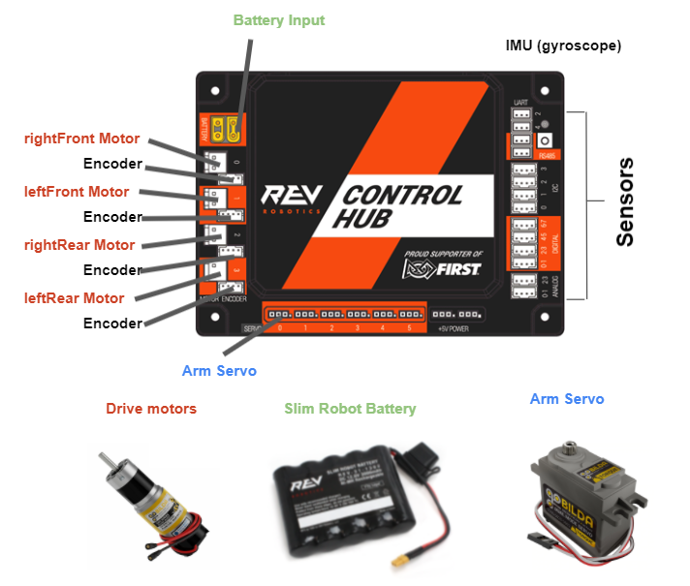

Above is an example diagram detailing the wiring for a Control Hub. You may find the locations of each of the ports, as well as an example of each of the objects that plugs into the ports. The parts that we use on our sample robot are slightly different and can be found in the next section. These example parts are:

* Power Input
  + Slim Battery
  + Power Switch
* Motors
  + Gobilda Yellow Jacket Motor
* Servo
  + Gobilda Servo (small movement applications)
* I2C
  + Color Sensor V2 (detects colors at a short range)
* Remote Control
  + FTC Legal Driver Station Phone
  + FTC Legal Gamepads

More detailed information about this Control Hub, as well as other resources such as CAD files, can be found at <https://www.revrobotics.com/rev-31-1595/>

# 4.0 Driver Station

The FTC Driver Station is the phone through which the drive team communicates with the robot. There are a number of guidelines that regulate the Driver Station and associated controlling mechanisms (sourced from Game Manual 1, 2021-2022 Freight Frenzy):

**DS01**: The Driver Station must consist of a **legal Android Device**, or a recently released REV Driver Hub. In this sample robot, we will use a Motorola Moto E5 phone.

*Legal Android Devices:*

* Motorola Moto G 2nd Generation
* Motorola Moto G 3rd Generation
* Motorola Moto G4 Play
* Motorola Moto G5
* Motorola Moto G5 Plus
* Motorola Moto E4
* Motorola Moto E5
* Motorola Moto E5 Play

**DS02**: The Driver Station may be connected to up to two gamepad controllers for robot driving, legal gamepads including:

* Logitech F310 Gamepad
* Xbox 360 controller for Windows
* Sony DualShock 4 Wireless Controller for PS4 operating in wired mode only
* Etpark Wired Controller for PS4

Here is a quick introduction of the Driver Station app interface.

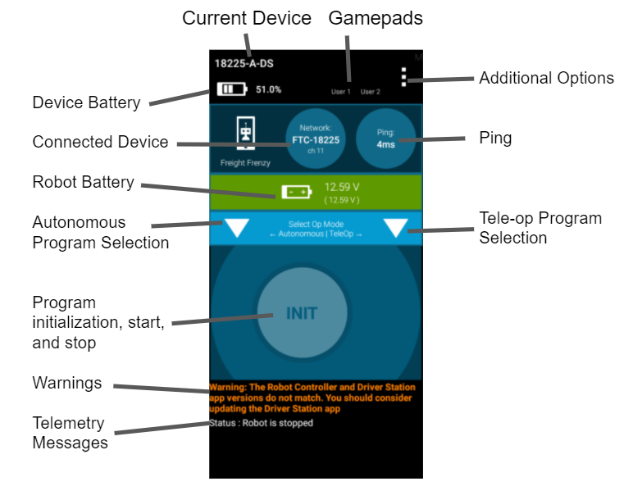

In the top bar, you can see the name of the device, the current device battery life, as well as the gamepads that are connected to the phone. The traffic light button in the top right also provides additional options and settings that can be explored.

The second bar shows the Control Hub that the Driver Station is connected to, as well as the ping on the network. Immediately below that you can find the battery voltage remaining.

The menu below shows two dropdowns, one on the left and one on the right. The button on the left is used to select programs for Autonomous, while the one on the right is for the driver-controlled (tele-op) programs.

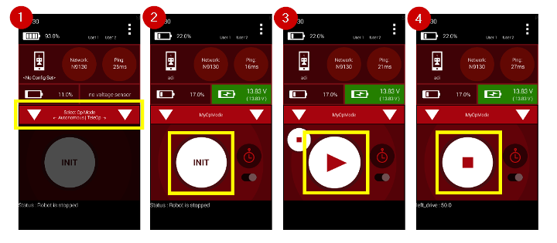

(CoderZ Knowledge Base)

In the above image, you can see the steps to run a program.

1. Select your desired program from one of the two dropdowns
2. Click the initialize button (“INIT”) to activate the program.
3. Click play. In autonomous mode, this will run your program. In tele-op, the robot will wait for driver input.
4. The program may be terminated at any time using the stop button.

Other than these features, there is also a timer feature, which will automatically stop your program from running after 30 seconds have elapsed, which is useful for the autonomous mode. Telemetry can also be viewed at the bottom of the phone, as seen in the first image where the driver can see the Target Power, Motor Power, and Servo Position values.

# 5.0 Drivetrain

The drivetrain is a fundamental part of a robot as all subsystems are built upon it. It can be built in a variety of ways.

**Frame type:** Designed in the shape of a square, triangle, or an H typically

**Transmission type:** Wheels can be powered directly with a motor, or make use of belts, chains, and gears

**Wheel type:** Typical choice between traction/grip, omni, and mecanum wheels

**Configuration:** Typically choose between swerve, holonomic, tank, mecanum, and regular

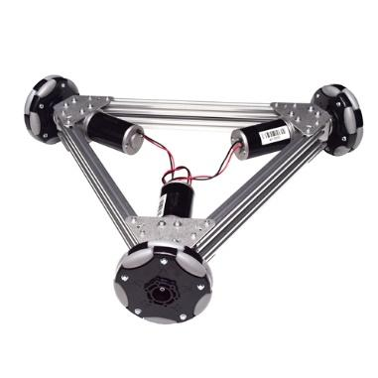 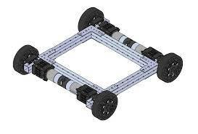 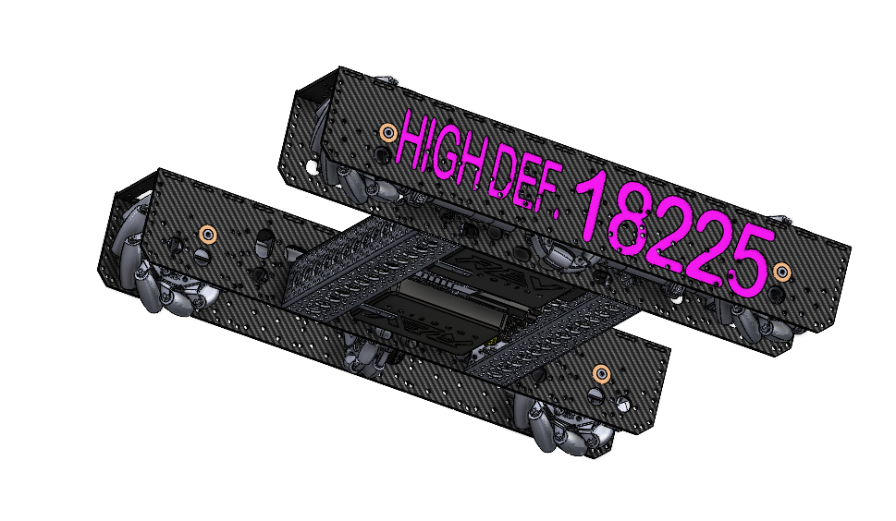

Our sample robot uses a commercial drivetrain kit. This will save lots of time for teams to work on other important tasks, such as programming, designing/building other subsystems, etc. Once you have accumulated some experience, it may be a good idea to start designing and building a custom drivetrain to truly tailor towards your needs.

There are many different commercial drivetrains - one that is used in our example is GoBilda’s Strafer Chassis Kit V4 because of its compact and versatile design. For more detailed information, visit here: <https://www.gobilda.com/strafer-chassis-kit-v4/>

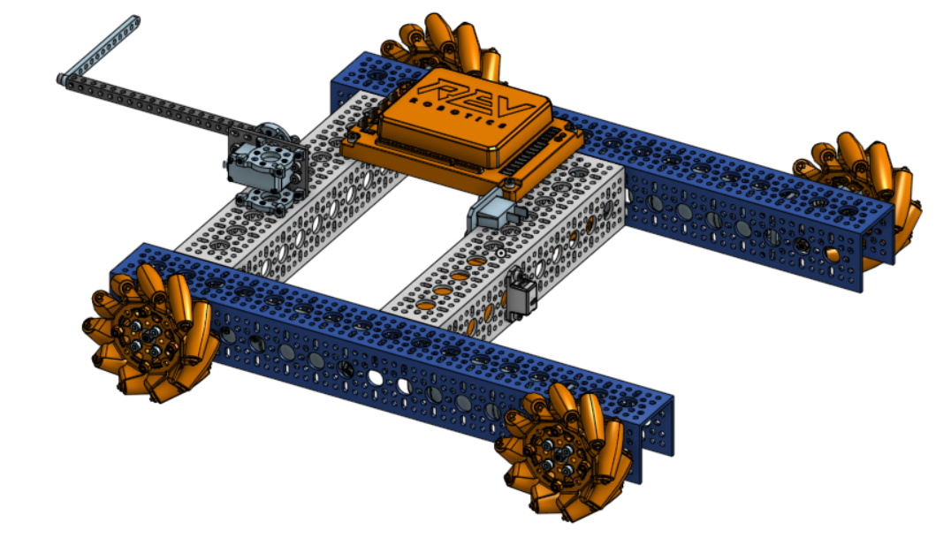

CAD Assembly of the GoBilda Strafer Chassis Kit V4 with a mounted Control Hub

# 6.0 Arm

Teams will have to design a new type of arm each year. Whether it be for picking up/delivering a game element, moving a platform, or reaching high into the air to place a block, robotic arms are used in essentially any FTC season.

For arm construction, teams can choose between varying structural components such as channels and beams. Arms are typically powered by servos, although motors can be used for extra power/torque. Additionally, teams have to custom design claws to grab game elements to accomplish each year’s challenges.

​​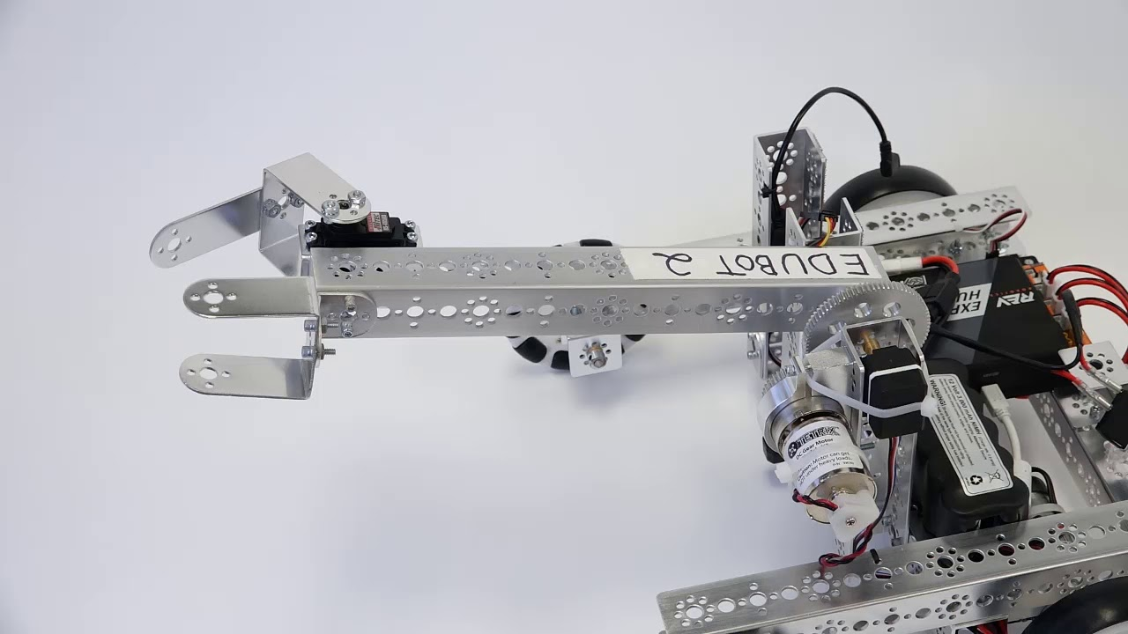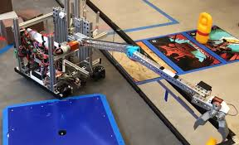

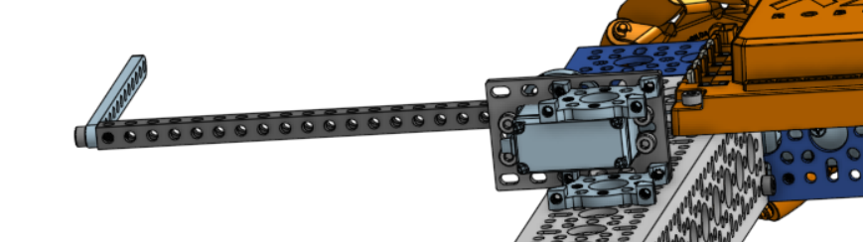

Basic arm design on sample robot

# 7.0 Sensors

In FTC, the most commonly used sensors are ultrasonic sensors to detect distances, color sensors for sorting objects/items, and touch sensors. All sensors must be I2C protocol (e.g. SPI is illegal). Additionally, external encoders can be used to build navigation devices. Some types of web cameras are also legal to be used in object detection and robot positioning.

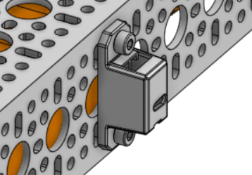

Color sensor attachment on sample robot

# 

# 8.0 Let’s Start Building!

1. Build the [GoBilda Strafer Chassis Kit v4](https://www.gobilda.com/strafer-chassis-kit-v4/) with [instructions](https://www.gobilda.com/content/user_manuals/3209-0001-0004-v4.1-assembly-instructions.pdf). Alternate kits are okay as well, but might not fit as well with our steps.
2. Prepare the necessary parts from the list in the appendix, as well as the required tools. Parts to include are (unlinked parts can be found below in the supplementary parts list:
   1. [Servo](https://www.gobilda.com/standard-size-servos/)
   2. [Power Switch](https://www.revrobotics.com/rev-31-1387/)
   3. [Color Sensor](https://www.revrobotics.com/rev-31-1557/)
   4. [Servo Hub](https://www.gobilda.com/1908-series-servo-hub-25-tooth-spline-32mm-diameter/)
   5. [Servo Bracket](https://www.gobilda.com/1801-series-servo-plate-for-standard-size-servos/)
   6. [Square Beam](https://www.gobilda.com/1106-series-square-beam-23-hole-184mm-length/)
   7. [Flat Beam](https://www.gobilda.com/1102-series-flat-beam-13-hole-104mm-length-2-pack/)
   8. [Mounting Bracket](https://www.gobilda.com/1221-series-2-side-2-post-pattern-mount-32-2/)
   9. Assorted screws and nuts in #6-32 sizes
3. Mount the control hub first. Align the control hub with holes on the side channel and middle channels and use screws and nuts to secure the control hub onto the chassis.
4. Secure the Power Switch to the middle channel, aligning the holes on the polycarbonate piece with the top of the middle channel.
5. Assemble the servo arm by attaching the flat and square beams as shown and screwing the square beam to the servo hub. Attach the servo hub to the servo and screw the servo into the servo bracket. The servo bracket then will connect to a mounting bracket, as shown, which can then be screwed into the middle connector channel.
6. Attach the color sensor to the front of the robot, mounting it on the middle U channel that is further to the right in the below picture.

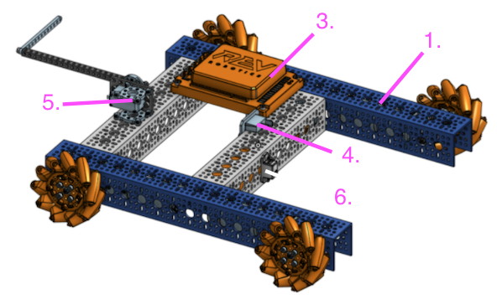

Labeled diagram detailing the instructions above

For more detailed reference, view our assembled CAD [here](https://cad.onshape.com/documents/ffda470bae739e2b5548ea95/w/1e754527187fe4a833181e7a/e/3384beefe5fa796e62e826b5?renderMode=0&uiState=615a93202220a570e484cff9)!

# 9.0 Purchasing Parts

[www.AndyMark.com](http://www.andymark.com) is the official site to purchase the FTC competition fields/elements.

Other common parts, such as motors, servos, channels, etc, can be found from the sites below:

* [www.gobilda.com](http://www.gobuilda.com), [www.servocity.com](http://www.servocity.com), [www.revrobotics.com](http://www.revrobotics.com), [www.vexrobotics.com](http://www.vexrobotics.com), [www.robotshop.com/](http://www.robotshop.com/), [www.boltdepot.com](http://www.boltdepot.com), [www.aliexpress.com](http://www.aliexpress.com), [www.amazon.com](http://www.amazon.com), [www.newark.com](http://www.newark.com)

The Control Hub is rather expensive - for newly registered teams, we recommend purchasing this via [www.firstinspire.org](http://www.firstinspire.org).

After a coach logs into this website, navigate to the Dashboard, click the “Payment & Product” menu, select “Order Products” submenu, and choose the Electronics Set to order.

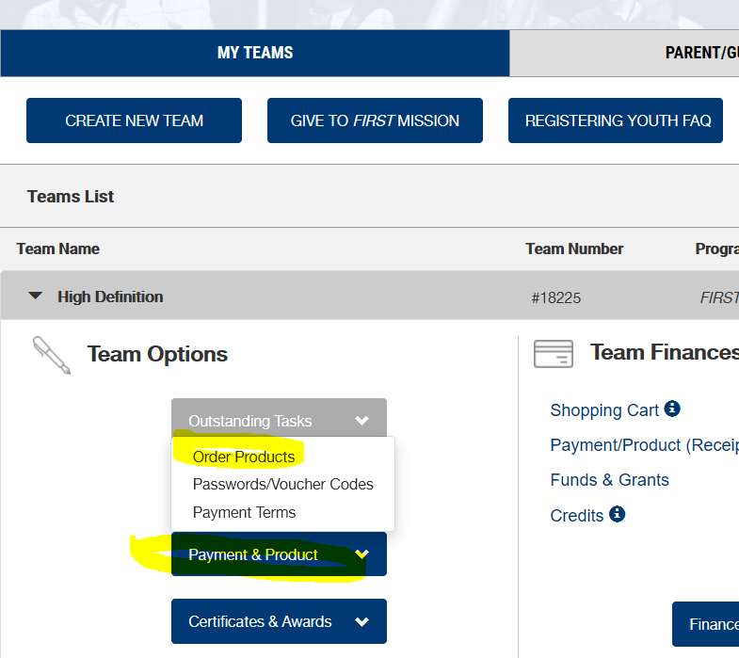

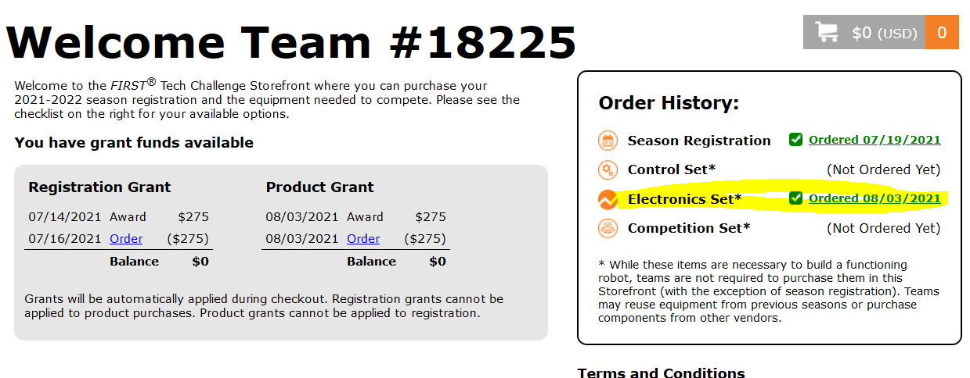

# Appendix

FTC legal/illegal part lists

<https://www.firstinspires.org/sites/default/files/uploads/resource_library/ftc/legal-illegal-parts-list.pdf>

FTC game manuals

<https://www.firstinspires.org/resource-library/ftc/game-and-season-info>

Minimum required parts for building a runnable robot chassis:

|  |  |  |  |  |
| --- | --- | --- | --- | --- |
| **Item Name** | **Image** | **Type** | **Purchase Link** | **Description** |
| Chassis |  | Strafer Chassis Kit V4 | <https://www.gobilda.com/strafer-chassis-kit-v4/> | Includes 4 motors, 4 mecanum wheels, channels, adapters, 2 installation L-Keys, etc. provides installation manual and CAD. |
| Battery |  | REV-31-1302 | <https://www.revrobotics.com/rev-31-1302/> | Have at least 2 batteries for backups. |
| Charger |  | REV-31-1299 | <https://www.revrobotics.com/rev-31-1299/> |  |
| GoBilda Motor cable |  | 3801-0613-0100 | <https://www.gobilda.com/2-pos-jst-vh-mh-fc-to-3-5mm-bullet-mh-fc-adaptor-100mm-length/> | Used to connect each motor to Control/extension Hub |
| Electronics Set |  | REV-35-1728 | <https://www.revrobotics.com/rev-35-1728/> | Recommend purchasing this set from [www.firstinspires.org](http://www.firstinspires.org)  since it has a discount. |
| XT30 Extension Cable |  | REV-31-1394 | <https://www.revrobotics.com/xt30-extension-cable-2-pack/> | This cable is used for providing power from Control Hub to Extension Hub. |
| Cell Phone |  |  |  | Please read the Legal part document shown in the appendix below |
| Game Pad |  |  |  | Please read the Legal part document shown in the appendix below |
| USB cable and hub |  |  |  | The cable and hub are used to connect phone and game pads. |

Tools required:

|  |  |
| --- | --- |
| **Item Name** | **Description** |
| 3mm Ball-end hex L-Key | Used for metric screws |
| 2.5mm Hex L-key | Used for metric screws |
| 7/64” ball end screwdriver | Used for #6-32 screws |
| 5.5mm Nut driver | <https://www.revrobotics.com/rev-41-1119/> |

Additional parts that supplement required parts:

|  |  |  |  |  |
| --- | --- | --- | --- | --- |
| **Item Name** | **Image** | **Type** | **Purchase Link** | **Description** |
| Servo |  |  | <https://www.gobilda.com/standard-size-servos/> | Different types based on the speed and torque.  24 and 25 tooth options |
| Extension Hub |  | REV-31-1153 | <https://www.revrobotics.com/rev-31-1153/> | Used when needed to connect more than 4 motors. |
| M2.5, M3, M4 Screw |  |  | <https://www.boltdepot.com/> | Recommend button and flat head screw |
| #6-32 screw |  |  | <https://www.boltdepot.com/> | Recommend button and flat head screw |
| ServoBlock |  | 3202-0001-2501 | <https://www.servocity.com/servoblocks/> | Note, there are 24 tooth and 25 tooth options. |
| Sensor cable |  | REV-31-1408 | <https://www.revrobotics.com/jst-ph-4-pin-sensor-cable-4-pack/> |  |
| Servo Cable & extension |  |  | <https://www.gobilda.com/connector-style-tjc8-servo/> |  |
| Motor encoder cable |  |  | <https://www.gobilda.com/4-pos-jst-ph-mh-fc-to-4-pos-jst-xh-mh-fc-adaptor-150mm-length/> |  |
| VEX motors |  | VEX 393 motors | <https://www.vexrobotics.com/motors.html> | This is the only motor which can be treated as continuous servo. |
| Color Sensor |  | REV-31-1557 | <https://www.revrobotics.com/rev-31-1557/> |  |
| 2m Distance Sensor |  | REV-31-1505 | <https://www.revrobotics.com/rev-31-1505/> |  |
| Touch Sensor |  | REV-31-1425 | <https://www.revrobotics.com/rev-31-1425/> |  |

Read this article which supplements our beginner’s guide:

<https://gm0.org/en/latest/docs/power-and-electronics/control-system.html>