LAB3

di chuyển vào sbin của hadoop

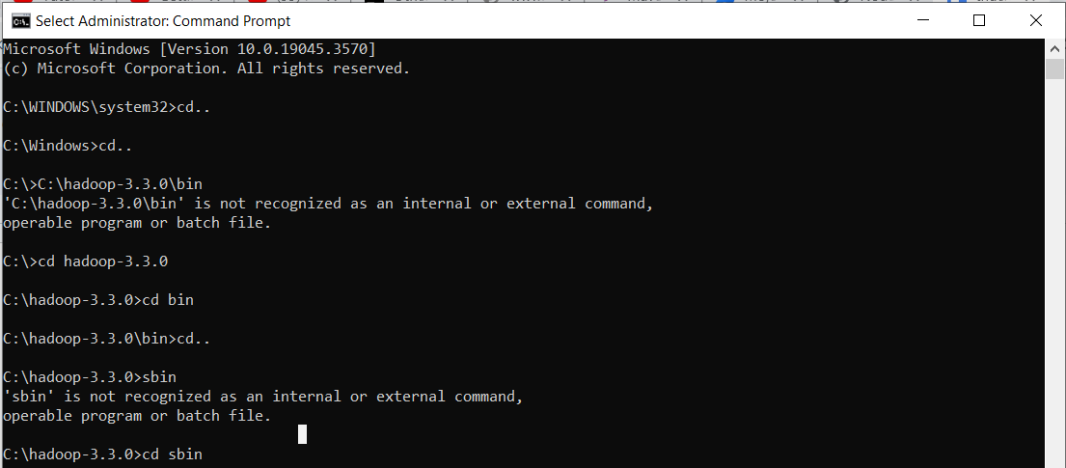

khởi động HDFS và các daemons ResourceManager và NodeManager của YARN.

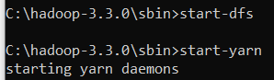

dùng lệnh jps để kiểm tra các daemons đã được khởi động chưa

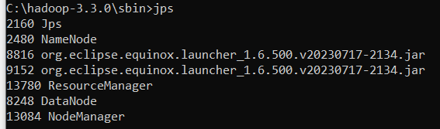

tạo 1 directory input trên HDFS và tải file data wordcount.txt trong C:/a có trong máy  
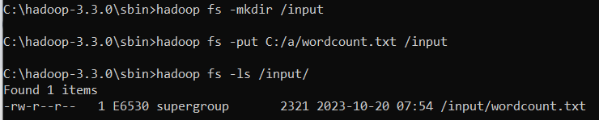

data trong wordcount

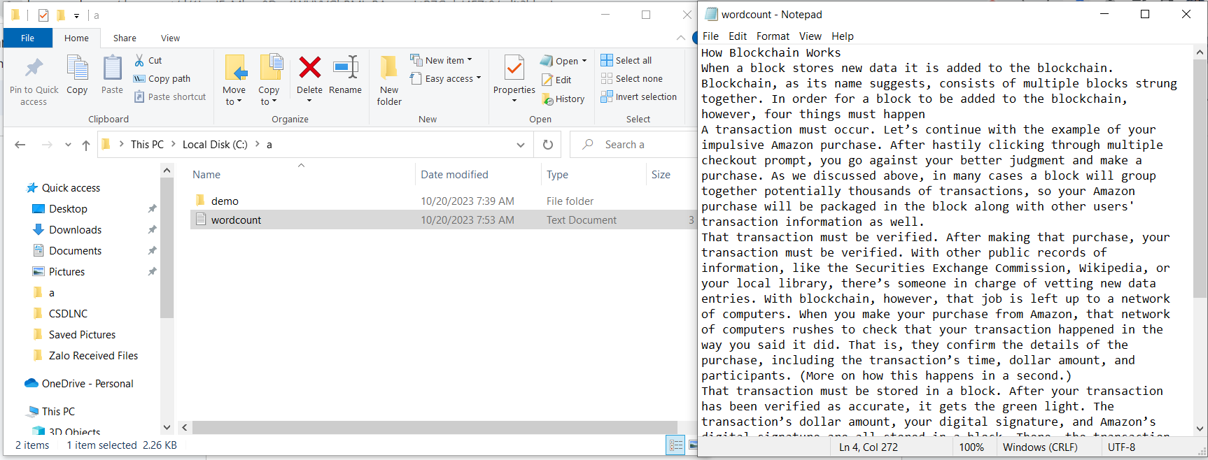

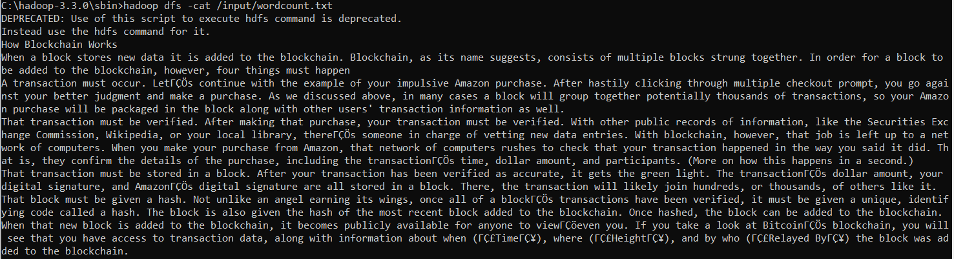

chạy lệnh để mapreduce file wordcount

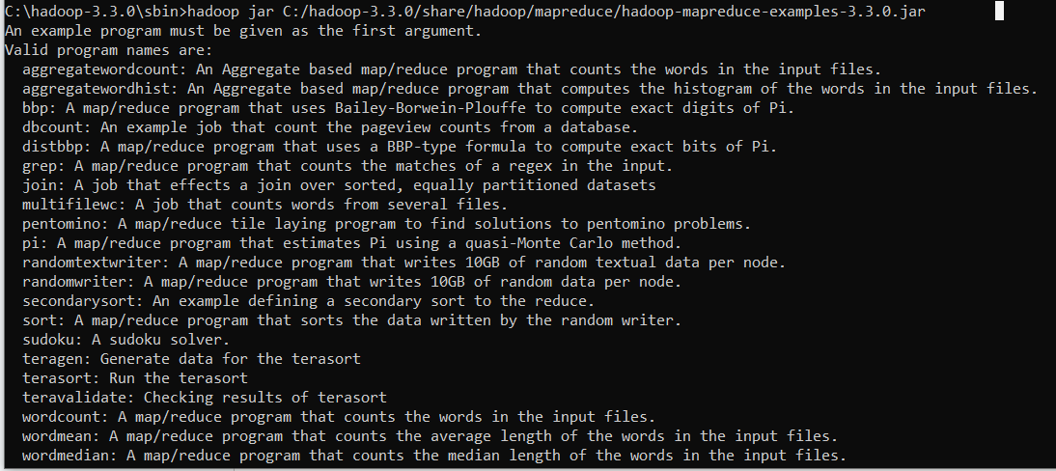

chạy mapreduce và lưu vào thư mục out trên HDFS  
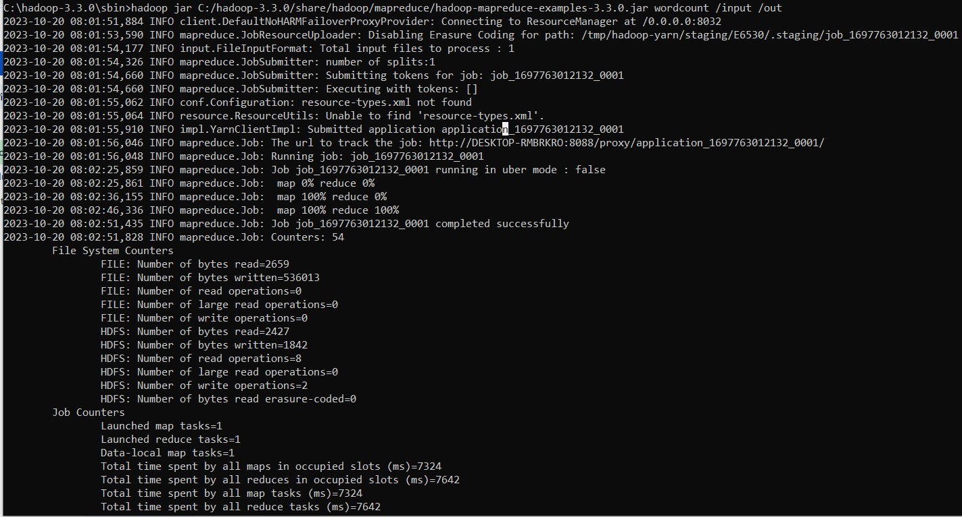

hiển thị nội dung của tất cả các tệp trong thư mục out trên HDFS

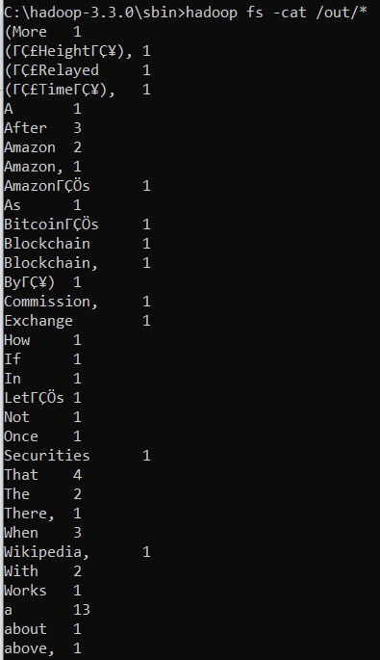

LAB5

Tạo project Maven đặt tên lab5

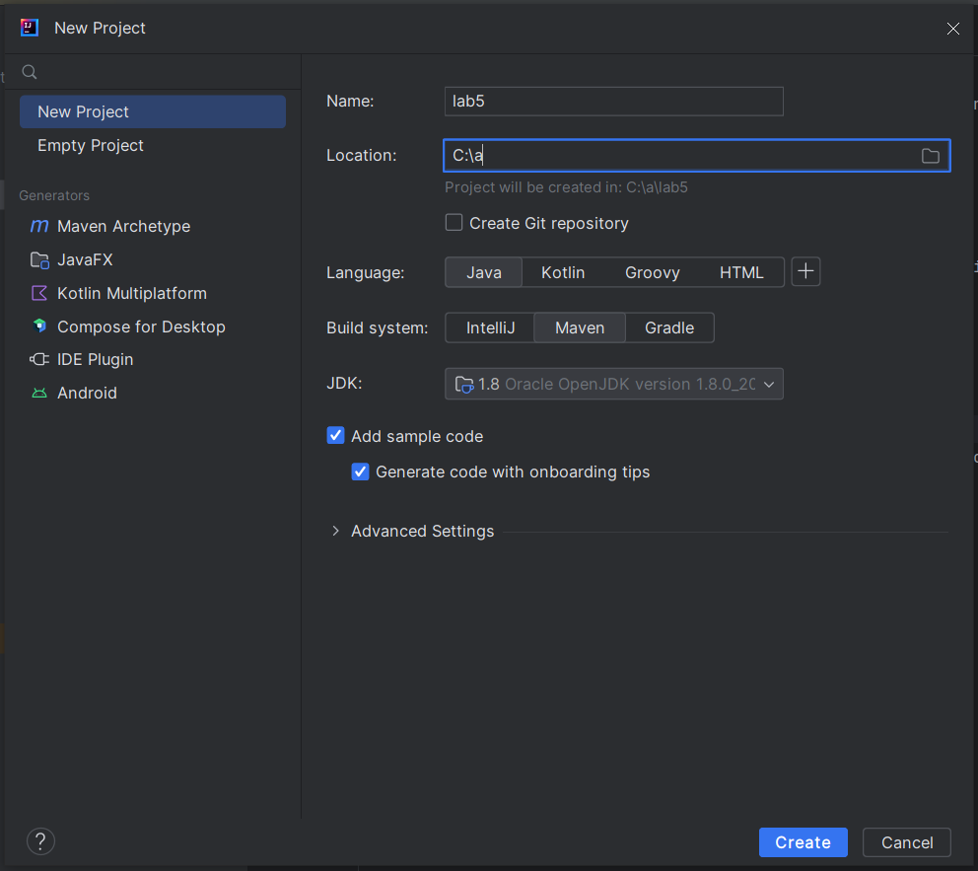

Tạo folder input và dữ liệu

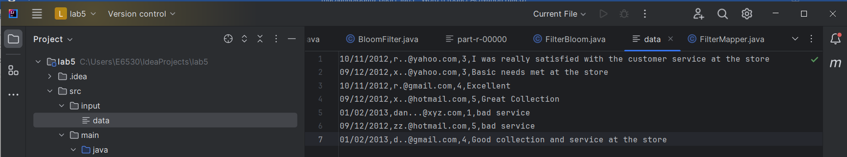

Tạo class FilterBloom

package org.example;  
import java.io.Serializable;  
import java.nio.charset.Charset;  
import java.security.MessageDigest;  
import java.security.NoSuchAlgorithmException;  
import java.util.BitSet;  
import java.util.Collection;  
  
public class FilterBloom<E> implements Serializable {  
 private BitSet bitset;  
 private int bitSetSize;  
 private double bitsPerElement;  
 private int expectedNumberOfFilterElements;  
 private int numberOfAddedElements;  
 private int k; // number of hash functions  
 static final Charset *charset* = Charset.*forName*("UTF-8");  
 static final String *hashName* = "MD5";  
 static final MessageDigest *digestFunction*;  
 static { // The digest method is reused between instances  
 MessageDigest tmp;  
 try {  
 tmp = java.security.MessageDigest.*getInstance*(*hashName*);  
 } catch (NoSuchAlgorithmException e) {  
 tmp = null;  
 }  
 *digestFunction* = tmp;  
 }  
 */**  
 * Constructs an empty Bloom filter. The total length of the  
 Bloom filter will be  
 * c*n.  
 *  
 * @param c is the number of bits used per element.  
 * @param n is the expected number of elements the filter will  
 contain.  
 * @param k is the number of hash functions used.  
 */* public FilterBloom(double c, int n, int k) {  
 this.expectedNumberOfFilterElements = n;  
 this.k = k;  
 this.bitsPerElement = c;  
 this.bitSetSize = (int)Math.*ceil*(c * n);  
 numberOfAddedElements = 0;  
 this.bitset = new BitSet(bitSetSize);  
 }  
 */**  
 * Constructs an empty Bloom filter. The optimal number of hash  
 functions (k) is estimated from the total size of the Bloom  
 * and the number of expected elements.  
 *  
 * @param bitSetSize defines how many bits should be used in  
 total for the filter.  
 * @param expectedNumberOElements defines the maximum number of  
 elements the filter is expected to contain.  
 */* public FilterBloom(int bitSetSize, int expectedNumberOElements) {  
 this(bitSetSize / (double)expectedNumberOElements,  
 expectedNumberOElements,  
 (int) Math.*round*((bitSetSize /  
 (double)expectedNumberOElements) * Math.*log*(2.0)));  
 }  
 */**  
 * Constructs an empty Bloom filter with a given false positive  
 probability. The number of bits per  
 * element and the number of hash functions is estimated  
 * to match the false positive probability.  
 *  
 * @param falsePositiveProbability is the desired false positive  
 probability.  
 * @param expectedNumberOfElements is the expected number of  
 elements in the Bloom filter.  
 */* public FilterBloom(double falsePositiveProbability, int  
 expectedNumberOfElements) {  
 this(Math.*ceil*(-(Math.*log*(falsePositiveProbability) /  
 Math.*log*(2))) / Math.*log*(2), // c = k / ln(2)  
 expectedNumberOfElements,  
 (int)Math.*ceil*(-(Math.*log*(falsePositiveProbability) /  
 Math.*log*(2)))); // k = ceil(-log_2(false prob.))  
 }  
 */**  
 * Construct a new Bloom filter based on existing Bloom filter  
 data.  
 *  
 * @param bitSetSize defines how many bits should be used for the  
 filter.  
 * @param expectedNumberOfFilterElements defines the maximum  
 number of elements the filter is expected to contain.  
 * @param actualNumberOfFilterElements specifies how many  
 elements have been inserted into the <code>filterData</code> BitSet.  
 * @param filterData a BitSet representing an existing Bloom  
 filter.  
 */* public FilterBloom(int bitSetSize, int  
 expectedNumberOfFilterElements, int actualNumberOfFilterElements,  
 BitSet filterData) {  
 this(bitSetSize, expectedNumberOfFilterElements);  
 this.bitset = filterData;  
 this.numberOfAddedElements = actualNumberOfFilterElements;  
 }  
 */**  
 * Generates a digest based on the contents of a String.  
 *  
 * @param val specifies the input data.  
 * @param charset specifies the encoding of the input data.  
 * @return digest as long.  
 */* public static int createHash(String val, Charset charset) {  
 return *createHash*(val.getBytes(charset));  
 }  
 */**  
 * Generates a digest based on the contents of a String.  
 *  
 * @param val specifies the input data. The encoding is expected  
 to be UTF-8.  
 * @return digest as long.  
 */* public static int createHash(String val) {  
 return *createHash*(val, *charset*);  
 }  
 */**  
 * Generates a digest based on the contents of an array of bytes.  
 *  
 * @param data specifies input data.  
 * @return digest as long.  
 */* public static int createHash(byte[] data) {  
 return *createHashes*(data, 1)[0];  
 }  
 */**  
 * Generates digests based on the contents of an array of bytes  
 and splits the result into 4-byte int's and store them in an array.  
 The  
 * digest function is called until the required number of int's  
 are produced. For each call to digest a salt  
 * is prepended to the data. The salt is increased by 1 for each  
 call.  
 *  
 * @param data specifies input data.  
 * @param hashes number of hashes/int's to produce.  
 * @return array of int-sized hashes  
 */* public static int[] createHashes(byte[] data, int hashes) {  
 int[] result = new int[hashes];  
 int k = 0;  
 byte salt = 0;  
 while (k < hashes) {  
 byte[] digest;  
 synchronized (*digestFunction*) {  
 *digestFunction*.update(salt);  
 salt++;  
 digest = *digestFunction*.digest(data);  
 }  
 for (int i = 0; i < digest.length/4 && k < hashes; i++) {  
 int h = 0;  
 for (int j = (i*4); j < (i*4)+4; j++) {  
 h <<= 8;  
  
 h |= ((int) digest[j]) & 0xFF;  
  
 }  
 result[k] = h;  
 k++;  
 }  
 }  
 return result;  
 }  
 */**  
 * Compares the contents of two instances to see if they are  
 equal.  
 *  
 * @param obj is the object to compare to.  
 * @return True if the contents of the objects are equal.  
 */* @Override  
 public boolean equals(Object obj) {  
 if (obj == null) {  
 return false;  
 }  
 if (getClass() != obj.getClass()) {  
 return false;  
 }  
 final FilterBloom<E> other = (FilterBloom<E>) obj;  
 if (this.expectedNumberOfFilterElements !=  
 other.expectedNumberOfFilterElements) {  
 return false;  
 }  
 if (this.k != other.k) {  
 return false;  
 }  
 if (this.bitSetSize != other.bitSetSize) {  
 return false;  
 }  
 if (this.bitset != other.bitset && (this.bitset == null ||  
 !this.bitset.equals(other.bitset))) {  
 return false;  
 }  
 return true;  
 }  
 */**  
 * Calculates a hash code for this class.  
 * @return hash code representing the contents of an instance of  
 this class.  
 */* @Override  
 public int hashCode() {  
 int hash = 7;  
 hash = 61 * hash + (this.bitset != null ?  
 this.bitset.hashCode() : 0);  
 hash = 61 * hash + this.expectedNumberOfFilterElements;  
 hash = 61 * hash + this.bitSetSize;  
 hash = 61 * hash + this.k;  
 return hash;  
 }  
  
 */**  
 * Calculates the expected probability of false positives based  
 on  
 * the number of expected filter elements and the size of the  
 Bloom filter.  
 * <br /><br />  
 * The value returned by this method is the <i>expected</i> rate  
 of false  
 * positives, assuming the number of inserted elements equals the  
 number of  
 * expected elements. If the number of elements in the Bloom  
 filter is less  
 * than the expected value, the true probability of false  
 positives will be lower.  
 *  
 * @return expected probability of false positives.  
 */* public double expectedFalsePositiveProbability() {  
 return  
 getFalsePositiveProbability(expectedNumberOfFilterElements);  
 }  
 */**  
 * Calculate the probability of a false positive given the  
 specified  
 * number of inserted elements.  
 *  
 * @param numberOfElements number of inserted elements.  
 * @return probability of a false positive.  
 */* public double getFalsePositiveProbability(double  
 numberOfElements) {  
// (1 - e^(-k * n / m)) ^ k  
 return Math.*pow*((1 - Math.*exp*(-k * (double) numberOfElements  
 / (double) bitSetSize)), k);  
 }  
 */**  
 * Get the current probability of a false positive. The  
 probability is calculated from  
 * the size of the Bloom filter and the current number of  
 elements added to it.  
 *  
 * @return probability of false positives.  
 */* public double getFalsePositiveProbability() {  
 return getFalsePositiveProbability(numberOfAddedElements);  
 }  
  
 */**  
 * Returns the value chosen for K.<br />  
 * <br />  
 * K is the optimal number of hash functions based on the size  
 * of the Bloom filter and the expected number of inserted  
 elements.  
 *  
 * @return optimal k.  
 */* public int getK() {  
 return k;  
 }  
 */**  
 * Sets all bits to false in the Bloom filter.  
 */* public void clear() {  
 bitset.clear();  
 numberOfAddedElements = 0;  
 }  
 */**  
 * Adds an object to the Bloom filter. The output from the  
 object's  
 * toString() method is used as input to the hash functions.  
 *  
 * @param element is an element to register in the Bloom filter.  
 */* public void add(E element) {  
 add(element.toString().getBytes(*charset*));  
 }  
 */**  
 * Adds an array of bytes to the Bloom filter.  
 *  
 * @param bytes array of bytes to add to the Bloom filter.  
 */* public void add(byte[] bytes) {  
 int[] hashes = *createHashes*(bytes, k);  
 for (int hash : hashes)  
 bitset.set(Math.*abs*(hash % bitSetSize), true);  
 numberOfAddedElements ++;  
 }  
 */**  
 * Adds all elements from a Collection to the Bloom filter.  
 * @param c Collection of elements.  
 */* public void addAll(Collection<? extends E> c) {  
 for (E element : c)  
 add(element);  
 }  
 */**  
 * Returns true if the element could have been inserted into the  
 Bloom filter.  
 * Use getFalsePositiveProbability() to calculate the probability  
 of this  
 * being correct.  
 *  
 * @param element element to check.  
 * @return true if the element could have been inserted into the  
 Bloom filter.  
 */* public boolean contains(E element) {  
 return contains(element.toString().getBytes(*charset*));  
 }  
 */**  
 * Returns true if the array of bytes could have been inserted  
 into the Bloom filter.  
 * Use getFalsePositiveProbability() to calculate the probability  
 of this  
 * being correct.  
 *  
 * @param bytes array of bytes to check.  
 * @return true if the array could have been inserted into the  
 Bloom filter.  
 */* public boolean contains(byte[] bytes) {  
 int[] hashes = *createHashes*(bytes, k);  
 for (int hash : hashes) {  
 if (!bitset.get(Math.*abs*(hash % bitSetSize))) {  
 return false;  
 }  
 }  
 return true;  
 }  
 */**  
 * Returns true if all the elements of a Collection could have  
 been inserted  
 * into the Bloom filter. Use getFalsePositiveProbability() to  
 calculate the  
 * probability of this being correct.  
 * @param c elements to check.  
 * @return true if all the elements in c could have been inserted  
 into the Bloom filter.  
 */* public boolean containsAll(Collection<? extends E> c) {  
 for (E element : c)  
 if (!contains(element))  
 return false;  
 return true;  
 }  
*/**  
 * Read a single bit from the Bloom filter.  
 * @param bit the bit to read.  
 * @return true if the bit is set, false if it is not.  
 */*public boolean getBit(int bit) {  
 return bitset.get(bit);  
}  
 */**  
 * Set a single bit in the Bloom filter.  
 * @param bit is the bit to set.  
 * @param value If true, the bit is set. If false, the bit is  
 cleared.  
 */* public void setBit(int bit, boolean value) {  
 bitset.set(bit, value);  
 }  
 */**  
 * Return the bit set used to store the Bloom filter.  
 * @return bit set representing the Bloom filter.  
 */* public BitSet getBitSet() {  
 return bitset;  
 }  
 */**  
 * Returns the number of bits in the Bloom filter. Use count() to  
 retrieve  
 * the number of inserted elements.  
 *  
 * @return the size of the bitset used by the Bloom filter.  
 */* public int size() {  
 return this.bitSetSize;  
 }  
 */**  
 * Returns the number of elements added to the Bloom filter after  
 it  
 * was constructed or after clear() was called.  
 *  
 * @return number of elements added to the Bloom filter.  
 */* public int count() {  
 return this.numberOfAddedElements;  
 }  
 */**  
 * Returns the expected number of elements to be inserted into  
 the filter.  
 * This value is the same value as the one passed to the  
 constructor.  
 *  
 * @return expected number of elements.  
 */* public int getExpectedNumberOfElements() {  
 return expectedNumberOfFilterElements;  
 }  
 */**  
 * Get expected number of bits per element when the Bloom filter  
 is full. This value is set by the constructor  
 * when the Bloom filter is created. See also  
 getBitsPerElement().  
 *  
 * @return expected number of bits per element.  
 */* public double getExpectedBitsPerElement() {  
 return this.bitsPerElement;  
 }  
 */**  
 * Get actual number of bits per element based on the number of  
 elements that have currently been inserted and the length  
 * of the Bloom filter. See also getExpectedBitsPerElement().  
 *  
 * @return number of bits per element.  
 */* public double getBitsPerElement() {  
 return this.bitSetSize / (double)numberOfAddedElements;  
 }  
}

Tạo class FilterMapper

package org.example;  
import java.lang.System.*;  
import java.io.IOException;  
import org.apache.hadoop.io.LongWritable;  
import org.apache.hadoop.io.NullWritable;  
import org.apache.hadoop.io.Text;  
import org.apache.hadoop.mapreduce.Mapper;  
import java.util.*;  
public class FilterMapper extends Mapper<LongWritable, Text, Text,  
 NullWritable> {  
 FilterBloom<String> filter;  
 @Override  
 protected void setup(org.apache.hadoop.mapreduce.Mapper.Context  
 context)  
 throws IOException, InterruptedException {  
 super.setup(context);  
 double falsePositiveProbability = 0.1;  
 int expectedNumberOfElements = 100;  
 filter = new FilterBloom<String>(falsePositiveProbability,  
 expectedNumberOfElements);  
 filter.add("bad service");  
 filter.add("iron man");  
 filter.add("marvel");  
 filter.add("end game");  
 }  
 protected void map(LongWritable key, Text value, Context context)  
 throws java.io.IOException, InterruptedException {  
 String[] tokens = value.toString().split(",");  
 for(String token :tokens){  
 System.*out*.println(token);  
 if(filter.contains(token)){  
 context.write(value, NullWritable.*get*());  
 }  
 }  
 }  
}

Tạo class main BloomFilter

package org.example;  
import java.io.IOException;  
import org.apache.hadoop.fs.Path;  
import org.apache.hadoop.io.IntWritable;  
import org.apache.hadoop.io.NullWritable;  
import org.apache.hadoop.io.Text;  
import org.apache.hadoop.mapreduce.lib.input.FileInputFormat;  
import org.apache.hadoop.mapreduce.lib.output.FileOutputFormat;  
import org.apache.hadoop.mapreduce.Counter;  
import org.apache.hadoop.mapreduce.CounterGroup;  
import org.apache.hadoop.mapreduce.Counters;  
import org.apache.hadoop.mapreduce.Job;  
public class BloomFilter {  
 public static void main(String[] args)  
 throws IOException, ClassNotFoundException,  
 InterruptedException {  
 Job job = new Job();  
 job.setJarByClass(org.example.FilterMapper.class);  
 job.setJobName("Customer Complaint Filter");  
 FileInputFormat.*addInputPath*(job, new Path("src/input/data"));  
 FileOutputFormat.*setOutputPath*(job, new Path("src/output"));  
 job.setMapperClass(org.example.FilterMapper.class);  
 job.setOutputKeyClass(Text.class);  
 job.setOutputValueClass(NullWritable.class);  
 job.waitForCompletion(true);  
 }  
}

chạy chương trình và xuất kết quả

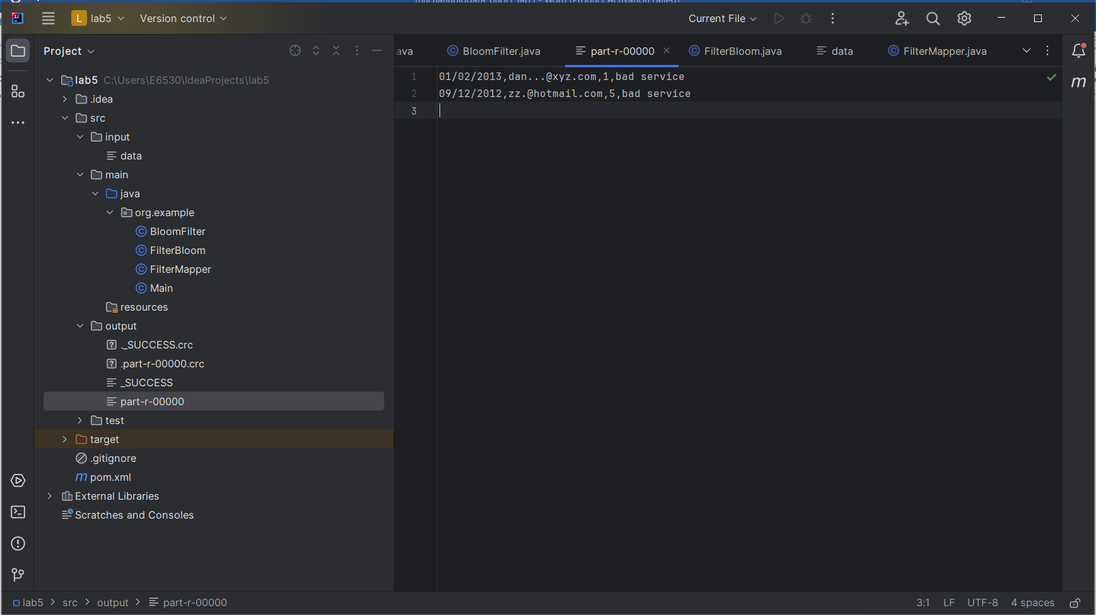

LAB 6

Tạo project maven đặt tên lab6

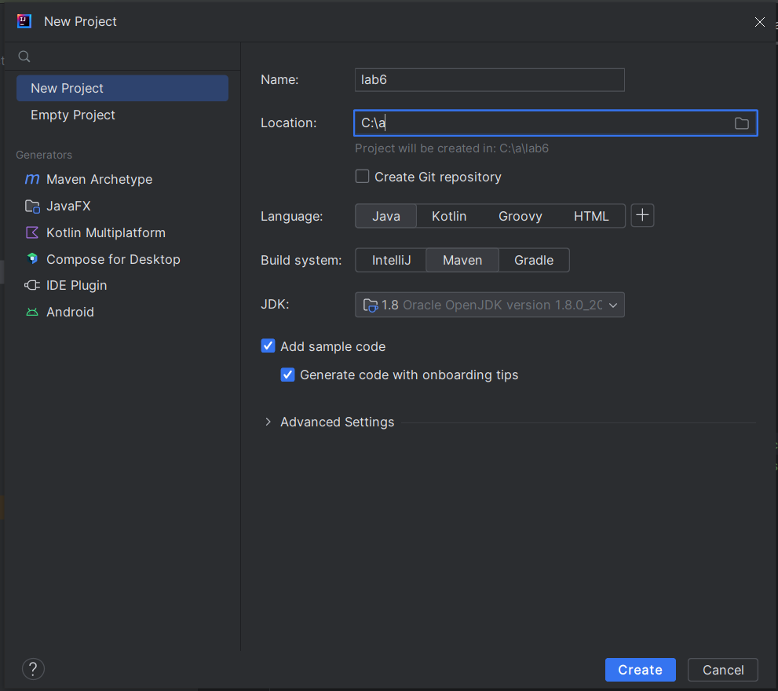

Tạo folder input và add file data   
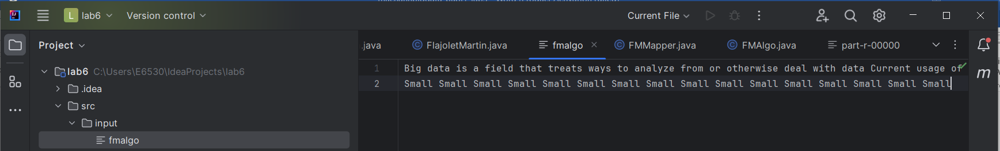

tạo class FlajoletMartin

package org.example;  
import java.io.IOException;  
import java.util.Collection;  
import java.util.Collections;  
import java.util.List;  
import java.util.ArrayList;  
public class FlajoletMartin {  
 private static final double *PHI* = 0.77351D;  
 private int hashFunctions;  
 private HashFunction[] hashes;  
 public FlajoletMartin(int numHashFunctions) {  
 this.hashFunctions = numHashFunctions;  
 hashes = new HashFunction[hashFunctions];  
 generateHashes();  
 }  
 private void generateHashes() {  
 for (int i = 0; i < hashFunctions; i++) {  
 hashes[i] = new HashFunction(i);  
 }  
 }  
 public int uniques(String str) {  
 List<Integer> averageR = new ArrayList<Integer>();  
 String[] stream = str.split(" ");  
 for (int i = 0; i < hashFunctions; i++){  
 int sumR = 0;  
 for (String word : stream) {  
 sumR =  
 Math.*max*(getFirstZero(hashes[i].getHash(word)), sumR);  
 }  
 averageR.add(sumR);  
 }  
 Collections.*sort*(averageR);  
 double r = 0;  
 int avgMid = averageR.size() / 2;  
 if (averageR.size() % 2 == 0) {  
 r = (averageR.get(avgMid) + averageR.get(avgMid+1))/2;  
 } else {  
 r = averageR.get(avgMid + 1);  
 }  
 return (int) (Math.*pow*(2, r));  
 }  
 private int getFirstZero(int val) {  
 if (val == 0)  
 return 0;  
 int pos = 0;  
// counting the position of first set bit  
 for (int i = 0; i < 64; i++) {  
 if ((val & (1 << i))== 0)  
 pos++;  
 else  
 break;  
 }  
 return pos;  
 }  
 private static class HashFunction {  
 private int numLoop;  
 public HashFunction(int loop) {  
 this.numLoop = loop;  
 }  
 public int getHash(Object s) {  
 int hash;  
 int i = 0;  
 do {  
 if (s instanceof String) {  
 hash = s.hashCode() * (i+1);  
 s = Integer.*toString*(hash);  
 } else if (s instanceof Number) {  
 hash = String.*valueOf*(s).hashCode() * (i+1);  
 s = Integer.*toString*(hash);  
 }  
 else {  
 String t = s.toString();  
 hash = t.hashCode() *(i+1);  
 s = Integer.*toString*(hash);  
 }  
 i += 1;  
 } while (i < numLoop);  
 return 13 + 7*Math.*abs*(hash);  
 }  
 }  
}

tạo class FMMapper

package org.example;  
import java.io.IOException;  
import org.*;  
import org.apache.hadoop.io.IntWritable;  
import org.apache.hadoop.io.LongWritable;  
import org.apache.hadoop.io.Text;  
import org.apache.hadoop.mapreduce.Mapper;  
public class FMMapper extends Mapper<LongWritable, Text, Text,  
 IntWritable>{  
 private static final int *EMPTY* = 0;  
 FlajoletMartin fm;  
 @Override  
 protected void setup(org.apache.hadoop.mapreduce.Mapper.Context  
 context)  
 throws IOException, InterruptedException {  
 super.setup(context);  
 fm = new FlajoletMartin(4);  
 }  
 @Override  
 public void map(LongWritable key, Text value, Context context)  
 throws IOException, InterruptedException {  
 String stream = value.toString();  
 String id = stream.substring(0, 4);  
 stream = stream.substring(5);  
 int distinct = fm.uniques(stream);  
 context.write(new Text(id), new IntWritable(distinct));  
 }  
}

tạo class main FMAlgo

package org.example;  
import java.io.IOException;  
import org.apache.hadoop.fs.Path;  
import org.apache.hadoop.io.IntWritable;  
import org.apache.hadoop.io.Text;  
import org.apache.hadoop.mapreduce.lib.input.FileInputFormat;  
import org.apache.hadoop.mapreduce.lib.output.FileOutputFormat;  
import org.apache.hadoop.mapreduce.Counter;  
import org.apache.hadoop.mapreduce.CounterGroup;  
import org.apache.hadoop.mapreduce.Counters;  
import org.apache.hadoop.mapreduce.Job;  
public class FMAlgo {  
 public static void main(String[] args)  
 throws IOException, ClassNotFoundException,  
 InterruptedException {  
 Job job = new Job();  
 job.setJarByClass(org.example.FMMapper.class);  
 job.setJobName("Multi stream FM algo");  
 FileInputFormat.*addInputPath*(job, new Path("src/input/fmalgo"));  
 FileOutputFormat.*setOutputPath*(job, new Path("src/ouput"));  
 job.setMapperClass(org.example.FMMapper.class);  
 job.setOutputKeyClass(Text.class);  
 job.setOutputValueClass(IntWritable.class);  
 job.waitForCompletion(true);  
 }  
}

chạy lệnh run chương trình và xuất kết quả

