Assignment 2 – Legacy Loan Calculator C++
Student: Muhammad Mehmood
Reg_no:24P-3037
Student: Farhan Bilal
Reg_no:24P-3037
Student: Syed Parvez Musharf

Course: Software Engineering
Instructor: Engr. Muhammad Umer Haroon

1. Project Overview
The Legacy Loan Calculator C++ project is a command-line application that calculates EMI (Equated Monthly Installments), total interest, and remaining balances for a loan.
The legacy code had the following issues:
- No input validation
- Hardcoded loan values
- Risk of integer overflow for large tenures
- Monolithic main.cpp Objectives:
- Fix bugs and validate input
- Refactor code into modular files
- Implement unit tests (GoogleTest)
- Generate Doxygen documentation
Technologies used: C++11, GoogleTest, Doxygen, Git

2. Bug Fixes & Refactoring
2.1 Bug Fixes
Input Validation:
if (principal <= 0 || interestRate <= 0 || tenure <= 0) { std::cerr << "Error: Invalid input values.\n"; return;
}
Integer Overflow Prevention:
long double monthlyRate = interestRate / 1200.0;
long double emi = principal * monthlyRate * pow(1 + monthlyRate, tenure) / (pow(1 + monthlyRate, tenure) - 1);
Remove Hardcoded Values (from config.txt):
principal=100000 interestRate=12 tenure=360
LoanConfig config = readConfig("config.txt");
2.2 Refactoring
- main.cpp → CLI & program entry
- Loan.h / Loan.cpp → Loan class
- Utils.h / Utils.cpp → helper functions
Benefits: Modularity, maintainability, readability

3. Unit Testing Test Cases:
Test Case | Description | Result
Normal EMI | Standard EMI calculation | ✅ Pass
Invalid Input | Negative/zero values | ✅ Pass
Large Tenure | Tenure > 1000 months | ✅ Pass
Insert Screenshot of test output here Example output:
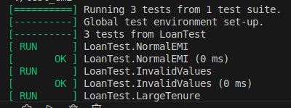

Output2:
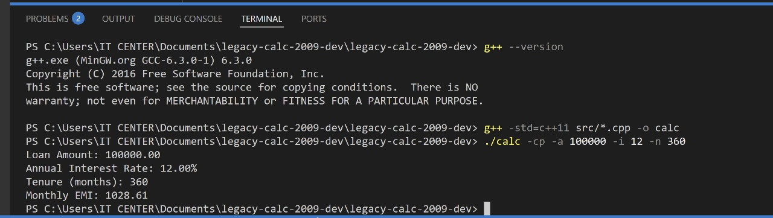

4. Doxygen Documentation
- Generated HTML docs in docs/html/
- All classes, structs, and functions documented
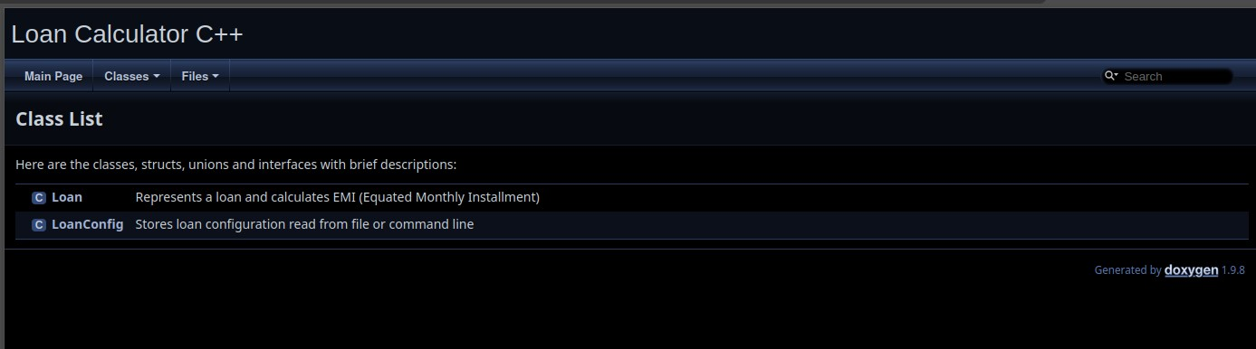
•
Example Doxygen comment:
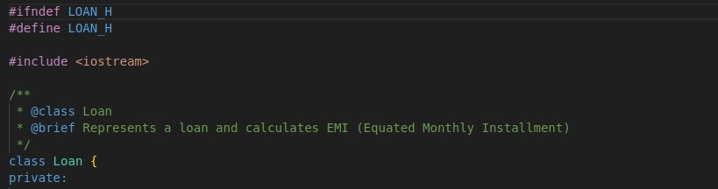

- Git Commit History:
- 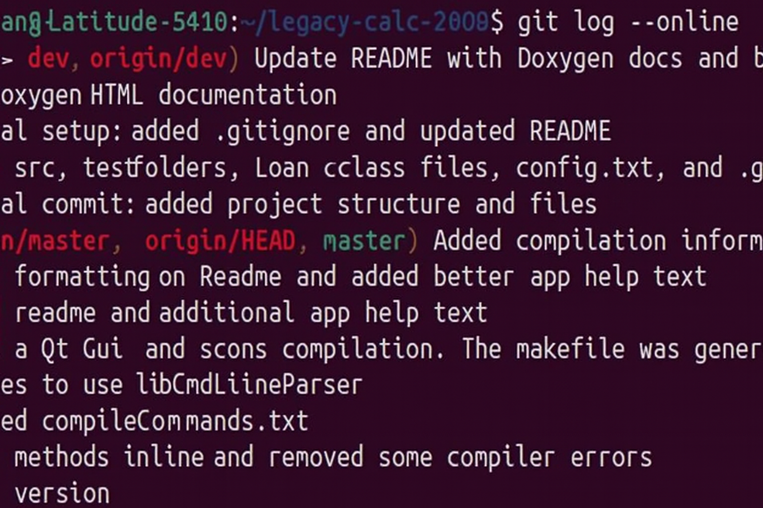

- Build & Run InstructionsBuild: g++ -std=c++11 src/*.cpp -o calc
Run:
./calc -cp -a 100000 -i 12 -n 360
Doxygen Documentation:

-> open docs/html/index.html
Run Unit Tests:
cd test g++ -std=c++11 test_emi.cpp -lgtest -lpthread -o test_emi ./test_emi

7. Conclusion
- Legacy bugs fixed
- Modular and clean code structure
- Unit tests passed
- Full Doxygen documentation available
- Repository ready for submission

