

The Islamic University – Gaza

Faculty of Information Technology

Computer Networks – SICT 3309

Hypertext Transfer Protocol

(HTTP)

**Done By:**

|  |  |
| --- | --- |
| Mohammad T. Sirhy | ID: 120162643 |
| Mohammad A. Hijazi | ID: 120161580 |

**Submitted to:**

Eng. Ehab M. Mortaja

May / 2019

# **Table of Contents**

Table of Contents I

List of Figures II

List of Tables III

List of Abbreviations IV

Introduction 1

# **List of Figures**

## Figure 1. Client connection to the server ………………………………………………1

# **List of Tables**

# **List of Abbreviations**

|  |  |
| --- | --- |
| Abbreviation | Full Name |
| HTTP | Hypertext Transfer Protocol |
| TCP/IP | transmission control protocol/Internet protocol |
| RFC | Requests For Comment |

# **Introduction**

Hypertext Transfer Protocol (HTTP) is an application-layer protocol for transmitting hypermedia

documents .

HTTP is perhaps the most popular application protocol used in the Internet (or The WEB).

* HTTP is an *asymmetric request-response client-server* protocol as illustrated.  An HTTP
* client sends a request message to an HTTP server.  The server, in turn, returns a response

message.  In other words, HTTP is a *pull protocol*, the client *pulls* information from the

server (instead of server *pushes* information down to the client).

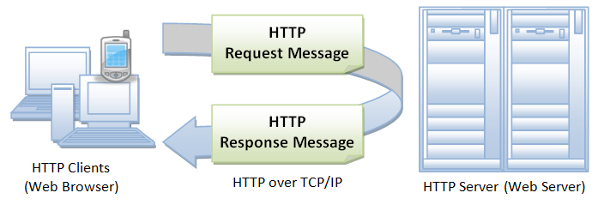

Figure . Client connection to the server

* HTTP is a stateless protocol. In other words, the current request does not know what has been

done in the previous requests.

* HTTP permits negotiating of data type and representation, so as to allow systems to be built

independently of the data being transferred.

* Quoting from the RFC2616 (Requests For Comment): " HTTP is an application-level protocol

for distributed, collaborative, hypermedia information systems. It is a generic, stateless,

protocol which can be used for many tasks beyond its use for hypertext, such as name servers

and distributed object management systems, through extension of its request methods, error

codes and headers."