Jeffrey Hsu

2020-Mar-14

IT FDN 100

Assignment08

Modifying CD Inventory to be Object-Orientated Programming

Introduction

This assignment introduces object orientated programming and how it differs from functional programming. We get basics on how to OOP and what it looks like along with how its more versatile than functional programming.

Getting Started

I first review the document provided, Foundations of Python Module 8[1]. I looked over what object orientated programming is and how it works. I also read a bit of chapter 8 from our textbook since I still wasn’t clear how OOP works. After reviewing both texts, I watched some videos on OOP and after doing all this I started to work on the assignment.

Working on the CD Inventory Script for OOP

For this week’s assignment, the main goal is to modify last weeks script with OOP. This required relying on a list of CD Objects instead of both a list and dictionary. We also are depending on creating objects with specific attributes such as getters and setter methods. This meant that cd id, cd title and cd artist will be their own objects with their own unique properties and the main script body will be using those objects in order to fulfill the actions. In order to OOP this code, a class CD must be created which will contain all the objects, additionally each object will also need properties and setter and getter methods. Then specific actions such as saving inventory and printing inventory must also be modified to use only list and not dictionary. This took a lot of trial and error along with watching additional OOP videos to work everything out. With some help from Dirk and Douglas, I was able to slowly figure out what I was doing wrong, particularly with my methods and main script. A lot had to do with implementing the objects into the methods and converting things to lists. The delete entry method had to be rewrote to accommodate the new objects since I wasn’t really sure how to modify the original method. I also tried to use properties and setter methods along with trying to privatize the objects. However, I encountered errors when I tried to do this and the only way I could make my code work was to get rid of properties and setter methods along with making the objects public. I wasn’t sure how to fix the issue and opted to leave them out for now since the code works this way. I would like to implement them in a way that would work so the error handling for cd id could be part of the object cd id. Another big thing with OOP is that in the main script and methods, everything is based around the class CD now so all the methods have to go back to that. This required modifying a few methods by adding cd = CD(cd_id, cd_title, cd_artist) for the program to work. As you can see in both figures 1 and 2, the code works but Im not sure if it’s the way that is wanted. I still believe the code uses list of CD Objects instead of dictionaries like the previous assignment. Here is a link to my GitHub repository, <https://github.com/Hijeff95/Assignment08>.

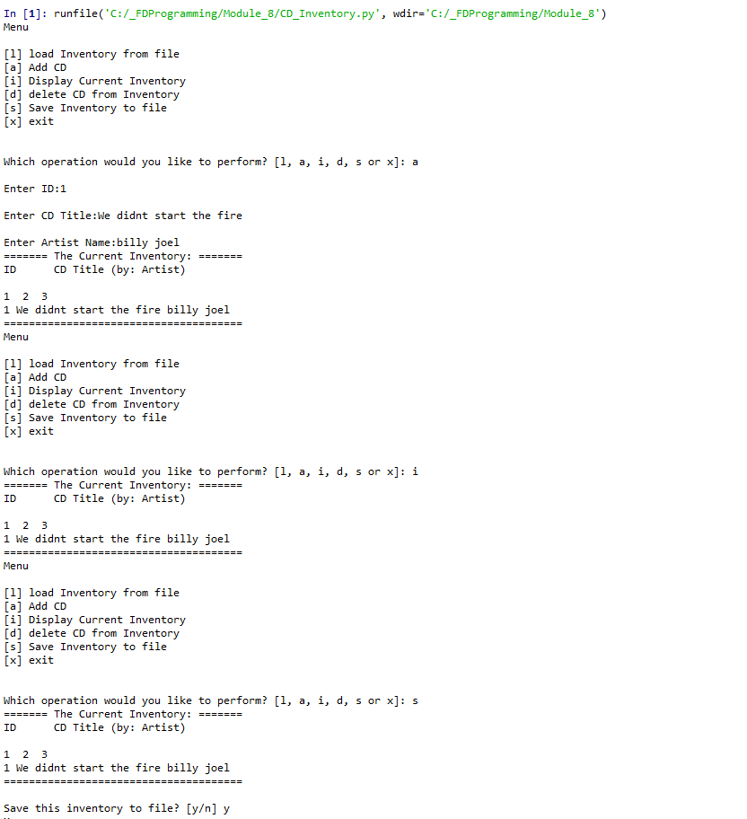

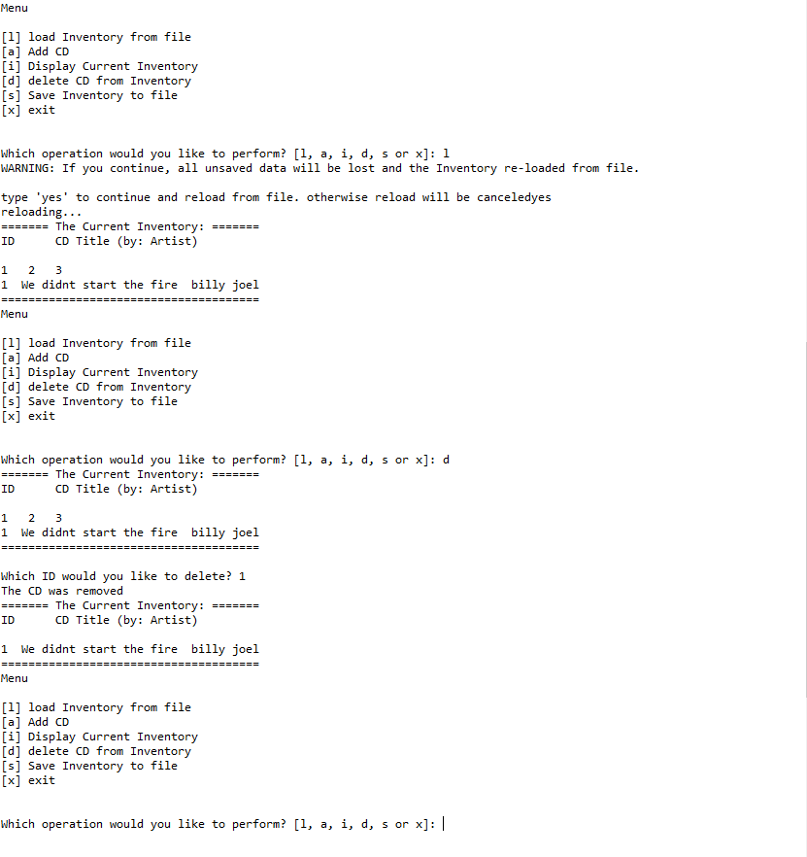

Figure 1: Script running in Spyder

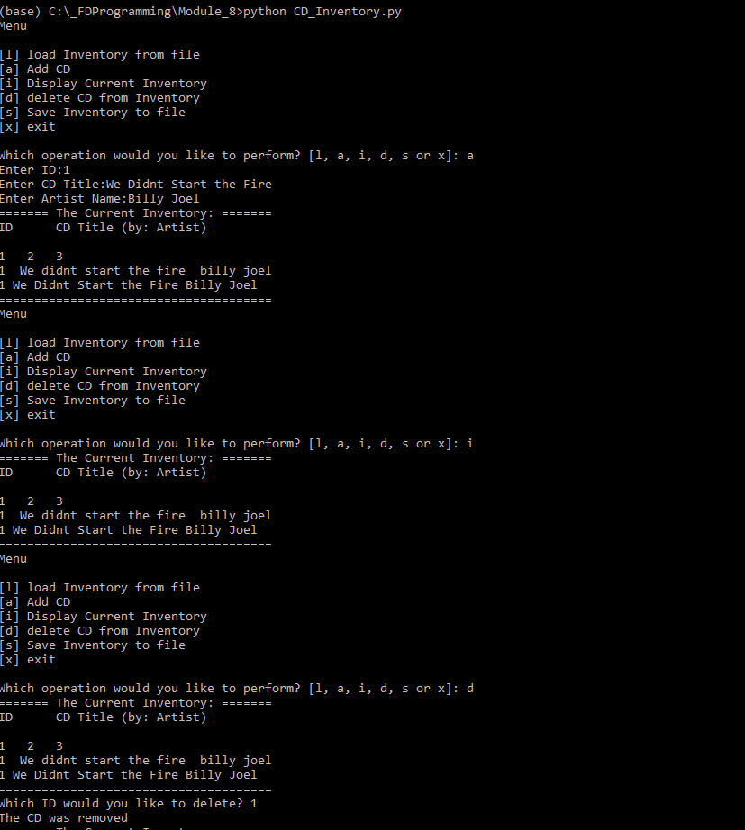

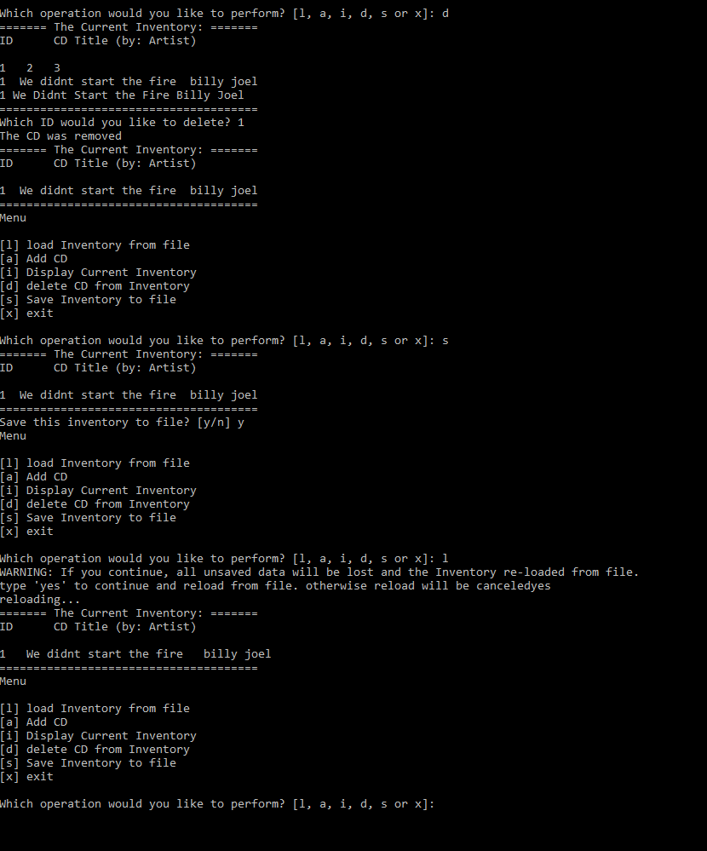

Figure 2: Script working in Anaconda

Summary

Overall the difficulty has been ramped up again with the introduction of object-oriented programming. It introduces a new concept that really requires times and effort in order to really understand and utilize it. This script took a lot more trial and error and more reading to complete the assignment. I was able to import some code from the last assignment however it required a lot of modification and rewriting for it to work with objects.

1. Foundation of Python Module 8 <file:///C:/_FDProgramming/Module_8/FDN_Py_Module_08.pdf>