Jeffrey Hsu

2020-Feb-20

IT FDN 100

Assignment05

Writing an Inventory Keeping Script as a Dictionary

Introduction

This assignment is an introduction to lists and dictionaries and how they work along, what functions each one has, and what are the differences. There is also an introduction on how to use GitHub.

Getting Started

I first review the document provided, Foundations of Python Module 5[1]. I reviewed through each of the examples provided and analyzed what each line of script did. After reviewing the examples and how dictionaries work along with the different functions introduced, I began working on my assignment which involves modifying Assignment04’s script into a dictionary.

Working on the CD Inventory Script

This time, a base script was provided and then we had to modify and add script depending on what was needed. Since this assignment provided a base script, it wasn’t as difficult as the previous assignment however there was still a sense of difficulty working with new functions. I again had to do a lot of testing of each piece separately just to see if it worked, especially the delete function which was the hardest to figure out. In fact, figuring out how to delete a specific row as inputted by the user was the most difficult to implement into the code. I had to ask a few friends who are fluent in Python for help and even referred to some finished assignments on GitHub in the class. One of the scripts I referred to was Andrew Yeo’s delete function[2]. I looked at how he did his and implemented his method in my own way in my script. In the end, I understood and figured out what I was doing wrong which helped finish my script. The biggest issue I had was I was completely doing the delete function wrong by not implementing a range and specifying each key and value within the dictionary. Because I wasn’t doing this, it would constantly give me errors when trying to use this function. In the end, I was able to implement it so that entering the ID number would delete the row of data associated with it. As shown in *Figure 1: Script running in Spyder*, the program works fine in Spyder. It also works fine in Anaconda as shown in *Figure 2: Script working in Anaconda.*

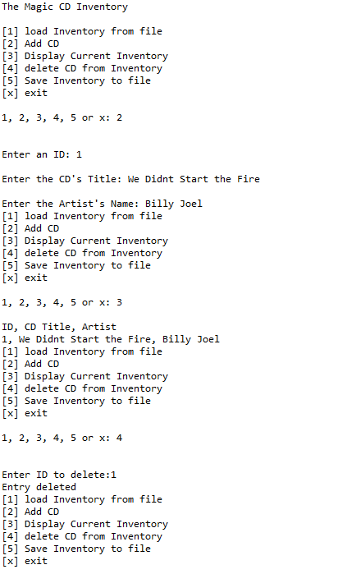

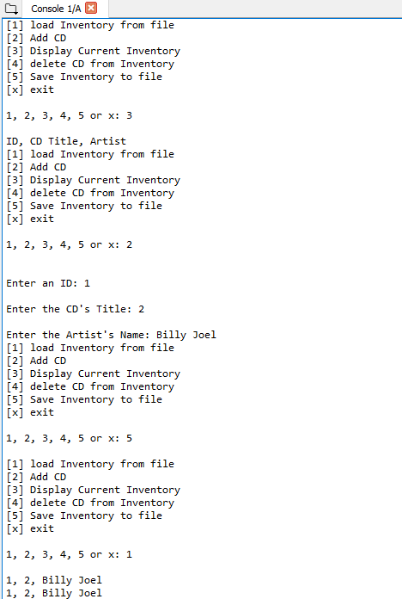

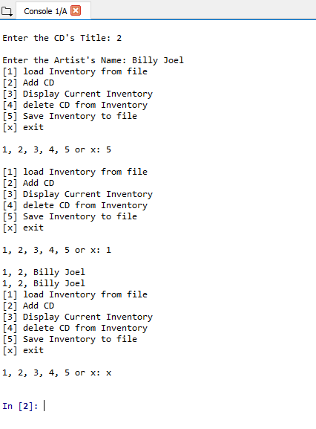

Figure 1: Script running in Spyder

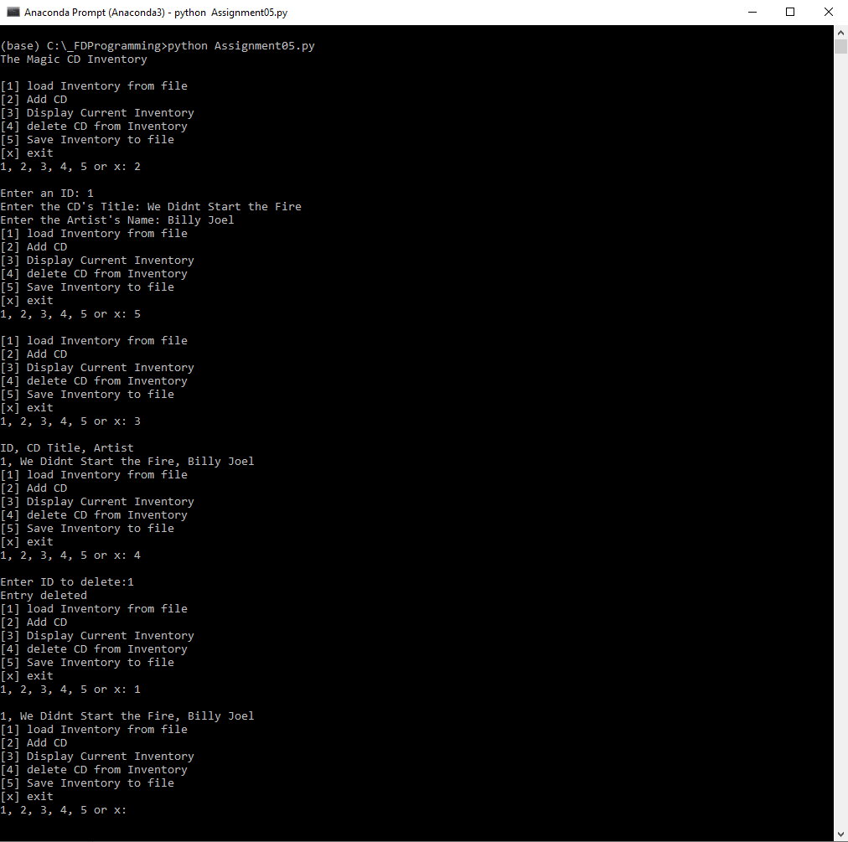

Figure 2: Script working in Anaconda

Summary

Overall, this assignment was not as difficult as the last one since we were given a base script and only had to fill in certain functions. However, that being sad, it was still relatively difficult due to the introduction of dictionaries and how to use it correct along with the functions. One of the hardest parts to figure out was how to implement the delete function correctly. In the end, consulting with GitHub and people allowed me to finish my script.

1. Foundation of Python Module 5 <file:///C:/_FDProgramming/Module_5/FDN_Py_Module_05.pdf>
2. https://github.com/andyhyeo/Assignment_05