SOFTWARE ARCHITECTURE DESIGN
AI-Powered Viva Examination System
AIVES | Group 3 | Milestone 3

Report Overview
This report describes the AIVES architecture and the implemented Milestone 3 workflows. The backend supports question and course-rubric management, exam sessions and student attempts, text and voice interview APIs, AI-assisted grading, lecturer score finalization, and result retrieval. Live Gemini, Azure AI Speech, and Azure SQL deployment still require environment-level verification.
Area | Milestone 3 status
Question and course rubric management | Implemented: separate question and course-rubric APIs; validation, persistence, update, and soft deletion.
Users, courses, authentication | Implemented backend capabilities; current roles are Lecturer and Student.
Live viva interview (Flow 3) | Backend routes and services are implemented for text/voice attempts, follow-up, transcript turns, and submission; live provider/browser integration still needs environment verification.
AI grading and lecturer finalization (Flow 4) | Backend supports lecturer-triggered AI grading, per-question assessments, score finalization, and result retrieval; external live services are not verified here.
State model | ExamSession and Transcript lifecycle enums are persisted domain states; Question authoring Draft/Validating are request workflow concepts.

1. Introduction

1.1 Purpose
AIVES supports oral examinations through a question bank, course-level scoring rubrics, scheduled sessions, student attempts, and AI-assisted interview and grading. This report documents the current repository implementation and distinguishes code-level support from integrations that have not been live-tested.

1.2 Scope and assumptions
Implementation statements are based on the current project source and backend contracts. The diagrams describe current code behavior unless explicitly labeled as target deployment. Gemini, Azure AI Speech, and Azure SQL credentials or live service behavior have not been verified end-to-end in this report; production readiness and performance are not claimed.

1.3 Main actors
Actor | Responsibility
Lecturer | Manages questions, course rubrics, exam sessions, grading, and final scores.
Student | Starts an exam attempt, submits text or voice answers, and views finalized results.
Third-party services | Google Gemini and Azure AI Speech provide AI and speech-processing capabilities; Azure SQL is the managed database target.

2. Milestone 3 Requirements and Workflows

2.1 Implemented workflow: question and rubric management
A lecturer manages questions and course-level rubrics through separate endpoints. Question create/update validates content, course, and Bloom level; rubric replacement uses PUT /api/courses/{courseId}/rubrics, validates the rubric matrix, soft-deletes the previous active rows, and saves the replacement set. Rubric weights total 100% within the backend tolerance of 0.01. Question deletion soft-deletes the question; it does not delete the course rubric matrix.
- AI generation returns question content as a draft for lecturer review; generation does not itself persist the question.
- The import endpoint is present in the contract, but file-based batch import is not treated here as a completed capability.
- Question authoring states describe request processing, not a persisted Question.Status field. ExamSession and Transcript have persisted lifecycle states and are shown in the state model.

2.2 Implemented workflow: live viva interview (Flow 3)
The implemented backend supports session creation/opening, student attempt start/resume, question and turn retrieval, text answers, AI follow-up, voice-answer upload, transcript persistence, and submission. Voice answers use Azure AI Speech for transcription, Gemini for follow-up, and Azure AI Speech for synthesized speech. The full browser-to-provider-to-Azure-SQL path still needs live environment verification.

2.3 Implemented workflow: AI grading and lecturer review (Flow 4)
The implemented grading flow is initiated by a lecturer for a submitted attempt. The backend stores rubric-based AI suggestions, feedback, and confidence per session question; a lecturer then finalizes each score with an optional comment. The official attempt total is stored only after every assessment is finalized. The result endpoint separates the AI suggested total from the official total.

2.4 Sequence diagram set
Sequence diagram | Purpose | Status
Sequence-CreateQuestion-Rubric-remake-v2 | Implemented Flow 1; question and course-rubric endpoints are separate. | Implemented
Sequence-Flow3-AIViva-Interview-remake-v2 | Implemented backend flow; live provider and browser integration still requires environment verification. | Implemented; live integrations unverified
Sequence-Flow4-AIGrading-HumanInTheLoop-remake-v2 | Implemented backend flow; live external-service behavior is not verified here. | Implemented; live integrations unverified

3. Requirements Model

3.1 Use case overview
The use case diagram summarizes lecturer and student actions and external AI/speech integrations. Administrator-only actions are excluded because the current authorization model has Lecturer and Student roles; external providers are supporting actors, not application users.
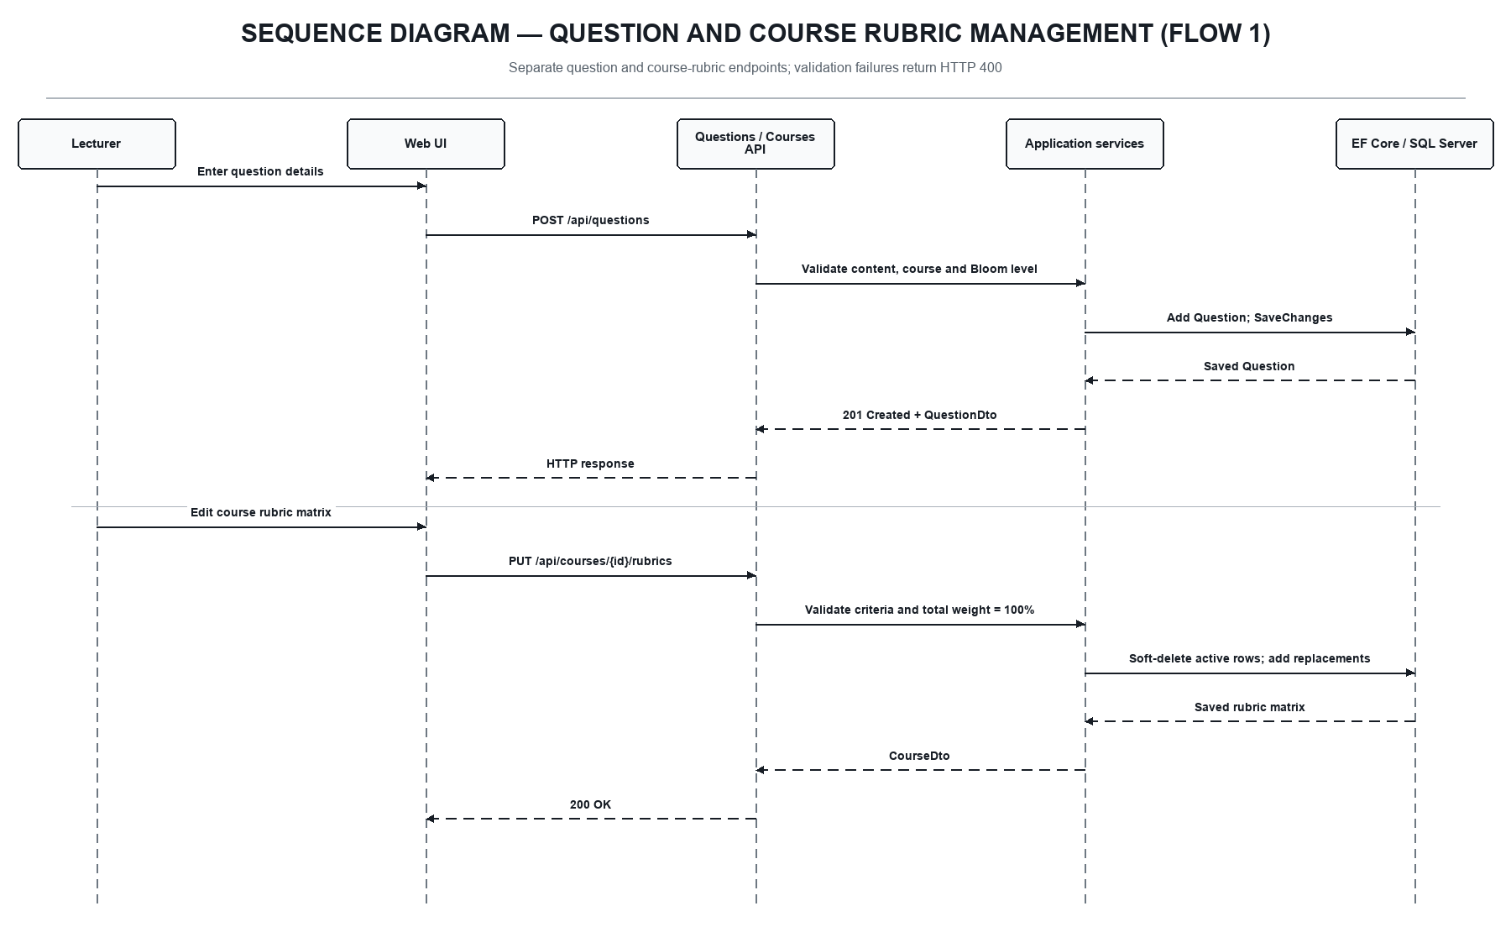
Figure 1. Sequence diagram for question and course-rubric management (Flow 1)
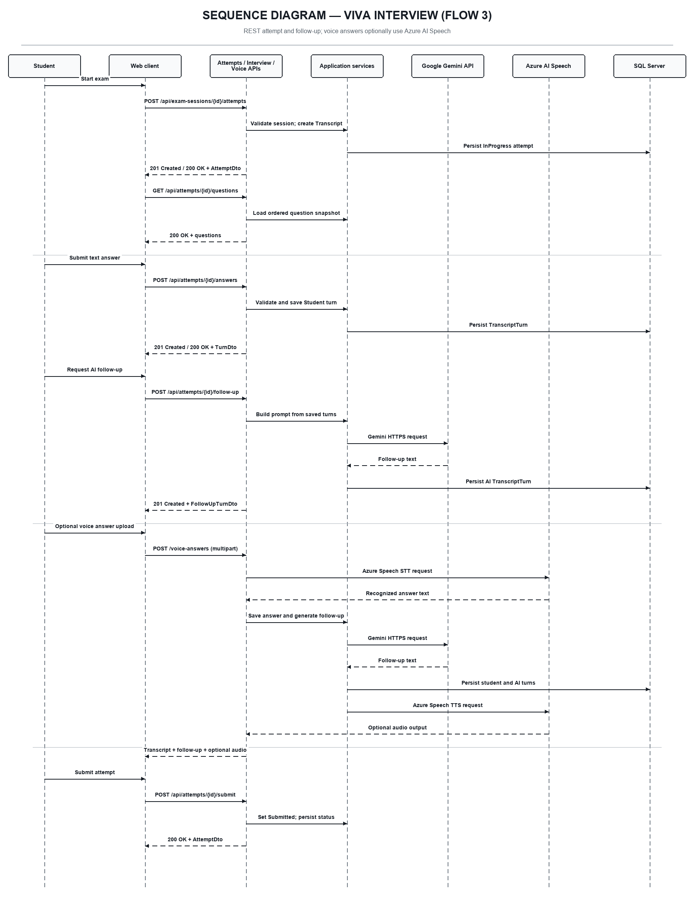
Figure 2. Sequence diagram for the viva interview workflow (Flow 3)
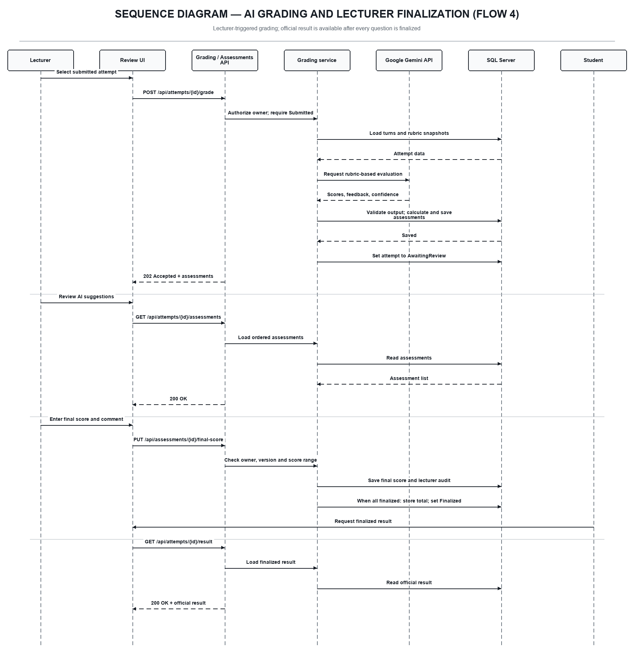
Figure 3. Sequence diagram for AI grading and lecturer finalization (Flow 4)
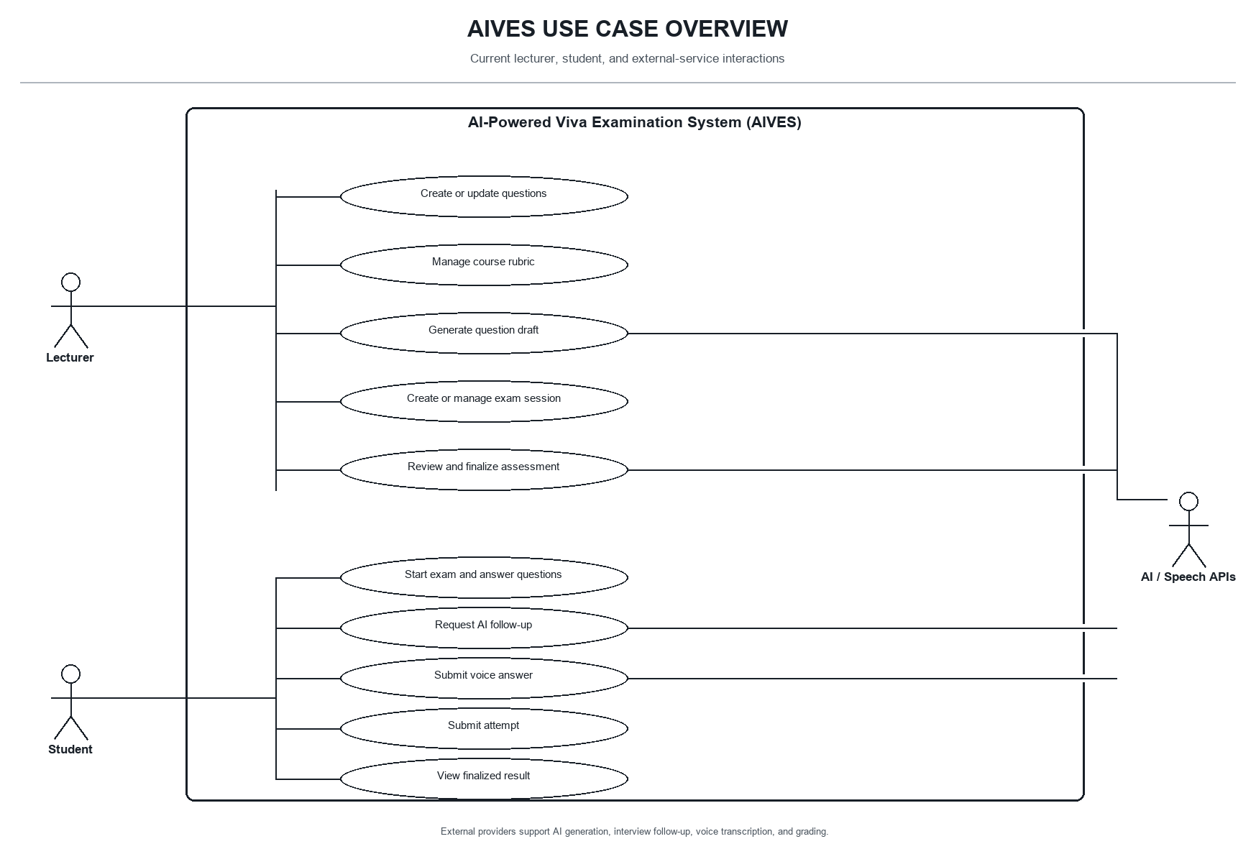
Figure 4. AIVES use case overview

3.2 Quality requirements
Quality area | Design consideration
Security | Authenticate API access with JWT bearer tokens; keep credentials and AI keys in configuration or secret storage.
Data integrity | Rubric weights are validated and rubric replacement is a separate Course-level operation; it is not part of Question persistence.
Maintainability | Keep domain rules independent from database and web concerns through inward-facing dependencies.
Traceability | Use audit fields and soft deletion where currently modeled; transcript and grading audit requirements remain target design.
Availability and performance | Measure under deployment-like conditions before making latency or uptime claims.

4. Architecture Design

4.1 Backend structure
The solution is organized into four projects. Dependencies point toward the domain and application contracts; infrastructure and the API host provide adapters at the outer boundary.
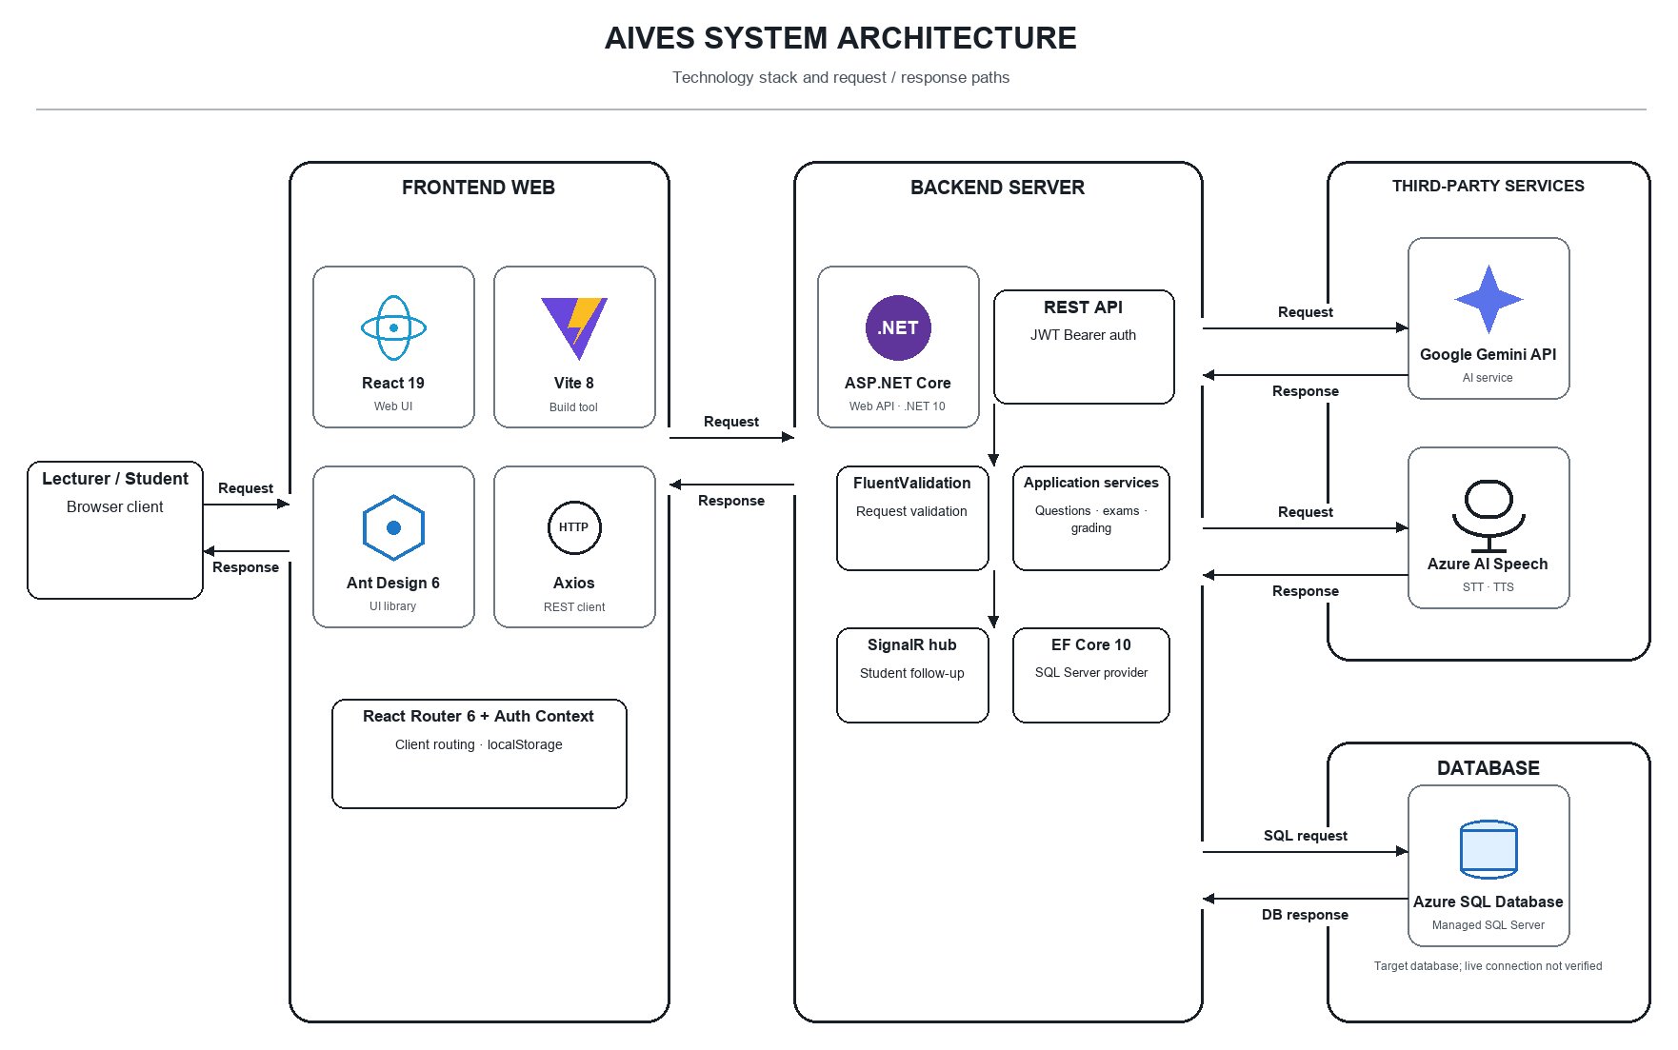
Figure 5. Current system architecture and external integrations
Layer / project | Responsibilities
Domain | Core entities and shared base types, including Question, Rubric, Course, User, and BloomLevel.
Application | Use-case services, DTOs, repository and unit-of-work abstractions, validation, and mapping.
Infrastructure | EF Core persistence and SQL Server provider; Azure SQL is the target managed deployment and live connection has not been verified here.
WebApi | HTTP controllers, middleware, authentication registration, Swagger, and the InterviewHub endpoint.

4.2 Technology stack observed in the repository
Area | Technology
Frontend framework | React 19 and Vite 8
UI components | Ant Design 6
HTTP client | Axios
Backend runtime | ASP.NET Core / .NET 10
Persistence | Entity Framework Core 10 and SQL Server provider
API documentation | Swagger / OpenAPI
Authentication | JWT bearer authentication and password hashing service
AI services | Google Gemini integration
Speech services | Azure AI Speech (STT / TTS)
Database target | Azure SQL Database; live connection not verified

4.3 Request path
For question creation, the API controller invokes QuestionBankService, which validates the request, checks the active course, and persists the Question through the unit of work and Entity Framework Core. Course rubric replacement is a separate CourseService operation. DTO mapping keeps persistence entities separate from HTTP response contracts.

5. Data Design

5.1 Implemented data model
Entity | Key relationships and purpose
User | Account details, role, and soft-delete flag.
Course | Course owns questions and rubric criteria; rubrics are managed at Course level.
Question | Course-linked question with Bloom level and audit fields; it does not own the course rubric matrix.
Rubric | Course-level scoring criterion with weight, maximum score, and audit fields.

The current context and migrations cover these core data areas. A Course owns its Questions and Rubric criteria; each ExamSessionQuestion stores the question and rubric snapshot used for an attempt. Rubric weights are validated as a complete course-level scoring matrix.

5.2 Conceptual data relationships
The conceptual ERD includes Course, Question, Rubric, ExamSession, ExamSessionQuestion, Transcript, TranscriptTurn, Assessment, and User. These entities are present in the current code model and migrations; deployment of the latest migrations to the shared Azure SQL database has not been verified.
Entity | Role in the current model
ExamSession | Scheduled viva session with persisted lifecycle state.
ExamSessionQuestion | Ordered question and rubric snapshot used for an attempt.
Transcript | One student attempt in a session.
TranscriptTurn | Ordered dialogue entry with speaker, content, and timestamp.
Assessment | Per-question AI suggestion and lecturer-finalized score.

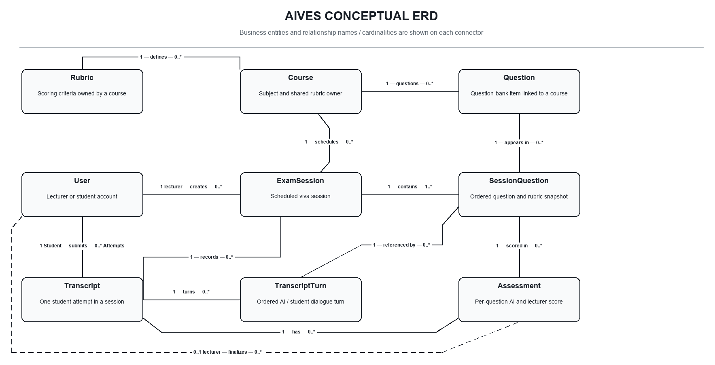
Figure 6. AIVES conceptual ERD
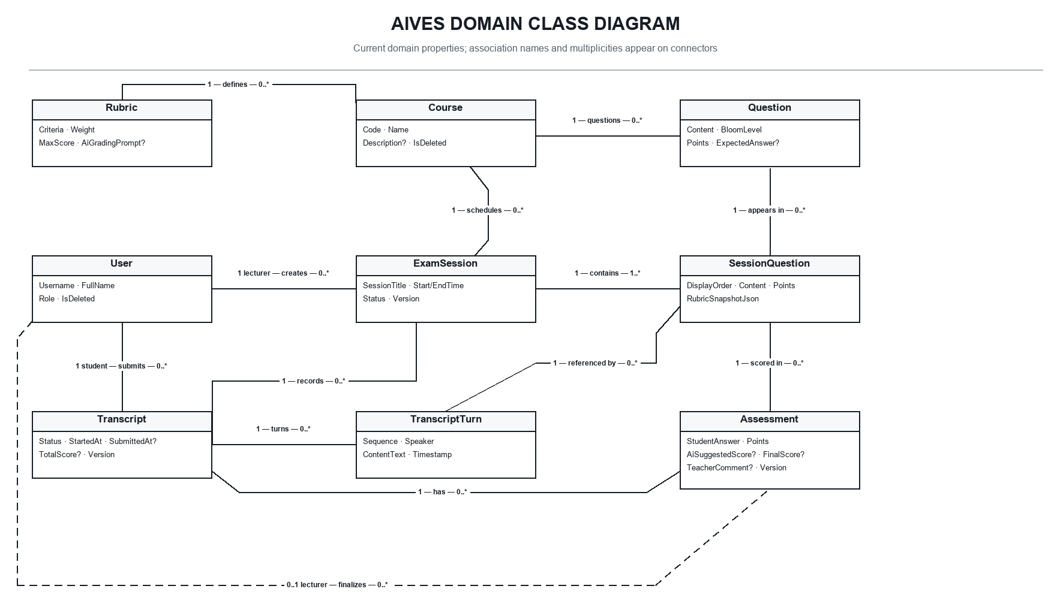
Figure 7. Core AIVES domain class model

6. Dynamic Model

6.1 Session and attempt state machines
The state diagrams show the persisted ExamSession and Transcript state transitions. Draft and validation steps for question authoring are workflow concepts; they are not persisted Question status values. Course rubrics are managed independently from Question lifecycle.
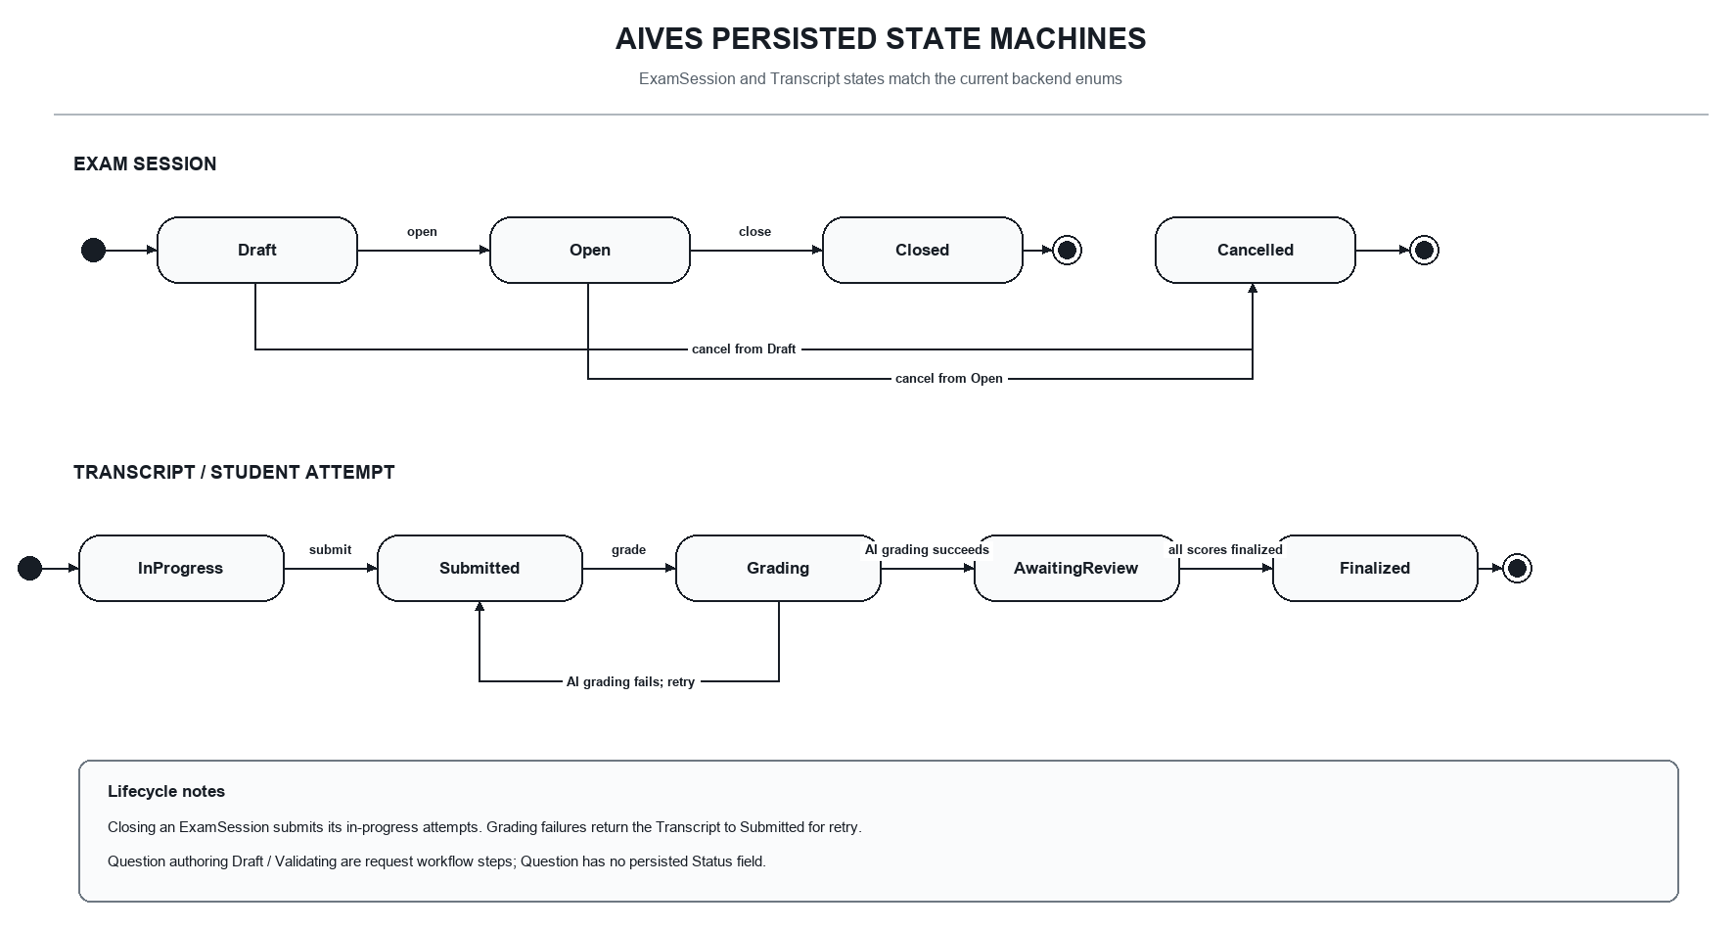
Figure 8. Session and student-attempt state machines

6.2 State model boundary
The report includes the session lifecycle (Draft, Open, Closed, Cancelled) and the student-attempt lifecycle (InProgress, Submitted, Grading, AwaitingReview, Finalized). These values correspond to the current domain enums.

7. Verification and Current Limitations
The backend progress record reports 436 checks passing on 31 October 2026 and a Release build with zero errors. Those checks use local test infrastructure; Gemini, Azure AI Speech, and Azure SQL live flows remain unverified.
- The interview and grading diagrams describe backend routes and behavior present in code. Live provider credentials, browser microphone behavior, and applying the latest migrations to Azure SQL remain separate verification tasks.
- The conceptual ERD intentionally omits PK/FK and implementation data types; relationship cardinalities are shown at a business level.
- The use case diagram summarizes the current lecturer and student scope and the external AI/speech integrations described in the workflow sections.
- No production deployment, response-time benchmark, or service-level objective is asserted here.

8. Conclusion
Milestone 3 now includes question and course-rubric management, exam-session and transcript lifecycles, text and voice interview APIs, AI-assisted per-question grading, lecturer finalization, and result retrieval. The diagrams distinguish these implemented backend workflows from deployment assumptions and live provider/database checks that still require confirmation.

Appendix A. Project references
Original sources are retained beside the updated remake diagrams for comparison and further editing.
docs/AIVES-System-Architecture-remake.drawio — current stack, third-party integrations, and request/response paths.
docs/UseCase-remake.drawio — current roles and use cases.
docs/Conceptual-ERD-AIVES-remake.drawio — business entities and cardinalities, without PK/FK fields.
docs/AIVES-UML-Class-Diagram-remake.drawio — current implementation class model.
docs/Sequence-CreateQuestion-Rubric-remake-v2.drawio — Flow 1.
docs/Sequence-Flow3-AIViva-Interview-remake-v2.drawio — Flow 3.
docs/Sequence-Flow4-AIGrading-HumanInTheLoop-remake-v2.drawio — Flow 4.
docs/State-Machine-Flow1-Implemented-remake.drawio and docs/State-Machine-Exam-Lifecycle-remake.drawio — current state diagrams.
BACKEND_CONTRACTS.md and BACKEND_PROGRESS.md — API contract and implementation record.

