SOFTWARE ARCHITECTURE DESIGN
AI-Powered Viva Examination System
AIVES | Group 3 | Milestone 3

Report Overview
This report describes the AIVES architecture and separates the software implemented for Milestone 3 from the planned viva and grading workflows. The current backend provides the question bank, rubric validation, course and user management, authentication, and AI-assisted question generation. The live interview and human-reviewed AI grading diagrams are target designs; their presence in the models does not mean those features are implemented.
Area | Milestone 3 status
Question and rubric management | Implemented: create, list, view, update, soft delete, validation, and AI question generation.
Users, courses, authentication | Backend components and API controllers are present; JWT-based authentication is configured.
Live viva interview (Flow 3) | Target workflow. End-to-end voice interview, transcript lifecycle, and adaptive follow-up are not represented as completed features.
AI grading and lecturer finalization (Flow 4) | Target workflow. Assessment persistence and lecturer finalization are planned.
Question authoring state machine | Describes the implemented Flow 1 lifecycle. Draft and validation are workflow steps, not persisted Question status values.

1. Introduction

1.1 Purpose
AIVES is intended to support oral examinations with a consistent question bank, structured scoring rubrics, and future AI-assisted interview and grading capabilities. This document records the current backend structure and the design direction for the next workflows.

1.2 Scope and assumptions
The implementation statements in this report are based on the project source tree, backend contracts, and current diagrams. Proposed entities and workflows are labeled as target design. Deployment services, performance targets, and production readiness are not claimed unless they are demonstrated by the repository.

1.3 Main actors
Actor | Responsibility
Lecturer | Creates and maintains questions and rubrics; reviews and finalizes scores in the target grading workflow.
Student | Uses the question or viva features assigned to the student; voice-based examination is part of the target workflow.
Administrator | Manages users and course information through administrative capabilities.
External AI provider | Gemini integration supports AI-assisted question generation. Speech processing and transcript grading are target capabilities.

2. Milestone 3 Requirements and Workflows

2.1 Implemented workflow: question and rubric management
A lecturer submits question content, course and Bloom level, together with one or more rubric criteria. The application validates the request and active course, then persists the question and rubric rows through the unit of work. Rubric weights must total 100%, with the backend tolerance documented as less than 0.01. Invalid requests return validation errors. Updating a question replaces its active rubric matrix; deleting a question soft-deletes the question and its rubrics.
- AI generation returns question content as a draft for lecturer review; generation does not itself persist the question.
- The import endpoint is present in the contract, but file-based batch import is not treated here as a completed capability.
- The state machine uses Draft, Validating, Saved, Updating, Validating (Update), and SoftDeleted as workflow states. The Question entity has no persisted Status field.

2.2 Target workflow: live viva interview (Flow 3)
The target sequence models a student joining an interview room, receiving a question, answering by voice, and repeating bounded follow-up turns before submitting. The proposed design includes speech-to-text, text-to-speech, transcript turns, question progression, and a submission event. These steps are design scope and should be verified against implementation before being described as operational.

2.3 Target workflow: AI grading and human review (Flow 4)
The target sequence evaluates a submitted transcript against question rubrics, produces suggested scores and feedback, and presents them to a lecturer. The lecturer may accept or adjust the proposed scores before finalization. The lecturer remains responsible for the official result. Assessment storage, finalization audit data, and this complete workflow are not claimed as implemented in Milestone 3.

2.4 Sequence diagram set
Sequence diagram | Purpose | Status
Sequence-CreateQuestion-Rubric | Create a question, validate rubric weights, and persist question plus rubrics. | Implemented Flow 1
Sequence-Flow3-AIViva-Interview | Model the real-time interview, voice loop, bounded follow-up, and transcript submission. | Target workflow
Sequence-Flow4-AIGrading-HumanInTheLoop | Model rubric-based AI suggestions and lecturer final review. | Target workflow

3. Requirements Model

3.1 Use case overview
The use case diagram summarizes the product scope across lecturer, student, administrator, and external AI roles. It includes implemented question authoring and administrative use cases alongside planned interview and grading use cases. Read it as a system-level scope model, not as a delivery checklist.
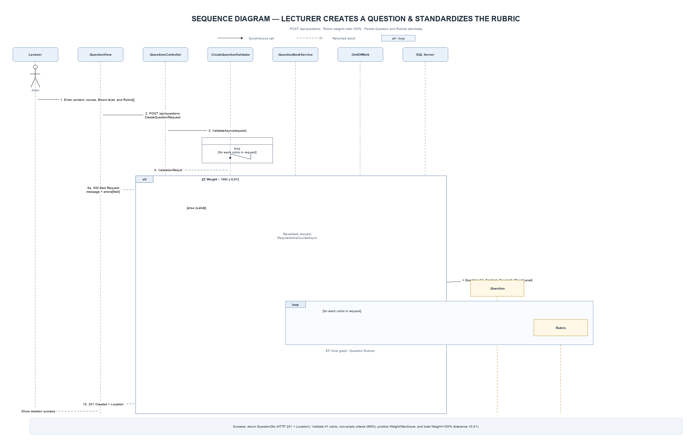
Figure 1. Sequence diagram for question and rubric creation (Flow 1)
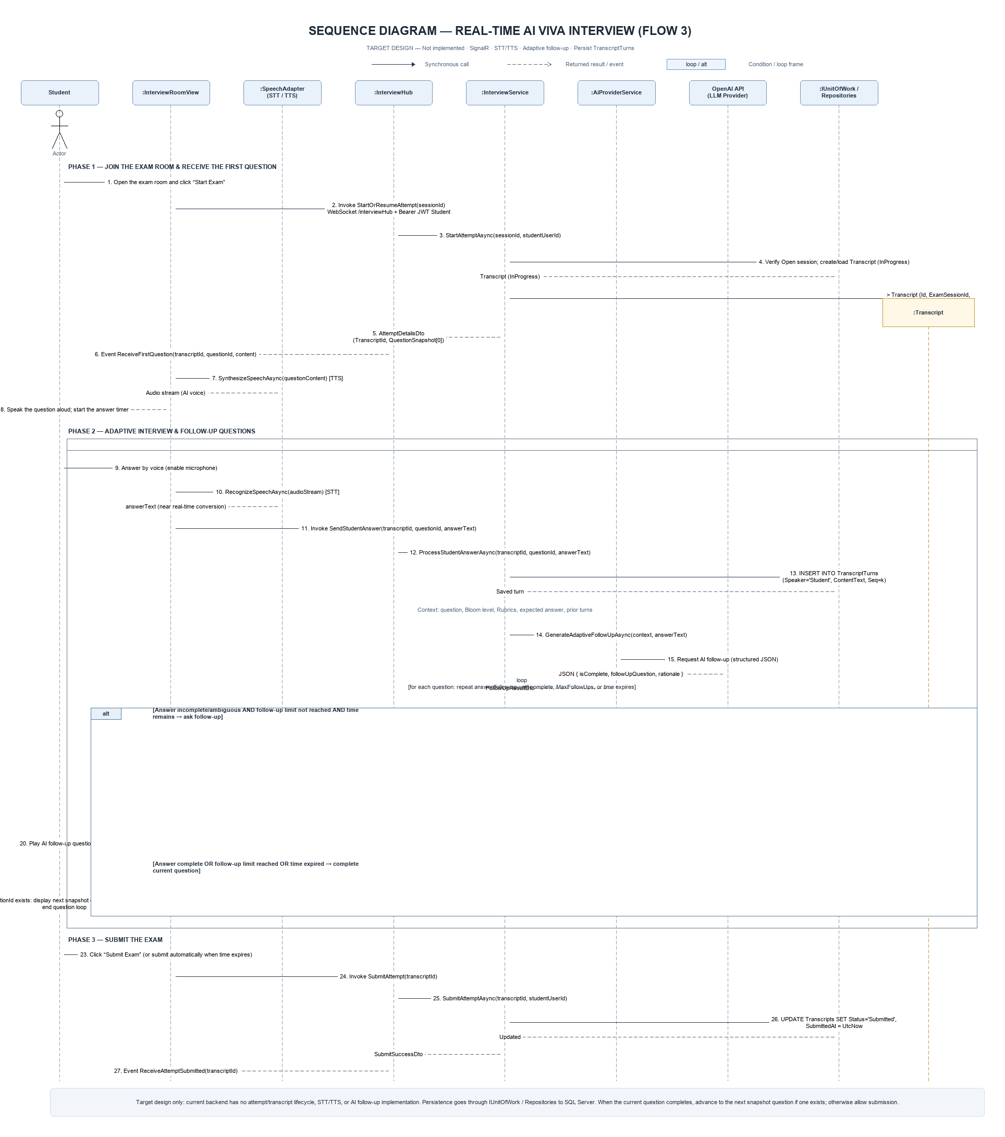
Figure 2. Sequence diagram for the AI viva interview (Flow 3)
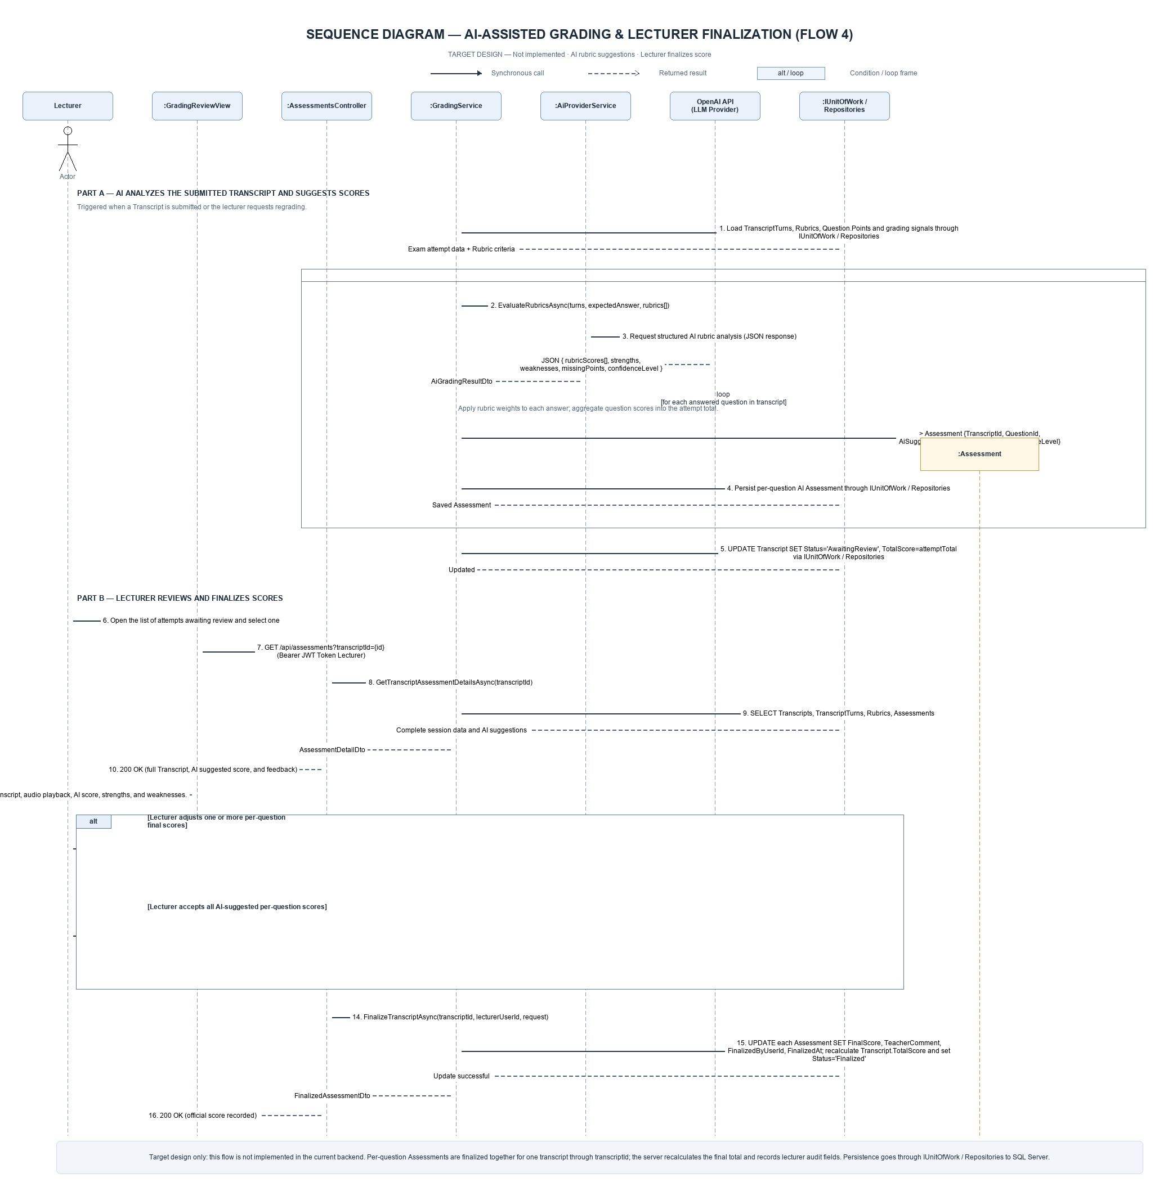
Figure 3. Sequence diagram for AI grading with lecturer review (Flow 4)
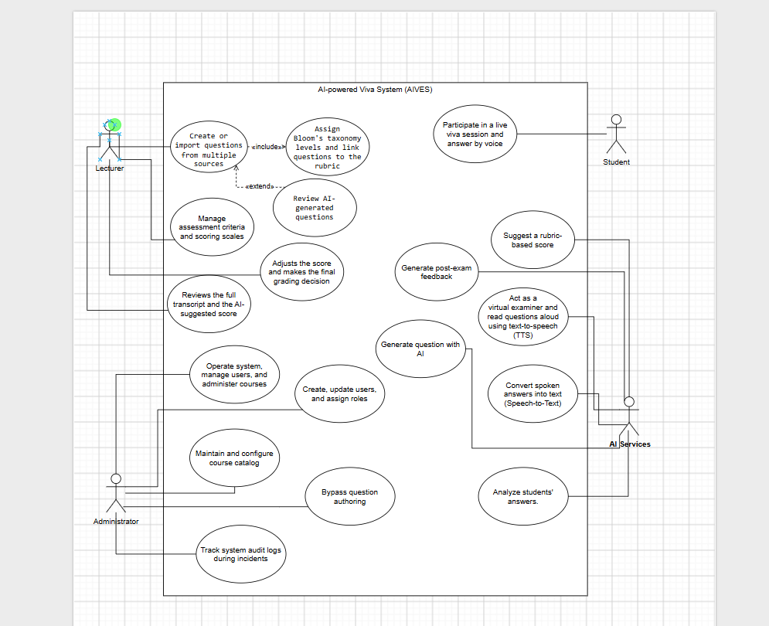
Figure 4. AIVES use case overview

3.2 Quality requirements
Quality area | Design consideration
Security | Authenticate API access with JWT bearer tokens; keep credentials and AI keys in configuration or secret storage.
Data integrity | Validate rubric weights and save the question/rubric aggregate through one unit-of-work commit.
Maintainability | Keep domain rules independent from database and web concerns through inward-facing dependencies.
Traceability | Use audit fields and soft deletion where currently modeled; transcript and grading audit requirements remain target design.
Availability and performance | Measure under deployment-like conditions before making latency or uptime claims.

4. Architecture Design

4.1 Backend structure
The solution is organized into four projects. Dependencies point toward the domain and application contracts; infrastructure and the API host provide adapters at the outer boundary.
Layer / project | Responsibilities
Domain | Core entities and shared base types, including Question, Rubric, Course, User, and BloomLevel.
Application | Use-case services, DTOs, repository and unit-of-work abstractions, validation, and mapping.
Infrastructure | Entity Framework Core persistence, SQL Server configuration, repositories, password hashing, JWT token issuance, and the Gemini client.
WebApi | HTTP controllers, middleware, authentication registration, Swagger, and the InterviewHub endpoint.

4.2 Technology stack observed in the repository
Area | Technology
Backend runtime | ASP.NET Core / .NET 10
Persistence | Entity Framework Core 10 and SQL Server provider
API documentation | Swagger / OpenAPI
Authentication | JWT bearer authentication and password hashing service
AI question generation | Google Gemini integration behind an application service interface
Frontend and hosting | Shown in architecture materials as the intended client/deployment context; deployment is not verified by this report.

4.3 Request path
For question creation, the API controller accepts a request and invokes the application service. Validators check the request before persistence. The service coordinates the question repository and unit of work; Entity Framework Core commits the entity graph to SQL Server. DTO mapping keeps persistence entities separate from the HTTP response shape.

5. Data Design

5.1 Implemented data model
Entity | Key relationships and purpose
User | Account details, role, and soft-delete flag.
Course | Course catalog entry that owns questions.
Question | Course-linked question with Bloom level and audit fields.
Rubric | Scoring criterion owned by a question, with weight and maximum score.

The current context and migrations cover these core data areas. A question has multiple rubric rows. Rubric weights are validated as a complete scoring matrix before create or update.

5.2 Target examination model
The revised conceptual ERD adds ExamSession, ExamSessionQuestion, Transcript, TranscriptTurn, and Assessment to represent scheduled sessions, a stable question set, dialogue turns, and per-question grading. These are target-model entities and must not be presented as tables already deployed in the current backend.
Target entity | Role in the proposed model
ExamSession | Represents a scheduled viva session for a course.
ExamSessionQuestion | Captures the selected questions, order, and relevant snapshots for a session.
Transcript | Represents one student attempt in a session.
TranscriptTurn | Stores ordered dialogue entries and their speaker, text, and timestamp.
Assessment | Stores per-question AI suggestions and lecturer-finalized scoring data.

6. Dynamic Model

6.1 Question authoring state machine
The state machine covers the implemented Flow 1 lifecycle, including create validation, saved questions, update validation, and soft deletion. Invalid requests return to editing with errors. Valid requests are persisted; updates replace active rubrics. “Draft” and “Validating” describe request-processing steps and are not database states.
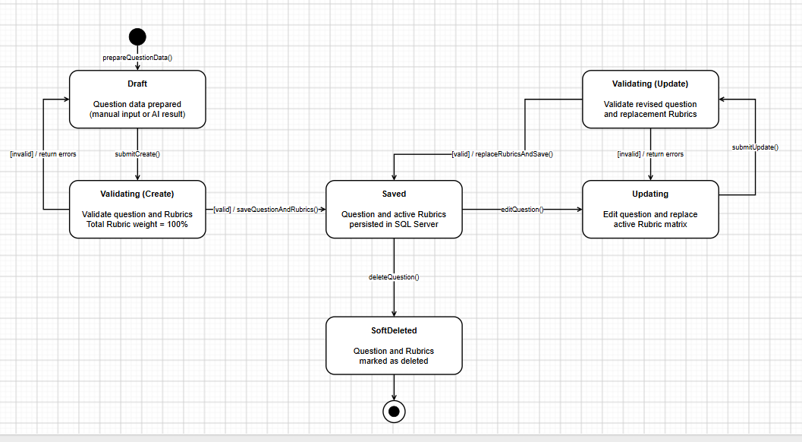
Figure 6. Implemented question authoring state machine (Flow 1)

6.2 State model boundary
This report includes one state machine because the current Milestone 3 implementation centers on question authoring. Interview-session and grading lifecycles belong to the target model and are not combined into this implemented state diagram.

7. Verification and Current Limitations
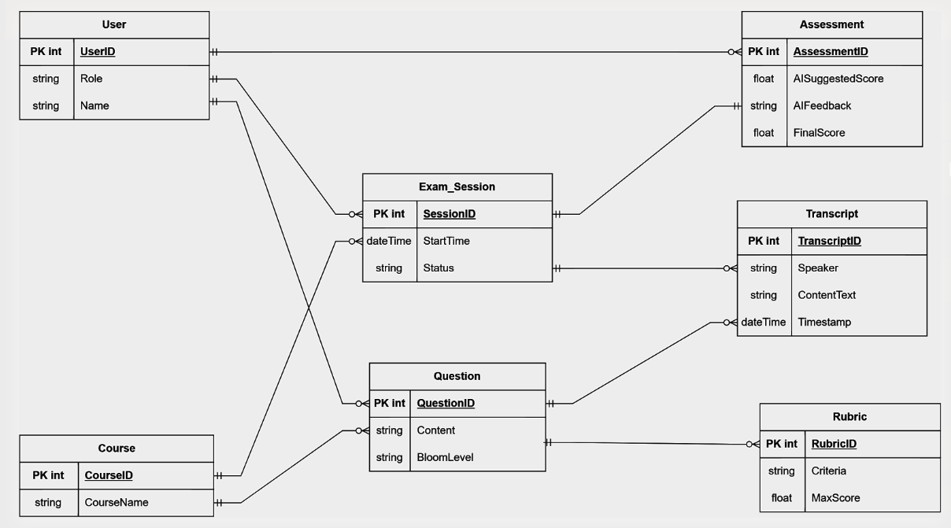
Figure 5. Revised conceptual ERD for the target examination model
The repository contains backend check projects for question-bank rules, rubric validation, course behavior, authentication, authorization, and SQL Server integration. Their presence indicates available verification coverage; this report does not claim that checks were executed or passed during this document update.
- The interview and grading diagrams are design artifacts. Confirm endpoint, persistence, and integration behavior in code before marking these workflows complete.
- The conceptual ERD contains planned entities beyond the current database context.
- The use case diagram includes both current and planned capabilities; use implementation status notes when presenting it.
- No production deployment, response-time benchmark, or service-level objective is asserted here.

8. Conclusion
Milestone 3 establishes the AIVES backend foundation and the question-bank workflow: validated question and rubric authoring, persistence, course and user capabilities, authentication, and AI-assisted question generation. The live viva and human-in-the-loop grading flows provide a direction for subsequent milestones, while their implementation status remains distinct from the current question-authoring state machine.

Appendix A. Project references
- docs/UseCase.drawio — current use case source.
- docs/State-diagram.drawio — current Flow 1 state machine source.
- docs/Conceptual-ERD-AIVES-remake.drawio — revised target conceptual ERD.
- docs/Sequence-CreateQuestion-Rubric-remake.drawio — implemented Flow 1 sequence.
- docs/Sequence-Flow3-AIViva-Interview-remake.drawio — target Flow 3 sequence.
- docs/Sequence-Flow4-AIGrading-HumanInTheLoop-remake.drawio — target Flow 4 sequence.
- BACKEND_CONTRACTS.md and BACKEND_PROGRESS.md — implementation contract and progress records.

