Motion Decomposition with Fitted Minimum Jerk Goals

Abstract
I approximate a recorded right-wrist trajectory with overlapping minimum-jerk displacement components. Speed lobes and intervening minima propose the component count and movement intervals. Onset and completion times are optimized near these intervals, while displacement vectors are fitted by linear least squares with fixed position endpoints. On two windows from the same AMASS clip, the nominal method reduces position RMSE relative to same-count uniform baselines. Velocity RMSE improves in the second window but worsens in the first. Count and timing-neighborhood sensitivity show that the proposals remain heuristic and affect reconstruction quality. The results support a motion-related fitting procedure while identifying limitations in boundary selection and velocity matching.

1 Introduction
The objective is to convert recorded motion into a compact sequence of overlapping minimum-jerk goals. The representation follows Sato et al. [1] and uses the classical smooth point-to-point profile [2]. Related submovement work also fits additive movement components [3]. The unknowns in this experiment are the number of components, their onset and completion times, and their three-dimensional displacements.
Earlier approaches in this project selected goals at fixed intervals or from local motion/error cues. The present method instead fits goal displacements and timing, with speed-based intervals providing an explicit motion-related proposal. Each component is a model element rather than a verified physiological movement unit; one curved movement may require several components.

2 Method

2.1 Overlapping minimum jerk components
For component i, let aᵢ and bᵢ be its onset and completion, Tᵢ=bᵢ−aᵢ its duration, and dᵢ its XYZ displacement vector. Clipped normalized time uᵢ gives the progress Sᵢ from zero before onset to one after completion:
$u_{i}(t) = min(1, max(0, \frac{t - a_{i}}{T_{i}}))$ (1)
$S_{i}(t) = 10{u_{i}}^{3} - 15{u_{i}}^{4} + 6{u_{i}}^{5}$ (2)
$\hat{p}(t) = p_{0} + \sum_{i = 1}^{K}{S_{i}(t)d_{i}}$ (3)
The individual profile has zero velocity and acceleration at its endpoints. Components may overlap, so their vector sum need not stop at intermediate goals. With fixed starting position p₀, cumulative goals are obtained from the fitted displacements:
$g_{i} = p_{0} + \sum_{j = 1}^{i}{d_{j}}$ (4)
During overlap, an intermediate cumulative goal need not be a point actually visited by the reconstructed wrist. The model describes kinematic motion; the fitting objective below does not separately minimize the jerk of the summed trajectory.

2.2 Proposing count and movement intervals
Detection speed is estimated from the full recorded XYZ trajectory using a third-order Savitzky–Golay derivative filter with 17 samples at 120 Hz [6], then cropped to each analysis window. Fitting and evaluation retain the original, unfiltered positions. I retain speed peaks with prominence at least 10% of the crop maximum detection speed and a minimum peak separation of 0.15 s.
The lowest-speed sample between each pair of consecutive retained peaks becomes a candidate boundary, with the crop endpoints completing the partition. The method proposes one component per retained speed lobe; if no peak is retained, it proposes one component. These are heuristic movement intervals, not known movement-unit labels.
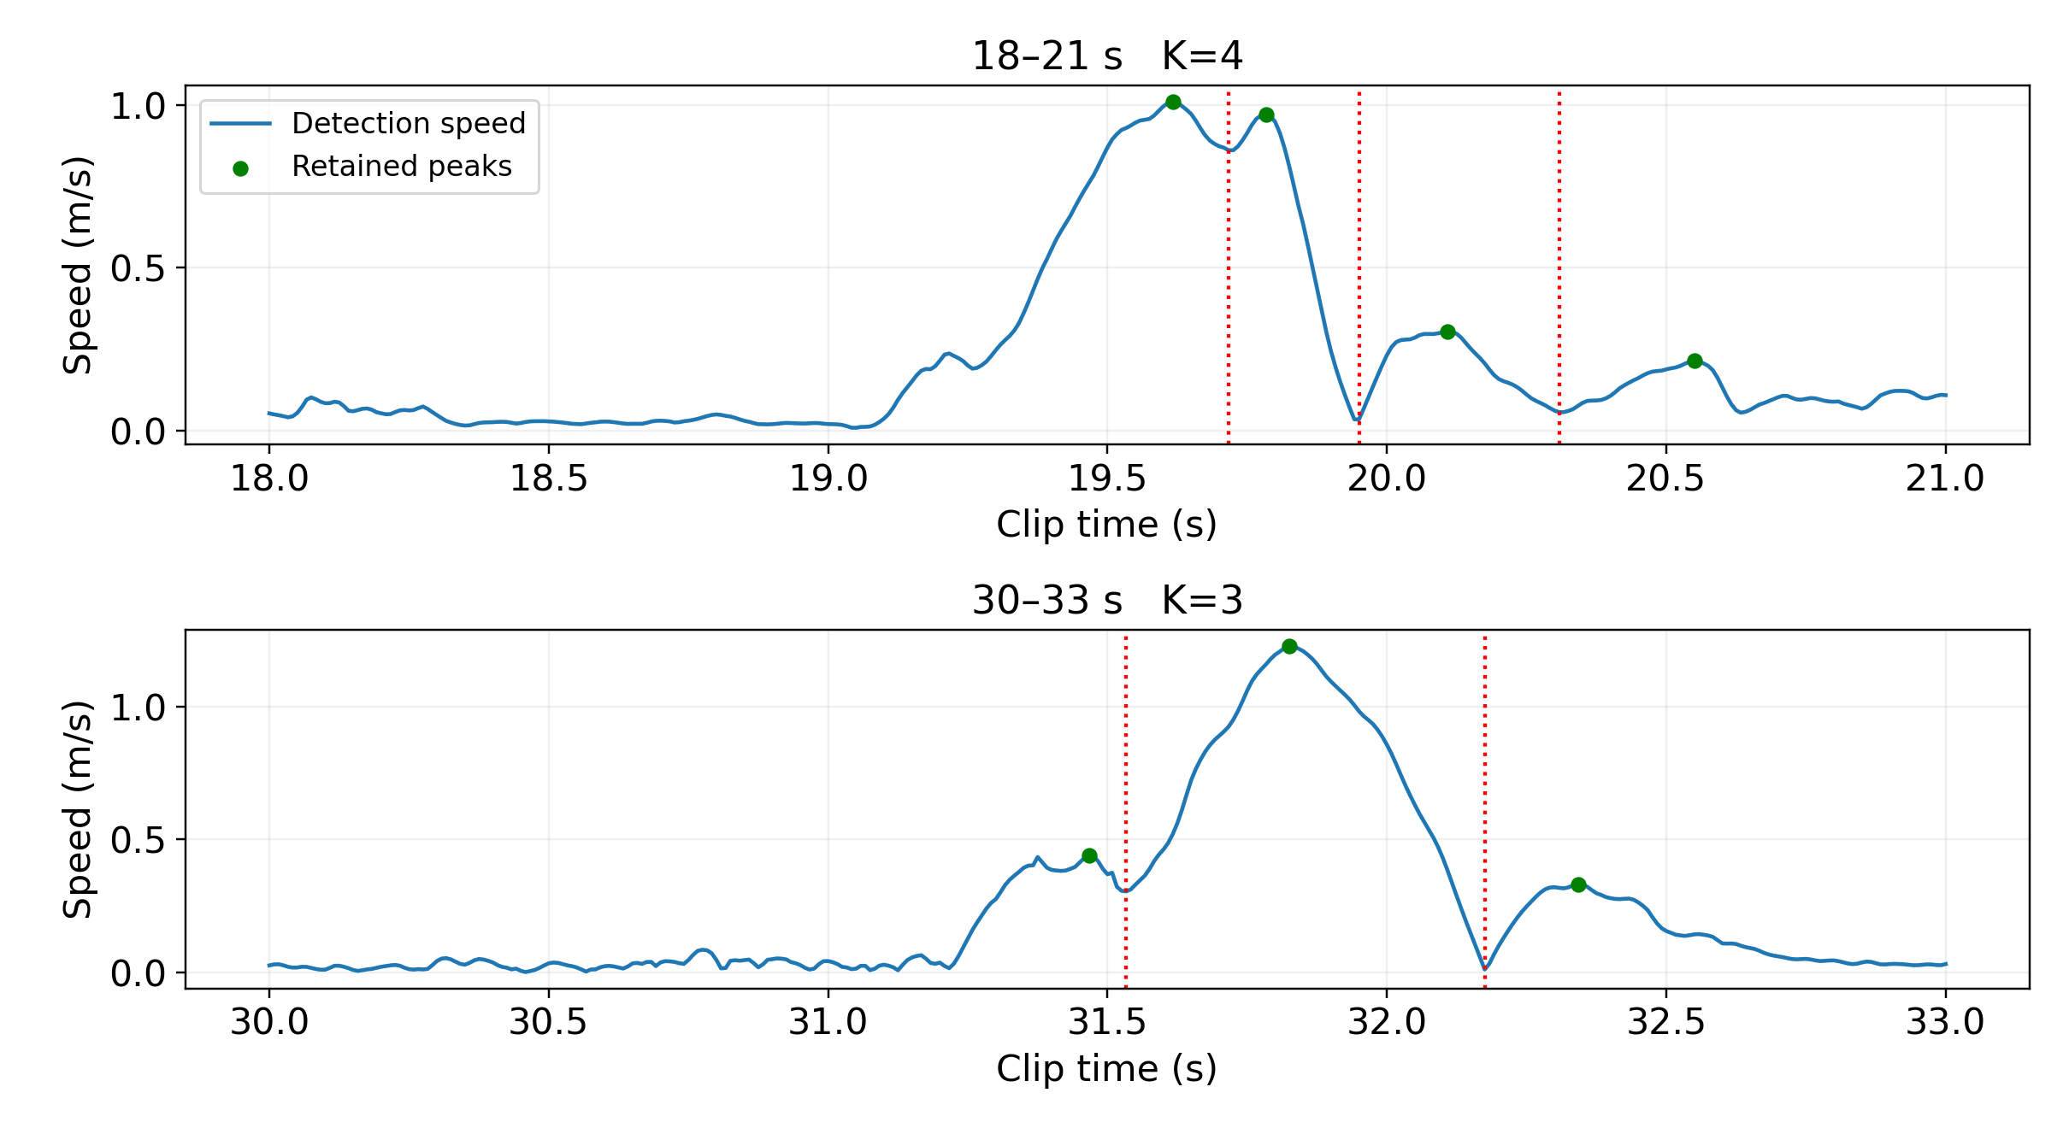
Figure 1. Detection speed and candidate boundaries at the nominal setting. Retained peaks propose four components in 18–21 s and three in 30–33 s; red dotted lines mark intervening speed minima.

2.3 Fitting displacement and timing
For fixed timings, Bₙᵢ=Sᵢ(tₙ) is known and the trajectory is linear in the displacement vectors. To preserve the observed final position pF, define Δ=pF−p₀ and eliminate the last displacement:
$Δ = p_{F} - p_{0} , d_{K} = Δ - \sum_{i = 1}^{K - 1}{d_{i}}$ (5)
The remaining K−1 vectors are fitted together using all observed samples. With Dfree containing those vectors as rows, the endpoint-constrained linear system is:
$F_{ni} = B_{ni} - B_{nK} , y_{n} = p_{n} - p_{0} - B_{nK}Δ$ (6)
$minimize over D_{free} {‖FD_{free} - y‖}^{2}$ (7)
The matrix norm denotes the sum of squared entries. For K=1, the sole displacement equals Δ and only its timing is fitted. Linear least squares is solved again at every trial timing, so the displacement fit remains consistent with the outer objective:
$minimize over a,b \sum_{n = 1}^{N}{{‖\hat{p}(t_{n}; a,b, D^{*}(a,b)) - p_{n}‖}^{2}}$ (8)
The outer solver uses bounded trust-region reflective least squares [5] with four initializations per condition. One initialization extends the proposed interval boundaries outward by 0.25 of their local scale; the others sample the allowed timing regions. The lowest-position-error successful fit is selected. Velocity is evaluated separately and is not included in the objective. No opposition penalty is used by the final method.

2.4 Local timing association
To keep each component associated with its proposed interval, its onset and completion are optimized near the corresponding boundaries. Let q₀,…,qK denote the boundaries. At an internal boundary, r is the smaller adjacent interval width; at a crop edge, it is the single adjacent width. With outward fraction α and inward fraction β, the timing bounds are:
$max(t_{0}, q_{i-1} - αr_{i-1}) ≤ a_{i} ≤ q_{i-1} + βr_{i-1}$ (9)
$q_{i} - βr_{i} ≤ b_{i} ≤ min(t_{F}, q_{i} + αr_{i})$ (10)
The nominal values are α=0.45 and β=0.20. Thus onset may move earlier by up to 0.45r or later by 0.20r; completion may move earlier by 0.20r or later by 0.45r. These fractions allow overlap and continuous fitting while preserving local association. They are empirical constraints, not physiological constants. Their influence is tested rather than assumed negligible.
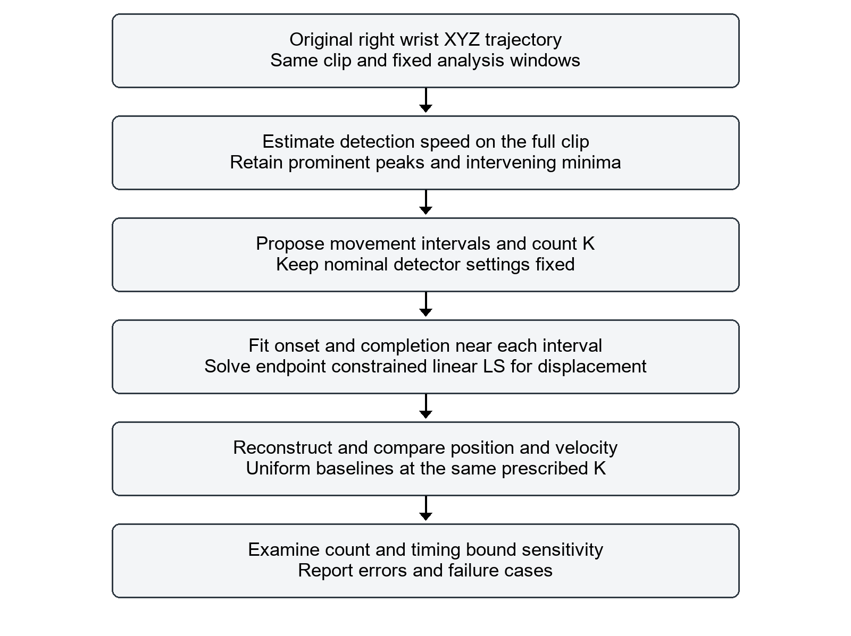
Figure 2. Overview of the final method. Speed structure proposes the count and intervals; timing and displacement are fitted, then evaluated against matched-count uniform baselines and parameter sensitivity.

3 Experimental design
The experiment uses the right wrist from the D3 Conversation Gestures clip in the ACCAD subset of AMASS [4], extracted with a female SMPL+H model. Positions are global XYZ coordinates in meters, including root orientation and translation. I analyze 18–21 s and 30–33 s independently; each window contains 361 samples at 120 Hz. Initial and final positions are fixed to the observed crop endpoints.
I compare the proposed method with two controls at the same prescribed K: uniform timing with sampled goal positions, and the same uniform timing with fitted displacements. Both controls use equal time intervals with a 0.25-interval overlap extension. All methods share the raw target, endpoint positions and overlapping representation. Timing optimization uses multiple nonlinear starts, whereas the fixed-time fitted control requires one linear solve, so computation is not equal.
Position and velocity RMSE are computed from three-dimensional vector errors. Both reference and reconstructed velocity use the same numerical differentiation convention, numpy.gradient with edge_order=2:
${RMSE}_{p} = \sqrt{\frac{\sum_{n = 1}^{N}{{‖\hat{p}(t_{n}) - p_{n}‖}^{2}}}{N}}$ (11)
${RMSE}_{v} = \sqrt{\frac{\sum_{n = 1}^{N}{{‖\hat{v}(t_{n}) - v_{n}‖}^{2}}}{N}}$ (12)
I also report the maximum three-dimensional position error. Position errors in the result table are expressed in centimeters. Count sensitivity varies peak prominence while keeping filtering and peak separation fixed; every distinct proposed partition is retained. Timing-bound sensitivity holds nominal counts and boundaries fixed while comparing narrower, nominal and wider neighborhoods. Neither sweep is used to replace the nominal setting after observing its error.

4 Results

4.1 Nominal reconstruction and uniform baselines
The nominal detector proposes K=4 for the first window and K=3 for the second. Table 1 gives the matched-count comparison.
Table 1. Reconstruction errors at the nominal counts.
Window s | Method | K | Pos RMSE cm | Vel RMSE m/s | Max pos cm
18–21 | Uniform sampled | 4 | 6.387 | 0.3061 | 18.318
18–21 | Uniform fitted | 4 | 5.254 | 0.3160 | 13.265
18–21 | Valley fitted | 4 | 4.194 | 0.3620 | 14.420
30–33 | Uniform sampled | 3 | 8.969 | 0.4172 | 24.562
30–33 | Uniform fitted | 3 | 7.535 | 0.4201 | 17.491
30–33 | Valley fitted | 3 | 3.022 | 0.2631 | 8.239
Position RMSE is lower than both uniform baselines in both windows. In the first window, however, velocity RMSE is higher than both baselines and maximum position error is higher than the uniform fitted control. The second window improves all three reported metrics. The method therefore provides a mixed result rather than an improvement across every metric.
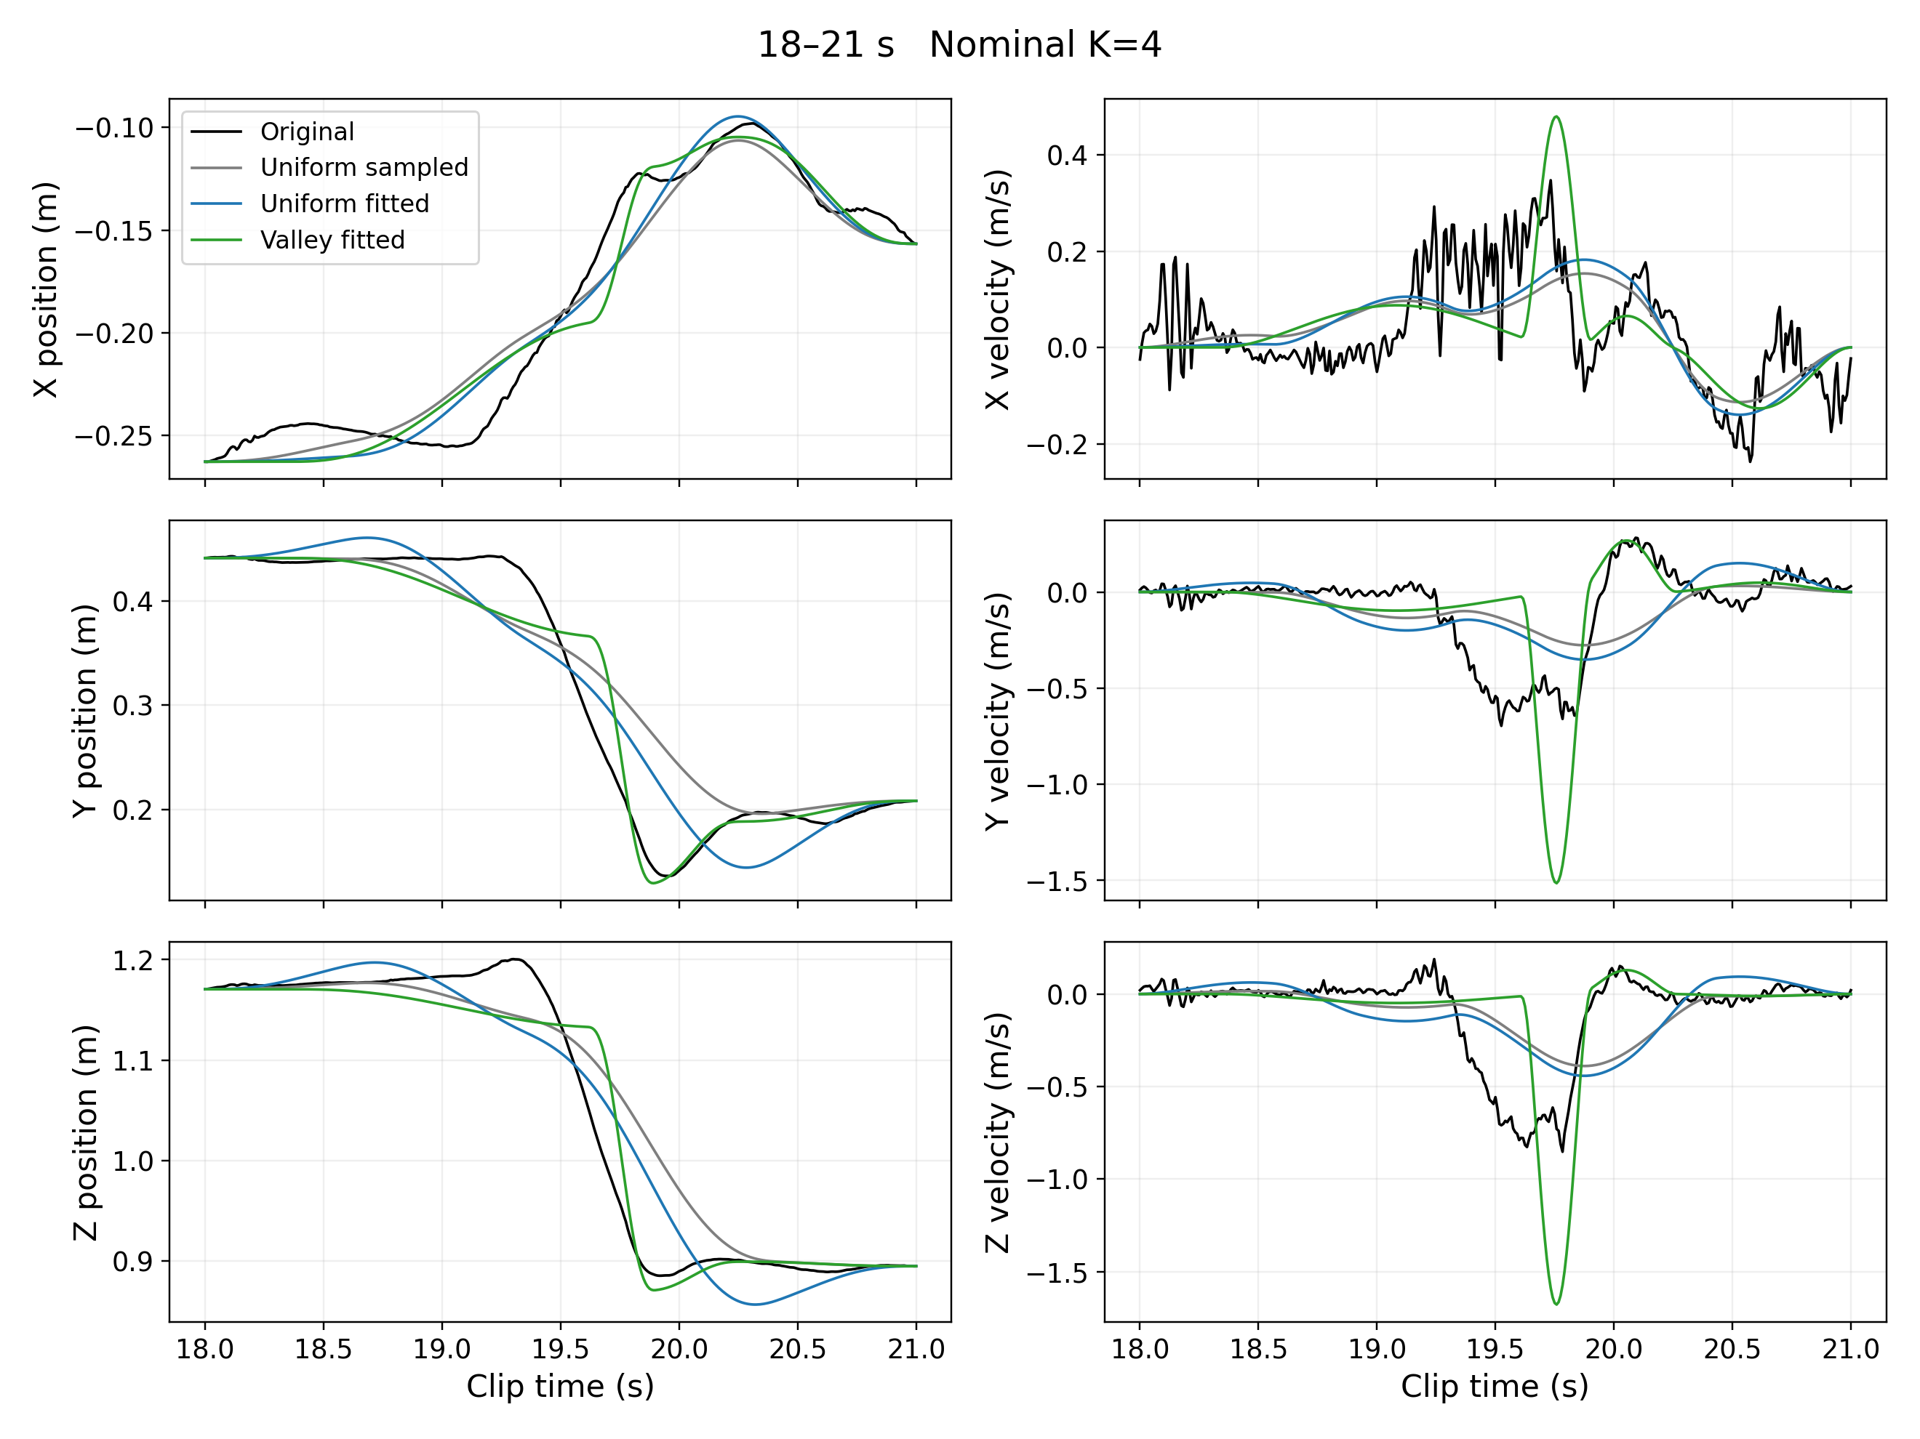
Figure 3. First-window XYZ position and velocity comparison at K=4. The fitted trajectory reduces average position error but introduces a sharp velocity excursion near the high-speed candidate boundary.
The first window contains a shallow relative speed minimum within a high-speed region. Assigning separate locally constrained components around that minimum can limit the reconstruction. The position-only objective also permits a reduction in position error without a corresponding velocity improvement.
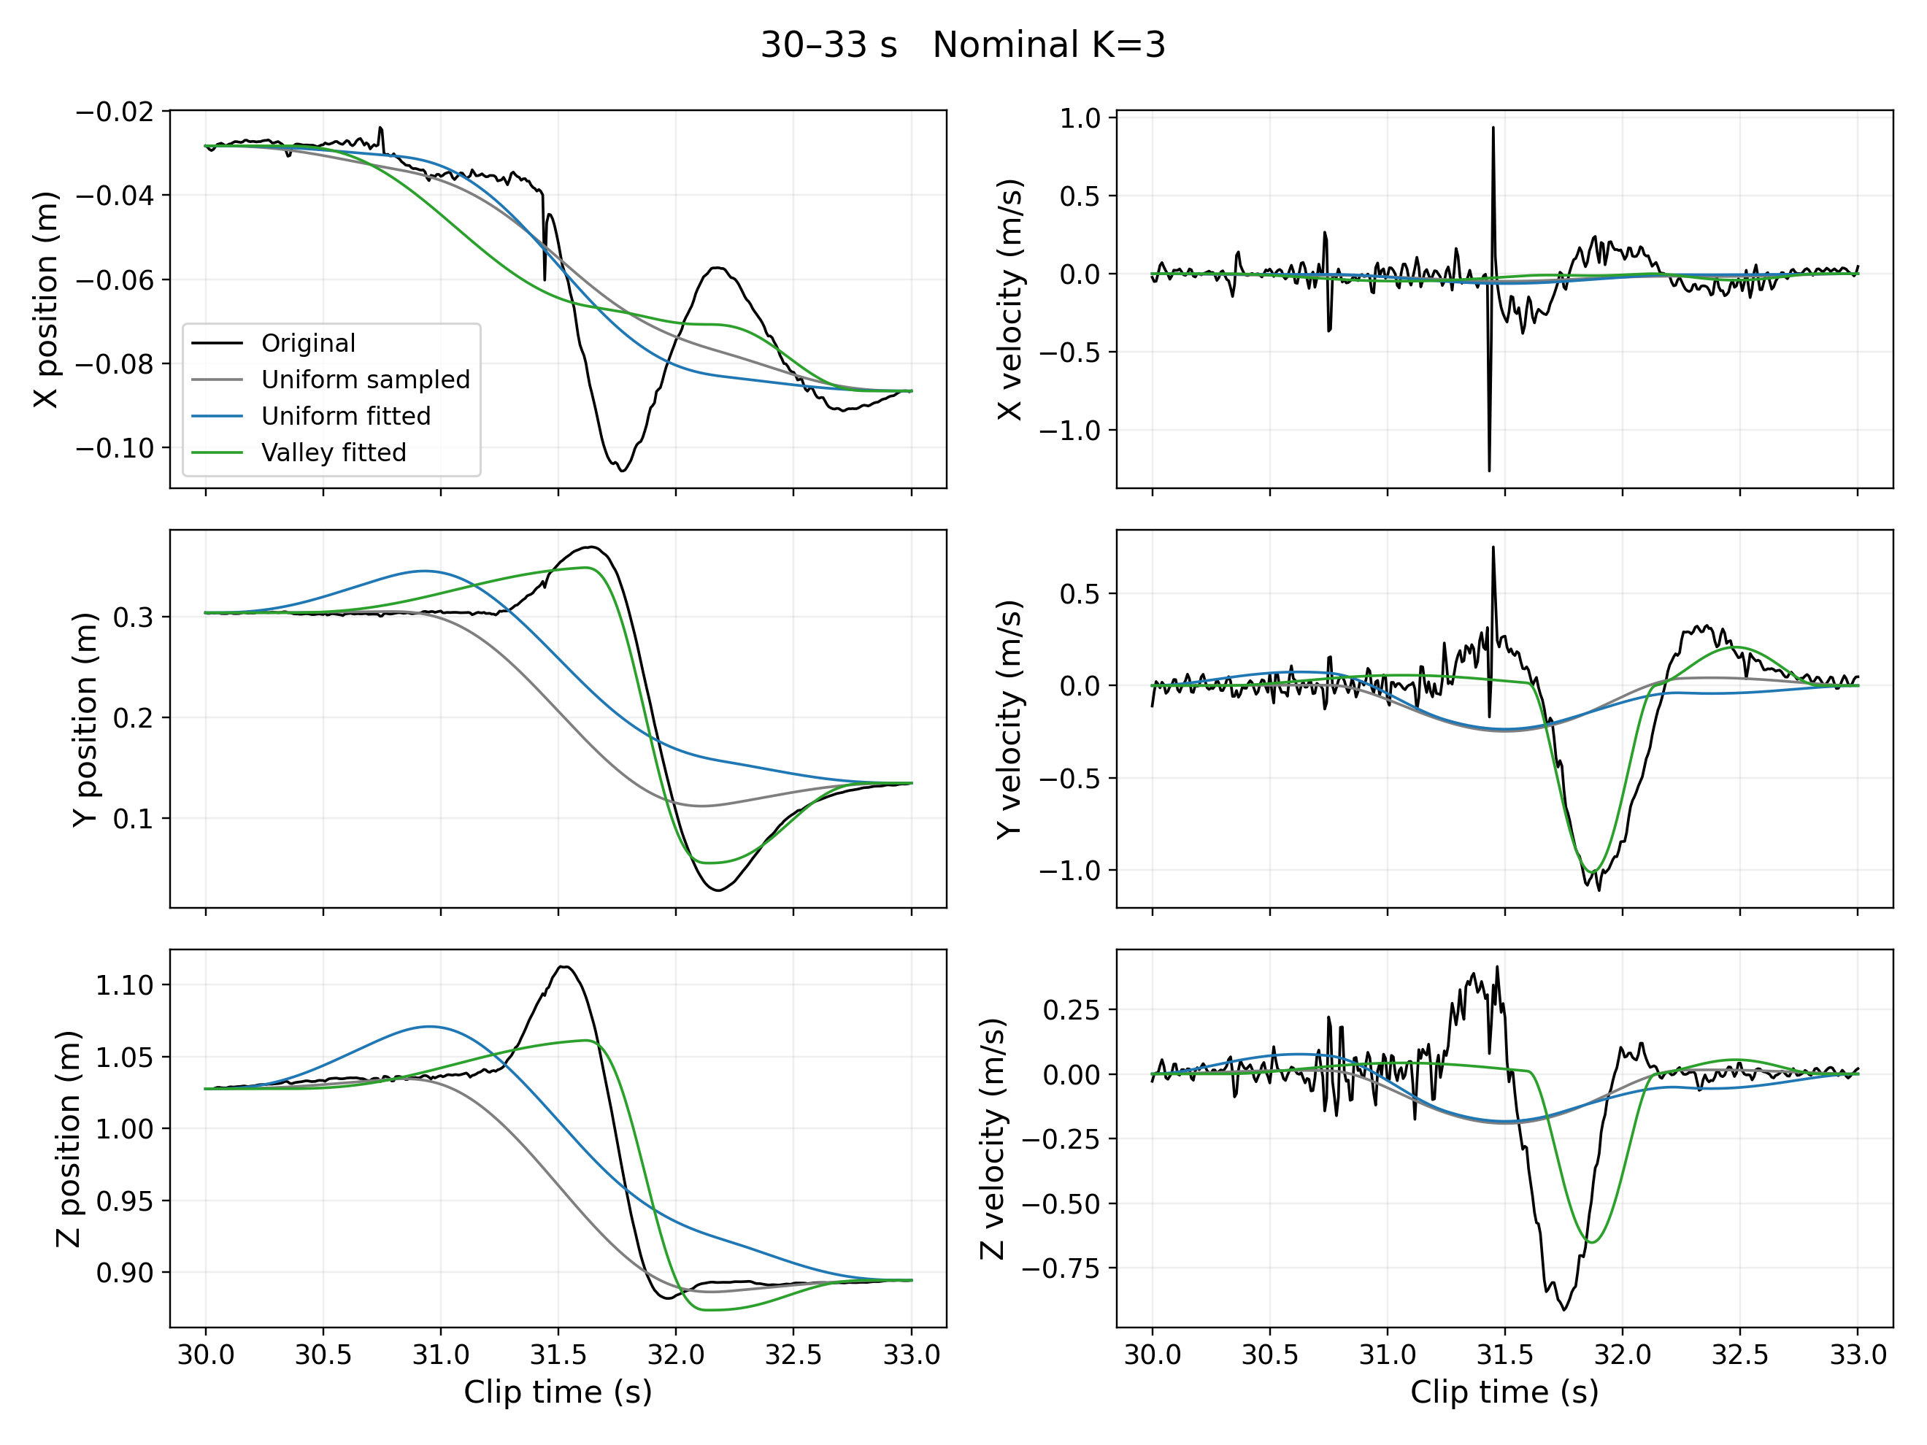
Figure 4. Second-window XYZ position and velocity comparison at K=3. The method captures the major Y and Z movement better than the same-count controls but still misses the X-position excursion and some earlier details.

4.2 Component count sensitivity
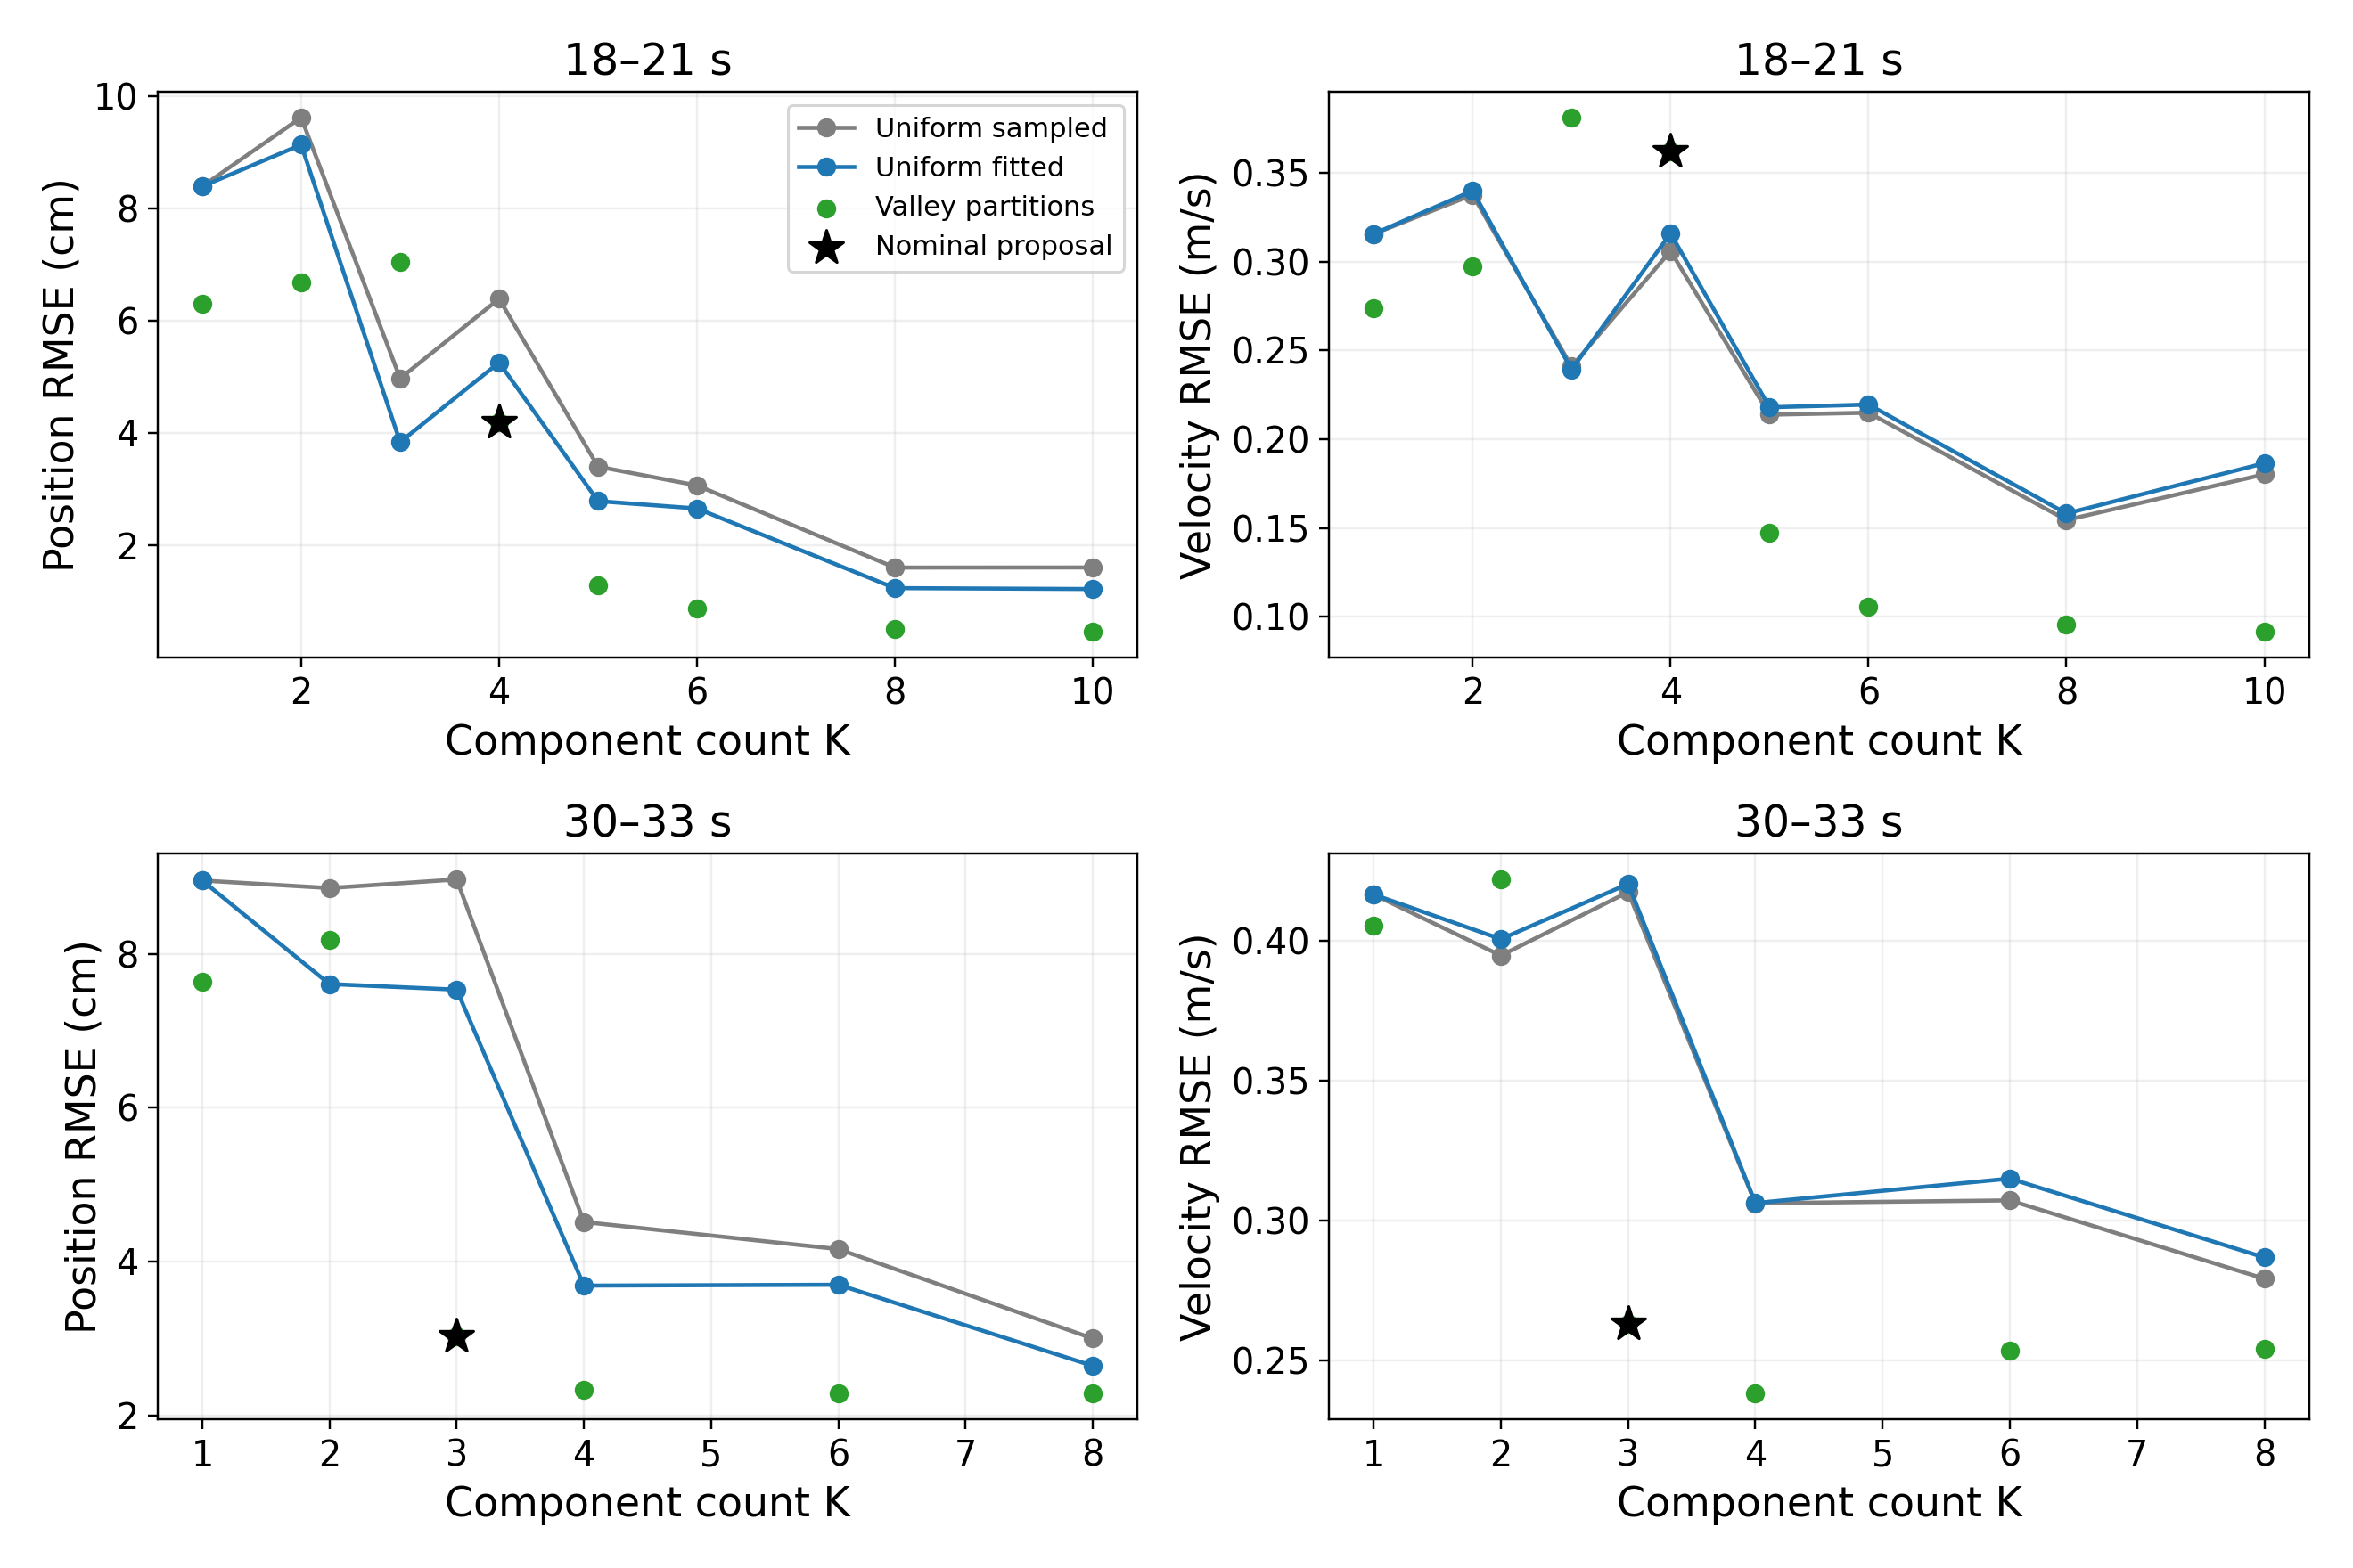
Figure 5. Position and velocity errors across distinct speed-based partitions and uniform baselines at the same K. Stars mark the nominal proposals. Changing prominence changes both count and boundaries, so this is not a count-only causal comparison.
Additional detected partitions substantially improve the first-window reconstruction. The second window improves from three to four components and then shows smaller position-error changes. The proposed count depends on detection settings, and error need not decrease monotonically because the associated timing regions also change. These curves characterize a tradeoff; they do not identify a uniquely correct number of movement units.

4.3 Timing neighborhood sensitivity
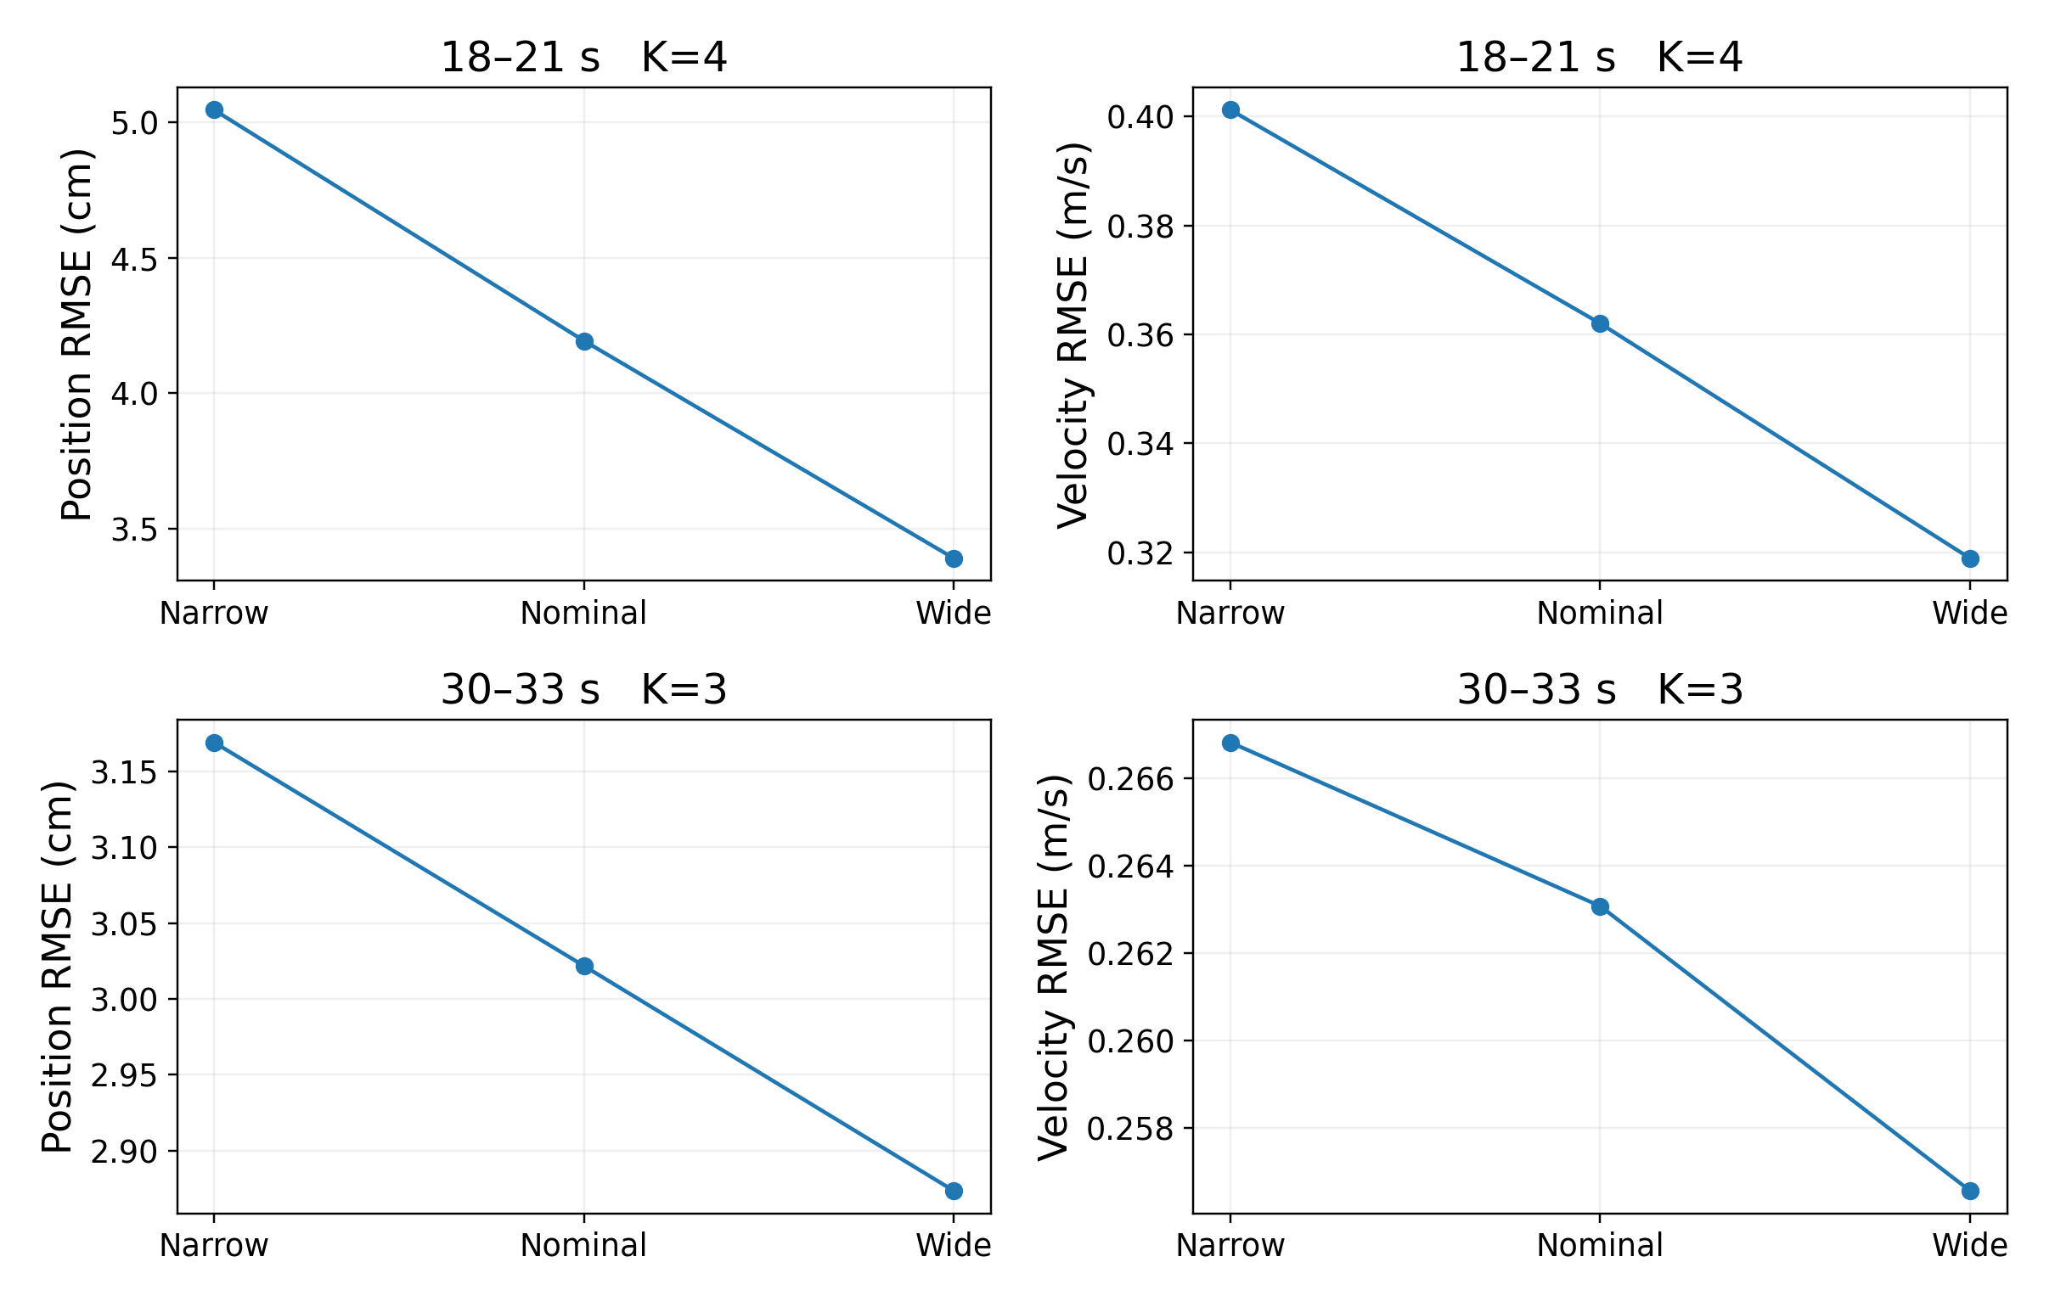
Figure 6. Timing-neighborhood sensitivity with fixed counts and candidate boundaries. Narrow, nominal and wide use (α,β)=(0.30,0.10), (0.45,0.20) and (0.60,0.30), respectively. The vertical scales differ between windows.
Wider neighborhoods reduce position RMSE in both windows, especially in the first, and fitted times frequently approach the permitted boundaries. The constraints therefore influence the result. Across these three settings, position RMSE remains below both uniform baselines in both windows; velocity RMSE remains higher in the first and lower in the second. I retain the nominal setting rather than selecting the wider setting after seeing its lower error. This check is limited to the two nominal partitions and varies the two fractions together.

5 Discussion and limitations
Speed minima provide motion-related candidate boundaries, but overlap may merge speed lobes and shallow minima may split one movement. Filtering and peak-selection settings also affect the proposed count. Local timing association preserves the connection to these candidates at the cost of fitting flexibility. The first-window velocity mismatch is an important failure case rather than evidence of a generally successful decomposition.
Earlier unrestricted fits and regularized variants exposed redundant or opposing components. This motivated an explicit association with candidate movement intervals. Those explorations do not provide a validated physiological interpretation, and local timing bounds do not guarantee the absence of cancellation. Their detailed results are retained in the repository rather than combined with the final method’s scores.
The main objective fits position only, so simultaneous improvement of position and velocity is not guaranteed. The model also has zero analytical velocity at the crop endpoints although the measured wrist may still be moving. Only two windows from one clip are examined. The experiment does not establish full-clip generalization, true neural movement units or whole-body physical feasibility.

6 Conclusion
The experiment replaces sampled goals and fixed timing with fitted displacement vectors and motion-related timing proposals. Endpoint-constrained linear least squares is combined with local timing optimization, and speed structure supplies an explicit count hypothesis. The method improves position reconstruction against matched-count uniform controls in both tested windows, while velocity improves only in the second. Sensitivity to the candidate partition and timing constraints remains a central limitation of this heuristic conversion procedure.

References
[1] Sato, H., Mitake, H., and Hasegawa, S. (2025). Artist-Directable Motion Generation Using Overlapping Minimum Jerk Trajectories for Interactive Embodied Social Agent Adapting to Dynamic Environments. Computer Animation and Virtual Worlds, 36, e70075. https://doi.org/10.1002/cav.70075
[2] Flash, T., and Hogan, N. (1985). The coordination of arm movements: An experimentally confirmed mathematical model. Journal of Neuroscience, 5(7), 1688–1703. https://doi.org/10.1523/JNEUROSCI.05-07-01688.1985
[3] Liao, J. Y., and Kirsch, R. F. (2014). Characterizing and Predicting Submovements during Human Three-Dimensional Arm Reaches. PLOS ONE, 9(7), e103387. https://doi.org/10.1371/journal.pone.0103387
[4] Mahmood, N., Ghorbani, N., Troje, N. F., Pons-Moll, G., and Black, M. J. (2019). AMASS: Archive of Motion Capture as Surface Shapes. ICCV, 5442–5451. https://amass.is.tue.mpg.de/
[5] SciPy 1.15.2 documentation. scipy.optimize.least_squares. https://docs.scipy.org/doc/scipy-1.15.2/reference/generated/scipy.optimize.least_squares.html
[6] SciPy 1.15.2 documentation. scipy.signal.savgol_filter and scipy.signal.find_peaks. https://docs.scipy.org/doc/scipy-1.15.2/reference/signal.html

