**Project Title**

Analysis and Simulation of Novint Falcon Haptic Device as a Robot Manipulator

**List of Group Members**

Peiguang Wang, Sichao Zhang

**Motivation**

Novint Falcon (Figure 1) is a 3-DOF haptic device initially made for the gaming industry but can be applied as a closed loop robot manipulator. Our team intends to analyze the kinematics and dynamics model of Falcon and generate appropriate control method to control it to move in expected trajectory.

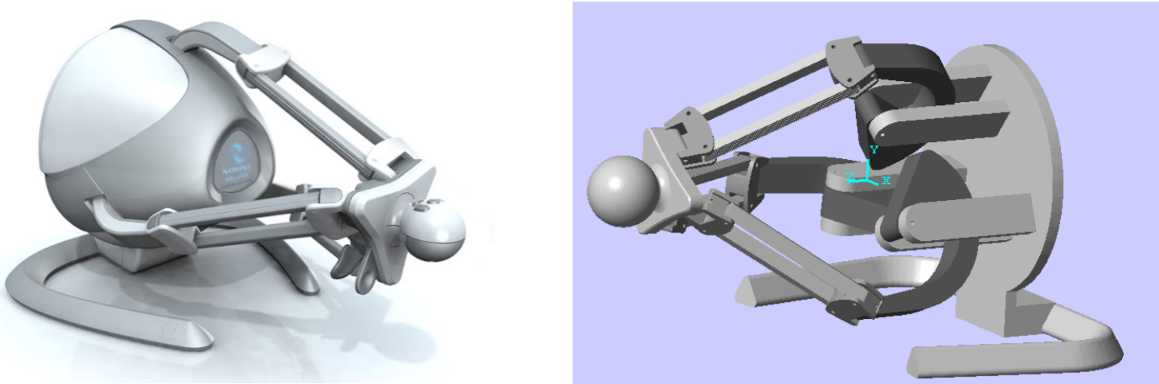

Figure Novint Falcon Haptic device [1]

Motivated by [3], we decided to use three Novint Falcon robots to solve a pinball maze. One example of the pinball maze is shown in figure 2. You can manipulate the ball by rotating the maze in different orientation, and the ball will move because of gravity. By carefully rotating the maze you can move the ball from start point to end point.

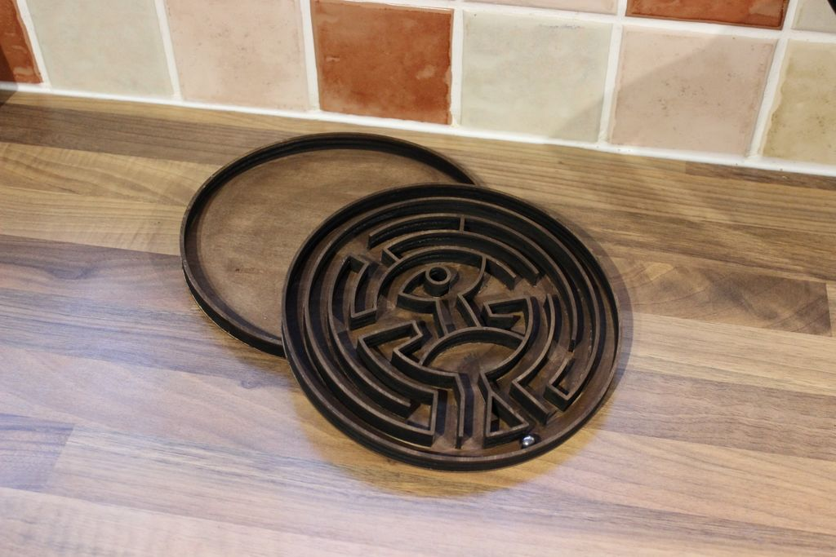

Figure One Example of Pinball Maze. You can manipulate the ball by rotating the maze in different orientation, and the ball will move because of gravity. By carefully rotating the maze you can move the ball from start point to end point.

We are going to use three three Novint Falcon to control the move of the pinball, like figure 3.

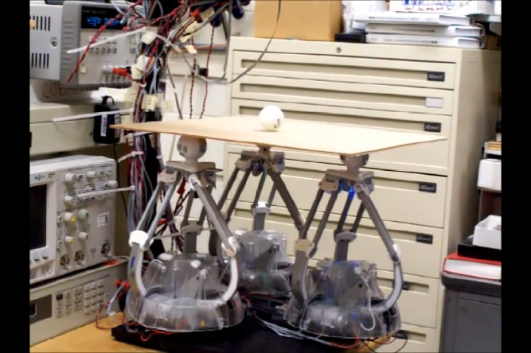

Figure Control the position of the pinball using three Novint Falcon robots[3]

**Technical description**

‘The controller (Falcon as a manipulator) uses a form similar to that of the delta-robot configuration and because of this form, makes an interesting apparatus for research into control and estimation problems for robots involving parallel linkages.’ [2]

**Evaluation method**

We are going to build a simulation program in MATLAB to see whether the robot solves the problem. Specially, we are going to write programs to test:

* By generating a path and see whether the robot follow the path to see whether the kinematics and inverse kinematics works.
* Simulation of the “pinball maze solving” process.

**Project time line**

Kinematics – 2 weeks

Inver Kinematics – 2 weeks

Pinball Maze Simulation – 4 weeks

Dynamic and control – If time permitting

**Reference**

[1]*Karbasizadeh, Nima, et al. "Dynamic identification of the Novint Falcon Haptic device." Robotics and Mechatronics (ICROM), 2016 4th International Conference on. IEEE, 2016.*

[2] *Martin, Steven, and Nick Hillier. "Characterisation of the Novint Falcon haptic device for application as a robot manipulator." Australasian Conference on Robotics and Automation (ACRA). 2009.*

[3] Youtube video: <https://www.youtube.com/watch?v=AglF4q0QBsM>