EX 5

Câu 1

Tạo repository

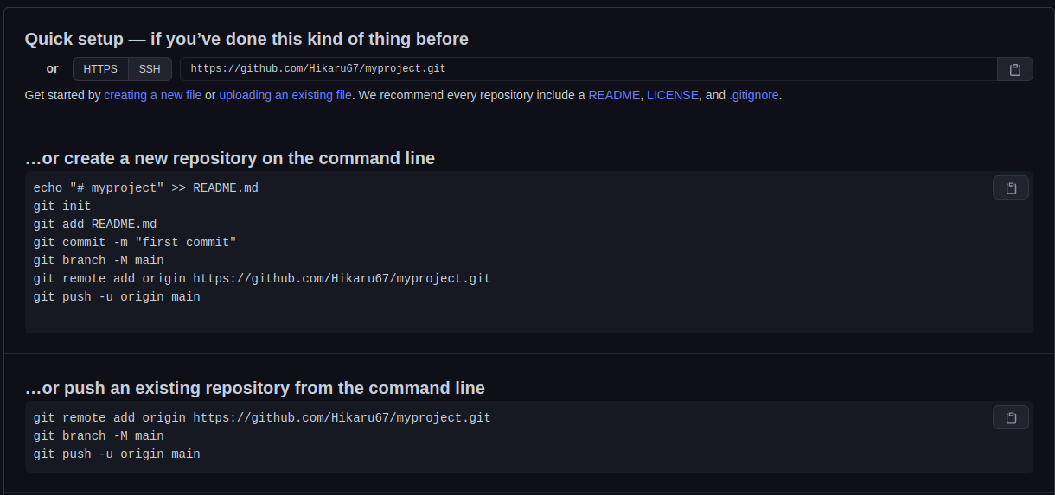

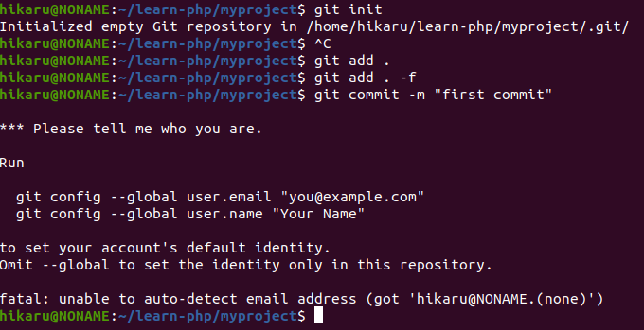

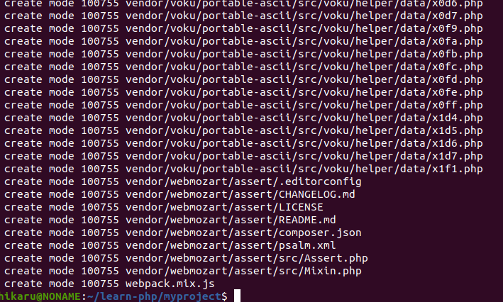

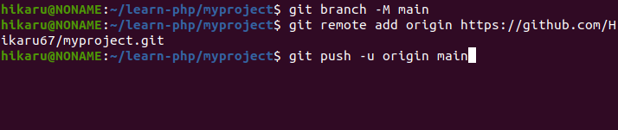

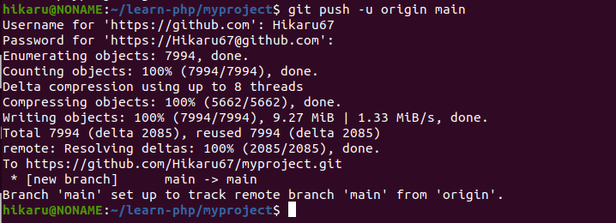

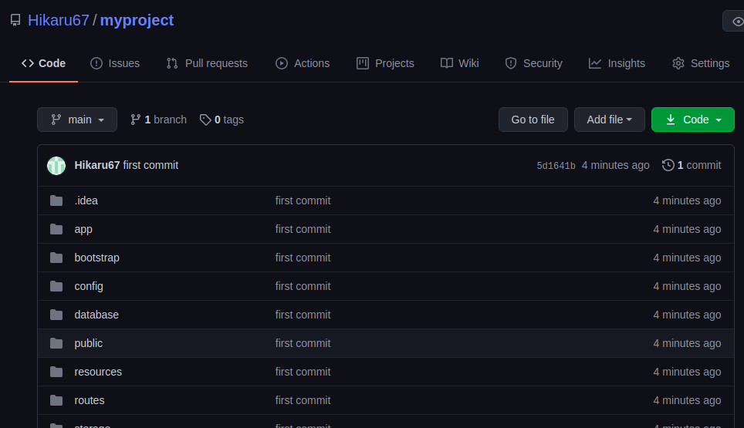a

Câu 2

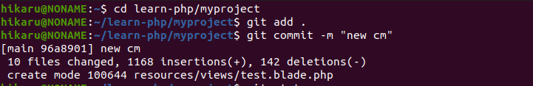

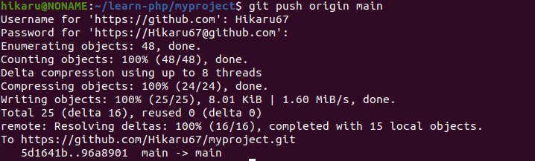



class UsersSeeder extends Seeder  
{  
 */\*\**  
 *\* Run the database seeds.*  
 *\**  
 *\** ***@return*** *void*  
 *\*/*  
public function run()  
 {  
  
 $data = [  
 [  
 'id' => 1,  
 'fullName' => 'Noname',  
 'birthday' => 1923788800,  
 'email' => 'shinigamii.hikaru@gmail.com',  
 'phoneNumber' => '0372056670',  
 'job' => 'no job',  
 'avatar' => '',  
 'facebook' => 'fb.me/hikaru67',  
 'gender' => *GENDER*['MALE'],  
 'country' => 'Hà Tĩnh',  
 'role' => 'admin',  
 'status' => *STATUS_USER*["ACTIVE"],  
 'created_at' => now(),  
 ],  
 [  
 'id' => 2,  
 'fullName' => 'Naix',  
 'birthday' => 923788800,  
 'email' => 'shoppingall4youu@gmail.com',  
 'phoneNumber' => '0915835xxx',  
 'job' => 'no job',  
 'avatar' => '',  
 'facebook' => 'fb.me/hikaru68',  
 'gender' => *GENDER*['MALE'],  
 'country' => 'Hà Tĩnh',  
 'role' => 'admin',  
 'status' => *STATUS_USER*["ACTIVE"],  
 'created_at' => now(),  
 ],  
 ];  
 Users::*insert*($data);  
// Users::factory(55)->create();  
 $user = factory(App\Users::class, 55)->create();  
  
 }  
}

class SubjectsSeeder extends Seeder  
{  
 */\*\**  
 *\* Run the database seeds.*  
 *\**  
 *\** ***@return*** *void*  
 *\*/*  
public function run()  
 {  
 $data = [  
 [  
 'id' => 1,  
 'name' => 'PHP',  
 'description' => 'description subject PHP',  
 'avatar' => '',  
 'status' => 1,  
 'userId' => 2,  
 'created_at' => now(),  
 ],  
 [  
 'id' => 2,  
 'name' => 'C#',  
 'description' => 'description subject C#',  
 'avatar' => '',  
 'status' => 1,  
 'userId' => 2,  
 'created_at' => now(),  
 ],  
 [  
 'id' => 3,  
 'name' => 'Python',  
 'description' => 'description subject Python',  
 'avatar' => '',  
 'status' => 1,  
 'userId' => 2,  
 'created_at' => now(),  
 ],  
 [  
 'id' => 4,  
 'name' => 'Java',  
 'description' => 'description subject Java',  
 'avatar' => '',  
 'status' => 1,  
 'userId' => 2,  
 'created_at' => now(),  
 ],  
 [  
 'id' => 5,  
 'name' => 'Laravel',  
 'description' => 'description subject Laravel',  
 'avatar' => '',  
 'status' => 1,  
 'userId' => 2,  
 'created_at' => now(),  
 ],  
 [  
 'id' => 6,  
 'name' => 'ReactJs',  
 'description' => 'description subject ReactJs',  
 'avatar' => '',  
 'status' => 1,  
 'userId' => 2,  
 'created_at' => now(),  
 ],  
 ];  
  
 Subjects::*insert*($data);  
 }  
}

class ClassesSeeder extends Seeder  
{  
 */\*\**  
 *\* Run the database seeds.*  
 *\**  
 *\** ***@return*** *void*  
 *\*/*  
public function run()  
 {  
 $data = [  
 [  
 'id' => 1,  
 'name' => 'Front end',  
 'avatar' => 'https://i.pinimg.com/originals/34/61/4d/34614d927f7c8c1c3562ef75f0471c37.jpg',  
 'status' => 1,  
 'userId' => 2,  
 'subjectId' => rand(1,5),  
 'created_at' => now(),  
 ],  
 [  
 'id' => 2,  
 'name' => 'Back end',  
 'avatar' => 'https://i.pinimg.com/originals/34/61/4d/34614d927f7c8c1c3562ef75f0471c37.jpg',  
 'status' => 1,  
 'userId' => 2,  
 'subjectId' => rand(1,5),  
 'created_at' => now(),  
 ],  
 [  
 'id' => 3,  
 'name' => 'Fullstack',  
 'avatar' => 'https://i.pinimg.com/originals/34/61/4d/34614d927f7c8c1c3562ef75f0471c37.jpg',  
 'status' => 1,  
 'userId' => 2,  
 'subjectId' => rand(1,5),  
 'created_at' => now(),  
 ],  
 [  
 'id' => 4,  
 'name' => 'Tester',  
 'avatar' => 'https://i.pinimg.com/originals/34/61/4d/34614d927f7c8c1c3562ef75f0471c37.jpg',  
 'status' => 1,  
 'userId' => 2,  
 'subjectId' => rand(1,5),  
 'created_at' => now(),  
 ],  
 [  
 'id' => 5,  
 'name' => 'Machine learning',  
 'avatar' => 'https://i.pinimg.com/originals/34/61/4d/34614d927f7c8c1c3562ef75f0471c37.jpg',  
 'status' => 1,  
 'userId' => 2,  
 'subjectId' => rand(1,5),  
 'created_at' => now(),  
 ],  
 [  
 'id' => 6,  
 'name' => 'Artificial Intelligence',  
 'avatar' => 'https://i.pinimg.com/originals/34/61/4d/34614d927f7c8c1c3562ef75f0471c37.jpg',  
 'status' => 2,  
 'userId' => 2,  
 'subjectId' => rand(1,5),  
 'created_at' => now(),  
 ],  
 ];  
  
 Classes::*insert*($data);  
 }  
}

class CourseRqsSeeder extends Seeder  
{  
 */\*\**  
 *\* Run the database seeds.*  
 *\**  
 *\** ***@return*** *void*  
 *\*/*  
public function run()  
 {  
 $data = [];  
 for($i = 1; $i <= 57; $i++){  
 if(Users::*find*($i)['role']=='user_course'){  
 $data[] = [  
 'id' => $i,  
 'frequency' => rand(1,3),  
 'durationTime' => (($a = rand(1,3))==1) ? 5400 : (($a == 2) ? 7200 : 9000),  
 'targetTop' => rand(1,3),  
 'wishJob'=> rand(1,3),  
 'completeExercise' => rand(1,3),  
 'outCondition' => rand(1,3),  
 'nowSkill' => 'none',  
 'mission' => 'none',  
 'userId' => $i,  
 'classesId' => rand(1,6),  
 'created_at' => now(),  
 ];  
 }  
 }  
 Course_rqs::*insert*($data);  
 }  
}

class DatabaseSeeder extends Seeder  
{  
 */\*\**  
 *\* Seed the application's database.*  
 *\**  
 *\** ***@return*** *void*  
 *\*/*  
public function run()  
 {  
 // \App\Models\User::factory(10)->create();  
 $this->call([  
 UsersSeeder::class,  
 SubjectsSeeder::class,  
 ClassesSeeder::class,

CourseRqsSeeder::class,  
 ]);  
 }  
}

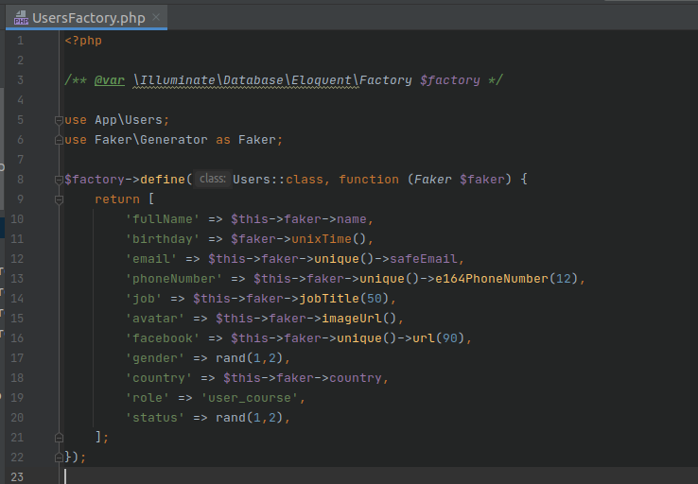a

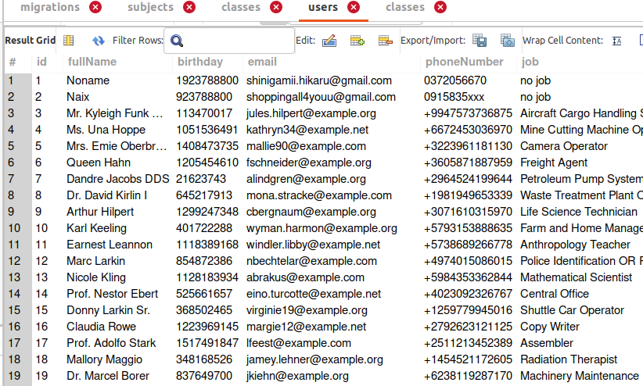a

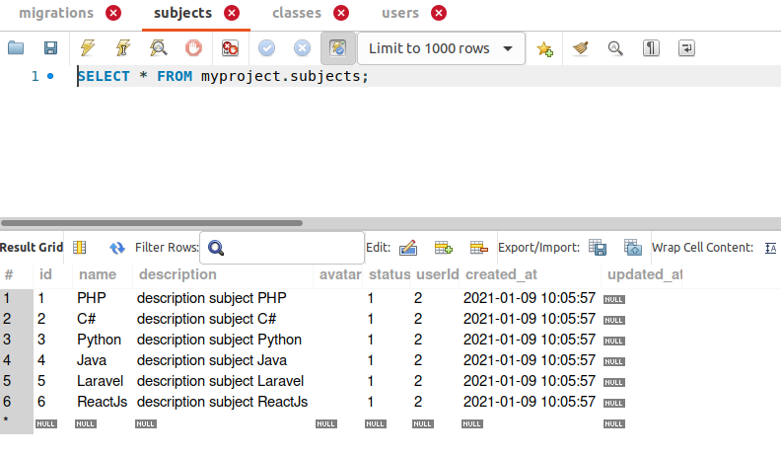a

