MARKETINTEL DB TECHNICAL SPECIFICATION — DOC-00
Master System Architecture & Developer Onboarding Manual
Enterprise Dual-Tier CRM, REA Reconstructed Topology, and End-to-End System Specifications
Platform Name | MarketIntel DB (Lead Intelligence & CRM Platform)
Document Identifier | DOC-00 (Version 1.0.0)
Lead Analysis Specialist | Agent 13 — Master Architecture & Traceability Lead
Date of Publication | October 27, 2026
Reverse Engineering Tool | REA 6.7.0 (Reverse Engineering Anything) + MCP
Classification | Confidential — Internal Engineering & Architecture Manual

1.0 Executive Overview & System Boundaries
MarketIntel DB is an enterprise-grade dual-tier customer relationship management (CRM) and market intelligence platform. The application orchestrates complex business workflows across prospect research, lead qualification, multi-channel outreach (email and WhatsApp), corporate hierarchical structures, event tracking, and social media campaign management.
The architecture strictly separates concerns between a reactive Single-Page Application (SPA) frontend built on React 19 and Vite, and a resilient Django 6.1.1 + Django REST Framework backend application server. The system communicates via cookie-based JSON Web Tokens (JWT) with strict cross-origin resource sharing (CORS) and Cross-Site Request Forgery (CSRF) protections.
[IMPORTANT] Reverse Engineering Methodology (REA 6.7.0)
This master technical specification was reconstructed using REA (Reverse Engineering Anything) MCP tooling, analyzing 85 frontend assets (1.53 MB JavaScript bundle), 530 backend Python AST symbols, 43 database models across 55 migration files, 90 RESTful API endpoints, and 230 automated test cases. The complete evidence bundle (230 MB) is retained under docs/technical-documentation-v1/rea-analysis/rea_evidence_bundle.json.

1.1 High-Level Component Topology
The platform is organized into four distinct horizontal execution tiers: Client Presentation Tier, Gateway/Proxy Tier, Application Service Tier, and Data Persistence/External Integration Tier.
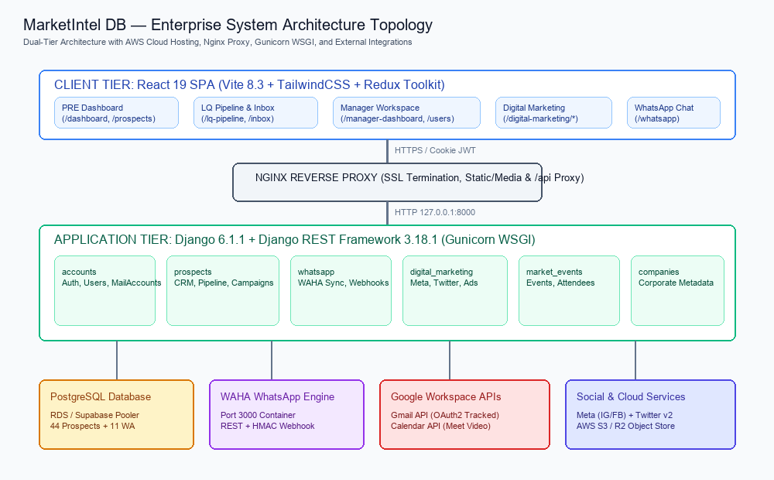
Figure: MarketIntel DB End-to-End Architecture Topology
System Tier | Primary Technologies | Network Port / Domain | Responsibilities & Isolation Rules
Client Presentation | React 19.2.8, Vite 8.3, TailwindCSS 4, Redux Toolkit | Port 5173 / AWS Amplify CDN | Role-based routing, interactive CRM tables, email composition, live WhatsApp UI
Gateway & Reverse Proxy | Nginx 1.24+ Reverse Proxy, SSL/TLS Termination | Port 80 / 443 (Domain Host) | Request routing (/api/ to Django, static assets, media uploads, proxy timeouts)
Application Server | Django 6.1.1, DRF 3.18.1, Gunicorn WSGI | Port 8000 (Internal Loopback) | Business logic, JWT verification, role permission enforcement, ORM query processing
Relational Database | PostgreSQL 15+ (RDS / Supabase Pooler) | Port 5432 / 6543 | Persistent relational CRM entities, hierarchical structures, audit trails, indexed phone digits
WhatsApp Engine | WAHA (WhatsApp HTTP API Container) | Port 3000 (Docker Container) | Multi-tenant WhatsApp Web pairing, QR streaming, HMAC webhook dispatch, media download
External Integrations | Google OAuth, Gmail API, Google Meet, Meta, Twitter | Outbound HTTPS (REST/OAuth) | Token-based user authentication, tracked email dispatch, video conference link creation

2.0 Core Subsystems & Application Domains
The backend repository organizes business logic into six cohesive Django applications: accounts, prospects, companies, market_events, whatsapp, and digital_marketing. Each app maintains isolated database models, view controllers, serializers, service layers, and permission boundaries.
2.1 Subsystem Responsibility Matrix
Subsystem | Source Location | Key Models | Primary Responsibilities
accounts | backend/accounts/ | UserProfile, MailAccount, EmailTemplate, EmailSignature, GoogleMailCredentials | Authentication, user administration, Gmail OAuth credentials, email template sanitization
prospects | backend/prospects/ | Prospect, ProspectContact, LeadQualification, OutreachEmail, EmailCampaign, Meeting | Core CRM prospect hierarchy, LQ pipeline, 90s campaign pacing, Google Meet scheduling
companies | backend/companies/ | Company | Corporate metadata, sector taxonomy, and industry classification reference entities
market_events | backend/market_events/ | MarketEvent, MarketEventParticipation | Industry conference registry, participant linking, and event-based prospect intelligence
whatsapp | backend/whatsapp/ | WhatsAppSession, WhatsAppMessage, WhatsAppConversation, WhatsAppSafetyEvent | WAHA engine communication, session QR pairing, HMAC webhook ingestion, SSRF safe media proxy
digital_marketing | backend/digital_marketing/ | SocialAccount, SocialPost, SocialAnalytics, AdCampaign, DirectMessage | Social connectivity (Meta IG/FB, Twitter v2), ad campaign analytics, social message triage

3.0 Critical Business Workflows & State Machines
MarketIntel DB implements strict state-driven business processes to maintain high data integrity. The primary workflows include Prospect Acquisition & Corporate Hierarchy, Lead Qualification Pipeline (LQ), and Bulk Email Outreach Pacing.
3.1 Lead Qualification (LQ) State Machine
Lead Qualifiers operate in a controlled queue of 5 sequentially assigned prospects. Each prospect progresses through explicit qualification states: PENDING -> IN_PROGRESS -> CALLBACK_SCHEDULED -> MEETING_SCHEDULED -> VERIFIED -> ISSUED or REJECTED.
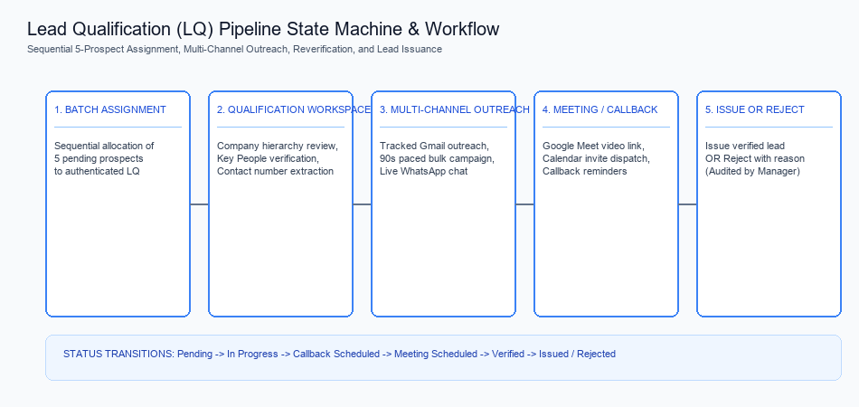
Figure: Lead Qualification Pipeline State Transitions
4.0 Developer Onboarding & Local Environment Setup
Developers onboarding to the MarketIntel DB repository must adhere to the following local setup procedures. The backend utilizes Python 3.12+ (or 3.14 compatible) with virtual environments, while the frontend requires Node.js 20+.
# 1. Backend Setup
cd backend
python -m venv venv
venv\Scripts\activate # On Windows
pip install -r requirements.txt
python manage.py migrate --settings=config.settings
python manage.py runserver 0.0.0.0:8000
# 2. Frontend Setup
cd ../frontend
npm install
npm run dev # Launches Vite dev server at http://localhost:5173

[WARNING] Production Database Isolation
Never run production migrations against local test SQLite databases. For isolated unit and regression testing, always run 'python manage.py test --settings=settings_sqlite_test'. This runs the test suite against an in-memory database without affecting PostgreSQL schemas.

