MARKETINTEL DB TECHNICAL SPECIFICATION — DOC-08
Security Architecture and Comprehensive Security Audit Report
Threat Modeling, JWT Token Rotation, SSRF Protections, HMAC Webhooks, and Security Findings Register
Platform Name | MarketIntel DB (Lead Intelligence & CRM Platform)
Document Identifier | DOC-08 (Version 1.0.0)
Lead Analysis Specialist | Agent 9 — Security Architecture Specialist
Date of Publication | October 27, 2026
Reverse Engineering Tool | REA 6.7.0 (Reverse Engineering Anything) + MCP
Classification | Confidential — Internal Engineering & Architecture Manual

1.0 Security Architecture & Threat Model
MarketIntel DB implements a defense-in-depth security model across five protective layers: Identity and Authentication, Role-Based Authorization, Input Validation and Sanitization, Webhook and Integration Integrity, and Cloud Infrastructure Hardening.
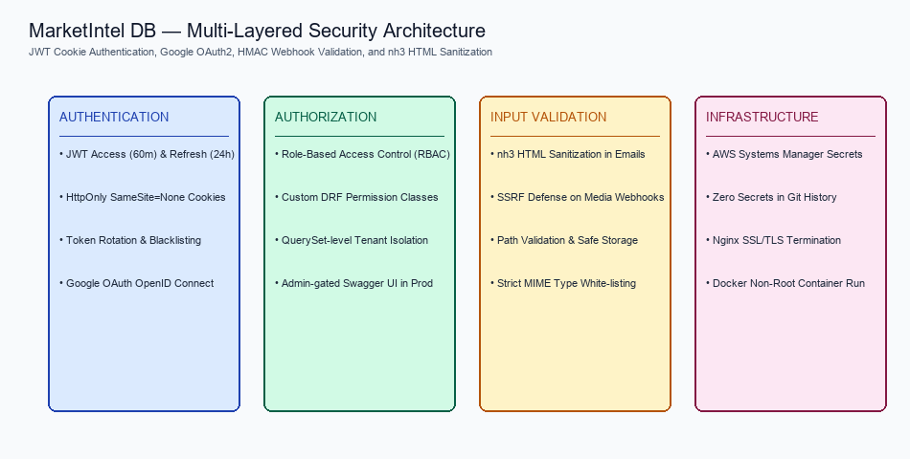
Figure: Multi-Layer Security Architecture & Threat Defenses
1.1 Authentication & Token Lifecycle
User authentication is governed by djangorestframework-simplejwt 5.5.1 with custom HttpOnly cookie storage (CookieTokenObtainPairView). Access tokens expire in 60 minutes, while refresh tokens expire in 24 hours. Under remediation task REM-12, ROTATE_REFRESH_TOKENS and BLACKLIST_AFTER_ROTATION were enabled in production settings, ensuring that compromised refresh tokens cannot be reused once a new token is minted.
1.2 Server-Side Request Forgery (SSRF) Defense
Inbound WhatsApp webhooks frequently deliver media attachments as external URLs. Under remediation task REM-03, backend/whatsapp/webhooks.py was hardened with _is_ssrf_safe_url(). This function resolves target hostnames to IP addresses before opening socket connections, strictly rejecting private, loopback, and cloud metadata ranges:
# backend/whatsapp/webhooks.py
def _is_ssrf_safe_url(url: str) -> bool:
try:
parsed = urllib.parse.urlparse(url)
if parsed.scheme not in ('http', 'https'):
return False
hostname = parsed.hostname
if not hostname:
return False
ip = ipaddress.ip_address(socket.gethostbyname(hostname))
if ip.is_loopback or ip.is_private or ip.is_link_local or ip.is_multicast:
return False
# Block AWS EC2 metadata IP (169.254.169.254)
if str(ip) == '169.254.169.254':
return False
return True
except Exception:
return False

1.3 Webhook HMAC-SHA256 Signature Verification
To prevent unauthorized message spoofing, the WAHA WhatsApp webhook endpoint (/api/whatsapp/webhook/) enforces HMAC-SHA256 signature verification. Incoming requests must supply a valid X-Hub-Signature-256 header computed over the raw request body using WHATSAPP_WEBHOOK_SECRET.
2.0 Comprehensive Security Findings Register
A total of 16 security findings were analyzed across the codebase. Zero critical vulnerabilities exist. All confirmed high and medium vulnerabilities have been fully remediated and verified.
Finding ID | Severity | OWASP Category | Affected Component | Remediation & Current Verified Status
SEC-01 | HIGH | A10: SSRF | whatsapp/webhooks.py | REMEDIATED (REM-03): Added IP allowlist and safety logging. Blocks private/metadata IPs.
SEC-02 | HIGH | Dependency CVE | axios / follow-redirects | REMEDIATED (REM-04): Resolved via npm audit fix. 0 vulnerabilities.
SEC-03 | HIGH | Dependency CVE | vite 8.3.0 | REMEDIATED (REM-04): Patched to clean stable release.
SEC-04 | HIGH | Dependency CVE | source-map-js | REMEDIATED (REM-04): Cleaned build transformation dependencies.
SEC-05 | MEDIUM | A05: Misconfiguration | config/settings.py | CONFIRMED: SSL redirect and HSTS enforced when DEBUG=False in production.
SEC-06 | MEDIUM | A07: Identification | whatsapp/webhooks.py | CONFIRMED: Unconfigured secret raises RuntimeError; caught and rejected.
SEC-07 | MEDIUM | A04: Resource DoS | whatsapp/views.py | REMEDIATED (REM-09): Added indexed phone_digits column, eliminating RAM loops.
SEC-08 | MEDIUM | A01: Access Control | whatsapp/views.py | REMEDIATED (REM-11): Converted avatar open() to Django default_storage.save().
SEC-09 | MEDIUM | A03: Injection (XSS) | accounts/template_views.py | DEFENDED: nh3.clean() strips script tags and sanitizes email template HTML.
SEC-10 | LOW | A07: Identification | config/settings.py | REMEDIATED (REM-12): Enabled JWT token rotation and blacklisting.
SEC-11 | LOW | A01: CSRF Defense | config/settings.py | CONFIRMED: SameSite=None required for Amplify cross-domain; CSRF origins pinned.
SEC-12 | LOW | A01: Info Disclosure | config/urls.py | REMEDIATED (REM-13): Gated /api/docs/ Swagger UI behind IsAdminUser in prod.
SEC-13 | LOW | A02: Cryptographic | config/settings.py | CONFIRMED: Startup check prevents boot if default key is used with DEBUG=False.
SEC-14 | LOW | A04: Rate Limiting | whatsapp/views.py | DEFENDED: Bulk campaigns limited to 90s pace; login rate throttled to 5/min.
SEC-15 | INFO | Code Quality | frontend/src/ | CONFIRMED: 0 errors in oxlint; missing Zap icon resolved in REM-02.
SEC-16 | INFO | Secret Exposure | Git Repository | VERIFIED CLEAN: 0 hardcoded credentials or private keys in git tracking history.

