Hikeshwar S
251901062
COMPUTER NETWORKS

Ex.No.12 | Examine Network Address Translation (NAT) using Cisco Packet Tracer
Date:

AIM
To configure and examine Network Address Translation (NAT) using Cisco Packet Tracer and verify communication between a private network and a public network.
Requirements
- Cisco Packet Tracer
- 1 Router (Cisco 1941)
- 2 Switches (Cisco 2960)
- 2 PCs
- Copper Straight-Through cables
Network Topology
Private Network Public Network

PC0 -------- Switch0 -------- Router -------- Switch1 -------- PC1
192.168.1.10 NAT Router 203.0.113.10
G0/0 Public PC
192.168.1.1
|
G0/1
203.0.113.1
IP Addressing
Device | Interface | IP Address | Subnet Mask
PC0 | FastEthernet0 | 192.168.1.10 | 255.255.255.0
Router | G0/0 | 192.168.1.1 | 255.255.255.0
Router | G0/1 | 203.0.113.1 | 255.255.255.0
PC1 | FastEthernet0 | 203.0.113.10 | 255.255.255.0
PROCEDURE
Step 1: Create the topology
- Open Cisco Packet Tracer.
- Place:
  - Two PCs.
  - Two 2960 switches.
  - One 1941 router.
- Connect:
  - PC0 → Switch0.
  - Switch0 → Router G0/0.
  - Router G0/1 → Switch1.
  - Switch1 → PC1.
- Use Copper Straight-Through cables.
Step 2: Configure PC0
Go to:
PC0 → Desktop → IP Configuration
Enter:
IP Address : 192.168.1.10
Subnet Mask : 255.255.255.0
Default Gateway : 192.168.1.1
Step 3: Configure PC1
Go to:
PC1 → Desktop → IP Configuration
Enter:
IP Address : 203.0.113.10
Subnet Mask : 255.255.255.0
Default Gateway : 203.0.113.1
Step 4: Configure the Router
Open:
Router → CLI
Configure the inside interface:
Router> enable
Router# configure terminal

Router(config)# interface gigabitEthernet 0/0
Router(config-if)# ip address 192.168.1.1 255.255.255.0
Router(config-if)# ip nat inside
Router(config-if)# no shutdown
Router(config-if)# exit
Configure the outside interface:
Router(config)# interface gigabitEthernet 0/1
Router(config-if)# ip address 203.0.113.1 255.255.255.0
Router(config-if)# ip nat outside
Router(config-if)# no shutdown
Router(config-if)# exit
Step 5: Configure NAT
Create an access list to identify the private network:
Router(config)# access-list 1 permit 192.168.1.0 0.0.0.255
Configure PAT (NAT Overload):
Router(config)# ip nat inside source list 1 interface gigabitEthernet 0/1 overload
This allows multiple private IP addresses to share the router's outside IP address.
Step 6: Verify the Router Configuration
Execute:
Router# show ip interface brief
Expected output:
Interface IP-Address Status
GigabitEthernet0/0 192.168.1.1 up
GigabitEthernet0/1 203.0.113.1 up
Step 7: Test Connectivity
From PC0, open:
Desktop → Command Prompt
Enter:
ping 192.168.1.1
Expected:
Reply from 192.168.1.1: bytes=32 time<1ms TTL=255
Now test the public-side PC:
ping 203.0.113.10
Expected:
Reply from 203.0.113.10: bytes=32 time<1ms TTL=127
Step 8: Verify NAT Translation
Generate traffic from PC0 by pinging PC1:
PC0> ping 203.0.113.10
Then, on the router, enter:
Router# show ip nat translations
Sample output:
Pro Inside global Inside local Outside local Outside global
icmp 203.0.113.1:1 192.168.1.10:1 203.0.113.10:1 203.0.113.10:1
This shows that the private IP address 192.168.1.10 has been translated to the router's public IP address 203.0.113.1.
Step 9: Verify NAT Statistics
Enter:
Router# show ip nat statistics
Sample output:
Total active translations: 1

Inside interfaces:
GigabitEthernet0/0

Outside interfaces:
GigabitEthernet0/1

Hits: 5
Misses: 0
The exact numbers may vary depending on the number of packets generated.

SAMPLE OUTPUT
PC0 pinging PC1:
PC> ping 203.0.113.10

Pinging 203.0.113.10 with 32 bytes of data:

Reply from 203.0.113.10: bytes=32 time<1ms TTL=127
Reply from 203.0.113.10: bytes=32 time<1ms TTL=127
Reply from 203.0.113.10: bytes=32 time<1ms TTL=127
Reply from 203.0.113.10: bytes=32 time<1ms TTL=127

Ping statistics:
Packets: Sent = 4, Received = 4, Lost = 0 (0% loss)
NAT Translation Table:
Router# show ip nat translations

Pro Inside global Inside local Outside local Outside global
icmp 203.0.113.1:1 192.168.1.10:1 203.0.113.10:1 203.0.113.10:1

OUTPUT:

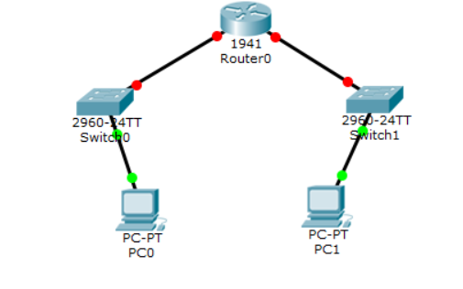
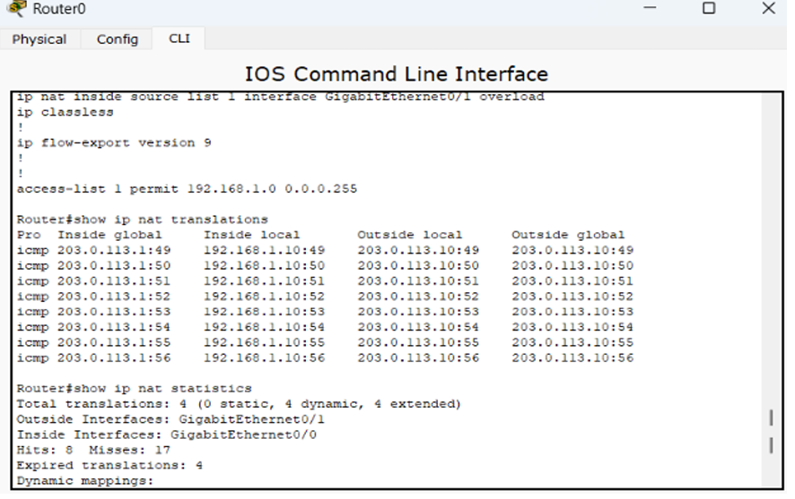

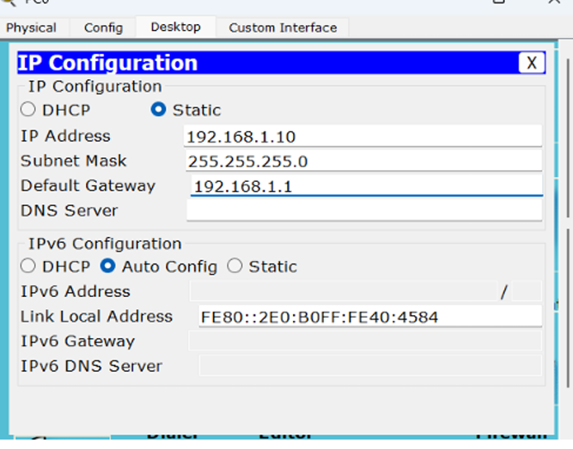

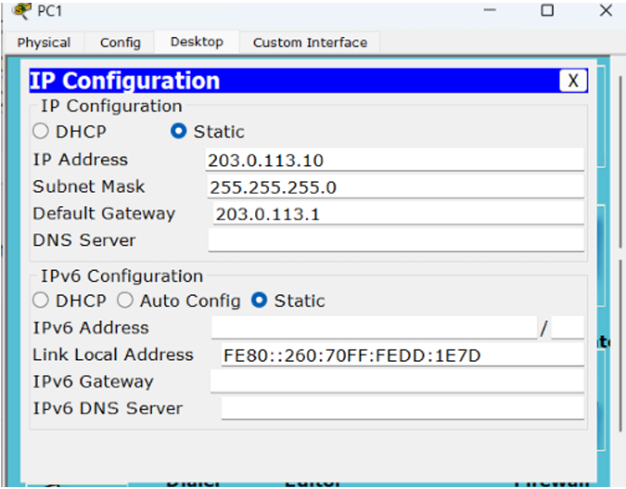

RESULT
Thus, Network Address Translation (NAT) was successfully configured and examined using Cisco Packet Tracer. The private IP address 192.168.1.10 was translated into the public IP address 203.0.113.1, and successful communication with the public network was verified.

