Hikeshwar S
251901062
COMPUTER NETWORKS

Ex.No.15 | Building anonymous FTP Scanner using ftplib module
DATE: | Building anonymous FTP Scanner using ftplib module

AIM:
To build an anonymous ftp scanner using ftplib module in python.

Introduction:
FTP Scanner:
A tool that automatically scans IPs/hosts for active FTP servers. It tests connectivity and credentials, reporting successful logins and vulnerabilities.
ftplib:
A built-in Python library for working with the File Transfer Protocol (FTP). It allows connecting to FTP servers, logging in, listing directories, and transferring files.

ALGORITHM:
- Start.
- Import the ftplib module.
- Specify the FTP server hostname.
- Connect to the FTP server.
- Log in using the username anonymous and password anonymous.
- If the login is successful:
- Display the login status.
- Display the server's welcome message.
- Display the directory listing.
- Close the FTP connection.
- If the login fails, display an error message.
- Stop.

PROGRAM:
import ftplib
def anonymous_login(hostname):
try:
# Connect to the FTP server
ftp = ftplib.FTP(hostname)
# Login using anonymous credentials
response = ftp.login('anonymous', 'anonymous')
print(response)
# Check whether anonymous login is successful
if "230" in response:
print("\n[*] FTP Anonymous Login Succeeded.")
print("Server:", hostname)
# Display welcome message
print("\nWelcome Message:")
print(ftp.getwelcome())
# Display directory listing
print("\nDirectory Listing:")
ftp.dir()
# Close the FTP connection
ftp.quit()
except Exception as e:
print("Error:", e)
print("\n[-] FTP Anonymous Login Failed.")
# Main Program
hostname = "ftp.be.debian.org"
anonymous_login(hostname)

SAMPLE OUTPUT:
230 Login successful.

[*] FTP Anonymous Login Succeeded.
Server: ftp.be.debian.org

Welcome Message:
220 FTP Server Ready

Directory Listing:
drwxr-xr-x 2 ftp ftp 4096 Jan 10 2026 debian
drwxr-xr-x 2 ftp ftp 4096 Jan 10 2026 cdimage
drwxr-xr-x 2 ftp ftp 4096 Jan 10 2026 project
-rw-r--r-- 1 ftp ftp 512 README.txt

221 Goodbye.

OUTPUT:
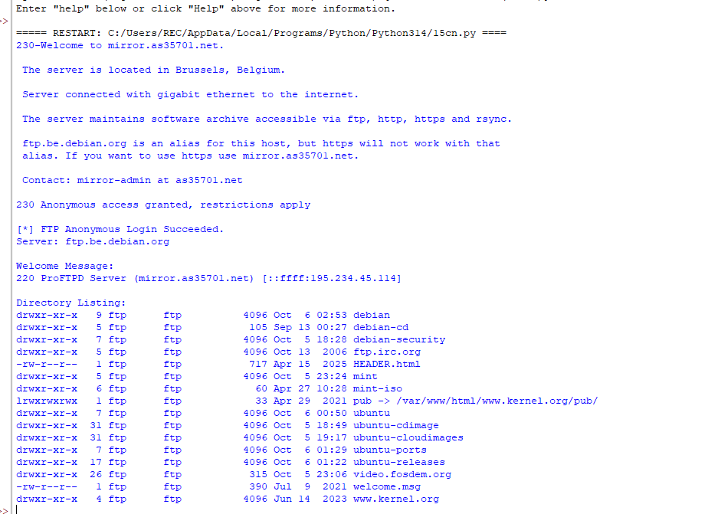

RESULT:
Thus an anonymous ftp scanner using ftplib module was built and executed successfully.

