Ex.No.4 | - Setup and configure a LAN (Local area network) using a Switch  and Ethernet cables in your lab.  - Connect 3-4 host machines to a switch.  - Assign ip addresses to each host machine.  - Check the connectivity between the machines by using ping command.  - Share and access files and folder across the machines of the LAN.
Date:
Hikeshwar S
251901062

COMPUTER NETWORKS

LAN:
A local area network (LAN) is a collection of devices connected together in one physical location, such as a building, office, or home. A LAN can be small or large, ranging from a home network with one user to an enterprise network with thousands of users and devices in an office or school.
Regardless of size, a LAN's single defining characteristic is that it connects devices that are in a single, limited area.

Set Up a LAN (Local Area Network) Directly

How to Set Up a LAN (Local Area Network)
Step 1: Plan the Network
Plan and design an appropriate network topology based on the network requirements and the physical location of the devices.

Step 2: Gather the Required Devices
Prepare the following hardware components:
- 4 Computers (PCs)
- 1 Network Switch (8-port, 16-port, or 24-port)
- 4 Ethernet (UTP) Cables
Step 3: Connect the Devices
Connect each computer to the network switch using Ethernet cables. Plug one end of the Ethernet cable into the Ethernet port of the computer and the other end into an available port on the switch. Ensure that the link LEDs on the switch and the computers are ON, indicating successful connections.

Step 4: Assign IP Addresses to the PCs
- Log in to each computer using an Administrator or Owner account.
- Open Control Panel → Network and Internet → Network and Sharing Center.
- Click Change Adapter Settings.
- Right-click Local Area Connection (or Ethernet) and select Properties.
- Select Internet Protocol Version 4 (TCP/IPv4) and click Properties.
- Select the Use the following IP address option.
- Enter the IP address and subnet mask for each computer as shown below:
Computer | IP Address | Subnet Mask
PC1 | 10.1.1.1 | 255.0.0.0
PC2 | 10.1.1.2 | 255.0.0.0
PC3 | 10.1.1.3 | 255.0.0.0
PC4 | 10.1.1.4 | 255.0.0.0
Click OK to save the configuration. Repeat the same procedure for all the PCs connected to the switch.
Step 5: Configure the Network Switch
- Connect a computer to the switch using an Ethernet cable.
- Open a web browser and enter the IP address of the switch in the address bar to access the switch's management interface.
- Log in using the appropriate username and password.
- Configure the basic settings of the switch.
- Assign the following management IP address to the switch:
Device | IP Address | Subnet Mask
Switch | 10.1.1.5 | 255.0.0.0
Save the configuration.

Step 6: Verify Network Connectivity
Open the Command Prompt on each computer and use the ping command to test connectivity with the other computers and the switch.
Example:
- ping 10.1.1.2
- ping 10.1.1.3
- ping 10.1.1.4
- ping 10.1.1.5
If replies are received without packet loss, the network has been configured successfully.

Step 7: Share a Folder
- Create or select a folder to be shared.
- Right-click the folder and select Properties.
- Open the Sharing tab.
- Click Share.
- Select Everyone from the list of users.
- Click Share and then Done.
The selected folder is now accessible to all computers on the same LAN.
Step 8: Access the Shared Folder
- Open File Explorer on another computer connected to the LAN.
- In the address bar, type the IP address or computer name of the shared computer. For example:
  - \\10.1.1.1
  - \\PC1
- Press Enter to view the shared folder.
- Open the folder and verify that files can be accessed successfully.
Procedure to Set Up a LAN Using Cisco Packet Tracer
Step 1: Design the Network Topology
- Open Cisco Packet Tracer.
- From the Network Devices section, select Switches and drag one 2960 Switch onto the workspace.
- From the End Devices section, drag four PCs onto the workspace.
- Rename the devices as PC0, PC1, PC2, and PC3.
Sample Design:
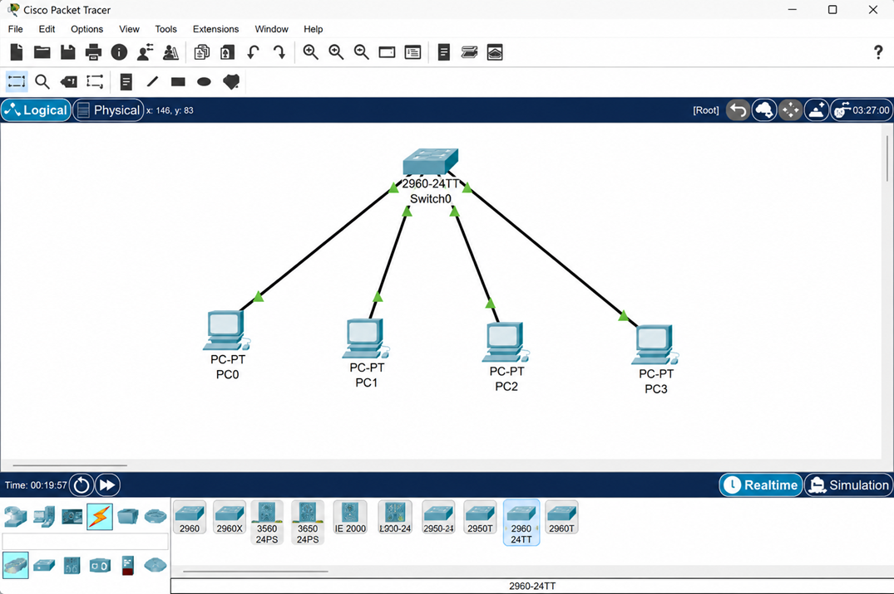
Step 2: Connect the Devices
- Click Connections (Lightning Bolt icon).
- Select Copper Straight-Through Cable.
- Connect the devices as follows:
Source Device | Interface | Destination Device | Interface
PC0 | FastEthernet0 | Switch0 | FastEthernet0/1
PC1 | FastEthernet0 | Switch0 | FastEthernet0/2
PC2 | FastEthernet0 | Switch0 | FastEthernet0/3
PC3 | FastEthernet0 | Switch0 | FastEthernet0/4
- Wait until the link LEDs turn green, indicating that the devices are successfully connected.
Step 3: Assign IP Addresses to the PCs
For each PC:
- Click the PC.
- Select the Desktop tab.
- Click IP Configuration.
- Enter the following IP addresses:
Device | IP Address | Subnet Mask
PC0 | 10.1.1.1 | 255.0.0.0
PC1 | 10.1.1.2 | 255.0.0.0
PC2 | 10.1.1.3 | 255.0.0.0
PC3 | 10.1.1.4 | 255.0.0.0
Leave the Default Gateway blank because no router is used in this LAN.
Step 4: Verify IP Configuration
On each PC:
- Open Desktop.
- Select Command Prompt.
- Execute the following command:
ipconfig
Verify that the configured IP address and subnet mask are displayed correctly.
Step 5: Test Network Connectivity
From PC0, open Command Prompt and execute:
ping 10.1.1.2
Similarly, test connectivity with the remaining PCs:
ping 10.1.1.3

ping 10.1.1.4
Repeat the ping test from each PC to ensure that all hosts can communicate successfully.
Step 6: Verify Packet Transmission Using Simulation Mode
- Click Simulation mode at the bottom-right corner of Packet Tracer.
- Select the Add Simple PDU tool (Envelope icon).
- Click PC0 as the source device.
- Click PC3 as the destination device.
- Click Auto Capture/Play.
Observe the ICMP Echo Request and Echo Reply packets travelling through the switch.
Step 7: Configure an FTP Server for File Sharing
Since Packet Tracer does not support Windows folder sharing, use an FTP server to simulate file sharing.
- Drag one Server from End Devices into the workspace.
- Connect the server to the switch using a Copper Straight-Through Cable.
- Configure the server with:
Device | IP Address | Subnet Mask
Server0 | 10.1.1.5 | 255.0.0.0
- Open Server0.
- Select Services → FTP.
- Turn the FTP service ON.
- Create a username and password (for example, student / student123).
Step 8: Access the FTP Server
On PC0:
- Open Desktop → Command Prompt.
- Connect to the FTP server using:
ftp 10.1.1.5
- Enter the configured username and password.
- Execute FTP commands such as:
dir
get sample.txt
put report.txt
Verify that files can be uploaded to and downloaded from the FTP server.
Step 9: Save the Project
- Click File → Save As.
- Save the Packet Tracer file with an appropriate name, for example:
LAN_Configuration.pkt
The LAN configuration is now complete.

OUTPUT:
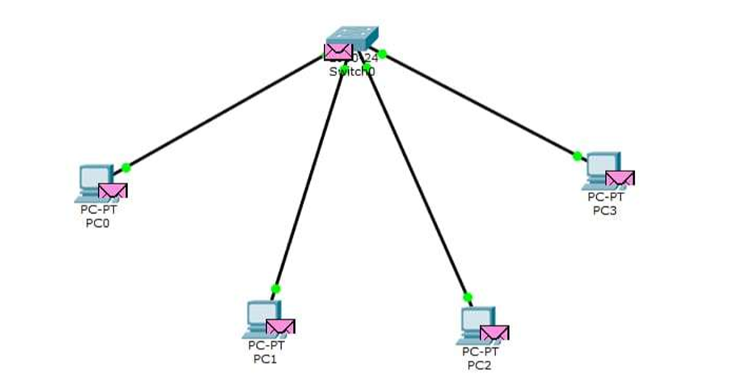
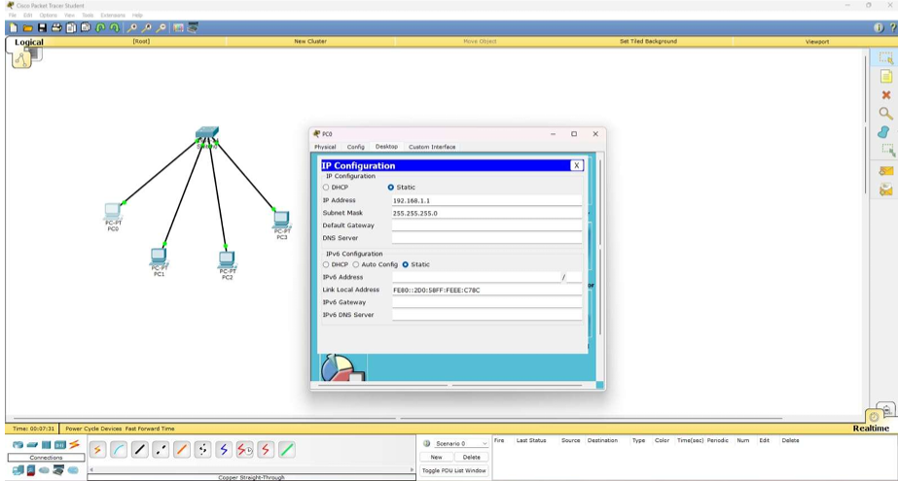

RESULT:
A LAN was successfully set up and configured using a switch and Ethernet cables.
The connected devices were successfully communicated and network connectivity was verified.

