Hikeshwar S
251901062

COMPUTER NETWORKS
Ex.No.6 | Develop a customized ping command to test the server connectivity
DATE:

6.1 Customized ping command to test the server connectivity
Aim:
To develop a customized ping command to test the server connectivity.
Algorithm for Program1: Customized ping command to test the server connectivity:
- Start.
- Import the socket and time modules.
- Specify the server name, port number, and number of attempts.
- Create a TCP socket.
- Set the timeout period.
- Record the start time.
- Connect to the server.
- Record the end time.
- Calculate and display the response time.
- If the connection fails, display "Request timed out".
- Repeat Steps 4–10 for the specified number of attempts.
- Stop.

PROGRAM 1:
Customized ping command to test the server connectivity:
import socket
import time
host = "google.com"
port = 80
count = 4
for i in range(count):
try:
# Create a socket
s = socket.socket(socket.AF_INET, socket.SOCK_STREAM)
# Set timeout (optional)
s.settimeout(3)
# Record start time
start = time.time()
# Connect to the server
s.connect((host, port))
# Record end time
end = time.time()
# Close the socket
s.close()
print(f"Reply from {host}: time={(end - start) * 1000:.2f} ms")
except Exception:
print("Request timed out")

Sample Output:
Reply from google.com: time=18.52 ms
Reply from google.com: time=17.84 ms
Reply from google.com: time=19.03 ms
Reply from google.com: time=18.26 ms

OUTPUT:

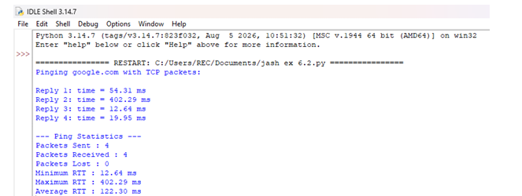

RESULT:
A customized ping command was successfully developed to test server connectivity.
The server’s reachability and response time were successfully verified.

6.2 Customized Ping Program to Measure Min, Max, and Average RTT
AIM:
To develop a Customized Ping Program to Measure Min, Max, and Average RTT ALGORITHM for Program 2:
• Start.
• Import the required modules.
• Initialize the server address, port number, and number of ping attempts.
• Create an empty list to store RTT values.
• Repeat the following for each ping attempt:
- Create a TCP socket.
- Set the timeout value.
- Record the start time.
- Connect to the server.
- Record the end time.
- Calculate the RTT and store it in the list.
- Display the RTT.
- If the connection fails, display "Request timed out".
• Calculate and display:
- Packets Sent
- Packets Received
- Packets Lost
- Minimum RTT
- Maximum RTT
- Average RTT
• Stop.

PROGRAM2: Customized Ping Program to Measure Min, Max, and Average RTT

import socket
import time
# Server details
host = "google.com"
port = 80
count = 4
# List to store RTT values
rtt_list = []
print(f"Pinging {host} with TCP packets:\n")
for i in range(count):
try:
# Create a TCP socket
s = socket.socket(socket.AF_INET, socket.SOCK_STREAM)
s.settimeout(3)
# Record start time
start = time.time()
# Connect to the server
s.connect((host, port))
# Record end time
end = time.time()
# Close the socket
s.close()
# Calculate RTT in milliseconds
rtt = (end - start) * 1000
rtt_list.append(rtt)
print(f"Reply {i+1}: time = {rtt:.2f} ms")
except Exception:
print(f"Reply {i+1}: Request timed out")
# Display statistics
if len(rtt_list) > 0:
print("\n--- Ping Statistics ---")
print(f"Packets Sent : {count}")
print(f"Packets Received : {len(rtt_list)}")
print(f"Packets Lost : {count - len(rtt_list)}")
print(f"Minimum RTT : {min(rtt_list):.2f} ms")
print(f"Maximum RTT : {max(rtt_list):.2f} ms")
print(f"Average RTT : {sum(rtt_list)/len(rtt_list):.2f} ms")
else:
print("\nNo response received from the server.")

SAMPLE OUTPUT:
Pinging google.com with TCP packets:

Reply 1: time = 18.24 ms
Reply 2: time = 17.81 ms
Reply 3: time = 19.15 ms
Reply 4: time = 18.56 ms

--- Ping Statistics ---
Packets Sent : 4
Packets Received : 4
Packets Lost : 0
Minimum RTT : 17.81 ms
Maximum RTT : 19.15 ms
Average RTT : 18.44 ms

OUTPUT:
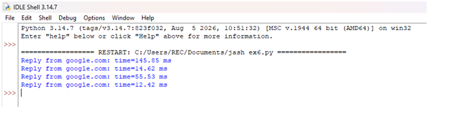

RESULT:
A customized ping command was successfully developed to test server connectivity.
The server’s reachability and response time were successfully verified.

