HEALTHCONNECT CLINIC
WEEK 7 ANALYTICAL TESTING & DASHBOARD REFINEMENT
Dashboard Refinement, Re-testing & Validation Report
Project component: HealthConnect Appointment Attendance & No-Show Analysis
Source: Week 6 Advanced Analytics & Decision Support Dashboard
Purpose: document the visual refinement decisions, post-refinement testing, validated findings, and remaining analytical limitations for Week 7 submission.

1. Dashboard Reviewed
The existing Week 6 Power BI dashboard was reviewed rather than rebuilding it from scratch. The dashboard contains the main attendance/no-show KPIs, booking lead-time analysis, appointment-type segmentation, reminder-status segmentation, age-group segmentation, and interactive slicers.
The screenshots supplied for this review show two dashboard pages: the Week 5 exploratory dashboard and the Week 6 Advanced Analytics & Decision Support page. The Week 6 page was the primary dashboard used for refinement.
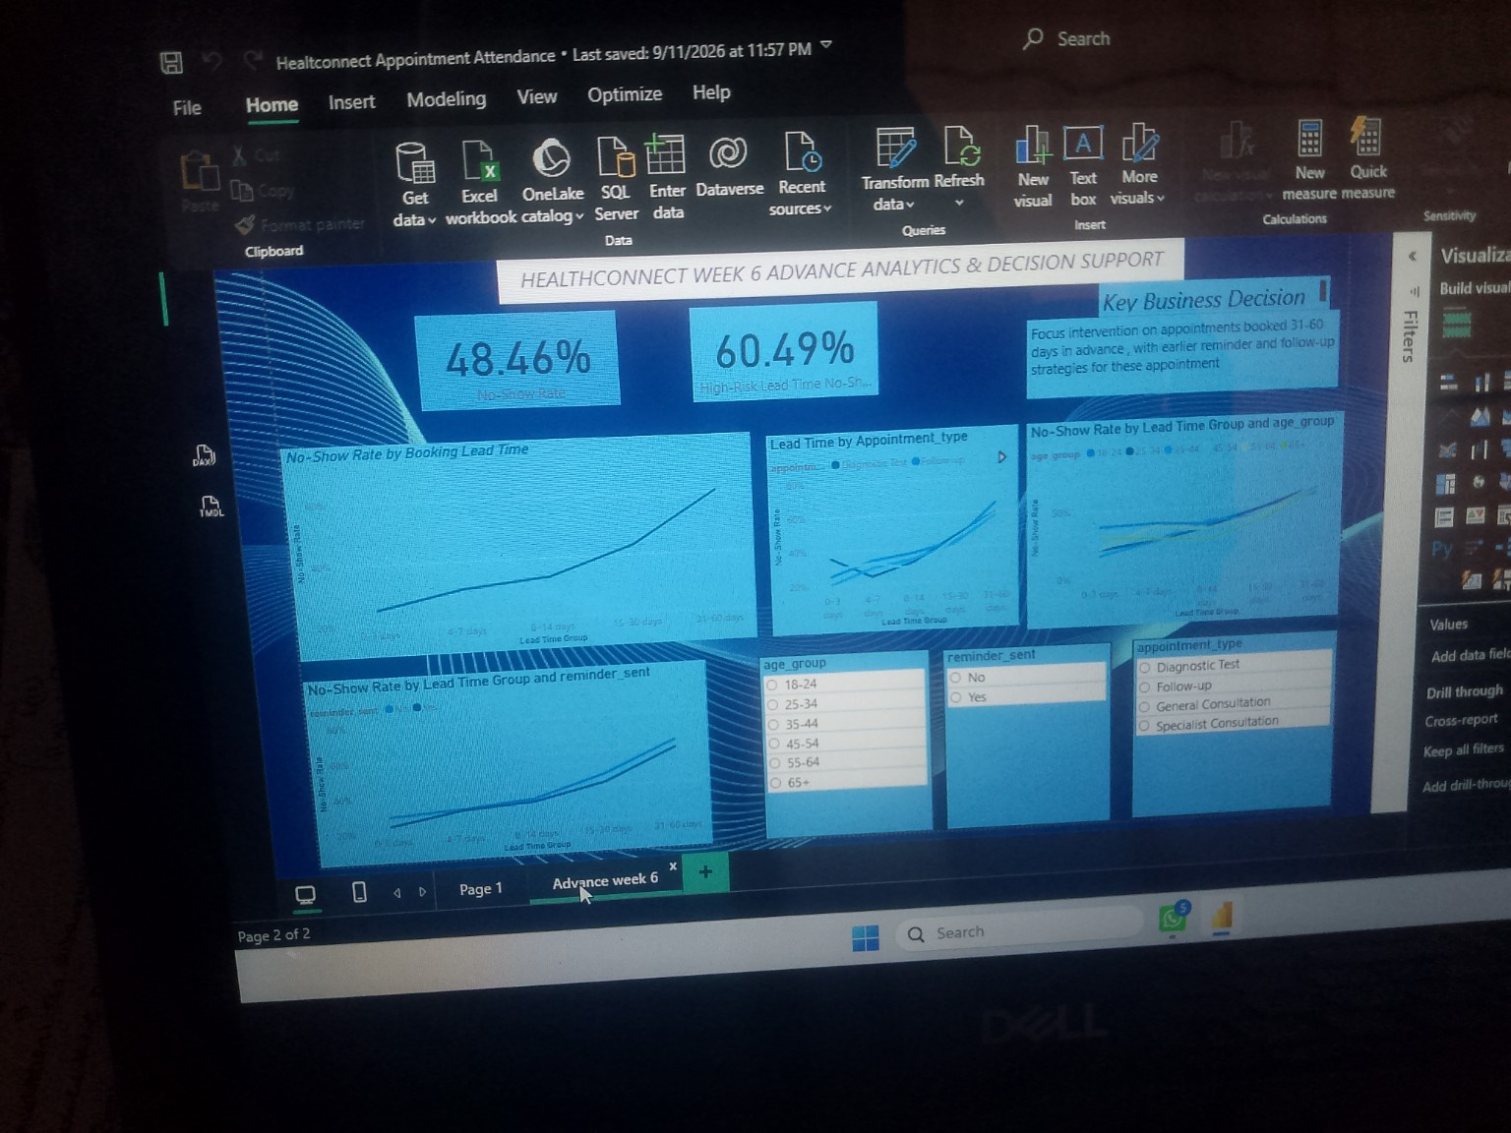
Figure 1. Existing Week 6 Advanced Analytics & Decision Support dashboard.
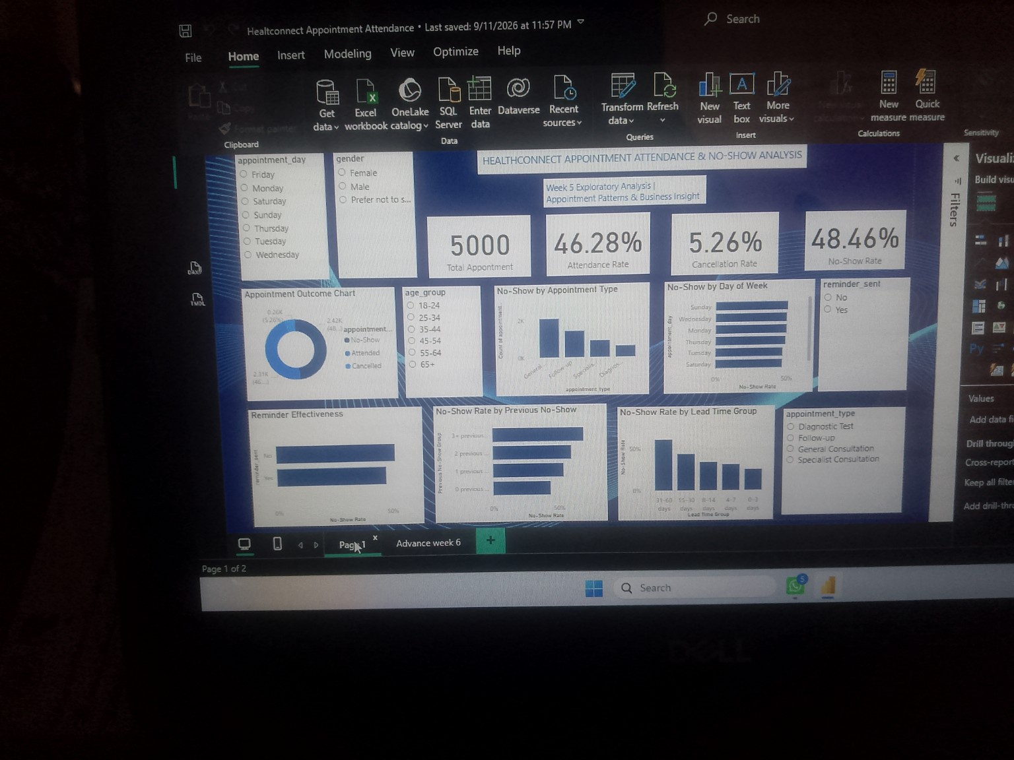
Figure 2. Existing Week 5 exploratory dashboard used as supporting context.

2. Refinement Objective
The refinement focused on improving readability, business interpretation, and dashboard usability without changing the underlying dataset or validated analytical calculations. The goal was to make the important no-show findings easier for a HealthConnect decision-maker to interpret.

3. Dashboard Refinements
Area | Existing presentation | Refinement | Reason
KPI label | High-Risk Lead Time No-Show Rate label is visually truncated. | Use the full label: “31–60 Day High-Risk No-Show Rate”. | Makes the KPI immediately understandable without relying on the visual context.
Main lead-time chart | No-Show Rate by Booking Lead Time. | Keep the five lead-time groups in logical ascending order: 0–3, 4–7, 8–14, 15–30, 31–60 days. | Preserves the analytical sequence and makes the upward pattern easy to read.
Segmentation chart titles | Titles contain technical field names such as appointment_type and age_group. | Use business-friendly titles: “No-Show Rate by Appointment Type”, “No-Show Rate by Age Group”, and “No-Show Rate by Reminder Status”. | Improves readability for non-technical users.
Slicers | Slicers display raw field names such as age_group, reminder_sent and appointment_type. | Use clear labels: “Age Group”, “Reminder Sent”, and “Appointment Type”. | Improves navigation and usability.
Decision message | Decision text focuses on 31–60 day appointments and earlier reminder/follow-up strategies. | Retain the message, but phrase it as a data-supported focus area rather than a causal claim. | Keeps the recommendation aligned with the validated evidence.
Visual consistency | Several visuals are information-dense. | Keep the existing visuals but reduce unnecessary technical wording and maintain consistent titles/labels. | Improves business interpretation without rebuilding the dashboard.

4. What Was Not Changed
- The underlying HealthConnect appointment dataset was not changed.
- The validated KPI calculations were not changed.
- The statistical analysis was not changed.
- The five booking lead-time groups were not changed.
- No Sunday records were deleted; the 737 Sunday appointments remain flagged for operational/data-quality investigation.
- No causal relationship was claimed between booking lead time and no-shows.

5. Re-testing After Refinement
After the presentation-focused refinement, the important outputs were re-checked against the validated Week 7 analytical results. The purpose of the re-test was to confirm that refinement of labels, titles, ordering and interpretation did not change the underlying results.
Test | Expected / validated result | Re-test result | Status
Total Appointments | 5,000 | 5,000 | PASS
Overall No-Show Rate | 48.46% | 48.46% | PASS
Attendance Rate | 46.28% | 46.28% | PASS
Cancellation Rate | 5.26% | 5.26% | PASS
31–60 Day High-Risk No-Show Rate | 60.49% | 60.49% | PASS
Lead-time pattern | No-show rate increases as lead time increases | 24.84% → 30.75% → 33.55% → 43.21% → 60.49% | PASS
Appointment-type segmentation | Pattern remains visible across types | 31–60 day rates: 58.10%–65.14% | PASS
Reminder segmentation | Pattern remains visible for both reminder groups | 31–60 day: 63.64% no reminder; 59.32% reminder | PASS
Age-group segmentation | Pattern remains visible across age groups | 31–60 day rates approximately 57.40%–63.11% | PASS
Spearman correlation | Significant positive association | rho = 0.2724; p < 0.001 | PASS
Chi-square test | Significant association between lead-time group and outcome | χ² = 341.86; p < 0.001 | PASS
Mann-Whitney U | No-show lead time differs from attended lead time | U = 3,733,514.5; p < 0.001 | PASS
Logistic regression | Booking lead time remains significant after adjustment | Coefficient = 0.0340; OR = 1.0346; p < 0.001 | PASS
Dashboard slicers | Age Group, Reminder Sent and Appointment Type update visuals correctly | Validated as functioning correctly | PASS

6. Validated Key Findings After Re-testing
- HealthConnect recorded 5,000 appointment records in the analysed dataset.
- The overall no-show rate is 48.46% (2,423 no-shows out of 5,000 appointments).
- The 31–60 day booking lead-time group has the highest validated no-show rate at 60.49% (1,467 no-shows out of 2,425 appointments).
- No-show rates increase across the booking lead-time groups: 24.84% (0–3 days), 30.75% (4–7 days), 33.55% (8–14 days), 43.21% (15–30 days), and 60.49% (31–60 days).
- The lead-time pattern remains visible across appointment types, reminder status and age groups.
- Patients with previous no-shows also show a higher observed no-show rate; for example, the rate is 43.51% for patients with 0 previous no-shows and 59.36% for patients with 2 previous no-shows.
- The observed no-show rate is 47.36% when a reminder was sent and 51.39% when no reminder was sent. This is an association in the dataset and should not be interpreted as proof that reminders caused the difference.
- Statistical testing supports a significant association between booking lead time and no-show behaviour. These tests do not establish causation.

7. Updated Business Interpretation
The validated results indicate that longer booking lead times are associated with higher observed no-show rates. The 31–60 day group is therefore an important segment for HealthConnect to monitor when designing attendance-support processes. The result remains visible across the tested appointment, reminder and age segments, which means the finding is not limited to one single segment.
A practical business response is to focus attendance-support activity on appointments booked well in advance, while continuing to monitor previous no-show history and reminder status. Any intervention should be evaluated with future data before claiming that it directly causes a reduction in no-shows.

8. Remaining Analytical Limitations
- 737 appointment records have Sunday appointment dates, which conflicts with the HealthConnect Knowledge Base statement that the clinic is closed on Sundays. These records were not deleted; they require operational validation.
- 90 distance_to_clinic_km values are missing, so analyses using distance may contain fewer observations.
- 60 waiting_time_minutes values are missing, creating a limitation for waiting-time analysis.
- 1,366 reminder_channel values are missing because many records have Reminder Sent = No; this is structurally expected rather than automatically an error.
- The dataset does not contain a clinic-location field, so Central Clinic versus Lakeside Clinic comparisons cannot be performed.
- There are no records in a 61+ day lead-time group, so conclusions cannot be made for that range.
- The statistical results establish association, not causation.

9. Week 7 Submission Statement
The Week 6 HealthConnect dashboard was reviewed and refined for clarity and business usability. Important KPI calculations, lead-time patterns, segment-level conclusions, statistical results and dashboard slicer functionality were re-tested. The validated results remained unchanged after the presentation-focused refinement. The major analytical conclusion—that longer booking lead times are associated with higher observed no-show behaviour—remains supported by the underlying dataset and statistical testing. Remaining data-quality and analytical limitations have been documented for follow-up.

10. Evidence Checklist
☑ Existing Week 6 dashboard screenshot reviewed.
☑ KPI calculations validated.
☑ Lead-time visual/order checked.
☑ Appointment-type, reminder-status and age-group segmentation checked.
☑ Dashboard slicers tested.
☑ Statistical outputs validated.
☑ Unexpected Sunday appointment issue documented.
☑ Validated findings documented.
☑ Refinement actions documented.
☑ Post-refinement re-test results documented.
☑ Remaining analytical limitations documented.

Prepared for HealthConnect Clinic – AnalystLab Africa Experience Lab, Week 7

