Bonus Question
Hikmat Paudel
2026-04-09

1. Recap Material
Give me notes on the recap material. These questions focus on material that students commonly struggle with (data wrangling, plotting, modeling, or debugging).
##Data Wrangling (dplyr)
Data wrangling is the process of preparing and transforming raw data into a useful format. The dplyr package provides several important functions:
- select() is used to choose specific columns
- filter() extracts rows based on conditions
- mutate() creates or modifies variables
- summarise() calculates summary statistics
- group_by() groups the data before summarizing
It is important to always check column names and ensure variables have the correct data types before performing operations.
Example
library(dplyr)
##
## Attaching package: 'dplyr'
## The following objects are masked from 'package:stats':
##
## filter, lag
## The following objects are masked from 'package:base':
##
## intersect, setdiff, setequal, union
# Create example dataset
df <- data.frame(
year = c(2025, 2025, 2024, 2025),
treatment = c("A", "B", "A", "B"),
yield = c(10, 15, 8, 20),
rep1 = c(5,6,4,7),
rep2 = c(7,5,6,8)
)
# Perform filtering, grouping, and summarizing
data_summary <- df %>%
filter(year == 2025) %>%
group_by(treatment) %>%
summarise(mean_yield = mean(yield, na.rm = TRUE))
# Show results
data_summary
## # A tibble: 2 × 2
## treatment mean_yield
## <chr> <dbl>
## 1 A 10
## 2 B 17.5
Common Mistakes Using summarise() without grouping first Incorrect or misspelled column names Treating categorical variables as numeric
##Plotting (ggplot2) The ggplot2 package is used to create visualizations. A basic plot structure looks like this:
library(ggplot2)
## Warning: package 'ggplot2' was built under R version 4.5.2
# Scatter plot with real columns
ggplot(df, aes(x = year, y = yield)) +
geom_point() +
theme_classic()
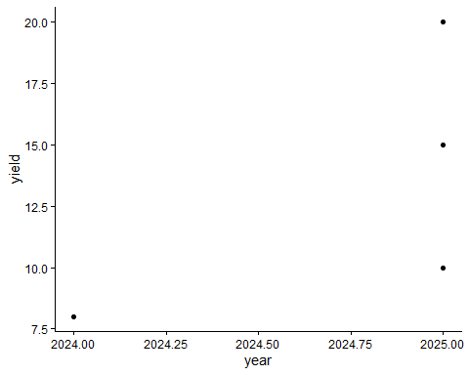 Common layers include: geom_point() for scatterplots geom_line() for line graphs geom_bar(stat = “identity”) for bar charts facet_wrap() for multiple panels theme_classic() for a simple design
Example
ggplot(df, aes(x = treatment, y = yield)) +
geom_boxplot() +
theme_classic()
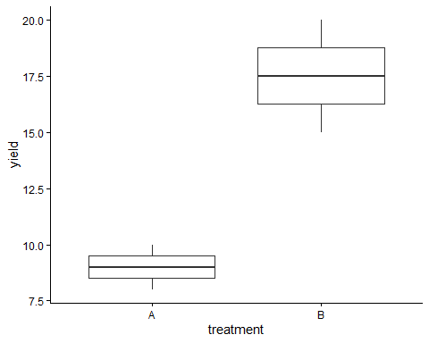
Common Mistakes Incorrect placement of variables inside/outside aes() Forgetting to use + between layers Using wrong variable names Plotting unsummarized data incorrectly
##Linear Modeling Linear models are used to study relationships between variables.
Examples
model <- lm(yield ~ treatment, data = df)
summary(model)
##
## Call:
## lm(formula = yield ~ treatment, data = df)
##
## Residuals:
## 1 2 3 4
## 1.0 -2.5 -1.0 2.5
##
## Coefficients:
## Estimate Std. Error t value Pr(>|t|)
## (Intercept) 9.000 1.904 4.727 0.0420 *
## treatmentB 8.500 2.693 3.157 0.0874 .
## ---
## Signif. codes: 0 '***' 0.001 '**' 0.01 '*' 0.05 '.' 0.1 ' ' 1
##
## Residual standard error: 2.693 on 2 degrees of freedom
## Multiple R-squared: 0.8329, Adjusted R-squared: 0.7493
## F-statistic: 9.966 on 1 and 2 DF, p-value: 0.08739
Important Outputs Estimate: shows the effect size p-value: indicates statistical significance R-squared: measures model fit Residuals: show prediction errors
Prediction
predict(model)
## 1 2 3 4
## 9.0 17.5 9.0 17.5
Common Mistakes Mixing up predictor and response variables Not converting categorical variables into factors Ignoring missing values in the dataset
##Debugging Debugging helps identify and fix errors in code. Useful strategies include: Carefully reading error messages Running code step-by-step Checking object and variable names Verifying parentheses and commas Inspecting data using str() and names()
Example
str(df)
## 'data.frame': 4 obs. of 5 variables:
## $ year : num 2025 2025 2024 2025
## $ treatment: chr "A" "B" "A" "B"
## $ yield : num 10 15 8 20
## $ rep1 : num 5 6 4 7
## $ rep2 : num 7 5 6 8
names(df)
## [1] "year" "treatment" "yield" "rep1" "rep2"

2. Extra Topic Exploration
Complete one of the extra optional materials provided, OR explore a topic of your choice, or find a topic online and explore the code and how it works.
I explored the pivot_longer() function from the tidyr package, which is used to reshape data from wide format into long format. This is especially useful when preparing data for visualization and analysis.
Example
library(tidyr)
## Warning: package 'tidyr' was built under R version 4.5.2
long_df <- df %>%
pivot_longer(
cols = starts_with("rep"),
names_to = "replicate",
values_to = "value")
long_df
## # A tibble: 8 × 5
## year treatment yield replicate value
## <dbl> <chr> <dbl> <chr> <dbl>
## 1 2025 A 10 rep1 5
## 2 2025 A 10 rep2 7
## 3 2025 B 15 rep1 6
## 4 2025 B 15 rep2 5
## 5 2024 A 8 rep1 4
## 6 2024 A 8 rep2 6
## 7 2025 B 20 rep1 7
## 8 2025 B 20 rep2 8
Why It Is Useful Makes plotting easier Simplifies grouping and summarizing Helps maintain a tidy data structure
Justification I chose this topic because reshaping data is an important step in many analyses. I wanted to better understand how to organize datasets in a way that works efficiently with visualization and modeling tools. This will help me work with more complex datasets in the future.

3. Introduction to renv
Follow the coding demonstration in class. Turn in notes.

renv Notes
Purpose: - Creates reproducible R environments
- Keeps track of package versions
- Helps others run the same code without issues

Initialize Project
install.packages("renv")
## The following package(s) will be installed:
## - renv [1.2.0]
## These packages will be installed into "C:/Users/admin/Desktop/Assignments-repository/renv/library/windows/R-4.5/x86_64-w64-mingw32".
##
## # Installing packages --------------------------------------------------------
## [32m✔[0m renv 1.2.0 [linked from cache]
## Successfully installed 1 package in 19 milliseconds.
renv::init()
## - The project is out-of-sync -- use `]8;;x-r-run:renv::status()renv::status()]8;;` for details.
Install Packages
install.packages("dplyr")
## The following package(s) will be installed:
## - dplyr [1.2.1]
## These packages will be installed into "C:/Users/admin/Desktop/Assignments-repository/renv/library/windows/R-4.5/x86_64-w64-mingw32".
##
## # Installing packages --------------------------------------------------------
## [32m✔[0m dplyr 1.2.1 [linked from cache]
## Successfully installed 1 package in 13 milliseconds.
Save Environment
renv::snapshot()
## The following required packages are not installed:
## - kable
## Packages must first be installed before renv can snapshot them.
## Use `]8;;x-r-run:renv::dependencies()renv::dependencies()]8;;` to see where this package is used in your project.
##
## - The lockfile is already up to date.
Restore Environment
renv::restore()
## - The library is already synchronized with the lockfile.
Files Created renv.lock → stores package version details renv/ folder → contains the project library
Why It Is Important Ensures results can be reproduced Avoids conflicts between package versions Makes it easier to share projects with others

