//Program for Palindrome
using System;

namespace ConsoleApp1
{
class Program
{
static void Main(string[] args)
{

int n, pal = 0, temp, x;
Console.WriteLine("Enter any number");
n =int.Parse(Console.ReadLine());
temp = n;
while (temp > 0)
{
x = temp % 10;
temp = temp / 10;
pal = pal * 10 + x;
}
if (pal == n)
Console.WriteLine("number is palindrome");
else
Console.WriteLine("number is not a palindrome");
Console.ReadKey();

}
}
}

//Program for error handling
using System;
namespace ConsoleApp1
{
class Program
{
static void Main(string[] args)
{
int a, b, c;
a = 10;
b = 0;
try
{
c = a / b;
Console.WriteLine(c);
}
catch(ArithmeticException ex)
{
Console.WriteLine("Exception");
}
finally
{
Console.WriteLine("I am in finally block");
}

Console.ReadKey();
}
}
}

// Program for richTextBox with OpenFileDialogBox:

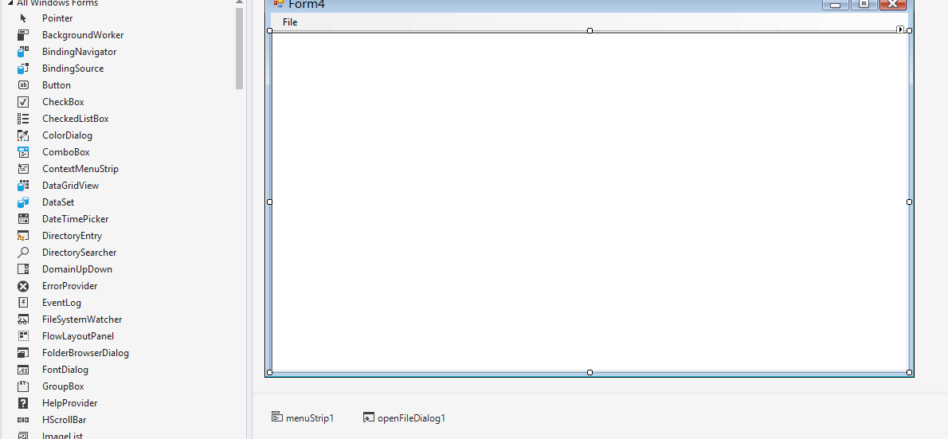

using System;
using System.Windows.Forms;

namespace WindowsFormsApp4
{
public partial class Form4 : Form
{
public Form4()
{
InitializeComponent();
}

private void OpenToolStripMenuItem_Click(object sender, EventArgs e)
{
if (openFileDialog1.ShowDialog() == DialogResult.OK)
{
string strfile = openFileDialog1.FileName;
richTextBox1.LoadFile(strfile, RichTextBoxStreamType.PlainText);
}
}
}
}
// Update records in Database operation:

using System;
using System.Windows.Forms;
using System.Data;
using System.Data.SqlClient;

namespace WindowsFormsApp4
{
public partial class Form3 : Form
{
public Form3()
{
InitializeComponent();
}

private void Button1_Click(object sender, EventArgs e)
{
SqlConnection con = new SqlConnection(@"Data Source=(LocalDB)\MSSQLLocalDB;AttachDbFilename=C:\Users\kumar\Documents\DCAP505DB.mdf;Integrated Security=True;Connect Timeout=30");
con.Open();
SqlCommand cmd = new SqlCommand("update studentDetailstbl set password=@password,email=@email,course=@course where username=@username", con);
cmd.Parameters.AddWithValue("username", textBox1.Text);
cmd.Parameters.AddWithValue("password", textBox3.Text);
cmd.Parameters.AddWithValue("email", textBox2.Text);
cmd.Parameters.AddWithValue("course", comboBox1.SelectedItem.ToString());
cmd.ExecuteNonQuery();
con.Close();
MessageBox.Show("Data updated");
}
}
}

