When something that doesn’t map to a number in an obvious way (such as "five" or undefined) is converted to a number, you get the value NaN.

« five » + 2

However, when null or undefined occurs on either side of the operator, it produces true only if both sides are one of null or undefined.

console.log(null == undefined); // → true
console.log(null == 0); // → false

That behavior is often useful. When you want to test whether a value has a real value instead of null or undefined, you can compare it to null with the == (or !=) operator.

Expressions like 0 == false and "" == false are also true because of automatic type conversion.

When you do not want any type conversions to happen, there are two additional operators: === and !==. The first tests whether a value is precisely equal to the other, and the second tests whether it is not precisely equal.
So "" === false is false as expected.

The || operator, for example, will return the value to its left when that can be converted to true and will return the value on its right otherwise.
This has the expected effect when the values are Boolean and does something analogous for values of other types.
console.log(null || "user") // → user
console.log("Agnes" || "user") // → Agnes

We can use this functionality as a way to fall back on a default value. If you have a value that might be empty, you can put || after it with a replacement value . If the initial value can be converted to false, you’ll get the replacement instead.

The && operator works similarly but the other way around. When the value to its left is something that converts to false, it returns that value, and otherwise it returns the value on its right.

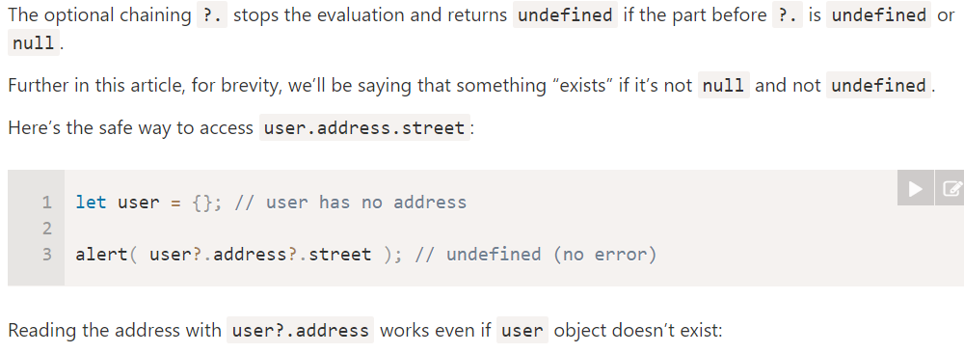

The precedence of the ?? operator is rather low: 7 in the MDN table.

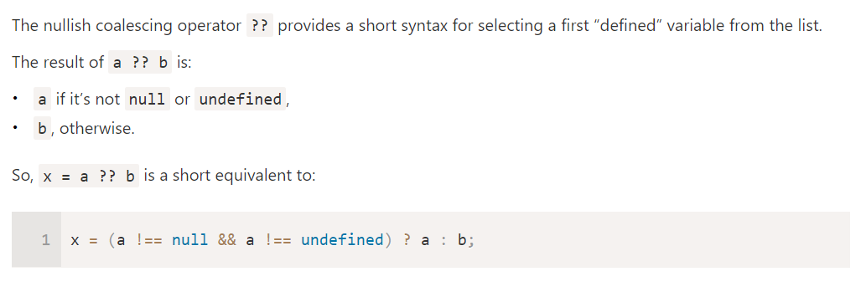

In some cases, JavaScript allows you to omit the semicolon at the end of a statement. In other cases, it has to be there, or the next line will be treated as part of the same statement. The rules for when it can be safely omitted are somewhat complex and error-prone. So in this book, every statement that needs a semicolon will always get one.

That’s a second kind of statement. The special word (keyword) let indicates that this sentence is going to define a binding. It is followed by the name of the binding and, if we want to immediately give it a value, by an = operator and an expression

si pas definit = undefined ( vraiment undefined )

let one = 1, two = 2;

The words var and const can also be used to create bindings, in a way similar to let.

The first, var (short for “variable”), is the way bindings were declared in pre-2015 JavaScript

The word const stands for constant. It defines a constant binding, which points at the same value for as long as it lives.

A binding name may include dollar signs ($) or underscores (_) but no other punctuation or special characters.

The full list of keywords and reserved words is rather long.

break case catch class const continue debugger default delete do else enum export extends false finally for function if implements import interface in instanceof let new package private protected public return static super switch this throw true try typeof var void while with yield

In the examples, I used console.log to output values. Most JavaScript systems (including all modern web browsers and Node.js) provide a console.log function that writes out its arguments to some text output device. In browsers, the output lands in the JavaScript console. This part of the browser interface is hidden by default, but most browsers open it when you press F12 or, on a Mac, command-option-I. If that does not work, search through the menus for an item named Developer Tools or similar. Though binding names cannot contain period characters, console.log does have one. This is because console.log isn’t a simple binding. It is actually an 26 expression that retrieves the log property from the value held by the console binding

The standard JavaScript functions, and most JavaScript programmers, follow the bottom style—they capitalize every word except the first.

fuzzyLittleTurtle

A return keyword without an expression after it will cause the function to return undefined. Functions that don’t have a return statement at all, such as makeNoise, similarly return undefined.

const hummus = function(factor) {

const ingredient = function(amount, unit, name) {
let ingredientAmount = amount * factor;
if (ingredientAmount > 1) { unit += "s"; }
console.log(`${ingredientAmount} ${unit} ${name}`);
};
ingredient(1, "can", "chickpeas");
ingredient(0.25, "cup", "tahini");
ingredient(0.25, "cup", "lemon juice");
ingredient(1, "clove", "garlic");
ingredient(2, "tablespoon", "olive oil");
ingredient(0.5, "teaspoon", "cumin");
} ;

This is a function declaration. The statement defines the binding square and points it at the given function. It is slightly easier to write and doesn’t require a semicolon after the function. There is one subtlety with this form of function definition.

console.log("The future says:", future());

function future() {
return "You'll never have flying cars";
}

const power = (base, exponent) => {
let result = 1;
for (let count = 0; count < exponent; count++) { result *= base; }
return result;
};

The arrow comes after the list of parameters and is followed by the function’s body. It expresses something like “this input (the parameters) produces this result (the body)”

const square1 = (x) => { return x * x; };
const square2 = x => x * x; // <=>

Because a function has to jump back to the place that called it when it returns, the computer must remember the context from which the call happened. In one case, console.log has to return to the greet function when it is done. In the other case, it returns to the end of the program. The place where the computer stores this context is the call stack. Every time a function is called, the current context is stored on top of this stack. When a function returns, it removes the top context from the stack and uses that context to continue execution

function greet(who) { console.log("Hello " + who); }
greet("Harry");
console.log("Bye");

greet()→ jump line 1 ( ou greet definis)

greet : console.log()→ go console log

fin greet : comeback line 2 ‘ou il a etait appelé

line 3 : go console log again

Storing this stack requires space in the computer’s memory. When the stack grows too big, the computer will fail with a message like “out of stack space” or “too much recursion”

n infinite back-and-forth between two functions
Rather, it would be infinite, if the computer had an infinite stack. As it is, we will run out of space, or “blow the stack”.

function chicken() { return egg(); }
function egg() { return chicken(); }
console.log(chicken() + " came first."); // → ??

JavaScript is extremely broad-minded about the number of arguments you pass to a function. If you pass too many, the extra ones are ignored. If you pass too few, the missing parameters get assigned the value undefined.

function minus(a, b) {
if (b === undefined) return -a;
else return a - b;
}

console.log(minus(10)); // → -10
console.log(minus(10, 5)); // → 5

function power(base, exponent = 2) ; default si pas preciser

function wrapValue(n) {
let local = n;
return ( ) => local; // retourne : ( )=>local
}
let wrap1 = wrapValue(1);
let wrap2 = wrapValue(2);

console.log(wrap1()); // → 1 // ( ) car return un lambda function a parametre vide
console.log(wrap2()); // → 2

function multiplier(factor) {
return number => number * factor;
}
let twice = multiplier(2);
console.log(twice(5)); // → 10

e. A good mental model is to think of function values as containing both the code in their body and the environment in which they are created. When called, the function body sees the environment in which it was created, not the environment in which it is called.

RECURSIOn

But this implementation has one problem: in typical JavaScript implementations, it’s about three times slower than the looping version. Running through a simple loop is generally cheaper than calling a function multiple times

Array javascript :

let listOfNumbers = [2, 3, 5, 7, 11];
console.log(listOfNumbers[2]); // → 5

The two main ways to access properties in JavaScript are with a dot and with square brackets.
Both value.x and value[x] access a property on value—but not necessarily the same property.

The difference is in how x is interpreted :

- When using a dot, the word after the dot is the literal name of the property.

- When using square brackets, the expression between the brackets is evaluated to get the property name.

Whereas value.x fetches the property of value named “x”, value[x] tries to evaluate the expression x and uses the result, converted to a string, as the property name.
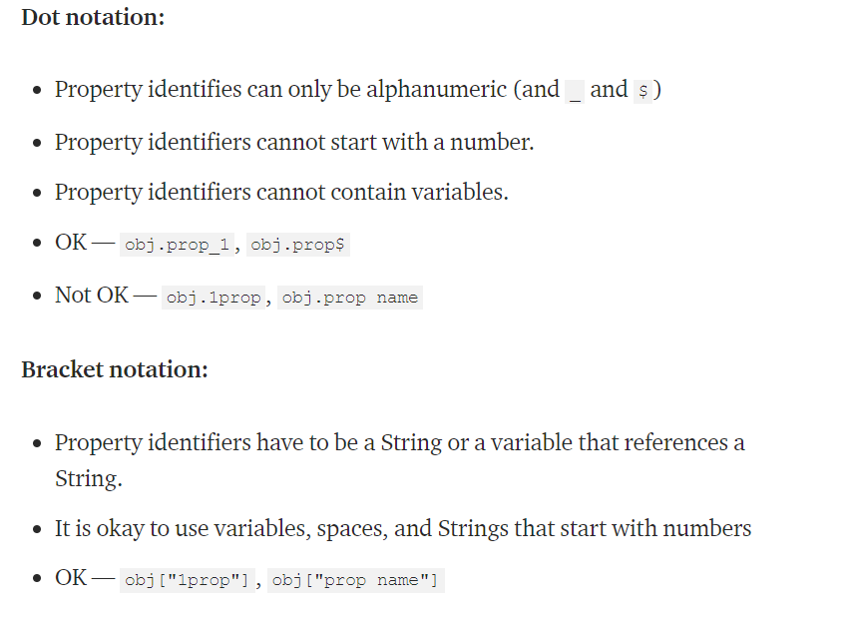
let obj = { cat: 'meow', dog: 'woof'};

let sound = obj['cat'];
console.log(sound);// meow

let sound = obj.cat;
console.log(sound) ;// meow

let dog = 'cat' ;

let sound = obj[dog]
console,log(sound) ; // meow

let sound = obj.dog;
console.log(sound);// woof

The length property of an array tells us how many elements it has. This property name is a valid binding name, and we know its name in advance, so to find the length of an array, you typically write array.length because that’s easier to write than array["length"].

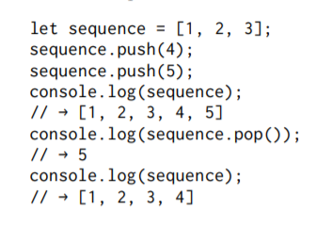

The push method adds values to the end of an array, and the pop method does the opposite, removing the last value in the array and returning it.

These somewhat silly names are the traditional terms for operations on a stack. A stack, in programming, is a data structure that allows you to push values into it and pop them out again in the opposite order so that the thing that was added last is removed first.

Objects :

Values of the type object are arbitrary collections of properties. One way to create an object is by using braces as an expression.

let day1 = {
squirrel: false,
events: ["work", "touched tree", "pizza", "running"]
};

console.log(day1.squirrel); // → false
console.log(day1.wolf); // → undefined
day1.wolf = false;
console.log(day1.wolf); // → false

Reading a property that doesn’t exist will give you the value undefined. It is possible to assign a value to a property expression with the = operator. This will replace the property’s value if it already existed or create a new property on the object if it didn’t.

The delete operator cuts off a tentacle from such an octopus. It is a unary operator that, when applied to an object property, will remove the named property from the object.
This is not a common thing to do, but it is possible.

let anObject = {left: 1, right: 2};
console.log(anObject.left); // → 1
delete anObject.left;
console.log(anObject.left); // → undefined
console.log("left" in anObject); // → false

The binary in operator, when applied to a string and an object, tells you whether that object has a property with that name.

The difference between setting a property to undefined and actually deleting it is that, in the first case, the object still has the property (it just doesn’t have a very interesting value), whereas in the second case the property is no longer present and in will return false.

To find out what properties an object has, you can use the Object.keys function. You give it an object, and it returns an array of strings—the object’s property names.

console.log(Object.keys({x: 0, y: 0, z: 2})); // → ["x", "y", "z"]

There’s an Object.assign function that copies all properties from one object into another.

let objectA = {a: 1, b: 2};
Object.assign(objectA, {b: 3, c: 4});

console.log(objectA); // → {a: 1, b: 3, c: 4}

let object1 = {value: 10};
let object2 = object1; // pointe vers meme objet
let object3 = {value: 10}; // <> objet

console.log(object1 == object2); // → true
console.log(object1 == object3); // → false

const score = {visitors: 0, home: 0};

score.visitors = 1; // This is okay

score = {visitors: 1, home: 1}; // This isn't allowed

When you compare objects with JavaScript’s == operator, it compares by identity: it will produce true only if both objects are precisely the same value. Comparing different objects will return false, even if they have identical properties. There is no “deep” comparison operation built into JavaScript, which compares objects by contents, but it is possible to write it yourself .

function addEntry(events, squirrel) { journal.push({events, squirrel}); }

Note that the object added to the journal looks a little odd. Instead of declaring properties like events: events, it just gives a property name. This is shorthand that means the same thing—if a property name in brace notation isn’t followed by a value, its value is taken from the binding with the same name.

Arrays have an includes method that checks whether a given value exists in the array. The function uses that to determine whether the event name it is interested in is part of the event list for a given day.

for (let entry of JOURNAL) { console.log(`${entry.events.length} events.`); }

function journalEvents(journal) {
let events = [];
for (let entry of journal) {
for (let event of entry.events) {
if (!events.includes(event)) { events.push(event); }
}
}
return events;
}

console.log(journalEvents(JOURNAL)); // → ["carrot", "exercise", "weekend", "bread", …]

We saw push and pop, which add and remove elements at the end of an array, earlier in this chapter. The corresponding methods for adding and removing things at the start of an array are called unshift and shift.

let todoList = [];

function remember(task) { todoList.push(task); } // mets fin file

function getTask() { return todoList.shift(); } // get et remove premier elem file

function rememberUrgently(task) { todoList.unshift(task); } // ajoute au debut file

To search for a specific value, arrays provide an indexOf method. The method searches through the array from the start to the end and returns the index at which the requested value was found—or -1 if it wasn’t found. To search from the end instead of the start, there’s a similar method called lastIndexOf.

console.log([1, 2, 3, 2, 1].indexOf(2)); // → 1
console.log([1, 2, 3, 2, 1].lastIndexOf(2)); // → 3

Both indexOf and lastIndexOf take an optional second argument that indicates where to start searching. Another fundamental array method is slice, which takes start and end indices and returns an array that has only the elements between them. The start index is inclusive, the end index exclusive.
console.log([0, 1, 2, 3, 4].slice(2, 4)); // → [2, 3]
console.log([0, 1, 2, 3, 4].slice(2)); // → [2, 3, 4]

When the end index is not given, slice will take all of the elements after the start index. You can also omit the start index to copy the entire array. The concat method can be used to glue arrays together to create a new array, similar to what the + operator does for strings.

function remove(array, index) {
return array.slice(0, index).concat(array.slice(index + 1));
}

console.log(remove(["a", "b", "c", "d", "e"], 2)); // → ["a", "b", "d", "e"]

If you pass concat an argument that is not an array, that value will be added to the new array as if it were a one-element array

you try to add a new property, it doesn’t stick.

let kim = "Kim";
kim.age = 88;
console.log(kim.age); // → undefined

Values of type string, number, and Boolean are not objects, and though the language doesn’t complain if you try to set new properties on them, it doesn’t actually store those properties. As mentioned earlier, such values are immutable and cannot be changed.

console.log("coconuts".slice(4, 7)); // → nut
console.log("coconut".indexOf("u")); // → 5

One difference is that a string’s indexOf can search for a string containing more than one character, whereas the corresponding array method looks only for a single element.

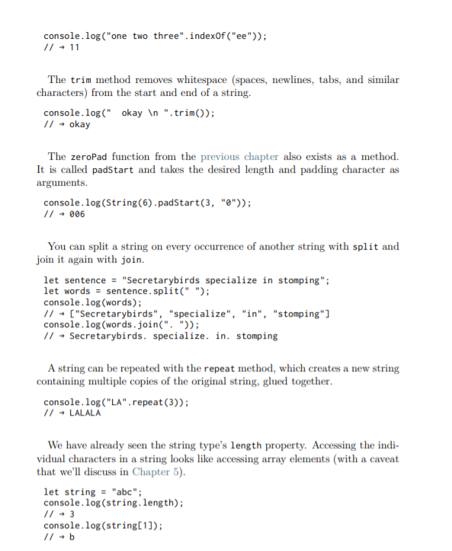

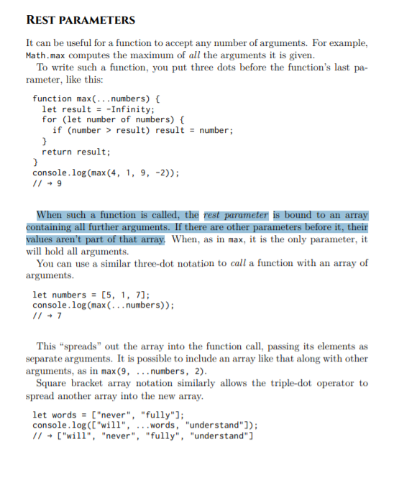

There is only one Math object, and it is almost never useful as a value. Rather, it provides a namespace so that all these functions and values do not have to be global bindings. Having too many global bindings “pollutes” the namespace. The more names have been taken, the more likely you are to accidentally overwrite the value of some existing binding. For example, it’s not unlikely to want to name something max in one of your programs. Since JavaScript’s built-in max function is tucked safely inside the Math object, we don’t have to worry about overwriting it. Many languages will stop you, or at least warn you, when you are defining a binding with a name that is already taken. JavaScript does this for bindings you declared with let or const but—perversely—not for standard bindings nor for bindings declared with var or function

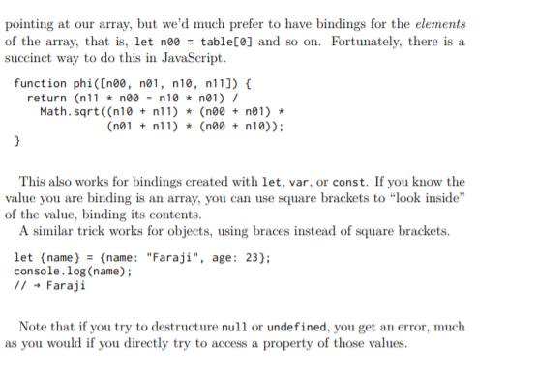

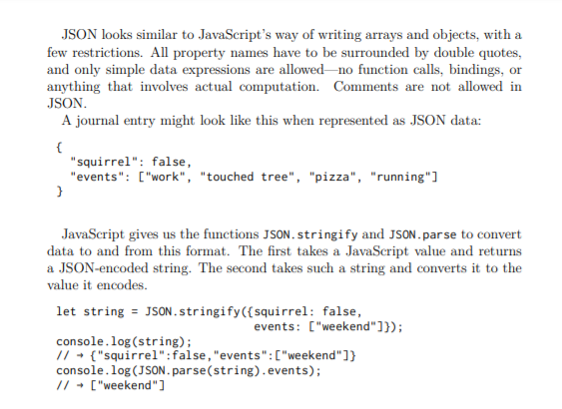

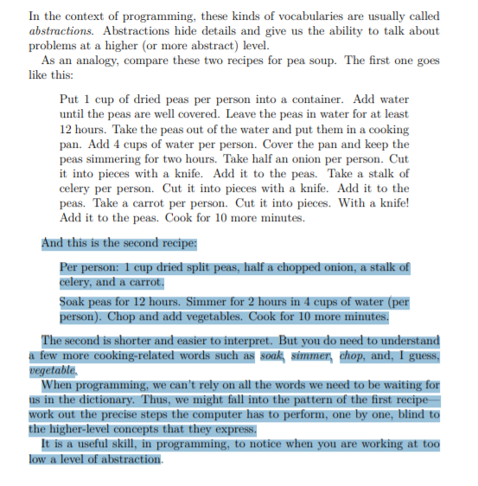

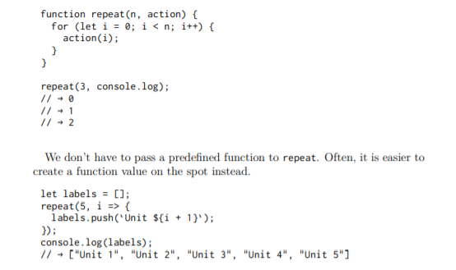

Functions that operate on other functions, either by taking them as arguments or by returning them, are called higher-order functions. Since we have already seen that functions are regular values, there is nothing particularly remarkable about the fact that such functions exist

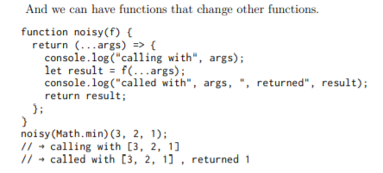

There is a built-in array method, forEach, that provides something like a for/of loop as a higher-order function.

["A", "B"].forEach(l => console.log(l));
// → A // → B

function textScripts(text) {
let scripts = countBy(text, char => {
let script = characterScript(char.codePointAt(0));
return script ? script.name : "none";
}).filter(({name}) => name != "none");

let total = scripts.reduce((n, {count}) => n + count, 0);
if (total == 0) return "No scripts found";

return scripts.map(({name, count}) => {
return `${Math.round(count * 100 / total)}% ${name}`;
}).join(", ");
}

function filter(array, test) { let passed = []; for (let element of array) { if (test(element)) { passed.push(element); } } return passed; }

Like forEach, filter is a standard array method. Filter array + boolean expression / test

function map(array, transform) { let mapped = []; for (let element of array) { mapped.push(transform(element)); } return mapped; }

The map method transforms an array by applying a function to all of its elements and building a new array from the returned values. The new array will have the same length as the input array, but its content will have been mapped to a new form by the function.

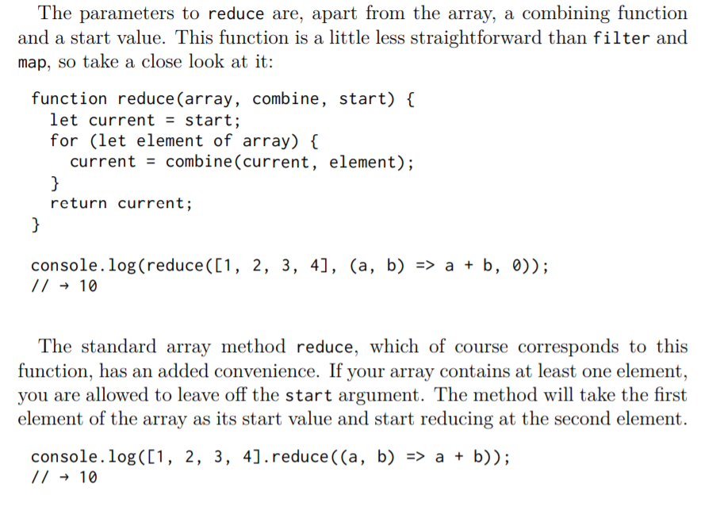

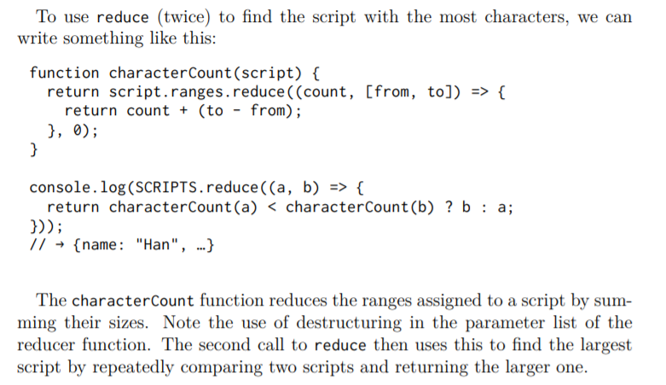

Range est un tableau de pair

ex : ranges: [ [1536, 1541], [1542, 1548], …. , [64336, 64450], [64467, 64830] ] ;

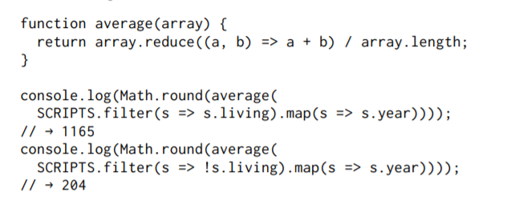
So given a character code, we could use a function like this to find the corresponding script (if any):

function characterScript(code) {
for (let script of SCRIPTS) {
if (script.ranges.some(([from, to]) => { return code >= from && code < to; }))
{ return script; }
}
return null; }

console.log(characterScript(121)); // → {name: "Latin", …}

The some method is another higher-order function. It takes a test function and tells you whether that function returns true for any of the elements in the array

In Chapter 1 I mentioned that JavaScript strings are encoded as a sequence of 16-bit numbers. These are called code units. A Unicode character code was initially supposed to fit within such a unit (which gives you a little over 65,000 characters).

g. And if your language doesn’t use two-unit characters, that will appear to work just fine. But as soon as someone tries to use such a program with some less common Chinese characters, it breaks. Fortunately, with the advent of emoji, everybody has started using two-unit characters, and the burden of dealing with such problems is more fairly distributed.

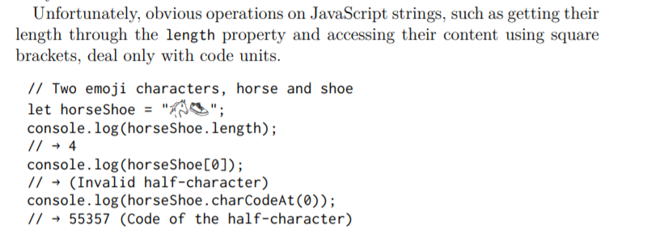

JavaScript’s charCodeAt method gives you a code unit, not a full character code. The codePointAt method, added later, does give a full Unicode character. So we could use that to get characters from a string. But the argument passed to codePointAt is still an index into the sequence of code units. So to run over all characters in a string, we’d still need to deal with the question of whether a character takes up one or two code units

Like codePointAt, this type of loop was introduced at a time where people were acutely aware of the problems with UTF-16. When you use it to loop over a string, it gives you real characters, not code units.

let roseDragon = "🌹🐉";
for (let char of roseDragon) { console.log(char); } // → 🌹 // → 🐉

If you have a character (which will be a string of one or two code units), you can use codePointAt(0) to get its code.

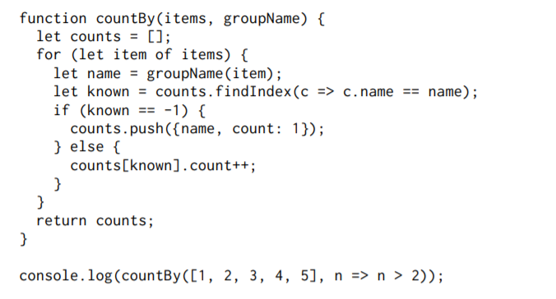
// → [{name: false, count: 2}, {name: true, count: 3}]

It uses another array method—findIndex. This method is somewhat like indexOf, but instead of looking for a specific value, it finds the first value for which the given function returns true. Like indexOf, it returns -1 when no such element is found.

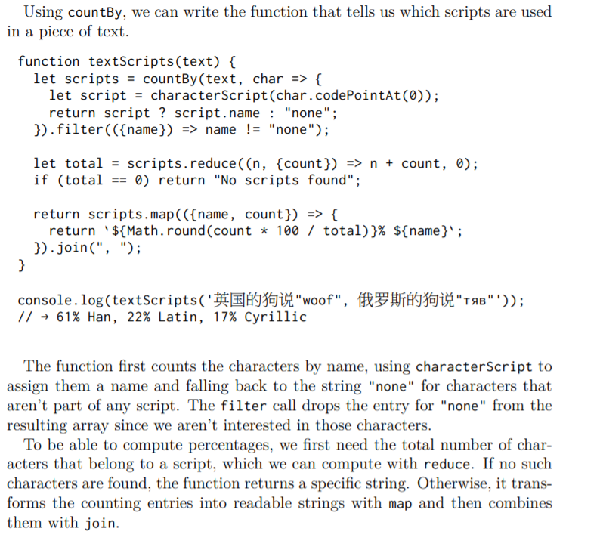

Many languages provide a way to distinguish public and private properties and prevent outside code from accessing the private ones altogether. JavaScript, once again taking the minimalist approach, does not—not yet at least. There is work underway to add this to the language.

Even though the language doesn’t have this distinction built in, JavaScript programmers are successfully using this idea. Typically, the available interface is described in documentation or comments. It is also common to put an 97 underscore (_) character at the start of property names to indicate that those properties are private. Separating interface from implementation is a great idea. It is usually called encapsulation.

let rabbit = {};
rabbit.speak = function(line) { console.log(`The rabbit says '${line}'`); };

rabbit.speak("I'm alive."); // → The rabbit says 'I'm alive.'

Arrow functions are different—they do not bind their own this but can see the this binding of the scope around them. Thus, you can do something like the following code, which references this from inside a local function:

function normalize() { console.log(this.coords.map(n => n / this.length)); }

normalize.call({coords: [0, 2, 3], length: 5}); // → [0, 0.4, 0.6]

let empty = {};
console.log(empty.toString); // → function toString()…{}
console.log(empty.toString()); // → [object Object]

In addition to their set of properties, most objects also have a prototype. A prototype is another object that is used as a fallback source of properties. When an object gets a request for a property that it does not have, its prototype will be searched for the property, then the prototype’s prototype, and so on. So who is the prototype of that empty object? It is the great ancestral prototype, the entity behind almost all objects, Object.prototype.

The prototype relations of JavaScript objects form a tree-shaped structure, and at the root of this structure sits Object.prototype

Many objects don’t directly have Object.prototype as their prototype but instead have another object that provides a different set of default properties. Functions derive from Function.prototype, and arrays derive from Array .prototype.

console.log(Object.getPrototypeOf({}) == Object.prototype); 99 // → true console.log(Object.getPrototypeOf(Object.prototype)); // → null

console.log(Object.getPrototypeOf(Math.max) == Function.prototype); // → true console.log(Object.getPrototypeOf([]) == Array.prototype); // → true

You can use Object.create to create an object with a specific prototype.

let protoRabbit = { speak(line) { console.log(`The ${this.type} rabbit says '${line}'`); } };

let killerRabbit = Object.create(protoRabbit);
killerRabbit.type = "killer";
killerRabbit.speak("SKREEEE!"); // → The killer rabbit says 'SKREEEE!'

Constructor :

function makeRabbit(type) {
let rabbit = Object.create(protoRabbit);
rabbit.type = type; return rabbit; }

Prototypes are useful for defining properties for which all instances of a class share the same value, such as methods. Properties that differ per instance, such as our rabbits’ type property, need to be stored directly in the objects themselves

JavaScript provides a way to make defining this type of function easier. If you put the keyword new in front of a function call, the function is treated as a constructor. This means that an object with the right prototype is automatically created, bound to this in the function, and returned at the end of the function.

The prototype object used when constructing objects is found by taking the prototype property of the constructor function. Function

Rabbit(type) { this.type = type; }
Rabbit.prototype.speak = function(line) { console.log(`The ${this.type} rabbit says '${line}'`); };ù let weirdRabbit = new Rabbit("weird");

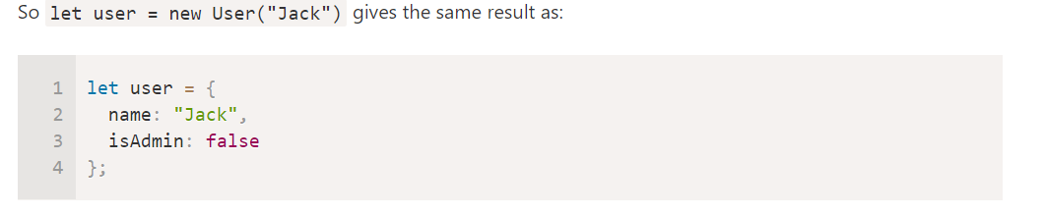
Now if we want to create other users, we can call new User("Ann"), new User("Alice") and so on. Much shorter than using literals every time, and also easy to read.
That’s the main purpose of constructors – to implement reusable object creation code

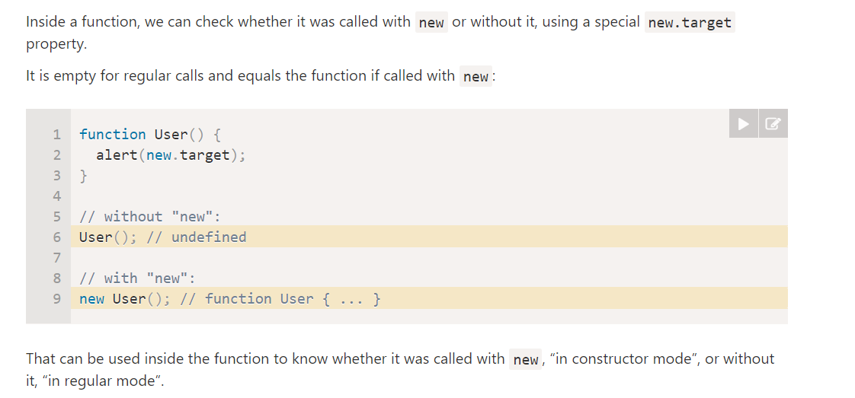

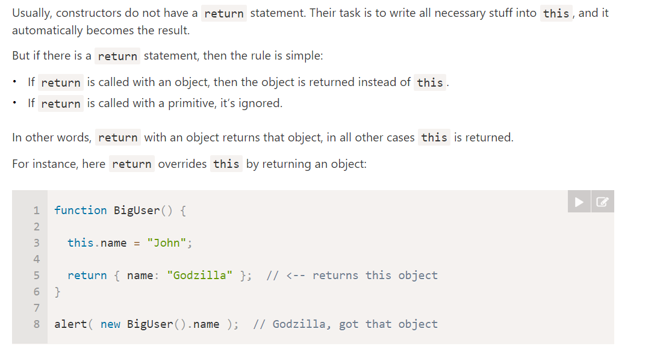
Usually constructors don’t have a return statement. Here we mention the special behavior with returning objects mainly for the sake of completeness.

By the way, we can omit parentheses after new, if it has no arguments:

Constructors (all functions, in fact) automatically get a property named prototype, which by default holds a plain, empty object that derives from Object.prototype . You can overwrite it with a new object if you want. Or you can add properties to the existing object, as the example does. By convention, the names of constructors are capitalized so that they can easily be distinguished from other function

The constructor function may have parameters that define how to construct the object, and what to put in it.
Of course, we can add to this not only properties, but methods as well.
For instance, new User(name) below creates an object with the given name and the method sayHi
function User(name) {
this.name = name;

this.sayHi = function() {
alert( "My name is: " + this.name );
};
}

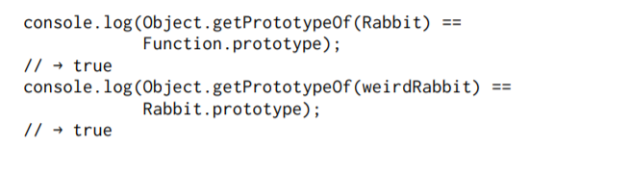
So JavaScript classes are constructor functions with a prototype property

EN 2015 :
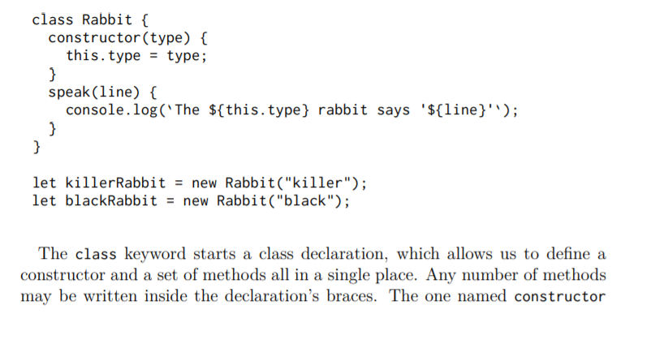

Class declarations currently allow only methods—properties that hold functions— to be added to the prototype. This can be somewhat inconvenient when you want to save a non-function value in there. For now, you can create such properties by directly manipulating the prototype after you’ve defined the class.

Like function, class can be used both in statements and in expressions.

let object = new class { getWord() { return "hello"; } };

. If there was already a property with the same name in the prototype, this property will no longer affect the object, as it is now hidden behind the object’s own property.

Rabbit.prototype.teeth = "small";
console.log(killerRabbit.teeth); // → small
killerRabbit.teeth = "long, sharp, and bloody";
console.log(killerRabbit.teeth); // → long, sharp, and bloody
console.log(blackRabbit.teeth); // → small
console.log(Rabbit.prototype.teeth); // → small

Overriding properties that exist in a prototype can be a useful thing to do. As the rabbit teeth example shows, overriding can be used to express exceptional properties in instances of a more generic class of objects, while letting the nonexceptional objects take a standard value from their prototype.

A map (noun) is a data structure that associates values (the keys) with other values. For example, you might want to map names to ages. It is possible to use objects for this.

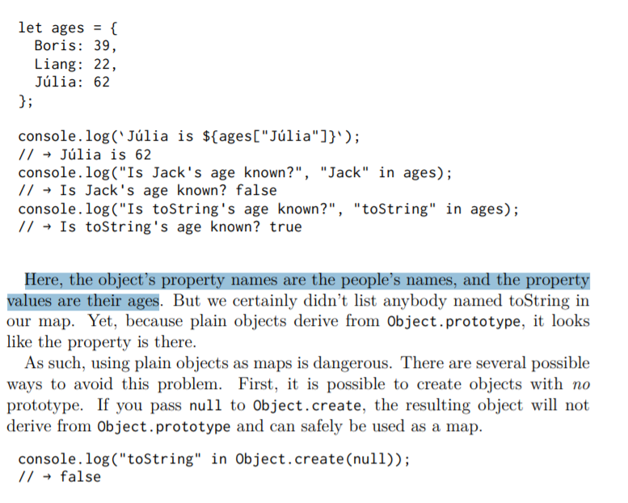
COMPREND PAS
Object property names must be strings. If you need a map whose keys can’t easily be converted to strings—such as objects—you cannot use an object as your map. Fortunately, JavaScript comes with a class called Map that is written for this exact purpose. It stores a mapping and allows any type of keys.

let ages = new Map();
ages.set("Boris", 39); ages.set("Liang", 22); ages.set("Júlia", 62);
console.log(`Júlia is ${ages.get("Júlia")}`); // → Júlia is 62
console.log("Is Jack's age known?", ages.has("Jack")); // → Is Jack's age known? false console.log(ages.has("toString")); // → false

The methods set, get, and has are part of the interface of the Map object.

Someone else did it or us, and we can go through this simple interface to use their work. If you do have a plain object that you need to treat as a map for some reason, it is useful to know that Object.keys returns only an object’s own keys, not those in the prototype. As an alternative to the in operator, you can use the hasOwnProperty method, which ignores the object’s prototype. console.log({x: 1}.hasOwnProperty("x")); // → true console.log({x: 1}.hasOwnProperty("toString")); // → false

When you call the String function (which converts a value to a string) on an object, it will call the toString method on that object to try to create a meaningful string from it.

Rabbit.prototype.toString = function() { return `a ${this.type} rabbit`; }; console.log(String(blackRabbit)); // → a black rabbit

When I claimed that property names are strings, that wasn’t entirely accurate. They usually are, but they can also be symbols. Symbols are values created with the Symbol function. Unlike strings, newly created symbols are unique—you cannot create the same symbol twice.

let sym = Symbol("name");
console.log(sym == Symbol("name")); // → false
Rabbit.prototype[sym] = 55; console.log(blackRabbit[sym]); // → 5 5

Symbol([description])

Une chaîne de caractères optionnelle. Correspond à une description du symbole, elle peut être utile pour déboguer (mais pas pour accéder au symbole).

Être à la fois unique et utilisable comme noms de propriété rend les symboles appropriés pour defining interfaces that can peacefully live alongside other properties, no matter what their names are.

Symbols allow us to create “hidden” properties of an object, that no other part of code can accidentally access or overwrite.
For instance, if we’re working with user objects, that belong to a third-party code. We’d like to add identifiers to them.
Let’s use a symbol key for it:
What’s the benefit of using Symbol("id") over a string "id"?
As user objects belongs to another code, and that code also works with them, we shouldn’t just add any fields to it. That’s unsafe. But a symbol cannot be accessed accidentally, the third-party code probably won’t even see it, so it’s probably all right to do.

const toStringSymbol = Symbol("toString");
Array.prototype[toStringSymbol] = function() { return `${this.length} cm of blue yarn`; };
console.log([1, 2].toString()); // → 1,2
console.log([1, 2][toStringSymbol]()); 107 // → 2 cm of blue yarn

It is possible to include symbol properties in object expressions and classes by using square brackets around the property name. That causes the property name to be evaluated, much like the square bracket property access notation, which allows us to refer to a binding that holds the symbol.
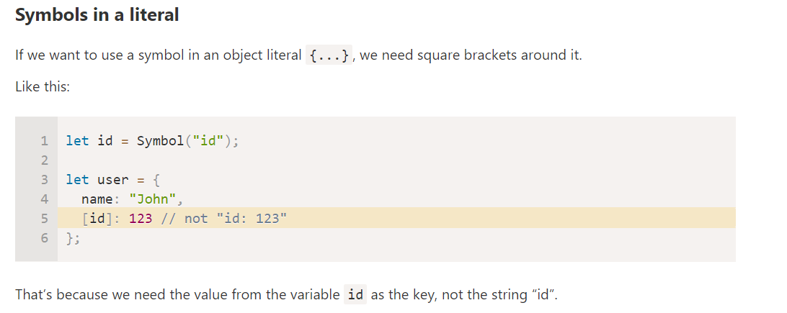

let stringObject = { [toStringSymbol]() { return "a jute rope"; } }; console.log(stringObject[toStringSymbol]()); // → a jute rope

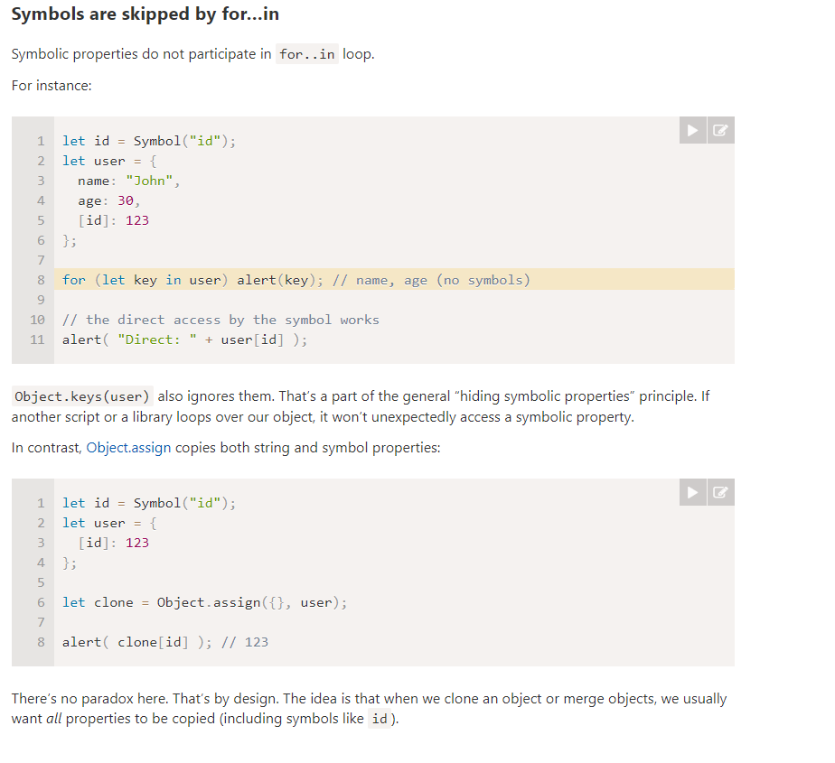
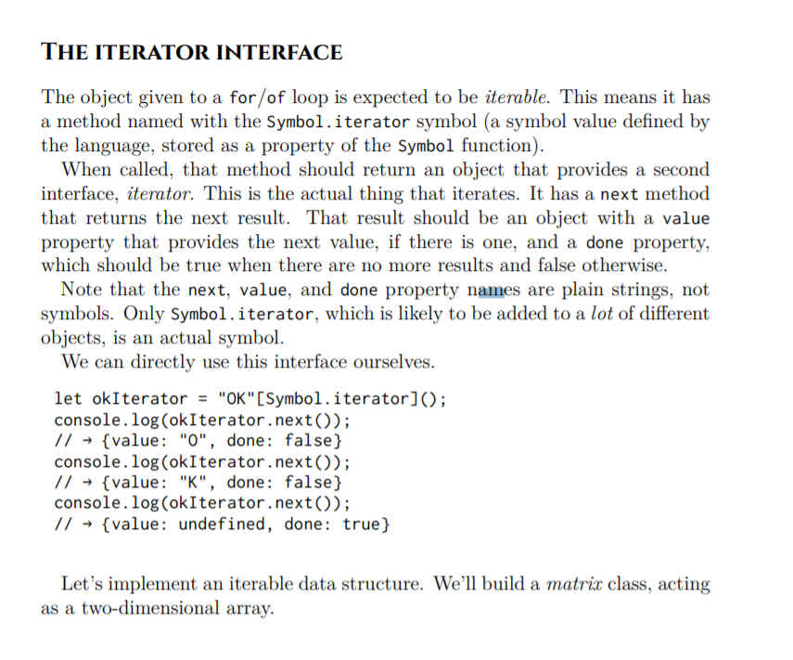

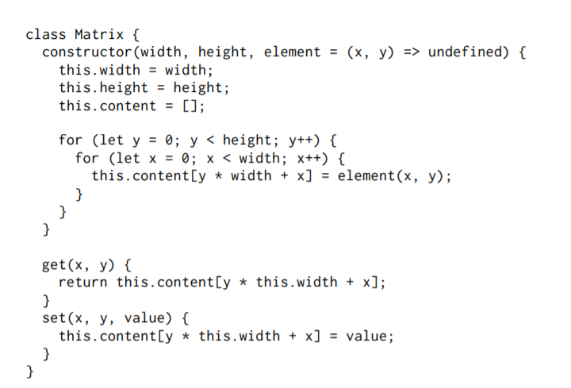

The constructor function takes a width, a height, and an optional element function that will be used to fill in the initial values

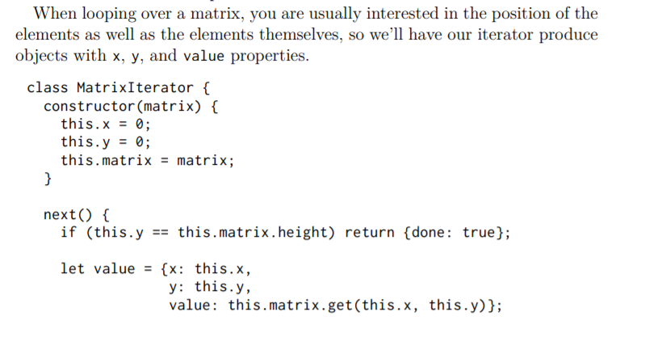
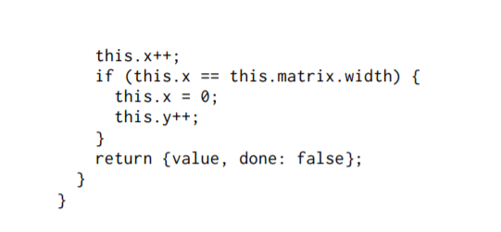

Matrix.prototype[Symbol.iterator] = function() { return new MatrixIterator(this); };

We can now loop over a matrix with for/of.
let matrix = new Matrix(2, 2, (x, y) => `value ${x},${y}`);
for (let {x, y, value} of matrix) { console.log(x, y, value); }
// → 0 0 value 0,0
// → 1 0 value 1,0
// → 0 1 value 0,1
// → 1 1 value 1,1

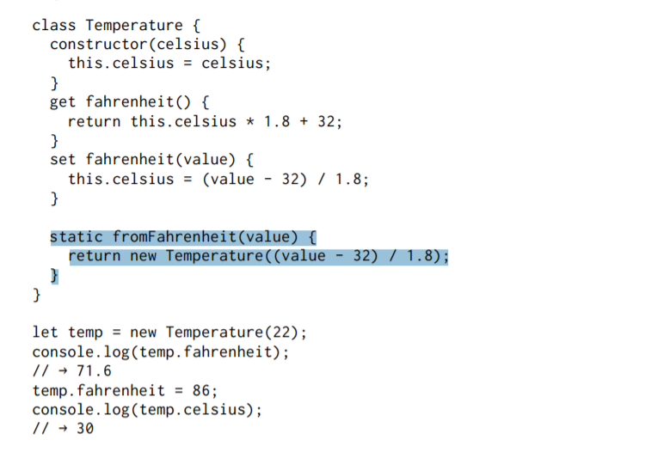
The Temperature class allows you to read and write the temperature in either degrees Celsius or degrees Fahrenheit, but internally it stores only Celsius and automatically converts to and from Celsius in the fahrenheit getter and setter.

Inside a class declaration, methods that have static written before their name are stored on the constructor. So the Temperature class allows you to write Temperature.fromFahrenheit(100) to create a temperature using degrees Fahrenheit.

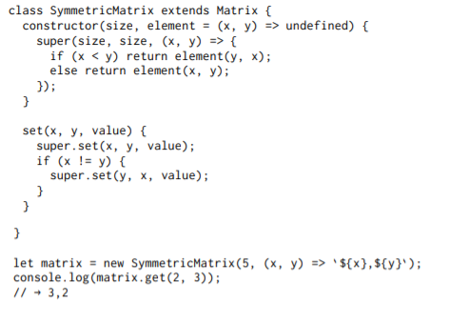

The use of the word extends indicates that this class shouldn’t be directly based on the default Object prototype but on some other class. This is called the superclass. The derived class is the subclass

To ensure the matrix is symmetrical, the constructor wraps the element function to swap the coordinates for values below the diagonal

It is occasionally useful to know whether an object was derived from a specific class. For this, JavaScript provides a binary operator called instanceof.

console.log( new SymmetricMatrix(2) instanceof SymmetricMatrix); // → true

There is a function called Object.freeze that changes an object so that writing to its properties is ignored. You could use that to make sure your objects aren’t changed, if you want to be careful. Freezing does require the computer to do some extra work, and having updates ignored is just about as likely to confuse someone as having them do the wrong thing. So I usually prefer to just tell people that a given object shouldn’t be messed with and hope they remember it.

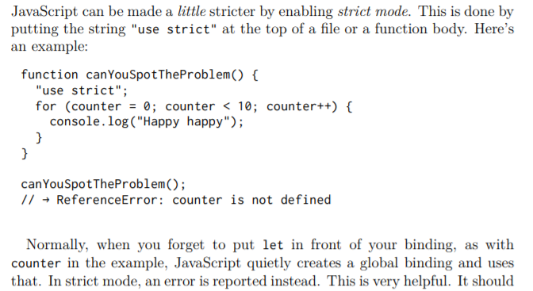

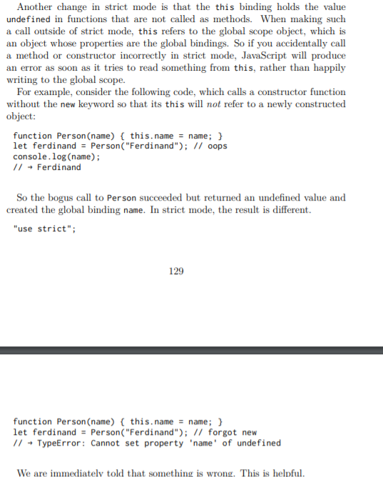

// (VillageState, Array) → {direction: string, memory: Array}
function goalOrientedRobot(state, memory) { // ... }

ajoute commentaire pour prevenir du type car javascript considère les types uniquement au run time donc meme si type correspond pas … il va juste essayer de les convertirs .

What do you think would be the type of the randomPick function that returns a random element from an array?
You’d need to introduce a type variable, T, which can stand in for any type, so that you can give randomPick a type like ([T])→ T (function from an array of Ts to a T).

When the types of a program are known, it is possible for the computer to check them for you, pointing out mistakes before the program is run. There are several JavaScript dialects that add types to the language and check them. The most popular one is called TypeScript. If you are interested in adding more rigor to your programs, I recommend you give it a try.

throw new Error("Invalid direction: " + result);

sinon pour try et catch pareil

In most JavaScript environments, instances of this constructor also gather information about the call stack that existed when the exception was created, a so-called stack trace. This information is stored in the stack property and can be helpful when trying to debug a problem: it tells us the function where the problem occurred and which functions made the failing call.

A finally block says “no matter what happens, run this code after trying to run the code in the try block.

JavaScript (in a rather glaring omission) doesn’t provide direct support for selectively catching exceptions: either you catch them all or you don’t catch any.

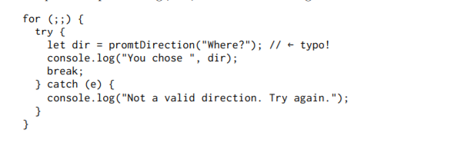

The for (;;) construct is a way to intentionally create a loop that doesn’t terminate on its own. We break out of the loop only when a valid direction is given. But we misspelled promptDirection, which will result in an “undefined variable” error. Because the catch block completely ignores its exception value (e), assuming it knows what the problem is, it wrongly treats the binding error as indicating bad input. Not only does this cause an infinite loop, it “buries” the useful error message about the misspelled binding
As a general rule, don’t blanket-catch exceptions unless it is for the purpose of “routing” them somewhere

So we want to catch a specific kind of exception. We can do this by checking in the catch block whether the exception we got is the one we are interested in and rethrowing it otherwise.

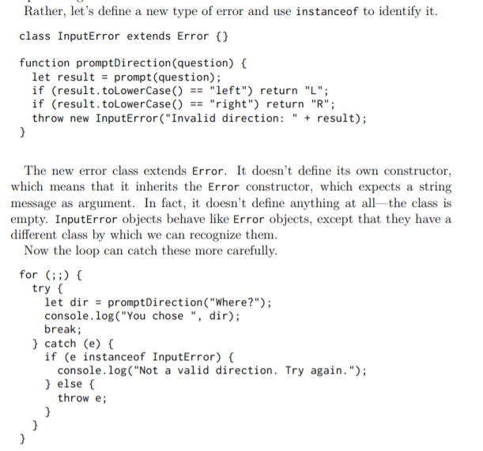

Assertion

function firstElement(array) {
if (array.length == 0) { throw new Error("firstElement called with []"); }
return array[0];
}

Now, instead of silently returning undefined (which you get when reading an array property that does not exist), this will loudly blow up your program as soon as you misuse it.

REGULAR EXPRESSION :

A regular expression is a type of object. It can be either constructed with the RegExp constructor or written as a literal value by enclosing a pattern in forward slash (/) characters.

let re1 = new RegExp("abc");
let re2 = /abc/;

debut entrée : / ; fin :\
=> echappe tout les « \ »avec « / » + echappe tout les caractères speciale comme « + ,- , . , ect »
=> permet de préserver les « \n » ou autre car la fin est un « / »

Regular expression objects have a number of methods. The simplest one is test. If you pass it a string, it will return a Boolean telling you whether the string contains a match of the pattern in the expression.

console.log(/abc/.test("abcde")); // → true

Finding out whether a string contains abc could just as well be done with a call to indexOf.

console.log(/'\d+'/.test("'123'")); // → true

The i at the end of the expression in the example makes this regular expression case insensitive, allowing it to match the uppercase B in the input string, even though the pattern is itself all lowercase

Regular expressions also have an exec (execute) method that will return null if no match was found and return an object with information about the match otherwise.

let match = /\d+/.exec("one two 100");
console.log(match); // → ["100"] console.log(match.index); // → 8

An object returned from exec has an index property that tells us where in the string the successful match begins. Other than that, the object looks like (and in fact is) an array of strings, whose first element is the string that was matched.

String values have a match method that behaves similarly

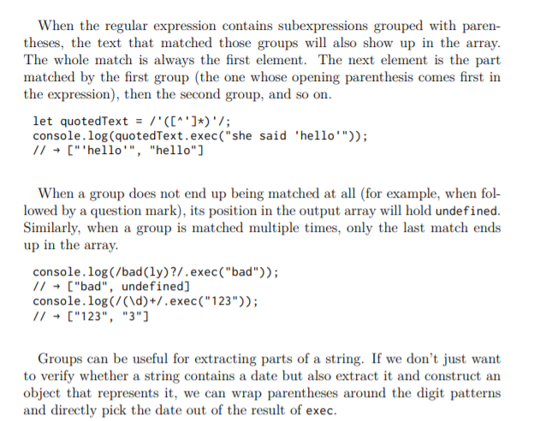

. If you simply create a date object using new, you get the current date and

time. console.log(new Date()); // → Mon Nov 13 2017 16:19:11 GMT+0100 (CET)

You can also create an object for a specific time.

console.log(new Date(2009, 11, 9)); // → Wed Dec 09 2009 00:00:00 GMT+0100 (CET)

JavaScript uses a convention where month numbers start at zero (so December is 11), yet day numbers start at one. This is confusing and silly. Be careful. The last four arguments (hours, minutes, seconds, and milliseconds) are optional and taken to be zero when not given.

The getTime method on a date object returns this number. It is big, as you can imagine. console.log(new Date(2013, 11, 19).getTime()); // → 1387407600000

(normal getTime avec unix timestamp depuis janvier 1970)

Date objects provide methods such as getFullYear, getMonth, getDate, getHours , getMinutes, and getSeconds to extract their components. Besides getFullYear there’s also getYear, which gives you the year minus 1900 (98 or 119) and is mostly useless.

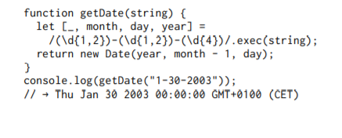

The _ (underscore) binding is ignored and used only to skip the full match element in the array returned by exec.

If we want to enforce that the match must span the whole string, we can add the markers ^ and $. The caret matches the start of the input string, whereas the dollar sign matches the end. So, /^\d+$/ matches a string consisting entirely of one or more digits, /^!/ matches any string that starts with an exclamation mark, and /x^/ does not match any string (there cannot be an x before the start of the string).

The engine will then realize that it needs an x to match the pattern. Since there is no x past the end of the string, the star operator tries to match one character less. B

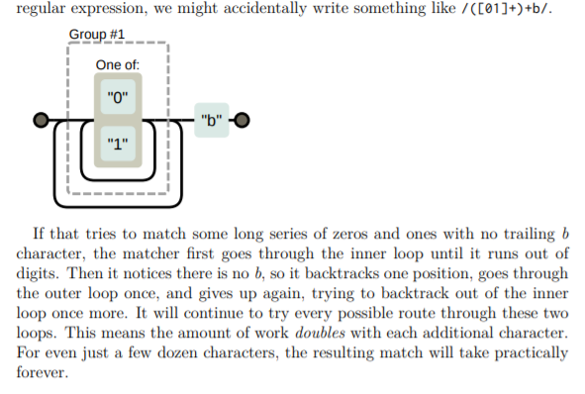

String values have a replace method that can be used to replace part of the string with another string. console.log("papa".replace("p", "m")); // → mapa

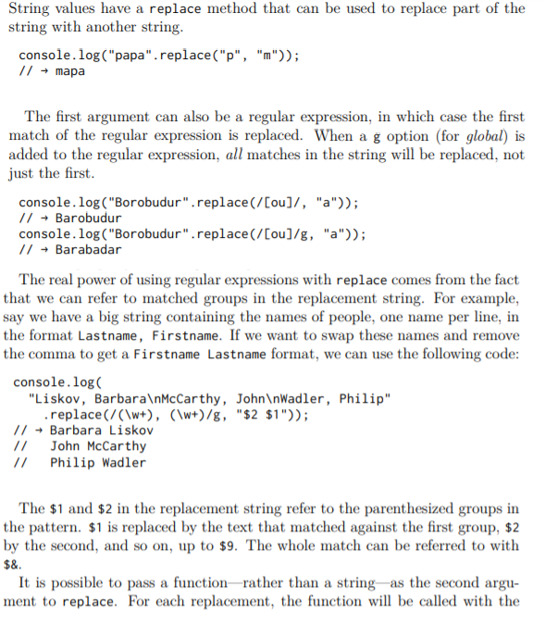

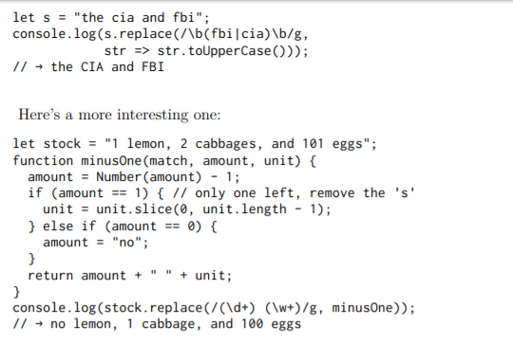

function stripComments(code) { return code.replace(/\/\/.*|\/\*[^]*?\*\//g, ""); }

console.log(stripComments("1 /* a */+/* b */ 1")); // → 1 + 1

The part before the or operator matches two slash characters followed by any number of non-newline characters. The part for multiline comments is more involved. We use [^] (any character that is not in the empty set of characters) as a way to match any character. We cannot just use a period here because block comments can continue on a new line, and the period character does not match newline characters

Because of this behavior, we say the repetition operators (+, *, ?, and {} ) are greedy, meaning they match as much as they can and backtrack from there. If you put a question mark after them (+?, *?, ??, {}?), they become nongreedy and start by matching as little as possible, matching more only when the remaining pattern does not fit the smaller match.

let name = "dea+hl[]rd";
let text = "This dea+hl[]rd guy is super annoying.";
let escaped = name.replace(/[\\[.+*?(){|^$]/g, "\\$&");
let regexp = new RegExp("\\b" + escaped + "\\b", "gi");
console.log(text.replace(regexp, "_$&_")); // → This _dea+hl[]rd_ guy is super annoying.

But there is another method, search, that does expect a regular expression. Like indexOf, it returns the first index on which the expression was found, or -1 when it wasn’t found.

console.log(" word".search(/\S/)); // → 2
console.log(" ".search(/\S/)); // → -1
Unfortunately, there is no way to indicate that the match should start at a given offset (like we can with the second argument to indexOf), which would often be useful

Regular expression objects have properties. One such property is source, which contains the string that expression was created from. Another property is lastIndex, which controls, in some limited circumstances, where the next match will start. Those circumstances are that the regular expression must have the global (g) or sticky (y) option enabled, and the match must happen through the exec method.

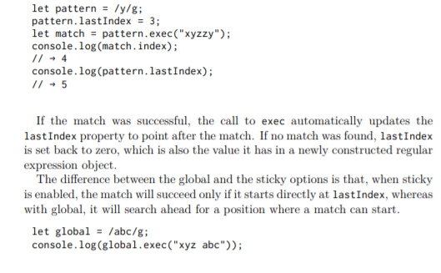

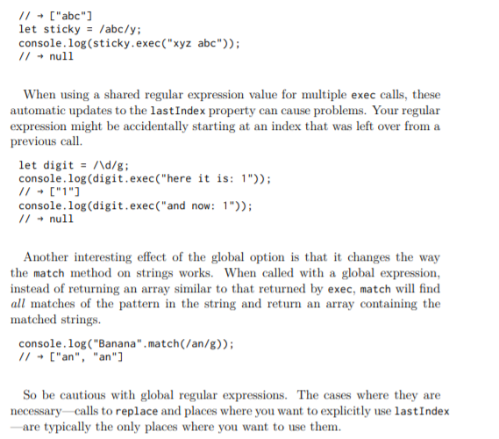

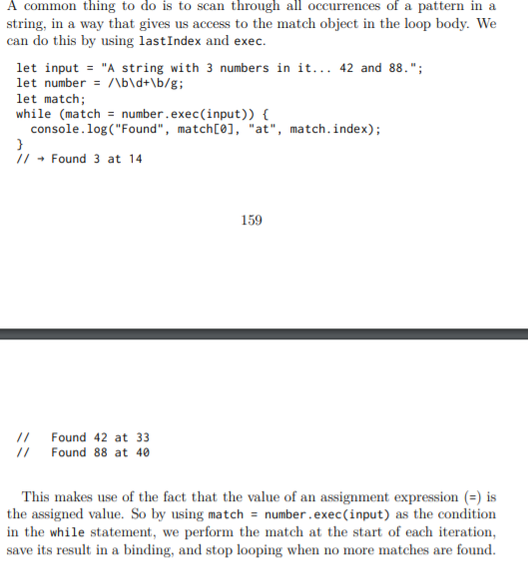

EXERCICE :

Parsing an INI file

+ lire pour non UNICODE = C la merde

Modules are an attempt to avoid these problems. A module is a piece of program that specifies which other pieces it relies on and which functionality it provides for other modules to use (its interface).

Module interfaces have a lot in common with object interfaces, as we saw them in Chapter 6. They make part of the module disponible to the outside world and keep the rest private. By restricting the ways in which modules interact with each other, the system becomes more like LEGO, where pieces interact through well-defined connectors, and less like mud, where everything mixes with everything.

The relations between modules are called dependencies. When a module needs a piece from another module, it is said to depend on that module. When this fact is clearly specified in the module itself, it can be used to figure out which other modules need to be present to be able to use a given module and to automatically load dependencies. To separate modules in that way, each needs its own private scope.

One of the advantages of building a program out of separate pieces, and being actually able to run those pieces on their own, is that you might be able to apply the same piece in different programs.

That’s where packages come in. A package is a chunk of code that can be distributed (copied and installed). It may contain one or more modules and has information about which other packages it depends on. A package also usually comes with documentation explaining what it does so that people who didn’t write it might still be able to use it.

Working in this way requires infrastructure. We need a place to store and find packages and a convenient way to install and upgrade them. In the JavaScript world, this infrastructure is provided by NPM (https://npmjs.org).

Upgrade => new functionality or corrige bug

NPM is two things: an online service where one can download (and upload) packages and a program (bundled with Node.js) that helps you install and manage them

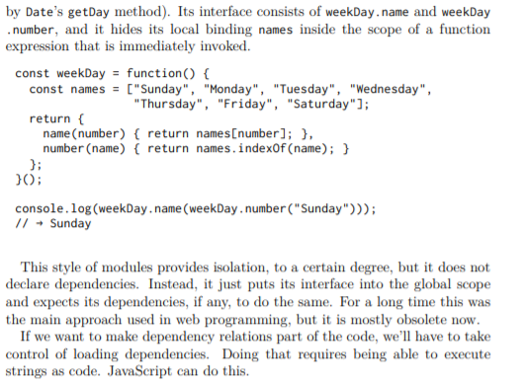

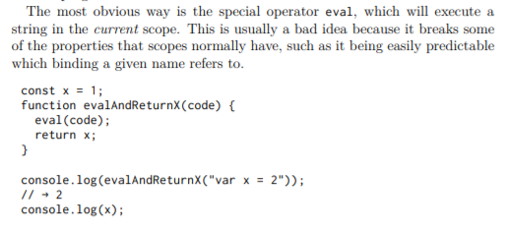

// → 1

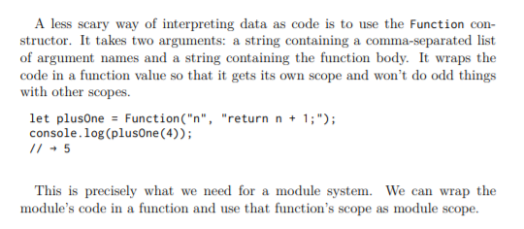

The most widely used approach to bolted-on JavaScript modules is called CommonJS modules. Node.js uses it and is the system used by most packages on NPM

The main concept in CommonJS modules is a function called require. When you call this with the module name of a dependency, it makes sure the module is loaded and returns its interface

All they have to do is call require to access their dependencies and put their interface in the object bound to exports.

This example module provides a date-formatting function. It uses two packages from NPM—ordinal to convert numbers to strings like "1st" and "2nd", and date-names to get the English names for weekdays and months. It exports a single function, formatDate, which takes a Date object and a template string.

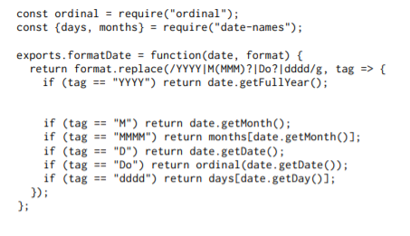

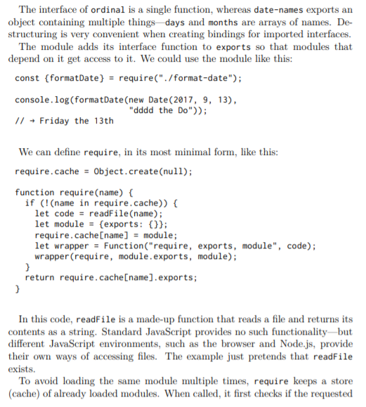

A quirk of the CommonJS modules is that, bien que the module system will create an empty interface object for you (bound to exports), you can replace that with any value by overwriting module.exports. This is done by many modules to export a single value instead of an interface object.
By defining require, exports, and module as parameters for the generated wrapper function (and passing the appropriate values when calling it), the loader makes sure that these bindings are available in the module’s scope.

The way the string given to require is translated to an actual filename or web address differs in different systems. When it starts with "./" or "../", it is generally interpreted as relative to the current module’s filename. So "./ format-date" would be the file named format-date.js in the same directory.

. The notation is slightly awkward— the things you add to exports are not available in the local scope, for example. And because require is a normal function call taking any kind of argument, not just a string literal, it can be hard to determine the dependencies of a module without running its code.

This is why the JavaScript standard from 2015 introduces its own, different module system. It is usually called ES modules, where ES stands for ECMAScript. The main concepts of dependencies and interfaces remain the same, but the details differ. For one thing, the notation is now integrated into the language. Instead of calling a function to access a dependency, you use a special import keyword.

COMPRENDS PAS :
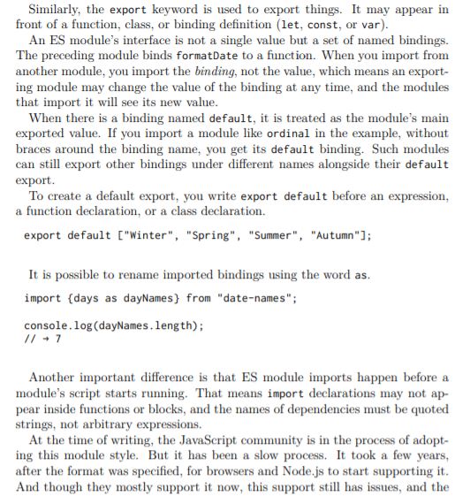
*

discussion on how such modules should be distributed through NPM is still ongoing. Many projects are written using ES modules and then automatically converted to some other format when published. We are in a transitional period in which two different module systems are used side by side, and it is useful to be able to read and write code in either of them.

To make this possible, they compile their code, translating it from their chosen JavaScript dialect to plain old JavaScript—or even to a past version of JavaScript—so that old browsers can run it.

Because fetching a single big file tends to be faster than fetching a lot of tiny ones, web programmers have started using tools that roll their programs (which they painstakingly split into modules) back into a single big file before they publish it to the Web. Such tools are called bundlers.

These are tools that take a JavaScript program and make it smaller by automatically removing comments and whitespace, renaming bindings, and replacing pieces of code with equivalent code that take up less space.

In a synchronous programming model, things happen one at a time. When you call a function that performs a long-running action, it returns only when the action has finished and it can return the result. This stops your program for the time the action takes.

An asynchronous model allows multiple things to happen at the same time. When you start an action, your program continues to run. When the action finishes, the program is informed and gets access to the result (for example, the data read from disk)

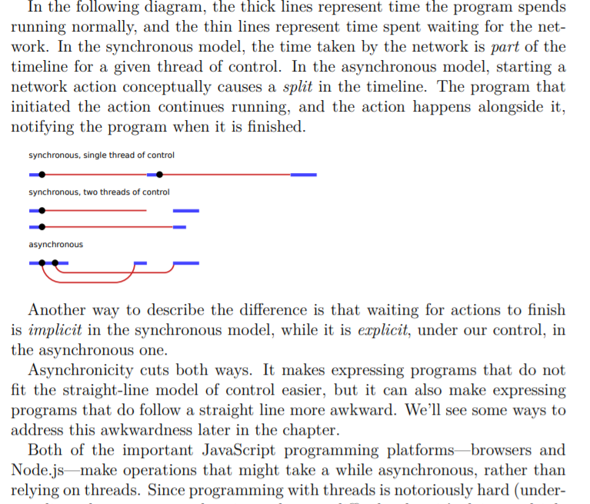

One approach to asynchronous programming is to make functions that perform a slow action take an extra argument, a callback function. The action is started, and when it finishes, the callback function is called with the result.

Performing multiple asynchronous actions in a row using callbacks means that you have to keep passing new functions to handle the continuation of the computation after the actions.

A function doing asynchronous work typically returns before the work is done, having arranged for a callback to be called when it completes. So we need some asynchronous mechanism—in this case, 184 another callback function—to signal when a response is available. In a way, asynchronicity is contagious. Any function that calls a function that works asynchronously must itself be asynchronous, using a callback or similar mechanism to deliver its result.

This is what the standard class Promise is for. A promise is an asynchronous action that may complete at some point and produce a value. It is able to notify anyone who is interested when its value is available

The easiest way to create a promise is by calling Promise.resolve. This function ensures that the value you give it is wrapped in a promise. If it’s already a promise, it is simply returned—otherwise, you get a new promise that immediately finishes with your value as its result.

To get the result of a promise, you can use its then method. This registers a callback function to be called when the promise resolves and produces a value. You can add multiple callbacks to a single promise, and they will be called, even if you add them after the promise has already resolved (finished).

But that’s not all the then method does. It returns another promise, which resolves to the value that the handler function returns or, if that returns a promise, waits for that promise and then resolves to its result.

A promised value is a value that might already be there or might appear at some point in the future. Computations defined in terms of promises act on such wrapped values and are executed asynchronously as the values become available.

To create a promise, you can use Promise as a constructor. It has a somewhat odd interface—the constructor expects a function as argument, which it the code that created the promise can resolve it.

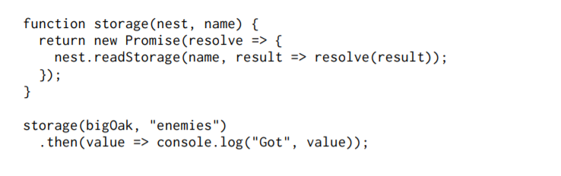

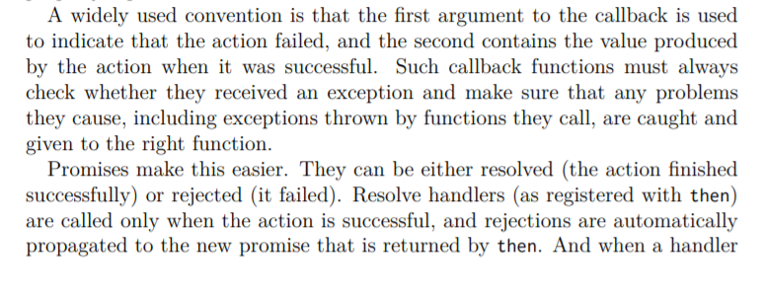
And when a handler throws an exception, this automatically causes the promise produced by its then call to be rejected. So if any element in a chain of asynchronous actions fails, the outcome of the whole chain is marked as rejected, and no success handlers are called beyond the point where it failed.

Much like resolving a promise provides a value, rejecting one also provides one, usually called the reason of the rejection. When an exception in a handler function causes the rejection, the exception value is used as the reason. Similarly, when a handler returns a promise that is rejected, that rejection flows into the next promise. There’s a Promise.reject function that creates a new, immediately rejected promise. To explicitly handle such rejections, promises have a catch method that registers a handler to be called when the promise is rejected, similar to how then handlers handle normal resolution. It’s also very much like then in that it returns a new promise, which resolves to the original promise’s value if it resolves normally and to the result of the catch handler otherwise. If a catch handler throws an error, the new promise is also rejected.

As a shorthand, then also accepts a rejection handler as a second argument, so you can install both types of handlers in a single method call. A function passed to the Promise constructor receives a second argument, alongside the resolve function, which it can use to reject the new promise. The chains of promise values created by calls to then and catch can be seen as a pipeline through which asynchronous values or failures move

Handlers that don’t match the type of outcome (success or failure) are ignored. But those that do match are called, and their outcome determines what kind of value comes next—success when it returns a non-promise value, rejection when it throws an exception, and the outcome of a promise when it returns one of those.

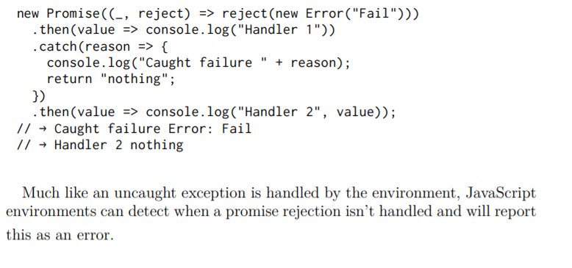

As it is, that will just cause the callback given to send to never be called, which will probably cause the program to stop without even noticing there is a problem. It would be nice if, after a given period of not getting a response, a request would time out and report failure.

To support this, send and defineRequestType follow the convention mentioned before, where the first argument passed to callbacks is the failure reason, if any, and the second is the actual result. These can be translated to promise resolution and rejection by our wrapper.

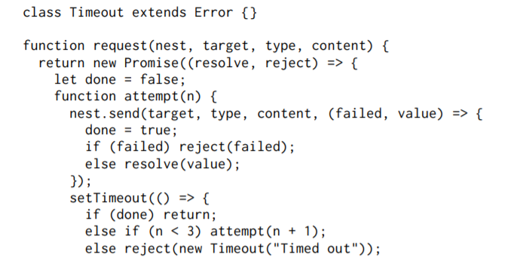
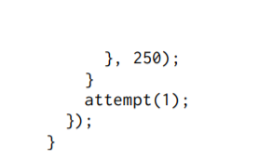

To build an asynchronous loop, for the retries, we need to use a recursive function—a regular loop doesn’t allow us to stop and wait for an asynchronous action. The attempt function makes a single attempt to send a request. It also sets a timeout that, if no response has come back after 250 milliseconds, either starts the next attempt or, if this was the third attempt, rejects the promise with an instance of Timeout as the reason.

DefineRequestType et
Pour nous isoler complètement des callbacks , we’ll go ahead and also define a wrapper for defineRequestType that allows the handler function to return a promise or plain value and wires that up to the callback for us.

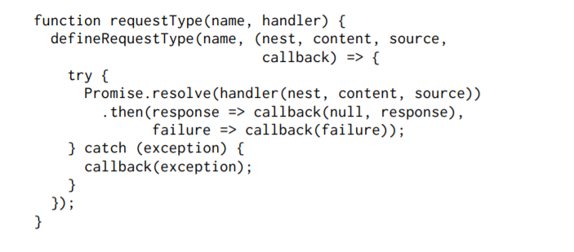
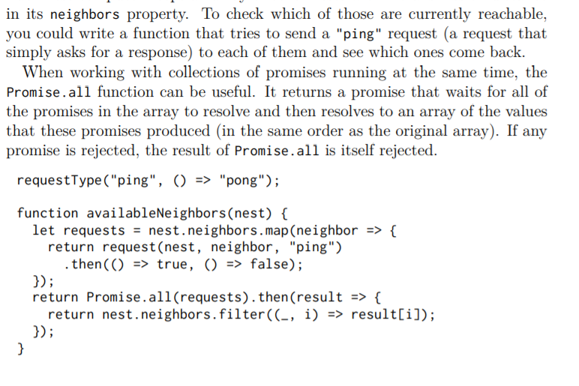
When a neighbor isn’t available, we don’t want the entire combined promise to fail since then we still wouldn’t know anything. So the function that is mapped over the set of neighbors to turn them into request promises attaches handlers that make successful requests produce true and rejected ones produce false. In the handler for the combined promise, filter is used to remove those elements from the neighbors array whose corresponding value is false. This makes use of the fact that filter passes the array index of the current element 190 as a second argument to its filtering function (map, some, and similar higherorder array methods do the same).

