Top level function is a term that describes writing program code outside of sub or function. There are various levels from declaring stuff to actually running program code like vbs/jscript.

So first, let’s see how we attach a script to a webpage. For server-side environments (like Node.js), you can execute the script with a command like "node my.js".

JavaScript programs can be inserted into any part of an HTML document with the help of the <script> tag.

The old HTML standard, HTML4, required a script to have a type. Usually it was type="text/javascript". It’s not required anymore.

The language attribute: <script language=…>

This attribute was meant to show the language of the script. This attribute no longer makes sense because JavaScript is the default language. There is no need to use it

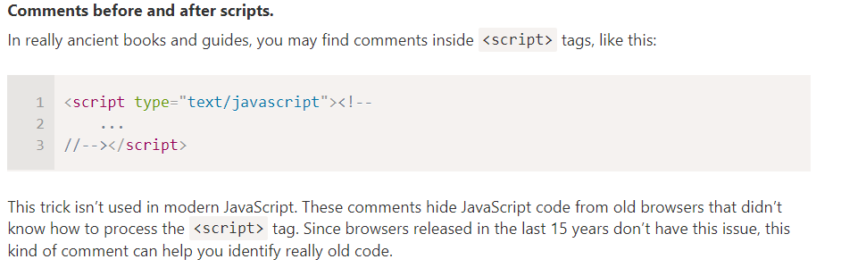

If we have a lot of JavaScript code, we can put it into a separate file.
Script files are attached to HTML with the src attribute:
<script src="/path/to/script.js"></script>

Here, /path/to/script.js is an absolute path to the script from the site root. One can also provide a relative path from the current page. For instance, src="script.js" would mean a file "script.js" in the current folder.
We can give a full URL as well. For instance:

<script src="/path/to/script.js"></script>
<script src="https://cdnjs.cloudflare.com/ajax/libs/lodash.js/4.17.11/lodash.js"></script>

To attach several scripts, use multiple tags:
<script src="/js/script1.js"></script>
<script src="/js/script2.js"></script>

As a rule, only the simplest scripts are put into HTML. More complex ones reside in separate files.
The benefit of a separate file is that the browser will download it and store it in its cache.
Other pages that reference the same script will take it from the cache instead of downloading it, so the file is actually downloaded only once.

If src is set, the script content is ignored.
<script src="file.js">
alert(1); // the content is ignored, because src is set
</script>

A semicolon may be omitted in most cases when a line break exists.
This would also work:
alert('Hello')
alert('World')

Here, JavaScript interprets the line break as an “implicit” semicolon. This is called an automatic semicolon insertion.

There are cases when a newline does not mean a semicolon. For example:

alert(3 +
1
+ 2);

Des fois marche pas mais balek mets des semi colon

To keep the old code working, most such modifications are off by default. You need to explicitly enable them with a special directive: "use strict".

Quite soon we’re going to learn functions (a way to group commands), so let’s note in advance that "use strict" can be put at the beginning of a function. Doing that enables strict mode in that function only. But usually people use it for the whole script.

The directive looks like a string: "use strict" or 'use strict'. When it is located at the top of a script, the whole script works the “modern” way.

Only comments may appear above "use strict".

When you use a developer console to run code, please note that it doesn’t use strict by default.
Sometimes, when use strict makes a difference, you’ll get incorrect results.

First, you can try to press Shift+Enter to input multiple lines, and put use strict on top, like this:
'use strict'; <Shift+Enter for a newline>
// ...your code
<Enter to run>
It works in most browsers, namely Firefox and Chrome.

If it doesn’t, e.g. in an old browser, there’s an ugly, but reliable way to ensure use strict. Put it inside this kind of wrapper:
(function() {
'use strict';

// ...your code here...
})()

Some people also define multiple variables in this multiline style:
let user = 'John',
age = 25,
message = 'Hello';

There are two limitations on variable names in JavaScript:
- The name must contain only letters, digits, or the symbols $ and _.
- The first character must not be a digit.
An assignment without use strict
Normally, we need to define a variable before using it. But in the old times, it was technically possible to create a variable by a mere assignment of the value without using let. This still works now if we don’t put use strict in our scripts to maintain compatibility with old scripts.
// note: no "use strict" in this example

num = 5; // the variable "num" is created if it didn't exist

alert(num); // 5

macro = const + caps lock avec underscore

In JavaScript, the “number” type cannot represent integer values larger than (253-1) (that’s 9007199254740991), or less than -(-253-1) for negatives. It’s a technical limitation caused by their internal representation.

BigInt type was recently added to the language to represent integers of arbitrary length.

A BigInt value is created by appending n to the end of an integer:
// the "n" at the end means it's a BigInt
const bigInt = 1234567890123456789012345678901234567890n;

Right now BigInt is supported in Firefox/Chrome/Edge, but not in Safari/IE.

A string in JavaScript must be surrounded by quotes.
let str = "Hello";
let str2 = 'Single quotes are ok too';
let phrase = `can embed another ${str}`;
In JavaScript, there are 3 types of quotes.
- Double quotes: "Hello".
- Single quotes: 'Hello'.
- Backticks: `Hello`.
Double and single quotes are “simple” quotes. There’s practically no difference between them in JavaScript.
Backticks are “extended functionality” quotes. They allow us to embed variables and expressions into a string by wrapping them in ${…}, for example:

Backticks are “extended functionality” quotes. They allow us to embed variables and expressions into a string by wrapping them in ${…}, for example:

let name = "John";

// embed a variable
alert( `Hello, ${name}!` ); // Hello, John!

// embed an expression
alert( `the result is ${1 + 2}` ); // the result is 3
The expression inside ${…} is evaluated and the result becomes a part of the string. We can put anything in there: a variable like name or an arithmetical expression like 1 + 2 or something more complex.
Please note that this can only be done in backticks. Other quotes don’t have this embedding functionality!
alert( "the result is ${1 + 2}" ); // the result is ${1 + 2} (double quotes do nothing)

In JavaScript, there is no such type. There’s only one type: string. A string may consist of only one character or many of them.

In JavaScript, null is not a “reference to a non-existing object” or a “null pointer” like in some other languages.
It’s just a special value which represents “nothing”, “empty” or “value unknown”.
The code above states that age is unknown.

All other types are called “primitive” because their values can contain only a single thing (be it a string or a number or whatever). In contrast, objects are used to store collections of data and more complex entities.

The typeof operator returns the type of the argument. It’s useful when we want to process values of different types differently or just want to do a quick check.
It supports two forms of syntax:
- As an operator: typeof x.
- As a function: typeof(x).
In other words, it works with parentheses or without them. The result is the same.
The call to typeof x returns a string with the type name:

typeof undefined // "undefined"

typeof 0 // "number"

typeof 10n // "bigint"

typeof true // "boolean"

typeof "foo" // "string"

typeof Symbol("id") // "symbol"

typeof Math // "object" (1)

typeof null // "object" (2)

typeof alert // "function" (3)

alert("Hello");
The mini-window with the message is called a modal window. The word “modal” means that the visitor can’t interact with the rest of the page, press other buttons, etc, until they have dealt with the window. In this case – until they press “OK”.

The function prompt accepts two arguments:
result = prompt(title, [default]);
It shows a modal window with a text message, an input field for the visitor, and the buttons OK/Cancel.
title
The text to show the visitor.
default
An optional second parameter, the initial value for the input field.
The square brackets in syntax [...]
The square brackets around default in the syntax above denote that the parameter as optional, not required.
he visitor can type something in the prompt input field and press OK. Then we get that text in the result. Or they can cancel the input by pressing Cancel or hitting the Esc key, then we get null as the result.
The call to prompt returns the text from the input field or null if the input was canceled.
For instance:
let age = prompt('How old are you?', 100);

alert(`You are ${age} years old!`); // You are 100 years old!

The second parameter is optional, but if we don’t supply it, Internet Explorer will insert the text "undefined" into the prompt.

The syntax:
result = confirm(question);
The function confirm shows a modal window with a question and two buttons: OK and Cancel.
The result is true if OK is pressed and false otherwise.

For example, alert automatically converts any value to a string to show it. Mathematical operations convert values to numbers.

alert( "6" / "2" ); // 3, strings are converted to numbers

Explicit conversion is usually required when we read a value from a string-based source like a text form but expect a number to be entered.
If the string is not a valid number, the result of such a conversion is NaN. For instance:
let age = Number("an arbitrary string instead of a number");

alert(age); // NaN, conversion failed

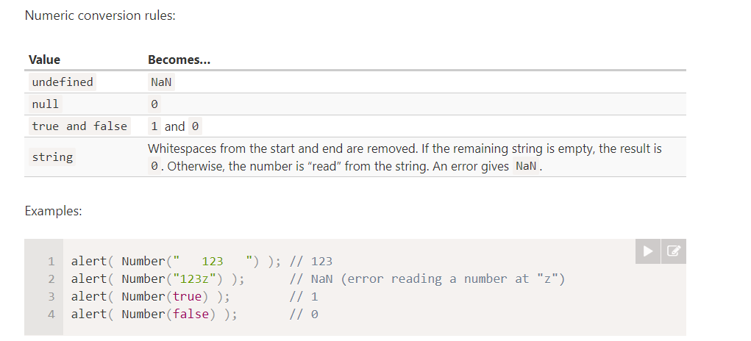

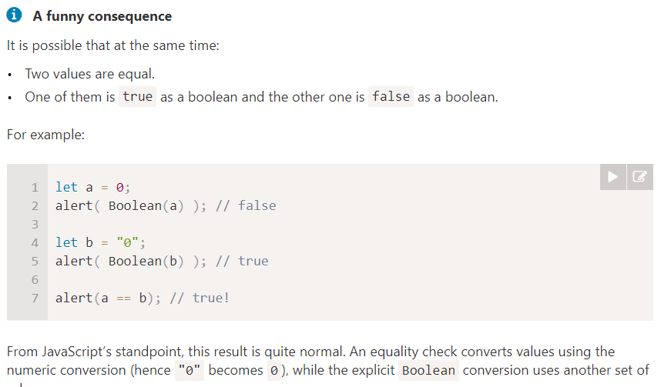

A strict equality operator === checks the equality without type conversion.

Comparison with null and undefined
There’s a non-intuitive behavior when null or undefined are compared to other values.
For a strict equality check ===
These values are different, because each of them is a different type.
alert( null === undefined ); // false
For a non-strict check ==
There’s a special rule. These two are a “sweet couple”: they equal each other (in the sense of ==), but not any other value.
alert( null == undefined ); // true
For maths and other comparisons < > <= >=
null/undefined are converted to numbers: null becomes 0, while undefined becomes NaN.
Now let’s see some funny things that happen when we apply these rules. And, what’s more important, how to not fall into a trap with them.

Strange result: null vs 0
Let’s compare null with a zero:

alert( null > 0 ); // (1) false
alert( null == 0 ); // (2) false
alert( null >= 0 ); // (3) true

Mathematically, that’s strange. The last result states that "null is greater than or equal to zero", so in one of the comparisons above it must be true, but they are both false.
The reason is that an equality check == and comparisons > < >= <= work differently. Comparisons convert null to a number, treating it as 0. That’s why (3) null >= 0 is true and (1) null > 0 is false.
On the other hand, the equality check == for undefined and null is defined such that, without any conversions, they equal each other and don’t equal anything else. That’s why (2) null == 0 is false.

An incomparable undefined
The value undefined shouldn’t be compared to other values:
alert( undefined > 0 ); // false (1)
alert( undefined < 0 ); // false (2)
alert( undefined == 0 ); // false (3)
Why does it dislike zero so much? Always false!
We get these results because:
- Comparisons (1) and (2) return false because undefined gets converted to NaN and NaN is a special numeric value which returns false for all comparisons.
- The equality check (3) returns false because undefined only equals null, undefined, and no other value.

The purpose of the question mark operator ? is to return one value or another depending on its condition. Please use it for exactly that. Use if when you need to execute different branches of code.

The result of a ?? b is:
- a if it’s not null or undefined,
- b, otherwise.
So, x = a ?? b is a short equivalent to:

|| returns the first truthy value.
- ?? returns the first defined value.

Please note that syntax constructs that are not expressions cannot be used with the ternary operator ?. In particular, directives such as break/continue aren’t allowed there.

(i > 5) ? alert(i) : continue; // continue isn't allowed here

The ordinary break after input would only break the inner loop. That’s not sufficient–labels, come to the rescue!
A label is an identifier with a colon before a loop:
labelName: for (...) {
...
}
The break <labelName> statement in the loop below breaks out to the label:
outer: for (let i = 0; i < 3; i++) {

for (let j = 0; j < 3; j++) {

let input = prompt(`Value at coords (${i},${j})`, '');

// if an empty string or canceled, then break out of both loops
if (!input) break outer; // (*)

// do something with the value...
}
}
alert('Done!');
In the code above, break outer looks upwards for the label named outer and breaks out of that loop.
So the control goes straight from (*) to alert('Done!').
We can also move the label onto a separate line:
outer:
for (let i = 0; i < 3; i++) { ... }
The continue directive can also be used with a label. In this case, code execution jumps to the next iteration of the labeled loop.
Labels do not allow to “jump” anywhere
Labels do not allow us to jump into an arbitrary place in the code.
For example, it is impossible to do this:
break label; // doesn't jumps to the label below

label: for (...)
A call to break/continue is only possible from inside a loop and the label must be somewhere above the directive.
Several variants of case which share the same code can be grouped.
For example, if we want the same code to run for case 3 and case 5:

let a = 3;

switch (a) {
case 4:
alert('Right!');
break;

case 3: // (*) grouped two cases
case 5:
alert('Wrong!');
alert("Why don't you take a math class?");
break;

default:
alert('The result is strange. Really.');
}

Let’s emphasize that the equality check is always strict. The values must be of the same type to match.
Pas switch avec case « lol » : puis derriere case 3 :

If a parameter is not provided, then its value becomes undefined.
For instance, the aforementioned function showMessage(from, text) can be called with a single argument:
showMessage("Ann");
That’s not an error. Such a call would output "Ann: undefined". There’s no text, so it’s assumed that text === undefined

That doesn’t work, because JavaScript assumes a semicolon after return. That’ll work the same as:
return;
(some + long + expression + or + whatever * f(a) + f(b))
So, it effectively becomes an empty return.
If we want the returned expression to wrap across multiple lines, we should start it at the same line as return. Or at least put the opening parentheses there as follows:
return (
some + long + expression
+ or +
whatever * f(a) + f(b)
)

The syntax that we used before is called a Function Declaration:
function sayHi() {
alert( "Hello" );
}
There is another syntax for creating a function that is called a Function Expression.
It looks like this:
let sayHi = function() {
alert( "Hello" );
};
Here, the function is created and assigned to the variable explicitly, like any other value. No matter how the function is defined, it’s just a value stored in the variable sayHi.
The meaning of these code samples is the same: "create a function and put it into the variable sayHi".

function sayHi() { // (1) create
alert( "Hello" );
}

let func = sayHi; // (2) copy

func(); // Hello // (3) run the copy (it works)!
sayHi(); // Hello // this still works too (why wouldn't it)

The arguments showOk and showCancel of ask are called callback functions or just callbacks.
The idea is that we pass a function and expect it to be “called back” later if necessary. In our case, showOk becomes the callback for “yes” answer, and showCancel for “no” answer.

function ask(question, yes, no) {
if (confirm(question)) yes()
else no();
}

ask(
"Do you agree?",
function() { alert("You agreed."); },
function() { alert("You canceled the execution."); }
);

Function Declaration: a function, declared as a separate statement, in the main code flow.
// Function Declaration
function sum(a, b) {
return a + b;
}
- Function Expression: a function, created inside an expression or inside another syntax construct. Here, the function is created at the right side of the “assignment expression” =:
// Function Expression
let sum = function(a, b) {
return a + b;
};

A Function Expression is created when the execution reaches it and is usable only from that moment.

A Function Declaration can be called earlier than it is defined.
For example, a global Function Declaration is visible in the whole script, no matter where it is.

It’s called “arrow functions”, because it looks like this:
let func = (arg1, arg2, ...argN) => expression
…This creates a function func that accepts arguments arg1..argN, then evaluates the expression on the right side with their use and returns its result.
In other words, it’s the shorter version of:
let func = function(arg1, arg2, ...argN) {
return expression;
};

The “switch” construct can replace multiple if checks. It uses === (strict equality) for comparisons.
An object can be created with figure brackets {…} with an optional list of properties. A property is a “key: value” pair, where key is a string (also called a “property name”), and value can be anything.

let user = new Object(); // "object constructor" syntax
let user = {}; // "object literal" syntax

We can immediately put some properties into {...} as “key: value” pairs:
let user = { // an object
name: "John", // by key "name" store value "John"
age: 30 // by key "age" store value 30
};
A property has a key (also known as “name” or “identifier”) before the colon ":" and a value to the right of it.

Let’s add a boolean one:
user.isAdmin = true;

To remove a property, we can use delete operator:
delete user.age;

We can also use multiword property names, but then they must be quoted:
let user = {
name: "John",
age: 30,
"likes birds": true // multiword property name must be quoted
};

The last property in the list may end with a comma:

let user = {
name: "John",
age: 30,
}
That is called a “trailing” or “hanging” comma. Makes it easier to add/remove/move around properties, because all lines become alike

Please note: an object declared as const can be modified.
For instance:

const user = {
name: "John"
};

user.name = "Pete"; // (*)

alert(user.name); // Pete
It might seem that the line (*) would cause an error, but no. The const fixes the value of user, but not its contents.
The const would give an error only if we try to set user=... as a whole.

For multiword properties, the dot access doesn’t work:
// this would give a syntax error
user.likes birds = true

user["likes birds"] = true;
let key = prompt("What do you want to know about the user?", "name");

// access by variable
alert( user[key] ); // John (if enter "name")

The dot notation cannot be used in a similar way:
let user = {
name: "John",
age: 30
};

let key = "name";
alert( user.key ) // undefined

We can use square brackets in an object literal, when creating an object. That’s called computed properties.
For instance:

let fruit = prompt("Which fruit to buy?", "apple");

let bag = {
[fruit]: 5, // the name of the property is taken from the variable fruit
};

alert( bag.apple ); // 5 if fruit="apple"
The meaning of a computed property is simple: [fruit] means that the property name should be taken from fruit.
So, if a visitor enters "apple", bag will become {apple: 5}.
Essentially, that works the same as:
let fruit = prompt("Which fruit to buy?", "apple");
let bag = {};

// take property name from the fruit variable
bag[fruit] = 5;
…But looks nicer.
We can use more complex expressions inside square brackets:
let fruit = 'apple';
let bag = {
[fruit + 'Computers']: 5 // bag.appleComputers = 5
};
Square brackets are much more powerful than the dot notation. They allow any property names and variables. But they are also more cumbersome to write.

function makeUser(name, age) {
return {
name: name,
age: age,
// ...other properties
};
}

let user = makeUser("John", 30);
alert(user.name); // John

function makeUser(name, age) {
return {
name, // same as name: name
age, // same as age: age
// ...
};
}

let user = {
name, // same as name:name
age: 30
};

As we already know, a variable cannot have a name equal to one of language-reserved words like “for”, “let”, “return” etc.
But for an object property, there’s no such restriction:
// these properties are all right
let obj = {
for: 1,
let: 2,
return: 3
};

alert( obj.for + obj.let + obj.return ); // 6

For instance, a number 0 becomes a string "0" when used as a property key:
let obj = {
0: "test" // same as "0": "test"
};

// both alerts access the same property (the number 0 is converted to string "0")
alert( obj["0"] ); // test
alert( obj[0] ); // test (same property)

let user = {};

alert( user.noSuchProperty === undefined ); // true means "no such property"
There’s also a special operator "in" for that.
The syntax is:
"key" in object
For instance:
let user = { name: "John", age: 30 };

alert( "age" in user ); // true, user.age exists
alert( "blabla" in user ); // false, user.blabla doesn't exist

let user = { age: 30 };

let key = "age";
alert( key in user ); // true, property "age" exists

Why does the in operator exist? Isn’t it enough to compare against undefined?
Well, most of the time the comparison with undefined works fine. But there’s a special case when it fails, but "in" works correctly.
It’s when an object property exists, but stores undefined:
let obj = {
test: undefined
};

alert( obj.test ); // it's undefined, so - no such property?

alert( "test" in obj ); // true, the property does exist!

For instance, let’s output all properties of user:
let user = {
name: "John",
age: 30,
isAdmin: true
};

for (let key in user) {
// keys
alert( key ); // name, age, isAdmin
// values for the keys
alert( user[key] ); // John, 30, true
}

Est ce que les objets sont triés :
The short answer is: “ordered in a special fashion”: integer properties are sorted, others appear in creation order. The details follow.

let codes = {
"49": "Germany",
"41": "Switzerland",
"44": "Great Britain",
// ..,
"1": "USA"
};

for (let code in codes) {
alert(code); // 1, 41, 44, 49
}

The “integer property” term here means a string that can be converted to-and-from an integer without a change.
So, “49” is an integer property name, because when it’s transformed to an integer number and back, it’s still the same. But “+49” and “1.2” are not:

So, to fix the issue with the phone codes, we can “cheat” by making the codes non-integer. Adding a plus "+" sign before each code is enough.
Like this:
let codes = {
"+49": "Germany",
"+41": "Switzerland",
"+44": "Great Britain",
// ..,
"+1": "USA"
};

for (let code in codes) {
alert( +code ); // 49, 41, 44, 1
}
Now it works as intended. (ordre creation comme autre)

One of the fundamental differences of objects vs primitives is that they are stored and copied “by reference”.

A variable stores not the object itself, but its “address in memory”, in other words “a reference” to it.

When an object variable is copied – the reference is copied, the object is not duplicated.
For instance:
let user = { name: "John" };

let admin = user; // copy the reference

The equality == and strict equality === operators for objects work exactly the same.
Two objects are equal only if they are the same object.

Pas de copie / clone en javascript donc for in sur l’objet pour copier tous les champs

Also we can use the method Object.assign for that.
The syntax is:
Object.assign(dest, [src1, src2, src3...])
- The first argument dest is a target object.
- Further arguments src1, ..., srcN (can be as many as needed) are source objects.
- It copies the properties of all source objects src1, ..., srcN into the target dest. In other words, properties of all arguments starting from the second are copied into the first object.
- The call returns dest.
For instance, we can use it to merge several objects into one:

let user = { name: "John" };

let permissions1 = { canView: true };
let permissions2 = { canEdit: true };

// copies all properties from permissions1 and permissions2 into user
Object.assign(user, permissions1, permissions2);

// now user = { name: "John", canView: true, canEdit: true }
If the copied property name already exists, it gets overwritten:
let user = { name: "John" };

Object.assign(user, { name: "Pete" });

alert(user.name); // now user = { name: "Pete" }
We also can use Object.assign to replace for..in loop for simple cloning:

let user = {
name: "John",
age: 30
};

let clone = Object.assign({}, user);

let user = {
name: "John",
sizes: {
height: 182,
width: 50
}
};

let clone = Object.assign({}, user);

alert( user.sizes === clone.sizes ); // true, same object

// user and clone share sizes
user.sizes.width++; // change a property from one place
alert(clone.sizes.width); // 51, see the result from the other one

To fix that, we should use the cloning loop that examines each value of user[key] and, if it’s an object, then replicate its structure as well. That is called a “deep cloning”.
There’s a standard algorithm for deep cloning that handles the case above and more complex cases, called the Structured cloning algorithm.
We can use recursion to implement it. Or, not to reinvent the wheel, take an existing implementation, for instance _.cloneDeep(obj) from the JavaScript library lodash.
The main concept of memory management in JavaScript is reachability.
Simply put, “reachable” values are those that are accessible or usable somehow. They are guaranteed to be stored in memory.
- There’s a base set of inherently reachable values, that cannot be deleted for obvious reasons.
For instance:
  - Local variables and parameters of the current function.
  - Variables and parameters for other functions on the current chain of nested calls.
  - Global variables.
  - (there are some other, internal ones as well)
These values are called roots.
- Any other value is considered reachable if it’s reachable from a root by a reference or by a chain of references.
Comme smart ptr piur memoire

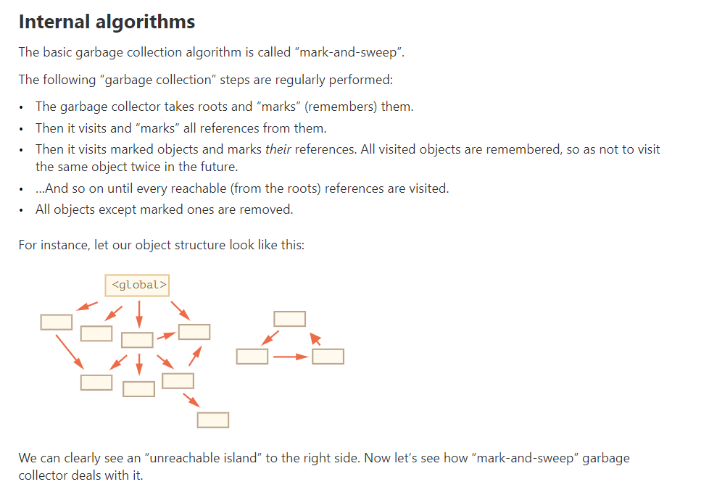

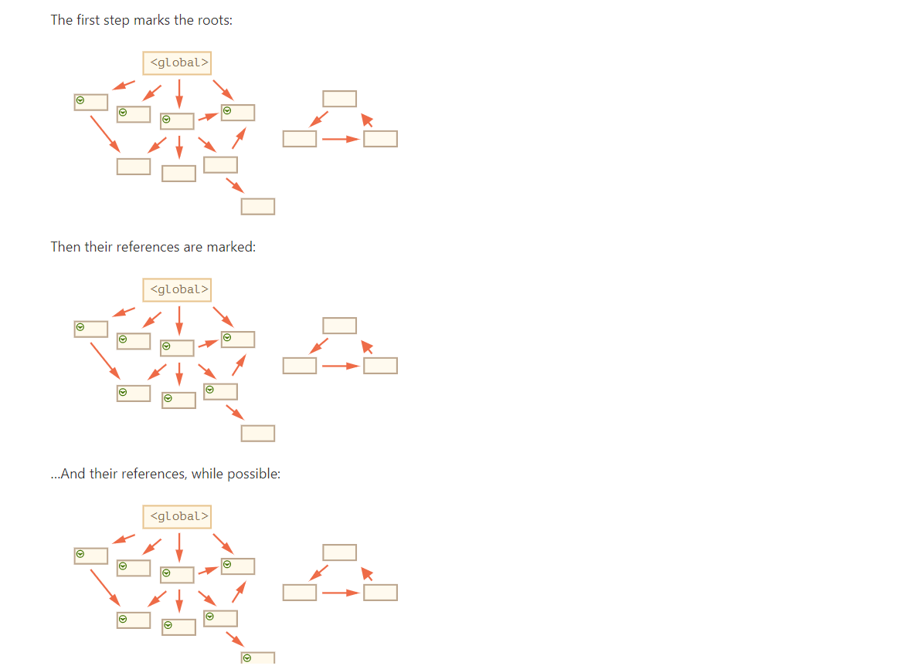
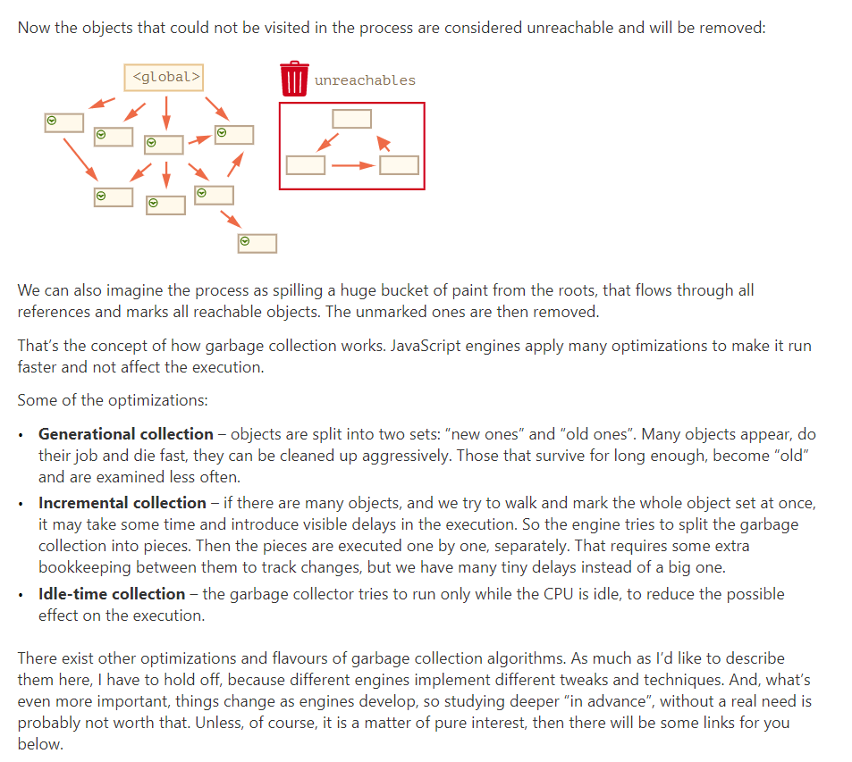

// these objects do the same

user = {
sayHi: function() {
alert("Hello");
}
};

// method shorthand looks better, right?
user = {
sayHi() { // same as "sayHi: function()"
alert("Hello");
}
};
To tell the truth, the notations are not fully identical. There are subtle differences related to object inheritance (to be covered later), but for now they do not matter. In almost all cases the shorter syntax is preferred.
Calling without an object: this == undefined
We can even call the function without an object at all:
function sayHi() {
alert(this);
}

sayHi(); // undefined

In this case this is undefined in strict mode. If we try to access this.name, there will be an error.
In non-strict mode the value of this in such case will be the global object (window in a browser, we’ll get to it later in the chapter Global object). This is a historical behavior that "use strict" fixes.

If you come from another programming language, then you are probably used to the idea of a "bound this", where methods defined in an object always have this referencing that object.
In JavaScript this is “free”, its value is evaluated at call-time and does not depend on where the method was declared, but rather on what object is “before the dot”.
The concept of run-time evaluated this has both pluses and minuses. On the one hand, a function can be reused for different objects. On the other hand, the greater flexibility creates more possibilities for mistakes.

Arrow functions are special: they don’t have their “own” this. If we reference this from such a function, it’s taken from the outer “normal” function.
For instance, here arrow() uses this from the outer user.sayHi() method:
let user = {
firstName: "Ilya",
sayHi() {
let arrow = () => alert(this.firstName);
arrow();
}
};

user.sayHi(); // Ilya

Constructor functions technically are regular functions. There are two conventions though:
- They are named with capital letter first.
- They should be executed only with "new" operator.

When a function is executed with new, it does the following steps:
- A new empty object is created and assigned to this.
- The function body executes. Usually it modifies this, adds new properties to it.
- The value of this is returned.
In other words, new User(...) does something like:

function User(name) {
// this = {}; (implicitly)

// add properties to this
this.name = name;
this.isAdmin = false;

// return this; (implicitly)
}

So let user = new User("Jack") gives the same result as:
let user = {
name: "Jack",
isAdmin: false
};

Let’s note once again – technically, any function can be used as a constructor. That is: any function can be run with new, and it will execute the algorithm above. The “capital letter first” is a common agreement, to make it clear that a function is to be run with new.

Inside a function, we can check whether it was called with new or without it, using a special new.target property.
It is empty for regular calls and equals the function if called with new:

function User() {
alert(new.target);
}

// without "new":
User(); // undefined

// with "new":
new User(); // function User { ... }

That can be used inside the function to know whether it was called with new, “in constructor mode”, or without it, “in regular mode”.
We can also make both new and regular calls to do the same, like this:
function User(name) {
if (!new.target) { // if you run me without new
return new User(name); // ...I will add new for you
}

this.name = name;
}

let john = User("John"); // redirects call to new User
alert(john.name); // John

Usually, constructors do not have a return statement. Their task is to write all necessary stuff into this, and it automatically becomes the result.
But if there is a return statement, then the rule is simple:
- If return is called with an object, then the object is returned instead of this.
- If return is called with a primitive, it’s ignored.
In other words, return with an object returns that object, in all other cases this is returned.

By the way, we can omit parentheses after new, if it has no arguments:
let user = new User; // <-- no parentheses
// same as
let user = new User();

Using constructor functions to create objects gives a great deal of flexibility. The constructor function may have parameters that define how to construct the object, and what to put in it.
Of course, we can add to this not only properties, but methods as well.

Before ?. appeared in the language, the && operator was used to work around that.

The optional chaining ?. stops the evaluation and returns undefined if the part before ?. is undefined or null.

Further in this article, for brevity, we’ll be saying that something “exists” if it’s not null and not undefined.
Here’s the safe way to access user.address.street:
let user = {}; // user has no address

alert( user?.address?.street ); // undefined (no error)
Reading the address with user?.address works even if user object doesn’t exist:

The optional chaining ?. is not an operator, but a special syntax construct, that also works with functions and square brackets.
For example, ?.() is used to call a function that may not exist.

let user1 = {
admin() {
alert("I am admin");
}
}

let user2 = {};

user1.admin?.(); // I am admin
user2.admin?.();

Here, in both lines we first use the dot . to get admin property, because the user object must exist, so it’s safe read from it.
Then ?.() checks the left part: if the user exists, then it runs (for user1). Otherwise (for user2) the evaluation stops without errors

alert( user1?.[key] ); // John
alert( user2?.[key] ); // undefined

Also we can use ?. with delete:
delete user?.name; // delete user.name if user exists

A “symbol” represents a unique identifier.
let id = Symbol();

A value of this type can be created using Symbol():
let id = Symbol("id"); // wiht description : « id »

Symbols don’t auto-convert to a string
alert(id); // TypeError: Cannot convert a Symbol value to a string

If we really want to show a symbol, we need to explicitly call .toString() on it, like here:

let id = Symbol("id");
alert(id.toString()); // Symbol(id), now it works
Or get symbol.description property to show the description only:

Symbols allow us to create “hidden” properties of an object, that no other part of code can accidentally access or overwrite.
What’s the benefit of using Symbol("id") over a string "id"?
As user objects belongs to another code, and that code also works with them, we shouldn’t just add any fields to it. That’s unsafe. But a symbol cannot be accessed accidentally, the third-party code probably won’t even see it, so it’s probably all right to do.
Also, imagine that another script wants to have its own identifier inside user, for its own purposes. That may be another JavaScript library, so that the scripts are completely unaware of each other.

If we want to use a symbol in an object literal {...}, we need square brackets around it.
Like this:

let id = Symbol("id");

let user = {
name: "John",
[id]: 123 // not "id: 123"
};

Symbols are skipped by for…in
Symbolic properties do not participate in for..in loop.
let id = Symbol("id");
let user = {
name: "John",
age: 30,
[id]: 123
};

for (let key in user) alert(key); // name, age (no symbols)
// the direct access by the symbol works
alert( "Direct: " + user[id] );

Object.keys(user) also ignores them. That’s a part of the general “hiding symbolic properties” principle. If another script or a library loops over our object, it won’t unexpectedly access a symbolic property.

In contrast, Object.assign copies both string and symbol properties:

As we’ve seen, usually all symbols are different, even if they have the same name. But sometimes we want same-named symbols to be same entities. For instance, different parts of our application want to access symbol "id" meaning exactly the same property.
To achieve that, there exists a global symbol registry. We can create symbols in it and access them later, and it guarantees that repeated accesses by the same name return exactly the same symbol.
In order to read (create if absent) a symbol from the registry, use Symbol.for(key).
That call checks the global registry, and if there’s a symbol described as key, then returns it, otherwise creates a new symbol Symbol(key) and stores it in the registry by the given key.
For instance:
// read from the global registry
let id = Symbol.for("id"); // if the symbol did not exist, it is created

// read it again (maybe from another part of the code)
let idAgain = Symbol.for("id");

// the same symbol
alert( id === idAgain ); // true
Symbols inside the registry are called global symbols. If we want an application-wide symbol, accessible everywhere in the code – that’s what they are for.

For global symbols, not only Symbol.for(key) returns a symbol by name, but there’s a reverse call: Symbol.keyFor(sym), that does the reverse: returns a name by a global symbol.

// get symbol by name
let sym = Symbol.for("name");
let sym2 = Symbol.for("id");

// get name by symbol
alert( Symbol.keyFor(sym) ); // name
alert( Symbol.keyFor(sym2) ); // id

The Symbol.keyFor internally uses the global symbol registry to look up the key for the symbol. So it doesn’t work for non-global symbols. If the symbol is not global, it won’t be able to find it and returns undefined.

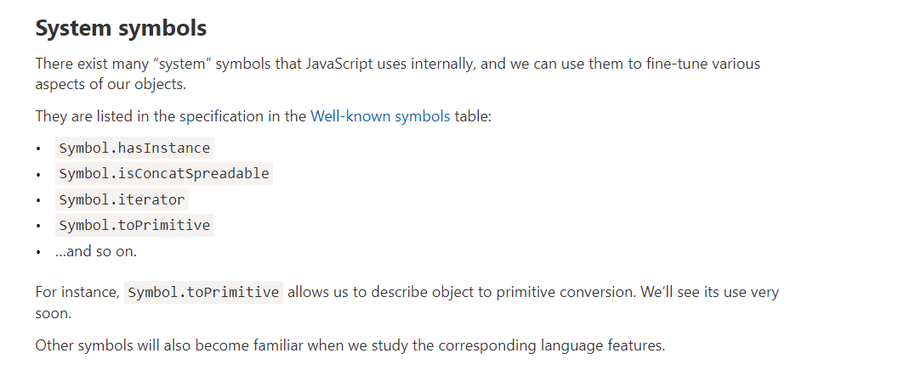

All objects are true in a boolean context. There are only numeric and string conversions.
- The numeric conversion happens when we subtract objects or apply mathematical functions. For instance, Date objects (to be covered in the chapter Date and time) can be subtracted, and the result of date1 - date2 is the time difference between two dates.
- As for the string conversion – it usually happens when we output an object like alert(obj) and in similar contexts.
here are three variants of type conversion, so-called “hints”, described in the specification:
« string «
« number «
"default"
Occurs in rare cases when the operator is “not sure” what type to expect.
For instance, binary plus + can work both with strings (concatenates them) and numbers (adds them), so both strings and numbers would do. So if the a binary plus gets an object as an argument, it uses the "default" hint to convert it.
Also, if an object is compared using == with a string, number or a symbol, it’s also unclear which conversion should be done, so the "default" hint is used.
// binary plus uses the "default" hint
let total = obj1 + obj2;

// obj == number uses the "default" hint
if (user == 1) { ... };
The greater and less comparison operators, such as < >, can work with both strings and numbers too. Still, they use the "number" hint, not "default". That’s for historical reasons.
In practice though, we don’t need to remember these peculiar details, because all built-in objects except for one case (Date object, we’ll learn it later) implement "default" conversion the same way as "number". And we can do the same.

Please note – there are only three hints. It’s that simple.
There is no “boolean” hint (all objects are true in boolean context) or anything else. And if we treat "default" and "number" the same, like most built-ins do, then there are only two conversions.

To do the conversion, JavaScript tries to find and call three object methods:
ll obj[Symbol.toPrimitive](hint) – the method with the symbolic key Symbol.toPrimitive (system symbol), if such method exists,
- Otherwise if hint is "string"
  - try obj.toString() and obj.valueOf(), whatever exists.
- Otherwise if hint is "number" or "default"
  - try obj.valueOf() and obj.toString(), whatever exist

obj[Symbol.toPrimitive] = function(hint) {
// must return a primitive value
// hint = one of "string", "number", "default"
};
For instance, here user object implements it:
let user = {
name: "John",
money: 1000,

[Symbol.toPrimitive](hint) {
alert(`hint: ${hint}`);
return hint == "string" ? `{name: "${this.name}"}` : this.money;
}
};

// conversions demo:
alert(user); // hint: string -> {name: "John"}

Methods toString and valueOf come from ancient times. They are not symbols (symbols did not exist that long ago), but rather “regular” string-named methods. They provide an alternative “old-style” way to implement the conversion.
If there’s no Symbol.toPrimitive then JavaScript tries to find them and try in the order:
- toString -> valueOf for “string” hint.
- valueOf -> toString otherwise.
These methods must return a primitive value. If toString or valueOf returns an object, then it’s ignored (same as if there were no method).
By default, a plain object has following toString and valueOf methods:
- The toString method returns a string "[object Object]".
- The valueOf method returns the object itself.
Here’s the demo:
let user = {name: "John"};

alert(user); // [object Object]
alert(user.valueOf() === user); // true
So if we try to use an object as a string, like in an alert or so, then by default we see [object Object].

And the default valueOf is mentioned here only for the sake of completeness, to avoid any confusion. As you can see, it returns the object itself, and so is ignored. Don’t ask me why, that’s for historical reasons. So we can assume it doesn’t exist.
Let’s implement these methods.
For instance, here user does the same as above using a combination of toString and valueOf instead of Symbol.toPrimitive:
let user = {
name: "John",
money: 1000,

// for hint="string"
toString() {
return `{name: "${this.name}"}`;
},

// for hint="number" or "default"
valueOf() {
return this.money;
}

};

alert(user); // toString -> {name: "John"}
alert(+user); // valueOf -> 1000
alert(user + 500); // valueOf -> 1500
As we can see, the behavior is the same as the previous example with Symbol.toPrimitive.
Often we want a single “catch-all” place to handle all primitive conversions. In this case, we can implement toString only, like this:
let user = {
name: "John",

toString() {
return this.name;
}
};

alert(user); // toString -> John
alert(user + 500); // toString -> John500
In the absence of Symbol.toPrimitive and valueOf, toString will handle all primitive conversions.
For historical reasons, if toString or valueOf returns an object, there’s no error, but such value is ignored (like if the method didn’t exist). That’s because in ancient times there was no good “error” concept in JavaScript.
In contrast, Symbol.toPrimitive must return a primitive, otherwise there will be an error.

Further conversions
As we know already, many operators and functions perform type conversions, e.g. multiplication * converts operands to numbers.
If we pass an object as an argument, then there are two stages:
- The object is converted to a primitive (using the rules described above).
- If the resulting primitive isn’t of the right type, it’s converted.
For instance:
let obj = {
// toString handles all conversions in the absence of other methods
toString() {
return "2";
}
};

alert(obj * 2); // 4, object converted to primitive "2", then multiplication made it a number
- The multiplication obj * 2 first converts the object to primitive (that’s a string "2").
- Then "2" * 2 becomes 2 * 2 (the string is converted to number).
Binary plus will concatenate strings in the same situation, as it gladly accepts a string:
let obj = {
toString() {
return "2";
}
};

alert(obj + 2); // 22 ("2" + 2), conversion to primitive returned a string => concatenat

Now let’s examine how recursive calls work. For that we’ll look under the hood of functions.
The information about the process of execution of a running function is stored in its execution context.
The execution context is an internal data structure that contains details about the execution of a function: where the control flow is now, the current variables, the value of this (we don’t use it here) and few other internal details.
One function call has exactly one execution context associated with it.
When a function makes a nested call, the following happens:
- The current function is paused.
- The execution context associated with it is remembered in a special data structure called execution context stack.
- The nested call executes.
- After it ends, the old execution context is retrieved from the stack, and the outer function is resumed from where it stopped.

The current context is “remembered” on top of the stack.
- The new context is created for the subcall.
- When the subcall is finished – the previous context is popped from the stack, and its execution continues.

A recursively-defined data structure is a data structure that can be defined using itself.

PRIMITIVE TYPE CHAPTER

We can choose to get the first parameters as variables, and gather only the rest.
Here the first two arguments go into variables and the rest go into titles array:
function showName(firstName, lastName, ...titles) {
alert( firstName + ' ' + lastName ); // Julius Caesar

// the rest go into titles array
// i.e. titles = ["Consul", "Imperator"]
alert( titles[0] ); // Consul
alert( titles[1] ); // Imperator
alert( titles.length ); // 2
}

showName("Julius", "Caesar", "Consul", "Imperator");

There is also a special array-like object named arguments that contains all arguments by their index.
For instance:
function showName() {
alert( arguments.length );
alert( arguments[0] );
alert( arguments[1] );

// it's iterable
// for(let arg of arguments) alert(arg);
}

// shows: 2, Julius, Caesar
showName("Julius", "Caesar");

// shows: 1, Ilya, undefined (no second argument)
showName("Ilya");
In old times, rest parameters did not exist in the language, and using arguments was the only way to get all arguments of the function. And it still works, we can find it in the old code.
But the downside is that although arguments is both array-like and iterable, it’s not an array. It does not support array methods, so we can’t call arguments.map(...) for example.
Also, it always contains all arguments. We can’t capture them partially, like we did with rest parameters.
So when we need these features, then rest parameters are preferred.

Arrow functions do not have "arguments"
If we access the arguments object from an arrow function, it takes them from the outer “normal” function.
Here’s an example:
function f() {
let showArg = () => alert(arguments[0]);
showArg();
}

f(1); // 1
As we remember, arrow functions don’t have their own this. Now we know they don’t have the special
arguments object either.

let arr = [3, 5, 1];

alert( Math.max(...arr) ); // 5 (spread turns array into a list of arguments)

Also, the spread syntax can be used to merge arrays:

let arr = [3, 5, 1];
let arr2 = [8, 9, 15];

let merged = [0, ...arr, 2, ...arr2];

alert(merged); // 0,3,5,1,2,8,9,15 (0, then arr, then 2, then arr2)

let str = "Hello";

alert( [...str] ); // H,e,l,l,o

let str = "Hello";

// Array.from converts an iterable into an array
alert( Array.from(str) ); // H,e,l,l,o

But there’s a subtle difference between Array.from(obj) and [...obj]:
- Array.from operates on both array-likes and iterables.
- The spread syntax works only with iterables.
Remember when we talked about Object.assign()
It is possible to do the same thing with the spread syntax.
let arr = [1, 2, 3];
let arrCopy = [...arr]; // spread the array into a list of parameters
// then put the result into a new array

let obj = { a: 1, b: 2, c: 3 };
let objCopy = { ...obj }; // spread the object into a list of parameters
// then return the result in a new object
// do the objects have the same contents?
alert(JSON.stringify(obj) === JSON.stringify(objCopy)); // true

// are the objects equal?
alert(obj === objCopy); // false (not same reference)

//{ /* si on ne veut pas d’erreur mets des scopes pour evtier chevauchement
// show message
let message = "Hello";
alert(message);
//}
// show another message
//{
let message = "Goodbye"; // Error: variable already declared
alert(message);
//}

file:///C:/Users/JUJU/Pictures/Variable%20scope.pdf

“Lexical Environment” is a specification object: it only exists “theoretically” in the language specification to describe how things work. We can’t get this object in our code and manipulate it directly.
JavaScript engines also may optimize it, discard variables that are unused to save memory and perform other internal tricks, as long as the visible behavior remains as described.

Variables, declared with var, are either function-wide or global. They are visible through blocks.
For instance:

if (true) {
var test = true; // use "var" instead of "let"
}

alert(test); // true, the variable lives after if
As var ignores code blocks, we’ve got a global variable test.

The same thing for loops: var cannot be block- or loop-local:

for (var i = 0; i < 10; i++) {
// ...
}

alert(i); // 10, "i" is visible after loop, it's a global variable

If a code block is inside a function, then var becomes a function-level variable:
function sayHi() {
if (true) {
var phrase = "Hello";
}

alert(phrase); // works
}

sayHi();
alert(phrase); // Error: phrase is not defined (Check the Developer Console)

As we can see, var pierces through if, for or other code blocks. That’s because a long time ago in JavaScript blocks had no Lexical Environments. And var is a remnant of that.
var declarations are processed when the function starts (or script starts for globals).

In other words, var variables are defined from the beginning of the function, no matter where the definition is (assuming that the definition is not in the nested function).
So this code:

function sayHi() {
phrase = "Hello";

alert(phrase);

var phrase;
}
sayHi();
…Is technically the same as this (moved var phrase above):
function sayHi() {
var phrase;

phrase = "Hello";

alert(phrase);
}
sayHi();

Or even as this (remember, code blocks are ignored):
function sayHi() {
phrase = "Hello"; // (*)

if (false) {
var phrase;
}

alert(phrase);
}
sayHi();
People also call such behavior “hoisting” (raising), because all var are “hoisted” (raised) to the top of the function.
So in the example above, if (false) branch never executes, but that doesn’t matter. The var inside it is processed in the beginning of the function, so at the moment of (*) the variable exists.

Declarations are hoisted, but assignments are not.
That’s best demonstrated with an example:

The line var phrase = "Hello" has two actions in it:
- Variable declaration var
- Variable assignment =.
The declaration is processed at the start of function execution (“hoisted”), but the assignment always works at the place where it appears. So the code works essentially like this:
Because all var declarations are processed at the function start, we can reference them at any place. But variables are undefined until the assignments.

As in the past there was only var, and it has no block-level visibility, programmers invented a way to emulate it. What they did was called “immediately-invoked function expressions” (abbreviated as IIFE).
That’s not something we should use nowadays, but you can find them in old scripts.
An IIFE looks like this:
(function() {

let message = "Hello";

alert(message); // Hello

})();
Here a Function Expression is created and immediately called. So the code executes right away and has its own private variables.
The Function Expression is wrapped with parenthesis (function {...}), because when JavaScript meets "function" in the main code flow, it understands it as the start of a Function Declaration. But a Function Declaration must have a name, so this kind of code will give an error:
// Try to declare and immediately call a function
function() { // <-- Error: Function statements require a function name

let message = "Hello";

alert(message); // Hello

}();

Even if we say: “okay, let’s add a name”, that won’t work, as JavaScript does not allow Function Declarations to be called immediately:
// syntax error because of parentheses below
function go() {

}(); // <-- can't call Function Declaration immediately
So, the parentheses around the function is a trick to show JavaScript that the function is created in the context of another expression, and hence it’s a Function Expression: it needs no name and can be called immediately.

There exist other ways besides parentheses to tell JavaScript that we mean a Function Expression:
// Ways to create IIFE

(function() {
alert("Parentheses around the function");
})();

(function() {
alert("Parentheses around the whole thing");
}());

!function() {
alert("Bitwise NOT operator starts the expression");
}();

+function() {
alert("Unary plus starts the expression");
}();

The global object provides variables and functions that are available anywhere. By default, those that are built into the language or the environment.
In a browser it is named window, for Node.js it is global, for other environments it may have another name.
Recently, globalThis was added to the language, as a standardized name for a global object, that should be supported across all environments. In some browsers, namely non-Chromium Edge, globalThis is not yet supported, but can be easily polyfilled.
We’ll use window here, assuming that our environment is a browser. If your script may run in other environments, it’s better to use globalThis instead.
All properties of the global object can be accessed directly:
alert("Hello");
// is the same as
window.alert("Hello");
In a browser, global functions and variables declared with var (not let/const!) become the property of the global object:
var gVar = 5;

alert(window.gVar); // 5 (became a property of the global object)
Please don’t rely on that! This behavior exists for compatibility reasons. Modern scripts use JavaScript modules where such thing doesn’t happen.
If we used let instead, such thing wouldn’t happen:
let gLet = 5;

alert(window.gLet); // undefined (doesn't become a property of the global object)
If a value is so important that you’d like to make it available globally, write it directly as a property:

// make current user information global, to let all scripts access it
window.currentUser = {
name: "John"
};

// somewhere else in code
alert(currentUser.name); // John

// or, if we have a local variable with the name "currentUser"
// get it from window explicitly (safe!)
alert(window.currentUser.name); // John
That said, using global variables is generally discouraged. There should be as few global variables as possible. The code design where a function gets “input” variables and produces certain “outcome” is clearer, less prone to errors and easier to test than if it uses outer or global variables.
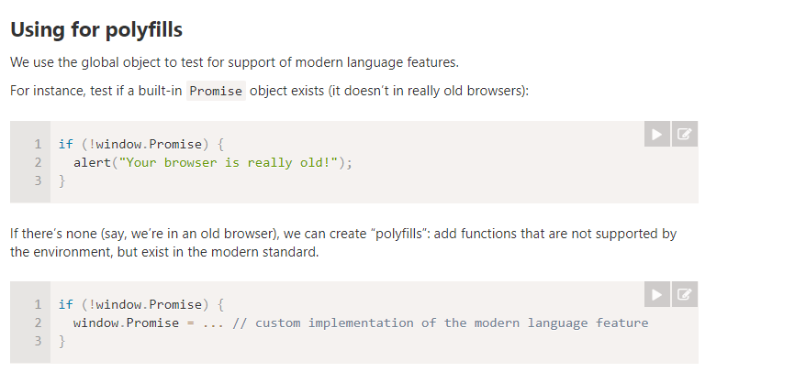

For instance, a function’s name is accessible as the “name” property:
function sayHi() {
alert("Hi");
}

alert(sayHi.name); // sayHi
What’s kind of funny, the name-assigning logic is smart. It also assigns the correct name to a function even if it’s created without one, and then immediately assigned:
let sayHi = function() {
alert("Hi");
};

alert(sayHi.name); // sayHi (there's a name!)
It also works if the assignment is done via a default value:
function f(sayHi = function() {}) {
alert(sayHi.name); // sayHi (works!)
}

f();
In the specification, this feature is called a “contextual name”. If the function does not provide one, then in an assignment it is figured out from the context.
Object methods have names too:
let user = {

sayHi() {
// ...
},

sayBye: function() {
// ...
}

}

alert(user.sayHi.name); // sayHi
alert(user.sayBye.name); // sayBye

There’s no magic though. There are cases when there’s no way to figure out the right name. In that case, the name property is empty, like here:
// function created inside array
let arr = [function() {}];

alert( arr[0].name ); // <empty string>
// the engine has no way to set up the right name, so there is none
In practice, however, most functions do have a name.

There is another built-in property “length” that returns the number of function parameters, for instance:
function f1(a) {}
function f2(a, b) {}
function many(a, b, ...more) {}

alert(f1.length); // 1
alert(f2.length); // 2
alert(many.length); // 2
Here we can see that rest parameters are not counted.

To call handler the right way, we examine the handler.length property.
The idea is that we have a simple, no-arguments handler syntax for positive cases (most frequent variant), but are able to support universal handlers as well:
function ask(question, ...handlers) {
let isYes = confirm(question);

for(let handler of handlers) {
if (handler.length == 0) {
if (isYes) handler();
} else {
handler(isYes);
}
}

}

// for positive answer, both handlers are called
// for negative answer, only the second one
ask("Question?", () => alert('You said yes'), result => alert(result));
This is a particular case of so-called polymorphism – treating arguments differently depending on their type or, in our case depending on the length. The idea does have a use in JavaScript libraries.

We can also add properties of our own.
Here we add the counter property to track the total calls count:

function sayHi() {
alert("Hi");

// let's count how many times we run
sayHi.counter++;
}
sayHi.counter = 0; // initial value

sayHi(); // Hi
sayHi(); // Hi

alert( `Called ${sayHi.counter} times` ); // Called 2 times
A property is not a variable
A property assigned to a function like sayHi.counter = 0 does not define a local variable counter inside it. In other words, a property counter and a variable let counter are two unrelated things.
We can treat a function as an object, store properties in it, but that has no effect on its execution. Variables are not function properties and vice versa. These are just parallel worlds.
Function properties can replace closures sometimes.
function makeCounter() {
// instead of:
// let count = 0

function counter() {
return counter.count++;
};

counter.count = 0;

return counter;
}

let counter = makeCounter();
alert( counter() ); // 0
alert( counter() ); // 1
The count is now stored in the function directly, not in its outer Lexical Environment.
Is it better or worse than using a closure?
The main difference is that if the value of count lives in an outer variable, then external code is unable to access it. Only nested functions may modify it. And if it’s bound to a function, then such a thing is possible:

function makeCounter() {

function counter() {
return counter.count++;
};

counter.count = 0;

return counter;
}

let counter = makeCounter();

counter.count = 10;
alert( counter() ); // 10

So the choice of implementation depends on our aims.

let sayHi = function func(who) {
alert(`Hello, ${who}`);
};
Did we achieve anything here? What’s the purpose of that additional "func" name?
First let’s note, that we still have a Function Expression. Adding the name "func" after function did not make it a Function Declaration, because it is still created as a part of an assignment expression.
Adding such a name also did not break anything.

There are two special things about the name func, that are the reasons for it:
- It allows the function to reference itself internally.
- It is not visible outside of the function.
The “internal name” feature described here is only available for Function Expressions, not for Function Declarations. For Function Declarations, there is no syntax for adding an “internal” name.
Sometimes, when we need a reliable internal name, it’s the reason to rewrite a Function Declaration to Named Function Expression form.

The syntax for creating a function:
let func = new Function ([arg1, arg2, ...argN], functionBody);
The function is created with the arguments arg1...argN and the given functionBody.
It’s easier to understand by looking at an example. Here’s a function with two arguments:
let sum = new Function('a', 'b', 'return a + b');

alert( sum(1, 2) ); // 3
And here there’s a function without arguments, with only the function body:
let sayHi = new Function('alert("Hello")');

sayHi(); // Hello
The major difference from other ways we’ve seen is that the function is created literally from a string, that is passed at run time.
All previous declarations required us, programmers, to write the function code in the script.
But new Function allows to turn any string into a function. For example, we can receive a new function from a server and then execute it:
let str = ... receive the code from a server dynamically ...

let func = new Function(str);
func();
It is used in very specific cases, like when we receive code from a server, or to dynamically compile a function from a template, in complex web-applications.

Usually, a function remembers where it was born in the special property [[Environment]]. It references the Lexical Environment from where it’s created .
But when a function is created using new Function, its [[Environment]] is set to reference not the current Lexical Environment, but the global one.
So, such function doesn’t have access to outer variables, only to the global ones.
function getFunc() {
let value = "test";

let func = new Function('alert(value)');

return func;
}

getFunc()(); // error: value is not defined
Compare it with the regular behavior:

function getFunc() {
let value = "test";

let func = function() { alert(value); };

return func;
}

getFunc()(); // "test", from the Lexical Environment of getFunc
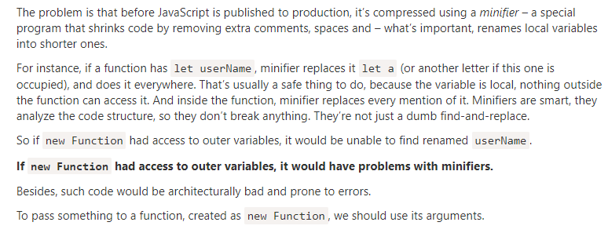
We may decide to execute a function not right now, but at a certain time later. That’s called “scheduling a call”.
There are two methods for it:
- setTimeout allows us to run a function once after the interval of time.
- setInterval allows us to run a function repeatedly, starting after the interval of time, then repeating continuously at that interval.
These methods are not a part of JavaScript specification. But most environments have the internal scheduler and provide these methods. In particular, they are supported in all browsers and Node.js.

The syntax:
let timerId = setTimeout(func|code, [delay], [arg1], [arg2], ...)
Parameters:
func|code
Function or a string of code to execute. Usually, that’s a function. For historical reasons, a string of code can be passed, but that’s not recommended.
delay
The delay before run, in milliseconds (1000 ms = 1 second), by default 0.
arg1, arg2…
Arguments for the function (not supported in IE9-)
For instance, this code calls sayHi() after one second:

function sayHi() {
alert('Hello');
}

setTimeout(sayHi, 1000);
With arguments:

function sayHi(phrase, who) {
alert( phrase + ', ' + who );
}

setTimeout(sayHi, 1000, "Hello", "John"); // Hello, John
If the first argument is a string, then JavaScript creates a function from it.
So, this will also work:
setTimeout("alert('Hello')", 1000);
But using strings is not recommended, use arrow functions instead of them, like this:
setTimeout(() => alert('Hello'), 1000);
Pass a function, but don’t run it
Novice developers sometimes make a mistake by adding brackets () after the function:
// wrong!
setTimeout(sayHi(), 1000);
That doesn’t work, because setTimeout expects a reference to a function. And here sayHi() runs the function, and the result of its execution is passed to setTimeout. In our case the result of sayHi() is undefined (the function returns nothing), so nothing is scheduled.

A call to setTimeout returns a “timer identifier” timerId that we can use to cancel the execution.
The syntax to cancel:
let timerId = setTimeout(...);
clearTimeout(timerId);
In the code below, we schedule the function and then cancel it (changed our mind). As a result, nothing happens:
let timerId = setTimeout(() => alert("never happens"), 1000);
alert(timerId); // timer identifier

clearTimeout(timerId);
alert(timerId); // same identifier (doesn't become null after canceling)
As we can see from alert output, in a browser the timer identifier is a number. In other environments, this can be something else. For instance, Node.js returns a timer object with additional methods.
Again, there is no universal specification for these methods, so that’s fine.
For browsers, timers are described in the timers section of HTML5 standard.

setInterval
The setInterval method has the same syntax as setTimeout:
let timerId = setInterval(func|code, [delay], [arg1], [arg2], ...)
All arguments have the same meaning. But unlike setTimeout it runs the function not only once, but regularly after the given interval of time.
To stop further calls, we should call clearInterval(timerId).
The following example will show the message every 2 seconds. After 5 seconds, the output is stopped:
// repeat with the interval of 2 seconds
let timerId = setInterval(() => alert('tick'), 2000);

// after 5 seconds stop
setTimeout(() => { clearInterval(timerId); alert('stop'); }, 5000);
Time goes on while alert is shown
In most browsers, including Chrome and Firefox the internal timer continues “ticking” while showing alert/confirm/prompt.
So if you run the code above and don’t dismiss the alert window for some time, then in the next alert will be shown immediately as you do it. The actual interval between alerts will be shorter than 2 seconds.

There are two ways of running something regularly.
One is setInterval. The other one is a nested setTimeout, like this:
/** instead of:
let timerId = setInterval(() => alert('tick'), 2000);
*/

let timerId = setTimeout(function tick() {
alert('tick');
timerId = setTimeout(tick, 2000); // (*)
}, 2000);
The setTimeout above schedules the next call right at the end of the current one (*).
The nested setTimeout is a more flexible method than setInterval. This way the next call may be scheduled differently, depending on the results of the current one.
let delay = 5000;

let timerId = setTimeout(function request() {
...send request...

if (request failed due to server overload) {
// increase the interval to the next run
delay *= 2;
}

timerId = setTimeout(request, delay);

}, delay);

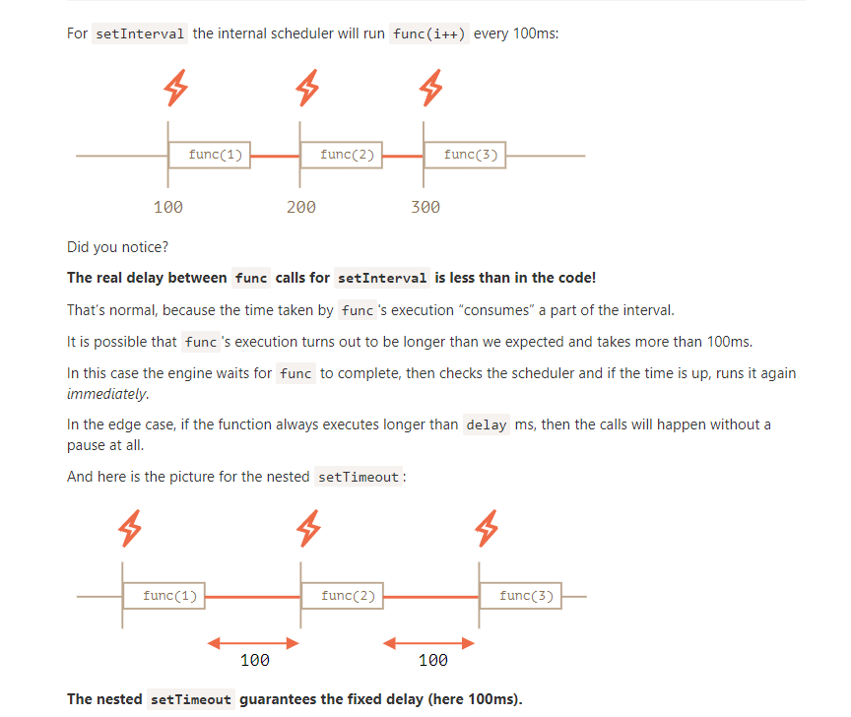
The nested setTimeout guarantees the fixed delay (here 100ms).
That’s because a new call is planned at the end of the previous one

Garbage collection and setInterval/setTimeout callback
When a function is passed in setInterval/setTimeout, an internal reference is created to it and saved in the scheduler. It prevents the function from being garbage collected, even if there are no other references to it.
// the function stays in memory until the scheduler calls it
setTimeout(function() {...}, 100);
For setInterval the function stays in memory until clearInterval is called.
There’s a side-effect. A function references the outer lexical environment, so, while it lives, outer variables live too. They may take much more memory than the function itself. So when we don’t need the scheduled function anymore, it’s better to cancel it, even if it’s very small.
There’s a special use case: setTimeout(func, 0), or just setTimeout(func).
This schedules the execution of func as soon as possible. But the scheduler will invoke it only after the currently executing script is complete.

In the browser, there’s a limitation of how often nested timers can run. The HTML5 standard says: “after five nested timers, the interval is forced to be at least 4 milliseconds.”.
Let’s demonstrate what it means with the example below. The setTimeout call in it re-schedules itself with zero delay. Each call remembers the real time from the previous one in the times array. What do the real delays look like? Let’s see:
let start = Date.now();
let times = [];

setTimeout(function run() {
times.push(Date.now() - start); // remember delay from the previous call

if (start + 100 < Date.now()) alert(times); // show the delays after 100ms
else setTimeout(run); // else re-schedule
});

// an example of the output:
// 1,1,1,1,9,15,20,24,30,35,40,45,50,55,59,64,70,75,80,85,90,95,100
First timers run immediately (just as written in the spec), and then we see 9, 15, 20, 24.... The 4+ ms obligatory delay between invocations comes into play.
The similar thing happens if we use setInterval instead of setTimeout: setInterval(f) runs f few times with zero-delay, and afterwards with 4+ ms delay.
That limitation comes from ancient times and many scripts rely on it, so it exists for historical reasons
For server-side JavaScript, that limitation does not exist, and there exist other ways to schedule an immediate asynchronous job, like setImmediate for Node.js. So this note is browser-specific.

Let’s say we have a function slow(x) which is CPU-heavy, but its results are stable. In other words, for the same x it always returns the same result.
If the function is called often, we may want to cache (remember) the results to avoid spending extra-time on recalculations.
But instead of adding that functionality into slow() we’ll create a wrapper function, that adds caching. As we’ll see, there are many benefits of doing so.
Here’s the code, and explanations follow:
function slow(x) {
// there can be a heavy CPU-intensive job here
alert(`Called with ${x}`);
return x;
}

function cachingDecorator(func) {
let cache = new Map();

return function(x) {
if (cache.has(x)) { // if there's such key in cache
return cache.get(x); // read the result from it
}

let result = func(x); // otherwise call func

cache.set(x, result); // and cache (remember) the result
return result;
};
}

slow = cachingDecorator(slow);

alert( slow(1) ); // slow(1) is cached
alert( "Again: " + slow(1) ); // the same

alert( slow(2) ); // slow(2) is cached
alert( "Again: " + slow(2) ); // the same as the previous line
In the code above cachingDecorator is a decorator: a special function that takes another function and alters its behavior.
The idea is that we can call cachingDecorator for any function, and it will return the caching wrapper. That’s great, because we can have many functions that could use such a feature, and all we need to do is to apply cachingDecorator to them.
By separating caching from the main function code we also keep the main code simpler

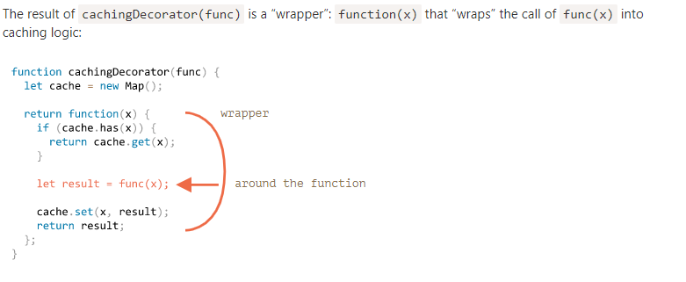

To summarize, there are several benefits of using a separate cachingDecorator instead of altering the code of slow itself:
- The cachingDecorator is reusable. We can apply it to another function.
- The caching logic is separate, it did not increase the complexity of slow itself (if there was any).
- We can combine multiple decorators if needed (other decorators will follow).

Using “func.call” for the context
The caching decorator mentioned above is not suited to work with object methods.
For instance, in the code below worker.slow() stops working after the decoration:

let worker = {
someMethod() {
return 1;
},

slow(x) {
// scary CPU-heavy task here
alert("Called with " + x);
return x * this.someMethod(); // (*)
}
};

// same code as before
function cachingDecorator(func) {
let cache = new Map();
return function(x) {
if (cache.has(x)) {
return cache.get(x);
}
let result = func(x); // (**)
cache.set(x, result);
return result;
};
}
The error occurs in the line (*) that tries to access this.someMethod and fails. Can you see why?
The reason is that the wrapper calls the original function as func(x) in the line (**). And, when called like that, the function gets this = undefined.
We would observe a similar symptom if we tried to run:
let func = worker.slow;
func(2);

In our case, we can use call in the wrapper to pass the context to the original function:

let worker = {
someMethod() {
return 1;
},

slow(x) {
alert("Called with " + x);
return x * this.someMethod(); // (*)
}
};

function cachingDecorator(func) {
let cache = new Map();
return function(x) {
if (cache.has(x)) {
return cache.get(x);
}
let result = func.call(this, x); // "this" is passed correctly now
cache.set(x, result);
return result;
};
}

worker.slow = cachingDecorator(worker.slow); // now make it caching

alert( worker.slow(2) ); // works
alert( worker.slow(2) ); // works, doesn't call the original (cached)

Now everything is fine.
To make it all clear, let’s see more deeply how this is passed along:
- After the decoration worker.slow is now the wrapper function (x) { ... }.
- So when worker.slow(2) is executed, the wrapper gets 2 as an argument and this=worker (it’s the object before dot).
- Inside the wrapper, assuming the result is not yet cached, func.call(this, x) passes the current this (=worker) and the current argument (=2) to the original method.

let worker = {
slow(min, max) {
alert(`Called with ${min},${max}`);
return min + max;
}
};

function cachingDecorator(func, hash) {
let cache = new Map();
return function() {
let key = hash(arguments); // (*)
if (cache.has(key)) {
return cache.get(key);
}

let result = func.call(this, ...arguments); // (**)

cache.set(key, result);
return result;
};
}

function hash(args) {
return args[0] + ',' + args[1];
}

worker.slow = cachingDecorator(worker.slow, hash);

alert( worker.slow(3, 5) ); // works
alert( "Again " + worker.slow(3, 5) ); // same (cached)

Now it works with any number of arguments (though the hash function would also need to be adjusted to allow any number of arguments. An interesting way to handle this will be covered below).
There are two changes:
- In the line (*) it calls hash to create a single key from arguments. Here we use a simple “joining” function that turns arguments (3, 5) into the key "3,5". More complex cases may require other hashing functions.
- Then (**) uses func.call(this, ...arguments) to pass both the context and all arguments the wrapper got (not just the first one) to the original function.

note perso (*) argumetns refere aux arguments de la fonction appelé après
=> worker.slow(3,5) ;

Passing all arguments along with the context to another function is called call forwarding.
That’s the simplest form of it:
let wrapper = function() {
return func.apply(this, arguments);
};
When an external code calls such wrapper, it is indistinguishable from the call of the original function func.

Borrowing a method
Now let’s make one more minor improvement in the hashing function:
function hash(args) {
return args[0] + ',' + args[1];
}
As of now, it works only on two arguments. It would be better if it could glue any number of args.
The natural solution would be to use arr.join method:
function hash(args) {
return args.join();
}
…Unfortunately, that won’t work. Because we are calling hash(arguments), and arguments object is both iterable and array-like, but not a real array.
So calling join on it would fail, as we can see below:

function hash() {
alert( arguments.join() ); // Error: arguments.join is not a function
}

hash(1, 2);
Still, there’s an easy way to use array join:

function hash() {
alert( [].join.call(arguments) ); // 1,2
}

hash(1, 2);
The trick is called method borrowing.
We take (borrow) a join method from a regular array ([].join) and use [].join.call to run it in the context of arguments.
Why does it work?
That’s because the internal algorithm of the native method arr.join(glue) is very simple.
Taken from the specification almost “as-is”:
- Let glue be the first argument or, if no arguments, then a comma ",".
- Let result be an empty string.
- Append this[0] to result.
- Append glue and this[1].
- Append glue and this[2].
- …Do so until this.length items are glued.
- Return result.
So, technically it takes this and joins this[0], this[1] …etc together. It’s intentionally written in a way that allows any array-like this (not a coincidence, many methods follow this practice). That’s why it also works with this=arguments.

When passing object methods as callbacks, for instance to setTimeout, there’s a known problem: "losing this".

We’ve already seen examples of losing this. Once a method is passed somewhere separately from the object – this is lost.
Here’s how it may happen with setTimeout:

let user = {
firstName: "John",
sayHi() {
alert(`Hello, ${this.firstName}!`);
}
};

setTimeout(user.sayHi, 1000); // Hello, undefined!
As we can see, the output shows not “John” as this.firstName, but undefined!
That’s because setTimeout got the function user.sayHi, separately from the object. The last line can be rewritten as:
let f = user.sayHi;
setTimeout(f, 1000); // lost user context

Functions provide a built-in method bind that allows to fix this.
The basic syntax is:
// more complex syntax will come a little later
let boundFunc = func.bind(context);
The result of func.bind(context) is a special function-like “exotic object”, that is callable as function and transparently passes the call to func setting this=context.
In other words, calling boundFunc is like func with fixed this.
For instance, here funcUser passes a call to func with this=user:

let user = {
firstName: "John"
};

function func() {
alert(this.firstName);
}

let funcUser = func.bind(user);
funcUser(); // John
Here func.bind(user) as a “bound variant” of func, with fixed this=user.
All arguments are passed to the original func “as is”, for instance:

let user = {
firstName: "John"
};

function func(phrase) {
alert(phrase + ', ' + this.firstName);
}

// bind this to user
let funcUser = func.bind(user);

funcUser("Hello"); // Hello, John (argument "Hello" is passed, and this=user)

If an object has many methods and we plan to actively pass it around, then we could bind them all in a loop:
for (let key in user) {
if (typeof user[key] == 'function') {
user[key] = user[key].bind(user);
}
}
JavaScript libraries also provide functions for convenient mass binding , e.g. _.bindAll(obj) in lodash.

Until now we have only been talking about binding this. Let’s take it a step further.
We can bind not only this, but also arguments. That’s rarely done, but sometimes can be handy.
The full syntax of bind:
let bound = func.bind(context, [arg1], [arg2], ...);
It allows to bind context as this and starting arguments of the function.
For instance, we have a multiplication function mul(a, b):
function mul(a, b) {
return a * b;
}
Let’s use bind to create a function double on its base:
function mul(a, b) {
return a * b;
}

let double = mul.bind(null, 2);

alert( double(3) ); // = mul(2, 3) = 6
alert( double(4) ); // = mul(2, 4) = 8
alert( double(5) ); // = mul(2, 5) = 10
The call to mul.bind(null, 2) creates a new function double that passes calls to mul, fixing null as the context and 2 as the first argument. Further arguments are passed “as is”.(tel que )
That’s called partial function application – we create a new function by fixing some parameters of the existing one.
Please note that here we actually don’t use this here. But bind requires it, so we must put in something like null.

Why do we usually make a partial function?
The benefit is that we can create an independent function with a readable name (double, triple). We can use it and not provide the first argument every time as it’s fixed with bind.
In other cases, partial application is useful when we have a very generic function and want a less universal variant of it for convenience.
For instance, we have a function send(from, to, text). Then, inside a user object we may want to use a partial variant of it: sendTo(to, text) that sends from the current user.
What if we’d like to fix some arguments, but not the context this? For example, for an object method.
The native bind does not allow that. We can’t just omit the context and jump to arguments.
Fortunately, a function partial for binding only arguments can be easily implemented.
Like this:

function partial(func, ...argsBound) {
return function(...args) { // (*)
return func.call(this, ...argsBound, ...args);
}
}

// Usage:
let user = {
firstName: "John",
say(time, phrase) {
alert(`[${time}] ${this.firstName}: ${phrase}!`);
}
};

// add a partial method with fixed time
user.sayNow = partial(user.say, new Date().getHours() + ':' + new Date().getMinutes());

user.sayNow("Hello");
// Something like:
// [10:00] John: Hello!
The result of partial(func[, arg1, arg2...]) call is a wrapper (*) that calls func with:
- Same this as it gets (for user.sayNow call it’s user)
- Then gives it ...argsBound – arguments from the partial call ("10:00")
- Then gives it ...args – arguments given to the wrapper ("Hello")
So easy to do it with the spread syntax, right?

If we used a “regular” function, there would be an error:

let group = {
title: "Our Group",
students: ["John", "Pete", "Alice"],

showList() {
this.students.forEach(function(student) {
// Error: Cannot read property 'title' of undefined
alert(this.title + ': ' + student)
});
}
};

group.showList();
The error occurs because forEach runs functions with this=undefined by default, so the attempt to access undefined.title is made.
That doesn’t affect arrow functions, because they just don’t have this.

There’s a subtle difference between an arrow function => and a regular function called with .bind(this):
- .bind(this) creates a “bound version” of the function.
- The arrow => doesn’t create any binding. The function simply doesn’t have this. The lookup of this is made exactly the same way as a regular variable search: in the outer lexical environment.

Arrow functions can’t run with new
Not having this naturally means another limitation: arrow functions can’t be used as constructors. They can’t be called with new.

Arrow functions also have no arguments variable.
That’s great for decorators, when we need to forward a call with the current this and arguments.
For instance, defer(f, ms) gets a function and returns a wrapper around it that delays the call by ms milliseconds:
function defer(f, ms) {
return function() {
setTimeout(() => f.apply(this, arguments), ms)
};
}

function sayHi(who) {
alert('Hello, ' + who);
}

let sayHiDeferred = defer(sayHi, 2000);
sayHiDeferred("John"); // Hello, John after 2 seconds
The same without an arrow function would look like:
function defer(f, ms) {
return function(...args) {
let ctx = this;
setTimeout(function() {
return f.apply(ctx, args);
}, ms);
};
}

Object properties, besides a value, have three special attributes (so-called “flags”):
- writable – if true, the value can be changed, otherwise it’s read-only.
- enumerable – if true, then listed in loops, otherwise not listed.
- configurable – if true, the property can be deleted and these attributes can be modified, otherwise not.
We didn’t see them yet, because generally they do not show up. When we create a property “the usual way”, all of them are true. But we also can change them anytime.

The method Object.getOwnPropertyDescriptor allows to query the full information about a property.
The syntax is:
let descriptor = Object.getOwnPropertyDescriptor(obj, propertyName);
obj
The object to get information from.
propertyName
The name of the property.
The returned value is a so-called “property descriptor” object: it contains the value and all the flags.
For instance:
let user = {
name: "John"
};

let descriptor = Object.getOwnPropertyDescriptor(user, 'name');

alert( JSON.stringify(descriptor, null, 2 ) );
/* property descriptor:
{
"value": "John",
"writable": true,
"enumerable": true,
"configurable": true
}
*/
To change the flags, we can use Object.defineProperty.
The syntax is:
Object.defineProperty(obj, propertyName, descriptor)
obj, propertyName
The object and its property to apply the descriptor.
descriptor
Property descriptor object to apply.
If the property exists, defineProperty updates its flags. Otherwise, it creates the property with the given value and flags; in that case, if a flag is not supplied, it is assumed false.
For instance, here a property name is created with all falsy flags:

let user = {};

Object.defineProperty(user, "name", {
value: "John"
});

let descriptor = Object.getOwnPropertyDescriptor(user, 'name');

alert( JSON.stringify(descriptor, null, 2 ) );
/*
{
"value": "John",
"writable": false,
"enumerable": false,
"configurable": false
}
*/
Compare it with “normally created” user.name above: now all flags are falsy. If that’s not what we want then we’d better set them to true in descriptor.
Now let’s see effects of the flags by example.

Let’s make user.name non-writable (can’t be reassigned) by changing writable flag:

let user = {
name: "John"
};

Object.defineProperty(user, "name", {
writable: false
});

user.name = "Pete"; // Error: Cannot assign to read only property 'name'
Now no one can change the name of our user, unless they apply their own defineProperty to override ours.

In the non-strict mode, no errors occur when writing to non-writable properties and such. But the operation still won’t succeed. Flag-violating actions are just silently ignored in non-strict.

Here’s the same example, but the property is created from scratch:
let user = { };

Object.defineProperty(user, "name", {
value: "John",
// for new properties we need to explicitly list what's true
enumerable: true,
configurable: true
});

alert(user.name); // John
user.name = "Pete"; // Error

Now let’s add a custom toString to user.
Normally, a built-in toString for objects is non-enumerable, it does not show up in for..in. But if we add a toString of our own, then by default it shows up in for..in, like this:

Non-enumerable properties are also excluded from Object.keys:

alert(Object.keys(user)); // name

The non-configurable flag (configurable:false) is sometimes preset for built-in objects and properties.
A non-configurable property can not be deleted.
For instance, Math.PI is non-writable, non-enumerable and non-configurable:

let descriptor = Object.getOwnPropertyDescriptor(Math, 'PI');

alert( JSON.stringify(descriptor, null, 2 ) );
/*
{
"value": 3.141592653589793,
"writable": false,
"enumerable": false,
"configurable": false
}
*/
Making a property non-configurable is a one-way road. We cannot change it back with defineProperty.
To be precise, non-configurability imposes several restrictions on defineProperty:
- Can’t change configurable flag.
- Can’t change enumerable flag.
- Can’t change writable: false to true (the other way round works).
- Can’t change get/set for an accessor property (but can assign them if absent).

Notable exception: a value of non-configurable, but writable property can be changed.
The idea of configurable: false is to prevent changes to property flags and its deletion, not changes to its value.

There’s a method Object.defineProperties(obj, descriptors) that allows to define many properties at once.
The syntax is:
Object.defineProperties(obj, {
prop1: descriptor1,
prop2: descriptor2
// ...
});
For instance:
Object.defineProperties(user, {
name: { value: "John", writable: false },
surname: { value: "Smith", writable: false },
// ...
});
So, we can set many properties at once.

Object.getOwnPropertyDescriptors
To get all property descriptors at once, we can use the method Object.getOwnPropertyDescriptors(obj).
Together with Object.defineProperties it can be used as a “flags-aware” way of cloning an object:
let clone = Object.defineProperties({}, Object.getOwnPropertyDescriptors(obj));
Normally when we clone an object, we use an assignment to copy properties, like this:
for (let key in user) {
clone[key] = user[key]
}
…But that does not copy flags. So if we want a “better” clone then Object.defineProperties is preferred.
Another difference is that for..in ignores symbolic properties, but Object.getOwnPropertyDescriptors returns all property descriptors including symbolic ones.

Sealing an object globally
Property descriptors work at the level of individual properties.
There are also methods that limit access to the whole object:
Object.preventExtensions(obj)
Forbids the addition of new properties to the object.
Object.seal(obj)
Forbids adding/removing of properties. Sets configurable: false for all existing properties.
Object.freeze(obj)
Forbids adding/removing/changing of properties. Sets configurable: false, writable: false for all existing properties.
And also there are tests for them:
Object.isExtensible(obj)
Returns false if adding properties is forbidden, otherwise true.
Object.isSealed(obj)
Returns true if adding/removing properties is forbidden, and all existing properties have configurable: false.
Object.isFrozen(obj)
Returns true if adding/removing/changing properties is forbidden, and all current properties are configurable: false, writable: false.
These methods are rarely used in practice.

let user = {
name: "John",
surname: "Smith",

get fullName() {
return `${this.name} ${this.surname}`;
},

set fullName(value) {
[this.name, this.surname] = value.split(" ");
}
};

// set fullName is executed with the given value.
user.fullName = "Alice Cooper";

alert(user.name); // Alice
alert(user.surname); // Cooper

As the result, we have a “virtual” property fullName. It is readable and writable.

Descriptors for accessor properties are different from those for data properties.
For accessor properties, there is no value or writable, but instead there are get and set functions.
That is, an accessor descriptor may have:
- get – a function without arguments, that works when a property is read,
- set – a function with one argument, that is called when the property is set,
- enumerable – same as for data properties,
- configurable – same as for data properties.
For instance, to create an accessor fullName with defineProperty, we can pass a descriptor with get and set:

let user = {
name: "John",
surname: "Smith"
};

Object.defineProperty(user, 'fullName', {
get() {
return `${this.name} ${this.surname}`;
},

set(value) {
[this.name, this.surname] = value.split(" ");
}
});

alert(user.fullName); // John Smith

for(let key in user) alert(key); // name, surname

Please note that a property can be either an accessor (has get/set methods) or a data property (has a value), not both.
If we try to supply both get and value in the same descriptor, there will be an error:
// Error: Invalid property descriptor.
Object.defineProperty({}, 'prop', {
get() {
return 1
},

value: 2
});

Now what to do with the old code that still uses age property?
We can try to find all such places and fix them, but that takes time and can be hard to do if that code is used by many other people. And besides, age is a nice thing to have in user, right?
Let’s keep it.
Adding a getter for age solves the problem:

function User(name, birthday) {
this.name = name;
this.birthday = birthday;

// age is calculated from the current date and birthday
Object.defineProperty(this, "age", {
get() {
let todayYear = new Date().getFullYear();
return todayYear - this.birthday.getFullYear();
}
});
}

let john = new User("John", new Date(1992, 6, 1));

alert( john.birthday ); // birthday is available
alert( john.age ); // ...as well as the age
Now the old code works too and we’ve got a nice additional property.

In JavaScript, objects have a special hidden property [[Prototype]] (as named in the specification), that is either null or references another object. That object is called “a prototype”:
The prototype is a little bit “magical”. When we want to read a property from object, and it’s missing, JavaScript automatically takes it from the prototype. In programming, such thing is called “prototypal inheritance”. Many cool language features and programming techniques are based on it.
The property [[Prototype]] is internal and hidden, but there are many ways to set it.
One of them is to use the special name __proto__, like this:

let animal = {
eats: true
};
let rabbit = {
jumps: true
};

rabbit.__proto__ = animal;
__proto__ is a historical getter/setter for [[Prototype]]
Please note that __proto__ is not the same as [[Prototype]]. It’s a getter/setter for it.
It exists for historical reasons. In modern language it is replaced with functions Object.getPrototypeOf/Object.setPrototypeOf that also get/set the prototype. We’ll study the reasons for that and these functions later.
By the specification, __proto__ must only be supported by browsers, but in fact all environments including server-side support it. For now, as __proto__ notation is a little bit more intuitively obvious, we’ll use it in the examples.
If we look for a property in rabbit, and it’s missing, JavaScript automatically takes it from animal.

So if animal has a lot of useful properties and methods, then they become automatically available in rabbit. Such properties are called “inherited”.

There are only two limitations:
- The references can’t go in circles. JavaScript will throw an error if we try to assign __proto__ in a circle.
- The value of __proto__ can be either an object or null. Other types are ignored.
Also it may be obvious, but still: there can be only one [[Prototype]]. An object may not inherit from two others.
The prototype is only used for reading properties.
Write/delete operations work directly with the object.

An interesting question may arise in the example above: what’s the value of this inside set fullName(value)? Where are the properties this.name and this.surname written: into user or admin?
The answer is simple: this is not affected by prototypes at all.
No matter where the method is found: in an object or its prototype. In a method call, this is always the object before the dot.
So, the setter call admin.fullName= uses admin as this, not user.

POUR FOR EACH
If that’s not what we want, and we’d like to exclude inherited properties, there’s a built-in method obj.hasOwnProperty(key): it returns true if obj has its own (not inherited) property named key.
So we can filter out inherited properties (or do something else with them):
But why does hasOwnProperty not appear in the for..in loop like eats and jumps do, if for..in lists inherited properties?
The answer is simple: it’s not enumerable. Just like all other properties of Object.prototype, it has enumerable:false flag. And for..in only lists enumerable properties. That’s why it and the rest of the Object.prototype properties are not listed.

Please note that F.prototype here means a regular property named "prototype" on F. It sounds something similar to the term “prototype”, but here we really mean a regular property with this name.
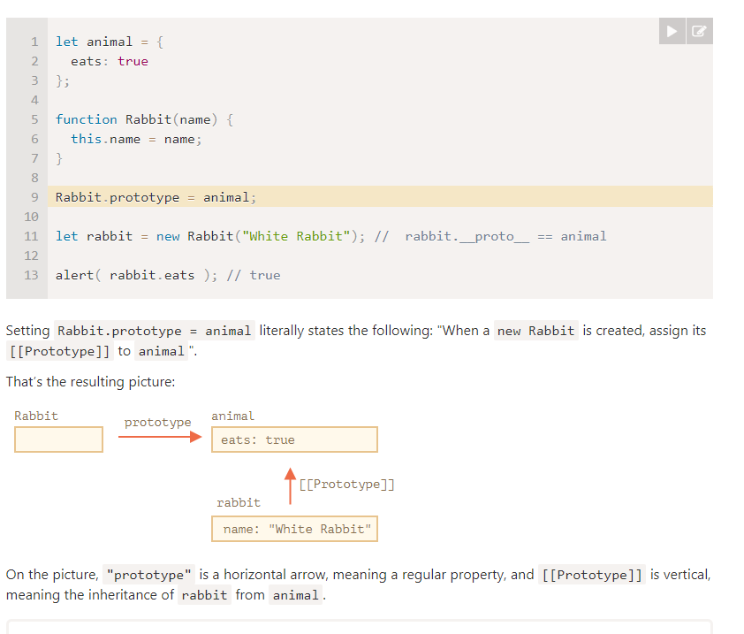

F.prototype only used at new F time
F.prototype property is only used when new F is called, it assigns [[Prototype]] of the new object.
If, after the creation, F.prototype property changes (F.prototype = <another object>), then new objects created by new F will have another object as [[Prototype]], but already existing objects keep the old one.

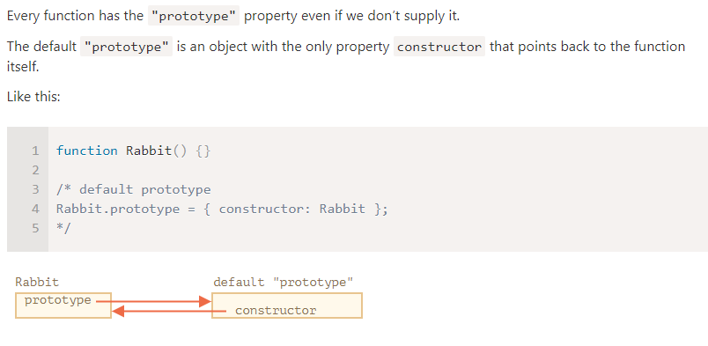
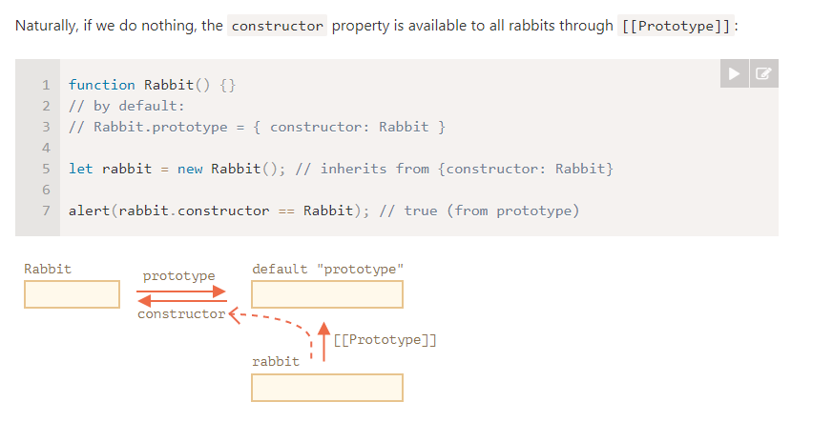

That’s handy when we have an object, don’t know which constructor was used for it (e.g. it comes from a 3rd party library), and we need to create another one of the same kind.
But probably the most important thing about "constructor" is that…
…JavaScript itself does not ensure the right "constructor" value.
Yes, it exists in the default "prototype" for functions, but that’s all. What happens with it later – is totally on us.
In particular, if we replace the default prototype as a whole, then there will be no "constructor" in it.
For instance:

function Rabbit() {}
Rabbit.prototype = {
jumps: true
};

let rabbit = new Rabbit();
alert(rabbit.constructor === Rabbit); // false
So, to keep the right "constructor" we can choose to add/remove properties to the default "prototype" instead of overwriting it as a whole:
function Rabbit() {}

// Not overwrite Rabbit.prototype totally
// just add to it
Rabbit.prototype.jumps = true
// the default Rabbit.prototype.constructor is preserved
Or, alternatively, recreate the constructor property manually:

Rabbit.prototype = {
jumps: true,
constructor: Rabbit
};

// now constructor is also correct, because we added it

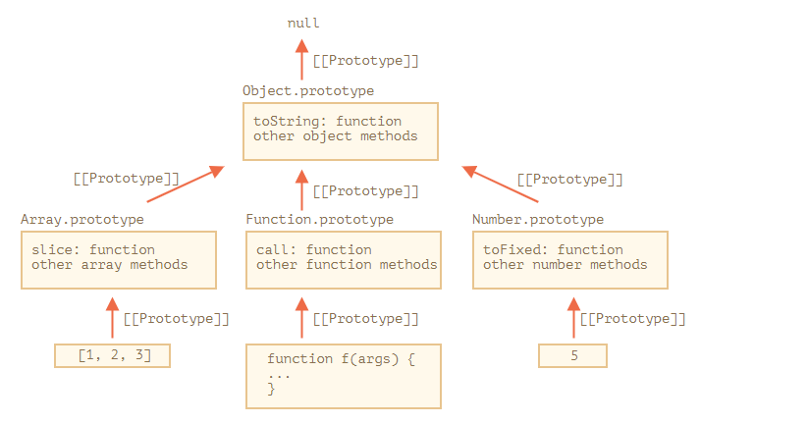

As we’ve seen before, Object.prototype has toString as well, but Array.prototype is closer in the chain, so the array variant is used.

Other built-in objects also work the same way. Even functions – they are objects of a built-in Function constructor, and their methods (call/apply and others) are taken from Function.prototype. Functions have their own toString too.

As we remember, they are not objects. But if we try to access their properties, temporary wrapper objects are created using built-in constructors String, Number and Boolean. They provide the methods and disappear.
These objects are created invisibly to us and most engines optimize them out, but the specification describes it exactly this way. Methods of these objects also reside in prototypes, available as String.prototype, Number.prototype and Boolean.prototype.
Values null and undefined have no object wrappers
Special values null and undefined stand apart. They have no object wrappers, so methods and properties are not available for them. And there are no corresponding prototypes either.

Native prototypes can be modified. For instance, if we add a method to String.prototype, it becomes available to all strings:

String.prototype.show = function() {
alert(this);
};

"BOOM!".show(); // BOOM!

Prototypes are global, so it’s easy to get a conflict. If two libraries add a method String.prototype.show, then one of them will be overwriting the method of the other.
So, generally, modifying a native prototype is considered a bad idea.

In modern programming, there is only one case where modifying native prototypes is approved. That’s polyfilling.
Polyfilling is a term for making a substitute for a method that exists in the JavaScript specification, but is not yet supported by a particular JavaScript engine.
We may then implement it manually and populate the built-in prototype with it.
For instance:
if (!String.prototype.repeat) { // if there's no such method
// add it to the prototype

String.prototype.repeat = function(n) {
// repeat the string n times

// actually, the code should be a little bit more complex than that
// (the full algorithm is in the specification)
// but even an imperfect polyfill is often considered good enough
return new Array(n + 1).join(this);
};
}

alert( "La".repeat(3) ); // LaLaLa

n the chapter Decorators and forwarding, call/apply we talked about method borrowing.
That’s when we take a method from one object and copy it into another.
Some methods of native prototypes are often borrowed.
For instance, if we’re making an array-like object, we may want to copy some Array methods to it.
E.g.

let obj = {
0: "Hello",
1: "world!",
length: 2,
};

obj.join = Array.prototype.join;

alert( obj.join(',') ); // Hello,world!
It works because the internal algorithm of the built-in join method only cares about the correct indexes and the length property. It doesn’t check if the object is indeed an array. Many built-in methods are like that.
Another possibility is to inherit by setting obj.__proto__ to Array.prototype, so all Array methods are automatically available in obj.
But that’s impossible if obj already inherits from another object. Remember, we only can inherit from one object at a time.
Borrowing methods is flexible, it allows to mix functionalities from different objects if needed.

The __proto__ is considered outdated and somewhat deprecated (in browser-only part of the JavaScript standard).
The modern methods are:
- Object.create(proto[, descriptors]) – creates an empty object with given proto as [[Prototype]] and optional property descriptors.
- Object.getPrototypeOf(obj) – returns the [[Prototype]] of obj.
- Object.setPrototypeOf(obj, proto) – sets the [[Prototype]] of obj to proto.
These should be used instead of __proto__.

For instance:

let animal = {
eats: true
};

// create a new object with animal as a prototype
let rabbit = Object.create(animal);

alert(rabbit.eats); // true

alert(Object.getPrototypeOf(rabbit) === animal); // true

Object.setPrototypeOf(rabbit, {}); // change the prototype of rabbit to {}
Object.create has an optional second argument: property descriptors. We can provide additional properties to the new object there, like this:
let animal = {
eats: true
};

let rabbit = Object.create(animal, {
jumps: {
value: true
}
});

alert(rabbit.jumps); // true
The descriptors are in the same format as described in the chapter Property flags and descriptors.
We can use Object.create to perform an object cloning more powerful than copying properties in for..in:
// fully identical shallow clone of obj
let clone = Object.create(Object.getPrototypeOf(obj), Object.getOwnPropertyDescriptors(obj));
This call makes a truly exact copy of obj, including all properties: enumerable and non-enumerable, data properties and setters/getters – everything, and with the right [[Prototype]].

The "prototype" property of a constructor function has worked since very ancient times.
- Later, in the year 2012, Object.create appeared in the standard. It gave the ability to create objects with a given prototype, but did not provide the ability to get/set it. So browsers implemented the non-standard __proto__ accessor that allowed the user to get/set a prototype at any time.
- Later, in the year 2015, Object.setPrototypeOf and Object.getPrototypeOf were added to the standard, to perform the same functionality as __proto__. As __proto__ was de-facto implemented everywhere, it was kind-of deprecated and made its way to the Annex B of the standard, that is: optional for non-browser environments.
Don’t change [[Prototype]] on existing objects if speed matters
Technically, we can get/set [[Prototype]] at any time. But usually we only set it once at the object creation time and don’t modify it anymore: rabbit inherits from animal, and that is not going to change.
nd JavaScript engines are highly optimized for this. Changing a prototype “on-the-fly” with Object.setPrototypeOf or obj.__proto__= is a very slow operation as it breaks internal optimizations for object property access operations.

Manque truc mais pas interessant imo

In JavaScript, a class is a kind of function.
Here, take a look:

class User {
constructor(name) { this.name = name; }
sayHi() { alert(this.name); }
}

// proof: User is a function
alert(typeof User); // function
What class User {...} construct really does is:
- Creates a function named User, that becomes the result of the class declaration. The function code is taken from the constructor method (assumed empty if we don’t write such method).
- Stores class methods, such as sayHi, in User.prototype.
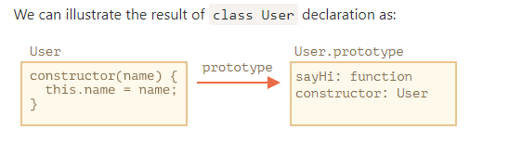

// rewriting class User in pure functions

// 1. Create constructor function
function User(name) {
this.name = name;
}
// a function prototype has "constructor" property by default,
// so we don't need to create it

// 2. Add the method to prototype
User.prototype.sayHi = function() {
alert(this.name);
};

// Usage:
let user = new User("John");
user.sayHi();

irst, a function created by class is labelled by a special internal property [[FunctionKind]]:"classConstructor". So it’s not entirely the same as creating it manually.
The language checks for that property in a variety of places. For example, unlike a regular function, it must be called with new:

Class methods are non-enumerable. A class definition sets enumerable flag to false for all methods in the "prototype".
That’s good, because if we for..in over an object, we usually don’t want its class methods.
- Classes always use strict. All code inside the class construct is automatically in strict mode.

Just like functions, classes can be defined inside another expression, passed around, returned, assigned, etc.
Here’s an example of a class expression:
let User = class {
sayHi() {
alert("Hello");
}
};

If a class expression has a name, it’s visible inside the class only:

// "Named Class Expression"
// (no such term in the spec, but that's similar to Named Function Expression)
let User = class MyClass {
sayHi() {
alert(MyClass); // MyClass name is visible only inside the class
}
};

new User().sayHi(); // works, shows MyClass definition

alert(MyClass); // error, MyClass name isn't visible outside of the class
We can even make classes dynamically “on-demand”, like this:
function makeClass(phrase) {
// declare a class and return it
return class {
sayHi() {
alert(phrase);
};
};
}

// Create a new class
let User = makeClass("Hello");

new User().sayHi(); // Hello

class User {

['say' + 'Hi']() {
alert("Hello");
}

}

new User().sayHi();

Previously, our classes only had methods.
“Class fields” is a syntax that allows to add any properties.
For instance, let’s add name property to class User:

class User {
name = "John";

sayHi() {
alert(`Hello, ${this.name}!`);
}
}

new User().sayHi(); // Hello, John!

The important difference of class fields is that they are set on individual objects, not User.prototype

Technically, they are processed after the constructor has done it’s job,

So if an object method is passed around and called in another context, this won’t be a reference to its object any more.
For instance, this code will show undefined:

class Button {
constructor(value) {
this.value = value;
}

click() {
alert(this.value);
}
}

let button = new Button("hello");

setTimeout(button.click, 1000); // undefined
The problem is called "losing this".
There are two approaches to fixing it, as discussed in the chapter Function binding:
- Pass a wrapper-function, such as setTimeout(() => button.click(), 1000).
- Bind the method to object, e.g. in the constructor:

class Button {
constructor(value) {
this.value = value;
this.click = this.click.bind(this);
}

click() {
alert(this.value);
}
}

let button = new Button("hello");

setTimeout(button.click, 1000); // hello
Class fields provide a more elegant syntax for the latter solution:

class Button {
constructor(value) {
this.value = value;
}
click = () => {
alert(this.value);
}
}

let button = new Button("hello");

setTimeout(button.click, 1000); // hello
The class field click = () => {...} creates an independent function on each Button object, with this bound to the object. Then we can pass button.click around anywhere, and it will be called with the right this.

As rabbits are animals, Rabbit class should be based on Animal, have access to animal methods, so that rabbits can do what “generic” animals can do.
The syntax to extend another class is: class Child extends Parent.
Let’s create class Rabbit that inherits from Animal:
class Rabbit extends Animal {
hide() {
alert(`${this.name} hides!`);
}
}

let rabbit = new Rabbit("White Rabbit");

rabbit.run(5); // White Rabbit runs with speed 5.
rabbit.hide(); // White Rabbit hides!

Internally, extends keyword works using the good old prototype mechanics. It sets Rabbit.prototype.[[Prototype]] to Animal.prototype. So, if a method is not found in Rabbit.prototype, JavaScript takes it from Animal.prototype.

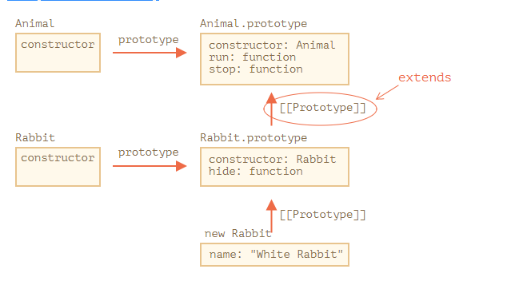
For instance, to find rabbit.run method, the engine checks (bottom-up on the picture):
- The rabbit object (has no run).
- Its prototype, that is Rabbit.prototype (has hide, but not run).
- Its prototype, that is (due to extends) Animal.prototype, that finally has the run method.
As we can recall from the chapter Native prototypes, JavaScript itself uses prototypal inheritance for built-in objects. E.g. Date.prototype.[[Prototype]] is Object.prototype. That’s why dates have access to generic object methods.

Class syntax allows to specify not just a class, but any expression after extends.
For instance, a function call that generates the parent class:

function f(phrase) {
return class {
sayHi() { alert(phrase) }
}
}

class User extends f("Hello") {}

new User().sayHi(); // Hello
Here class User inherits from the result of f("Hello").
That may be useful for advanced programming patterns when we use functions to generate classes depending on many conditions and can inherit from them.

class Rabbit extends Animal {
hide() {
alert(`${this.name} hides!`);
}

stop() {
super.stop(); // call parent stop
this.hide(); // and then hide
}
}

As was mentioned in the chapter Arrow functions revisited, arrow functions do not have super.
If accessed, it’s taken from the outer function. For instance:
class Rabbit extends Animal {
stop() {
setTimeout(() => super.stop(), 1000); // call parent stop after 1sec
}
}
The super in the arrow function is the same as in stop(), so it works as intended. If we specified a “regular” function here, there would be an error:
// Unexpected super
setTimeout(function() { super.stop() }, 1000);

The task may seem simple, but it isn’t. The engine knows the current object this, so it could get the parent method as this.__proto__.method. Unfortunately, such a “naive” solution won’t work.

let animal = {
name: "Animal",
eat() {
alert(`${this.name} eats.`);
}
};

let rabbit = {
__proto__: animal,
name: "Rabbit",
eat() {
// that's how super.eat() could presumably work
this.__proto__.eat.call(this); // (*)
}
};

rabbit.eat(); // Rabbit eats.
At the line (*) we take eat from the prototype (animal) and call it in the context of the current object. Please note that .call(this) is important here, because a simple this.__proto__.eat() would execute parent eat in the context of the prototype, not the current object.

Now let’s add one more object to the chain. We’ll see how things break:

let animal = {
name: "Animal",
eat() {
alert(`${this.name} eats.`);
}
};

let rabbit = {
__proto__: animal,
eat() {
// ...bounce around rabbit-style and call parent (animal) method
this.__proto__.eat.call(this); // (*)
}
};

let longEar = {
__proto__: rabbit,
eat() {
// ...do something with long ears and call parent (rabbit) method
this.__proto__.eat.call(this); // (**)
}
};

longEar.eat(); // Error: Maximum call stack size exceeded
The code doesn’t work anymore! We can see the error trying to call longEar.eat().
It may be not that obvious, but if we trace longEar.eat() call, then we can see why. In both lines (*) and (**) the value of this is the current object (longEar). That’s essential: all object methods get the current object as this, not a prototype or something.
So, in both lines (*) and (**) the value of this.__proto__ is exactly the same: rabbit. They both call rabbit.eat without going up the chain in the endless loop.

- Inside longEar.eat(), the line (**) calls rabbit.eat providing it with this=longEar.
// inside longEar.eat() we have this = longEar
this.__proto__.eat.call(this) // (**)
// becomes
longEar.__proto__.eat.call(this)
// that is
rabbit.eat.call(this);
- Then in the line (*) of rabbit.eat, we’d like to pass the call even higher in the chain, but this=longEar, so this.__proto__.eat is again rabbit.eat!
// inside rabbit.eat() we also have this = longEar
this.__proto__.eat.call(this) // (*)
// becomes
longEar.__proto__.eat.call(this)
// or (again)
rabbit.eat.call(this);
- …So rabbit.eat calls itself in the endless loop, because it can’t ascend any further.
The problem can’t be solved by using this alone.

[[HomeObject]]
To provide the solution, JavaScript adds one more special internal property for functions: [[HomeObject]].
When a function is specified as a class or object method, its [[HomeObject]] property becomes that object.
Then super uses it to resolve the parent prototype and its methods.
Let’s see how it works, first with plain objects:

let animal = {
name: "Animal",
eat() { // animal.eat.[[HomeObject]] == animal
alert(`${this.name} eats.`);
}
};

let rabbit = {
__proto__: animal,
name: "Rabbit",
eat() { // rabbit.eat.[[HomeObject]] == rabbit
super.eat();
}
};

let longEar = {
__proto__: rabbit,
name: "Long Ear",
eat() { // longEar.eat.[[HomeObject]] == longEar
super.eat();
}
};

// works correctly
longEar.eat(); // Long Ear eats.
It works as intended, due to [[HomeObject]] mechanics. A method, such as longEar.eat, knows its [[HomeObject]] and takes the parent method from its prototype. Without any use of this.

With constructors it gets a little bit tricky.
Until now, Rabbit did not have its own constructor.
According to the specification, if a class extends another class and has no constructor, then the following
class Rabbit extends Animal {
// generated for extending classes without own constructors
constructor(...args) {
super(...args);
}
}
As we can see, it basically calls the parent constructor passing it all the arguments. That happens if we don’t write a constructor of our own.
Now let’s add a custom constructor to Rabbit. It will specify the earLength in addition to name:

class Animal {
constructor(name) {
this.speed = 0;
this.name = name;
}
// ...
}

class Rabbit extends Animal {

constructor(name, earLength) {
this.speed = 0;
this.name = name;
this.earLength = earLength;
}

// ...
}

// Doesn't work!
let rabbit = new Rabbit("White Rabbit", 10); // Error: this is not defined.
Whoops! We’ve got an error. Now we can’t create rabbits. What went wrong?
The short answer is: constructors in inheriting classes must call super(...), and (!) do it before using this.
…But why? What’s going on here? Indeed, the requirement seems strange.
Of course, there’s an explanation. Let’s get into details, so you’ll really understand what’s going on.
In JavaScript, there’s a distinction between a constructor function of an inheriting class (so-called “derived constructor”) and other functions. A derived constructor has a special internal property [[ConstructorKind]]:"derived". That’s a special internal label.
That label affects its behavior with new.
- When a regular function is executed with new, it creates an empty object and assigns it to this.
- But when a derived constructor runs, it doesn’t do this. It expects the parent constructor to do this job.
So a derived constructor must call super in order to execute its parent (non-derived) constructor, otherwise the object for this won’t be created. And we’ll get an error.
For the Rabbit constructor to work, it needs to call super() before using this, like here:

class Animal {

constructor(name) {
this.speed = 0;
this.name = name;
}

// ...
}

class Rabbit extends Animal {

constructor(name, earLength) {
super(name);
this.earLength = earLength;
}

// ...
}

// now fine
let rabbit = new Rabbit("White Rabbit", 10);
alert(rabbit.name); // White Rabbit
alert(rabbit.earLength); // 10

Here Article.compare stands “above” articles, as a means to compare them. It’s not a method of an article, but rather of the whole class.
Another example would be a so-called “factory” method. Imagine, we need few ways to create an article:
- Create by given parameters (title, date etc).
- Create an empty article with today’s date.
- …or else somehow.
The first way can be implemented by the constructor. And for the second one we can make a static method of the class.
Like Article.createTodays() here:

class Article {
constructor(title, date) {
this.title = title;
this.date = date;
}
static createTodays() {
// remember, this = Article
return new this("Today's digest", new Date());
}
}

let article = Article.createTodays();

alert( article.title ); // Today's digest
Now every time we need to create a today’s digest, we can call Article.createTodays(). Once again, that’s not a method of an article, but a method of the whole class.
Static methods are also used in database-related classes to search/save/remove entries from the database, like this:
// assuming Article is a special class for managing articles
// static method to remove the article:
Article.remove({id: 12345});

class User {
static staticMethod() {
alert(this === User);
}
}

User.staticMethod(); // true
That actually does the same as assigning it as a property directly:
class User { }

User.staticMethod = function() {
alert(this === User);
};

User.staticMethod(); // true

class Article {
static publisher = "Ilya Kantor";
}

alert( Article.publisher ); // Ilya Kantor
That is the same as a direct assignment to Article:
Article.publisher = "Ilya Kantor";

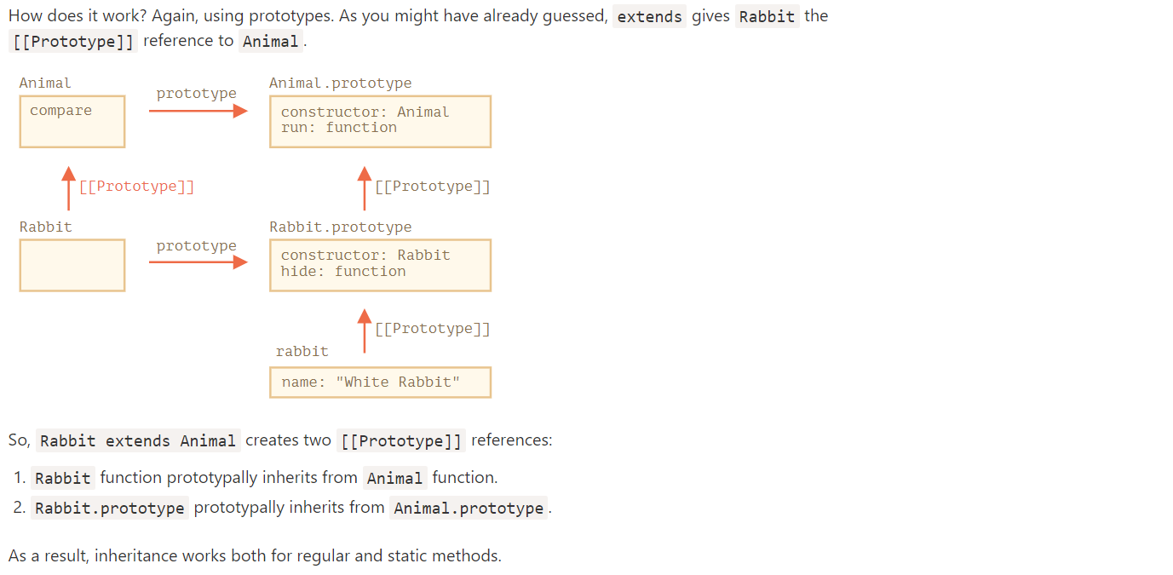
Protected fields are not implemented in JavaScript on the language level, but in practice they are very convenient, so they are emulated.

Protected properties are usually prefixed with an underscore _.
That is not enforced on the language level, but there’s a well-known convention between programmers that such properties and methods should not be accessed from the outside.
or power property, let’s make it read-only. It sometimes happens that a property must be set at creation time only, and then never modified.
That’s exactly the case for a coffee machine: power never changes.
To do so, we only need to make getter, but not the setter:
lass CoffeeMachine {

_waterAmount = 0;

set waterAmount(value) {
if (value < 0) throw new Error("Negative water");
this._waterAmount = value;
}

get waterAmount() {
return this._waterAmount;
}

constructor(power) {
this._power = power;
}

// ...

constructor(power) {
this._power = power;
}

get power() {
return this._power;
}

}

get + set = private
get = read only
set= write only
rien = public

But most of the time get.../set... functions are preferred, like this:
class CoffeeMachine {
_waterAmount = 0;

setWaterAmount(value) {
if (value < 0) throw new Error("Negative water");
this._waterAmount = value;
}

getWaterAmount() {
return this._waterAmount;
}
}

new CoffeeMachine().setWaterAmount(100);
That looks a bit longer, but functions are more flexible. They can accept multiple arguments (even if we don’t need them right now).
If we inherit class MegaMachine extends CoffeeMachine, then nothing prevents us from accessing this._waterAmount or this._power from the methods of the new class.
So protected fields are naturally inheritable. Unlike private ones that we’ll see below.

This is a recent addition to the language. Not supported in JavaScript engines, or supported partially yet, requires polyfilling.
There’s a finished JavaScript proposal, almost in the standard, that provides language-level support for private properties and methods.
Privates should start with #. They are only accessible from inside the class.
For instance, here’s a private #waterLimit property and the water-checking private method #checkWater:

class CoffeeMachine {
#waterLimit = 200;

#checkWater(value) {
if (value < 0) throw new Error("Negative water");
if (value > this.#waterLimit) throw new Error("Too much water");
}

}

let coffeeMachine = new CoffeeMachine();

// can't access privates from outside of the class
coffeeMachine.#checkWater(); // Error
coffeeMachine.#waterLimit = 1000; // Error
On the language level, # is a special sign that the field is private. We can’t access it from outside or from inheriting classes.

Private fields do not conflict with public ones. We can have both private #waterAmount and public waterAmount fields at the same time.
Unlike protected ones, private fields are enforced by the language itself. That’s a good thing.

But if we inherit from CoffeeMachine, then we’ll have no direct access to #waterAmount. We’ll need to rely on waterAmount getter/setter:
class MegaCoffeeMachine extends CoffeeMachine {
method() {
alert( this.#waterAmount ); // Error: can only access from CoffeeMachine
}
}
In many scenarios such limitation is too severe. If we extend a CoffeeMachine, we may have legitimate reasons to access its internals. That’s why protected fields are used more often, even though they are not supported by the language syntax.
Private fields are not available as this[name]
Private fields are special.
As we know, usually we can access fields using this[name]:
class User {
...
sayHi() {
let fieldName = "name";
alert(`Hello, ${this[fieldName]}`);
}
}
With private fields that’s impossible: this['#name'] doesn’t work. That’s a syntax limitation to ensure privacy.

When arr.filter() is called, it internally creates the new array of results using exactly arr.constructor, not basic Array. That’s actually very cool, because we can keep using PowerArray methods further on the result.
Even more, we can customize that behavior.
We can add a special static getter Symbol.species to the class. If it exists, it should return the constructor that JavaScript will use internally to create new entities in map, filter and so on.
If we’d like built-in methods like map or filter to return regular arrays, we can return Array in Symbol.species, like here:

class PowerArray extends Array {
isEmpty() {
return this.length === 0;
}

// built-in methods will use this as the constructor
static get [Symbol.species]() {
return Array;
}
}

let arr = new PowerArray(1, 2, 5, 10, 50);
alert(arr.isEmpty()); // false

// filter creates new array using arr.constructor[Symbol.species] as constructor
let filteredArr = arr.filter(item => item >= 10);

// filteredArr is not PowerArray, but Array
alert(filteredArr.isEmpty()); // Error: filteredArr.isEmpty is not a function
As you can see, now .filter returns Array. So the extended functionality is not passed any further.
Other collections work similarly
Other collections, such as Map and Set, work alike. They also use Symbol.species.
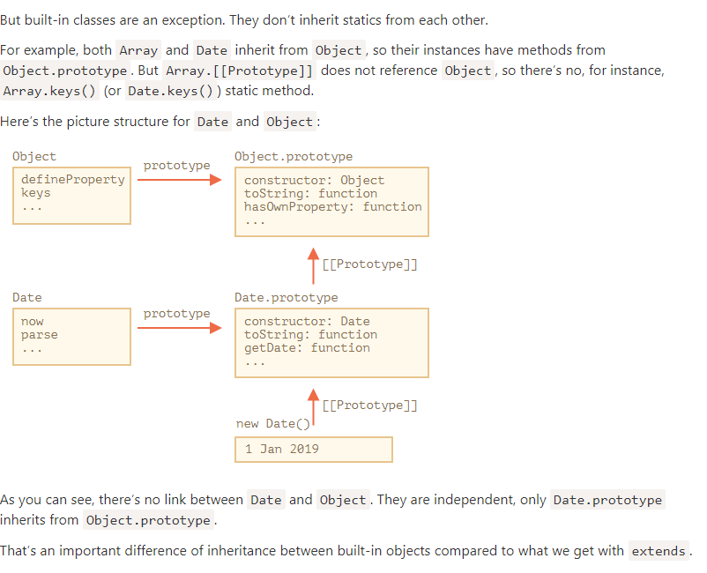
he instanceof operator allows to check whether an object belongs to a certain class. It also takes inheritance into account.
Such a check may be necessary in many cases. Here we’ll use it for building a polymorphic function, the one that treats arguments differently depending on their type.

The instanceof operator
The syntax is:
obj instanceof Class
It returns true if obj belongs to the Class or a class inheriting from it.
It also works with constructor functions:

// instead of class
function Rabbit() {}

alert( new Rabbit() instanceof Rabbit ); // true
…And with built-in classes like Array:
let arr = [1, 2, 3];
alert( arr instanceof Array ); // true
alert( arr instanceof Object ); // true

Please note that arr also belongs to the Object class. That’s because Array prototypically inherits from Object.
Normally, instanceof examines the prototype chain for the check. We can also set a custom logic in the static method Symbol.hasInstance.
The algorithm of obj instanceof Class works roughly as follows:
- If there’s a static method Symbol.hasInstance, then just call it: Class[Symbol.hasInstance](obj). It should return either true or false, and we’re done. That’s how we can customize the behavior of instanceof.
For example:
// setup instanceOf check that assumes that
// anything with canEat property is an animal
class Animal {
static [Symbol.hasInstance](obj) {
if (obj.canEat) return true;
}
}

let obj = { canEat: true };

alert(obj instanceof Animal); // true: Animal[Symbol.hasInstance](obj) is called
- Most classes do not have Symbol.hasInstance. In that case, the standard logic is used: obj instanceOf Class checks whether Class.prototype is equal to one of the prototypes in the obj prototype chain.
In other words, compare one after another:
obj.__proto__ === Class.prototype?
obj.__proto__.__proto__ === Class.prototype?
obj.__proto__.__proto__.__proto__ === Class.prototype?
...
// if any answer is true, return true
// otherwise, if we reached the end of the chain, return false
In the example above rabbit.__proto__ === Rabbit.prototype, so that gives the answer immediately.
In the case of an inheritance, the match will be at the second step:

class Animal {}
class Rabbit extends Animal {}

let rabbit = new Rabbit();
alert(rabbit instanceof Animal); // true

// rabbit.__proto__ === Rabbit.prototype
// rabbit.__proto__.__proto__ === Animal.prototype (match!)

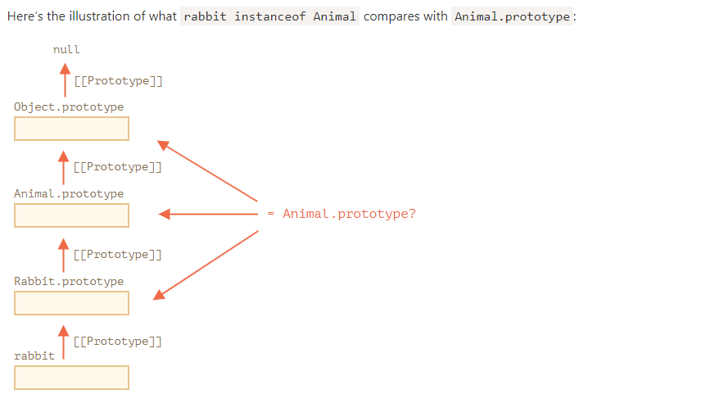

By the way, there’s also a method objA.isPrototypeOf(objB), that returns true if objA is somewhere in the chain of prototypes for objB. So the test of obj instanceof Class can be rephrased as Class.prototype.isPrototypeOf(obj).
It’s funny, but the Class constructor itself does not participate in the check! Only the chain of prototypes and Class.prototype matters.
That can lead to interesting consequences when a prototype property is changed after the object is created.
Like here:

function Rabbit() {}
let rabbit = new Rabbit();

// changed the prototype
Rabbit.prototype = {};

// ...not a rabbit any more!
alert( rabbit instanceof Rabbit ); // false

We already know that plain objects are converted to string as [object Object]:
let obj = {};

alert(obj); // [object Object]
alert(obj.toString()); // the same
That’s their implementation of toString. But there’s a hidden feature that makes toString actually much more powerful than that. We can use it as an extended typeof and an alternative for instanceof.
Sounds strange? Indeed. Let’s demystify.
By specification, the built-in toString can be extracted from the object and executed in the context of any other value. And its result depends on that value.
- For a number, it will be [object Number]
Let’s demonstrate:

// copy toString method into a variable for convenience
let objectToString = Object.prototype.toString;

// what type is this?
let arr = [];

alert( objectToString.call(arr) ); // [object Array]
Here we used call as described in the chapter Decorators and forwarding, call/apply to execute the function objectToString in the context this=arr.
Internally, the toString algorithm examines this and returns the corresponding result. More examples:
let s = Object.prototype.toString;

alert( s.call(123) ); // [object Number]
alert( s.call(null) ); // [object Null]
alert( s.call(alert) ); // [object Function]

The behavior of Object toString can be customized using a special object property Symbol.toStringTag.
For instance:
let user = {
[Symbol.toStringTag]: "User"
};

alert( {}.toString.call(user) ); // [object User]
For most environment-specific objects, there is such a property. Here are some browser specific examples:
// toStringTag for the environment-specific object and class:
alert( window[Symbol.toStringTag]); // window
alert( XMLHttpRequest.prototype[Symbol.toStringTag] ); // XMLHttpRequest

alert( {}.toString.call(window) ); // [object Window]
alert( {}.toString.call(new XMLHttpRequest()) ); // [object XMLHttpRequest]
As you can see, the result is exactly Symbol.toStringTag (if exists), wrapped into [object ...].
At the end we have “typeof on steroids” that not only works for primitive data types, but also for built-in objects and even can be customized.
We can use {}.toString.call instead of instanceof for built-in objects when we want to get the type as a string rather than just to check.

But sometimes that feels limiting. For instance, we have a class StreetSweeper and a class Bicycle, and want to make their mix: a StreetSweepingBicycle.

Or we have a class User and a class EventEmitter that implements event generation, and we’d like to add the functionality of EventEmitter to User, so that our users can emit events.

As defined in Wikipedia, a mixin is a class containing methods that can be used by other classes without a need to inherit from it.
In other words, a mixin provides methods that implement a certain behavior, but we do not use it alone, we use it to add the behavior to other classes.

The simplest way to implement a mixin in JavaScript is to make an object with useful methods, so that we can easily merge them into a prototype of any class.
For instance here the mixin sayHiMixin is used to add some “speech” for User:

// mixin
let sayHiMixin = {
sayHi() {
alert(`Hello ${this.name}`);
},
sayBye() {
alert(`Bye ${this.name}`);
}
};

// usage:
class User {
constructor(name) {
this.name = name;
}
}

// copy the methods
Object.assign(User.prototype, sayHiMixin);

// now User can say hi
new User("Dude").sayHi(); // Hello Dude!

Now let’s make a mixin for real life.
An important feature of many browser objects (for instance) is that they can generate events. Events are a great way to “broadcast information” to anyone who wants it. So let’s make a mixin that allows us to easily add event-related functions to any class/object.
- The mixin will provide a method .trigger(name, [...data]) to “generate an event” when something important happens to it. The name argument is a name of the event, optionally followed by additional arguments with event data.
- Also the method .on(name, handler) that adds handler function as the listener to events with the given name. It will be called when an event with the given name triggers, and get the arguments from the .trigger call.
- …And the method .off(name, handler) that removes the handler listener.
After adding the mixin, an object user will be able to generate an event "login" when the visitor logs in. And another object, say, calendar may want to listen for such events to load the calendar for the logged-in person.
Or, a menu can generate the event "select" when a menu item is selected, and other objects may assign handlers to react on that event. And so on.
Here’s the code:
let eventMixin = {
/**
* Subscribe to event, usage:
* menu.on('select', function(item) { ... }
*/
on(eventName, handler) {
if (!this._eventHandlers) this._eventHandlers = {};
if (!this._eventHandlers[eventName]) {
this._eventHandlers[eventName] = [];
}
this._eventHandlers[eventName].push(handler);
},

/**
* Cancel the subscription, usage:
* menu.off('select', handler)
*/
off(eventName, handler) {
let handlers = this._eventHandlers?.[eventName];
if (!handlers) return;
for (let i = 0; i < handlers.length; i++) {
if (handlers[i] === handler) {
handlers.splice(i--, 1);
}
}
},

/**
* Generate an event with the given name and data
* this.trigger('select', data1, data2);
*/
trigger(eventName, ...args) {
if (!this._eventHandlers || !this._eventHandlers[eventName]) {
return; // no handlers for that event name
}

// call the handlers
this._eventHandlers[eventName].forEach(handler => handler.apply(this, args));
}
};
- .on(eventName, handler) – assigns function handler to run when the event with that name occurs. Technically, there’s an _eventHandlers property that stores an array of handlers for each event name, and it just adds it to the list.
- .off(eventName, handler) – removes the function from the handlers list.
- .trigger(eventName, ...args) – generates the event: all handlers from _eventHandlers[eventName] are called, with a list of arguments ...args.
Usage:

// Make a class
class Menu {
choose(value) {
this.trigger("select", value);
}
}
// Add the mixin with event-related methods
Object.assign(Menu.prototype, eventMixin);

let menu = new Menu();

// add a handler, to be called on selection:
menu.on("select", value => alert(`Value selected: ${value}`));

// triggers the event => the handler above runs and shows:
// Value selected: 123
menu.choose("123");
Now, if we’d like any code to react to a menu selection, we can listen for it with menu.on(...).
And eventMixin mixin makes it easy to add such behavior to as many classes as we’d like, without interfering with the inheritance chain

try..catch works synchronously
If an exception happens in “scheduled” code, like in setTimeout, then try..catch won’t catch it:
try {
setTimeout(function() {
noSuchVariable; // script will die here
}, 1000);
} catch (e) {
alert( "won't work" );
}
That’s because the function itself is executed later, when the engine has already left the try..catch construct.
To catch an exception inside a scheduled function, try..catch must be inside that function:
setTimeout(function() {
try {
noSuchVariable; // try..catch handles the error!
} catch {
alert( "error is caught here!" );
}
}, 1000);

When an error occurs, JavaScript generates an object containing the details about it. The object is then passed as an argument to catch:
try {
// ...
} catch(err) { // <-- the "error object", could use another word instead of err
// ...
}
For all built-in errors, the error object has two main properties:
name
Error name. For instance, for an undefined variable that’s "ReferenceError".
message
Textual message about error details.
There are other non-standard properties available in most environments. One of most widely used and supported is:
stack
Current call stack: a string with information about the sequence of nested calls that led to the error. Used for debugging purposes.
// The error is converted to string as "name: message"
alert(err); // ReferenceError: lalala is not defined

he throw operator generates an error.
The syntax is:
throw <error object>
Technically, we can use anything as an error object. That may be even a primitive, like a number or a string, but it’s better to use objects, preferably with name and message properties (to stay somewhat compatible with built-in errors).
JavaScript has many built-in constructors for standard errors: Error, SyntaxError, ReferenceError, TypeError and others. We can use them to create error objects as well.
Their syntax is:
let error = new Error(message);
// or
let error = new SyntaxError(message);
let error = new ReferenceError(message);
// ...
For built-in errors (not for any objects, just for errors), the name property is exactly the name of the constructor. And message is taken from the argument.
For instance:
let error = new Error("Things happen o_O");

alert(error.name); // Error
alert(error.message); // Things happen o_O

let json = '{ "age": 30 }'; // incomplete data

try {

let user = JSON.parse(json); // <-- no errors

if (!user.name) {
throw new SyntaxError("Incomplete data: no name"); // (*)
}

alert( user.name );

} catch(e) {
alert( "JSON Error: " + e.message ); // JSON Error: Incomplete data: no name
}

In our case, try..catch is placed to catch “incorrect data” errors. But by its nature, catch gets all errors from try. Here it gets an unexpected error, but still shows the same "JSON Error" message. That’s wrong and also makes the code more difficult to debug.
To avoid such problems, we can employ the “rethrowing” technique. The rule is simple:
Catch should only process errors that it knows and “rethrow” all others.
The “rethrowing” technique can be explained in more detail as:
- Catch gets all errors.
- In the catch(err) {...} block we analyze the error object err.
- If we don’t know how to handle it, we do throw err.
Usually, we can check the error type using the instanceof operator:

try {
user = { /*...*/ };
} catch(err) {
if (err instanceof ReferenceError) {
alert('ReferenceError'); // "ReferenceError" for accessing an undefined variable
}
}
We can also get the error class name from err.name property. All native errors have it. Another option is to read err.constructor.name.
In the code below, we use rethrowing so that catch only handles SyntaxError:

let json = '{ "age": 30 }'; // incomplete data
try {

let user = JSON.parse(json);

if (!user.name) {
throw new SyntaxError("Incomplete data: no name");
}

blabla(); // unexpected error

alert( user.name );

} catch(e) {

if (e instanceof SyntaxError) {
alert( "JSON Error: " + e.message );
} else {
throw e; // rethrow (*)
}

}
The error throwing on line (*) from inside catch block “falls out” of try..catch and can be either caught by an outer try..catch construct (if it exists), or it kills the script.
So the catch block actually handles only errors that it knows how to deal with and “skips” all others.

Wait, that’s not all.
The try..catch construct may have one more code clause: finally.
If it exists, it runs in all cases:
- after try, if there were no errors,
- after catch, if there were errors.
The extended syntax looks like this:

try {
... try to execute the code ...
} catch(e) {
... handle errors ...
} finally {
... execute always ...
}
Try running this code:
try {
alert( 'try' );
if (confirm('Make an error?')) BAD_CODE();
} catch (e) {
alert( 'catch' );
} finally {
alert( 'finally' );
}
The code has two ways of execution:
- If you answer “Yes” to “Make an error?”, then try -> catch -> finally.
- If you say “No”, then try -> finally.
The finally clause is often used when we start doing something and want to finalize it in any case of outcome.
For instance, we want to measure the time that a Fibonacci numbers function fib(n) takes. Naturally, we can start measuring before it runs and finish afterwards. But what if there’s an error during the function call? In particular, the implementation of fib(n) in the code below returns an error for negative or non-integer numbers.
The finally clause is a great place to finish the measurements no matter what.
Here finally guarantees that the time will be measured correctly in both situations – in case of a successful execution of fib and in case of an error in it:

let num = +prompt("Enter a positive integer number?", 35)

let diff, result;

function fib(n) {
if (n < 0 || Math.trunc(n) != n) {
throw new Error("Must not be negative, and also an integer.");
}
return n <= 1 ? n : fib(n - 1) + fib(n - 2);
}

let start = Date.now();

try {
result = fib(num);
} catch (e) {
result = 0;
} finally {
diff = Date.now() - start;
}

alert(result || "error occurred");

alert( `execution took ${diff}ms` );

The finally clause works for any exit from try..catch. That includes an explicit return.
In the example below, there’s a return in try. In this case, finally is executed just before the control returns to the outer code.

function func() {

try {
return 1;

} catch (e) {
/* ... */
} finally {
alert( 'finally' );
}
}

alert( func() ); // first works alert from finally, and then this one

The try..finally construct, without catch clause, is also useful. We apply it when we don’t want to handle errors here (let them fall through), but want to be sure that processes that we started are finalized.

Let’s imagine we’ve got a fatal error outside of try..catch, and the script died. Like a programming error or some other terrible thing.
Is there a way to react on such occurrences? We may want to log the error, show something to the user (normally they don’t see error messages), etc.
There is none in the specification, but environments usually provide it, because it’s really useful. For instance, Node.js has process.on("uncaughtException") for that. And in the browser we can assign a function to the special window.onerror property, that will run in case of an uncaught error.
The syntax:
window.onerror = function(message, url, line, col, error) {
// ...
};
message
Error message.
url
URL of the script where error happened.
line, col
Line and column numbers where error happened.
error
Error object.
For instance:

<script>
window.onerror = function(message, url, line, col, error) {
alert(`${message}\n At ${line}:${col} of ${url}`);
};

function readData() {
badFunc(); // Whoops, something went wrong!
}

readData();
</script>
The role of the global handler window.onerror is usually not to recover the script execution – that’s probably impossible in case of programming errors, but to send the error message to developers.
There are also web-services that provide error-logging for such cases, like https://errorception.com or http://www.muscula.com.
They work like this:
- We register at the service and get a piece of JS (or a script URL) from them to insert on pages.
- That JS script sets a custom window.onerror function.
- When an error occurs, it sends a network request about it to the service.
- We can log in to the service web interface and see errors.

hen we develop something, we often need our own error classes to reflect specific things that may go wrong in our tasks. For errors in network operations we may need HttpError, for database operations DbError, for searching operations NotFoundError and so on.
Our errors should support basic error properties like message, name and, preferably, stack. But they also may have other properties of their own, e.g. HttpError objects may have a statusCode property with a value like 404 or 403 or 500.
JavaScript allows to use throw with any argument, so technically our custom error classes don’t need to inherit from Error. But if we inherit, then it becomes possible to use obj instanceof Error to identify error objects. So it’s better to inherit from it.
As the application grows, our own errors naturally form a hierarchy. For instance, HttpTimeoutError may inherit from HttpError, and so on.

// The "pseudocode" for the built-in Error class defined by JavaScript itself
class Error {
constructor(message) {
this.message = message;
this.name = "Error"; // (different names for different built-in error classes)
this.stack = <call stack>; // non-standard, but most environments support it
}
}
Now let’s inherit ValidationError from it and try it in action:
class ValidationError extends Error {
constructor(message) {
super(message); // (1)
this.name = "ValidationError"; // (2)

}
}

function test() { // readUser
throw new ValidationError("Whoops!");
}
try {
let user = readUser('{ "age": 25 }');
} catch (err) {
if (err instanceof ValidationError) {
alert("Invalid data: " + err.message); // Invalid data: No field: name
} else if (err instanceof SyntaxError) { // (*)
alert("JSON Syntax Error: " + err.message);
} else {
throw err; // unknown error, rethrow it (**)
}

// ...
// instead of (err instanceof SyntaxError)
} else if (err.name == "SyntaxError") { // (*)
// ...
The instanceof version is much better, because in the future we are going to extend ValidationError, make subtypes of it, like PropertyRequiredError. And instanceof check will continue to work for new inheriting classes. So that’s future-proof.

Please note that this.name in PropertyRequiredError constructor is again assigned manually. That may become a bit tedious – to assign this.name = <class name> in every custom error class. We can avoid it by making our own “basic error” class that assigns this.name = this.constructor.name. And then inherit all our custom errors from it.
Let’s call it MyError.
Here’s the code with MyError and other custom error classes, simplified:

class MyError extends Error {
constructor(message) {
super(message);
this.name = this.constructor.name;
}
}

class ValidationError extends MyError { }

class PropertyRequiredError extends ValidationError {
constructor(property) {
super("No property: " + property);
this.property = property;
}
}

// name is correct
alert( new PropertyRequiredError("field").name ); // PropertyRequiredError

Often the answer is “No”: we’d like to be “one level above all that”. We just want to know if there was a “data reading error” – why exactly it happened is often irrelevant (the error message describes it). Or, even better, we’d like to have a way to get the error details, but only if we need to.
The technique that we describe here is called “wrapping exceptions”.
- We’ll make a new class ReadError to represent a generic “data reading” error.
- The function readUser will catch data reading errors that occur inside it, such as ValidationError and SyntaxError, and generate a ReadError instead.
- The ReadError object will keep the reference to the original error in its cause property.
Then the code that calls readUser will only have to check for ReadError, not for every kind of data reading errors. And if it needs more details of an error, it can check its cause property.
Here’s the code that defines ReadError and demonstrates its use in readUser and try..catch:

class ReadError extends Error {
constructor(message, cause) {
super(message);
this.cause = cause;
this.name = 'ReadError';
}
}

class ValidationError extends Error { /*...*/ }
class PropertyRequiredError extends ValidationError { /* ... */ }

function validateUser(user) {
if (!user.age) {
throw new PropertyRequiredError("age");
}

if (!user.name) {
throw new PropertyRequiredError("name");
}
}

function readUser(json) {
let user;

try {
user = JSON.parse(json);
} catch (err) {
if (err instanceof SyntaxError) {
throw new ReadError("Syntax Error", err);
} else {
throw err;
}
}

try {
validateUser(user);
} catch (err) {
if (err instanceof ValidationError) {
throw new ReadError("Validation Error", err);
} else {
throw err;
}
}

}

try {
readUser('{bad json}');
} catch (e) {
if (e instanceof ReadError) {
alert(e);
// Original error: SyntaxError: Unexpected token b in JSON at position 1
alert("Original error: " + e.cause);
} else {
throw e;
}
}
In the code above, readUser works exactly as described – catches syntax and validation errors and throws ReadError errors instead (unknown errors are rethrown as usual).
So the outer code checks instanceof ReadError and that’s it. No need to list all possible error types.
The approach is called “wrapping exceptions”, because we take “low level” exceptions and “wrap” them into ReadError that is more abstract. It is widely used in object-oriented programming.

Naturally, the browser probably didn’t have time to load the script. As of now, the loadScript function doesn’t provide a way to track the load completion. The script loads and eventually runs, that’s all. But we’d like to know when it happens, to use new functions and variables from that script.
Let’s add a callback function as a second argument to loadScript that should execute when the script loads:

function loadScript(src, callback) {
let script = document.createElement('script');
script.src = src;

script.onload = () => callback(script);

document.head.append(script);
}
Now if we want to call new functions from the script, we should write that in the callback:
loadScript('/my/script.js', function() {
// the callback runs after the script is loaded
newFunction(); // so now it works
...
});

That’s the idea: the second argument is a function (usually anonymous) that runs when the action is completed.

How can we load two scripts sequentially: the first one, and then the second one after it?
The natural solution would be to put the second loadScript call inside the callback, like this:

loadScript('/my/script.js', function(script) {

alert(`Cool, the ${script.src} is loaded, let's load one more`);

loadScript('/my/script2.js', function(script) {
alert(`Cool, the second script is loaded`);
});

});

function loadScript(src, callback) {
let script = document.createElement('script');
script.src = src;

script.onload = () => callback(null, script);
script.onerror = () => callback(new Error(`Script load error for ${src}`));

document.head.append(script);
}
It calls callback(null, script) for successful load and callback(error) otherwise.

1, The first argument of the callback is reserved for an error if it occurs. Then callback(err) is called.
2,,The second argument (and the next ones if needed) are for the successful result. Then callback(null, result1, result2…) is called.

This is a real-life analogy for things we often have in programming:
- A “producing code” that does something and takes time. For instance, some code that loads the data over a network. That’s a “singer”.
- A “consuming code” that wants the result of the “producing code” once it’s ready. Many functions may need that result. These are the “fans”.
- A promise is a special JavaScript object that links the “producing code” and the “consuming code” together. In terms of our analogy: this is the “subscription list”. The “producing code” takes whatever time it needs to produce the promised result, and the “promise” makes that result available to all of the subscribed code when it’s ready.

The constructor syntax for a promise object is:
let promise = new Promise(function(resolve, reject) {
// executor (the producing code, "singer")
});

The function passed to new Promise is called the executor. When new Promise is created, the executor runs automatically. It contains the producing code which should eventually produce the result. In terms of the analogy above: the executor is the “singer”

Its arguments resolve and reject are callbacks provided by JavaScript itself. Our code is only inside the executor.
When the executor obtains the result, be it soon or late, doesn’t matter, it should call one of these callbacks:
- resolve(value) — if the job finished successfully, with result value.
- reject(error) — if an error occurred, error is the error object.
So to summarize: the executor runs automatically and attempts to perform a job. When it is finished with the attempt it calls resolve if it was successful or reject if there was an error.
The promise object returned by the new Promise constructor has these internal properties:
- state — initially "pending", then changes to either "fulfilled" when resolve is called or "rejected" when reject is called.
- result — initially undefined, then changes to value when resolve(value) called or error when reject(error) is called.

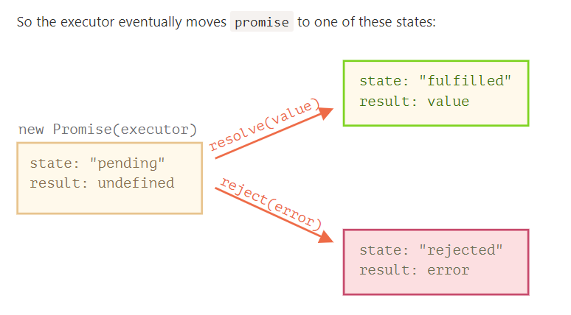
To summarize, the executor should perform a job (usually something that takes time) and then call resolve or reject to change the state of the corresponding promise object.

The executor is called automatically and immediately (by new Promise).
- The executor receives two arguments: resolve and reject. These functions are pre-defined by the JavaScript engine, so we don’t need to create them. We should only call one of them when ready.
After one second of “processing” the executor calls resolve("done") to produce the result. This changes the state of the promise object:

In case something goes wrong, the executor should call reject. That can be done with any type of argument (just like resolve). But it is recommended to use Error objects (or objects that inherit from Error).

In practice, an executor usually does something asynchronously and calls resolve/reject after some time, but it doesn’t have to. We also can call resolve or reject immediately, like this:
let promise = new Promise(function(resolve, reject) {
// not taking our time to do the job
resolve(123); // immediately give the result: 123
});
For instance, this might happen when we start to do a job but then see that everything has already been completed and cached.
The properties state and result of the Promise object are internal. We can’t directly access them. We can use the methods .then/.catch/.finally for that. They are described below.

The executor is called automatically and immediately (by new Promise).
- The executor receives two arguments: resolve and reject. These functions are pre-defined by the JavaScript engine, so we don’t need to create them. We should only call one of them when ready.
After one second of “processing” the executor calls resolve("done") to produce the result. This changes the state of the promise object:

let promise = new Promise(function(resolve, reject) {
setTimeout(() => resolve("done!"), 1000);
});

// resolve runs the first function in .then
promise.then(
result => alert(result), // shows "done!" after 1 second
error => alert(error) // doesn't run
);
The first function was executed.
And in the case of a rejection, the second one:

let promise = new Promise(function(resolve, reject) {
setTimeout(() => reject(new Error("Whoops!")), 1000);
});

// reject runs the second function in .then
promise.then(
result => alert(result), // doesn't run
error => alert(error) // shows "Error: Whoops!" after 1 second
);

If we’re interested only in successful completions, then we can provide only one function argument to .then

If we’re interested only in errors, then we can use null as the first argument: .then(null, errorHandlingFunction). Or we can use .catch(errorHandlingFunction), which is exactly the same:

let promise = new Promise((resolve, reject) => {
setTimeout(() => reject(new Error("Whoops!")), 1000);
});

// .catch(f) is the same as promise.then(null, f)
promise.catch(alert); // shows "Error: Whoops!" after 1 second
The call .catch(f) is a complete analog of .then(null, f), it’s just a shorthand.
Just like there’s a finally clause in a regular try {...} catch {...}, there’s finally in promises.
The call .finally(f) is similar to .then(f, f) in the sense that f always runs when the promise is settled: be it resolve or reject.
finally is a good handler for performing cleanup, e.g. stopping our loading indicators, as they are not needed anymore, no matter what the outcome is.
Like this:

new Promise((resolve, reject) => {
/* do something that takes time, and then call resolve/reject */
})
// runs when the promise is settled, doesn't matter successfully or not
.finally(() => stop loading indicator)
.then(result => show result, err => show error)
It’s not exactly an alias of then(f,f) though. There are several important differences:
- A finally handler has no arguments. In finally we don’t know whether the promise is successful or not. That’s all right, as our task is usually to perform “general” finalizing procedures.
- A finally handler passes through results and errors to the next handler.
For instance, here the result is passed through finally to then:
new Promise((resolve, reject) => {
setTimeout(() => resolve("result"), 2000)
})
.finally(() => alert("Promise ready"))
.then(result => alert(result)); // <-- .then handles the result

Last, but not least, .finally(f) is a more convenient syntax than .then(f, f): no need to duplicate the function f.

If a promise is pending, .then/catch/finally handlers wait for it. Otherwise, if a promise has already settled, they execute immediately:
// the promise becomes resolved immediately upon creation
let promise = new Promise(resolve => resolve("done!"));

promise.then(alert); // done! (shows up right now)

Here’s the callback-based variant, just to remind us of it:
function loadScript(src, callback) {
let script = document.createElement('script');
script.src = src;

script.onload = () => callback(null, script);
script.onerror = () => callback(new Error(`Script load error for ${src}`));

document.head.append(script);
}
Let’s rewrite it using Promises.
The new function loadScript will not require a callback. Instead, it will create and return a Promise object that resolves when the loading is complete. The outer code can add handlers (subscribing functions) to it using .then:
function loadScript(src) {
return new Promise(function(resolve, reject) {
let script = document.createElement('script');
script.src = src;

script.onload = () => resolve(script);
script.onerror = () => reject(new Error(`Script load error for ${src}`));

document.head.append(script);
});
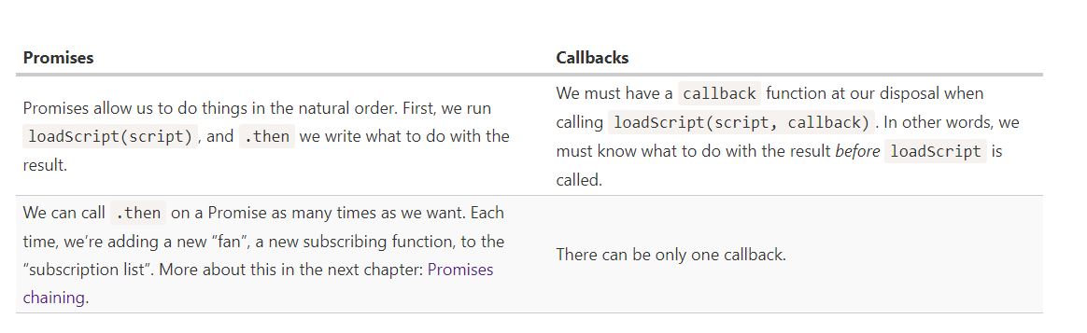

The whole thing works, because a call to promise.then returns a promise, so that we can call the next .then on it.
When a handler returns a value, it becomes the result of that promise, so the next .then is called with it.
A classic newbie error: technically we can also add many .then to a single promise. This is not chaining.
We can add more asynchronous actions to the chain. Please note that the code is still “flat” — it grows down, not to the right. There are no signs of the “pyramid of doom”.
Technically, we could add .then directly to each loadScript, like this:
loadScript("/article/promise-chaining/one.js").then(script1 => {
loadScript("/article/promise-chaining/two.js").then(script2 => {
loadScript("/article/promise-chaining/three.js").then(script3 => {
// this function has access to variables script1, script2 and script3
one();
two();
three();
});
});
});
This code does the same: loads 3 scripts in sequence. But it “grows to the right”. So we have the same problem as with callbacks.
To be precise, a handler may return not exactly a promise, but a so-called “thenable” object – an arbitrary object that has a method .then. It will be treated the same way as a promise.
The idea is that 3rd-party libraries may implement “promise-compatible” objects of their own. They can have an extended set of methods, but also be compatible with native promises, because they implement .then.
Here’s an example of a thenable object

class Thenable {
constructor(num) {
this.num = num;
}
then(resolve, reject) {
alert(resolve); // function() { native code }
// resolve with this.num*2 after the 1 second
setTimeout(() => resolve(this.num * 2), 1000); // (**)
}
}

new Promise(resolve => resolve(1))
.then(result => {
return new Thenable(result); // (*)
})
.then(alert); // shows 2 after 1000ms
JavaScript checks the object returned by the .then handler in line (*): if it has a callable method named then, then it calls that method providing native functions resolve, reject as arguments (similar to an executor) and waits until one of them is called. In the example above resolve(2) is called after 1 second (**). Then the result is passed further down the chain.
This feature allows us to integrate custom objects with promise chains without having to inherit from Promise.

The code of a promise executor and promise handlers has an "invisible try..catch" around it. If an exception happens, it gets caught and treated as a rejection.
For instance, this code:

new Promise((resolve, reject) => {
throw new Error("Whoops!");
}).catch(alert); // Error: Whoops!
…Works exactly the same as this:

new Promise((resolve, reject) => {
reject(new Error("Whoops!"));
}).catch(alert); // Error: Whoops!

The "invisible try..catch" around the executor automatically catches the error and turns it into rejected promise.
This happens not only in the executor function, but in its handlers as well. If we throw inside a .then handler, that means a rejected promise, so the control jumps to the nearest error handler.

This happens for all errors, not just those caused by the throw statement. For example, a programming error:

new Promise((resolve, reject) => {
resolve("ok");
}).then((result) => {
blabla(); // no such function
}).catch(alert); // ReferenceError: blabla is not defined

// the execution: catch -> catch -> then
new Promise((resolve, reject) => {

throw new Error("Whoops!");

}).catch(function(error) { // (*)

if (error instanceof URIError) {
// handle it
} else {
alert("Can't handle such error");

throw error; // throwing this or another error jumps to the next catch
}

}).then(function() {
/* doesn't run here */
}).catch(error => { // (**)

alert(`The unknown error has occurred: ${error}`);
// don't return anything => execution goes the normal way

});

The event is the part of the HTML standard.
If an error occurs, and there’s no .catch, the unhandledrejection handler triggers, and gets the event object with the information about the error, so we can do something.
Usually such errors are unrecoverable, so our best way out is to inform the user about the problem and probably report the incident to the server.

Let’s say we want many promises to execute in parallel and wait until all of them are ready.
For instance, download several URLs in parallel and process the content once they are all done.
That’s what Promise.all is for.
The syntax is:
let promise = Promise.all([...promises...]);
Promise.all takes an array of promises (it technically can be any iterable, but is usually an array) and returns a new promise.
The new promise resolves when all listed promises are settled, and the array of their results becomes its result.
For instance, the Promise.all below settles after 3 seconds, and then its result is an array [1, 2, 3]:
Promise.all([
new Promise(resolve => setTimeout(() => resolve(1), 3000)), // 1
new Promise(resolve => setTimeout(() => resolve(2), 2000)), // 2
new Promise(resolve => setTimeout(() => resolve(3), 1000)) // 3
]).then(alert); // 1,2,3 when promises are ready: each promise contributes an array member
Please note that the order of the resulting array members is the same as in its source promises. Even though the first promise takes the longest time to resolve, it’s still first in the array of results.
A common trick is to map an array of job data into an array of promises, and then wrap that into Promise.all.
For instance, if we have an array of URLs, we can fetch them all like this:
let urls = [
'https://api.github.com/users/iliakan',
'https://api.github.com/users/remy',
'https://api.github.com/users/jeresig'
];

// map every url to the promise of the fetch
let requests = urls.map(url => fetch(url));

// Promise.all waits until all jobs are resolved
Promise.all(requests)
.then(responses => responses.forEach(
response => alert(`${response.url}: ${response.status}`)
));

If any of the promises is rejected, the promise returned by Promise.all immediately rejects with that error.
For example, if there are multiple fetch calls, like in the example above, and one fails, the others will still continue to execute, but Promise.all won’t watch them anymore. They will probably settle, but their results will be ignored.
For example, if there are multiple fetch calls, like in the example above, and one fails, the others will still continue to execute, but Promise.all won’t watch them anymore. They will probably settle, but their results will be ignored.
Promise.all does nothing to cancel them, as there’s no concept of “cancellation” in promises. In another chapter we’ll cover AbortController that can help with that, but it’s not a part of the Promise API.

For instance, here the results are [1, 2, 3]:
Promise.all([
new Promise((resolve, reject) => {
setTimeout(() => resolve(1), 1000)
}),
2,
3
]).then(alert); // 1, 2, 3
So we are able to pass ready values to Promise.all where convenient.

Promise.all rejects as a whole if any promise rejects. That’s good for “all or nothing” cases, when we need all results successful to proceed:
Promise.all([
fetch('/template.html'),
fetch('/style.css'),
fetch('/data.json')
]).then(render); // render method needs results of all fetches
Promise.allSettled just waits for all promises to settle, regardless of the result. The resulting array has:
- {status:"fulfilled", value:result} for successful responses,
- {status:"rejected", reason:error} for errors.

If the browser doesn’t support Promise.allSettled, it’s easy to polyfill:
if(!Promise.allSettled) {
Promise.allSettled = function(promises) {
return Promise.all(promises.map(p => Promise.resolve(p).then(value => ({
state: 'fulfilled',
value
}), reason => ({
state: 'rejected',
reason
}))));
};
}
In this code, promises.map takes input values, turns them into promises (just in case a non-promise was passed) with p => Promise.resolve(p), and then adds .then handler to every one.
That handler turns a successful result value into {state:'fulfilled', value}, and an error reason into {state:'rejected', reason}. That’s exactly the format of Promise.allSettled.
Now we can use Promise.allSettled to get the results of all given promises, even if some of them reject.

Promise.race
Similar to Promise.all, but waits only for the first settled promise and gets its result (or error).
The syntax is:
let promise = Promise.race(iterable);
For instance, here the result will be 1:
Promise.race([
new Promise((resolve, reject) => setTimeout(() => resolve(1), 1000)),
new Promise((resolve, reject) => setTimeout(() => reject(new Error("Whoops!")), 2000)),
new Promise((resolve, reject) => setTimeout(() => resolve(3), 3000))
]).then(alert); // 1
The first promise here was fastest, so it became the result. After the first settled promise “wins the race”, all further results/errors are ignored.

Methods Promise.resolve and Promise.reject are rarely needed in modern code, because async/await syntax (we’ll cover it a bit later) makes them somewhat obsolete.
We cover them here for completeness and for those who can’t use async/await for some reason.

Promise.resolve
Promise.resolve(value) creates a resolved promise with the result value.
Same as:
let promise = new Promise(resolve => resolve(value));
The method is used for compatibility, when a function is expected to return a promise.
For example, the loadCached function below fetches a URL and remembers (caches) its content. For future calls with the same URL it immediately gets the previous content from cache, but uses Promise.resolve to make a promise of it, so the returned value is always a promise:

let cache = new Map();

function loadCached(url) {
if (cache.has(url)) {
return Promise.resolve(cache.get(url)); // (*)
}

return fetch(url)
.then(response => response.text())
.then(text => {
cache.set(url,text);
return text;
});
}
We can write loadCached(url).then(…), because the function is guaranteed to return a promise. We can always use .then after loadCached. That’s the purpose of Promise.resolve in the line (*).

Promise.reject
Promise.reject(error) creates a rejected promise with error.
Same as:
let promise = new Promise((resolve, reject) => reject(error));
In practice, this method is almost never used.

In practice we’ll probably need to promisify many functions, so it makes sense to use a helper. We’ll call it promisify(f): it accepts a to-promisify function f and returns a wrapper function.
That wrapper does the same as in the code above: returns a promise and passes the call to the original f, tracking the result in a custom callback:
function promisify(f) {
return function (...args) { // return a wrapper-function
return new Promise((resolve, reject) => {
function callback(err, result) { // our custom callback for f
if (err) {
reject(err);
} else {
resolve(result);
}
}

args.push(callback); // append our custom callback to the end of f arguments

f.call(this, ...args); // call the original function
});
};
};

// usage:
let loadScriptPromise = promisify(loadScript);
loadScriptPromise(...).then(...);

Here we assume that the original function expects a callback with two arguments (err, result). That’s what we encounter most often. Then our custom callback is in exactly the right format, and promisify works great for such a case.
But what if the original f expects a callback with more arguments callback(err, res1, res2, ...)?
Here’s a more advanced version of promisify: if called as promisify(f, true), the promise result will be an array of callback results [res1, res2, ...]:

For more exotic callback formats, like those without err at all: callback(result), we can promisify such functions manually without using the helper.
There are also modules with a bit more flexible promisification functions, e.g. es6-promisify. In Node.js, there’s a built-in util.promisify function for that.
Please note:
Promisification is a great approach, especially when you use async/await (see the next chapter), but not a total replacement for callbacks.
Remember, a promise may have only one result, but a callback may technically be called many times.
So promisification is only meant for functions that call the callback once. Further calls will be ignored.

Even when a Promise is immediately resolved, the code on the lines below .then/.catch/.finally will still execute before these handlers.
Here’s a demo

let promise = Promise.resolve();

promise.then(() => alert("promise done!"));

alert("code finished"); // this alert shows first
If you run it, you see code finished first, and then promise done!.
That’s strange, because the promise is definitely done from the beginning.

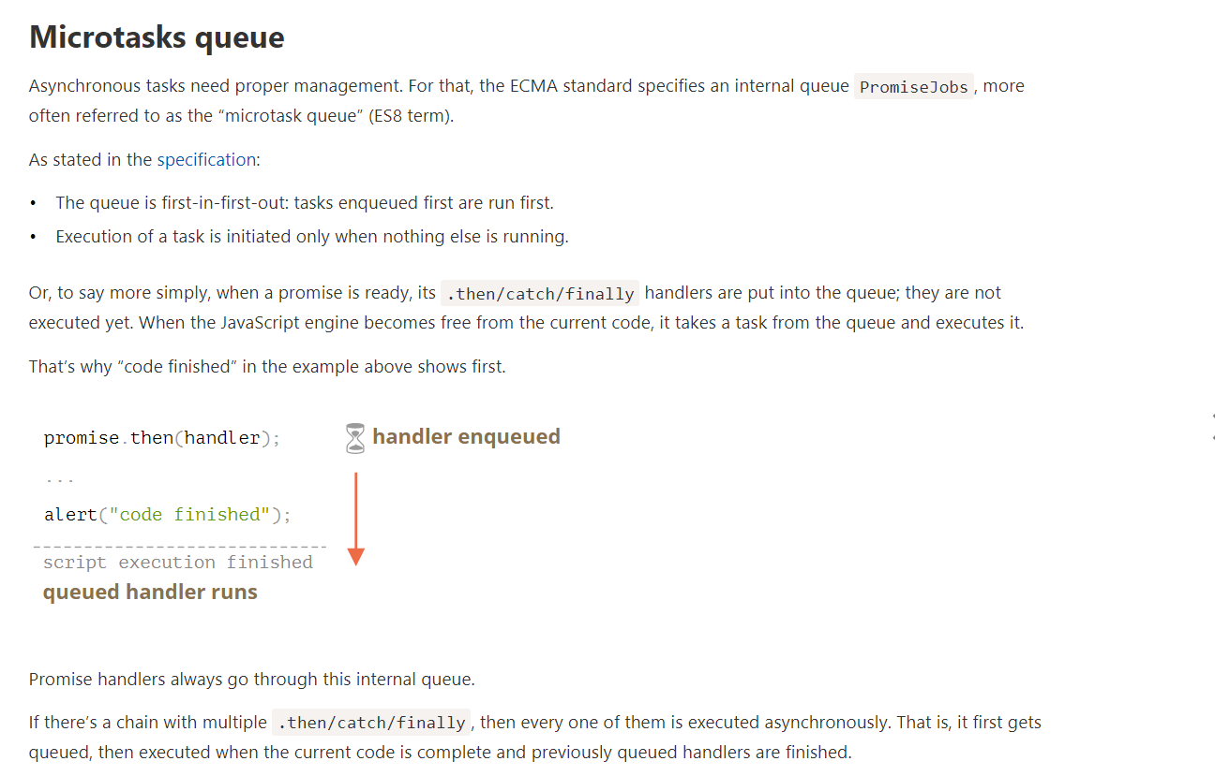

An “unhandled rejection” occurs when a promise error is not handled at the end of the microtask queue.
Normally, if we expect an error, we add .catch to the promise chain to handle it:

let promise = Promise.reject(new Error("Promise Failed!"));
promise.catch(err => alert('caught'));

// doesn't run: error handled
window.addEventListener('unhandledrejection', event => alert(event.reason));
But if we forget to add .catch, then, after the microtask queue is empty, the engine triggers the event:
let promise = Promise.reject(new Error("Promise Failed!"));

// Promise Failed!
window.addEventListener('unhandledrejection', event => alert(event.reason));
What if we handle the error later? Like this:

let promise = Promise.reject(new Error("Promise Failed!"));
setTimeout(() => promise.catch(err => alert('caught')), 1000);

// Error: Promise Failed!
window.addEventListener('unhandledrejection', event => alert(event.reason));
Now, if we run it, we’ll see Promise Failed! first and then caught.
If we didn’t know about the microtasks queue, we could wonder: “Why did unhandledrejection handler run? We did catch and handle the error!”
But now we understand that unhandledrejection is generated when the microtask queue is complete: the engine examines promises and, if any of them is in the “rejected” state, then the event triggers.
In the example above, .catch added by setTimeout also triggers. But it does so later, after unhandledrejection has already occurred, so it doesn’t change anything.

The word “async” before a function means one simple thing: a function always returns a promise. Other values are wrapped in a resolved promise automatically.
For instance, this function returns a resolved promise with the result of 1; let’s test it:
async function f() {
return 1;
}

f().then(alert); // 1
…We could explicitly return a promise, which would be the same:
async function f() {
return Promise.resolve(1);
}

f().then(alert); // 1

The syntax:
// works only inside async functions
let value = await promise;
The keyword await makes JavaScript wait until that promise settles and returns its result.

Let’s emphasize: await literally makes JavaScript wait until the promise settles, and then go on with the result. That doesn’t cost any CPU resources, because the engine can do other jobs in the meantime: execute other scripts, handle events, etc.
It’s just a more elegant syntax of getting the promise result than promise.then, easier to read and write.

If we try to use await in non-async function, there would be a syntax error:

function f() {
let promise = Promise.resolve(1);
let result = await promise; // Syntax error
}

We will get this error if we do not put async before a function. As said, await only works inside an async function.
eople who are just starting to use await tend to forget the fact that we can’t use await in top-level code. For example, this will not work:
// syntax error in top-level code
let response = await fetch('/article/promise-chaining/user.json');
let user = await response.json();
But we can wrap it into an anonymous async function, like this:
(async () => {
let response = await fetch('/article/promise-chaining/user.json');
let user = await response.json();
...
})();
Like promise.then, await allows us to use thenable objects (those with a callable then method). The idea is that a third-party object may not be a promise, but promise-compatible: if it supports .then, that’s enough to use it with await.

If await gets a non-promise object with .then, it calls that method providing the built-in functions resolve and reject as arguments (just as it does for a regular Promise executor). Then await waits until one of them is called (in the example above it happens in the line (*)) and then proceeds with the result.

To declare an async class method, just prepend it with async:

class Waiter {
async wait() {
return await Promise.resolve(1);
}
}

new Waiter()
.wait()
.then(alert); // 1
The meaning is the same: it ensures that the returned value is a promise and enables await.

If a promise resolves normally, then await promise returns the result. But in the case of a rejection, it throws the error, just as if there were a throw statement at that line.
When we use async/await, we rarely need .then, because await handles the waiting for us. And we can use a regular try..catch instead of .catch. That’s usually (but not always) more convenient.
But at the top level of the code, when we’re outside any async function, we’re syntactically unable to use await, so it’s a normal practice to add .then/catch to handle the final result or falling-through error, like in the line (*) of the example above.

When we need to wait for multiple promises, we can wrap them in Promise.all and then await:
// wait for the array of results
let results = await Promise.all([
fetch(url1),
fetch(url2),
...
]);

Generators can return (“yield”) multiple values, one after another, on-demand. They work great with iterables, allowing to create data streams with ease.
To create a generator, we need a special syntax construct: function*, so-called “generator function”.
It looks like this:
function* generateSequence() {
yield 1;
yield 2;
return 3;
}
Generator functions behave differently from regular ones. When such function is called, it doesn’t run its code. Instead it returns a special object, called “generator object”, to manage the execution.

The main method of a generator is next(). When called, it runs the execution until the nearest yield <value> statement (value can be omitted, then it’s undefined). Then the function execution pauses, and the yielded value is returned to the outer code.
The result of next() is always an object with two properties:
- value: the yielded value.
- done: true if the function code has finished, otherwise false.
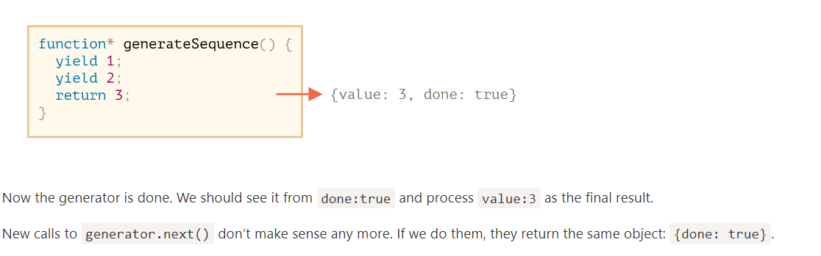

function* f(…) or function *f(…)?
Both syntaxes are correct.
But usually the first syntax is preferred, as the star * denotes that it’s a generator function, it describes the kind, not the name, so it should stick with the function keyword.
As you probably already guessed looking at the next() method, generators are iterable.
We can loop over their values using for..of:

It’s because for..of iteration ignores the last value, when done: true. So, if we want all results to be shown by for..of, we must return them with yield:

function* generateSequence() {
yield 1;
yield 2;
return 3;
}
function* generateSequence2() {
yield 1;
yield 2;
yield 3;
}

let generator = generateSequence();

for(let value of generator) {
alert(value); // 1, then 2
}
for(let value of generator2) {
alert(value); // 1, then 2 then 3
}

In the code above, ...generateSequence() turns the iterable generator object into an array of items (read more about the spread syntax in the chapter Rest parameters and spread syntax)

n the examples above we generated finite sequences, but we can also make a generator that yields values forever. For instance, an unending sequence of pseudo-random numbers.
That surely would require a break (or return) in for..of over such generator. Otherwise, the loop would repeat forever and hang.

enerator composition is a special feature of generators that allows to transparently “embed” generators in each other.
For instance, we have a function that generates a sequence of numbers:
function* generateSequence(start, end) {
for (let i = start; i <= end; i++) yield i;
}

or generators, there’s a special yield* syntax to “embed” (compose) one generator into another.

The composed generator:

function* generateSequence(start, end) {
for (let i = start; i <= end; i++) yield i;
}

function* generatePasswordCodes() {

// 0..9
yield* generateSequence(48, 57);

// A..Z
yield* generateSequence(65, 90);

// a..z
yield* generateSequence(97, 122);

}

let str = '';

for(let code of generatePasswordCodes()) {
str += String.fromCharCode(code);
}

alert(str); // 0..9A..Za..z
The yield* directive delegates the execution to another generator. This term means that yield* gen iterates over the generator gen and transparently forwards its yields outside. As if the values were yielded by the outer generator.

// yield* generateSequence(48, 57);
<=>
for (let i = 48; i <= 57; i++) yield i;

Until this moment, generators were similar to iterable objects, with a special syntax to generate values. But in fact they are much more powerful and flexible.
That’s because yield is a two-way street: it not only returns the result to the outside, but also can pass the value inside the generator.
To do so, we should call generator.next(arg), with an argument. That argument becomes the result of yield.
Let’s see an example:

function* gen() {
// Pass a question to the outer code and wait for an answer
let result = yield "2 + 2 = ?"; // (*)

alert(result);
}

let generator = gen();

let question = generator.next().value; // <-- yield returns the value

generator.next(4); // --> pass the result into the generator

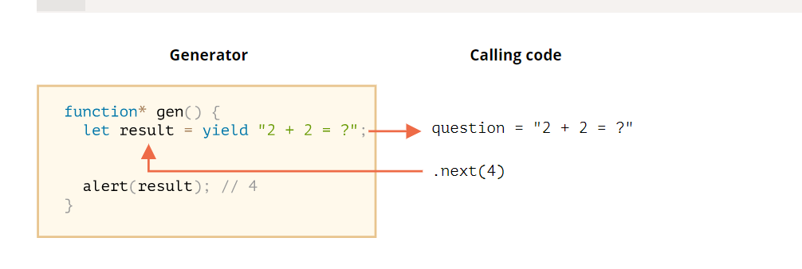
unction* gen() {
let ask1 = yield "2 + 2 = ?";

alert(ask1); // 4

let ask2 = yield "3 * 3 = ?"

alert(ask2); // 9
}

let generator = gen();

alert( generator.next().value ); // "2 + 2 = ?"

alert( generator.next(4).value ); // "3 * 3 = ?"

alert( generator.next(9).done ); // true

To pass an error into a yield, we should call generator.throw(err). In that case, the err is thrown in the line with that yield.
For instance, here the yield of "2 + 2 = ?" leads to an error:
function* gen() {
try {
let result = yield "2 + 2 = ?"; // (1)

alert("The execution does not reach here, because the exception is thrown above");
} catch(e) {
alert(e); // shows the error
}
}

let generator = gen();

let question = generator.next().value;

generator.throw(new Error("The answer is not found in my database")); // (2)
The error, thrown into the generator at line (2) leads to an exception in line (1) with yield. In the example above, try..catch catches it and shows it.
If we don’t catch it, then just like any exception, it “falls out” the generator into the calling code.
The current line of the calling code is the line with generator.throw, labelled as (2). So we can catch it here, like this:

function* generate() {
let result = yield "2 + 2 = ?"; // Error in this line
}

let generator = generate();

let question = generator.next().value;

try {
generator.throw(new Error("The answer is not found in my database"));
} catch(e) {
alert(e); // shows the error
}
If we don’t catch the error there, then, as usual, it falls through to the outer calling code (if any) and, if uncaught, kills the script.

We need to use Symbol.asyncIterator instead of Symbol.iterator.
- next() should return a promise.
- To iterate over such an object, we should use a for await (let item of iterable) loop.
Let’s make an iterable range object, like the one before, but now it will return values asynchronously, one per second:

let range = {
from: 1,
to: 5,

// for await..of calls this method once in the very beginning
[Symbol.asyncIterator]() { // (1)
// ...it returns the iterator object:
// onward, for await..of works only with that object,
// asking it for next values using next()
return {
current: this.from,
last: this.to,

// next() is called on each iteration by the for await..of loop
async next() { // (2)
// it should return the value as an object {done:.., value :...}
// (automatically wrapped into a promise by async)

// can use await inside, do async stuff:
await new Promise(resolve => setTimeout(resolve, 1000)); // (3)

if (this.current <= this.last) {
return { done: false, value: this.current++ };
} else {
return { done: true };
}
}
};
}
};

(async () => {

for await (let value of range) { // (4)
alert(value); // 1,2,3,4,5
}

})()
As we can see, the structure is similar to regular iterators:
- To make an object asynchronously iterable, it must have a method Symbol.asyncIterator (1).
- This method must return the object with next() method returning a promise (2).
- The next() method doesn’t have to be async, it may be a regular method returning a promise, but async allows us to use await, so that’s convenient. Here we just delay for a second (3).
- To iterate, we use for await(let value of range) (4), namely add “await” after “for”. It calls range[Symbol.asyncIterator]() once, and then its next() for values.
Here’s a small cheatsheet:
 | Iterators | Async iterators
Object method to provide iterator | Symbol.iterator | Symbol.asyncIterator
next() return value is | any value | Promise
to loop, use | for..of | for await..of
The spread syntax ... doesn’t work asynchronously
Features that require regular, synchronous iterators, don’t work with asynchronous ones.
For instance, a spread syntax won’t work:
alert( [...range] ); // Error, no Symbol.iterator
That’s natural, as it expects to find Symbol.iterator, same as for..of without await. Not Symbol.asyncIterator.

In regular generators we can’t use await. All values must come synchronously: there’s no place for delay in for..of, it’s a synchronous construct.
But what if we need to use await in the generator body? To perform network requests, for instance.
No problem, just prepend it with async, like this:

async function* generateSequence(start, end) {

for (let i = start; i <= end; i++) {

// yay, can use await!
await new Promise(resolve => setTimeout(resolve, 1000));

yield i;
}

}

(async () => {

let generator = generateSequence(1, 5);
for await (let value of generator) {
alert(value); // 1, then 2, then 3, then 4, then 5
}

})();

It’s indeed very simple. We add the async keyword, and the generator now can use await inside of it, rely on promises and other async functions.

echnically, another difference of an async generator is that its generator.next() method is now asynchronous also, it returns promises.
In a regular generator we’d use result = generator.next() to get values. In an async generator, we should add await, like this:
result = await generator.next(); // result = {value: ..., done: true/false}

As we already know, to make an object iterable, we should add Symbol.iterator to it.

let range = {
from: 1,
to: 5,
[Symbol.iterator]() {
return <object with next to make range iterable>
}
}

A common practice for Symbol.iterator is to return a generator, rather than a plain object with next as in the example before.
module from another one:
A module is just a file. One script is one module.
Modules can load each other and use special directives export and import to interchange functionality, call functions of one module from another one:
- export keyword labels variables and functions that should be accessible from outside the current module.
- import allows the import of functionality from other modules.
For instance, if we have a file sayHi.js exporting a function:
// 📁 sayHi.js
export function sayHi(user) {
alert(`Hello, ${user}!`);
}
…Then another file may import and use it:
// 📁 main.js
import {sayHi} from './sayHi.js';

alert(sayHi); // function...
sayHi('John'); // Hello, John!
The import directive loads the module by path ./sayHi.js relative to the current file, and assigns exported function sayHi to the corresponding variable.

If you try to open a web-page locally, via file:// protocol, you’ll find that import/export directives don’t work. Use a local web-server, such as static-server or use the “live server” capability of your editor, such as VS Code Live Server Extension to test them.

What’s different in modules, compared to “regular” scripts?
There are core features, valid both for browser and server-side JavaScript.

Always “use strict”
Modules always use strict, by default. E.g. assigning to an undeclared variable will give an error.

Module-level scope
Each module has its own top-level scope. In other words, top-level variables and functions from a module are not seen in other scripts.
Modules are expected to export what they want to be accessible from outside and import what they need.

If we really need to make a window-level global variable, we can explicitly assign it to window and access as window.user. But that’s an exception requiring a good reason.

A module code is evaluated only the first time when imported
If the same module is imported into multiple other places, its code is executed only the first time, then exports are given to all importers.

That’s kind of a minor feature, but for completeness we should mention it.
In a module, top-level this is undefined.

Module scripts are always deferred, same effect as defer attribute (described in the chapter Scripts: async, defer), for both external and inline scripts.
In other words:
- downloading external module scripts <script type="module" src="..."> doesn’t block HTML processing, they load in parallel with other resources.
- module scripts wait until the HTML document is fully ready (even if they are tiny and load faster than HTML), and then run.
- relative order of scripts is maintained: scripts that go first in the document, execute first.
As a side-effect, module scripts always “see” the fully loaded HTML-page, including HTML elements below them.

For instance:

<script type="module">
alert(typeof button); // object: the script can 'see' the button below
// as modules are deferred, the script runs after the whole page is loaded
</script>

Compare to regular script below:

<script>
alert(typeof button); // Error: button is undefined, the script can't see elements below
// regular scripts run immediately, before the rest of the page is processed
</script>

<button id="button">Button</button>
Please note: the second script actually runs before the first! So we’ll see undefined first, and then object.
That’s because modules are deferred, so we wait for the document to be processed. The regular script runs immediately, so we see its output first.
When using modules, we should be aware that the HTML page shows up as it loads, and JavaScript modules run after that, so the user may see the page before the JavaScript application is ready. Some functionality may not work yet. We should put “loading indicators”, or otherwise ensure that the visitor won’t be confused by that.

For non-module scripts, the async attribute only works on external scripts. Async scripts run immediately when ready, independently of other scripts or the HTML document.
For module scripts, it works on inline scripts as well.
For example, the inline script below has async, so it doesn’t wait for anything.
It performs the import (fetches ./analytics.js) and runs when ready, even if the HTML document is not finished yet, or if other scripts are still pending.

In the browser, import must get either a relative or absolute URL. Modules without any path are called “bare” modules. Such modules are not allowed in import.
For instance, this import is invalid:
import {sayHi} from 'sayHi'; // Error, "bare" module
// the module must have a path, e.g. './sayHi.js' or wherever the module is
Certain environments, like Node.js or bundle tools allow bare modules, without any path, as they have their own ways for finding modules and hooks to fine-tune them. But browsers do not support bare modules yet.

Compatibility, “nomodule”
Old browsers do not understand type="module". Scripts of an unknown type are just ignored. For them, it’s possible to provide a fallback using the nomodule attribute:
<script type="module">
alert("Runs in modern browsers");
</script>

<script nomodule>
alert("Modern browsers know both type=module and nomodule, so skip this")
alert("Old browsers ignore script with unknown type=module, but execute this.");
</script>

Build tools
In real-life, browser modules are rarely used in their “raw” form. Usually, we bundle them together with a special tool such as Webpack and deploy to the production server.
One of the benefits of using bundlers – they give more control over how modules are resolved, allowing bare modules and much more, like CSS/HTML modules.
Build tools do the following:
- Take a “main” module, the one intended to be put in <script type="module"> in HTML.
- Analyze its dependencies: imports and then imports of imports etc.
- Build a single file with all modules (or multiple files, that’s tunable), replacing native import calls with bundler functions, so that it works. “Special” module types like HTML/CSS modules are also supported.
- In the process, other transformations and optimizations may be applied:
  - Unreachable code removed.
  - Unused exports removed (“tree-shaking”).
  - Development-specific statements like console and debugger removed.
  - Modern, bleeding-edge JavaScript syntax may be transformed to older one with similar functionality using Babel.
  - The resulting file is minified (spaces removed, variables replaced with shorter names, etc).
If we use bundle tools, then as scripts are bundled together into a single file (or few files), import/export statements inside those scripts are replaced by special bundler functions. So the resulting “bundled” script does not contain any import/export, it doesn’t require type="module", and we can put it into a regular script:
<!-- Assuming we got bundle.js from a tool like Webpack -->
<script src="bundle.js"></script>
That said, native modules are also usable. So we won’t be using Webpack here: you can configure it later.

We can label any declaration as exported by placing export before it, be it a variable, function or a class.
For instance, here all exports are valid:

// export an array
export let months = ['Jan', 'Feb', 'Mar','Apr', 'Aug', 'Sep', 'Oct', 'Nov', 'Dec'];

// export a constant
export const MODULES_BECAME_STANDARD_YEAR = 2015;

// export a class
export class User {
constructor(name) {
this.name = name;
}
}

Please note that export before a class or a function does not make it a function expression. It’s still a function declaration, albeit exported.
Most JavaScript style guides don’t recommend semicolons after function and class declarations.
That’s why there’s no need for a semicolon at the end of export class and export function

Also, we can put export separately.
Here we first declare, and then export:

function sayHi(user) {
alert(`Hello, ${user}!`);
}

function sayBye(user) {
alert(`Bye, ${user}!`);
}

export {sayHi, sayBye}; // a list of exported variables

…Or, technically we could put export above functions as well.

Usually, we put a list of what to import in curly braces import {...}, like this:

// 📁 main.js
import {sayHi, sayBye} from './say.js';

sayHi('John'); // Hello, John!
sayBye('John'); // Bye, John!
But if there’s a lot to import, we can import everything as an object using import * as <obj>, for instance:

// 📁 main.js
import * as say from './say.js';

say.sayHi('John');
say.sayBye('John');

Modern build tools (webpack and others) bundle modules together and optimize them to speedup loading and remove unused stuff.
Let’s say, we added a 3rd-party library say.js to our project with many functions:
// 📁 say.js
export function sayHi() { ... }
export function sayBye() { ... }
export function becomeSilent() { ... }
Now if we only use one of say.js functions in our project:
// 📁 main.js
import {sayHi} from './say.js';
…Then the optimizer will see that and remove the other functions from the bundled code, thus making the build smaller. That is called “tree-shaking”.
- Explicitly listing what to import gives shorter names: sayHi() instead of say.sayHi().
- Explicit list of imports gives better overview of the code structure: what is used and where. It makes code support and refactoring easier.

We can also use as to import under different names.
For instance, let’s import sayHi into the local variable hi for brevity, and import sayBye as bye:

// 📁 main.js
import {sayHi as hi, sayBye as bye} from './say.js';

hi('John'); // Hello, John!

The similar syntax exists for export.
Now hi and bye are official names for outsiders, to be used in imports:

// 📁 main.js
import * as say from './say.js';

say.hi('John'); // Hello, John!
say.bye('John'); // Bye, John!

In practice, there are mainly two kinds of modules.
- Modules that contain a library, pack of functions, like say.js above.
- Modules that declare a single entity, e.g. a module user.js exports only class User.
Mostly, the second approach is preferred, so that every “thing” resides in its own module.
Naturally, that requires a lot of files, as everything wants its own module, but that’s not a problem at all. Actually, code navigation becomes easier if files are well-named and structured into folders.
Modules provide a special export default (“the default export”) syntax to make the “one thing per module” way look better.
Put export default before the entity to export:

// 📁 user.js
export default class User { // just add "default"
constructor(name) {
this.name = name;
}
}
There may be only one export default per file.
…And then import it without curly braces:

// 📁 main.js
import User from './user.js'; // not {User}, just User

new User('John');
Imports without curly braces look nicer. A common mistake when starting to use modules is to forget curly braces at all. So, remember, import needs curly braces for named exports and doesn’t need them for the default one.
Named export | Default export
export class User {...} | export default class User {...}
import {User} from ... | import User from ...
Technically, we may have both default and named exports in a single module, but in practice people usually don’t mix them. A module has either named exports or the default one.
As there may be at most one default export per file, the exported entity may have no name.
For instance, these are all perfectly valid default exports:
export default class { // no class name
constructor() { ... }
}
export default function(user) { // no function name
alert(`Hello, ${user}!`);
}
// export a single value, without making a variable
export default ['Jan', 'Feb', 'Mar','Apr', 'Aug', 'Sep', 'Oct', 'Nov', 'Dec'];
Not giving a name is fine, because there is only one export default per file, so import without curly braces knows what to import.
Without default, such an export would give an error:
export class { // Error! (non-default export needs a name)
constructor() {}
}

function sayHi(user) {
alert(`Hello, ${user}!`);
}

// same as if we added "export default" before the function
export {sayHi as default};

// 📁 user.js
export default class User {
constructor(name) {
this.name = name;
}
}

export function sayHi(user) {
alert(`Hello, ${user}!`);
}

And, finally, if importing everything * as an object, then the default property is exactly the default export:
// 📁 main.js
import * as user from './user.js';

let User = user.default; // the default export
new User('John');

import {default as User, sayHi} from './user.js';

new User('John');

…While for a default export, we always choose the name when importing:
import User from './user.js'; // works
import MyUser from './user.js'; // works too
// could be import Anything... and it'll still work
So team members may use different names to import the same thing, and that’s not good.
Usually, to avoid that and keep the code consistent, there’s a rule that imported variables should correspond to file names, e.g:
import User from './user.js';
import LoginForm from './loginForm.js';
import func from '/path/to/func.js';
...
Still, some teams consider it a serious drawback of default exports. So they prefer to always use named exports. Even if only a single thing is exported, it’s still exported under a name, without default.
Re-export” syntax export ... from ... allows to import things and immediately export them (possibly under another name), like this:
export {sayHi} from './say.js'; // re-export sayHi

export {default as User} from './user.js'; // re-export default
Why would that be needed? Let’s see a practical use case.
Imagine, we’re writing a “package”: a folder with a lot of modules, with some of the functionality exported outside (tools like NPM allow us to publish and distribute such packages), and many modules are just “helpers”, for internal use in other package modules.
The file structure could be like this:
auth/
index.js
user.js
helpers.js
tests/
login.js
providers/
github.js
facebook.js
...
We’d like to expose the package functionality via a single entry point, the “main file” auth/index.js, to be used like this:
import {login, logout} from 'auth/index.js'
The idea is that outsiders, developers who use our package, should not meddle with its internal structure, search for files inside our package folder. We export only what’s necessary in auth/index.js and keep the rest hidden from prying eyes.
As the actual exported functionality is scattered among the package, we can import it into auth/index.js and export from it:
// 📁 auth/index.js

// import login/logout and immediately export them
import {login, logout} from './helpers.js';
export {login, logout};

// import default as User and export it
import User from './user.js';
export {User};
...
Now users of our package can import {login} from "auth/index.js".
The syntax export ... from ... is just a shorter notation for such import-export:
// 📁 auth/index.js
// import login/logout and immediately export them
export {login, logout} from './helpers.js';

// import default as User and export it
export {default as User} from './user.js';
...

The default export needs separate handling when re-exporting.
export User from './user.js' won’t work. What can go wrong?… But that’s a syntax error!
To re-export the default export, we have to write export {default as User}, as in the example above.
- export * from './user.js' re-exports only named exports, but ignores the default one.
If we’d like to re-export both named and the default export, then two statements are needed:
export * from './user.js'; // to re-export named exports
export {default} from './user.js'; // to re-export the default export
Such oddities of re-exporting the default export are one of the reasons why some developers don’t like them.

Export and import statements that we covered in previous chapters are called “static”. The syntax is very simple and strict.
First, we can’t dynamically generate any parameters of import.
The module path must be a primitive string, can’t be a function call. This won’t work:
import ... from getModuleName(); // Error, only from "string" is allowed
Second, we can’t import conditionally or at run-time:
if(...) {
import ...; // Error, not allowed!
}

{
import ...; // Error, we can't put import in any block
}
That’s because import/export aim to provide a backbone for the code structure. That’s a good thing, as code structure can be analyzed, modules can be gathered and bundled into one file by special tools, unused exports can be removed (“tree-shaken”). That’s possible only because the structure of imports/exports is simple and fixed.
But how can we import a module dynamically, on-demand?
The import(module) expression loads the module and returns a promise that resolves into a module object that contains all its exports. It can be called from any place in the code.
We can use it dynamically in any place of the code, for instance:
let modulePath = prompt("Which module to load?");

import(modulePath)
.then(obj => <module object>)
.catch(err => <loading error, e.g. if no such module>)
Or, we could use let module = await import(modulePath) if inside an async function.
For instance, if we have the following module say.js:
// 📁 say.js
export function hi() {
alert(`Hello`);
}

export function bye() {
alert(`Bye`);
}
…Then dynamic import can be like this:
let {hi, bye} = await import('./say.js');

hi();
bye();
Or, if say.js has the default export:
// 📁 say.js
export default function() {
alert("Module loaded (export default)!");
}
…Then, in order to access it, we can use default property of the module object:
let obj = await import('./say.js');
let say = obj.default;
// or, in one line: let {default: say} = await import('./say.js');

say();

Dynamic imports work in regular scripts, they don’t require script type="module".
Please note:
Although import() looks like a function call, it’s a special syntax that just happens to use parentheses (similar to super()).
So we can’t copy import to a variable or use call/apply with it. It’s not a function.

L'objet Proxy est utilisé afin de définir un comportement sur mesure pour certaines opérations fondamentales (par exemple, l'accès aux propriétés, les affectations, les énumérations, les appels de fonctions, etc.)
A Proxy object wraps another object and intercepts operations, like reading/writing properties and others, optionally handling them on its own, or transparently allowing the object to handle them.

The syntax:
let proxy = new Proxy(target, handler)
- target – is an object to wrap, can be anything, including functions.
- handler – proxy configuration: an object with “traps”, methods that intercept operations. – e.g. get trap for reading a property of target, set trap for writing a property into target, and so on.
For operations on proxy, if there’s a corresponding trap in handler, then it runs, and the proxy has a chance to handle it, otherwise the operation is performed on target.

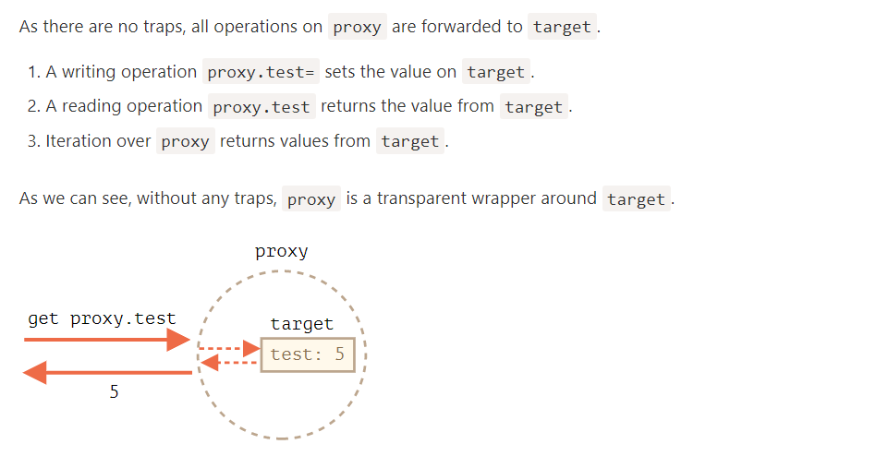
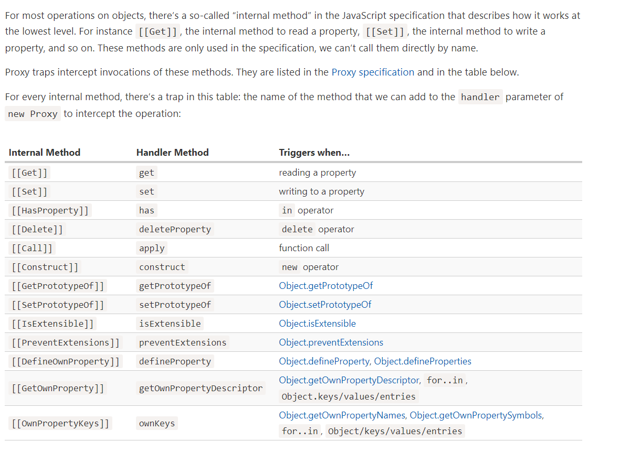

JavaScript enforces some invariants – conditions that must be fulfilled by internal methods and traps.
Most of them are for return values:
- [[Set]] must return true if the value was written successfully, otherwise false.
- [[Delete]] must return true if the value was deleted successfully, otherwise false.
- …and so on, we’ll see more in examples below.
There are some other invariants, like:
- [[GetPrototypeOf]], applied to the proxy object must return the same value as [[GetPrototypeOf]] applied to the proxy object’s target object. In other words, reading prototype of a proxy must always return the prototype of the target object.
Traps can intercept these operations, but they must follow these rules.
Invariants ensure correct and consistent behavior of language features. The full invariants list is in the specification. You probably won’t violate them if you’re not doing something weird.

The most common traps are for reading/writing properties.
To intercept reading, the handler should have a method get(target, property, receiver).
It triggers when a property is read, with following arguments:
- target – is the target object, the one passed as the first argument to new Proxy,
- property – property name,
- receiver – if the target property is a getter, then receiver is the object that’s going to be used as this in its call. Usually that’s the proxy object itself (or an object that inherits from it, if we inherit from proxy). Right now we don’t need this argument, so it will be explained in more detail later.
U sually when one tries to get a non-existing array item, they get undefined, but we’ll wrap a regular array into the proxy that traps reading and returns 0 if there’s no such property:

let numbers = [0, 1, 2];

numbers = new Proxy(numbers, {
get(target, prop) {
if (prop in target) {
return target[prop];
} else {
return 0; // default value
}
}
});

alert( numbers[1] ); // 1
alert( numbers[123] ); // 0 (no such item)

We can use Proxy to implement any logic for “default” values.
dictionary = new Proxy(dictionary, {
get(target, phrase) { // intercept reading a property from dictionary
if (phrase in target) { // if we have it in the dictionary
return target[phrase]; // return the translation
} else {
// otherwise, return the non-translated phrase
return phrase;
}
}

Please note how the proxy overwrites the variable:
dictionary = new Proxy(dictionary, ...);
The proxy should totally replace the target object everywhere. No one should ever reference the target object after it got proxied. Otherwise it’s easy to mess up.

Let’s say we want an array exclusively for numbers. If a value of another type is added, there should be an error.
The set trap triggers when a property is written.
set(target, property, value, receiver):
- target – is the target object, the one passed as the first argument to new Proxy,
- property – property name,
- value – property value,
- receiver – similar to get trap, matters only for setter properties.
The set trap should return true if setting is successful, and false otherwise (triggers TypeError).

umbers = new Proxy(numbers, { // (*)
set(target, prop, val) { // to intercept property writing
if (typeof val == 'number') {
target[prop] = val;
return true;
} else {
return false;
}
}
});

numbers.push(1); // added successfully
numbers.push(2); // added successfully
alert("Length is: " + numbers.length); // 2

numbers.push("test"); // TypeError ('set' on proxy returned false)
alert("This line is never reached (error in the line above)");
We don’t have to override value-adding array methods like push and unshift, and so on, to add checks in there, because internally they use the [[Set]] operation that’s intercepted by the proxy.

For set, it must return true for a successful write.
If we forget to do it or return any falsy value, the operation triggers TypeError.

Object.keys, for..in loop and most other methods that iterate over object properties use [[OwnPropertyKeys]] internal method (intercepted by ownKeys trap) to get a list of properties.
Such methods differ in details:
- Object.getOwnPropertyNames(obj) returns non-symbol keys.
- Object.getOwnPropertySymbols(obj) returns symbol keys.
- Object.keys/values() returns non-symbol keys/values with enumerable flag (property flags were explained in the article Property flags and descriptors).
- for..in loops over non-symbol keys with enumerable flag, and also prototype keys.

In the example below we use ownKeys trap to make for..in loop over user, and also Object.keys and Object.values, to skip properties starting with an underscore _:

let user = {
name: "John",
age: 30,
_password: "***"
};

user = new Proxy(user, {
ownKeys(target) {
return Object.keys(target).filter(key => !key.startsWith('_'));
}
});

// "ownKeys" filters out _password
for(let key in user) alert(key); // name, then: age

Although, if we return a key that doesn’t exist in the object, Object.keys won’t list it:

let user = { };

user = new Proxy(user, {
ownKeys(target) {
return ['a', 'b', 'c'];
}
});

alert( Object.keys(user) ); // <empty>
Why? The reason is simple: Object.keys returns only properties with the enumerable flag. To check for it, it calls the internal method [[GetOwnProperty]] for every property to get its descriptor. And here, as there’s no property, its descriptor is empty, no enumerable flag, so it’s skipped.
For Object.keys to return a property, we need it to either exist in the object, with the enumerable flag, or we can intercept calls to [[GetOwnProperty]] (the trap getOwnPropertyDescriptor does it), and return a descriptor with enumerable: true.
let user = { };

user = new Proxy(user, {
ownKeys(target) { // called once to get a list of properties
return ['a', 'b', 'c'];
},

getOwnPropertyDescriptor(target, prop) { // called for every property
return {
enumerable: true,
configurable: true
/* ...other flags, probable "value:..." */
};
}

});

alert( Object.keys(user) ); // a, b, c

Let’s note once again: we only need to intercept [[GetOwnProperty]] if the property is absent in the object.
Protected properties with “deleteProperty” and other traps
There’s a widespread convention that properties and methods prefixed by an underscore _ are internal. They shouldn’t be accessed from outside the object.
We’ll need the traps:
- get to throw an error when reading such property,
- set to throw an error when writing,
- deleteProperty to throw an error when deleting,
- ownKeys to exclude properties starting with _ from for..in and methods like Object.keys.
Here’s the code:

let user = {
name: "John",
_password: "***"
};

user = new Proxy(user, {
get(target, prop) {
if (prop.startsWith('_')) {
throw new Error("Access denied");
}
let value = target[prop];
return (typeof value === 'function') ? value.bind(target) : value; // (*)
},
set(target, prop, val) { // to intercept property writing
if (prop.startsWith('_')) {
throw new Error("Access denied");
} else {
target[prop] = val;
return true;
}
},
deleteProperty(target, prop) { // to intercept property deletion
if (prop.startsWith('_')) {
throw new Error("Access denied");
} else {
delete target[prop];
return true;
}
},
ownKeys(target) { // to intercept property list
return Object.keys(target).filter(key => !key.startsWith('_'));
}
});

// "get" doesn't allow to read _password
try {
alert(user._password); // Error: Access denied
} catch(e) { alert(e.message); }

// "set" doesn't allow to write _password
try {
user._password = "test"; // Error: Access denied
} catch(e) { alert(e.message); }

// "deleteProperty" doesn't allow to delete _password
try {
delete user._password; // Error: Access denied
} catch(e) { alert(e.message); }

// "ownKeys" filters out _password
for(let key in user) alert(key); // name
Please note the important detail in the get trap, in the line (*):

get(target, prop) {
// ...
let value = target[prop];
return (typeof value === 'function') ? value.bind(target) : value; // (*)
}
Why do we need a function to call value.bind(target)?
The reason is that object methods, such as user.checkPassword(), must be able to access _password:
user = {
// ...
checkPassword(value) {
// object method must be able to read _password
return value === this._password;
}
}
A call to user.checkPassword() call gets proxied user as this (the object before dot becomes this), so when it tries to access this._password, the get trap activates (it triggers on any property read) and throws an error.
So we bind the context of object methods to the original object, target, in the line (*). Then their future calls will use target as this, without any traps.
That solution usually works, but isn’t ideal, as a method may pass the unproxied object somewhere else, and then we’ll get messed up: where’s the original object, and where’s the proxied one?
Besides, an object may be proxied multiple times (multiple proxies may add different “tweaks” to the object), and if we pass an unwrapped object to a method, there may be unexpected consequences.
So, such a proxy shouldn’t be used everywhere.
Private properties of a class
Modern JavaScript engines natively support private properties in classes, prefixed with #. They are described in the article Private and protected properties and methods. No proxies required.
Such properties have their own issues though. In particular, they are not inherited.
We’d like to use the in operator to check that a number is in range.
The has trap intercepts in calls.
has(target, property)
- target – is the target object, passed as the first argument to new Proxy,
- property – property name
Here’s the demo:

let range = {
start: 1,
end: 10
};

range = new Proxy(range, {
has(target, prop) {
return prop >= target.start && prop <= target.end;
}
});
e can wrap a proxy around a function as well.
The apply(target, thisArg, args) trap handles calling a proxy as function:
- target is the target object (function is an object in JavaScript),
- thisArg is the value of this.
- args is a list of arguments.
For example, let’s recall delay(f, ms) decorator, that we did in the article Decorators and forwarding, call/apply.

But a wrapper function does not forward property read/write operations or anything else. After the wrapping, the access is lost to properties of the original functions, such as name, length and others:

function delay(f, ms) {
return new Proxy(f, {
apply(target, thisArg, args) {
setTimeout(() => target.apply(thisArg, args), ms);
}
});
}
function sayHi(user) {
alert(`Hello, ${user}!`);
}

sayHi = delay(sayHi, 3000);

alert(sayHi.length); // 1 (*) proxy forwards "get length" operation to the target

sayHi("John"); // Hello, John! (after 3 seconds)

Reflect us a built-in object that simplifies creation of Proxy
It was said previously that internal methods, such as [[Get]], [[Set]] and others are specification-only, they can’t be called directly.
The Reflect object makes that somewhat possible. Its methods are minimal wrappers around the internal methods.
Here are examples of operations and Reflect calls that do the same:
Operation | Reflect call | Internal method
obj[prop] | Reflect.get(obj, prop) | [[Get]]
obj[prop] = value | Reflect.set(obj, prop, value) | [[Set]]
delete obj[prop] | Reflect.deleteProperty(obj, prop) | [[Delete]]
new F(value) | Reflect.construct(F, value) | [[Construct]]
… | … | …
For example:
let user = {};

Reflect.set(user, 'name', 'John');

alert(user.name); // John
In particular, Reflect allows us to call operators (new, delete…) as functions (Reflect.construct, Reflect.deleteProperty, …). That’s an interesting capability, but here another thing is important.
For every internal method, trappable by Proxy, there’s a corresponding method in Reflect, with the same name and arguments as the Proxy trap.
So we can use Reflect to forward an operation to the original object.
In this example, both traps get and set transparently (as if they didn’t exist) forward reading/writing operations to the object, showing a message:

let user = {
name: "John",
};

user = new Proxy(user, {
get(target, prop, receiver) {
alert(`GET ${prop}`);
return Reflect.get(target, prop, receiver); // (1)
},
set(target, prop, val, receiver) {
alert(`SET ${prop}=${val}`);
return Reflect.set(target, prop, val, receiver); // (2)
}
});

let name = user.name; // shows "GET name"
user.name = "Pete"; // shows "SET name=Pete"

That is, everything’s simple: if a trap wants to forward the call to the object, it’s enough to call Reflect.<method> with the same arguments.
In most cases we can do the same without Reflect, for instance, reading a property Reflect.get(target, prop, receiver) can be replaced by target[prop]. There are important nuances though.

Let’s see an example that demonstrates why Reflect.get is better. And we’ll also see why get/set have the third argument receiver, that we didn’t use before.

let user = {
_name: "Guest",
get name() {
return this._name;
}
};

let userProxy = new Proxy(user, {
get(target, prop, receiver) {
return target[prop]; // (*) target = user
}
});

let admin = {
__proto__: userProxy,
_name: "Admin"
};

// Expected: Admin
alert(admin.name); // outputs: Guest (?!?)

The problem is actually in the proxy, in the line (*).
- When we read admin.name, as admin object doesn’t have such own property, the search goes to its prototype.
- The prototype is userProxy.
- When reading name property from the proxy, its get trap triggers and returns it from the original object as target[prop] in the line (*).
A call to target[prop], when prop is a getter, runs its code in the context this=target. So the result is this._name from the original object target, that is: from user.
To fix such situations, we need receiver, the third argument of get trap. It keeps the correct this to be passed to a getter. In our case that’s admin.
How to pass the context for a getter? For a regular function we could use call/apply, but that’s a getter, it’s not “called”, just accessed.
Reflect.get can do that. Everything will work right if we use it.
let userProxy = new Proxy(user, {
get(target, prop, receiver) { // receiver = admin
return Reflect.get(target, prop, receiver); // (*)
}
});

get(target, prop, receiver) {
return Reflect.get(...arguments);
}

Reflect calls are named exactly the same way as traps and accept the same arguments. They were specifically designed this way.
So, return Reflect... provides a safe no-brainer to forward the operation and make sure we don’t forget anything related to that.

Many built-in objects, for example Map, Set, Date, Promise and others make use of so-called “internal slots”.
These are like properties, but reserved for internal, specification-only purposes. For instance, Map stores items in the internal slot [[MapData]]. Built-in methods access them directly, not via [[Get]]/[[Set]] internal methods. So Proxy can’t intercept that.

Example :
let map = new Map();

let proxy = new Proxy(map, {});

proxy.set('test', 1); // Error

Internally, a Map stores all data in its [[MapData]] internal slot. The proxy doesn’t have such a slot. The built-in method Map.prototype.set method tries to access the internal property this.[[MapData]], but because this=proxy, can’t find it in proxy and just fails.
Fortunately, there’s a way to fix it:

let map = new Map();

let proxy = new Proxy(map, {
get(target, prop, receiver) {
let value = Reflect.get(...arguments);
return typeof value == 'function' ? value.bind(target) : value;
}
});

proxy.set('test', 1);
alert(proxy.get('test')); // 1 (works!)
Now it works fine, because get trap binds function properties, such as map.set, to the target object (map) itself.
Unlike the previous example, the value of this inside proxy.set(...) will be not proxy, but the original map. So when the internal implementation of set tries to access this.[[MapData]] internal slot, it succeeds.
A notable exception: built-in Array doesn’t use internal slots. That’s for historical reasons, as it appeared so long ago.
So there’s no such problem when proxying an array.

The similar thing happens with private class fields.
For example, getName() method accesses the private #name property and breaks after proxying:
The reason is that private fields are implemented using internal slots. JavaScript does not use [[Get]]/[[Set]] when accessing them.
In the call getName() the value of this is the proxied user, and it doesn’t have the slot with private fields.
Once again, the solution with binding the method makes it work:
class User {
#name = "Guest";

getName() {
return this.#name;
}
}

let user = new User();

user = new Proxy(user, {
get(target, prop, receiver) {
let value = Reflect.get(...arguments);
return typeof value == 'function' ? value.bind(target) : value;
}
});

alert(user.getName()); // Guest
That said, the solution has drawbacks, as explained previously: it exposes the original object to the method, potentially allowing it to be passed further and breaking other proxied functionality.

The proxy and the original object are different objects. That’s natural, right?
So if we use the original object as a key, and then proxy it, then the proxy can’t be found:

let allUsers = new Set();

class User {
constructor(name) {
this.name = name;
allUsers.add(this);
}
}

let user = new User("John");

alert(allUsers.has(user)); // true

user = new Proxy(user, {});

alert(allUsers.has(user)); // false
As we can see, after proxying we can’t find user in the set allUsers, because the proxy is a different object.

Proxies can’t intercept a strict equality test ===
Proxies can intercept many operators, such as new (with construct), in (with has), delete (with deleteProperty) and so on.
But there’s no way to intercept a strict equality test for objects. An object is strictly equal to itself only, and no other value.
So all operations and built-in classes that compare objects for equality will differentiate between the object and the proxy. No transparent replacement here.

A revocable proxy is a proxy that can be disabled.
Let’s say we have a resource, and would like to close access to it any moment.
What we can do is to wrap it into a revocable proxy, without any traps. Such a proxy will forward operations to object, and we can disable it at any moment.
The syntax is:
let {proxy, revoke} = Proxy.revocable(target, handler)
The call returns an object with the proxy and revoke function to disable it.
Here’s an example:
let object = {
data: "Valuable data"
};

let {proxy, revoke} = Proxy.revocable(object, {});

// pass the proxy somewhere instead of object...
alert(proxy.data); // Valuable data

// later in our code
revoke();

// the proxy isn't working any more (revoked)
alert(proxy.data); // Error
A call to revoke() removes all internal references to the target object from the proxy, so they are no more connected. The target object can be garbage-collected after that.
We can also store revoke in a WeakMap, to be able to easily find it by a proxy object:
let revokes = new WeakMap();

let object = {
data: "Valuable data"
};

let {proxy, revoke} = Proxy.revocable(object, {});

revokes.set(proxy, revoke);

// ..later in our code..
revoke = revokes.get(proxy);
revoke();

alert(proxy.data); // Error (revoked)
The benefit of such an approach is that we don’t have to carry revoke around. We can get it from the map by proxy when needed.
We use WeakMap instead of Map here because it won’t block garbage collection. If a proxy object becomes “unreachable” (e.g. no variable references it any more), WeakMap allows it to be wiped from memory together with its revoke that we won’t need any more.

The built-in eval function allows to execute a string of code.
The syntax is:
let result = eval(code);

A string of code may be long, contain line breaks, function declarations, variables and so on.
The result of eval is the result of the last statement.
The eval’ed code is executed in the current lexical environment, so it can see outer variables:
In strict mode, eval has its own lexical environment. So functions and variables, declared inside eval, are not visible outside:
// reminder: 'use strict' is enabled in runnable examples by default

eval("let x = 5; function f() {}");

alert(typeof x); // undefined (no such variable)
// function f is also not visible
Without use strict, eval doesn’t have its own lexical environment, so we would see x and f outside.
Code minifiers (tools used before JS gets to production, to compress it) rename local variables into shorter ones (like a, b etc) to make the code smaller. That’s usually safe, but not if eval is used, as local variables may be accessed from eval’ed code string. So minifiers don’t do that renaming for all variables potentially visible from eval. That negatively affects code compression ratio.
Using outer local variables inside eval is also considered a bad programming practice, as it makes maintaining the code more difficult.
There are two ways how to be totally safe from such problems.
If eval’ed code doesn’t use outer variables, please call eval as window.eval(...):
This way the code is executed in the global scope:
let x = 1;
{
let x = 5;
window.eval('alert(x)'); // 1 (global variable)
}
If eval’ed code needs local variables, change eval to new Function and pass them as arguments:
let f = new Function('a', 'alert(a)');

f(5); // 5
The new Function construct is explained in the chapter The "new Function" syntax. It creates a function from a string, also in the global scope. So it can’t see local variables. But it’s so much clearer to pass them explicitly as arguments, like in the example above.

Currying is an advanced technique of working with functions. It’s used not only in JavaScript, but in other languages as well.
Currying is a transformation of functions that translates a function from callable as f(a, b, c) into callable as f(a)(b)(c).
Currying doesn’t call a function. It just transforms it.

function curry(f) { // curry(f) does the currying transform
return function(a) {
return function(b) {
return f(a, b);
};
};
}

// usage
function sum(a, b) {
return a + b;
}

let curriedSum = curry(sum);

alert( curriedSum(1)(2) ); // 3

More advanced implementations of currying, such as _.curry from lodash library, return a wrapper that allows a function to be called both normally and partially:
function sum(a, b) {
return a + b;
}

let curriedSum = _.curry(sum); // using _.curry from lodash library

alert( curriedSum(1, 2) ); // 3, still callable normally
alert( curriedSum(1)(2) ); // 3, called partially

function curry(func) {

return function curried(...args) {
if (args.length >= func.length) {
return func.apply(this, args);
} else {
return function(...args2) {
return curried.apply(this, args.concat(args2));
}
}
};

}

function sum(a, b, c) {
return a + b + c;
}

let curriedSum = curry(sum);

alert( curriedSum(1, 2, 3) ); // 6, still callable normally
alert( curriedSum(1)(2,3) ); // 6, currying of 1st arg
alert( curriedSum(1)(2)(3) ); // 6, full currying

When we run it, there are two if execution branches:
- Call now: if passed args count is the same as the original function has in its definition (func.length) or longer, then just pass the call to it.
- Get a partial: otherwise, func is not called yet. Instead, another wrapper pass is returned, that will re-apply curried providing previous arguments together with the new ones. Then on a new call, again, we’ll get either a new partial (if not enough arguments) or, finally, the result.

Fixed-length functions only
The currying requires the function to have a fixed number of arguments.
A function that uses rest parameters, such as f(...args), can’t be curried this way.
A little more than currying
By definition, currying should convert sum(a, b, c) into sum(a)(b)(c).
But most implementations of currying in JavaScript are advanced, as described: they also keep the function callable in the multi-argument variant.
As you can see, the call results in an error, because the value of "this" inside the call becomes undefined.
This works (object dot method):
user.hi();
This doesn’t (evaluated method):
(user.name == "John" ? user.hi : user.bye)(); // Error!
Looking closely, we may notice two operations in obj.method() statement:
- First, the dot '.' retrieves the property obj.method.
- Then parentheses () execute it.
So, how does the information about this get passed from the first part to the second one?
If we put these operations on separate lines, then this will be lost for sure:

let user = {
name: "John",
hi() { alert(this.name); }
}

// split getting and calling the method in two lines
let hi = user.hi;
hi(); // Error, because this is undefined
Here hi = user.hi puts the function into the variable, and then on the last line it is completely standalone, and so there’s no this.
To make user.hi() calls work, JavaScript uses a trick – the dot '.' returns not a function, but a value of the special Reference Type.
The Reference Type is a “specification type”. We can’t explicitly use it, but it is used internally by the language.
The value of Reference Type is a three-value combination (base, name, strict), where:
- base is the object.
- name is the property name.
- strict is true if use strict is in effect.
The result of a property access user.hi is not a function, but a value of Reference Type. For user.hi in strict mode it is:
// Reference Type value
(user, "hi", true)
When parentheses () are called on the Reference Type, they receive the full information about the object and its method, and can set the right this (=user in this case).
Reference type is a special “intermediary” internal type, with the purpose to pass information from dot . to calling parentheses ().
Any other operation like assignment hi = user.hi discards the reference type as a whole, takes the value of user.hi (a function) and passes it on. So any further operation “loses” this.
So, as the result, the value of this is only passed the right way if the function is called directly using a dot obj.method() or square brackets obj['method']() syntax (they do the same here). Later in this tutorial, we will learn various ways to solve this problem such as func.bind().

BigInt is a special numeric type that provides support for integers of arbitrary length.
A bigint is created by appending n to the end of an integer literal or by calling the function BigInt that creates bigints from strings, numbers etc.

Please note: the division 5/2 returns the result rounded towards zero, without the decimal part. All operations on bigints return bigints.
We can’t mix bigints and regular numbers:
alert(1n + 2); // Error: Cannot mix BigInt and other types
We should explicitly convert them if needed: using either BigInt() or Number(), like this:
let bigint = 1n;

The conversion operations are always silent, never give errors, but if the bigint is too huge and won’t fit the number type, then extra bits will be cut off, so we should be careful doing such conversion.
The unary plus is not supported on bigints
The unary plus operator +value is a well-known way to convert value to a number.
On bigints it’s not supported, to avoid confusion:
let bigint = 1n;

alert( +bigint ); // error
So we should use Number() to convert a bigint to a number.

Please note though, as numbers and bigints belong to different types, they can be equal ==, but not strictly equal ===:
alert( 1 == 1n ); // true

alert( 1 === 1n ); // false

Polyfilling bigints is tricky. The reason is that many JavaScript operators, such as +, - and so on behave differently with bigints compared to regular numbers.
For example, division of bigints always returns a bigint (rounded if necessary).
To emulate such behavior, a polyfill would need to analyze the code and replace all such operators with its functions. But doing so is cumbersome and would cost a lot of performance.
So, there’s no well-known good polyfill.
Although, the other way around is proposed by the developers of JSBI library.
This library implements big numbers using its own methods. We can use them instead of native bigints:
Operation | native BigInt | JSBI
Creation from Number | a = BigInt(789) | a = JSBI.BigInt(789)
Addition | c = a + b | c = JSBI.add(a, b)
Subtraction | c = a - b | c = JSBI.subtract(a, b)
… | … | …
…And then use the polyfill (Babel plugin) to convert JSBI calls to native bigints for those browsers that support them.
In other words, this approach suggests that we write code in JSBI instead of native bigints. But JSBI works with numbers as with bigints internally, emulates them closely following the specification, so the code will be “bigint-ready”.
We can use such JSBI code “as is” for engines that don’t support bigints and for those that do support – the polyfill will convert the calls to native bigints.
l
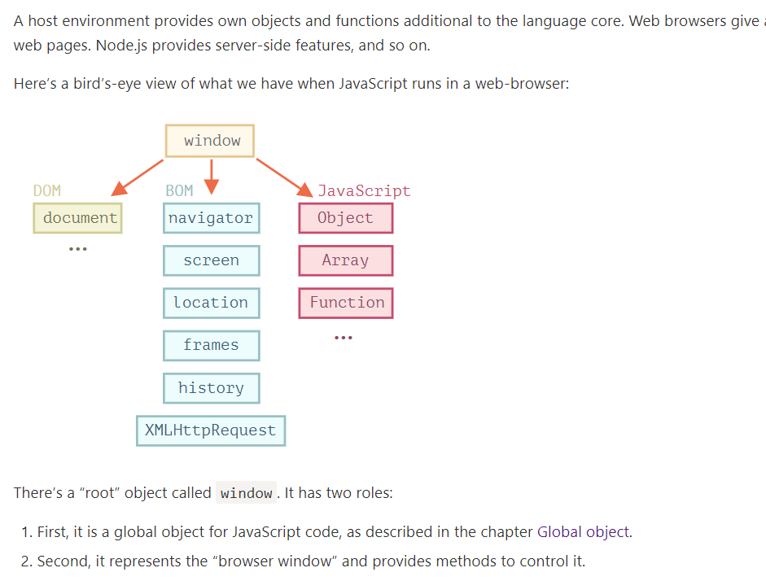

DOM (Document Object Model)
Document Object Model, or DOM for short, represents all page content as objects that can be modified.
The document object is the main “entry point” to the page. We can change or create anything on the page using it.
For instance:
// change the background color to red
document.body.style.background = "red";

// change it back after 1 second
setTimeout(() => document.body.style.background = "", 1000);
Here we used document.body.style, but there’s much, much more. Properties and methods are described in the specification:
- DOM Living Standard at https://dom.spec.whatwg.org
DOM is not only for browsers
The DOM specification explains the structure of a document and provides objects to manipulate it. There are non-browser instruments that use DOM too.
For instance, server-side scripts that download HTML pages and process them can also use DOM. They may support only a part of the specification though.

CSSOM for styling
CSS rules and stylesheets are structured in a different way than HTML. There’s a separate specification, CSS Object Model (CSSOM), that explains how they are represented as objects, and how to read and write them.
CSSOM is used together with DOM when we modify style rules for the document. In practice though, CSSOM is rarely required, because usually CSS rules are static. We rarely need to add/remove CSS rules from JavaScript, but that’s also possible.
The Browser Object Model (BOM) represents additional objects provided by the browser (host environment) for working with everything except the document.
For instance:
- The navigator object provides background information about the browser and the operating system. There are many properties, but the two most widely known are: navigator.userAgent – about the current browser, and navigator.platform – about the platform (can help to differ between Windows/Linux/Mac etc).
- The location object allows us to read the current URL and can redirect the browser to a new one.
Here’s how we can use the location object:
alert(location.href); // shows current URL
if (confirm("Go to Wikipedia?")) {
location.href = "https://wikipedia.org"; // redirect the browser to another URL
}
Functions alert/confirm/prompt are also a part of BOM: they are directly not related to the document, but represent pure browser methods of communicating with the user.
Specifications
BOM is the part of the general HTML specification.
Yes, you heard that right. The HTML spec at https://html.spec.whatwg.org is not only about the “HTML language” (tags, attributes), but also covers a bunch of objects, methods and browser-specific DOM extensions. That’s “HTML in broad terms”. Also, some parts have additional specs listed at https://spec.whatwg.or

The backbone of an HTML document is tags.
According to the Document Object Model (DOM), every HTML tag is an object. Nested tags are “children” of the enclosing one. The text inside a tag is an object as well.
All these objects are accessible using JavaScript, and we can use them to modify the page.
For example, document.body is the object representing the <body> tag.
Running this code will make the <body> red for 3 seconds:
document.body.style.background = 'red'; // make the background red

setTimeout(() => document.body.style.background = '', 3000); // return back

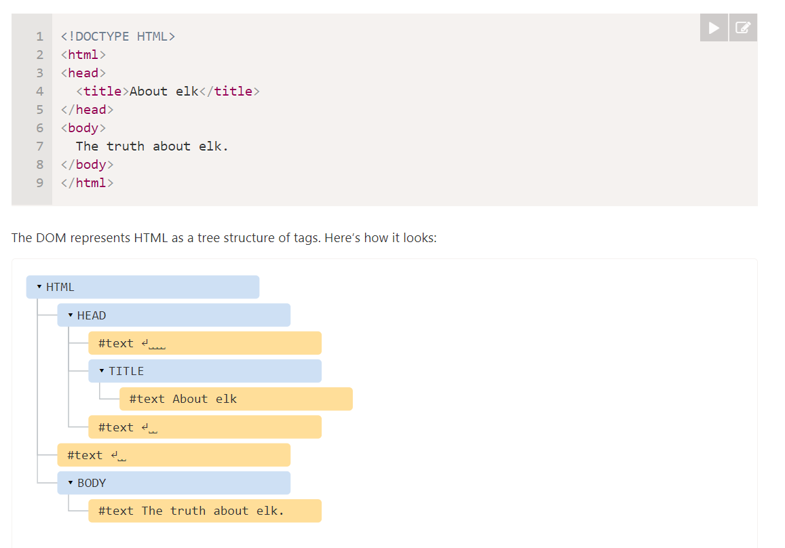
Every tree node is an object.
Tags are element nodes (or just elements) and form the tree structure: <html> is at the root, then <head> and <body> are its children, etc.
The text inside elements forms text nodes, labelled as #text. A text node contains only a string. It may not have children and is always a leaf of the tree.
For instance, the <title> tag has the text "About elk".
Spaces and newlines are totally valid characters, like letters and digits. They form text nodes and become a part of the DOM. So, for instance, in the example above the <head> tag contains some spaces before <title>, and that text becomes a #text node (it contains a newline and some spaces only).
There are only two top-level exclusions:
- Spaces and newlines before <head> are ignored for historical reasons.
- If we put something after </body>, then that is automatically moved inside the body, at the end, as the HTML spec requires that all content must be inside <body>. So there can’t be any spaces after </body>.
In other cases everything’s straightforward – if there are spaces (just like any character) in the document, then they become text nodes in the DOM, and if we remove them, then there won’t be any.

Browser tools (to be covered soon) that work with DOM usually do not show spaces at the start/end of the text and empty text nodes (line-breaks) between tags.
Developer tools save screen space this way.
On further DOM pictures we’ll sometimes omit them when they are irrelevant. Such spaces usually do not affect how the document is displayed.
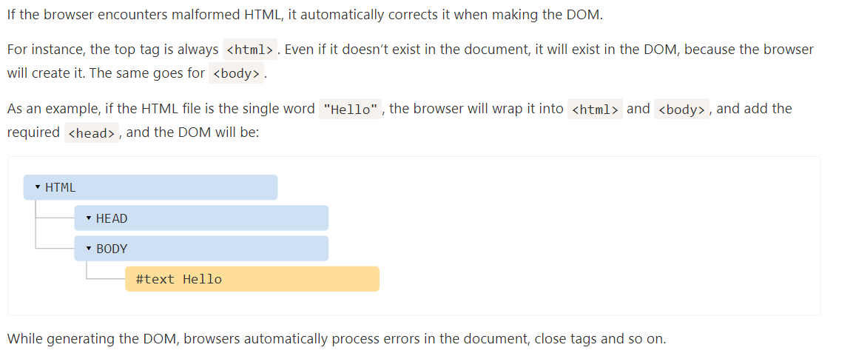
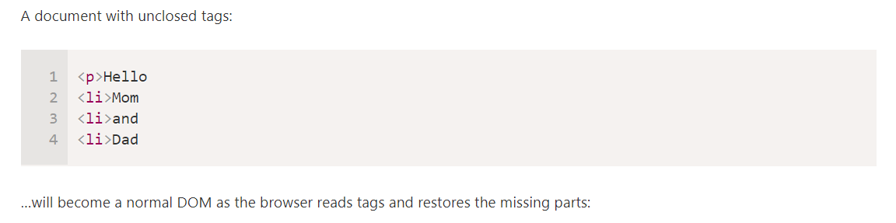

An interesting “special case” is tables. By the DOM specification they must have <tbody>, but HTML text may (officially) omit it. Then the browser creates <tbody> in the DOM automatically.

There are some other node types besides elements and text nodes.
For example, comments:
We can see here a new tree node type – comment node, labeled as #comment, between two text nodes.
We may think – why is a comment added to the DOM? It doesn’t affect the visual representation in any way. But there’s a rule – if something’s in HTML, then it also must be in the DOM tree.
Everything in HTML, even comments, becomes a part of the DOM.
Even the <!DOCTYPE...> directive at the very beginning of HTML is also a DOM node. It’s in the DOM tree right before <html>. We are not going to touch that node, we even don’t draw it on diagrams for that reason, but it’s there.
The document object that represents the whole document is, formally, a DOM node as well.
There are 12 node types. In practice we usually work with 4 of them:
- document – the “entry point” into DOM.
- element nodes – HTML-tags, the tree building blocks.
- text nodes – contain text.
- comments – sometimes we can put information there, it won’t be shown, but JS can read it from the DOM.
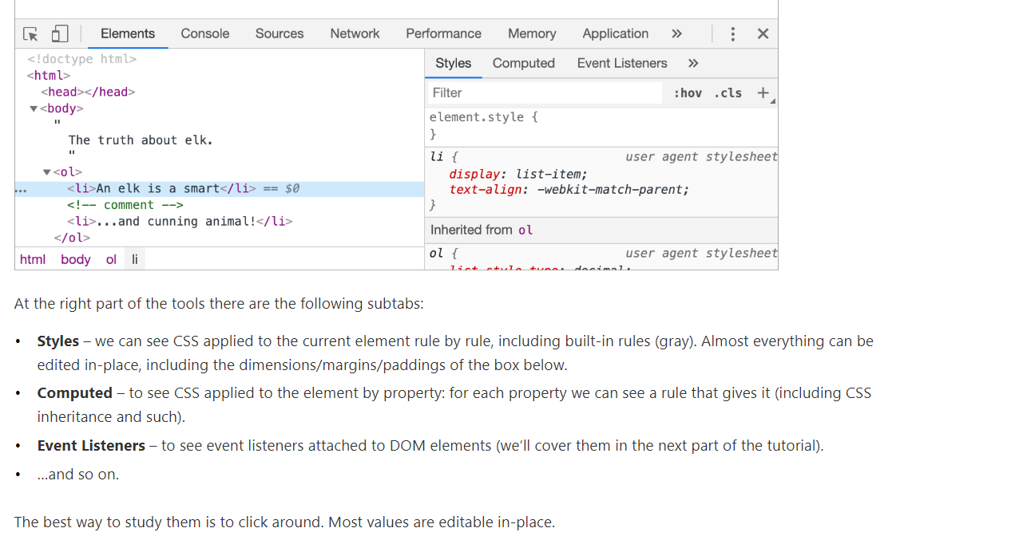
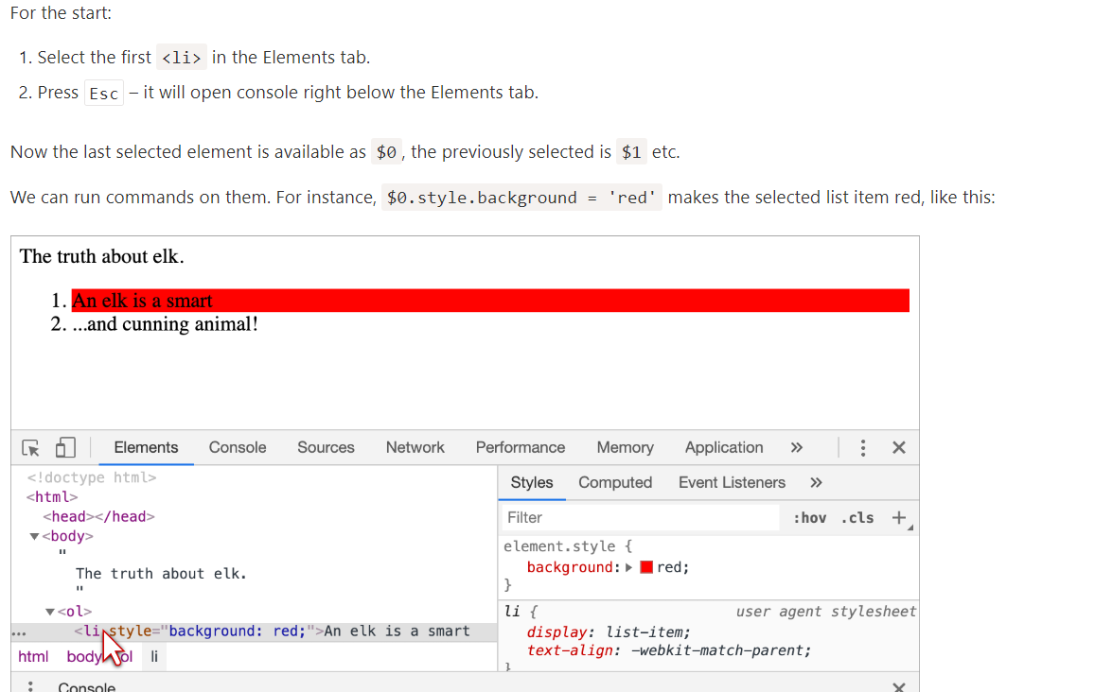

There’s also a road back. If there’s a variable referencing a DOM node, then we can use the command inspect(node) in Console to see it in the Elements pane.
Or we can just output the DOM node in the console and explore “in-place”, like document.body below:

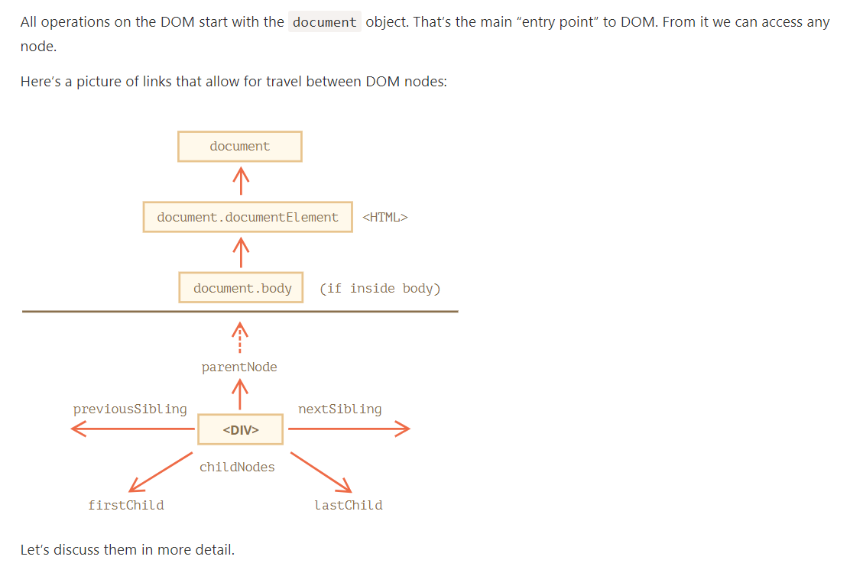

The topmost tree nodes are available directly as document properties:
<html> = document.documentElement
The topmost document node is document.documentElement. That’s the DOM node of the <html> tag.
<body> = document.body
Another widely used DOM node is the <body> element – document.body.
<head> = document.head
The <head> tag is available as document.head.

There’s a catch: document.body can be null
A script cannot access an element that doesn’t exist at the moment of running.
In particular, if a script is inside <head>, then document.body is unavailable, because the browser did not read it yet.

In the DOM world null means “doesn’t exist”
In the DOM, the null value means “doesn’t exist” or “no such node”.

There are two terms that we’ll use from now on:
- Child nodes (or children) – elements that are direct children. In other words, they are nested exactly in the given one. For instance, <head> and <body> are children of <html> element.
- Descendants – all elements that are nested in the given one, including children, their children and so on.
The childNodes collection lists all child nodes, including text nodes.
<script>
for (let i = 0; i < document.body.childNodes.length; i++) {
alert( document.body.childNodes[i] ); // Text, DIV, Text, UL, ..., SCRIPT
}
</script>

Please note an interesting detail here. If we run the example above, the last element shown is <script>. In fact, the document has more stuff below, but at the moment of the script execution the browser did not read it yet, so the script doesn’t see it.
Properties firstChild and lastChild give fast access to the first and last children.
They are just shorthands. If there exist child nodes, then the following is always true:
elem.childNodes[0] === elem.firstChild
elem.childNodes[elem.childNodes.length - 1] === elem.lastChild
There’s also a special function elem.hasChildNodes() to check whether there are any child nodes.
As we can see, childNodes looks like an array. But actually it’s not an array, but rather a collection – a special array-like iterable object.
There are two important consequences:
- We can use for..of to iterate over it:
2, Array methods won’t work, because it’s not an array:
The first thing is nice. The second is tolerable, because we can use Array.from to create a “real” array from the collection, if we want array methods:
DOM collections are read-only
DOM collections, and even more – all navigation properties listed in this chapter are read-only.
We can’t replace a child by something else by assigning childNodes[i] = ....
Changing DOM needs other methods. We will see them in the next chapter.
DOM collections are live
Almost all DOM collections with minor exceptions are live. In other words, they reflect the current state of DOM.
If we keep a reference to elem.childNodes, and add/remove nodes into DOM, then they appear in the collection automatically.
Don’t use for..in to loop over collections
Collections are iterable using for..of. Sometimes people try to use for..in for that.
Please, don’t. The for..in loop iterates over all enumerable properties. And collections have some “extra” rarely used properties that we usually do not want to get:
<body>
<script>
// shows 0, 1, length, item, values and more.
for (let prop in document.body.childNodes) alert(prop);
</script>
</body>
Siblings are nodes that are children of the same parent.
For instance, here <head> and <body> are siblings:
<html>
<head>...</head><body>...</body>
</html>
- <body> is said to be the “next” or “right” sibling of <head>,
- <head> is said to be the “previous” or “left” sibling of <body>.
The next sibling is in nextSibling property, and the previous one – in previousSibling.
The parent is available as parentNode.
// parent of <body> is <html>
alert( document.body.parentNode === document.documentElement ); // true

// after <head> goes <body>
alert( document.head.nextSibling ); // HTMLBodyElement

// before <body> goes <head>
alert( document.body.previousSibling ); // HTMLHeadElement
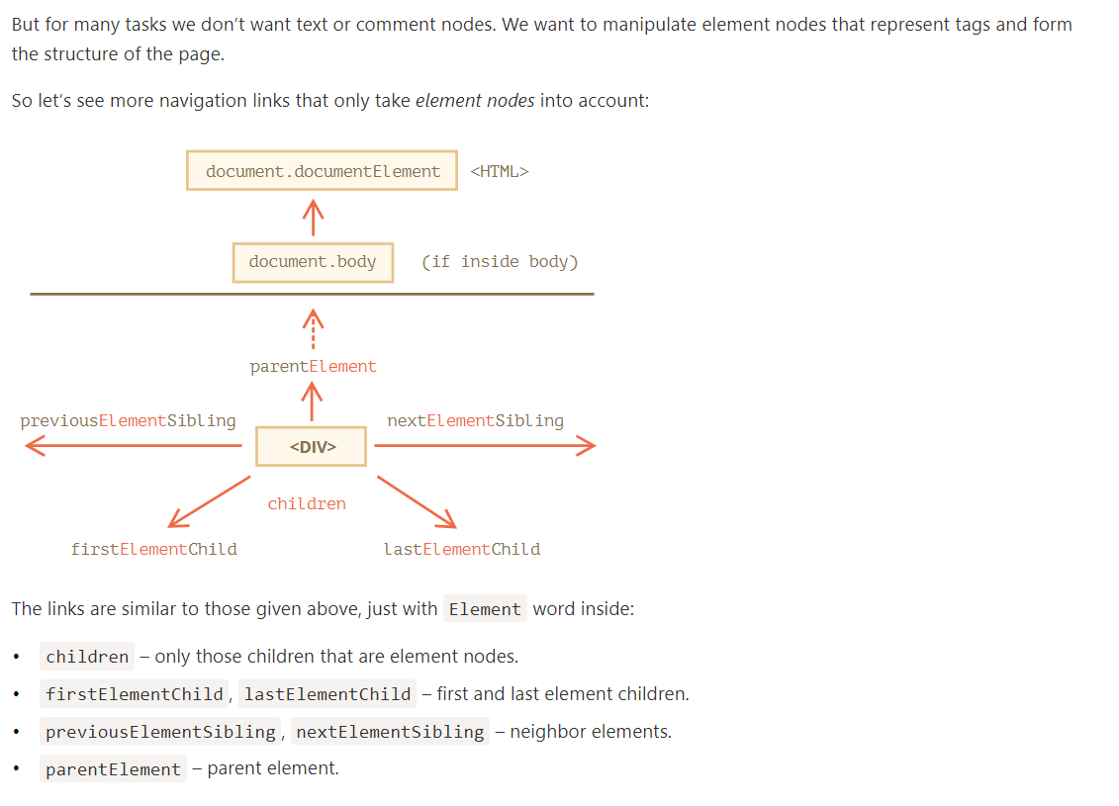
The parentElement property returns the “element” parent, while parentNode returns “any node” parent. These properties are usually the same: they both get the parent.
With the one exception of document.documentElement:
alert( document.documentElement.parentNode ); // document
alert( document.documentElement.parentElement ); // null
The reason is that the root node document.documentElement (<html>) has document as its parent. But document is not an element node, so parentNode returns it and parentElement does not.
This detail may be useful when we want to travel up from an arbitrary element elem to <html>, but not to the document:
while(elem = elem.parentElement) { // go up till <html>
alert( elem );
}
ertain types of DOM elements may provide additional properties, specific to their type, for convenience.
Tables are a great example of that, and represent a particularly important case:
The <table> element supports (in addition to the given above) these properties:
- table.rows – the collection of <tr> elements of the table.
- table.caption/tHead/tFoot – references to elements <caption>, <thead>, <tfoot>.
- table.tBodies – the collection of <tbody> elements (can be many according to the standard, but there will always be at least one – even if it is not in the source HTML, the browser will put it in the DOM).
<thead>, <tfoot>, <tbody> elements provide the rows property:
- tbody.rows – the collection of <tr> inside.
<tr>:
- tr.cells – the collection of <td> and <th> cells inside the given <tr>.
- tr.sectionRowIndex – the position (index) of the given <tr> inside the enclosing <thead>/<tbody>/<tfoot>.
- tr.rowIndex – the number of the <tr> in the table as a whole (including all table rows).
<td> and <th>:
- td.cellIndex – the number of the cell inside the enclosing <tr>.
An example of usage:
<table id="table">
<tr>
<td>one</td><td>two</td>
</tr>
<tr>
<td>three</td><td>four</td>
</tr>
</table>

<script>
// get td with "two" (first row, second column)
let td = table.rows[0].cells[1];
td.style.backgroundColor = "red"; // highlight it
</script>
The specification: tabular data.
There are also additional navigation properties for HTML forms. We’ll look at them later when we start working with forms.
If an element has the id attribute, we can get the element using the method document.getElementById(id), no matter where it is.
<div id="elem">
<div id="elem-content">Element</div>
</div>

<div id="elem">
<div id="elem-content">Element</div>
</div>

<script>
// elem is a reference to DOM-element with id="elem"
elem.style.background = 'red';

// id="elem-content" has a hyphen inside, so it can't be a variable name
// ...but we can access it using square brackets: window['elem-content']
</script>

…That’s unless we declare a JavaScript variable with the same name, then it takes precedence:
<div id="elem"></div>

<script>
let elem = 5; // now elem is 5, not a reference to <div id="elem">

alert(elem); // 5
</script>

Please don’t use id-named global variables to access elements
This behavior is described in the specification, so it’s kind of standard. But it is supported mainly for compatibility.
The browser tries to help us by mixing namespaces of JS and DOM. That’s fine for simple scripts, inlined into HTML, but generally isn’t a good thing. There may be naming conflicts. Also, when one reads JS code and doesn’t have HTML in view, it’s not obvious where the variable comes from.
Here in the tutorial we use id to directly reference an element for brevity, when it’s obvious where the element comes from.
In real life document.getElementById is the preferred method.
The id must be unique. There can be only one element in the document with the given id.
If there are multiple elements with the same id, then the behavior of methods that use it is unpredictable, e.g. document.getElementById may return any of such elements at random. So please stick to the rule and keep id unique.
Only document.getElementById, not anyElem.getElementById
The method getElementById that can be called only on document object. It looks for the given id in the whole document.
By far, the most versatile method, elem.querySelectorAll(css) returns all elements inside elem matching the given CSS selector.
Here we look for all <li> elements that are last children:

<ul>
<li>The</li>
<li>test</li>
</ul>
<ul>
<li>has</li>
<li>passed</li>
</ul>
<script>
let elements = document.querySelectorAll('ul > li:last-child');

for (let elem of elements) {
alert(elem.innerHTML); // "test", "passed"
}
</script>
This method is indeed powerful, because any CSS selector can be used.
Can use pseudo-classes as well
Pseudo-classes in the CSS selector like :hover and :active are also supported. For instance, document.querySelectorAll(':hover') will return the collection with elements that the pointer is over now (in nesting order: from the outermost <html> to the most nested one).

querySelector
The call to elem.querySelector(css) returns the first element for the given CSS selector.
In other words, the result is the same as elem.querySelectorAll(css)[0], but the latter is looking for all elements and picking one, while elem.querySelector just looks for one. So it’s faster and also shorter to write.
The elem.matches(css) does not look for anything, it merely checks if elem matches the given CSS-selector. It returns true or false.
The method comes in handy when we are iterating over elements (like in an array or something) and trying to filter out those that interest us.
if (elem.matches('a[href$="zip"]')) {
alert("The archive reference: " + elem.href );
}

Ancestors of an element are: parent, the parent of parent, its parent and so on. The ancestors together form the chain of parents from the element to the top.
The method elem.closest(css) looks the nearest ancestor that matches the CSS-selector. The elem itself is also included in the search.
In other words, the method closest goes up from the element and checks each of parents. If it matches the selector, then the search stops, and the ancestor is returned.

<h1>Contents</h1>

<div class="contents">
<ul class="book">
<li class="chapter">Chapter 1</li>
<li class="chapter">Chapter 1</li>
</ul>
</div>

<script>
let chapter = document.querySelector('.chapter'); // LI

alert(chapter.closest('.book')); // UL
alert(chapter.closest('.contents')); // DIV

alert(chapter.closest('h1')); // null (because h1 is not an ancestor)
</script>

There are also other methods to look for nodes by a tag, class, etc.
Today, they are mostly history, as querySelector is more powerful and shorter to write.
So here we cover them mainly for completeness, while you can still find them in the old scripts.
- elem.getElementsByTagName(tag) looks for elements with the given tag and returns the collection of them. The tag parameter can also be a star "*" for “any tags”.
- elem.getElementsByClassName(className) returns elements that have the given CSS class.
- document.getElementsByName(name) returns elements with the given name attribute, document-wide. Very rarely used.

The "s" letter is absent in getElementById, because it returns a single element. But getElementsByTagName returns a collection of elements, so there’s "s" inside.

It returns a collection, not an element!

All methods "getElementsBy*" return a live collection. Such collections always reflect the current state of the document and “auto-update” when it changes.
In contrast, querySelectorAll returns a static collection. It’s like a fixed array of elements.
Now we can easily see the difference. The static collection did not increase after the appearance of a new div in the document.

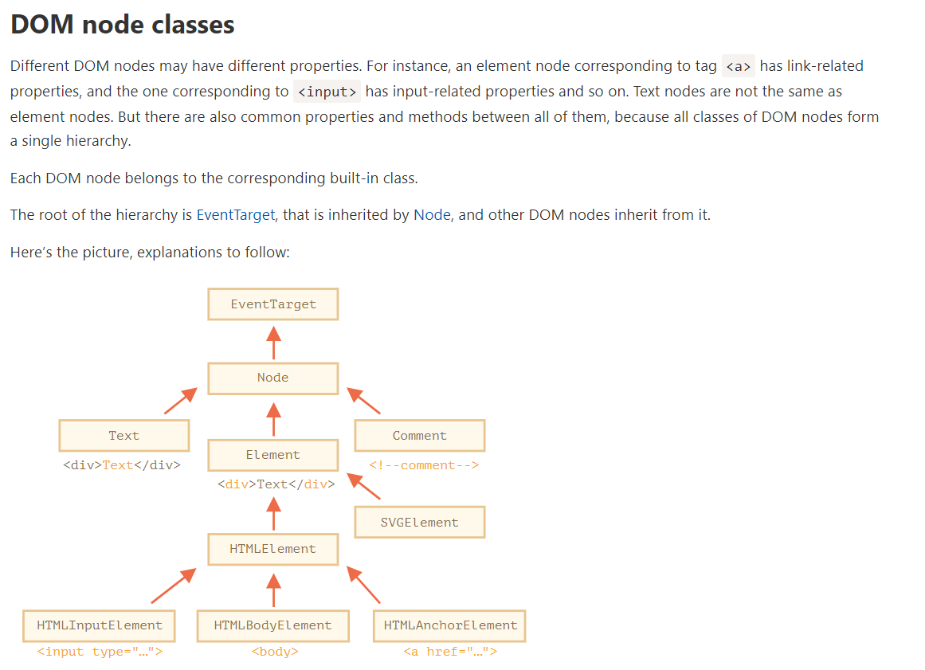
The classes are:
- EventTarget – is the root “abstract” class. Objects of that class are never created. It serves as a base, so that all DOM nodes support so-called “events”, we’ll study them later.
- Node – is also an “abstract” class, serving as a base for DOM nodes. It provides the core tree functionality: parentNode, nextSibling, childNodes and so on (they are getters). Objects of Node class are never created. But there are concrete node classes that inherit from it, namely: Text for text nodes, Element for element nodes and more exotic ones like Comment for comment nodes.
- Element – is a base class for DOM elements. It provides element-level navigation like nextElementSibling, children and searching methods like getElementsByTagName, querySelector. A browser supports not only HTML, but also XML and SVG. The Element class serves as a base for more specific classes: SVGElement, XMLElement and HTMLElement.
- HTMLElement – is finally the basic class for all HTML elements. It is inherited by concrete HTML elements:
  - HTMLInputElement – the class for <input> elements,
  - HTMLBodyElement – the class for <body> elements,
  - HTMLAnchorElement – the class for <a> elements,
  - …and so on, each tag has its own class that may provide specific properties and methods.
So, the full set of properties and methods of a given node comes as the result of the inheritance.
For example, let’s consider the DOM object for an <input> element. It belongs to HTMLInputElement class.
It gets properties and methods as a superposition of (listed in inheritance order):
- HTMLInputElement – this class provides input-specific properties,
- HTMLElement – it provides common HTML element methods (and getters/setters),
- Element – provides generic element methods,
- Node – provides common DOM node properties,
- EventTarget – gives the support for events (to be covered),
- …and finally it inherits from Object, so “plain object” methods like hasOwnProperty are also available.
To see the DOM node class name, we can recall that an object usually has the constructor property. It references the class constructor, and constructor.name is its name:
alert( document.body.constructor.name ); // HTMLBodyElement
…Or we can just toString it:
alert( document.body ); // [object HTMLBodyElement]
We also can use instanceof to check the inheritance:

As we can see, DOM nodes are regular JavaScript objects. They use prototype-based classes for inheritance.
That’s also easy to see by outputting an element with console.dir(elem) in a browser. There in the console you can see HTMLElement.prototype, Element.prototype and so on.

Most browsers support two commands in their developer tools: console.log and console.dir. They output their arguments to the console. For JavaScript objects these commands usually do the same.
But for DOM elements they are different:
- console.log(elem) shows the element DOM tree.
- console.dir(elem) shows the element as a DOM object, good to explore its properties.

In the specification, DOM classes aren’t described by using JavaScript, but a special Interface description language (IDL), that is usually easy to understand.
In IDL all properties are prepended with their types. For instance, DOMString, boolean and so on.

Here’s an excerpt from it, with comments:

// Define HTMLInputElement
// The colon ":" means that HTMLInputElement inherits from HTMLElement
interface HTMLInputElement: HTMLElement {
// here go properties and methods of <input> elements

// "DOMString" means that the value of a property is a string
attribute DOMString accept;
attribute DOMString alt;
attribute DOMString autocomplete;
attribute DOMString value;

// boolean value property (true/false)
attribute boolean autofocus;
...
// now the method: "void" means that the method returns no value
void select();
...
}

The nodeType property provides one more, “old-fashioned” way to get the “type” of a DOM node.
It has a numeric value:
- elem.nodeType == 1 for element nodes,
- elem.nodeType == 3 for text nodes,
- elem.nodeType == 9 for the document object,
- there are few other values in the specification.
In modern scripts, we can use instanceof and other class-based tests to see the node type, but sometimes nodeType may be simpler. We can only read nodeType, not change it.
Given a DOM node, we can read its tag name from nodeName or tagName properties:
For instance:
alert( document.body.nodeName ); // BODY
alert( document.body.tagName ); // BODY
Is there any difference between tagName and nodeName?
Sure, the difference is reflected in their names, but is indeed a bit subtle.
- The tagName property exists only for Element nodes.
- The nodeName is defined for any Node:
  - for elements it means the same as tagName.
  - for other node types (text, comment, etc.) it has a string with the node type.
In other words, tagName is only supported by element nodes (as it originates from Element class), while nodeName can say something about other node types.

The browser has two modes of processing documents: HTML and XML. Usually the HTML-mode is used for webpages. XML-mode is enabled when the browser receives an XML-document with the header: Content-Type: application/xml+xhtml.
In HTML mode tagName/nodeName is always uppercased: it’s BODY either for <body> or <BoDy>.
In XML mode the case is kept “as is”. Nowadays XML mode is rarely used.
The innerHTML property allows to get the HTML inside the element as a string.
We can also modify it. So it’s one of the most powerful ways to change the page.
The example shows the contents of document.body and then replaces it completely:
document.body.innerHTML = 'The new BODY!'; // replace it
We can try to insert invalid HTML, the browser will fix our errors:
<body>

<script>
document.body.innerHTML = '<b>test'; // forgot to close the tag
alert( document.body.innerHTML ); // <b>test</b> (fixed)
Scripts don’t execute
If innerHTML inserts a <script> tag into the document – it becomes a part of HTML, but doesn’t execute.

Beware: “innerHTML+=” does a full overwrite
We can append HTML to an element by using elem.innerHTML+="more html".
Like this:
chatDiv.innerHTML += "<div>Hello<img src='smile.gif'/> !</div>";
chatDiv.innerHTML += "How goes?";
But we should be very careful about doing it, because what’s going on is not an addition, but a full overwrite.
Technically, these two lines do the same:

elem.innerHTML += "...";
// is a shorter way to write:
elem.innerHTML = elem.innerHTML + "..."
In other words, innerHTML+= does this:
- The old contents is removed.
- The new innerHTML is written instead (a concatenation of the old and the new one).
As the content is “zeroed-out” and rewritten from the scratch, all images and other resources will be reloaded.
In the chatDiv example above the line chatDiv.innerHTML+="How goes?" re-creates the HTML content and reloads smile.gif (hope it’s cached). If chatDiv has a lot of other text and images, then the reload becomes clearly visible.
There are other side-effects as well. For instance, if the existing text was selected with the mouse, then most browsers will remove the selection upon rewriting innerHTML. And if there was an <input> with a text entered by the visitor, then the text will be removed. And so on.

The outerHTML property contains the full HTML of the element. That’s like innerHTML plus the element itself.
Beware: unlike innerHTML, writing to outerHTML does not change the element. Instead, it replaces it in the DOM.
Yeah, sounds strange, and strange it is, that’s why we make a separate note about it here. Take a look.

Consider the example:

<div>Hello, world!</div>

<script>
let div = document.querySelector('div');

// replace div.outerHTML with <p>...</p>
div.outerHTML = '<p>A new element</p>'; // (*)

// Wow! 'div' is still the same!
alert(div.outerHTML); // <div>Hello, world!</div> (**)
</script>
Looks really odd, right?
In the line (*) we replaced div with <p>A new element</p>. In the outer document (the DOM) we can see the new content instead of the <div>. But, as we can see in line (**), the value of the old div variable hasn’t changed!
The outerHTML assignment does not modify the DOM element (the object referenced by, in this case, the variable ‘div’), but removes it from the DOM and inserts the new HTML in its place.
So what happened in div.outerHTML=... is:
- div was removed from the document.
- Another piece of HTML <p>A new element</p> was inserted in its place.
- div still has its old value. The new HTML wasn’t saved to any variable.
It’s so easy to make an error here: modify div.outerHTML and then continue to work with div as if it had the new content in it. But it doesn’t. Such thing is correct for innerHTML, but not for outerHTML.
We can write to elem.outerHTML, but should keep in mind that it doesn’t change the element we’re writing to (‘elem’). It puts the new HTML in its place instead. We can get references to the new elements by querying the DOM.

nodeValue/data: text node content
The innerHTML property is only valid for element nodes.
Other node types, such as text nodes, have their counterpart: nodeValue and data properties. These two are almost the same for practical use, there are only minor specification differences. So we’ll use data, because it’s shorter.

The textContent provides access to the text inside the element: only text, minus all <tags>.
<div id="news">
<h1>Headline!</h1>
<p>Martians attack people!</p>
</div>

<script>
// Headline! Martians attack people!
alert(news.textContent);
</script>
As we can see, only text is returned, as if all <tags> were cut out, but the text in them remained.
In practice, reading such text is rarely needed.

Writing to textContent is much more useful, because it allows to write text the “safe way”.
Let’s say we have an arbitrary string, for instance entered by a user, and want to show it.
- With innerHTML we’ll have it inserted “as HTML”, with all HTML tags.
- With textContent we’ll have it inserted “as text”, all symbols are treated literally.
Compare the two:
<div id="elem1"></div>
<div id="elem2"></div>

<script>
let name = prompt("What's your name?", "<b>Winnie-the-pooh!</b>");

elem1.innerHTML = name;
elem2.textContent = name;
</script>
- The first <div> gets the name “as HTML”: all tags become tags, so we see the bold name.
- The second <div> gets the name “as text”, so we literally see <b>Winnie-the-pooh!</b>.
In most cases, we expect the text from a user, and want to treat it as text. We don’t want unexpected HTML in our site. An assignment to textContent does exactly that.
The “hidden” attribute and the DOM property specifies whether the element is visible or not.
Technically, hidden works the same as style="display:none". But it’s shorter to write.

DOM elements also have additional properties, in particular those that depend on the class:
- value – the value for <input>, <select> and <textarea> (HTMLInputElement, HTMLSelectElement…).
- href – the “href” for <a href="..."> (HTMLAnchorElement).
- id – the value of “id” attribute, for all elements (HTMLElement).
- …and much more…
For instance:
<input type="text" id="elem" value="value">

<script>
alert(elem.type); // "text"
alert(elem.id); // "elem"
alert(elem.value); // value
</script>
Most standard HTML attributes have the corresponding DOM property, and we can access it like that.
If we want to know the full list of supported properties for a given class, we can find them in the specification. For instance, HTMLInputElement is documented at https://html.spec.whatwg.org/#htmlinputelement.
Or if we’d like to get them fast or are interested in a concrete browser specification – we can always output the element using console.dir(elem) and read the properties. Or explore “DOM properties” in the Elements tab of the browser developer tools.
When the browser loads the page, it “reads” (another word: “parses”) the HTML and generates DOM objects from it. For element nodes, most standard HTML attributes automatically become properties of DOM objects.
For instance, if the tag is <body id="page">, then the DOM object has body.id="page".
We’ve already seen built-in DOM properties. There are a lot. But technically no one limits us, and if there aren’t enough, we can add our own.
DOM nodes are regular JavaScript objects. We can alter them.
For instance, let’s create a new property in document.body:
document.body.myData = {
name: 'Caesar',
title: 'Imperator'
};

alert(document.body.myData.title); // Imperator
We can add a method as well:
document.body.sayTagName = function() {
alert(this.tagName);
};

document.body.sayTagName(); // BODY (the value of "this" in the method is document.body)
We can also modify built-in prototypes like Element.prototype and add new methods to all elements:
Element.prototype.sayHi = function() {
alert(`Hello, I'm ${this.tagName}`);
};

document.documentElement.sayHi(); // Hello, I'm HTML
document.body.sayHi(); // Hello, I'm BODY
So, DOM properties and methods behave just like those of regular JavaScript objects:
- They can have any value.
- They are case-sensitive (write elem.nodeType, not elem.NoDeTyPe).
In HTML, tags may have attributes. When the browser parses the HTML to create DOM objects for tags, it recognizes standard attributes and creates DOM properties from them.
So when an element has id or another standard attribute, the corresponding property gets created. But that doesn’t happen if the attribute is non-standard.
Please note that a standard attribute for one element can be unknown for another one. For instance, "type" is standard for <input> (HTMLInputElement), but not for <body> (HTMLBodyElement). Standard attributes are described in the specification for the corresponding element class.
Here we can see it:

<body id="body" type="...">
<input id="input" type="text">
<script>
alert(input.type); // text
alert(body.type); // undefined: DOM property not created, because it's non-standard
</script>
</body>
So, if an attribute is non-standard, there won’t be a DOM-property for it. Is there a way to access such attributes?
Sure. All attributes are accessible by using the following methods:
- elem.hasAttribute(name) – checks for existence.
- elem.getAttribute(name) – gets the value.
- elem.setAttribute(name, value) – sets the value.
- elem.removeAttribute(name) – removes the attribute.
These methods operate exactly with what’s written in HTML.
Also one can read all attributes using elem.attributes: a collection of objects that belong to a built-in Attr class, with name and value properties.
<body something="non-standard">
<script>
alert(document.body.getAttribute('something')); // non-standard
</script>
</body>
HTML attributes have the following features:
- Their name is case-insensitive (id is same as ID).
- Their values are always strings.

<body>
<div id="elem" about="Elephant"></div>

<script>
alert( elem.getAttribute('About') ); // (1) 'Elephant', reading

elem.setAttribute('Test', 123); // (2), writing

alert( elem.outerHTML ); // (3), see if the attribute is in HTML (yes)

for (let attr of elem.attributes) { // (4) list all
alert( `${attr.name} = ${attr.value}` );
}
</script>
</body>
Please note:
- getAttribute('About') – the first letter is uppercase here, and in HTML it’s all lowercase. But that doesn’t matter: attribute names are case-insensitive.
- We can assign anything to an attribute, but it becomes a string. So here we have "123" as the value.

But there are exclusions, for instance input.value synchronizes only from attribute → to property, but not back:*
When a standard attribute changes, the corresponding property is auto-updated, and (with some exceptions) vice versa.
In the example below id is modified as an attribute, and we can see the property changed too. And then the same backwards:

<input>

<script>
let input = document.querySelector('input');

// attribute => property
input.setAttribute('value', 'text');
alert(input.value); // text

// NOT property => attribute
input.value = 'newValue';
alert(input.getAttribute('value')); // text (not updated!)
</script>
In the example above:
- Changing the attribute value updates the property.
- But the property change does not affect the attribute.

That “feature” may actually come in handy, because the user actions may lead to value changes, and then after them, if we want to recover the “original” value from HTML, it’s in the attribute.

Most properties are strings though.
Quite rarely, even if a DOM property type is a string, it may differ from the attribute. For instance, the href DOM property is always a full URL, even if the attribute contains a relative URL or just a #hash.

There are other examples. The style attribute is a string, but the style property is an object:

Sometimes non-standard attributes are used to pass custom data from HTML to JavaScript, or to “mark” HTML-elements for JavaScript.
Like this:
<!-- mark the div to show "name" here -->
<div show-info="name"></div>
<!-- and age here -->
<div show-info="age"></div>

<script>
// the code finds an element with the mark and shows what's requested
let user = {
name: "Pete",
age: 25
};

for(let div of document.querySelectorAll('[show-info]')) {
// insert the corresponding info into the field
let field = div.getAttribute('show-info');
div.innerHTML = user[field]; // first Pete into "name", then 25 into "age"
}
</script>
Also they can be used to style an element.
For instance, here for the order state the attribute order-state is used:
<style>
/* styles rely on the custom attribute "order-state" */
.order[order-state="new"] {
color: green;
}

.order[order-state="pending"] {
color: blue;
}

.order[order-state="canceled"] {
color: red;
}
</style>

<div class="order" order-state="new">
A new order.
</div>

<div class="order" order-state="pending">
A pending order.
</div>

<div class="order" order-state="canceled">
A canceled order.
</div>

Why would using an attribute be preferable to having classes like .order-state-new, .order-state-pending, order-state-canceled?
Because an attribute is more convenient to manage. The state can be changed as easy as:
// a bit simpler than removing old/adding a new class
div.setAttribute('order-state', 'canceled');
But there may be a possible problem with custom attributes. What if we use a non-standard attribute for our purposes and later the standard introduces it and makes it do something? The HTML language is alive, it grows, and more attributes appear to suit the needs of developers. There may be unexpected effects in such case.
To avoid conflicts, there exist data-* attributes.
All attributes starting with “data-” are reserved for programmers’ use. They are available in the dataset property.
For instance, if an elem has an attribute named "data-about", it’s available as elem.dataset.about.
Using data-* attributes is a valid, safe way to pass custom data.
Please note that we can not only read, but also modify data-attributes. Then CSS updates the view accordingly: in the example above the last line (*) changes the color to blue.

DOM modification is the key to creating “live” pages.
Here we’ll see how to create new elements “on the fly” and modify the existing page content.
To create DOM nodes, there are two methods:
document.createElement(tag)
Creates a new element node with the given tag:
let div = document.createElement('div');
document.createTextNode(text)
Creates a new text node with the given text:
let textNode = document.createTextNode('Here I am');

Creating the message
In our case the message is a div with alert class and the HTML in it:
let div = document.createElement('div');
div.className = "alert";
div.innerHTML = "<strong>Hi there!</strong> You've read an important message.";

We created the element, but as of now it’s only in a variable. We can’t see the element on the page, as it’s not yet a part of the document.
There’s a special method append for that: document.body.append(div).
This set of methods provides more ways to insert:
- node.append(...nodes or strings) – append nodes or strings at the end of node,
- node.prepend(...nodes or strings) – insert nodes or strings at the beginning of node,
- node.before(...nodes or strings) –- insert nodes or strings before node,
- node.after(...nodes or strings) –- insert nodes or strings after node,
- node.replaceWith(...nodes or strings) –- replaces node with the given nodes or strings.
Here’s an example of using these methods to add items to a list and the text before/after it:
<ol id="ol">
<li>0</li>
<li>1</li>
<li>2</li>
</ol>

<script>
ol.before('before'); // insert string "before" before <ol>
ol.after('after'); // insert string "after" after <ol>

let liFirst = document.createElement('li');
liFirst.innerHTML = 'prepend';
ol.prepend(liFirst); // insert liFirst at the beginning of <ol>

let liLast = document.createElement('li');
liLast.innerHTML = 'append';
ol.append(liLast); // insert liLast at the end of <ol>
</script>

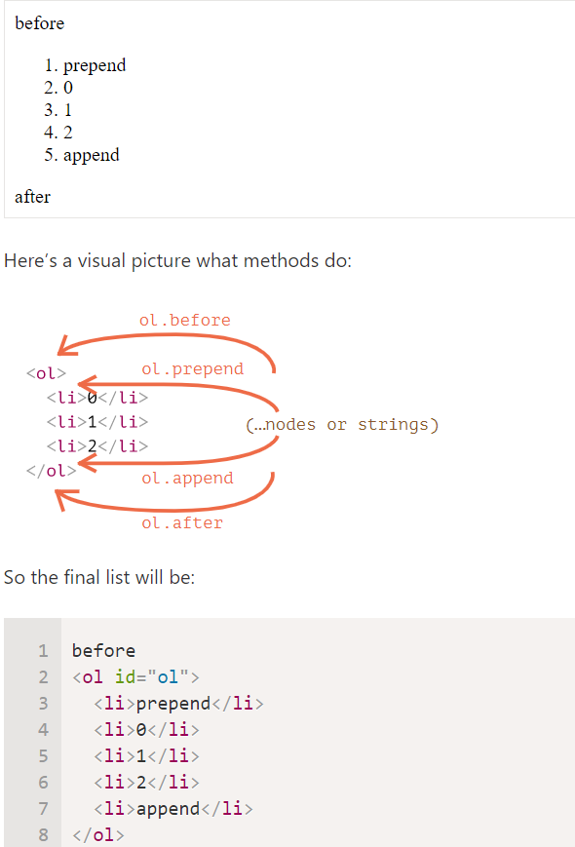

These methods can insert multiple lists of nodes and text pieces in a single call.
For instance, here a string and an element are inserted:
<div id="div"></div>
<script>
div.before('<p>Hello</p>', document.createElement('hr'));
</script>
All text is inserted as text.

In other words, strings are inserted in a safe way, like elem.textContent does it.
So, these methods can only be used to insert DOM nodes or text pieces.
But what if we want to insert HTML “as html”, with all tags and stuff working, like elem.innerHTML?

insertAdjacentHTML/Text/Element
For that we can use another, pretty versatile method: elem.insertAdjacentHTML(where, html).
The first parameter is a code word, specifying where to insert relative to elem. Must be one of the following:
- "beforebegin" – insert html immediately before elem,
- "afterbegin" – insert html into elem, at the beginning,
- "beforeend" – insert html into elem, at the end,
- "afterend" – insert html immediately after elem.
The second parameter is an HTML string, that is inserted “as HTML”.

<div id="div"></div>
<script>
div.insertAdjacentHTML('beforebegin', '<p>Hello</p>');
div.insertAdjacentHTML('afterend', '<p>Bye</p>');
</script>
…Would lead to:
<p>Hello</p>
<div id="div"></div>
<p>Bye</p>

We can easily notice similarities between this and the previous picture. The insertion points are actually the same, but this method inserts HTML.
The method has two brothers:
- elem.insertAdjacentText(where, text) – the same syntax, but a string of text is inserted “as text” instead of HTML,
- elem.insertAdjacentElement(where, elem) – the same syntax, but inserts an element.
They exist mainly to make the syntax “uniform”. In practice, only insertAdjacentHTML is used most of the time. Because for elements and text, we have methods append/prepend/before/after – they are shorter to write and can insert nodes/text pieces.

To remove a node, there’s a method node.remove().

<script>
let div = document.createElement('div');
div.className = "alert";
div.innerHTML = "<strong>Hi there!</strong> You've read an important message.";

document.body.append(div);
setTimeout(() => div.remove(), 1000);
</script>

disapear after a second

Please note: if we want to move an element to another place – there’s no need to remove it from the old one.
All insertion methods automatically remove the node from the old place.
For instance, let’s swap elements:
<div id="first">First</div>
<div id="second">Second</div>
<script>
// no need to call remove
second.after(first); // take #second and after it insert #first
</script>

Sometimes when we have a big element, that may be faster and simpler.
- The call elem.cloneNode(true) creates a “deep” clone of the element – with all attributes and subelements. If we call elem.cloneNode(false), then the clone is made without child elements.
<script>
let div2 = div.cloneNode(true); // clone the message
div2.querySelector('strong').innerHTML = 'Bye there!'; // change the clone

div.after(div2); // show the clone after the existing div
</script>

DocumentFragment is a special DOM node that serves as a wrapper to pass around lists of nodes.
We can append other nodes to it, but when we insert it somewhere, then its content is inserted instead.

DocumentFragment is rarely used explicitly. Why append to a special kind of node, if we can return an array of nodes instead? Rewritten example:

<ul id="ul"></ul>

<script>
function getListContent() {
let result = [];

for(let i=1; i<=3; i++) {
let li = document.createElement('li');
li.append(i);
result.push(li);
}

return result;
}

ul.append(...getListContent()); // append + "..." operator = friends!
</script>
We mention DocumentFragment mainly because there are some concepts on top of it, like template element, that we’ll cover much later.

There are also “old school” DOM manipulation methods, existing for historical reasons.
These methods come from really ancient times. Nowadays, there’s no reason to use them, as modern methods, such as append, prepend, before, after, remove, replaceWith, are more flexible.
The only reason we list these methods here is that you can find them in many old scripts:
parentElem.appendChild(node)
Appends node as the last child of parentElem.

parentElem.insertBefore(node, nextSibling)
Inserts node before nextSibling into parentElem.
parentElem.replaceChild(node, oldChild)
Replaces oldChild with node among children of parentElem.
parentElem.removeChild(node)
Removes node from parentElem (assuming node is its child).

All these methods return the inserted/removed node. In other words, parentElem.appendChild(node) returns node. But usually the returned value is not used, we just run the method.

A word about “document.write”
There’s one more, very ancient method of adding something to a web-page: document.write.

The call to document.write(html) writes the html into page “right here and now”. The html string can be dynamically generated, so it’s kind of flexible. We can use JavaScript to create a full-fledged webpage and write it.
The method comes from times when there was no DOM, no standards… Really old times. It still lives, because there are scripts using it.
In modern scripts we can rarely see it, because of the following important limitation:
The call to document.write only works while the page is loading.
If we call it afterwards, the existing document content is erased.
For instance:

<p>After one second the contents of this page will be replaced...</p>
<script>
// document.write after 1 second
// that's after the page loaded, so it erases the existing content
setTimeout(() => document.write('<b>...By this.</b>'), 1000);
</script>
So it’s kind of unusable at “after loaded” stage, unlike other DOM methods we covered above.
That’s the downside.
There’s an upside also. Technically, when document.write is called while the browser is reading (“parsing”) incoming HTML, and it writes something, the browser consumes it just as if it were initially there, in the HTML text.
So it works blazingly fast, because there’s no DOM modification involved. It writes directly into the page text, while the DOM is not yet built.
So if we need to add a lot of text into HTML dynamically, and we’re at page loading phase, and the speed matters, it may help. But in practice these requirements rarely come together. And usually we can see this method in scripts just because they are old.
In the ancient time, there was a limitation in JavaScript: a reserved word like "class" could not be an object property. That limitation does not exist now, but at that time it was impossible to have a "class" property, like elem.class.
So for classes the similar-looking property "className" was introduced: the elem.className corresponds to the "class" attribute.
f we assign something to elem.className, it replaces the whole string of classes. Sometimes that’s what we need, but often we want to add/remove a single class.
There’s another property for that: elem.classList.
The elem.classList is a special object with methods to add/remove/toggle a single class.
For instance:

<body class="main page">
<script>
// add a class
document.body.classList.add('article');

alert(document.body.className); // main page article
</script>
</body>
So we can operate both on the full class string using className or on individual classes using classList. What we choose depends on our needs.
Methods of classList:
- elem.classList.add/remove("class") – adds/removes the class.
- elem.classList.toggle("class") – adds the class if it doesn’t exist, otherwise removes it.
- elem.classList.contains("class") – checks for the given class, returns true/false.
Besides, classList is iterable, so we can list all classes with for..of, like this:
The property elem.style is an object that corresponds to what’s written in the "style" attribute. Setting elem.style.width="100px" works the same as if we had in the attribute style a string width:100px. $ometimes we want to assign a style property, and later remove it.
For instance, to hide an element, we can set elem.style.display = "none".
Then later we may want to remove the style.display as if it were not set. Instead of delete elem.style.display we should assign an empty string to it: elem.style.display = "".
// if we run this code, the <body> will blink
document.body.style.display = "none"; // hide

setTimeout(() => document.body.style.display = "", 1000); // back to normal
If we set style.display to an empty string, then the browser applies CSS classes and its built-in styles normally, as if there were no such style.display property at all.
Full rewrite with style.cssText
Normally, we use style.* to assign individual style properties. We can’t set the full style like div.style="color: red; width: 100px", because div.style is an object, and it’s read-only.
To set the full style as a string, there’s a special property style.cssText:
<div id="div">Button</div>

<script>
// we can set special style flags like "important" here
div.style.cssText=`color: red !important;
background-color: yellow;
width: 100px;
text-align: center;
`;

alert(div.style.cssText);
</script>
This property is rarely used, because such assignment removes all existing styles: it does not add, but replaces them. May occasionally delete something needed. But we can safely use it for new elements, when we know we won’t delete an existing style.
The same can be accomplished by setting an attribute: div.setAttribute('style', 'color: red...').
The style property operates only on the value of the "style" attribute, without any CSS cascade.
So we can’t read anything that comes from CSS classes using elem.style.
For instance, here style doesn’t see the margin:

<head>
<style> body { color: red; margin: 5px } </style>
</head>
<body>

The red text
<script>
alert(document.body.style.color); // empty
alert(document.body.style.marginTop); // empty
</script>
</body>
…But what if we need, say, to increase the margin by 20px? We would want the current value of it.
There’s another method for that: getComputedStyle.
The syntax is:
getComputedStyle(element, [pseudo])
element
Element to read the value for.
pseudo
A pseudo-element if required, for instance ::before. An empty string or no argument means the element itself.
The result is an object with styles, like elem.style, but now with respect to all CSS classes.
For instance:
<head>
<style> body { color: red; margin: 5px } </style>
</head>
<body>

<script>
let computedStyle = getComputedStyle(document.body);

// now we can read the margin and the color from it

alert( computedStyle.marginTop ); // 5px
alert( computedStyle.color ); // rgb(255, 0, 0)
</script>

</body>
Computed and resolved values
There are two concepts in CSS:
- A computed style value is the value after all CSS rules and CSS inheritance is applied, as the result of the CSS cascade. It can look like height:1em or font-size:125%.
- A resolved style value is the one finally applied to the element. Values like 1em or 125% are relative. The browser takes the computed value and makes all units fixed and absolute, for instance: height:20px or font-size:16px. For geometry properties resolved values may have a floating point, like width:50.5px.
A long time ago getComputedStyle was created to get computed values, but it turned out that resolved values are much more convenient, and the standard changed.
So nowadays getComputedStyle actually returns the resolved value of the property, usually in px for geometry.
getComputedStyle requires the full property name
We should always ask for the exact property that we want, like paddingLeft or marginTop or borderTopWidth. Otherwise the correct result is not guaranteed.
Visited links may be colored using :visited CSS pseudoclass.
But getComputedStyle does not give access to that color, because otherwise an arbitrary page could find out whether the user visited a link by creating it on the page and checking the styles.
JavaScript may not see the styles applied by :visited. And also, there’s a limitation in CSS that forbids applying geometry-changing styles in :visited. That’s to guarantee that there’s no side way for an evil page to test if a link was visited and hence to break the privacy.
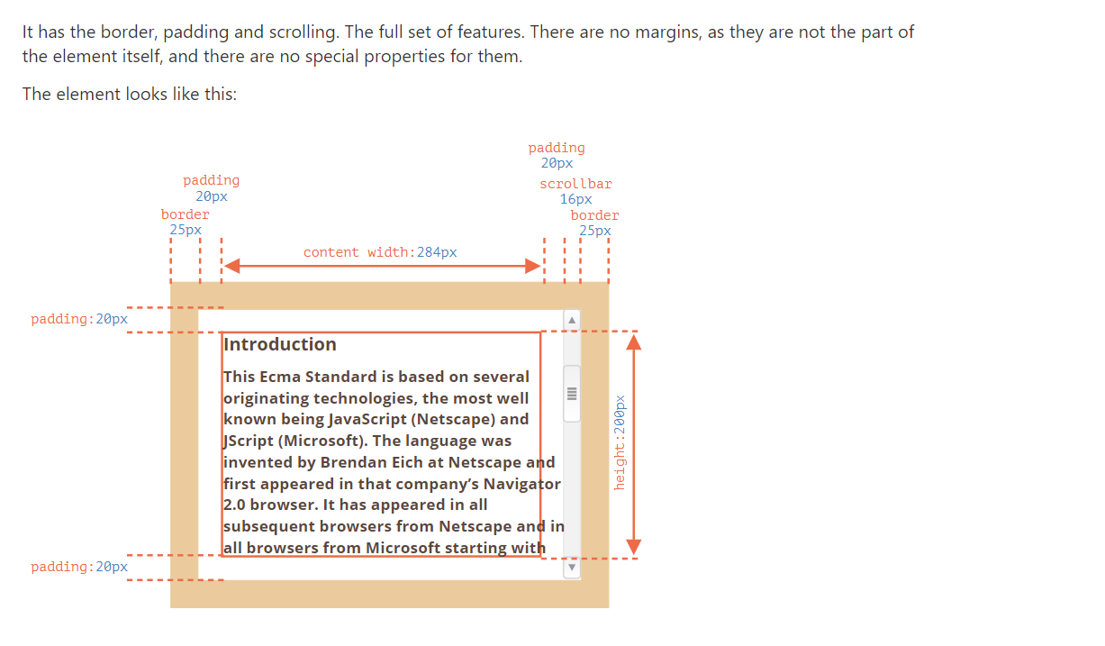
ou can open the document in the sandbox.
Mind the scrollbar
The picture above demonstrates the most complex case when the element has a scrollbar. Some browsers (not all) reserve the space for it by taking it from the content (labeled as “content width” above).
So, without scrollbar the content width would be 300px, but if the scrollbar is 16px wide (the width may vary between devices and browsers) then only 300 - 16 = 284px remains, and we should take it into account. That’s why examples from this chapter assume that there’s a scrollbar. Without it, some calculations are simpler.
The padding-bottom area may be filled with text
Usually paddings are shown empty on our illustrations, but if there’s a lot of text in the element and it overflows, then browsers show the “overflowing” text at padding-bottom, that’s normal.

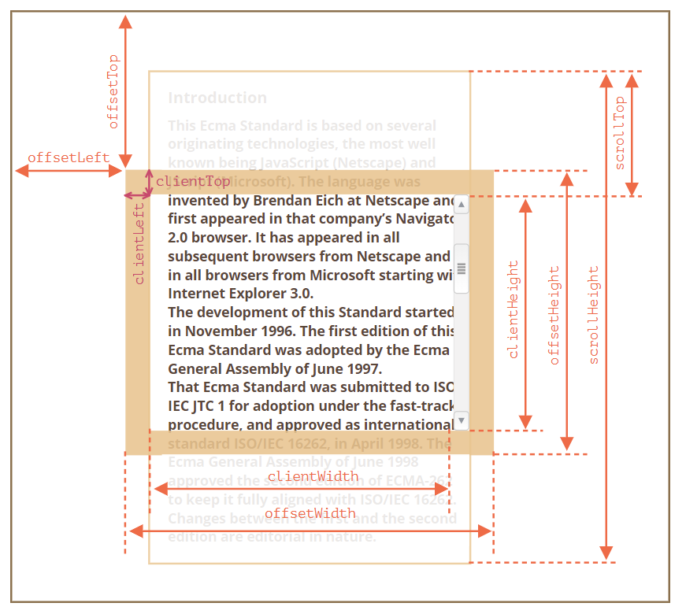
offsetParent, offsetLeft/Top
These properties are rarely needed, but still they are the “most outer” geometry properties, so we’ll start with them.
The offsetParent is the nearest ancestor that the browser uses for calculating coordinates during rendering.
That’s the nearest ancestor that is one of the following:
- CSS-positioned (position is absolute, relative, fixed or sticky), or
- <td>, <th>, or <table>, or
- <body>.
Properties offsetLeft/offsetTop provide x/y coordinates relative to offsetParent upper-left corner.
In the example below the inner <div> has <main> as offsetParent and offsetLeft/offsetTop shifts from its upper-left corner (180):
<main style="position: relative" id="main">
<article>
<div id="example" style="position: absolute; left: 180px; top: 180px">...</div>
</article>
</main>
<script>
alert(example.offsetParent.id); // main
alert(example.offsetLeft); // 180 (note: a number, not a string "180px")
alert(example.offsetTop); // 180
</script>

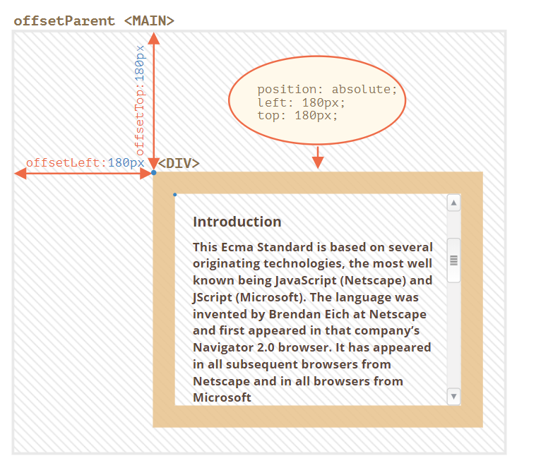
There are several occasions when offsetParent is null:
- For not shown elements (display:none or not in the document).
- For <body> and <html>.
- For elements with position:fixed.

offsetWidth/Height
Now let’s move on to the element itself.
These two properties are the simplest ones. They provide the “outer” width/height of the element. Or, in other words, its full size including borders.
For our sample element:
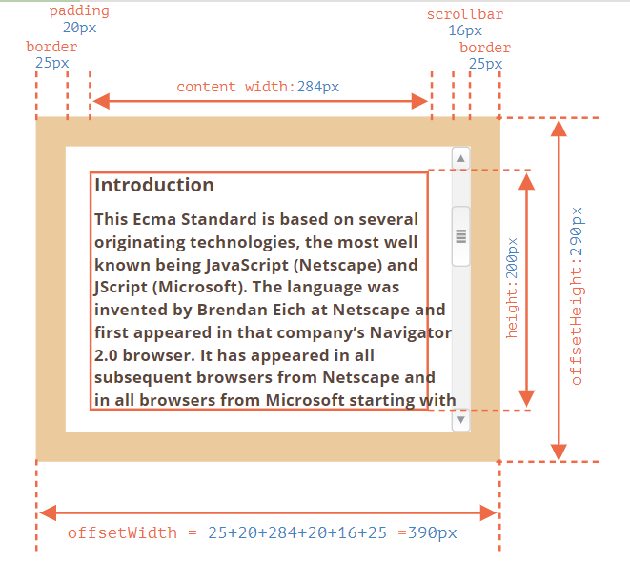
- offsetWidth = 390 – the outer width, can be calculated as inner CSS-width (300px) plus paddings (2 * 20px) and borders (2 * 25px).
- offsetHeight = 290 – the outer height.
Geometry properties are zero/null for elements that are not displayed
Geometry properties are calculated only for displayed elements.
If an element (or any of its ancestors) has display:none or is not in the document, then all geometry properties are zero (or null for offsetParent).
For example, offsetParent is null, and offsetWidth, offsetHeight are 0 when we created an element, but haven’t inserted it into the document yet, or it (or it’s ancestor) has display:none.
We can use this to check if an element is hidden, like this:
function isHidden(elem) {
return !elem.offsetWidth && !elem.offsetHeight;
}
Please note that such isHidden returns true for elements that are on-screen, but have zero sizes (like an empty <div>).

clientTop/Left
Inside the element we have the borders.
To measure them, there are properties clientTop and clientLeft.
In our example:
- clientLeft = 25 – left border width
- clientTop = 25 – top border width
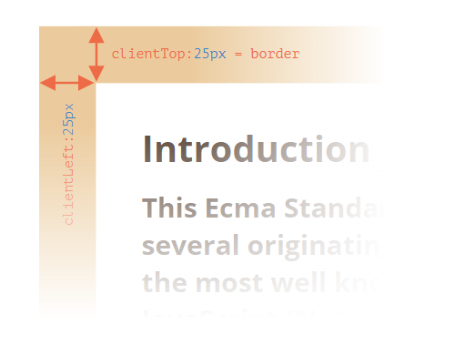

…But to be precise – these properties are not border width/height, but rather relative coordinates of the inner side from the outer side.
What’s the difference?
It becomes visible when the document is right-to-left (the operating system is in Arabic or Hebrew languages). The scrollbar is then not on the right, but on the left, and then clientLeft also includes the scrollbar width.
In that case, clientLeft would be not 25, but with the scrollbar width 25 + 16 = 41.

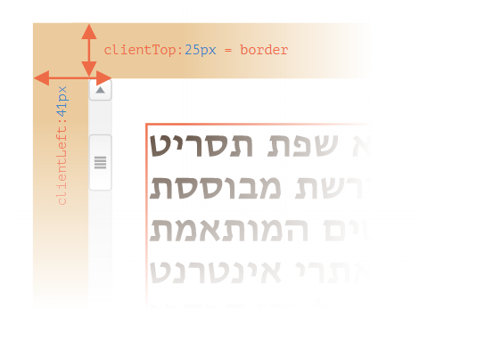

Here’s the example in hebrew:

clientWidth/Height
These properties provide the size of the area inside the element borders.
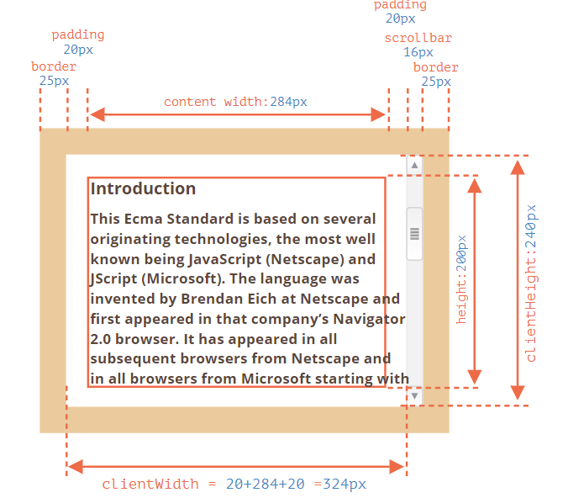
They include the content width together with paddings, but without the scrollbar:

On the picture above let’s first consider clientHeight.
There’s no horizontal scrollbar, so it’s exactly the sum of what’s inside the borders: CSS-height 200px plus top and bottom paddings (2 * 20px) total 240px.
Now clientWidth – here the content width is not 300px, but 284px, because 16px are occupied by the scrollbar. So the sum is 284px plus left and right paddings, total 324px.
If there are no paddings, then clientWidth/Height is exactly the content area, inside the borders and the scrollbar (if any).

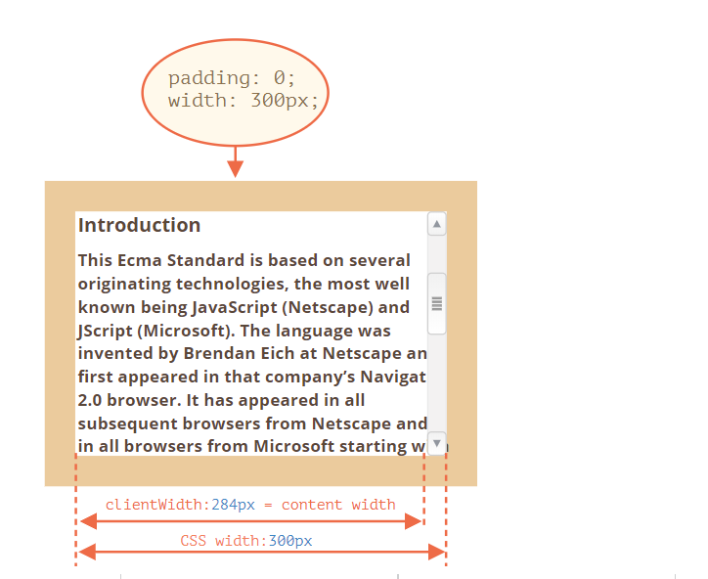

So when there’s no padding we can use clientWidth/clientHeight to get the content area size.

scrollWidth/Height
These properties are like clientWidth/clientHeight, but they also include the scrolled out (hidden) parts:

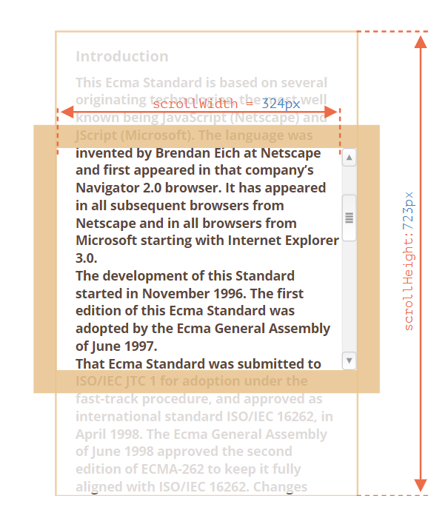

On the picture above:
- scrollHeight = 723 – is the full inner height of the content area including the scrolled out parts.
- scrollWidth = 324 – is the full inner width, here we have no horizontal scroll, so it equals clientWidth.
We can use these properties to expand the element wide to its full width/height.
Like this:
// expand the element to the full content height
element.style.height = `${element.scrollHeight}px`;

Click the button to expand the element:

text text text text text text text text text text text text text text text text text text text text text text text text text text text text text text text text text text text text text text text text text text text text text text text text text text text text text text text text text text text text text text text text text text text text text text text text text text text text text text text text text text text text text text text text text text text text text text text text text text text text text text text text text text text text text text text text text text text text text text text text text text text text text text text text text text text text text text text text text text text text
element.style.height = ${element.scrollHeight}px

scrollLeft/scrollTop
Properties scrollLeft/scrollTop are the width/height of the hidden, scrolled out part of the element.
On the picture below we can see scrollHeight and scrollTop for a block with a vertical scroll.


In other words, scrollTop is “how much is scrolled up”.
scrollLeft/scrollTop can be modified
Most of the geometry properties here are read-only, but scrollLeft/scrollTop can be changed, and the browser will scroll the element.
If you click the element below, the code elem.scrollTop += 10 executes. That makes the element content scroll 10px down.
Click
Me
1
2
3
4
5
6
7
8
9
Setting scrollTop to 0 or a big value, such as 1e9 will make the element scroll to the very top/bottom respectively.

Don’t take width/height from CSS
We’ve just covered geometry properties of DOM elements, that can be used to get widths, heights and calculate distances.
But as we know from the chapter Styles and classes, we can read CSS-height and width using getComputedStyle.
So why not to read the width of an element with getComputedStyle, like this?
let elem = document.body;

alert( getComputedStyle(elem).width ); // show CSS width for elem
Why should we use geometry properties instead? There are two reasons:
- First, CSS width/height depend on another property: box-sizing that defines “what is” CSS width and height. A change in box-sizing for CSS purposes may break such JavaScript.
- Second, CSS width/height may be auto, for instance for an inline element:

<span id="elem">Hello!</span>

<script>
alert( getComputedStyle(elem).width ); // auto
</script>
From the CSS standpoint, width:auto is perfectly normal, but in JavaScript we need an exact size in px that we can use in calculations. So here CSS width is useless.
And there’s one more reason: a scrollbar. Sometimes the code that works fine without a scrollbar becomes buggy with it, because a scrollbar takes the space from the content in some browsers. So the real width available for the content is less than CSS width. And clientWidth/clientHeight take that into account.
…But with getComputedStyle(elem).width the situation is different. Some browsers (e.g. Chrome) return the real inner width, minus the scrollbar, and some of them (e.g. Firefox) – CSS width (ignore the scrollbar). Such cross-browser differences is the reason not to use getComputedStyle, but rather rely on geometry properties.
If your browser reserves the space for a scrollbar (most browsers for Windows do), then you can test it below.

The element with text has CSS width:300px.
On a Desktop Windows OS, Firefox, Chrome, Edge all reserve the space for the scrollbar. But Firefox shows 300px, while Chrome and Edge show less. That’s because Firefox returns the CSS width and other browsers return the “real” width.
Please note that the described difference is only about reading getComputedStyle(...).width from JavaScript, visually everything is correct.

How do we find the width and height of the browser window? How do we get the full width and height of the document, including the scrolled out part? How do we scroll the page using JavaScript?
For most such requests, we can use the root document element document.documentElement, that corresponds to the <html> tag. But there are additional methods and peculiarities important enough to consider.

Width/height of the window
To get window width and height we can use clientWidth/clientHeight of document.documentElement:

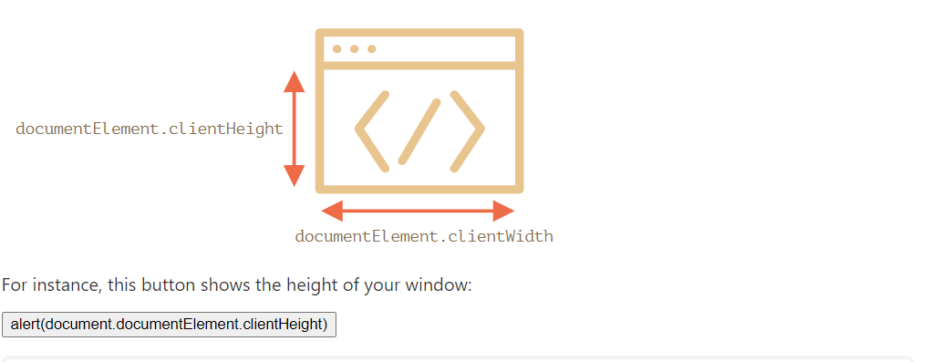
Not window.innerWidth/Height
Browsers also support properties window.innerWidth/innerHeight. They look like what we want. So why not to use them instead?
If there exists a scrollbar, and it occupies some space, clientWidth/clientHeight provide the width/height without it (subtract it). In other words, they return width/height of the visible part of the document, available for the content.
…And window.innerWidth/innerHeight include the scrollbar.
If there’s a scrollbar, and it occupies some space, then these two lines show different values:
alert( window.innerWidth ); // full window width
alert( document.documentElement.clientWidth ); // window width minus the scrollbar
In most cases we need the available window width: to draw or position something. That is: inside scrollbars if there are any. So we should use documentElement.clientHeight/Width.
DOCTYPE is important
Please note: top-level geometry properties may work a little bit differently when there’s no <!DOCTYPE HTML> in HTML. Odd things are possible.
In modern HTML we should always write DOCTYPE.

Width/height of the document
Theoretically, as the root document element is document.documentElement, and it encloses all the content, we could measure document full size as document.documentElement.scrollWidth/scrollHeight.
But on that element, for the whole page, these properties do not work as intended. In Chrome/Safari/Opera if there’s no scroll, then documentElement.scrollHeight may be even less than documentElement.clientHeight! Sounds like a nonsense, weird, right?
To reliably obtain the full document height, we should take the maximum of these properties:
let scrollHeight = Math.max(
document.body.scrollHeight, document.documentElement.scrollHeight,
document.body.offsetHeight, document.documentElement.offsetHeight,
document.body.clientHeight, document.documentElement.clientHeight
);

alert('Full document height, with scrolled out part: ' + scrollHeight);
Why so? Better don’t ask. These inconsistencies come from ancient times, not a “smart” logic.

Get the current scroll
DOM elements have their current scroll state in elem.scrollLeft/scrollTop.
For document scroll document.documentElement.scrollLeft/Top works in most browsers, except older WebKit-based ones, like Safari (bug 5991), where we should use document.body instead of document.documentElement.
Luckily, we don’t have to remember these peculiarities at all, because the scroll is available in the special properties window.pageXOffset/pageYOffset:
alert('Current scroll from the top: ' + window.pageYOffset);
alert('Current scroll from the left: ' + window.pageXOffset);
These properties are read-only.

Scrolling: scrollTo, scrollBy, scrollIntoView
Important:
To scroll the page from JavaScript, its DOM must be fully built.
For instance, if we try to scroll the page from the script in <head>, it won’t work.
Regular elements can be scrolled by changing scrollTop/scrollLeft.
We can do the same for the page using document.documentElement.scrollTop/Left (except Safari, where document.body.scrollTop/Left should be used instead).
Alternatively, there’s a simpler, universal solution: special methods window.scrollBy(x,y) and window.scrollTo(pageX,pageY).
- The method scrollBy(x,y) scrolls the page relative to its current position. For instance, scrollBy(0,10) scrolls the page 10px down.
The button below demonstrates this:
window.scrollBy(0,10)
- The method scrollTo(pageX,pageY) scrolls the page to absolute coordinates, so that the top-left corner of the visible part has coordinates (pageX, pageY) relative to the document’s top-left corner. It’s like setting scrollLeft/scrollTop.
To scroll to the very beginning, we can use scrollTo(0,0).
window.scrollTo(0,0)
These methods work for all browsers the same way.

scrollIntoView
For completeness, let’s cover one more method: elem.scrollIntoView(top).
The call to elem.scrollIntoView(top) scrolls the page to make elem visible. It has one argument:
- if top=true (that’s the default), then the page will be scrolled to make elem appear on the top of the window. The upper edge of the element is aligned with the window top.
- if top=false, then the page scrolls to make elem appear at the bottom. The bottom edge of the element is aligned with the window bottom.
The button below scrolls the page to make itself show at the window top:
this.scrollIntoView()
And this button scrolls the page to show it at the bottom:
this.scrollIntoView(false)

Forbid the scrolling
Sometimes we need to make the document “unscrollable”. For instance, when we need to cover it with a large message requiring immediate attention, and we want the visitor to interact with that message, not with the document.
To make the document unscrollable, it’s enough to set document.body.style.overflow = "hidden". The page will freeze on its current scroll.
Try it:
document.body.style.overflow = ‘hidden’
document.body.style.overflow = ‘’
The first button freezes the scroll, the second one resumes it.
We can use the same technique to “freeze” the scroll for other elements, not just for document.body.
The drawback of the method is that the scrollbar disappears. If it occupied some space, then that space is now free, and the content “jumps” to fill it.
That looks a bit odd, but can be worked around if we compare clientWidth before and after the freeze, and if it increased (the scrollbar disappeared) then add padding to document.body in place of the scrollbar, to keep the content width the same.

Coordinates
To move elements around we should be familiar with coordinates.
Most JavaScript methods deal with one of two coordinate systems:
- Relative to the window – similar to position:fixed, calculated from the window top/left edge.
  - we’ll denote these coordinates as clientX/clientY, the reasoning for such name will become clear later, when we study event properties.
- Relative to the document – similar to position:absolute in the document root, calculated from the document top/left edge.
  - we’ll denote them pageX/pageY.
When the page is scrolled to the very beginning, so that the top/left corner of the window is exactly the document top/left corner, these coordinates equal each other. But after the document shifts, window-relative coordinates of elements change, as elements move across the window, while document-relative coordinates remain the same.
On this picture we take a point in the document and demonstrate its coordinates before the scroll (left) and after it (right):
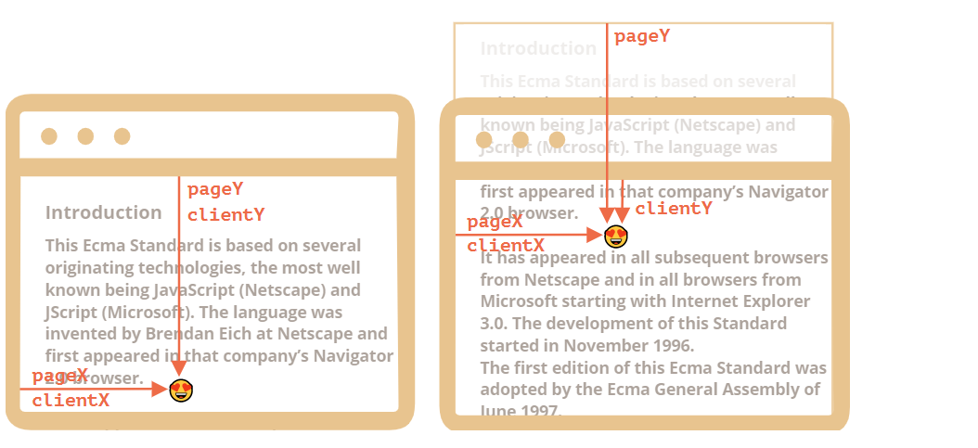
When the document scrolled:
- pageY – document-relative coordinate stayed the same, it’s counted from the document top (now scrolled out).
- clientY – window-relative coordinate did change (the arrow became shorter), as the same point became closer to window top.

Element coordinates: getBoundingClientRect
The method elem.getBoundingClientRect() returns window coordinates for a minimal rectangle that encloses elem as an object of built-in DOMRect class.
Main DOMRect properties:
- x/y – X/Y-coordinates of the rectangle origin relative to window,
- width/height – width/height of the rectangle (can be negative).
Additionally, there are derived properties:
- top/bottom – Y-coordinate for the top/bottom rectangle edge,
- left/right – X-coordinate for the left/right rectangle edge.
For instance click this button to see its window coordinates:
If you scroll the page and repeat, you’ll notice that as window-relative button position changes, its window coordinates (y/top/bottom if you scroll vertically) change as well.
Here’s the picture of elem.getBoundingClientRect() output:
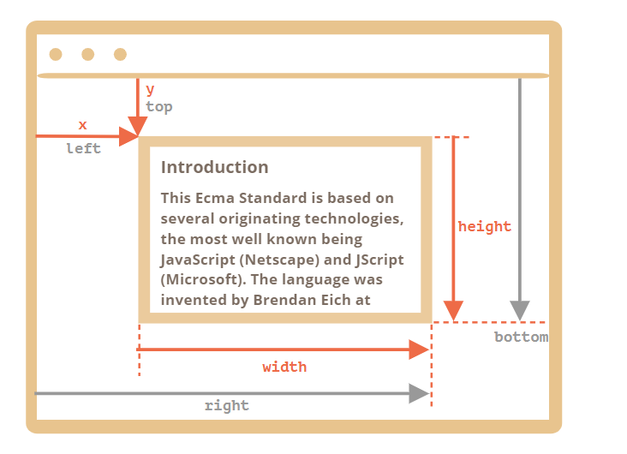
As you can see, x/y and width/height fully describe the rectangle. Derived properties can be easily calculated from them:
- left = x
- top = y
- right = x + width
- bottom = y + height
Please note:
- Coordinates may be decimal fractions, such as 10.5. That’s normal, internally browser uses fractions in calculations. We don’t have to round them when setting to style.left/top.
- Coordinates may be negative. For instance, if the page is scrolled so that elem is now above the window, then elem.getBoundingClientRect().top is negative.
Why derived properties are needed? Why does top/left exist if there’s x/y?
Mathematically, a rectangle is uniquely defined with its starting point (x,y) and the direction vector (width,height). So the additional derived properties are for convenience.
Technically it’s possible for width/height to be negative, that allows for “directed” rectangle, e.g. to represent mouse selection with properly marked start and end.
Negative width/height values mean that the rectangle starts at its bottom-right corner and then “grows” left-upwards.
Here’s a rectangle with negative width and height (e.g. width=-200, height=-100):
As you can see, left/top do not equal x/y in such case.
In practice though, elem.getBoundingClientRect() always returns positive width/height, here we mention negative width/height only for you to understand why these seemingly duplicate properties are not actually duplicates.
Internet Explorer and Edge: no support for x/y
Internet Explorer and Edge don’t support x/y properties for historical reasons.
So we can either make a polyfill (add getters in DomRect.prototype) or just use top/left, as they are always the same as x/y for positive width/height, in particular in the result of elem.getBoundingClientRect().
Coordinates right/bottom are different from CSS position properties
There are obvious similarities between window-relative coordinates and CSS position:fixed.
But in CSS positioning, right property means the distance from the right edge, and bottom property means the distance from the bottom edge.
If we just look at the picture above, we can see that in JavaScript it is not so. All window coordinates are counted from the top-left corner, including these ones.

elementFromPoint(x, y)
The call to document.elementFromPoint(x, y) returns the most nested element at window coordinates (x, y).
The syntax is:
let elem = document.elementFromPoint(x, y);
For instance, the code below highlights and outputs the tag of the element that is now in the middle of the window:
let centerX = document.documentElement.clientWidth / 2;
let centerY = document.documentElement.clientHeight / 2;

let elem = document.elementFromPoint(centerX, centerY);

elem.style.background = "red";
alert(elem.tagName);
As it uses window coordinates, the element may be different depending on the current scroll position.
For out-of-window coordinates the elementFromPoint returns null
The method document.elementFromPoint(x,y) only works if (x,y) are inside the visible area.
If any of the coordinates is negative or exceeds the window width/height, then it returns null.
Here’s a typical error that may occur if we don’t check for it:

let elem = document.elementFromPoint(x, y);
// if the coordinates happen to be out of the window, then elem = null
elem.style.background = ''; // Error!

Using for “fixed” positioning
Most of time we need coordinates in order to position something.
To show something near an element, we can use getBoundingClientRect to get its coordinates, and then CSS position together with left/top (or right/bottom).
For instance, the function createMessageUnder(elem, html) below shows the message under elem:

let elem = document.getElementById("coords-show-mark");

function createMessageUnder(elem, html) {
// create message element
let message = document.createElement('div');
// better to use a css class for the style here
message.style.cssText = "position:fixed; color: red";

// assign coordinates, don't forget "px"!
let coords = elem.getBoundingClientRect();

message.style.left = coords.left + "px";
message.style.top = coords.bottom + "px";

message.innerHTML = html;

return message;
}

// Usage:
// add it for 5 seconds in the document
let message = createMessageUnder(elem, 'Hello, world!');
document.body.append(message);
setTimeout(() => message.remove(), 5000);
Click the button to run it:
Button with id=“coords-show-mark”, the message will appear under it
The code can be modified to show the message at the left, right, below, apply CSS animations to “fade it in” and so on. That’s easy, as we have all the coordinates and sizes of the element.
But note the important detail: when the page is scrolled, the message flows away from the button.
The reason is obvious: the message element relies on position:fixed, so it remains at the same place of the window while the page scrolls away.
To change that, we need to use document-based coordinates and position:absolute.

Document coordinates
Document-relative coordinates start from the upper-left corner of the document, not the window.
In CSS, window coordinates correspond to position:fixed, while document coordinates are similar to position:absolute on top.
We can use position:absolute and top/left to put something at a certain place of the document, so that it remains there during a page scroll. But we need the right coordinates first.
There’s no standard method to get the document coordinates of an element. But it’s easy to write it.
The two coordinate systems are connected by the formula:
- pageY = clientY + height of the scrolled-out vertical part of the document.
- pageX = clientX + width of the scrolled-out horizontal part of the document.
The function getCoords(elem) will take window coordinates from elem.getBoundingClientRect() and add the current scroll to them:
// get document coordinates of the element
function getCoords(elem) {
let box = elem.getBoundingClientRect();

return {
top: box.top + window.pageYOffset,
left: box.left + window.pageXOffset
};
}
If in the example above we used it with position:absolute, then the message would stay near the element on scroll.
The modified createMessageUnder function:
function createMessageUnder(elem, html) {
let message = document.createElement('div');
message.style.cssText = "position:absolute; color: red";

let coords = getCoords(elem);

message.style.left = coords.left + "px";
message.style.top = coords.bottom + "px";

message.innerHTML = html;

return message;
}

An event is a signal that something has happened. All DOM nodes generate such signals (but events are not limited to DOM).
Here’s a list of the most useful DOM events, just to take a look at:
Mouse events:
- click – when the mouse clicks on an element (touchscreen devices generate it on a tap).
- contextmenu – when the mouse right-clicks on an element.
- mouseover / mouseout – when the mouse cursor comes over / leaves an element.
- mousedown / mouseup – when the mouse button is pressed / released over an element.
- mousemove – when the mouse is moved.
Keyboard events:
- keydown and keyup – when a keyboard key is pressed and released.
Form element events:
- submit – when the visitor submits a <form>.
- focus – when the visitor focuses on an element, e.g. on an <input>.
Document events:
- DOMContentLoaded – when the HTML is loaded and processed, DOM is fully built.
CSS events:
- transitionend – when a CSS-animation finishes.
There are many other events. We’ll get into more details of particular events in next chapters.

Event handlers
To react on events we can assign a handler – a function that runs in case of an event.
Handlers are a way to run JavaScript code in case of user actions.
There are several ways to assign a handler. Let’s see them, starting from the simplest one.

HTML-attribute
A handler can be set in HTML with an attribute named on<event>.
For instance, to assign a click handler for an input, we can use onclick, like here:
<input value="Click me" onclick="alert('Click!')" type="button">

On mouse click, the code inside onclick runs.
Please note that inside onclick we use single quotes, because the attribute itself is in double quotes. If we forget that the code is inside the attribute and use double quotes inside, like this: onclick="alert("Click!")", then it won’t work right.
An HTML-attribute is not a convenient place to write a lot of code, so we’d better create a JavaScript function and call it there.
Here a click runs the function countRabbits():
<script>
function countRabbits() {
for(let i=1; i<=3; i++) {
alert("Rabbit number " + i);
}
}
</script>

<input type="button" onclick="countRabbits()" value="Count rabbits!">

As we know, HTML attribute names are not case-sensitive, so ONCLICK works as well as onClick and onCLICK… But usually attributes are lowercased: onclick.
If the handler is assigned using an HTML-attribute then the browser reads it, creates a new function from the attribute content and writes it to the DOM property.
So this way is actually the same as the previous one.
These two code pieces work the same:
- Only HTML:
<input type="button" onclick="alert('Click!')" value="Button">

- HTML + JS:

<input type="button" id="button" value="Button">
<script>
button.onclick = function() {
alert('Click!');
};
</script>

In the first example, the HTML attribute is used to initialize the button.onclick, while in the second example – the script, that’s all the difference.
As there’s only one onclick property, we can’t assign more than one event handler.
In the example below adding a handler with JavaScript overwrites the existing handler:

<input type="button" id="elem" onclick="alert('Before')" value="Click me">
<script>
elem.onclick = function() { // overwrites the existing handler
alert('After'); // only this will be shown
};
</script>

In the example below adding a handler with JavaScript overwrites the existing handler:

<input type="button" id="elem" onclick="alert('Before')" value="Click me">
<script>
elem.onclick = function() { // overwrites the existing handler
alert('After'); // only this will be shown
};
</script>

To remove a handler – assign elem.onclick = null
The value of this inside a handler is the element. The one which has the handler on it.

We can set an existing function as a handler:
function sayThanks() {
alert('Thanks!');
}

elem.onclick = sayThanks;
But be careful: the function should be assigned as sayThanks, not sayThanks().
If we add parentheses, then sayThanks() becomes is a function call. So the last line actually takes the result of the function execution, that is undefined (as the function returns nothing), and assigns it to onclick. That doesn’t work.
…On the other hand, in the markup we do need the parentheses:
<input type="button" id="button" onclick="sayThanks()">
The difference is easy to explain. When the browser reads the attribute, it creates a handler function with body from the attribute content.
So the markup generates this property:

button.onclick = function() {
sayThanks(); // <-- the attribute content goes here
};
Don’t use setAttribute for handlers.
Such a call won’t work:
// a click on <body> will generate errors,
// because attributes are always strings, function becomes a string
document.body.setAttribute('onclick', function() { alert(1) });
DOM-property case matters.
Assign a handler to elem.onclick, not elem.ONCLICK, because DOM properties are case-sensitive.
Let’s say, one part of our code wants to highlight a button on click, and another one wants to show a message on the same click.
We’d like to assign two event handlers for that. But a new DOM property will overwrite the existing one:
input.onclick = function() { alert(1); }
// ...
input.onclick = function() { alert(2); } // replaces the previous handler
Developers of web standards understood that long ago and suggested an alternative way of managing handlers using special methods addEventListener and removeEventListener. They are free of such a problem.
The syntax to add a handler:
element.addEventListener(event, handler, [options]);
event
Event name, e.g. "click".
handler
The handler function.
options
An additional optional object with properties:
- once: if true, then the listener is automatically removed after it triggers.
- capture: the phase where to handle the event, to be covered later in the chapter Bubbling and capturing. For historical reasons, options can also be false/true, that’s the same as {capture: false/true}.
- passive: if true, then the handler will not call preventDefault(), we’ll explain that later in Browser default actions.
To remove the handler, use removeEventListener:
element.removeEventListener(event, handler, [options]);
Removal requires the same function
To remove a handler we should pass exactly the same function as was assigned.
That doesn’t work:
elem.addEventListener( "click" , () => alert('Thanks!'));
// ....
elem.removeEventListener( "click", () => alert('Thanks!'));
The handler won’t be removed, because removeEventListener gets another function – with the same code, but that doesn’t matter, as it’s a different function object.
Here’s the right way:
function handler() {
alert( 'Thanks!' );
}

input.addEventListener("click", handler);
// ....
input.removeEventListener("click", handler);
Please note – if we don’t store the function in a variable, then we can’t remove it. There’s no way to “read back” handlers assigned by addEventListener.
For some events, handlers only work with addEventListener
There exist events that can’t be assigned via a DOM-property. Only with addEventListener.
For instance, the DOMContentLoaded event, that triggers when the document is loaded and DOM is built.
// will never run
document.onDOMContentLoaded = function() {
alert("DOM built");
};
// this way it works
document.addEventListener("DOMContentLoaded", function() {
alert("DOM built");
});
So addEventListener is more universal. Although, such events are an exception rather than the rule.
To properly handle an event we’d want to know more about what’s happened. Not just a “click” or a “keydown”, but what were the pointer coordinates? Which key was pressed? And so on.
When an event happens, the browser creates an event object, puts details into it and passes it as an argument to the handler.
Here’s an example of getting pointer coordinates from the event object:

<input type="button" value="Click me" id="elem">

<script>
elem.onclick = function(event) {
// show event type, element and coordinates of the click
alert(event.type + " at " + event.currentTarget);
alert("Coordinates: " + event.clientX + ":" + event.clientY);
};
</script>
Some properties of event object:
event.type
Event type, here it’s "click".
event.currentTarget
Element that handled the event. That’s exactly the same as this, unless the handler is an arrow function, or its this is bound to something else, then we can get the element from event.currentTarget.
event.clientX / event.clientY
Window-relative coordinates of the cursor, for pointer events.
There are more properties. Many of them depend on the event type: keyboard events have one set of properties, pointer events – another one, we’ll study them later when we come to different events in details.
The event object is also available in HTML handlers
If we assign a handler in HTML, we can also use the event object, like this:
<input type="button" onclick="alert(event.type)" value="Event type">

That’s possible because when the browser reads the attribute, it creates a handler like this: function(event) { alert(event.type) }. That is: its first argument is called "event", and the body is taken from the attribute.

Object handlers: handleEvent
We can assign not just a function, but an object as an event handler using addEventListener. When an event occurs, its handleEvent method is called.
For instance:
<button id="elem">Click me</button>

<script>
let obj = {
handleEvent(event) {
alert(event.type + " at " + event.currentTarget);
}
};

elem.addEventListener('click', obj);
</script>

As we can see, when addEventListener receives an object as the handler, it calls obj.handleEvent(event) in case of an event.
We could also use a class for that:

<button id="elem">Click me</button>

<script>
class Menu {
handleEvent(event) {
switch(event.type) {
case 'mousedown':
elem.innerHTML = "Mouse button pressed";
break;
case 'mouseup':
elem.innerHTML += "...and released.";
break;
}
}
}

let menu = new Menu();
elem.addEventListener('mousedown', menu);
elem.addEventListener('mouseup', menu);
</script>
Here the same object handles both events. Please note that we need to explicitly setup the events to listen using addEventListener. The menu object only gets mousedown and mouseup here, not any other types of events.
The method handleEvent does not have to do all the job by itself. It can call other event-specific methods instead, like this:
<button id="elem">Click me</button>

<script>
class Menu {
handleEvent(event) {
// mousedown -> onMousedown
let method = 'on' + event.type[0].toUpperCase() + event.type.slice(1);
this[method](event);
}

onMousedown() {
elem.innerHTML = "Mouse button pressed";
}

onMouseup() {
elem.innerHTML += "...and released.";
}
}

let menu = new Menu();
elem.addEventListener('mousedown', menu);
elem.addEventListener('mouseup', menu);
</script>
Now event handlers are clearly separated, that may be easier to support.

The bubbling principle is simple.
When an event happens on an element, it first runs the handlers on it, then on its parent, then all the way up on other ancestors.
Let’s say we have 3 nested elements FORM > DIV > P with a handler on each of them:
<style>
body * {
margin: 10px;
border: 1px solid blue;
}
</style>

<form onclick="alert('form')">FORM
<div onclick="alert('div')">DIV
<p onclick="alert('p')">P</p>
</div>
</form>
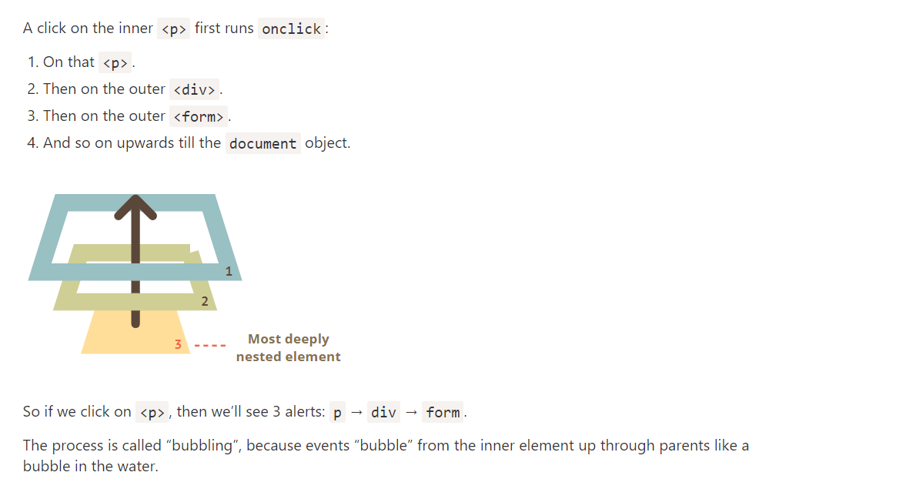
The key word in this phrase is “almost”.
For instance, a focus event does not bubble. There are other examples too, we’ll meet them. But still it’s an exception, rather than a rule, most events do bubble.

event.target
A handler on a parent element can always get the details about where it actually happened.
The most deeply nested element that caused the event is called a target element, accessible as event.target.
Note the differences from this (=event.currentTarget):
- event.target – is the “target” element that initiated the event, it doesn’t change through the bubbling process.
- this – is the “current” element, the one that has a currently running handler on it.
For instance, if we have a single handler form.onclick, then it can “catch” all clicks inside the form. No matter where the click happened, it bubbles up to <form> and runs the handler.
In form.onclick handler:
- this (=event.currentTarget) is the <form> element, because the handler runs on it.
- event.target is the actual element inside the form that was clicked.

That is: for a click on <td> the event first goes through the ancestors chain down to the element (capturing phase), then it reaches the target and triggers there (target phase), and then it goes up (bubbling phase), calling handlers on its way.
Before we only talked about bubbling, because the capturing phase is rarely used. Normally it is invisible to us.
Handlers added using on<event>-property or using HTML attributes or using two-argument addEventListener(event, handler) don’t know anything about capturing, they only run on the 2nd and 3rd phases.
To catch an event on the capturing phase, we need to set the handler capture option to true:
elem.addEventListener(..., {capture: true})
// or, just "true" is an alias to {capture: true}
elem.addEventListener(..., true)
There are two possible values of the capture option:
- If it’s false (default), then the handler is set on the bubbling phase.
- If it’s true, then the handler is set on the capturing phase.
Note that while formally there are 3 phases, the 2nd phase (“target phase”: the event reached the element) is not handled separately: handlers on both capturing and bubbling phases trigger at that phase.
Let’s see both capturing and bubbling in action:
<style>
body * {
margin: 10px;
border: 1px solid blue;
}
</style>

<form>FORM
<div>DIV
<p>P</p>
</div>
</form>

<script>
for(let elem of document.querySelectorAll('*')) {
elem.addEventListener("click", e => alert(`Capturing: ${elem.tagName}`), true);
elem.addEventListener("click", e => alert(`Bubbling: ${elem.tagName}`));
}
</script>

Stopping bubbling
A bubbling event goes from the target element straight up. Normally it goes upwards till <html>, and then to document object, and some events even reach window, calling all handlers on the path.
But any handler may decide that the event has been fully processed and stop the bubbling.
The method for it is event.stopPropagation().
For instance, here body.onclick doesn’t work if you click on <button>:
<body onclick="alert(`the bubbling doesn't reach here`)">
<button onclick="event.stopPropagation()">Click me</button>
</body>

event.stopImmediatePropagation()
If an element has multiple event handlers on a single event, then even if one of them stops the bubbling, the other ones still execute.
In other words, event.stopPropagation() stops the move upwards, but on the current element all other handlers will run.
To stop the bubbling and prevent handlers on the current element from running, there’s a method event.stopImmediatePropagation(). After it no other handlers execute.
Don’t stop bubbling without a need!
Bubbling is convenient. Don’t stop it without a real need: obvious and architecturally well thought out.
Sometimes event.stopPropagation() creates hidden pitfalls that later may become problems.
For instance:
- We create a nested menu. Each submenu handles clicks on its elements and calls stopPropagation so that the outer menu won’t trigger.
- Later we decide to catch clicks on the whole window, to track users’ behavior (where people click). Some analytic systems do that. Usually the code uses document.addEventListener('click'…) to catch all clicks.
- Our analytic won’t work over the area where clicks are stopped by stopPropagation. Sadly, we’ve got a “dead zone”.
There’s usually no real need to prevent the bubbling. A task that seemingly requires that may be solved by other means. One of them is to use custom events, we’ll cover them later. Also we can write our data into the event object in one handler and read it in another one, so we can pass to handlers on parents information about the processing below.

Capturing
There’s another phase of event processing called “capturing”. It is rarely used in real code, but sometimes can be useful.
The standard DOM Events describes 3 phases of event propagation:
- Capturing phase – the event goes down to the element.
- Target phase – the event reached the target element.
- Bubbling phase – the event bubbles up from the element.
Here’s the picture of a click on <td> inside a table, taken from the specification:

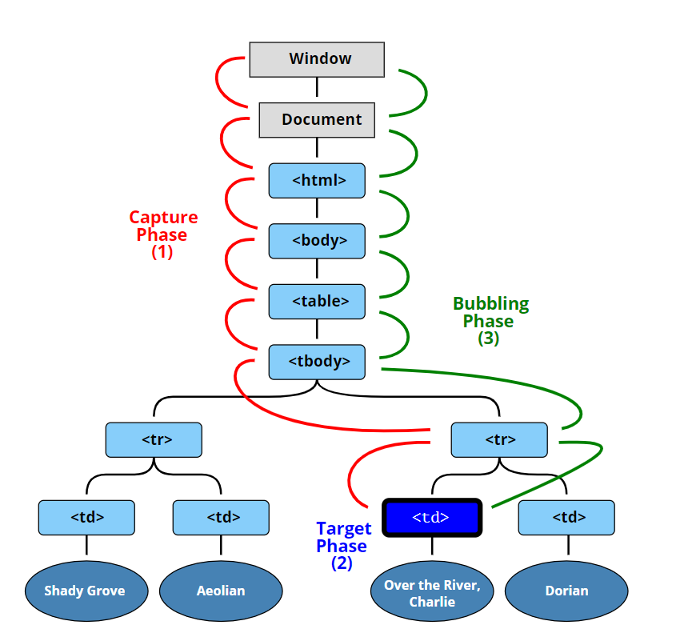
The code sets click handlers on every element in the document to see which ones are working.
If you click on <p>, then the sequence is:
- HTML → BODY → FORM → DIV (capturing phase, the first listener):
- P (target phase, triggers two times, as we’ve set two listeners: capturing and bubbling)
- DIV → FORM → BODY → HTML (bubbling phase, the second listener).
There’s a property event.eventPhase that tells us the number of the phase on which the event was caught. But it’s rarely used, because we usually know it in the handler.
To remove the handler, removeEventListener needs the same phase
If we addEventListener(..., true), then we should mention the same phase in removeEventListener(..., true) to correctly remove the handler.
Listeners on same element and same phase run in their set order
If we have multiple event handlers on the same phase, assigned to the same element with addEventListener, they run in the same order as they are created:
elem.addEventListener("click", e => alert(1)); // guaranteed to trigger first
elem.addEventListener("click", e => alert(2));

Capturing and bubbling allow us to implement one of most powerful event handling patterns called event delegation.
The idea is that if we have a lot of elements handled in a similar way, then instead of assigning a handler to each of them – we put a single handler on their common ancestor.
In the handler we get event.target, see where the event actually happened and handle it.

Instead of assign an onclick handler to each <td> (can be many) – we’ll setup the “catch-all” handler on <table> element.
It will use event.target to get the clicked element and highlight it.
The code:

let selectedTd;

table.onclick = function(event) {
let target = event.target; // where was the click?

if (target.tagName != 'TD') return; // not on TD? Then we're not interested

highlight(target); // highlight it
};

function highlight(td) {
if (selectedTd) { // remove the existing highlight if any
selectedTd.classList.remove('highlight');
}
selectedTd = td;
selectedTd.classList.add('highlight'); // highlight the new td
}
Such a code doesn’t care how many cells there are in the table. We can add/remove <td> dynamically at any time and the highlighting will still work.
Still, there’s a drawback.
The click may occur not on the <td>, but inside it.
In our case if we take a look inside the HTML, we can see nested tags inside <td>, like <strong>:

<td>
<strong>Northwest</strong>
...
</td>
Naturally, if a click happens on that <strong> then it becomes the value of event.target.

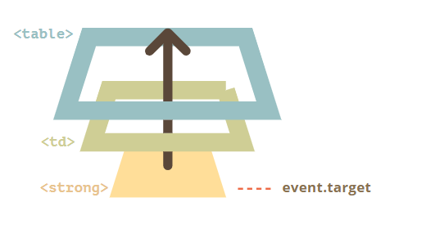

In the handler table.onclick we should take such event.target and find out whether the click was inside <td> or not.
Here’s the improved code:
table.onclick = function(event) {
let td = event.target.closest('td'); // (1)

if (!td) return; // (2)

if (!table.contains(td)) return; // (3)

highlight(td); // (4)
};
Explanations:
- The method elem.closest(selector) returns the nearest ancestor that matches the selector. In our case we look for <td> on the way up from the source element.
- If event.target is not inside any <td>, then the call returns immediately, as there’s nothing to do.
- In case of nested tables, event.target may be a <td>, but lying outside of the current table. So we check if that’s actually our table’s <td>.
- And, if it’s so, then highlight it.
As the result, we have a fast, efficient highlighting code, that doesn’t care about the total number of <td> in the table.

Let’s say, we want to make a menu with buttons “Save”, “Load”, “Search” and so on. And there’s an object with methods save, load, search… How to match them?
The first idea may be to assign a separate handler to each button. But there’s a more elegant solution. We can add a handler for the whole menu and data-action attributes for buttons that has the method to call:
<button data-action="save">Click to Save</button>
The handler reads the attribute and executes the method. Take a look at the working example:

<div id="menu">
<button data-action="save">Save</button>
<button data-action="load">Load</button>
<button data-action="search">Search</button>
</div>

<script>
class Menu {
constructor(elem) {
this._elem = elem;
elem.onclick = this.onClick.bind(this); // (*)
}

save() {
alert('saving');
}

load() {
alert('loading');
}

search() {
alert('searching');
}

onClick(event) {
let action = event.target.dataset.action;
if (action) {
this[action]();
}
};
}

new Menu(menu);
</script>

Please note that this.onClick is bound to this in (*). That’s important, because otherwise this inside it would reference the DOM element (elem), not the Menu object, and this[action] would not be what we need.
So, what advantages does delegation give us here?
We could also use classes .action-save, .action-load, but an attribute data-action is better semantically. And we can use it in CSS rules too.
- We don’t need to write the code to assign a handler to each button. Just make a method and put it in the markup.
- The HTML structure is flexible, we can add/remove buttons at any time.
We can also use event delegation to add “behaviors” to elements declaratively, with special attributes and classes.
The pattern has two parts:
- We add a custom attribute to an element that describes its behavior.
- A document-wide handler tracks events, and if an event happens on an attributed element – performs the action.

Behavior: Counter
For instance, here the attribute data-counter adds a behavior: “increase value on click” to buttons:
Counter: <input type="button" value="1" data-counter>
One more counter: <input type="button" value="2" data-counter>

<script>
document.addEventListener('click', function(event) {

if (event.target.dataset.counter != undefined) { // if the attribute exists...
event.target.value++;
}

});
</script>

If we click a button – its value is increased. Not buttons, but the general approach is important here.
There can be as many attributes with data-counter as we want. We can add new ones to HTML at any moment. Using the event delegation we “extended” HTML, added an attribute that describes a new behavior.
For document-level handlers – always addEventListener
When we assign an event handler to the document object, we should always use addEventListener, not document.on<event>, because the latter will cause conflicts: new handlers overwrite old ones.
For real projects it’s normal that there are many handlers on document set by different parts of the code.

Behavior: Toggler
One more example of behavior. A click on an element with the attribute data-toggle-id will show/hide the element with the given id:

<button data-toggle-id="subscribe-mail">
Show the subscription form
</button>

<form id="subscribe-mail" hidden>
Your mail: <input type="email">
</form>

<script>
document.addEventListener('click', function(event) {
let id = event.target.dataset.toggleId;
if (!id) return;

let elem = document.getElementById(id);

elem.hidden = !elem.hidden;
});
</script>

Let’s note once again what we did. Now, to add toggling functionality to an element – there’s no need to know JavaScript, just use the attribute data-toggle-id.
That may become really convenient – no need to write JavaScript for every such element. Just use the behavior. The document-level handler makes it work for any element of the page.
We can combine multiple behaviors on a single element as well.
The “behavior” pattern can be an alternative to mini-fragments of JavaScript.

Many events automatically lead to certain actions performed by the browser.
For instance:
- A click on a link – initiates navigation to its URL.
- A click on a form submit button – initiates its submission to the server.
- Pressing a mouse button over a text and moving it – selects the text.
If we handle an event in JavaScript, we may not want the corresponding browser action to happen, and want to implement another behavior instead.

Preventing browser actions
There are two ways to tell the browser we don’t want it to act:
- The main way is to use the event object. There’s a method event.preventDefault().
- If the handler is assigned using on<event> (not by addEventListener), then returning false also works the same.
In this HTML a click on a link doesn’t lead to navigation, browser doesn’t do anything:
<a href="/" onclick="return false">Click here</a>
or
<a href="/" onclick="event.preventDefault()">here</a>

In the next example we’ll use this technique to create a JavaScript-powered menu.
Returning false from a handler is an exception
The value returned by an event handler is usually ignored.
The only exception is return false from a handler assigned using on<event>.
In all other cases, return value is ignored. In particular, there’s no sense in returning true.

Example: the menu
Consider a site menu, like this:
<ul id="menu" class="menu">
<li><a href="/html">HTML</a></li>
<li><a href="/javascript">JavaScript</a></li>
<li><a href="/css">CSS</a></li>
</ul>

Menu items are implemented as HTML-links <a>, not buttons <button>. There are several reasons to do so, for instance:
- Many people like to use “right click” – “open in a new window”. If we use <button> or <span>, that doesn’t work.
- Search engines follow <a href="..."> links while indexing.
So we use <a> in the markup. But normally we intend to handle clicks in JavaScript. So we should prevent the default browser action.
Like here:

menu.onclick = function(event) {
if (event.target.nodeName != 'A') return;

let href = event.target.getAttribute('href');
alert( href ); // ...can be loading from the server, UI generation etc

return false; // prevent browser action (don't go to the URL)
};
If we omit return false, then after our code executes the browser will do its “default action” – navigating to the URL in href. And we don’t need that here, as we’re handling the click by ourselves.
By the way, using event delegation here makes our menu very flexible. We can add nested lists and style them using CSS to “slide down”.
Follow-up events
Certain events flow one into another. If we prevent the first event, there will be no second.
For instance, mousedown on an <input> field leads to focusing in it, and the focus event. If we prevent the mousedown event, there’s no focus.
Try to click on the first <input> below – the focus event happens. But if you click the second one, there’s no focus.

<input value="Focus works" onfocus="this.value=''">
<input onmousedown="return false" onfocus="this.value=''" value="Click me">

That’s because the browser action is canceled on mousedown. The focusing is still possible if we use another way to enter the input. For instance, the Tab key to switch from the 1st input into the 2nd. But not with the mouse click any more.

The “passive” handler option
The optional passive: true option of addEventListener signals the browser that the handler is not going to call preventDefault().
Why that may be needed?
There are some events like touchmove on mobile devices (when the user moves their finger across the screen), that cause scrolling by default, but that scrolling can be prevented using preventDefault() in the handler.
So when the browser detects such event, it has first to process all handlers, and then if preventDefault is not called anywhere, it can proceed with scrolling. That may cause unnecessary delays and “jitters” in the UI.
The passive: true options tells the browser that the handler is not going to cancel scrolling. Then browser scrolls immediately providing a maximally fluent experience, and the event is handled by the way.
For some browsers (Firefox, Chrome), passive is true by default for touchstart and touchmove events.

event.defaultPrevented
The property event.defaultPrevented is true if the default action was prevented, and false otherwise.
There’s an interesting use case for it.
You remember in the chapter Bubbling and capturing we talked about event.stopPropagation() and why stopping bubbling is bad?
Sometimes we can use event.defaultPrevented instead, to signal other event handlers that the event was handled.
Let’s see a practical example.
By default the browser on contextmenu event (right mouse click) shows a context menu with standard options. We can prevent it and show our own, like this:

<button>Right-click shows browser context menu</button>

<button oncontextmenu="alert('Draw our menu'); return false">
Right-click shows our context menu
</button>

Now, in addition to that context menu we’d like to implement document-wide context menu.
Upon right click, the closest context menu should show up.
<p>Right-click here for the document context menu</p>
<button id="elem">Right-click here for the button context menu</button>

<script>
elem.oncontextmenu = function(event) {
event.preventDefault();
alert("Button context menu");
};

document.oncontextmenu = function(event) {
event.preventDefault();
alert("Document context menu");
};
</script>

The problem is that when we click on elem, we get two menus: the button-level and (the event bubbles up) the document-level menu.
How to fix it? One of solutions is to think like: “When we handle right-click in the button handler, let’s stop its bubbling” and use event.stopPropagation():

<p>Right-click for the document menu</p>
<button id="elem">Right-click for the button menu (fixed with event.stopPropagation)</button>

<script>
elem.oncontextmenu = function(event) {
event.preventDefault();
event.stopPropagation();
alert("Button context menu");
};

document.oncontextmenu = function(event) {
event.preventDefault();
alert("Document context menu");
};
</script>

Now the button-level menu works as intended. But the price is high. We forever deny access to information about right-clicks for any outer code, including counters that gather statistics and so on. That’s quite unwise.
An alternative solution would be to check in the document handler if the default action was prevented? If it is so, then the event was handled, and we don’t need to react on it.

<p>Right-click for the document menu (added a check for event.defaultPrevented)</p>
<button id="elem">Right-click for the button menu</button>

<script>
elem.oncontextmenu = function(event) {
event.preventDefault();
alert("Button context menu");
};

document.oncontextmenu = function(event) {
if (event.defaultPrevented) return;

event.preventDefault();
alert("Document context menu");
};
</script>

Now everything also works correctly. If we have nested elements, and each of them has a context menu of its own, that would also work. Just make sure to check for event.defaultPrevented in each contextmenu handler.
event.stopPropagation() and event.preventDefault()
As we can clearly see, event.stopPropagation() and event.preventDefault() (also known as return false) are two different things. They are not related to each other.
Nested context menus architecture
There are also alternative ways to implement nested context menus. One of them is to have a single global object with a handler for document.oncontextmenu, and also methods that allow us to store other handlers in it.
The object will catch any right-click, look through stored handlers and run the appropriate one.
But then each piece of code that wants a context menu should know about that object and use its help instead of the own contextmenu handler.

Summary

Event constructor
Build-in event classes form a hierarchy, similar to DOM element classes. The root is the built-in Event class.
We can create Event objects like this:
let event = new Event(type[, options]);
Arguments:
- type – event type, a string like "click" or our own like "my-event".
- options – the object with two optional properties:
  - bubbles: true/false – if true, then the event bubbles.
  - cancelable: true/false – if true, then the “default action” may be prevented. Later we’ll see what it means for custom events.
By default both are false: {bubbles: false, cancelable: false}.

dispatchEvent
After an event object is created, we should “run” it on an element using the call elem.dispatchEvent(event).
Then handlers react on it as if it were a regular browser event. If the event was created with the bubbles flag, then it bubbles.
In the example below the click event is initiated in JavaScript. The handler works same way as if the button was clicked:
<button id="elem" onclick="alert('Click!');">Autoclick</button>

<script>
let event = new Event("click");
elem.dispatchEvent(event);
</script>
event.isTrusted
There is a way to tell a “real” user event from a script-generated one.
The property event.isTrusted is true for events that come from real user actions and false for script-generated events.

Bubbling example
We can create a bubbling event with the name "hello" and catch it on document.
All we need is to set bubbles to true:
<h1 id="elem">Hello from the script!</h1>

<script>
// catch on document...
document.addEventListener("hello", function(event) { // (1)
alert("Hello from " + event.target.tagName); // Hello from H1
});

// ...dispatch on elem!
let event = new Event("hello", {bubbles: true}); // (2)
elem.dispatchEvent(event);

// the handler on document will activate and display the message.

</script>
Notes:
- We should use addEventListener for our custom events, because on<event> only exists for built-in events, document.onhello doesn’t work.
- Must set bubbles:true, otherwise the event won’t bubble up.
The bubbling mechanics is the same for built-in (click) and custom (hello) events. There are also capturing and bubbling stages.

MouseEvent, KeyboardEvent and others
Here’s a short list of classes for UI Events from the UI Event specification:
- UIEvent
- FocusEvent
- MouseEvent
- WheelEvent
- KeyboardEvent
- …
We should use them instead of new Event if we want to create such events. For instance, new MouseEvent("click").
The right constructor allows to specify standard properties for that type of event.
Like clientX/clientY for a mouse event:

let event = new MouseEvent("click", {
bubbles: true,
cancelable: true,
clientX: 100,
clientY: 100
});

alert(event.clientX); // 100
Please note: the generic Event constructor does not allow that.
Let’s try:

let event = new Event("click", {
bubbles: true, // only bubbles and cancelable
cancelable: true, // work in the Event constructor
clientX: 100,
clientY: 100
});

alert(event.clientX); // undefined, the unknown property is ignored!
Technically, we can work around that by assigning directly event.clientX=100 after creation. So that’s a matter of convenience and following the rules. Browser-generated events always have the right type.
The full list of properties for different UI events is in the specification, for instance, MouseEvent.

Custom events
For our own, completely new events types like "hello" we should use new CustomEvent. Technically CustomEvent is the same as Event, with one exception.
In the second argument (object) we can add an additional property detail for any custom information that we want to pass with the event.
For instance:

<h1 id="elem">Hello for John!</h1>

<script>
// additional details come with the event to the handler
elem.addEventListener("hello", function(event) {
alert(event.detail.name);
});

elem.dispatchEvent(new CustomEvent("hello", {
detail: { name: "John" }
}));
</script>
The detail property can have any data. Technically we could live without, because we can assign any properties into a regular new Event object after its creation. But CustomEvent provides the special detail field for it to evade conflicts with other event properties.
Besides, the event class describes “what kind of event” it is, and if the event is custom, then we should use CustomEvent just to be clear about what it is.

event.preventDefault()
Many browser events have a “default action”, such as nagivating to a link, starting a selection, and so on.
For new, custom events, there are definitely no default browser actions, but a code that dispatches such event may have its own plans what to do after triggering the event.
By calling event.preventDefault(), an event handler may send a signal that those actions should be canceled.
In that case the call to elem.dispatchEvent(event) returns false. And the code that dispatched it knows that it shouldn’t continue.
Let’s see a practical example – a hiding rabbit (could be a closing menu or something else).
Below you can see a #rabbit and hide() function that dispatches "hide" event on it, to let all interested parties know that the rabbit is going to hide.
Any handler can listen for that event with rabbit.addEventListener('hide',...) and, if needed, cancel the action using event.preventDefault(). Then the rabbit won’t disappear:
<pre id="rabbit">
|\ /|
\|_|/
/. .\
=\_Y_/=
{>o<}
</pre>
<button onclick="hide()">Hide()</button>

<script>
// hide() will be called automatically in 2 seconds
function hide() {
let event = new CustomEvent("hide", {
cancelable: true // without that flag preventDefault doesn't work
});
if (!rabbit.dispatchEvent(event)) {
alert('The action was prevented by a handler');
} else {
rabbit.hidden = true;
}
}

rabbit.addEventListener('hide', function(event) {
if (confirm("Call preventDefault?")) {
event.preventDefault();
}
});
</script>

Please note: the event must have the flag cancelable: true, otherwise the call event.preventDefault() is ignored.

Events-in-events are synchronous
Usually events are processed in a queue. That is: if the browser is processing onclick and a new event occurs, e.g. mouse moved, then it’s handing is queued up, corresponding mousemove handlers will be called after onclick processing is finished.
The notable exception is when one event is initiated from within another one, e.g. using dispatchEvent. Such events are processed immediately: the new event handlers are called, and then the current event handling is resumed.
For instance, in the code below the menu-open event is triggered during the onclick.
It’s processed immediately, without waiting for onlick handler to end:
<button id="menu">Menu (click me)</button>

<script>
menu.onclick = function() {
alert(1);

menu.dispatchEvent(new CustomEvent("menu-open", {
bubbles: true
}));

alert(2);
};

// triggers between 1 and 2
document.addEventListener('menu-open', () => alert('nested'));
</script>

The output order is: 1 → nested → 2.
Please note that the nested event menu-open is caught on the document. The propagation and handling of the nested event is finished before the processing gets back to the outer code (onclick).
That’s not only about dispatchEvent, there are other cases. If an event handler calls methods that trigger to other events – they are too processed synchronously, in a nested fashion.
Let’s say we don’t like it. We’d want onclick to be fully processed first, independently from menu-open or any other nested events.
Then we can either put the dispatchEvent (or another event-triggering call) at the end of onclick or, maybe better, wrap it in the zero-delay setTimeout:
<button id="menu">Menu (click me)</button>

<script>
menu.onclick = function() {
alert(1);

setTimeout(() => menu.dispatchEvent(new CustomEvent("menu-open", {
bubbles: true
})));

alert(2);
};

document.addEventListener('menu-open', () => alert('nested'));
</script>
Now dispatchEvent runs asynchronously after the current code execution is finished, including mouse.onclick, so event handlers are totally separate.
The output order becomes: 1 → 2 → nested.

