So first, let’s see how we attach a script to a webpage. For server-side environments (like Node.js), you can execute the script with a command like "node my.js".

<script type= « text/javascript> = « ancien »

URL pour include script ( download par navigateur puis mit dans cache si autre page utilise script alors on va chercher dans le cache)

The directive looks like a string: "use strict" or 'use strict'. When it is located at the top of a script, the whole script works the “modern” way.

BigInt type was recently added to the language to represent integers of arbitrary length.

Backticks are “extended functionality” quotes. They allow us to embed variables and expressions into a string by wrapping them in ${…}, for example:

let name = "John";

// embed a variable
alert( `Hello, ${name}!` ); // Hello, John!

// embed an expression
alert( `the result is ${1 + 2}` ); // the result is 3

The call to typeof x returns a string with the type name
alert("Hello");
The mini-window with the message is called a modal window. The word “modal” means that the visitor can’t interact with the rest of the page, press other buttons, etc, until they have dealt with the window.

result = prompt(title, [default]);
It shows a modal window with a text message, an input field for the visitor, and the buttons OK/Cancel.
title
The text to show the visitor.
default
An optional second parameter, the initial value for the input field.
The call to prompt returns the text from the input field or null if the input was canceled.
The second parameter is optional, but if we don’t supply it, Internet Explorer will insert the text "undefined" into the prompt.

The syntax:
result = confirm(question);
The function confirm shows a modal window with a question and two buttons: OK and Cancel.
The result is true if OK is pressed and false otherwise.

Return NaN si conversion explicite fail

Regle conversion numerique : Number(str)

undefined => NaN
null => 0
true et false => 1 et 0
string => espace(s) de début/fin sont enlevés puis ( str.empty()?0:str.readnumber() ) si erreur alors NaN

« == » teste l’égalité en utilisant ces règles

A strict equality operator === checks the equality without type conversion.

Note :
For a strict equality check ===
These values are different, because each of them is a different type.
For a non-strict check ==
There’s a special rule. These two are a “sweet couple”: they equal each other (in the sense of ==), but not any other value.
alert( null == undefined ); // true

For maths and other comparisons < > <= ≥
null/undefined are converted to numbers: null becomes 0, while undefined becomes NaN.

The equality check == for undefined and null is defined such that, without any conversions, they equal each other and don’t equal anything else.

alert( null > 0 ); // (1) false
alert( null == 0 ); // (2) false
alert( null >= 0 ); // (3) true

The result of a ?? b is:
- a if it’s not null or undefined,
- b, otherwise.
|| returns the first truthy value.
- ?? returns the first defined value.
The break <labelName> statement in the loop below breaks out to the labelThe continue directive can also be used with a label. In this case, code execution jumps to the next iteration of the labeled loop.
Let’s emphasize that the equality check is always strict. The values must be of the same type to match.
Pas switch avec case « lol » : puis derriere case 3 :

On peut appeler fonction avec param en moins ils seront undefined
function sayHi() { // (1) create
alert( "Hello" );
}

let func = sayHi; // (2) copy

func(); // Hello // (3) run the copy (it works)!
sayHi(); // Hello // this still works too (why wouldn't it)

Function Declaration:
A function, declared as a separate statement, in the main code flow.
// Function Declaration
function sum(a, b) {
return a + b;
}
- Function Expression:
A function, created inside an expression or inside another syntax construct. Here, the function is created at the right side of the “assignment expression” =:
// Function Expression
let sum = function(a, b) {
return a + b;
};

A Function Expression is created when the execution reaches it and is usable only from that moment.
A Function Declaration can be called earlier than it is defined.

It’s called “arrow functions”, because it looks like this:
let func = (arg1, arg2, ...argN) => expression

let user = new Object(); // "object constructor" syntax
let user = {}; // "object literal" syntax

We can immediately put some properties into {...} as “key: value” pairs:
let user = { // an object
name: "John", // by key "name" store value "John"
age: 30 // by key "age" store value 30
};
A property has a key (also known as “name” or “identifier”) before the colon ":" and a value to the right of it.
Let’s add a boolean one:
user.isAdmin = true;

To remove a property, we can use delete operator:
delete user.age;

We can also use multiword property names, but then they must be quoted:

"likes birds": true // multiword property name must be quoted

const user = { … } => on peut toujours modifier sont contenus mais pas la valeur de user : user = …. ( pointeur constant vers un objet non const )
For multiword properties, the dot access doesn’t work donc
user["likes birds"] = true;

let key = prompt("What do you want to know about the user?", "name");

// access by variable
alert( user[key] ); // John (if enter "name")

We can use square brackets in an object literal, when creating an object. That’s called computed properties.
For instance:

let fruit = prompt("Which fruit to buy?", "apple");

let bag = {
[fruit]: 5, // the name of the property is taken from the variable fruit
};

alert( bag.apple ); // 5 if fruit="apple"

function makeUser(name, age) {
return {
name, // same as name: name
age, // same as age: age
// ...
};
}

plus court que de mettre name :name cette fois ci le param
In the example above, properties have the same names as variables. The use-case of making a property from a variable is so common, that there’s a special property value shorthand to make it shorter.

let user = { name: "John", age: 30 };

alert( "age" in user ); // true, user.age exists
let key = "age";
alert( key in user ); // true, property "age" exists
alert( "blabla" in user ); // false, user.blabla doesn't exist

Est ce que les objets sont triés :
The short answer is: “ordered in a special fashion”: integer properties are sorted, others appear in creation order. The details follow.

Pour evtier nombre ranger croissant mettre un « + » devant comme ca!= integer property name ( un string pouvant etre convertie en nombre sans changement exemple « 42 »).

One of the fundamental differences of objects vs primitives is that they are stored and copied “by reference”.

A variable stores not the object itself, but its “address in memory”, in other words “a reference” to it.
When an object variable is copied – the reference is copied, the object is not duplicated.
Comme en java

The equality == and strict equality === operators for objects work exactly the same. Object egal si est le meme sinon!= .

Pas de copie / clone en javascript donc for in sur l’objet pour copier tous les champs
ou
Object.assign(dest, [src1, src2, src3...])
- The first argument dest is a target object.
- Further arguments src1, ..., srcN (can be as many as needed) are source objects.
It copies the properties of all source objects src1, ..., srcN into the target dest.
If the copied property name already exists, it gets overwritten:
We also can use Object.assign to replace for..in loop for simple cloning:
let clone = Object.assign({}, user);

Si on clone un objet de la sorte alors que user contient lui même un objet alors le clone et user partageront ce même objet/on copie la ref.
To fix that, we should use the cloning loop that examines each value of user[key] and, if it’s an object, then replicate its structure as well. That is called a “deep cloning”.
There’s a standard algorithm for deep cloning that handles the case above and more complex cases, called the Structured cloning algorithm.
We can use recursion to implement it. Or, not to reinvent the wheel, take an existing implementation, for instance _.cloneDeep(obj) from the JavaScript library lodash.

The value of this is evaluated during the run-time, depending on the context.
Calling without an object: this == undefined
We can even call the function without an object at all:
function sayHi() {
alert(this);
}

sayHi(); // undefined

In this case this is undefined in strict mode. If we try to access this.name, there will be an error.
In non-strict mode the value of this in such case will be the global object (window in a browser, we’ll get to it later in the chapter Global object). This is a historical behavior that "use strict" fixes.

In JavaScript this is “free”, its value is evaluated at call-time and does not depend on where the method was declared, but rather on what object is “before the dot”.
The concept of run-time evaluated this has both pluses and minuses. On the one hand, a function can be reused for different objects. On the other hand, the greater flexibility creates more possibilities for mistakes.

Arrow functions are special: they don’t have their “own” this. If we reference this from such a function, it’s taken from the outer “normal” function.

When a function is executed with new, it does the following steps:
- A new empty object is created and assigned to this. // this = {}; (implicitly)
- The function body executes. Usually it modifies this, adds new properties to it. // example : add properties to this
- The value of this is returned. // return this; (implicitly)
So let user = new User("Jack") gives the same result as:
let user = {
name: "Jack",
isAdmin: false
};

Let’s note once again – technically, any function can be used as a constructor. That is: any function can be run with new, and it will execute the algorithm above.

Inside a function, we can check whether it was called with new or without it, using a special new.target property.
It is empty for regular calls and equals the function if called with new:

function User() {
alert(new.target);
}

// without "new":
User(); // undefined

// with "new":
new User(); // function User { ... }

That can be used inside the function to know whether it was called with new, “in constructor mode”, or without it, “in regular mode”.
Usually, constructors do not have a return statement. Their task is to write all necessary stuff into this, and it automatically becomes the result.
But if there is a return statement, then the rule is simple:
- If return is called with an object, then the object is returned instead of this.
- If return is called with a primitive, it’s ignored.
In other words, return with an object returns that object, in all other cases this is returned.
By the way, we can omit parentheses after new, if it has no arguments

The optional chaining ?. stops the evaluation and returns undefined if the part before ?. is undefined or null.
Further in this article, for brevity, we’ll be saying that something “exists” if it’s not null and not undefined.
Here’s the safe way to access user.address.street:
let user = {}; // user has no address
alert( user?.address?.street ); // undefined (no error)
même si undefined ou null ca marche

The optional chaining ?. is not an operator, but a special syntax construct, that also works with functions and square brackets.
alert( user2?.[key] ); // square brace : cout : undefined
user2.admin?.(); //function
delete user?.name; // delete user.name if user exists

A “symbol” represents a unique identifier.
let id = Symbol();

A value of this type can be created using Symbol():
let id = Symbol("id"); // wiht description : « id »

Symbols don’t auto-convert to a string
alert(id); // TypeError: Cannot convert a Symbol value to a string
=> to string on it ou de get symbol.descirption property

Symbols allow us to create “hidden” properties of an object, that no other part of code can accidentally access or overwrite.

If we want to use a symbol in an object literal {...}, we need square brackets around it.

let id = Symbol("id");

let user = {
name: "John",
[id]: 123 // not "id: 123"
};

Symbols are skipped by for…in et Object.keys(user) ignores them. That’s a part of the general “hiding symbolic properties” principle. If another script or a library loops over our object, it won’t unexpectedly access a symbolic property.

In contrast, Object.assign copies both string and symbol properties:
To achieve that, there exists a global symbol registry. We can create symbols in it and access them later, and it guarantees that repeated accesses by the same name return exactly the same symbol.
In order to read (create if absent) a symbol from the registry, use Symbol.for(key).
That call checks the global registry, and if there’s a symbol described as key, then returns it, otherwise creates a new symbol Symbol(key) and stores it in the registry by the given key.

// read from the global registry
let id = Symbol.for("id"); // if the symbol did not exist, it is created

// read it again (maybe from another part of the code)
let idAgain = Symbol.for("id");

// the same symbol
alert( id === idAgain ); // true

For global symbols, not only Symbol.for(key) returns a symbol by name, but there’s a reverse call: Symbol.keyFor(sym), that does the reverse: returns a name by a global symbol. So it doesn’t work for non-global symbols. If the symbol is not global, it won’t be able to find it and returns undefined.
There are three variants of type conversion, so-called “hints”, described in the specification:
« string «
« number «
"default"
Occurs in rare cases when the operator is “not sure” what type to expect.For exemple if the a binary plus gets an object as an argument, it uses the "default" hint to convert it.
Comparaison use number not default for historical reason .
All built-in objects except for one case (Date object, we’ll learn it later) implement "default" conversion the same way as "number". And we can do the same.

There is no “boolean” hint (all objects are true in boolean context) or anything else. And if we treat "default" and "number" the same, like most built-ins do, then there are only two conversions.

To do the conversion, JavaScript tries to find and call three object methods:
ll obj[Symbol.toPrimitive](hint) – the method with the symbolic key Symbol.toPrimitive (system symbol), if such method exists,
- Otherwise if hint is "string"
  - try obj.toString() and obj.valueOf(), whatever exists.
- Otherwise if hint is "number" or "default"
  - try obj.valueOf() and obj.toString(), whatever exist

obj[Symbol.toPrimitive] = function(hint) {
// must return a primitive value
// hint = one of "string", "number", "default"
};
For instance, here user object implements it:
let user = {
name: "John",
money: 1000,

[Symbol.toPrimitive](hint) {
alert(`hint: ${hint}`);
return hint == "string" ? `{name: "${this.name}"}` : this.money;
}
};

// conversions demo:
alert(user); // hint: string -> {name: "John"}

Methods toString and valueOf come from ancient times. They are not symbols (symbols did not exist that long ago), but rather “regular” string-named methods. They provide an alternative “old-style” way to implement the conversion.

If there’s no Symbol.toPrimitive then JavaScript tries to find them and try in the order:
- toString -> valueOf for “string” hint.
- valueOf -> toString otherwise.
These methods must return a primitive value. If toString or valueOf returns an object, then it’s ignored (same as if there were no method).
By default, a plain object has following toString and valueOf methods:
- The toString method returns a string "[object Object]".
- The valueOf method returns the object itself.
Valueof As you can see, it returns the object itself, and so is ignored.

If we pass an object as an argument, then there are two stages:
- The object is converted to a primitive (using the rules described above).
- If the resulting primitive isn’t of the right type, it’s converted.
The execution context is an internal data structure that contains details about the execution of a function: where the control flow is now, the current variables, the value of this (we don’t use it here) and few other internal details.

When a function makes a nested call, the following happens:
- The current function is paused.
- The execution context associated with it is remembered in a special data structure called execution context stack.
- The nested call executes.
- After it ends, the old execution context is retrieved from the stack, and the outer function is resumed from where it stopped.

The current context is “remembered” on top of the stack.
- The new context is created for the subcall.
- When the subcall is finished – the previous context is popped from the stack, and its execution continues.

A recursively-defined data structure is a data structure that can be defined using itself.

Rest parameters ...
A function can be called with any number of arguments, no matter how it is defined.
The rest parameters must be at the end

There is also a special array-like object named arguments that contains all arguments by their index. Mais pas un array donc iterable mais pas acces methode array .

Arrow functions do not have "arguments"
If we access the arguments object from an arrow function, it takes them from the outer “normal” function.

REVERSE transformer tableau en liste :
For this particular task we could also use Array.from, because it converts an iterable (like a string) into an array:

let arr = [3, 5, 1];
alert( Math.max(...arr) ); // 5 (spread turns array into a list of arguments)

let arr2 = [3, 5, 1];
let arr3 = [8, 9, 15];

let merged = [0, ...arr2, 2, ...arr3];

alert(merged); // 0,3,5,1,2,8,9,15 (0, then arr, then 2, then arr2)

But there’s a subtle difference between Array.from(obj) and [...obj]:
- Array.from operates on both array-likes and iterables.
- The spread syntax works only with iterables.
Remember when we talked about Object.assign()

let arr = [1, 2, 3];
let arrCopy = [...arr]; // spread the array into a list of parameters
// then put the result into a new array

let obj = { a: 1, b: 2, c: 3 };
let objCopy = { ...obj }; // spread the object into a list of parameters
// then return the result in a new object
This way of copying an object is much shorter than let objCopy = Object.assign({}, obj); or for an array let arrCopy = Object.assign([], arr); so we prefer to use it whenever we can.

In JavaScript, there are 3 ways to declare a variable: let, const (the modern ones), and var (the remnant of the past).
- In this article we’ll use let variables in examples.
- Variables, declared with const, behave the same, so this article is about const too.
- The old var has some notable differences, they will be covered in the article The old "var".

In JavaScript, every running function, code block {...}, and the script as a whole have an internal (hidden) associated object known as the Lexical Environment.
The Lexical Environment object consists of two parts:
- Environment Record – an object that stores all local variables as its properties (and some other information like the value of this).
- A reference to the outer lexical environment, the one associated with the outer code.
A “variable” is just a property of the special internal object, Environment Record. “To get or change a variable” means “to get or change a property of that object”.

In this simple code without functions, there is only one Lexical Environment ( gloabal Lexical Environment) => outer ref = null

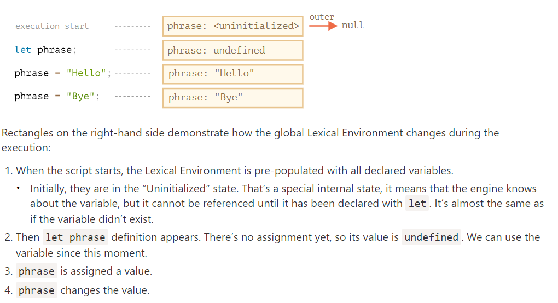
The difference is that a Function Declaration is instantly fully initialized.
When a Lexical Environment is created, a Function Declaration immediately becomes a ready-to-use function (unlike let, that is unusable till the declaration).
That’s why we can use a function, declared as Function Declaration, even before the declaration itself.
PAS APPLIQUE A FUNCTION EXPRESSION ( let say= function(name) ,,,, )
When a function runs, at the beginning of the call, a new Lexical Environment is created automatically to store local variables and parameters of the call.

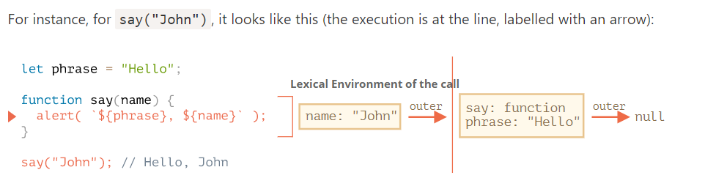
When the code wants to access a variable – the inner Lexical Environment is searched first, then the outer one, then the more outer one and so on until the global one.
If a variable is not found anywhere, that’s an error in strict mode (without use strict, an assignment to a non-existing variable creates a new global variable, for compatibility with old code).
All functions remember the Lexical Environment in which they were made. Technically, there’s no magic here: all functions have the hidden property named [[Environment]], that keeps the reference to the Lexical Environment where the function was created: pertmet acces outer variable
The [[Environment]] reference is set once and forever at function creation time. Exemple : counter,[[Environement]] pou acceder a la variable counter dans l’environement.

A closure is a function that remembers its outer variables and can access them. In some languages, that’s not possible, or a function should be written in a special way to make it happen. But as explained above, in JavaScript, all functions are naturally closures (there is only one exception, to be covered in The "new Function" syntax).
function creerFonction() {
var nom = "Mozilla";
function afficheNom() {
console.log(nom);
}
return afficheNom;
}

var maFonction = creerFonction();
maFonction();
maFonction est une fermeture. La fermeture combine la fonction afficheNom et son environnement. Cet environnement est composé de toutes les variables locales accessibles (dans la portée) à la création de la fermeture. Ici maFonction est une fermeture qui contient la fonction afficheNom et une référence à la variable var nom = "Mozilla" qui existait lorsque la fermeture a été créée. L'instance de afficheNom conserve une référence à son environnement lexical, dans lequel nom existe.

Utilisation :
Ainsi, on peut utiliser une fermeture pour tout endroit où on utiliserait un objet et ce avec une seule méthode.

GARBAGE
Usually, a Lexical Environment is removed from memory with all the variables after the function call finishes. That’s because there are no references to it. As any JavaScript object, it’s only kept in memory while it’s reachable.

As we’ve seen, in theory while a function is alive, all outer variables are also retained.
But in practice, JavaScript engines try to optimize that. They analyze variable usage and if it’s obvious from the code that an outer variable is not used – it is removed.
An important side effect in V8 (Chrome, Opera) is that such variable will become unavailable in debugging.
Variables, declared with var, are either function-wide( visible au sein d’une fonction ) or global. They are visible through blocks/ignor block ( example : for ( var i=0;i<10;i++){//} alert(i) ).
var accepte les re-declaration!= let si 2 declaration meme var =>erreur
var declarations are processed when the function starts (or script starts for globals).
In other words, var variables are defined from the beginning of the function, no matter where the definition is (assuming that the definition is not in the nested function).

function sayHi() {
phrase = "Hello"; // (*)

if (false) {
var phrase;
}

alert(phrase);
}
sayHi();

The declaration is processed at the start of function execution (“hoisted”), but the assignment always works at the place where it appears.

As in the past there was only var, and it has no block-level visibility, programmers invented a way to emulate it. What they did was called “immediately-invoked function expressions” (abbreviated as IIFE).
An IIFE looks like this:
(function() {

let message = "Hello";

alert(message); // Hello

})();

The Function Expression is wrapped with parenthesis (function {...}), because when JavaScript meets "function" in the main code flow, it understands it as the start of a Function Declaration. But a Function Declaration must have a name, so this kind of code will give an error:

So, the parentheses around the function is a trick to show JavaScript that the function is created in the context of another expression, and hence it’s a Function Expression: it needs no name and can be called immediately.

GLOBAL VAR :
In a browser it is named window, for Node.js it is global, for other environments it may have another name.

Recently, globalThis was added to the language, as a standardized name for a global object, that should be supported across all environments.
Marche pas sur nouvelle config :
In a browser, global functions and variables declared with var become the property of the global object:

var gVar = 5;

alert(window.gVar); // 5 (became a property of the global object)

Si val très importante mettre sous forme de property :
// make current user information global, to let all scripts access it
window.currentUser = {
name: "John"
};

In the specification, this feature is called a “contextual name”. If the function does not provide one, then in an assignment it is figured out from the context.
function sayHi() {
alert("Hi");
}

alert(sayHi.name); // sayHi

let sayHi = function() {
alert("Hi");
};

alert(sayHi.name); // sayHi (there's a name!)

function f(sayHi = function() {}) {
alert(sayHi.name); // sayHi (works!)
}

f();

Object method have name too (moi : classe méthode)
There is another built-in property “length” that returns the number of function parameters, for instance:
function many(a, b, ...more) {}
alert(many.length); // 2

Here we can see that rest parameters are not counted.

We can also add properties of our own.
Here we add the counter property to track the total calls count:
function sayHi() {
alert("Hi");

// let's count how many times we run
sayHi.counter++;
}
sayHi.counter = 0; // initial value

Function properties can replace closures sometimes.

The syntax for creating a function:
let func = new Function ([arg1, arg2, ...argN], functionBody);
The function is created with the arguments arg1...argN and the given functionBody.
Exemple :
let sum = new Function('a', 'b', 'return a + b');

alert( sum(1, 2) ); // 3

The major difference from other ways we’ve seen is that the function is created literally from a string, that is passed at run time.

When a function is created using new Function, its [[Environment]] is set to reference not the current Lexical Environment, but the global one. So, such function doesn’t have access to outer variables, only to the global ones.
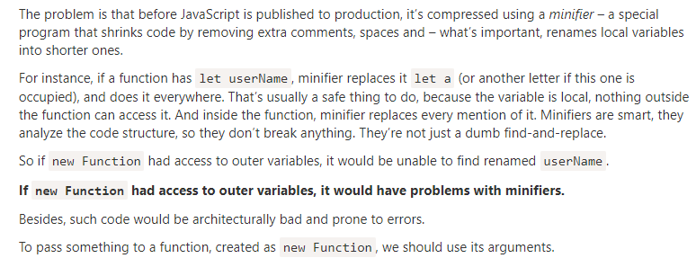

We may decide to execute a function not right now, but at a certain time later. That’s called “scheduling a call”.
There are two methods for it:
- setTimeout allows us to run a function once after the interval of time.
- setInterval allows us to run a function repeatedly, starting after the interval of time, then repeating continuously at that interval.
The syntax:
let timerId = setTimeout(func|code, [delay], [arg1], [arg2], ...)
Parameters:
func|code
Function or a string of code to execute. Usually, that’s a function. For historical reasons, a string of code can be passed, but that’s not recommended(prefere arrow function).
delay
The delay before run, in milliseconds (1000 ms = 1 second), by default 0.
arg1, arg2…
Arguments for the function (not supported in IE9-)
Passez une ref vers une fonction ex : sayHi et pas sayHi() qui run/call la fonction .
A call to setTimeout returns a “timer identifier” timerId that we can use to cancel the execution.
The syntax to cancel:
let timerId = setTimeout(...);
clearTimeout(timerId);

setInterval
The setInterval method has the same syntax as setTimeout:
let timerId = setInterval(func|code, [delay], [arg1], [arg2], ...)
All arguments have the same meaning. But unlike setTimeout it runs the function not only once, but regularly after the given interval of time.
To stop further calls, we should call clearInterval(timerId).
The following example will show the message every 2 seconds. After 5 seconds, the output is stopped:
// repeat with the interval of 2 seconds
let timerId = setInterval(() => alert('tick'), 2000);

// after 5 seconds stop
setTimeout(() => { clearInterval(timerId); alert('stop'); }, 5000);

Time goes on while alert is shown
In most browsers, including Chrome and Firefox the internal timer continues “ticking” while showing alert/confirm/prompt.
So if you run the code above and don’t dismiss the alert window for some time, then in the next alert will be shown immediately as you do it. The actual interval between alerts will be shorter than 2 seconds.

There are two ways of running something regularly

One is setInterval. The other one is a nested setTimeout, like this:
/** instead of:
let timerId = setInterval(() => alert('tick'), 2000);
*/

let timerId = setTimeout(function tick() {
alert('tick');
timerId = setTimeout(tick, 2000); // (*)
}, 2000);
The setTimeout above schedules the next call right at the end of the current one (*).
The nested setTimeout is a more flexible method than setInterval. This way the next call may be scheduled differently, depending on the results of the current one.
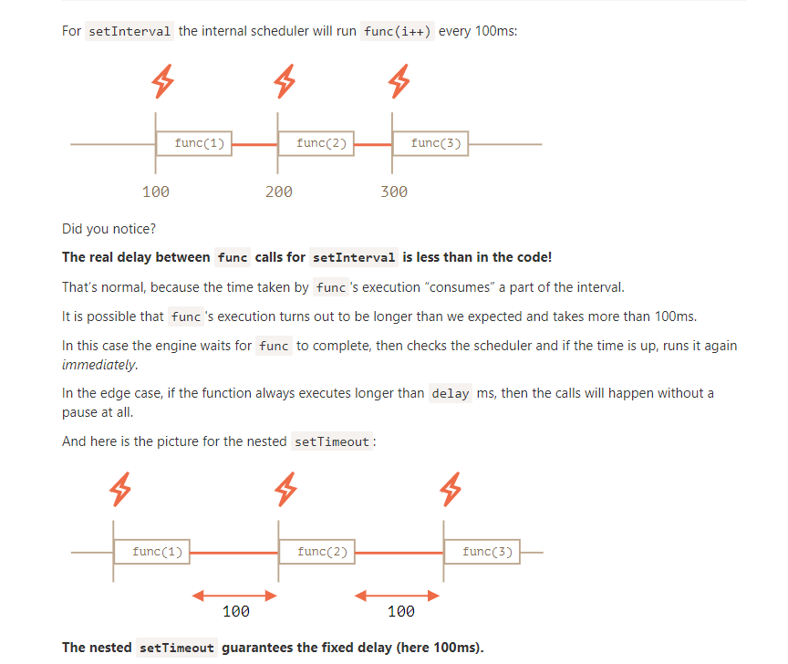
When a function is passed in setInterval/setTimeout, an internal reference is created to it and saved in the scheduler. It prevents the function from being garbage collected, even if there are no other references to it.
For setInterval the function stays in memory until clearInterval is called.

There’s a side-effect. A function references the outer lexical environment, so, while it lives, outer variables live too. They may take much more memory than the function itself

There’s a special use case: setTimeout(func, 0), or just setTimeout(func).
This schedules the execution of func as soon as possible. But the scheduler will invoke it only after the currently executing script is complete.

In the browser, there’s a limitation of how often nested timers can run. The HTML5 standard says: “after five nested timers, the interval is forced to be at least 4 milliseconds.”.For server-side JavaScript, that limitation does not exist, and there exist other ways to schedule an immediate asynchronous job, like setImmediate for Node.js. So this note is browser-specific.

Let’s say we have a function slow(x) which is CPU-heavy, but its results are stable. In other words, for the same x it always returns the same result.
If the function is called often, we may want to cache (remember) the results to avoid spending extra-time on recalculations.
But instead of adding that functionality into slow() we’ll create a wrapper function, that adds caching. As we’ll see, there are many benefits of doing so

ere’s the code, and explanations follow:
function slow(x) {
// there can be a heavy CPU-intensive job here
alert(`Called with ${x}`);
return x;
}

function cachingDecorator(func) {
let cache = new Map();

return function(x) {
if (cache.has(x)) { // if there's such key in cache
return cache.get(x); // read the result from it
}

let result = func(x); // otherwise call func

cache.set(x, result); // and cache (remember) the result
return result;
};
}

slow = cachingDecorator(slow);

alert( slow(1) ); // slow(1) is cached
alert( "Again: " + slow(1) ); // the same

alert( slow(2) ); // slow(2) is cached
alert( "Again: " + slow(2) ); // the same as the previous line
In the code above cachingDecorator is a decorator: a special function that takes another function and alters its behavior.
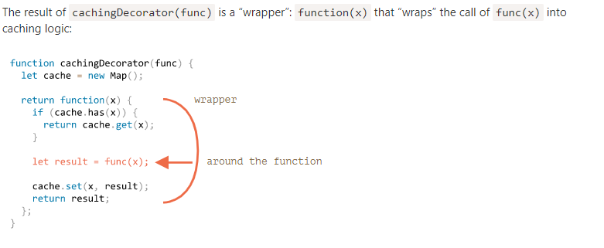

The caching decorator mentioned above is not suited to work with object methods.

So, the wrapper passes the call to the original method, but without the context this. Hence the error.
Let’s fix it.
There’s a special built-in function method func.call(context, …args) that allows to call a function explicitly setting this.
The syntax is:
func.call(context, arg1, arg2, ...)
It runs func providing the first argument as this, and the next as the arguments.
function say(phrase) {
alert(this.name + ': ' + phrase);
}

let user = { name: "John" };

// user becomes this, and "Hello" becomes the first argument
say.call( user, "Hello" ); // John: Hello

nstead of func.call(this, ...arguments) we could use func.apply(this, arguments).
The syntax of built-in method func.apply is:
func.apply(context, args)
It runs the func setting this=context and using an array-like object args as the list of arguments.
The only syntax difference between call and apply is that call expects a list of arguments, while apply takes an array-like object with them.
So these two calls are almost equivalent:
func.call(context, ...args); // pass an array as list with spread syntax
func.apply(context, args); // is same as using call
There’s only a subtle difference:
- The spread syntax ... allows to pass iterable args as the list to call.
- The apply accepts only array-like args.
So, where we expect an iterable, call works, and where we expect an array-like, apply works.
And for objects that are both iterable and array-like, like a real array, we can use any of them, but apply will probably be faster, because most JavaScript engines internally optimize it better.

We’ve already seen examples of losing this. Once a method is passed somewhere separately from the object – this is lost.
Here’s how it may happen with setTimeout:

let user = {
firstName: "John",
sayHi() {
alert(`Hello, ${this.firstName}!`);
}
};

setTimeout(user.sayHi, 1000); // Hello, undefined!

The last line can be rewritten as:
let f = user.sayHi;
setTimeout(f, 1000); // lost user context

Functions provide a built-in method bind that allows to fix this.
The basic syntax is:
// more complex syntax will come a little later
let boundFunc = func.bind(context);
The result of func.bind(context) is a special function-like “exotic object”, that is callable as function and transparently passes the call to func setting this=context.

In other words, calling boundFunc is like func with fixed this.
If an object has many methods and we plan to actively pass it around, then we could bind them all in a loop:
for (let key in user) {
if (typeof user[key] == 'function') {
user[key] = user[key].bind(user);
}
}
JavaScript libraries also provide functions for convenient mass binding , e.g. _.bindAll(obj) in lodash.

We can bind not only this, but also arguments. That’s rarely done, but sometimes can be handy.
The full syntax of bind:
let bound = func.bind(context, [arg1], [arg2], ...);
It allows to bind context as this and starting arguments of the function.

function mul(a, b) {
return a * b;
}

let double = mul.bind(null, 2);

alert( double(3) ); // = mul(2, 3) = 6

That’s called partial function application – we create a new function by fixing some parameters of the existing one.

Arrow functions can’t run with new
Not having this naturally means another limitation: arrow functions can’t be used as constructors. They can’t be called with new.

Arrow functions also have no arguments variable .That’s great for decorators, when we need to forward a call with the current this and arguments (car pas this ni arguments dans arrow)

function defer(f, ms) {
return function() {
setTimeout(() => f.apply(this, arguments), ms)
};
}

Object properties, besides a value, have three special attributes (so-called “flags”):
- writable – if true, the value can be changed, otherwise it’s read-only.
- enumerable – if true, then listed in loops, otherwise not listed.
- configurable – if true, the property can be deleted and these attributes can be modified, otherwise not.
When we create a property “the usual way”, all of them are true. But we also can change them anytime.

The method Object.getOwnPropertyDescriptor allows to query the full information about a property.
The syntax is:
let descriptor = Object.getOwnPropertyDescriptor(obj, propertyName);

obj
The object to get information from.
propertyName
The name of the property.
The returned value is a so-called “property descriptor” object: it contains the value and all the flags.
For instance:
let user = {
name: "John"
};

let descriptor = Object.getOwnPropertyDescriptor(user, 'name');

alert( JSON.stringify(descriptor, null, 2 ) );
/* property descriptor:
{
"value": "John",
"writable": true,
"enumerable": true,
"configurable": true
}
*/
To change the flags, we can use Object.defineProperty.
The syntax is:
Object.defineProperty(obj, propertyName, descriptor)

obj, propertyName
The object and its property to apply the descriptor.
descriptor
Property descriptor object to apply.
If the property exists, defineProperty updates its flags. Otherwise, it creates the property with the given value and flags; in that case, if a flag is not supplied, it is assumed false.
For instance, here a property name is created with all falsy flags:

let user = {};

Object.defineProperty(user, "name", {
value: "John"
});

let descriptor = Object.getOwnPropertyDescriptor(user, 'name');

alert( JSON.stringify(descriptor, null, 2 ) );
/*
{
"value": "John",
"writable": false,
"enumerable": false,
"configurable": false
}
*/

In the non-strict mode, no errors occur when writing to non-writable properties and such. But the operation still won’t succeed. Flag-violating actions are just silently ignored in non-strict.

Here’s the same example, but the property is created from scratch:
let user = { };

Object.defineProperty(user, "name", {
value: "John",
// for new properties we need to explicitly list what's true
enumerable: true,
configurable: true
});

alert(user.name); // John
user.name = "Pete"; // Error

The non-configurable flag (configurable:false) is sometimes preset for built-in objects and properties.
A non-configurable property can not be deleted.
Making a property non-configurable is a one-way road. We cannot change it back with defineProperty.
To be precise, non-configurability imposes several restrictions on defineProperty:
- Can’t change configurable flag.
- Can’t change enumerable flag.
- Can’t change writable: false to true (the other way round works).
- Can’t change get/set for an accessor property (but can assign them if absent).

Notable exception: a value of non-configurable, but writable property can be changed.
The idea of configurable: false is to prevent changes to property flags and its deletion, not changes to its value.

There’s a method Object.defineProperties(obj, descriptors) that allows to define many properties at once.
The syntax is:
Object.defineProperties(obj, {
prop1: descriptor1,
prop2: descriptor2
// ...
});
For instance:
Object.defineProperties(user, {
name: { value: "John", writable: false },
surname: { value: "Smith", writable: false },
// ...
});
So, we can set many properties at once.

To get all property descriptors at once, we can use the method Object.getOwnPropertyDescriptors(obj).
Together with Object.defineProperties it can be used as a “flags-aware” way of cloning an object:
let clone = Object.defineProperties({}, Object.getOwnPropertyDescriptors(obj));

Normally when we clone an object, we use an assignment to copy properties, like this:
for (let key in user) {
clone[key] = user[key]
}
…But that does not copy flags. So if we want a “better” clone then Object.defineProperties is preferred.
Another difference is that for..in ignores symbolic properties, but Object.getOwnPropertyDescriptors returns all property descriptors including symbolic ones.

Sealing an object globally
Property descriptors work at the level of individual properties.
There are also methods that limit access to the whole object:
Object.preventExtensions(obj)
Forbids the addition of new properties to the object.
Object.seal(obj)
Forbids adding/removing of properties. Sets configurable: false for all existing properties.
Object.freeze(obj)
Forbids adding/removing/changing of properties. Sets configurable: false, writable: false for all existing properties.
And also there are tests for them:
Object.isExtensible(obj)
Returns false if adding properties is forbidden, otherwise true.
Object.isSealed(obj)
Returns true if adding/removing properties is forbidden, and all existing properties have configurable: false.
Object.isFrozen(obj)
Returns true if adding/removing/changing properties is forbidden, and all current properties are configurable: false, writable: false.
These methods are rarely used in practice.

let user = {
name: "John",
surname: "Smith",

get fullName() {
return `${this.name} ${this.surname}`;
},

set fullName(value) {
[this.name, this.surname] = value.split(" ");
}
};

// set fullName is executed with the given value.
user.fullName = "Alice Cooper";

alert(user.name); // Alice
alert(user.surname); // Cooper

si pas de set alors l’assignation provoquera une erreur
As the result, we have a “virtual” property fullName. It is readable and writable.

For accessor properties, there is no value or writable, but instead there are get and set functions.
That is, an accessor descriptor may have:
- get – a function without arguments, that works when a property is read,
- set – a function with one argument, that is called when the property is set,
- enumerable – same as for data properties,
- configurable – same as for data properties.
Please note that a property can be either an accessor (has get/set methods) or a data property (has a value), not both.

For instance, to create an accessor fullName with defineProperty, we can pass a descriptor with get and set:
Object.defineProperty(user, 'fullName', {
get() {
return `${this.name} ${this.surname}`;
},

set(value) {
[this.name, this.surname] = value.split(" ");
}
});

If we try to supply both get and value in the same descriptor, there will be an error :
// Error: Invalid property descriptor.
Object.defineProperty({}, 'prop', {
get() {
return 1
},

value: 2
});

Getters/setters can be used as wrappers over “real” property values to gain more control over operations with them.
For instance, if we want to forbid too short names for user, we can have a setter name and keep the value in a separate property _name:
let user = {
get name() {
return this._name;
},

set name(value) {
if (value.length < 4) {
alert("Name is too short, need at least 4 characters");
return;
}
this._name = value;
}
};

user.name = "Pete";
alert(user.name); // Pete

user.name = ""; // Name is too short...
So, the name is stored in _name property, and the access is done via getter and setter.
Technically, external code is able to access the name directly by using user._name. But there is a widely known convention that properties starting with an underscore "_" are internal and should not be touched from outside the object.
function User(name, age) {
this.name = name;
this.age = age;
}

let john = new User("John", 25);

alert( john.age ); // 25
…But sooner or later, things may change. Instead of age we may decide to store birthday, because it’s more precise and convenient:

We can try to find all such places and fix them, but that takes time and can be hard to do if that code is used by many other people. And besides, age is a nice thing to have in user, right?
Let’s keep it.
Adding a getter for age solves the problem:
function User(name, birthday) {
this.name = name;
this.birthday = birthday;

// age is calculated from the current date and birthday
Object.defineProperty(this, "age", {
get() {
let todayYear = new Date().getFullYear();
return todayYear - this.birthday.getFullYear();
}
});
}

let john = new User("John", new Date(1992, 6, 1));

alert( john.birthday ); // birthday is available
alert( john.age ); // ...as well as the age

One of the great uses of accessors is that they allow to take control over a “regular” data property at any moment by replacing it with a getter and a setter and tweak its behavior.

In JavaScript, objects have a special hidden property [[Prototype]] (as named in the specification), that is either null or references another object. That object is called “a prototype”:
The prototype is a little bit “magical”. When we want to read a property from object, and it’s missing, JavaScript automatically takes it from the prototype. In programming, such thing is called “prototypal inheritance”.
The property [[Prototype]] is internal and hidden, but there are many ways to set it.
One of them is to use the special name __proto__, like this:

let animal = {
eats: true
};
let rabbit = {
jumps: true
};

rabbit.__proto__ = animal; // sets animal to be a prototype of rabbit

Please note that __proto__ is not the same as [[Prototype]]. It’s a getter/setter for it.
It exists for historical reasons. In modern language it is replaced with functions Object.getPrototypeOf/Object.setPrototypeOf that also get/set the prototype.
By the specification, __proto__ must only be supported by browsers, but in fact all environments including server-side support it.

There are only two limitations:
- The references can’t go in circles. JavaScript will throw an error if we try to assign __proto__ in a circle.
- The value of __proto__ can be either an object or null. Other types are ignored.
Also it may be obvious, but still: there can be only one [[Prototype]]. An object may not inherit from two others.

Writing doesn’t use prototype
The prototype is only used for reading properties.
Write/delete operations work directly with the object.

(Logique et apporte confusion :The answer is simple: this is not affected by prototypes at all.
No matter where the method is found: in an object or its prototype. In a method call, this is always the object before the dot.)

The for..in loop iterates over inherited properties too.

If that’s not what we want, and we’d like to exclude inherited properties, there’s a built-in method obj.hasOwnProperty(key): it returns true if obj has its own (not inherited) property named key.
So we can filter out inherited properties (or do something else with them):

Here we have the following inheritance chain: rabbit inherits from animal, that inherits from Object.prototype (because animal is a literal object {...}, so it’s by default), and then null above it:

All properties of Object.prototype has enumerable:false flag. And for..in only lists enumerable properties. That’s why hasOwnProperty and the rest of the Object.prototype properties are not listed.

Almost all other key/value-getting methods, such as Object.keys, Object.values and so on ignore inherited properties.
They only operate on the object itself. Properties from the prototype are not taken into account.

Remember, new objects can be created with a constructor function, like new F().
If F.prototype is an object, then the new operator uses it to set [[Prototype]] for the new object.

JavaScript had prototypal inheritance from the beginning. It was one of the core features of the language.
But in the old times, there was no direct access to it. The only thing that worked reliably was a "prototype" property of the constructor function, described in this chapter. So there are many scripts that still use it.

Please note that F.prototype here means a regular property named "prototype" on F. It sounds something similar to the term “prototype”, but here we really mean a regular property with this name.

Rabbit.prototype = animal;

let rabbit = new Rabbit("White Rabbit"); // rabbit.__proto__ == animal

Setting Rabbit.prototype = animal literally states the following: "When a new Rabbit is created, assign its [[Prototype]] to animal".
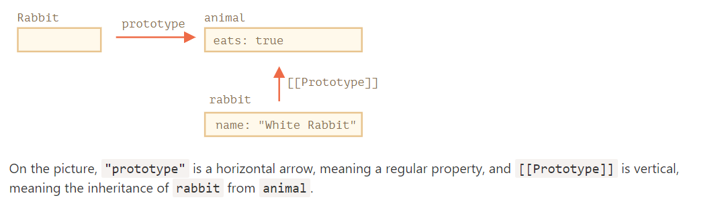

F.prototype property is only used when new F is called, it assigns [[Prototype]] of the new object.
If, after the creation, F.prototype property changes (F.prototype = <another object>), then new objects created by new F will have another object as [[Prototype]], but already existing objects keep the old one.
Every function has the "prototype" property even if we don’t supply it.
The default "prototype" is an object with the only property constructor that points back to the function itself.
Like this:
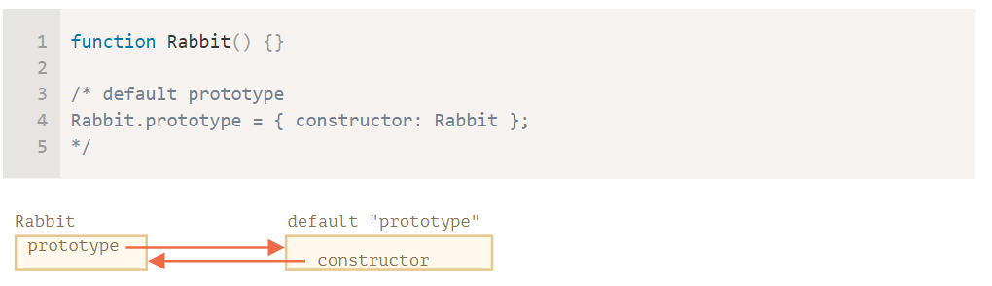
J’ai pas compris après .

Native prototypes
For instance, when we create an array [1, 2, 3], the default new Array() constructor is used internally. So Array.prototype becomes its prototype and provides methods. That’s very memory-efficient.
Other built-in objects also work the same way. Even functions – they are objects of a built-in Function constructor, and their methods (call/apply and others) are taken from Function.prototype. Functions have their own toString too ( object aussi a un tostring mais le plus proche toostring est pris)

As we remember, they are not objects. But if we try to access their properties, temporary wrapper objects are created using built-in constructors String, Number and Boolean. They provide the methods and disappear.
These objects are created invisibly to us and most engines optimize them out, but the specification describes it exactly this way.
Values null and undefined have no object wrappers

Native prototypes can be modified. For instance, if we add a method to String.prototype, it becomes available to all strings mais souvent c’est une mauvaise idée car comme les proto sont globaux il est facile d’avoir des conflits .
In modern programming, there is only one case where modifying native prototypes is approved. That’s polyfilling.
Polyfilling is a term for making a substitute for a method that exists in the JavaScript specification, but is not yet supported by a particular JavaScript engine.We may then implement it manually and populate the built-in prototype with it.

Borrowing from prototypes
In the chapter Decorators and forwarding, call/apply we talked about method borrowing.
That’s when we take a method from one object and copy it into another.
Some methods of native prototypes are often borrowed.
For instance, if we’re making an array-like object, we may want to copy some Array methods to it.
let obj = {
0: "Hello",
1: "world!",
length: 2,
};

obj.join = Array.prototype.join;

Another possibility is to inherit by setting obj.__proto__ to Array.prototype, so all Array methods are automatically available in obj.But that’s impossible if obj already inherits from another object. Remember, we only can inherit from one object at a time.
Borrowing methods is flexible, it allows to mix functionalities from different objects if needed.

REMEMBER :
The __proto__ is considered outdated and somewhat deprecated (in browser-only part of the JavaScript standard).
The modern methods are:
- Object.create(proto[, descriptors]) – creates an empty object with given proto as [[Prototype]] and optional property descriptors.
- Object.getPrototypeOf(obj) – returns the [[Prototype]] of obj.
- Object.setPrototypeOf(obj, proto) – sets the [[Prototype]] of obj to proto.
These should be used instead of __proto__.
Object.create has an optional second argument: property descriptors. We can provide additional properties to the new object .
We can use Object.create to perform an object cloning more powerful than copying properties in for..in:
let clone = Object.create(Object.getPrototypeOf(obj), Object.getOwnPropertyDescriptors(obj));

This call makes a truly exact copy of obj, including all properties: enumerable and non-enumerable, data properties and setters/getters – everything, and with the right [[Prototype]].

NOTE :
Technically, we can get/set [[Prototype]] at any time. But usually we only set it once at the object creation time and don’t modify it anymore: rabbit inherits from animal, and that is not going to change.
And JavaScript engines are highly optimized for this. Changing a prototype “on-the-fly” with Object.setPrototypeOf or obj.__proto__= is a very slow operation as it breaks internal optimizations for object property access operations. So avoid it unless you know what you’re doing, or JavaScript speed totally doesn’t matter for you.

The basic syntax is:
class MyClass {
// class methods
constructor() { ... }
method1() { ... }
method2() { ... }
method3() { ... }
...
}

The notation here is not to be confused with object literals. Within the class, no commas are required.!= comma separation
Then use new MyClass() to create a new object with all the listed methods.
The constructor() method is called automatically by new, so we can initialize the object there.

When new User("John") is called:
- A new object is created.
- The constructor runs with the given argument and execute code dans ce constructeur
In JavaScript, a class is a kind of function.

What class User {...} construct really does is:
- Creates a function named User, that becomes the result of the class declaration. The function code is taken from the constructor method (assumed empty if we don’t write such method).
- Stores class methods, such as sayHi, in User.prototype.
After new User object is created, when we call its method, it’s taken from the prototype, just as described in the chapter F.prototype. So the object has access to class methods.

First, a function created by class is labelled by a special internal property [[FunctionKind]]:"classConstructor". So it’s not entirely the same as creating it manually.
For example, unlike a regular function, it must be called with new:
class User {
constructor() {}
}

alert(typeof User); // function
User(); // Error: Class constructor User cannot be invoked without 'new'

Class methods are non-enumerable. A class definition sets enumerable flag to false for all methods in the "prototype".
That’s good, because if we for..in over an object, we usually don’t want its class methods.
- Classes always use strict. All code inside the class construct is automatically in strict mode.

Just like functions, classes can be defined inside another expression, passed around, returned, assigned, etc.
Here’s an example of a class expression:
let User = class {
sayHi() {
alert("Hello");
}
};
Similar to Named Function Expressions, class expressions may have a name.

Just like literal objects, classes may include getters/setters, computed properties etc.

Here’s an example with a computed method name using brackets [...]:

class User {

['say' + 'Hi']() {
alert("Hello");
}

}

new User().sayHi();

Previously, our classes only had methods.
“Class fields” is a syntax that allows to add any properties.
class User {
name = "John"; /:proprety

sayHi() {
alert(`Hello, ${this.name}!`);
}
}

new User().sayHi(); // Hello, John!

The important difference of class fields is that they are set on individual objects, not User.prototype:
Technically, they are processed after the constructor has done it’s job, and we can use for them complex expressions and function calls:
class User {
name = prompt("Name, please?", "John");
}

Losing this :
class Button {
constructor(value) {
this.value = value;
}

click() {
alert(this.value);
}
}

let button = new Button("hello");

setTimeout(button.click, 1000); // undefined

Class fields provide a more elegant syntax for the latter solution: (lose this)

class Button {
constructor(value) {
this.value = value;
}
click = () => {
alert(this.value);
}
}

let button = new Button("hello");

setTimeout(button.click, 1000); // hello
The class field click = () => {...} creates an independent function on each Button object, with this bound to the object. Then we can pass button.click around anywhere, and it will be called with the right this.

The syntax to extend another class is: class Child extends Parent. Internally, extends keyword works using the good old prototype mechanics. It sets Rabbit.prototype.[[Prototype]] to Animal.prototype. So, if a method is not found in Rabbit.prototype, JavaScript takes it from Animal.prototype.

Class syntax allows to specify not just a class, but any expression after extends.
For instance, a function call that generates the parent class:

function f(phrase) {
return class {
sayHi() { alert(phrase) }
}
}

class User extends f("Hello") {}

new User().sayHi(); // Hello
Here class User inherits from the result of f("Hello").
That may be useful for advanced programming patterns when we use functions to generate classes depending on many conditions and can inherit from them.

Classes provide "super" keyword for that.
- super.method(...) to call a parent method.
- super(...) to call a parent constructor (inside our constructor only).
As was mentioned in the chapter Arrow functions revisited, arrow functions do not have super.
If accessed, it’s taken from the outer function
According to the specification, if a class extends another class and has no constructor, then the following “empty” constructor is generated:

class Rabbit extends Animal {
// generated for extending classes without own constructors
constructor(...args) {
super(...args);
}
}

Constructors in inheriting classes must call super(...), and (!) do it before using this.
In JavaScript, there’s a distinction between a constructor function of an inheriting class (so-called “derived constructor”) and other functions. A derived constructor has a special internal property [[ConstructorKind]]:"derived". That’s a special internal label.
That label affects its behavior with new.
- When a regular function is executed with new, it creates an empty object and assigns it to this.
- But when a derived constructor runs, it doesn’t do this. It expects the parent constructor to do this job.
So a derived constructor must call super in order to execute its parent (non-derived) constructor, otherwise the object for this won’t be created. And we’ll get an error.
We can also assign a method to the class function itself, not to its "prototype". Such methods are called static.
In a class, they are prepended by static keyword, like this:

class User {
static staticMethod() {
alert(this === User);
}
}

User.staticMethod(); // true

That actually does the same as assigning it as a property directly:
class User { }

User.staticMethod = function() {
alert(this === User);
};

User.staticMethod(); // true

Usually, static methods are used to implement functions that belong to the class, but not to any particular object of it. Here Article.compare stands “above” articles, as a means to compare them. It’s not a method of an article, but rather of the whole class.

Static properties
A recent addition
This is a recent addition to the language. Examples work in the recent Chrome.
That is the same as a direct assignment to Myclass
static sont herité

Protected fields are not implemented in JavaScript on the language level, but in practice they are very convenient, so they are emulated.
Protected properties are usually prefixed with an underscore _.
That is not enforced on the language level, but there’s a well-known convention between programmers.
Read only ( set once / à la creation ) :To do so, we only need to make getter, but not the setter .
De même :
get + set = private
get = read only
set= write only
rien = public
on peut utiliser le keyword get mais il est préférable d’utiliser la syntaxe : getMyproperty
ex : getWaterAmount() {return this._waterAmount; }

That looks a bit longer, but functions are more flexible. They can accept multiple arguments (even if we don’t need them right now).

If we inherit class MegaMachine extends CoffeeMachine, then nothing prevents us from accessing this._waterAmount or this._power from the methods of the new class.
So protected fields are naturally inheritable. Unlike private ones that we’ll see below.
This is a recent addition to the language. Not supported in JavaScript engines, or supported partially yet, requires polyfilling.
Privates should start with #. They are only accessible from inside the class.
Private fields do not conflict with public ones. We can have both private #waterAmount and public waterAmount fields at the same time.
Unlike protected ones, private fields are enforced by the language itself. That’s a good thing.
But if we inherit from CoffeeMachine, then we’ll have no direct access to #waterAmount. We’ll need to rely on waterAmount getter/setter:
rivate fields are not available as this[name]
With private fields that’s impossible: this['#name'] doesn’t work. That’s a syntax limitation to ensure privacy.

We can add a special static getter Symbol.species to the class. If it exists, it should return the constructor that JavaScript will use internally to create new entities in map, filter and so on.
If we’d like built-in methods like map or filter to return regular arrays, we can return Array in Symbol.species

Normally, when one class extends another, both static and non-static methods are inherited.
But built-in classes are an exception. They don’t inherit statics from each other
As you can see, there’s no link between Date and Object. They are independent, only Date.prototype inherits from Object.prototype.
That’s an important difference of inheritance between built-in objects compared to what we get with extends.

The syntax is:
obj instanceof Class
It returns true if obj belongs to the Class or a class inheriting from it.

Normally, instanceof examines the prototype chain for the check. We can also set a custom logic in the static method Symbol.hasInstance.

The algorithm of obj instanceof Class works roughly as follows:
- If there’s a static method Symbol.hasInstance, then just call it: Class[Symbol.hasInstance](obj). It should return either true or false, and we’re done. That’s how we can customize the behavior of instanceof.
2,Most classes do not have Symbol.hasInstance. In that case, the standard logic is used: obj instanceOf Class checks whether Class.prototype is equal to one of the prototypes in the obj prototype chain.

By the way, there’s also a method objA.isPrototypeOf(objB), that returns true if objAis somewhere in the chain of prototypes for objB. So the test of obj instanceof Class can be rephrased as Class.prototype.isPrototypeOf(obj). .
By specification, the built-in toString can be extracted from the object and executed in the context of any other value. And its result depends on that value. Internally, the toString algorithm examines thisand returns the corresponding result
The behavior of Object toString can be customized using a special object property Symbol.toStringTag.
let user = { [Symbol.toStringTag]: "User" }; alert( {}.toString.call(user) ); // [object User]
For most environment-specific objects, there is such a property. as you can see, the result is exactly Symbol.toStringTag (if exists), wrapped into [object ...]
Resume : we can use {}.toString.call instead of instanceof for built-in objects when we want to get the type as a string rather than just to check.

In JavaScript we can only inherit from a single object. There can be only one [[Prototype]] for an object. And a class may extend only one other class.
But sometimes that feels limiting.
There’s a concept that can help here, called “mixins”.
As defined in Wikipedia, a mixin is a class containing methods that can be used by other classes without a need to inherit from it.
In other words, a mixin provides methods that implement a certain behavior, but we do not use it alone, we use it to add the behavior to other classes.
The simplest way to implement a mixin in JavaScript is to make an object with useful methods, so that we can easily merge them into a prototype of any class.

There’s no inheritance, but a simple method copying. So User may inherit from another class and also include the mixin to “mix-in” the additional methods, like this:
class User extends Person {
// ...
}

Object.assign(User.prototype, sayHiMixin);

Mixins can make use of inheritance inside themselves.
CAS PRATIQUE PAS UTILE :
For instance, here sayHiMixin inherits from sayMixin:
let sayHiMixin = {
__proto__: sayMixin, // (or we could use Object.create to set the prototype here)

sayHi() {
// call parent method
super.say(`Hello ${this.name}`); // (*)
},
sayBye() {
super.say(`Bye ${this.name}`); // (*)
}
};

Please note that the call to the parent method super.say() from sayHiMixin (at lines labelled with (*)) looks for the method in the prototype of that mixin, not the class.

That’s because methods sayHi and sayBye were initially created in sayHiMixin. So even though they got copied, their [[HomeObject]] internal property references sayHiMixin, as shown in the picture above.
As super looks for parent methods in [[HomeObject]].[[Prototype]], that means it searches sayHiMixin.[[Prototype]], not User.[[Prototype]].

Usually, a script “dies” (immediately stops) in case of an error, printing it to console.
But there’s a syntax construct try..catch that allows us to “catch” errors so the script can, instead of dying, do something more reasonable.

t works like this:
- First, the code in try {...} is executed.
- If there were no errors, then catch(err) is ignored: the execution reaches the end of try and goes on, skipping catch.
- If an error occurs, then the try execution is stopped, and control flows to the beginning of catch(err). The err variable (we can use any name for it) will contain an error object with details about what happened.

So, an error inside the try {…} block does not kill the script – we have a chance to handle it in catch.
For try..catch to work, the code must be runnable. In other words, it should be valid JavaScript.
It won’t work if the code is syntactically wrong, for instance it has unmatched curly braces:
The JavaScript engine first reads the code, and then runs it. The errors that occur on the reading phase are called “parse-time” errors and are unrecoverable (from inside that code). That’s because the engine can’t understand the code.
So, try..catch can only handle errors that occur in valid code. Such errors are called “runtime errors” or, sometimes, “exceptions”.
If an exception happens in “scheduled” code, like in setTimeout, then try..catch won’t catch it:
try {
setTimeout(function() {
noSuchVariable; // script will die here
}, 1000);
} catch (e) {
alert( "won't work" );
}

That’s because the function itself is executed later, when the engine has already left the try..catch construct.
To catch an exception inside a scheduled function, try..catch must be inside that function:
setTimeout(function() {
try {
noSuchVariable; // try..catch handles the error!
} catch {
alert( "error is caught here!" );
}
}, 1000);

When an error occurs, JavaScript generates an object containing the details about it. The object is then passed as an argument to catch:
try {
// ...
} catch(err) { // <-- the "error object", could use another word instead of err
// ...
}
For all built-in errors, the error object has two main properties:
name
Error name. For instance, for an undefined variable that’s "ReferenceError".
message
Textual message about error details.
There are other non-standard properties available in most environments. One of most widely used and supported is:
stack
Current call stack: a string with information about the sequence of nested calls that led to the error. Used for debugging purposes.
This is a recent addition to the language. Old browsers may need polyfills.
If we don’t need error details, catch may omit it:
try {
// ...
} catch { // <-- without (err)
// ...
}

The throw operator generates an error.
The syntax is:
throw <error object>
Technically, we can use anything as an error object. That may be even a primitive, like a number or a string, but it’s better to use objects, preferably with name and message properties (to stay somewhat compatible with built-in errors).
JavaScript has many built-in constructors for standard errors: Error, SyntaxError, ReferenceError, TypeError and others. We can use them to create error objects as well.
For built-in errors (not for any objects, just for errors), the name property is exactly the name of the constructor. And message is taken from the argument.
Catch should only process errors that it knows and “rethrow” all others.
The “rethrowing” technique can be explained in more detail as:
- Catch gets all errors.
- In the catch(err) {...} block we analyze the error object err.
- If we don’t know how to handle it, we do throw err.
Usually, we can check the error type using the instanceof operator:

try {
user = { /*...*/ };
} catch(err) {
if (err instanceof ReferenceError) {
alert('ReferenceError'); // "ReferenceError" for accessing an undefined variable
}
}
We can also get the error class name from err.name property. All native errors have it. Another option is to read err.constructor.name.
The try..catch construct may have one more code clause: finally.
If it exists, it runs in all cases:
- after try, if there were no errors,
- after catch, if there were errors.
The finally clause is often used when we start doing something and want to finalize it in any case of outcome.

The finally clause works for any exit from try..catch. That includes an explicit return.

The try..finally construct, without catch clause, is also useful. We apply it when we don’t want to handle errors here (let them fall through), but want to be sure that processes that we started are finalized.
There is none in the specification, but environments usually provide it, because it’s really useful. For instance, Node.js has process.on("uncaughtException") for that. And in the browser we can assign a function to the special window.onerror property, that will run in case of an uncaught error.
The syntax:
window.onerror = function(message, url, line, col, error) {
// ...
};
message
Error message.
url
URL of the script where error happened.
line, col
Line and column numbers where error happened.
error
Error object.
The role of the global handler window.onerror is usually not to recover the script execution – that’s probably impossible in case of programming errors, but to send the error message to developers.
There are also web-services that provide error-logging for such cases, like https://errorception.com or http://www.muscula.com.
They work like this:
- We register at the service and get a piece of JS (or a script URL) from them to insert on pages.
- That JS script sets a custom window.onerror function.
- When an error occurs, it sends a network request about it to the service.
- We can log in to the service web interface and see errors.
When we develop something, we often need our own error classes to reflect specific things that may go wrong in our tasks.
JavaScript allows to use throw with any argument, so technically our custom error classes don’t need to inherit from Error. But if we inherit, then it becomes possible to use obj instanceof Error to identify error objects. So it’s better to inherit from it.

JavaScript requires us to call super in the child constructor, so that’s obligatory. The parent constructor sets the message property.
The parent constructor also sets the name property to "Error", so in the line (2) we reset it to the right value.
That may become a bit tedious – to assign this.name = <class name> in every custom error class. We can avoid it by making our own “basic error” class that assigns this.name = this.constructor.name. And then inherit all our custom errors from it.

Si pas cas par cas pour chaque erreur mais que pour certaine et les autres on les regroupes
The technique that we describe here is called “wrapping exceptions”.
- We’ll make a new class ReadError to represent a generic “data reading” error.
- The function readUser will catch data reading errors that occur inside it, such as ValidationError and SyntaxError, and generate a ReadError instead.
- The ReadError object will keep the reference to the original error in its cause property.
The approach is called “wrapping exceptions”, because we take “low level” exceptions and “wrap” them into ReadError that is more abstract. It is widely used in object-oriented programming.

Many functions are provided by JavaScript host environments that allow you to schedule asynchronous actions. In other words, actions that we initiate now, but they finish later.
For instance, one such function is the setTimeout function.
If there’s any code below loadScript(…), it doesn’t wait until the script loading finishes.
loadScript('/my/script.js');
// the code below loadScript
// doesn't wait for the script loading to finish
// ...

Let’s add a callback function as a second argument to loadScript that should execute when the script loads:
function loadScript(src, callback) {
let script = document.createElement('script');
script.src = src;

script.onload = () => callback(script);

document.head.append(script);
}

That’s the idea: the second argument is a function (usually anonymous) that runs when the action is completed. That’s called a “callback-based” style of asynchronous programming. A function that does something asynchronously should provide a callback argument where we put the function to run after it’s complete.

The natural solution would be to put the second loadScript call inside the callback, like this:

loadScript('/my/script.js', function(script) {

alert(`Cool, the ${script.src} is loaded, let's load one more`);

loadScript('/my/script2.js', function(script) {
alert(`Cool, the second script is loaded`);
});

});
After the outer loadScript is complete, the callback initiates the inner one.
Here’s an improved version of loadScript that tracks loading errors:
function loadScript(src, callback) {
let script = document.createElement('script');
script.src = src;

script.onload = () => callback(null, script);
script.onerror = () => callback(new Error(`Script load error for ${src}`));

document.head.append(script);
}
It calls callback(null, script) for successful load and callback(error) otherwise.
The usage:
loadScript('/my/script.js', function(error, script) {
if (error) {
// handle error
} else {
// script loaded successfully
}
});
Once again, the recipe that we used for loadScript is actually quite common. It’s called the “error-first callback” style.

The convention is:
- The first argument of the callback is reserved for an error if it occurs. Then callback(err) is called.
- The second argument (and the next ones if needed) are for the successful result. Then callback(null, result1, result2…) is called.
As calls become more nested, the code becomes deeper and increasingly more difficult to manage, especially if we have real code instead of ... that may include more loops, conditional statements and so on.
PYRAMID OF DOOM /CALLBACK HELL
The “pyramid” of nested calls grows to the right with every asynchronous action. Soon it spirals out of control.
Also, the functions named step* are all of single use, they are created only to avoid the “pyramid of doom.” No one is going to reuse them outside of the action chain. So there’s a bit of namespace cluttering here.

The constructor syntax for a promise object is:
let promise = new Promise(function(resolve, reject) {
// executor (the producing code, "singer")
});
The function passed to new Promise is called the executor. When new Promise is created, the executor runs automatically. It contains the producing code which should eventually produce the result. In terms of the analogy above: the executor is the “singer”.
Its arguments resolve and reject are callbacks provided by JavaScript itself. Our code is only inside the executor.
When the executor obtains the result, be it soon or late, doesn’t matter, it should call one of these callbacks:
- resolve(value) — if the job finished successfully, with result value.
- reject(error) — if an error occurred, error is the error object.
So to summarize: the executor runs automatically and attempts to perform a job. When it is finished with the attempt it calls resolve if it was successful or reject if there was an error.
The promise object returned by the new Promise constructor has these internal properties:
- state — initially "pending", then changes to either "fulfilled" when resolve is called or "rejected" when reject is called.
- result — initially undefined, then changes to value when resolve(value) called or error when reject(error) is called.

A promise that is either resolved or rejected is called “settled”, as opposed to an initially “pending” promise.

The executor should call only one resolve or one reject. Any state change is final.
All further calls of resolve and reject are ignored:

let promise = new Promise(function(resolve, reject) {
resolve("done");

reject(new Error("…")); // ignored
setTimeout(() => resolve("…")); // ignored
});
The idea is that a job done by the executor may have only one result or an error.
Also, resolve/reject expect only one argument (or none) and will ignore additional arguments.
In case something goes wrong, the executor should call reject. That can be done with any type of argument (just like resolve). But it is recommended to use Error objects (or objects that inherit from Error). The reasoning for that will soon become apparent.
The properties state and result of the Promise object are internal. We can’t directly access them. We can use the methods .then/.catch/.finally for that. They are described below.

then
The most important, fundamental one is .then.
The syntax is:

promise.then(
function(result) { /* handle a successful result */ },
function(error) { /* handle an error */ }
);
The first argument of .then is a function that runs when the promise is resolved, and receives the result.
The second argument of .then is a function that runs when the promise is rejected, and receives the error
If we’re interested only in successful completions, then we can provide only one function argument to .then

catch
If we’re interested only in errors, then we can use null as the first argument: .then(null, errorHandlingFunction). Or we can use .catch(errorHandlingFunction), which is exactly the same:
The call .catch(f) is a complete analog of .then(null, f), it’s just a shorthand.

finally
Just like there’s a finally clause in a regular try {...} catch {...}, there’s finally in promises.
The call .finally(f) is similar to .then(f, f) in the sense that f always runs when the promise is settled: be it resolve or reject.
finally is a good handler for performing cleanup, e.g. stopping our loading indicators, as they are not needed anymore, no matter what the outcome is.
It’s not exactly an alias of then(f,f) though. There are several important differences:
- A finally handler has no arguments. In finally we don’t know whether the promise is successful or not. That’s all right, as our task is usually to perform “general” finalizing procedures.
- A finally handler passes through results and errors to the next handler.
3.Last, but not least, .finally(f) is a more convenient syntax than .then(f, f): no need to duplicate the function f.

If a promise is pending, .then/catch/finally handlers wait for it. Otherwise, if a promise has already settled, they execute immediately:
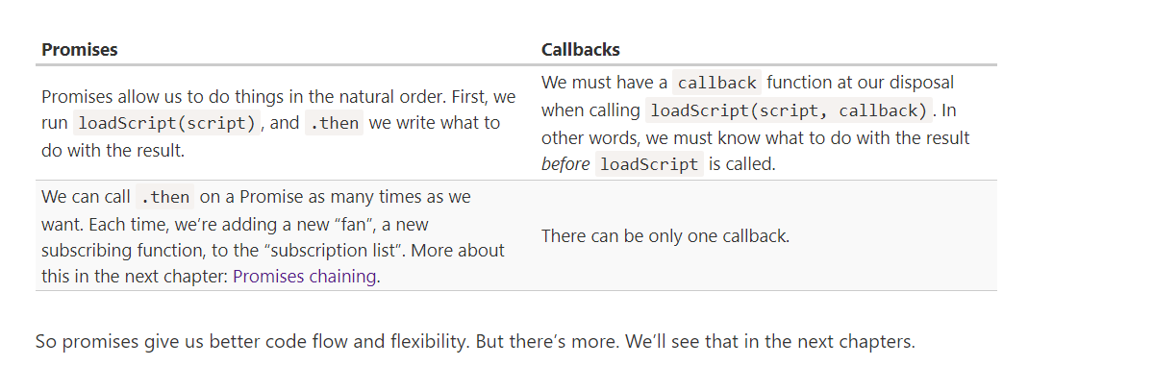

To be precise, a handler may return not exactly a promise, but a so-called “thenable” object – an arbitrary object that has a method .then. It will be treated the same way as a promise.
The idea is that 3rd-party libraries may implement “promise-compatible” objects of their own. They can have an extended set of methods, but also be compatible with native promises, because they implement .then.
This feature allows us to integrate custom objects with promise chains without having to inherit from Promise.
As a good practice, an asynchronous action should always return a promise. That makes it possible to plan actions after it; even if we don’t plan to extend the chain now, we may need it later.
Promise chaining example :

loadScript("/article/promise-chaining/one.js")
.then(function(script) {
return loadScript("/article/promise-chaining/two.js");
})
.then(function(script) {
return loadScript("/article/promise-chaining/three.js");
})
.then(function(script) {
// use functions declared in scripts
// to show that they indeed loaded
one();
two();
three();
});

arrow pour que ca soit plus court .

Promise chains are great at error handling. When a promise rejects, the control jumps to the closest rejection handler. That’s very convenient in practice.
The easiest way to catch all errors is to append .catch to the end of chain:
.catch(error => alert(error.message));
Normally, such .catch doesn’t trigger at all. But if any of the promises above rejects (a network problem or invalid json or whatever), then it would catch it.
The code of a promise executor and promise handlers has an "invisible try..catch" around it. If an exception happens, it gets caught and treated as a rejection.
For instance, this code:

new Promise((resolve, reject) => {
throw new Error("Whoops!");
}).catch(alert); // Error: Whoops!
…Works exactly the same as this:

new Promise((resolve, reject) => {
reject(new Error("Whoops!"));
}).catch(alert); // Error: Whoops!
The "invisible try..catch" around the executor automatically catches the error and turns it into rejected promise.
This happens not only in the executor function, but in its handlers as well. If we throw inside a .then handler, that means a rejected promise, so the control jumps to the nearest error handler.
If we throw inside .catch, then the control goes to the next closest error handler. And if we handle the error and finish normally, then it continues to the next closest successful .then handler.

In case of an error, the promise becomes rejected, and the execution should jump to the closest rejection handler. But there is none. So the error gets “stuck”. There’s no code to handle it. => The JavaScript engine tracks such rejections and generates a global error in that case. You can see it in the console if you run the example above.
If an error occurs, and there’s no .catch, the unhandledrejection handler triggers, and gets the event object with the information about the error, so we can do something.
Usually such errors are unrecoverable, so our best way out is to inform the user about the problem and probably report the incident to the server.
In non-browser environments like Node.js there are other ways to track unhandled errors.
Let’s say we want many promises to execute in parallel and wait until all of them are ready.
For instance, download several URLs in parallel and process the content once they are all done.
That’s what Promise.all is for.
The syntax is:
let promise = Promise.all([...promises...]);
Promise.all takes an array of promises (it technically can be any iterable, but is usually an array) and returns a new promise.
The new promise resolves when all listed promises are settled, and the array of their results becomes its result.
For instance, the Promise.all below settles after 3 seconds, and then its result is an array [1, 2, 3]:

Note that the order of the resulting array members is the same as in its source promises. Even though the first promise takes the longest time to resolve, it’s still first in the array of results
A common trick is to map an array of job data into an array of promises, and then wrap that into Promise.all.

If any of the promises is rejected, the promise returned by Promise.all immediately rejects with that error.
For example, if there are multiple fetch calls, like in the example above, and one fails, the others will still continue to execute, but Promise.all won’t watch them anymore.
Promise.all does nothing to cancel them, as there’s no concept of “cancellation” in promises. In another chapter we’ll cover AbortController that can help with that, but it’s not a part of the Promise API.
Promise.allSettled just waits for all promises to settle, regardless of the result. The resulting array has:
- {status:"fulfilled", value:result} for successful responses,
- {status:"rejected", reason:error} for errors.
If the browser doesn’t support Promise.allSettled, it’s easy to polyfill:
if(!Promise.allSettled) {
Promise.allSettled = function(promises) {
return Promise.all(promises.map(p => Promise.resolve(p).then(value => ({
state: 'fulfilled',
value
}), reason => ({
state: 'rejected',
reason
}))));
};
}
In this code, promises.map takes input values, turns them into promises (just in case a non-promise was passed) with p => Promise.resolve(p), and then adds .then handler to every one.

Promise.race
Similar to Promise.all, but waits only for the first settled promise and gets its result (or error).The first promise here was fastest, so it became the result.
The syntax is:
let promise = Promise.race(iterable);

Methods Promise.resolve and Promise.reject are rarely needed in modern code, because async/await syntax (we’ll cover it a bit later) makes them somewhat obsolete.

Promise.resolve
Promise.resolve(value) creates a resolved promise with the result value.
Same as:
let promise = new Promise(resolve => resolve(value));
The method is used for compatibility, when a function is expected to return a promise.

Promise.reject
Promise.reject(error) creates a rejected promise with error.
Same as:
let promise = new Promise((resolve, reject) => reject(error));
In practice, this method is almost never used.

In practice we’ll probably need to promisify many functions, so it makes sense to use a helper. We’ll call it promisify(f): it accepts a to-promisify function f and returns a wrapper function.
That wrapper does the same as in the code above: returns a promise and passes the call to the original f, tracking the result in a custom callback:
function promisify(f) {
return function (...args) { // return a wrapper-function
return new Promise((resolve, reject) => {
function callback(err, result) { // our custom callback for f
if (err) {
reject(err);
} else {
resolve(result);
}
}

args.push(callback); // append our custom callback to the end of f arguments

f.call(this, ...args); // call the original function
});
};
};

// usage:
let loadScriptPromise = promisify(loadScript);
loadScriptPromise(...).then(...);

Here we assume that the original function expects a callback with two arguments (err, result). That’s what we encounter most often. Then our custom callback is in exactly the right format, and promisify works great for such a case.
But what if the original f expects a callback with more arguments callback(err, res1, res2, ...)?
Here’s a more advanced version of promisify: if called as promisify(f, true), the promise result will be an array of callback results [res1, res2, ...]:

For more exotic callback formats, like those without err at all: callback(result), we can promisify such functions manually without using the helper.
There are also modules with a bit more flexible promisification functions, e.g. es6-promisify. In Node.js, there’s a built-in util.promisify function for that.

Remember, a promise may have only one result, but a callback may technically be called many times.
So promisification is only meant for functions that call the callback once. Further calls will be ignored.
Even when a Promise is immediately resolved, the code on the lines below .then/.catch/.finally will still execute before these handlers.
Here’s a demo:
let promise = Promise.resolve();

promise.then(() => alert("promise done!"));

alert("code finished"); // this alert shows first
If you run it, you see code finished first, and then promise done!.
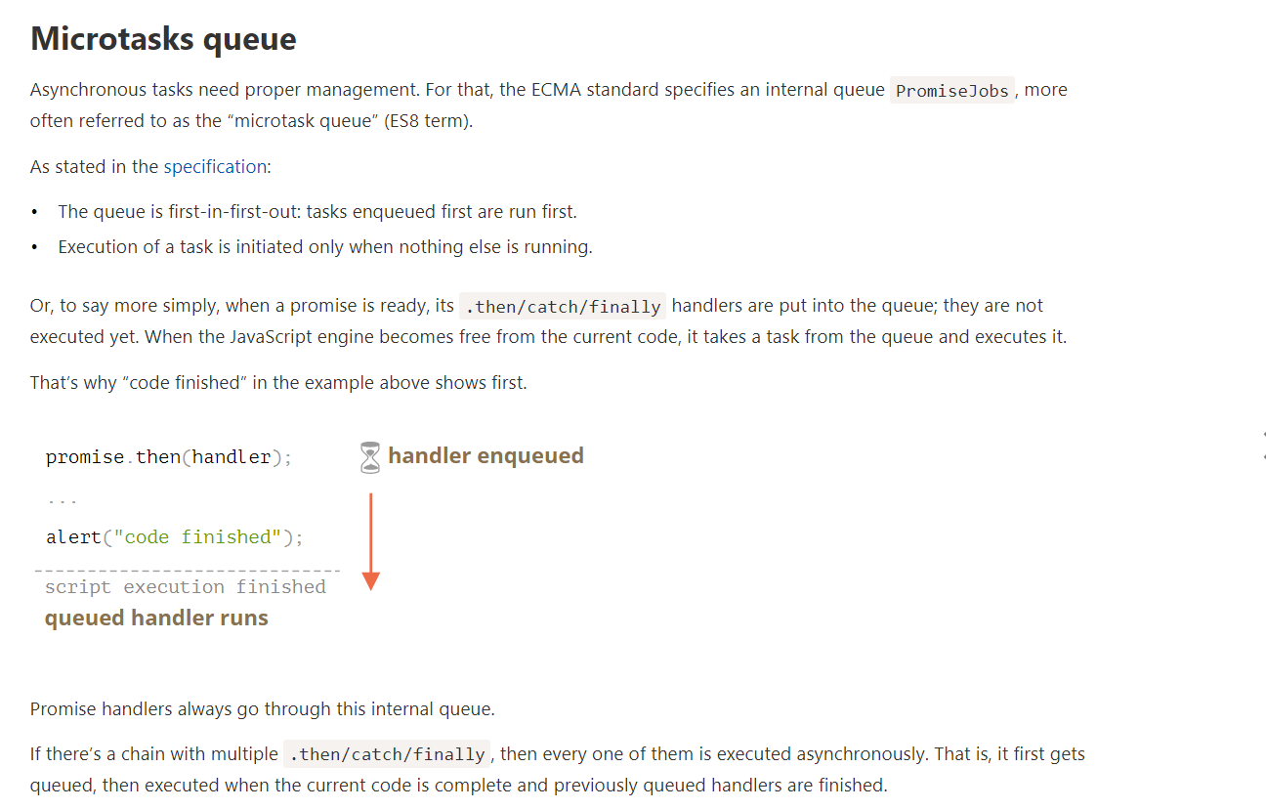
What if the order matters for us? How can we make code finished run after promise done?
Easy, just put it into the queue with .then:
An “unhandled rejection” occurs when a promise error is not handled at the end of the microtask queue.

There’s a special syntax to work with promises in a more comfortable fashion, called “async/await”. It’s surprisingly easy to understand and use.

Async functions
Let’s start with the async keyword. It can be placed before a function, like this:
async function f() {
return 1;
}
The word “async” before a function means one simple thing: a function always returns a promise. Other values are wrapped in a resolved promise automatically.

Await
The syntax:
// works only inside async functions
let value = await promise;
The keyword await makes JavaScript wait until that promise settles and returns its result.
Let’s emphasize: await literally makes JavaScript wait until the promise settles, and then go on with the result. That doesn’t cost any CPU resources, because the engine can do other jobs in the meantime: execute other scripts, handle events, etc.
If we try to use await in non-async function, there would be a syntax error:
People who are just starting to use await tend to forget the fact that we can’t use await in top-level code.
The idea is that a third-party object may not be a promise, but promise-compatible: if it supports .then, that’s enough to use it with await.
Here’s a demo Thenable class; the await below accepts its instances:
class Thenable {
constructor(num) {
this.num = num;
}
then(resolve, reject) {
alert(resolve);
// resolve with this.num*2 after 1000ms
setTimeout(() => resolve(this.num * 2), 1000); // (*)
}
};

async function f() {
// waits for 1 second, then result becomes 2
let result = await new Thenable(1);
alert(result);
}

f();

If await gets a non-promise object with .then, it calls that method providing the built-in functions resolve and reject as arguments (just as it does for a regular Promise executor). Then await waits until one of them is called (in the example above it happens in the line (*)) and then proceeds with the result.

To declare an async class method, just prepend it with async:

class Waiter {
async wait() {
return await Promise.resolve(1);
}
}

new Waiter()
.wait()
.then(alert); // 1
The meaning is the same: it ensures that the returned value is a promise and enables await.
If a promise resolves normally, then await promise returns the result. But in the case of a rejection, it throws the error, just as if there were a throw statement at that line.
We can catch that error using try..catch, the same way as a regular throw
If a promise resolves normally, then await promise returns the result. But in the case of a rejection, it throws the error, just as if there were a throw statement at that line.
When we need to wait for multiple promises, we can wrap them in Promise.all and then await:
// wait for the array of results
let results = await Promise.all([
fetch(url1),
fetch(url2),
...
]);

Regular functions return only one, single value (or nothing).
Generators can return (“yield”) multiple values, one after another, on-demand. They work great with iterables, allowing to create data streams with ease.

To create a generator, we need a special syntax construct: function*, so-called “generator function”.
It looks like this:
function* generateSequence() {
yield 1;
yield 2;
return 3;
}
// "generator function" creates "generator object"
let generator = generateSequence();
alert(generator); // [object Generator]

The function code execution hasn’t started yet:
Generator functions behave differently from regular ones. When such function is called, it doesn’t run its code. Instead it returns a special object, called “generator object”, to manage the execution.

The main method of a generator is next(). When called, it runs the execution until the nearest yield <value> statement (value can be omitted, then it’s undefined). Then the function execution pauses, and the yielded value is returned to the outer code.
The result of next() is always an object with two properties:
- value: the yielded value.
- done: true if the function code has finished, otherwise false.
Une fois que done = true alors fin generateur/sequence

Note :
function* f(…) or function *f(…)?
Both syntaxes are correct.
But usually the first syntax is preferred, as the star * denotes that it’s a generator function, it describes the kind, not the name, so it should stick with the function keyword.

Because for..of iteration ignores the last value, when done: true. So, if we want all results to be shown by for..of, we must return them with yield:

function* generateSequence() {
yield 1;
yield 2;
yield 3;
}

let generator = generateSequence();

for(let value of generator) {
alert(value); // 1, then 2, then 3
}

Car iterable ...generateSequence() turns the iterable generator object into an array of items

Generator composition is a special feature of generators that allows to transparently “embed” generators in each other.
For generators, there’s a special yield* syntax to “embed” (compose) one generator into another.

function* generateSequence(start, end) {
for (let i = start; i <= end; i++) yield i;
}

function* generatePasswordCodes() {

// 0..9
yield* generateSequence(48, 57);

// A..Z
yield* generateSequence(65, 90);

// a..z
yield* generateSequence(97, 122);

}

let str = '';

for(let code of generatePasswordCodes()) {
str += String.fromCharCode(code);
}

alert(str); // 0..9A..Za..z

The yield* directive delegates the execution to another generator. This term means that yield* gen iterates over the generator gen and transparently forwards its yields outside. As if the values were yielded by the outer generator.

A generator composition is a natural way to insert a flow of one generator into another. It doesn’t use extra memory to store intermediate results.

That’s because yield is a two-way street: it not only returns the result to the outside, but also can pass the value inside the generator.
To do so, we should call generator.next(arg), with an argument. That argument becomes the result of yield.
Let’s see an example:

function* gen() {
// Pass a question to the outer code and wait for an answer
let result = yield "2 + 2 = ?"; // (*)

alert(result);
}

let generator = gen();

let question = generator.next().value; // <-- yield returns the value

generator.next(4); // --> pass the result into the generator

The first call generator.next() should be always made without an argument (the argument is ignored if passed). It starts the execution and returns the result of the first yield "2+2=?". At this point the generator pauses the execution, while staying on the line (*).
- Then, as shown at the picture above, the result of yield gets into the question variable in the calling code.
- On generator.next(4), the generator resumes, and 4 gets in as the result: let result = 4.
function* gen() {
let ask1 = yield "2 + 2 = ?";

alert(ask1); // 4

let ask2 = yield "3 * 3 = ?"

alert(ask2); // 9
}

let generator = gen();

alert( generator.next().value ); // "2 + 2 = ?"

alert( generator.next(4).value ); // "3 * 3 = ?"

alert( generator.next(9).done ); // true

To pass an error into a yield, we should call generator.throw(err). In that case, the err is thrown in the line with that yield.

For instance, here the yield of "2 + 2 = ?" leads to an error:

function* gen() {
try {
let result = yield "2 + 2 = ?"; // (1)

alert("The execution does not reach here, because the exception is thrown above");
} catch(e) {
alert(e); // shows the error
}
}

let generator = gen();

let question = generator.next().value;

generator.throw(new Error("The answer is not found in my database")); // (2)

The error, thrown into the generator at line (2) leads to an exception in line (1) with yield. In the example above, try..catch catches it and shows it.
If we don’t catch it, then just like any exception, it “falls out” the generator into the calling code.
The current line of the calling code is the line with generator.throw, labelled as (2). So we can catch it here, like this:

function* generate() {
let result = yield "2 + 2 = ?"; // Error in this line
}

let generator = generate();

let question = generator.next().value;

try {
generator.throw(new Error("The answer is not found in my database"));
} catch(e) {
alert(e); // shows the error
}
If we don’t catch the error there, then, as usual, it falls through to the outer calling code (if any) and, if uncaught, kills the script.

A “regular” iterable object, as described in the chapter Iterables, looks like this:

let range = {
from: 1,
to: 5,

// for..of calls this method once in the very beginning
[Symbol.iterator]() {
// ...it returns the iterator object:
// onward, for..of works only with that object,
// asking it for next values using next()
return {
current: this.from,
last: this.to,

// next() is called on each iteration by the for..of loop
next() { // (2)
// it should return the value as an object {done:.., value :...}
if (this.current <= this.last) {
return { done: false, value: this.current++ };
} else {
return { done: true };
}
}
};
}
};

for(let value of range) {
alert(value); // 1 then 2, then 3, then 4, then 5
}

To make the object iterable asynchronously:
- We need to use Symbol.asyncIterator instead of Symbol.iterator.
- next() should return a promise.
- To iterate over such an object, we should use a for await (let item of iterable) loop.
Let’s make an iterable range object, like the one before, but now it will return values asynchronously, one per second:

let range = {
from: 1,
to: 5,

// for await..of calls this method once in the very beginning
[Symbol.asyncIterator]() { // (1)
// ...it returns the iterator object:
// onward, for await..of works only with that object,
// asking it for next values using next()
return {
current: this.from,
last: this.to,

// next() is called on each iteration by the for await..of loop
async next() { // (2)
// it should return the value as an object {done:.., value :...}
// (automatically wrapped into a promise by async)

// can use await inside, do async stuff:
await new Promise(resolve => setTimeout(resolve, 1000)); // (3)

if (this.current <= this.last) {
return { done: false, value: this.current++ };
} else {
return { done: true };
}
}
};
}
};

(async () => {

for await (let value of range) { // (4)
alert(value); // 1,2,3,4,5
}

})()
As we can see, the structure is similar to regular iterators:
- To make an object asynchronously iterable, it must have a method Symbol.asyncIterator (1).
- This method must return the object with next() method returning a promise (2).
- The next() method doesn’t have to be async, it may be a regular method returning a promise, but async allows us to use await, so that’s convenient. Here we just delay for a second (3).
- To iterate, we use for await(let value of range) (4), namely add “await” after “for”. It calls range[Symbol.asyncIterator]() once, and then its next() for values.

Here’s a small cheatsheet:

 | Iterators | Async iterators
Object method to provide iterator | Symbol.iterator | Symbol.asyncIterator
next() return value is | any value | Promise
to loop, use | for..of | for await..of

The spread syntax ... doesn’t work asynchronously
Features that require regular, synchronous iterators, don’t work with asynchronous ones.
For instance, a spread syntax won’t work:
alert( [...range] ); // Error, no Symbol.iterator
That’s natural, as it expects to find Symbol.iterator, same as for..of without await. Not Symbol.asyncIterator.

async function* generateSequence(start, end) {

for (let i = start; i <= end; i++) {

// yay, can use await!
await new Promise(resolve => setTimeout(resolve, 1000));

yield i;
}

}

(async () => {

let generator = generateSequence(1, 5);
for await (let value of generator) {
alert(value); // 1, then 2, then 3, then 4, then 5
}

})();

Now we have the async generator, iterable with for await...of.
Technically, another difference of an async generator is that its generator.next() method is now asynchronous also, it returns promises.
In a regular generator we’d use result = generator.next() to get values. In an async generator, we should add await, like this:

As we already know, to make an object iterable, we should add Symbol.iterator to it.

A common practice for Symbol.iterator is to return a generator, rather than a plain object with next as in the example before.

*[Symbol.iterator]() { // a shorthand for [Symbol.iterator]: function*()
for(let value = this.from; value <= this.to; value++) {
yield value;
}

As our application grows bigger, we want to split it into multiple files, so called “modules”. A module may contain a class or a library of functions for a specific purpose.

To name some (for historical reasons):
- AMD – one of the most ancient module systems, initially implemented by the library require.js.
- CommonJS – the module system created for Node.js server.
- UMD – one more module system, suggested as a universal one, compatible with AMD and CommonJS.
Now all these slowly become a part of history, but we still can find them in old scripts.
The language-level module system appeared in the standard in 2015, gradually evolved since then, and is now supported by all major browsers and in Node.js. So we’ll study the modern JavaScript modules from now on.
A module is just a file. One script is one module. As simple as that.
Modules can load each other and use special directives export and import to interchange functionality, call functions of one module from another one:
- export keyword labels variables and functions that should be accessible from outside the current module.
- import allows the import of functionality from other modules.
For instance, if we have a file sayHi.js exporting a function:
export function sayHi(user) {
alert(`Hello, ${user}!`);
}

Then another file may import and use it:
import {sayHi} from './sayHi.js';
sayHi('John'); // Hello, John!

The import directive loads the module by path ./sayHi.js relative to the current file, and assigns exported function sayHi to the corresponding variable.

As modules support special keywords and features, we must tell the browser that a script should be treated as a module, by using the attribute <script type="module">.
The browser automatically fetches and evaluates the imported module (and its imports if needed), and then runs the script.

Modules work only via HTTP(s), not in local files
If you try to open a web-page locally, via file:// protocol, you’ll find that import/export directives don’t work. Use a local web-server, such as static-server or use the “live server” capability of your editor, such as VS Code Live Server Extension to test modules.

Difference between regular script and module
Modules always use strict, by default.

Each module has its own top-level scope. In other words, top-level variables and functions from a module are not seen in other scripts.
Ex :
user.js content :
let user= « Jhon » ;
hello.js content :
alert(user) ; => n’affiche rien car ne voit pas user var
solution :inclure import {user} from './user.js'; dans hello
page web index.html :
« import user+ hello »
In the browser, independent top-level scope also exists for each <script type="module">:
<script type="module">
// The variable is only visible in this module script
let user = "John";
</script>

<script type="module">
alert(user); // Error: user is not defined
</script>

If the same module is imported into multiple other places, its code is executed only the first time, then exports are given to all importers.

First, if executing a module code brings side-effects, like showing a message, then importing it multiple times will trigger it only once
In practice, top-level module code is mostly used for initialization, creation of internal data structures, and if we want something to be reusable – export it.
So, let’s reiterate – the module is executed only once. Exports are generated, and then they are shared between importers, so if something changes the admin object, other modules will see that.
Such behavior allows us to configure modules on first import. We can setup its properties once, and then in further imports it’s ready.

The object import.meta contains the information about the current module.
Its content depends on the environment. In the browser, it contains the url of the script, or a current webpage url if inside HTML:

In a module, top-level this is undefined.
Module scripts are always deferred, same effect as defer attribute for both external and inline scripts.
In other words:
- downloading external module scripts <script type="module" src="..."> doesn’t block HTML processing, they load in parallel with other resources.
- module scripts wait until the HTML document is fully ready (even if they are tiny and load faster than HTML), and then run.
- relative order of scripts is maintained: scripts that go first in the document, execute first.
As a side-effect, module scripts always “see” the fully loaded HTML-page, including HTML elements below them.

For instance:

<script type="module">
alert(typeof button); // object: the script can 'see' the button below
// as modules are deferred, the script runs after the whole page is loaded
</script>

Compare to regular script below:

<script>
alert(typeof button); // Error: button is undefined, the script can't see elements below
// regular scripts run immediately, before the rest of the page is processed
</script>

<button id="button">Button</button>

When using modules, we should be aware that the HTML page shows up as it loads, and JavaScript modules run after that, so the user may see the page before the JavaScript application is ready. Some functionality may not work yet. We should put “loading indicators”, or otherwise ensure that the visitor won’t be confused by that.
PAS COMPRIS :
Forr non-module scripts, the async attribute only works on external scripts. Async scripts run immediately when ready, independently of other scripts or the HTML document.
For module scripts, it works on inline scripts as well.
For example, the inline script below has async, so it doesn’t wait for anything.
It performs the import (fetches ./analytics.js) and runs when ready, even if the HTML document is not finished yet, or if other scripts are still pending.
That’s good for functionality that doesn’t depend on anything, like counters, ads, document-level event listeners.
External scripts that have type="module" are different in two aspects:
- External scripts with the same src run only once:
External scripts that are fetched from another origin (e.g. another site) require CORS headers, as described in the chapter Fetch: Cross-Origin Requests. In other words, if a module script is fetched from another origin, the remote server must supply a header Access-Control-Allow-Origin allowing the fetch.

<!-- another-site.com must supply Access-Control-Allow-Origin -->
<!-- otherwise, the script won't execute -->
<script type="module" src="http://another-site.com/their.js"></script>
That ensures better security by default.

No “bare” modules allowed
In the browser, import must get either a relative or absolute URL. Modules without any path are called “bare” modules. Such modules are not allowed in import.
For instance, this import is invalid:
import {sayHi} from 'sayHi'; // Error, "bare" module
// the module must have a path, e.g. './sayHi.js' or wherever the module is
Certain environments, like Node.js or bundle tools allow bare modules, without any path, as they have their own ways for finding modules and hooks to fine-tune them. But browsers do not support bare modules yet.

Compatibility, “nomodule”
Old browsers do not understand type="module". Scripts of an unknown type are just ignored. For them, it’s possible to provide a fallback using the nomodule attribute:
<script type="module">
alert("Runs in modern browsers");
</script>

<script nomodule>
alert("Modern browsers know both type=module and nomodule, so skip this")
alert("Old browsers ignore script with unknown type=module, but execute this.");
</script>

In real-life, browser modules are rarely used in their “raw” form. Usually, we bundle them together with a special tool such as Webpack and deploy to the production server.
One of the benefits of using bundlers – they give more control over how modules are resolved, allowing bare modules and much more, like CSS/HTML modules.
Build tools do the following:
- Take a “main” module, the one intended to be put in <script type="module"> in HTML.
- Analyze its dependencies: imports and then imports of imports etc.
- Build a single file with all modules (or multiple files, that’s tunable), replacing native import calls with bundler functions, so that it works. “Special” module types like HTML/CSS modules are also supported.
- In the process, other transformations and optimizations may be applied:
  - Unreachable code removed.
  - Unused exports removed (“tree-shaking”).
  - Development-specific statements like console and debugger removed.
  - Modern, bleeding-edge JavaScript syntax may be transformed to older one with similar functionality using Babel.
  - The resulting file is minified (spaces removed, variables replaced with shorter names, etc).
If we use bundle tools, then as scripts are bundled together into a single file (or few files), import/export statements inside those scripts are replaced by special bundler functions. So the resulting “bundled” script does not contain any import/export, it doesn’t require type="module", and we can put it into a regular script:
<!-- Assuming we got bundle.js from a tool like Webpack -->
<script src="bundle.js"></script>
That said, native modules are also usable. So we won’t be using Webpack here: you can configure it later.

We can label any declaration as exported by placing export before it, be it a variable, function or a class.
No semicolons after export class/function
Please note that export before a class or a function does not make it a function expression. It’s still a function declaration, albeit exported.
Most JavaScript style guides don’t recommend semicolons after function and class declarations.
That’s why there’s no need for a semicolon at the end of export class and export function:

Also, we can put export separately.
// 📁 say.js
function sayHi(user) {
alert(`Hello, ${user}!`);
}

function sayBye(user) {
alert(`Bye, ${user}!`);
}

export {sayHi, sayBye}; // a list of exported variables
…Or, technically we could put export above functions as well

if there’s a lot to import, we can import everything as an object using import * as <obj>, for instance:
ex :import * as say from './say.js';
why should we ever explicitly list what we need to import?
Well, there are few reasons.
- Modern build tools (webpack and others) bundle modules together and optimize them to speedup loading and remove unused stuff.
2,Explicitly listing what to import gives shorter names: sayHi() instead of say.sayHi().
3,Explicit list of imports gives better overview of the code structure: what is used and where. It makes code support and refactoring easier.

We can also use as to import under different names.
import {sayHi as hi, sayBye as bye} from './say.js';

The similar syntax exists for export.
export {sayHi as hi, sayBye as bye};

In practice, there are mainly two kinds of modules.
- Modules that contain a library, pack of functions, like say.js above.
- Modules that declare a single entity, e.g. a module user.js exports only class User.
Mostly, the second approach is preferred, so that every “thing” resides in its own module.

Modules provide a special export default (“the default export”) syntax to make the “one thing per module” way look better :
// 📁 user.js
export default class User { // just add "default"
constructor(name) {
this.name = name;
}
}

There may be only one export default per file.
…And then import it without curly braces:

// 📁 main.js
import User from './user.js'; // not {User}, just User

new User('John');

Remember, import needs curly braces for named exports and doesn’t need them for the default one.

Technically, we may have both default and named exports in a single module, but in practice people usually don’t mix them. A module has either named exports or the default one.
As there may be at most one default export per file, the exported entity may have no name.
For instance, these are all perfectly valid default exports:
export default class { // no class name
constructor() { ... }
}
//pareil pour function et var ( genre : let ,,,, => export default[ ‘jan’ , ‘fev’ ,,,,] )
In some situations the default keyword is used to reference the default export.
For example, to export a function separately from its definition:
function sayHi(user) {
alert(`Hello, ${user}!`);
}

// same as if we added "export default" before the function
export {sayHi as default};

Rare :
Here’s how to import the default export along with a named one:

// 📁 main.js
import {default as User, sayHi} from './user.js';

new User('John');
And, finally, if importing everything * as an object, then the default property is exactly the default export:
// 📁 main.js
import * as user from './user.js';

let User = user.default; // the default export
new User('John');

Named exports are explicit. They exactly name what they import, so we have that information from them; that’s a good thing.
Named exports force us to use exactly the right name to import:
While for a default export, we always choose the name when importing
import User from './user.js'; // works
import MyUser from './user.js'; // works too
// could be import Anything... and it'll still work

So team members may use different names to import the same thing, and that’s not good.
Usually, to avoid that and keep the code consistent, there’s a rule that imported variables should correspond to file names,
Certain pense que ce un-name est un defaut du default export donc utilise toujours named export meme si une seule choes est exporté

Re-export
“Re-export” syntax export ... from ... allows to import things and immediately export them (possibly under another name), like this:
export {sayHi} from './say.js'; // re-export sayHi

export {default as User} from './user.js'; // re-export default

The default export needs separate handling when re-exporting.
export User from './user.js' won’t work. What can go wrong?… But that’s a syntax error!
To re-export the default export, we have to write export {default as User}, as in the example above.
- export * from './user.js' re-exports only named exports, but ignores the default one.
If we’d like to re-export both named and the default export, then two statements are needed:
export * from './user.js'; // to re-export named exports
export {default} from './user.js'; // to re-export the default export

Export and import statements that we covered in previous chapters are called “static”. The syntax is very simple and strict.

The module path must be a primitive string, can’t be a function call. This won’t work:
import ... from getModuleName(); // Error, only from "string" is allowed
Second, we can’t import conditionally or at run-time:
That’s a good thing, as code structure can be analyzed, modules can be gathered and bundled into one file by special tools, unused exports can be removed (“tree-shaken”). That’s possible only because the structure of imports/exports is simple and fixed.

The import(module) expression loads the module and returns a promise that resolves into a module object that contains all its exports. It can be called from any place in the code.
We can use it dynamically in any place of the code, for instance:
let modulePath = prompt("Which module to load?");

import(modulePath)
.then(obj => <module object>)
.catch(err => <loading error, e.g. if no such module>)
Or, we could use let module = await import(modulePath) if inside an async function.
Then dynamic import can be like this:
let {hi, bye} = await import('./say.js');

hi();
bye();

…Then, in order to access it, we can use default property of the module object:
let obj = await import('./say.js');
let say = obj.default;
// or, in one line: let {default: say} = await import('./say.js');

say();

Dynamic imports work in regular scripts, they don’t require script type="module".
we can’t copy import to a variable or use call/apply with it. It’s not a function.

A Proxy object wraps another object and intercepts operations, like reading/writing properties and others, optionally handling them on its own, or transparently allowing the object to handle them.
The syntax:
let proxy = new Proxy(target, handler)
- target – is an object to wrap, can be anything, including functions.
- handler – proxy configuration: an object with “traps”, methods that intercept operations. – e.g. get trap for reading a property of target, set trap for writing a property into target, and so on.

For operations on proxy, if there’s a corresponding trap in handler, then it runs, and the proxy has a chance to handle it, otherwise the operation is performed on target.
What can we intercept with them?
For most operations on objects, there’s a so-called “internal method” in the JavaScript specification that describes how it works at the lowest level. For instance [[Get]], the internal method to read a property, [[Set]], the internal method to write a property, and so on. These methods are only used in the specification, we can’t call them directly by name.
Proxy traps intercept invocations of these methods. They are listed in the Proxy specification and in the table below.
For every internal method, there’s a trap in this table: the name of the method that we can add to the handler parameter of new Proxy to intercept the operation:
Internal Method | Handler Method | Triggers when…
[[Get]] | get | reading a property
[[Set]] | set | writing to a property
[[HasProperty]] | has | in operator
[[Delete]] | deleteProperty | delete operator
[[Call]] | apply | function call
[[Construct]] | construct | new operator
[[GetPrototypeOf]] | getPrototypeOf | Object.getPrototypeOf
[[SetPrototypeOf]] | setPrototypeOf | Object.setPrototypeOf
[[IsExtensible]] | isExtensible | Object.isExtensible
[[PreventExtensions]] | preventExtensions | Object.preventExtensions
[[DefineOwnProperty]] | defineProperty | Object.defineProperty, Object.defineProperties
[[GetOwnProperty]] | getOwnPropertyDescriptor | Object.getOwnPropertyDescriptor, for..in, Object.keys/values/entries
[[OwnPropertyKeys]] | ownKeys | Object.getOwnPropertyNames, Object.getOwnPropertySymbols, for..in, Object/keys/values/entries
avaScript enforces some invariants – conditions that must be fulfilled by internal methods and traps.
Most of them are for return values:
- [[Set]] must return true if the value was written successfully, otherwise false.
- [[Delete]] must return true if the value was deleted successfully, otherwise false.
- …and so on, we’ll see more in examples below.
There are some other invariants, like:
- [[GetPrototypeOf]], applied to the proxy object must return the same value as [[GetPrototypeOf]] applied to the proxy object’s target object. In other words, reading prototype of a proxy must always return the prototype of the target object.
Traps can intercept these operations, but they must follow these rules.
Invariants ensure correct and consistent behavior of language features. The full invariants list is in the specification. You probably won’t violate them if you’re not doing something weird.
To intercept reading, the handler should have a method get(target, property, receiver).
It triggers when a property is read, with following arguments:
- target – is the target object, the one passed as the first argument to new Proxy,
- property – property name,
- receiver – if the target property is a getter, then receiver is the object that’s going to be used as this in its call. Usually that’s the proxy object itself (or an object that inherits from it, if we inherit from proxy). Right now we don’t need this argument, so it will be explained in more detail later.

Usually when one tries to get a non-existing array item, they get undefined, but we’ll wrap a regular array into the proxy that traps reading and returns 0 if there’s no such property:
let numbers = [0, 1, 2];

numbers = new Proxy(numbers, {
get(target, prop) {
if (prop in target) {
return target[prop];
} else {
return 0; // default value
}
}
});

alert( numbers[1] ); // 1
alert( numbers[123] ); // 0 (no such item)

Please note how the proxy overwrites the variable:
dictionary = new Proxy(dictionary, ...);
The proxy should totally replace the target object everywhere. No one should ever reference the target object after it got proxied. Otherwise it’s easy to mess up.
The set trap triggers when a property is written.
set(target, property, value, receiver):
- target – is the target object, the one passed as the first argument to new Proxy,
- property – property name,
- value – property value,
- receiver – similar to get trap, matters only for setter properties.
The set trap should return true if setting is successful, and false otherwise (triggers TypeError).

let numbers = [];

numbers = new Proxy(numbers, { // (*)
set(target, prop, val) { // to intercept property writing
if (typeof val == 'number') {
target[prop] = val;
return true;
} else {
return false;
}
}
});

numbers.push(1); // added successfully
numbers.push(2); // added successfully
alert("Length is: " + numbers.length); // 2

numbers.push("test"); // TypeError ('set' on proxy returned false)

alert("This line is never reached (error in the line above)");

Please note: the built-in functionality of arrays is still working! Values are added by push. The length property auto-increases when values are added. Our proxy doesn’t break anything.
We don’t have to override value-adding array methods like push and unshift, and so on, to add checks in there, because internally they use the [[Set]] operation that’s intercepted by the proxy.

Don’t forget to return true sino type error
Object.keys, for..in loop and most other methods that iterate over object properties use [[OwnPropertyKeys]] internal method (intercepted by ownKeys trap) to get a list of properties.
Such methods differ in details:
- Object.getOwnPropertyNames(obj) returns non-symbol keys.
- Object.getOwnPropertySymbols(obj) returns symbol keys.
- Object.keys/values() returns non-symbol keys/values with enumerable flag (property flags were explained in the article Property flags and descriptors).
- for..in loops over non-symbol keys with enumerable flag, and also prototype keys.
Although, if we return a key that doesn’t exist in the object, Object.keys won’t list it:

let user = { };

user = new Proxy(user, {
ownKeys(target) {
return ['a', 'b', 'c'];
}
});

alert( Object.keys(user) ); // <empty>

La raison est simple Object.keys return seulement les propriétés avec the enumerable flag . Pour verifier cela , il appelle la méthode interne [[GetOwnProperty]] pour chaque property pour avoir son descriptor . Or ici , comme il n’y a pas de property son descriptor est vide => no enumerable flag so it’s skipped.

For Object.keys to return a property, we need it to either exist in the object, with the enumerable flag, or we can intercept calls to [[GetOwnProperty]] (the trap getOwnPropertyDescriptor does it), and return a descriptor with enumerable: true.
Here’s an example of that:
let user = { };

user = new Proxy(user, {
ownKeys(target) { // called once to get a list of properties
return ['a', 'b', 'c'];
},

getOwnPropertyDescriptor(target, prop) { // called for every property
return {
enumerable: true,
configurable: true
/* ...other flags, probable "value:..." */
};
}

});

alert( Object.keys(user) ); // a, b, c
Let’s note once again: we only need to intercept [[GetOwnProperty]] if the property is absent in the object.
There’s a widespread convention that properties and methods prefixed by an underscore _ are internal. They shouldn’t be accessed from outside the object.
Technically that’s possible though:
let user = {
name: "John",
_password: "secret"
};

alert(user._password); // secret
Let’s use proxies to prevent any access to properties starting with _.

Please note the important detail in the get trap, in the line (*):

get(target, prop) {
// ...
let value = target[prop];
return (typeof value === 'function') ? value.bind(target) : value; // (*)
}
Why do we need a function to call value.bind(target)?
The reason is that object methods, such as user.checkPassword(), must be able to access _password:
user = {
// ...
checkPassword(value) {
// object method must be able to read _password
return value === this._password;
}
}
A call to user.checkPassword() call gets proxied user as this (the object before dot becomes this), so when it tries to access this._password, the get trap activates (it triggers on any property read) and throws an error.
So we bind the context of object methods to the original object, target, in the line (*). Then their future calls will use target as this, without any traps.
That solution usually works, but isn’t ideal, as a method may pass the unproxied object somewhere else, and then we’ll get messed up: where’s the original object, and where’s the proxied one?
Besides, an object may be proxied multiple times (multiple proxies may add different “tweaks” to the object), and if we pass an unwrapped object to a method, there may be unexpected consequences.
So, such a proxy shouldn’t be used everywhere.

Modern JavaScript engines natively support private properties in classes, prefixed with #. They are described in the article Private and protected properties and methods. No proxies required.
Such properties have their own issues though. In particular, they are not inherited.

We’d like to use the in operator to check that a number is in range.
The has trap intercepts in calls.
has(target, property)
- target – is the target object, passed as the first argument to new Proxy,
- property – property name
Here’s the demo:

let range = {
start: 1,
end: 10
};

range = new Proxy(range, {
has(target, prop) {
return prop >= target.start && prop <= target.end;
}
});
Wrapping functions: "apply"
We can wrap a proxy around a function as well.
The apply(target, thisArg, args) trap handles calling a proxy as function:
- target is the target object (function is an object in JavaScript),
- thisArg is the value of this.
- args is a list of arguments.
But a wrapper function does not forward property read/write operations or anything else. After the wrapping, the access is lost to properties of the original functions, such as name, length and others:

function delay(f, ms) {
return function() {
setTimeout(() => f.apply(this, arguments), ms);
};
}

function sayHi(user) {
alert(`Hello, ${user}!`);
}

alert(sayHi.length); // 1 (function length is the arguments count in its declaration)

sayHi = delay(sayHi, 3000);

alert(sayHi.length); // 0 (in the wrapper declaration, there are zero arguments)
Proxy is much more powerful, as it forwards everything to the target object.
Let’s use Proxy instead of a wrapping function:

function delay(f, ms) {
return new Proxy(f, {
apply(target, thisArg, args) {
setTimeout(() => target.apply(thisArg, args), ms);
}
});
}

function sayHi(user) {
alert(`Hello, ${user}!`);
}

sayHi = delay(sayHi, 3000);

alert(sayHi.length); // 1 (*) proxy forwards "get length" operation to the target

sayHi("John"); // Hello, John! (after 3 seconds)

Reflect is a built-in object that simplifies creation of Proxy.
It was said previously that internal methods, such as [[Get]], [[Set]] and others are specification-only, they can’t be called directly.
Here are examples of operations and Reflect calls that do the same:
Operation | Reflect call | Internal method
obj[prop] | Reflect.get(obj, prop) | [[Get]]
obj[prop] = value | Reflect.set(obj, prop, value) | [[Set]]
delete obj[prop] | Reflect.deleteProperty(obj, prop) | [[Delete]]
new F(value) | Reflect.construct(F, value) | [[Construct]]

For example:
let user = {};

Reflect.set(user, 'name', 'John');

alert(user.name); // John
In particular, Reflect allows us to call operators (new, delete…) as functions (Reflect.construct, Reflect.deleteProperty, …). That’s an interesting capability, but here another thing is important.
For every internal method, trappable by Proxy, there’s a corresponding method in Reflect, with the same name and arguments as the Proxy trap.
That is, everything’s simple: if a trap wants to forward the call to the object, it’s enough to call Reflect.<method> with the same arguments
In most cases we can do the same without Reflect, for instance, reading a property Reflect.get(target, prop, receiver) can be replaced by target[prop]. There are important nuances though.

let user = {
_name: "Guest",
get name() {
return this._name;
}
};

let userProxy = new Proxy(user, {
get(target, prop, receiver) {
return target[prop]; // (*) target = user
}
});

let admin = {
__proto__: userProxy,
_name: "Admin"
};

// Expected: Admin
alert(admin.name); // outputs: Guest (?!?)

A call to target[prop], when prop is a getter, runs its code in the context this=target. So the result is this._name from the original object target, that is: from user.
To fix such situations, we need receiver, the third argument of get trap. It keeps the correct this to be passed to a getter. In our case that’s admin.
How to pass the context for a getter? For a regular function we could use call/apply, but that’s a getter, it’s not “called”, just accessed.
Reflect.get can do that. Everything will work right if we use it.
let userProxy = new Proxy(user, {
get(target, prop, receiver) { // receiver = admin
return Reflect.get(target, prop, receiver); // (*)
}
});
We can rewrite the trap even shorter:

get(target, prop, receiver) {
return Reflect.get(...arguments);
}
Reflect calls are named exactly the same way as traps and accept the same arguments. They were specifically designed this way.
Many built-in objects, for example Map, Set, Date, Promise and others make use of so-called “internal slots”.
These are like properties, but reserved for internal, specification-only purposes. For instance, Map stores items in the internal slot [[MapData]]. Built-in methods access them directly, not via [[Get]]/[[Set]] internal methods

The built-in method Map.prototype.set method tries to access the internal property this.[[MapData]], but because this=proxy, can’t find it in proxy and just fails.

ortunately, there’s a way to fix it:

let map = new Map();

let proxy = new Proxy(map, {
get(target, prop, receiver) {
let value = Reflect.get(...arguments);
return typeof value == 'function' ? value.bind(target) : value;
}
});

proxy.set('test', 1);
alert(proxy.get('test')); // 1 (works!)
Now it works fine, because get trap binds function properties, such as map.set, to the target object (map) itself.
Unlike the previous example, the value of this inside proxy.set(...) will be not proxy, but the original map. So when the internal implementation of set tries to access this.[[MapData]] internal slot, it succeeds.
Array has no internal slots
A notable exception: built-in Array doesn’t use internal slots. That’s for historical reasons, as it appeared so long ago.
The similar thing happens with private class fields. (ex : #name = "Guest";)
The reason is that private fields are implemented using internal slots. JavaScript does not use [[Get]]/[[Set]] when accessing them.
user = new Proxy(user, {});

alert(allUsers.has(user)); // false

car proxy!=traget donc si target a un key le proxy en a une differente.
Proxies can’t intercept a strict equality test ===

A revocable proxy is a proxy that can be disabled.
The syntax is:
let {proxy, revoke} = Proxy.revocable(target, handler)
The call returns an object with the proxy and revoke function to disable it.
A call to revoke() removes all internal references to the target object from the proxy, so they are no more connected. The target object can be garbage-collected after that.
PAS TROP COMPRIS :
We can also store revoke in a WeakMap, to be able to easily find it by a proxy object:
let revokes = new WeakMap();

let object = {
data: "Valuable data"
};

let {proxy, revoke} = Proxy.revocable(object, {});

revokes.set(proxy, revoke);

// ..later in our code..
revoke = revokes.get(proxy);
revoke();

alert(proxy.data); // Error (revoked)
The benefit of such an approach is that we don’t have to carry revoke around. We can get it from the map by proxy when needed.
We use WeakMap instead of Map here because it won’t block garbage collection. If a proxy object becomes “unreachable” (e.g. no variable references it any more), WeakMap allows it to be wiped from memory together with its revoke that we won’t need any more.
The built-in eval function allows to execute a string of code.
The syntax is:
let result = eval(code);

A string of code may be long, contain line breaks, function declarations, variables and so on.
The result of eval is the result of the last statement.
The eval’ed code is executed in the current lexical environment, so it can see outer variables:
In strict mode, eval has its own lexical environment. So functions and variables, declared inside eval, are not visible outside:
Code minifiers (tools used before JS gets to production, to compress it) rename local variables into shorter ones (like a, b etc) to make the code smaller. That’s usually safe, but not if eval is used, as local variables may be accessed from eval’ed code string. So minifiers don’t do that renaming for all variables potentially visible from eval. That negatively affects code compression ratio.
Using outer local variables inside eval is also considered a bad programming practice, as it makes maintaining the code more difficult.
There are two ways how to be totally safe from such problems.
If eval’ed code doesn’t use outer variables, please call eval as window.eval(...):
This way the code is executed in the global scope

If eval’ed code needs local variables, change eval to new Function and pass them as arguments:
let f = new Function('a', 'alert(a)');

f(5); // 5

Currying is an advanced technique of working with functions. It’s used not only in JavaScript, but in other languages as well.
Currying is a transformation of functions that translates a function from callable as f(a, b, c) into callable as f(a)(b)(c).
Currying doesn’t call a function. It just transforms it.
More advanced implementations of currying, such as _.curry from lodash library, return a wrapper that allows a function to be called both normally and partially:
function sum(a, b) {
return a + b;
}

let curriedSum = _.curry(sum); // using _.curry from lodash library

alert( curriedSum(1, 2) ); // 3, still callable normally
alert( curriedSum(1)(2) ); // 3, called partially

function curry(func) {

return function curried(...args) {
if (args.length >= func.length) {
return func.apply(this, args);
} else {
return function(...args2) {
return curried.apply(this, args.concat(args2));
}
}
};

}

function sum(a, b, c) {
return a + b + c;
}

let curriedSum = curry(sum);

alert( curriedSum(1, 2, 3) ); // 6, still callable normally
alert( curriedSum(1)(2,3) ); // 6, currying of 1st arg
alert( curriedSum(1)(2)(3) ); // 6, full currying

The currying requires the function to have a fixed number of arguments.
A function that uses rest parameters, such as f(...args), can’t be curried this way.
(user.name == "John" ? user.hi : user.bye)(); // Error!

let user = {
name: "John",
hi() { alert(this.name); }
}

// split getting and calling the method in two lines
let hi = user.hi;
hi(); // Error, because this is undefined there’s no this.

To make user.hi() calls work, JavaScript uses a trick – the dot '.' returns not a function, but a value of the special Reference Type.
The Reference Type is a “specification type”. We can’t explicitly use it, but it is used internally by the language.
The value of Reference Type is a three-value combination (base, name, strict), where:
- base is the object.
- name is the property name.
- strict is true if use strict is in effect.
The result of a property access user.hi is not a function, but a value of Reference Type. For user.hi in strict mode it is:
// Reference Type value
(user, "hi", true)
When parentheses () are called on the Reference Type, they receive the full information about the object and its method, and can set the right this (=user in this case).
Reference type is a special “intermediary” internal type, with the purpose to pass information from dot . to calling parentheses ().
Any other operation like assignment hi = user.hi discards the reference type as a whole, takes the value of user.hi (a function) and passes it on. So any further operation “loses” this.
So, as the result, the value of this is only passed the right way if the function is called directly using a dot obj.method() or square brackets obj['method']() syntax (they do the same here). Later in this tutorial, we will learn various ways to solve this problem such as func.bind().
BigInt is a special numeric type that provides support for integers of arbitrary length.
A bigint is created by appending n to the end of an integer literal or by calling the function BigInt that creates bigints from strings, numbers etc.

All operations on bigints return bigints.
We can’t mix bigints and regular numbers:
alert(1n + 2); // Error: Cannot mix BigInt and other types

We should explicitly convert them if needed:
using either BigInt() or Number(), like this:
let bigint = 1n;
let number = 2;

// number to bigint
alert(bigint + BigInt(number)); // 3

// bigint to number
alert(Number(bigint) + number); // 3

The conversion operations are always silent, never give errors, but if the bigint is too huge and won’t fit the number type, then extra bits will be cut off, so we should be careful doing such conversion.
The unary plus is not supported on bigints
The unary plus operator +value is a well-known way to convert value to a number.
On bigints it’s not supported, to avoid confusion:
let bigint = 1n;

alert( +bigint ); // error
So we should use Number() to convert a bigint to a number.

Please note though, as numbers and bigints belong to different types, they can be equal ==, but not strictly equal ===:
alert( 1 == 1n ); // true

alert( 1 === 1n ); // false

Polyfilling bigints is tricky. The reason is that many JavaScript operators, such as +, - and so on behave differently with bigints compared to regular numbers.
For example, division of bigints always returns a bigint (rounded if necessary).
To emulate such behavior, a polyfill would need to analyze the code and replace all such operators with its functions. But doing so is cumbersome and would cost a lot of performance.
So, there’s no well-known good polyfill.
Although, the other way around is proposed by the developers of JSBI library.
This library implements big numbers using its own methods. We can use them instead of native bigints:
Operation | native BigInt | JSBI
Creation from Number | a = BigInt(789) | a = JSBI.BigInt(789)
Addition | c = a + b | c = JSBI.add(a, b)
Subtraction | c = a - b | c = JSBI.subtract(a, b)
… | … | …
…And then use the polyfill (Babel plugin) to convert JSBI calls to native bigints for those browsers that support them.
In other words, this approach suggests that we write code in JSBI instead of native bigints. But JSBI works with numbers as with bigints internally, emulates them closely following the specification, so the code will be “bigint-ready”.
We can use such JSBI code “as is” for engines that don’t support bigints and for those that do support – the polyfill will convert the calls to native bigints.

The JavaScript language was initially created for web browsers. Since then it has evolved and become a language with many uses and platforms.

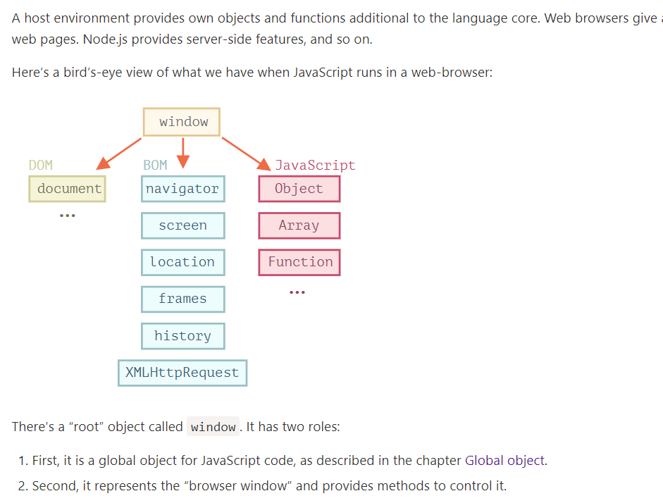

DOM (Document Object Model)
Document Object Model, or DOM for short, represents all page content as objects that can be modified.
The document object is the main “entry point” to the page. We can change or create anything on the page using it.
For instance:
// change the background color to red
document.body.style.background = "red";

// change it back after 1 second
setTimeout(() => document.body.style.background = "", 1000);
Here we used document.body.style, but there’s much, much more. Properties and methods are described in the specification:
- DOM Living Standard at https://dom.spec.whatwg.org
DOM is not only for browsers
The DOM specification explains the structure of a document and provides objects to manipulate it. There are non-browser instruments that use DOM too.
For instance, server-side scripts that download HTML pages and process them can also use DOM. They may support only a part of the specification though.

CSSOM for styling
CSS rules and stylesheets are structured in a different way than HTML. There’s a separate specification, CSS Object Model (CSSOM), that explains how they are represented as objects, and how to read and write them.
CSSOM is used together with DOM when we modify style rules for the document. In practice though, CSSOM is rarely required, because usually CSS rules are static. We rarely need to add/remove CSS rules from JavaScript, but that’s also possible.
The Browser Object Model (BOM) represents additional objects provided by the browser (host environment) for working with everything except the document.
For instance:
- The navigator object provides background information about the browser and the operating system. There are many properties, but the two most widely known are: navigator.userAgent – about the current browser, and navigator.platform – about the platform (can help to differ between Windows/Linux/Mac etc).
- The location object allows us to read the current URL and can redirect the browser to a new one.
Here’s how we can use the location object:
alert(location.href); // shows current URL
if (confirm("Go to Wikipedia?")) {
location.href = "https://wikipedia.org"; // redirect the browser to another URL
}
Functions alert/confirm/prompt are also a part of BOM: they are directly not related to the document, but represent pure browser methods of communicating with the user.
Specifications
BOM is the part of the general HTML specification.
Yes, you heard that right. The HTML spec at https://html.spec.whatwg.org is not only about the “HTML language” (tags, attributes), but also covers a bunch of objects, methods and browser-specific DOM extensions. That’s “HTML in broad terms”. Also, some parts have additional specs listed at https://spec.whatwg.or

The backbone of an HTML document is tags.
According to the Document Object Model (DOM), every HTML tag is an object. Nested tags are “children” of the enclosing one. The text inside a tag is an object as well.
All these objects are accessible using JavaScript, and we can use them to modify the page.
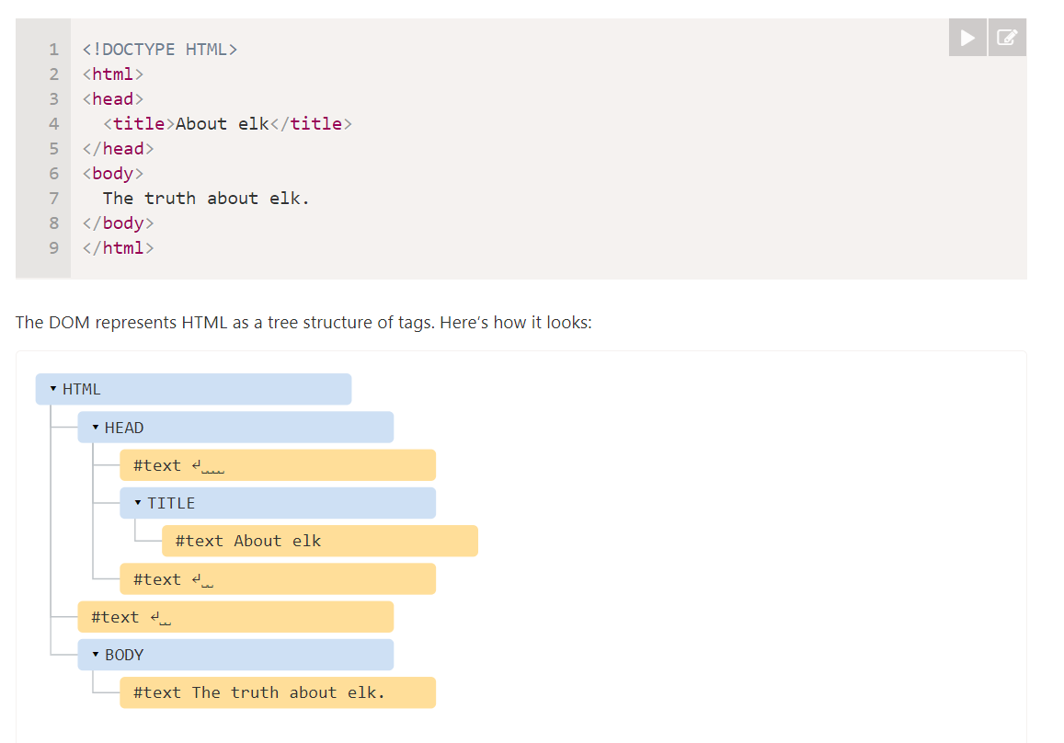
Every tree node is an object.

The text inside elements forms text nodes, labelled as #text. A text node contains only a string. It may not have children and is always a leaf of the tree.
There are only two top-level exclusions:
- Spaces and newlines before <head> are ignored for historical reasons.
- If we put something after </body>, then that is automatically moved inside the body, at the end, as the HTML spec requires that all content must be inside <body>. So there can’t be any spaces after </body>.
In other cases everything’s straightforward – if there are spaces (just like any character) in the document, then they become text nodes in the DOM, and if we remove them, then there won’t be any.

Browser tools (to be covered soon) that work with DOM usually do not show spaces at the start/end of the text and empty text nodes (line-breaks) between tags.

If the browser encounters malformed HTML, it automatically corrects it when making the DOM.
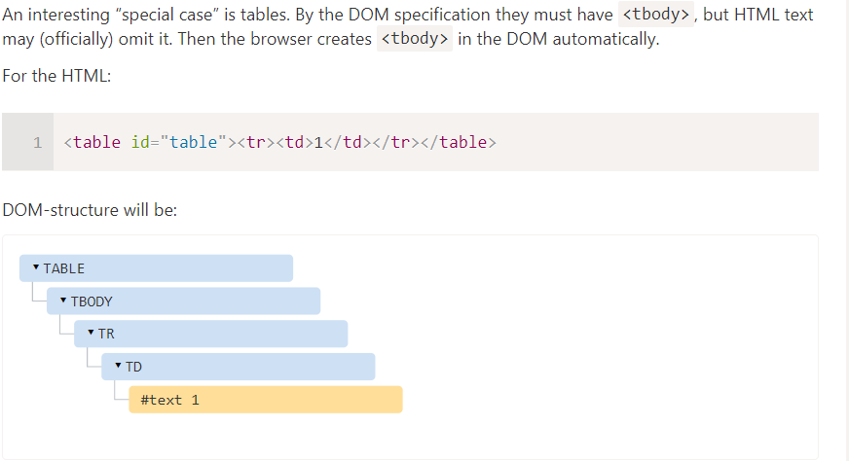
Everything in HTML, even comments, becomes a part of the DOM. (Even the <!DOCTYPE...> )

There are 12 node types. In practice we usually work with 4 of them:
- document – the “entry point” into DOM.
- element nodes – HTML-tags, the tree building blocks.
- text nodes – contain text.
- comments – sometimes we can put information there, it won’t be shown, but JS can read it from the DOM.
To see the DOM structure in real-time, try Live DOM Viewer. Just type in the document, and it will show up as a DOM at an instant.

Please note that the DOM structure in developer tools is simplified. Text nodes are shown just as text. And there are no “blank” (space only) text nodes at all.
Clicking the button in the left-upper corner allows us to choose a node from the webpage using a mouse (or other pointer devices) and “inspect” it (scroll to it in the Elements tab).
Another way to do it would be just right-clicking on a webpage and selecting “Inspect” in the context menu.

At the right part of the tools there are the following subtabs:
- Styles – we can see CSS applied to the current element rule by rule, including built-in rules (gray). Almost everything can be edited in-place, including the dimensions/margins/paddings of the box below.
- Computed – to see CSS applied to the element by property: for each property we can see a rule that gives it (including CSS inheritance and such).
- Event Listeners – to see event listeners attached to DOM elements (we’ll cover them in the next part of the tutorial).
- …and so on.
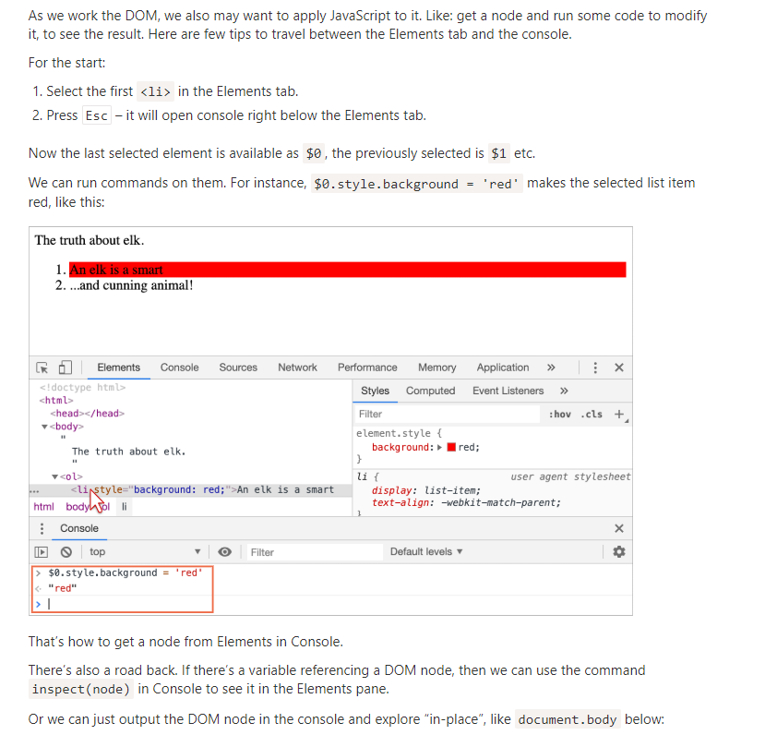

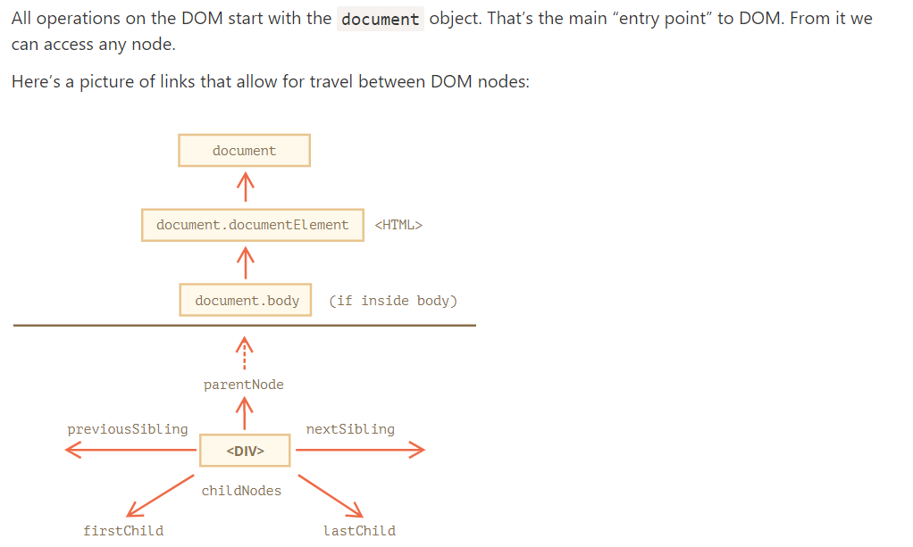

The topmost tree nodes are available directly as document properties
<html> = document.documentElement
<body> = document.body
<head> = document.head
There’s a catch: document.body can be null
A script cannot access an element that doesn’t exist at the moment of running.

In the DOM, the null value means “doesn’t exist” or “no such node”.

Child nodes (or children) – elements that are direct children
Descendants – all elements that are nested in the given one, including children, their children and so on.

The childNodes collection lists all child nodes, including text nodes.

The example below shows children of document.body:

<script>
for (let i = 0; i < document.body.childNodes.length; i++) {
alert( document.body.childNodes[i] ); // Text, DIV, Text, UL, ..., SCRIPT
}
</script>
more stuff…

Please note an interesting detail here. If we run the example above, the last element shown is <script>. In fact, the document has more stuff below, but at the moment of the script execution the browser did not read it yet, so the script doesn’t see it.
Properties firstChild and lastChild give fast access to the first and last children.
They are just shorthands. If there exist child nodes, then the following is always true:
elem.childNodes[0] === elem.firstChild
elem.childNodes[elem.childNodes.length - 1] === elem.lastChild
There’s also a special function elem.hasChildNodes() to check whether there are any child nodes.
As we can see, childNodes looks like an array. But actually it’s not an array, but rather a collection – a special array-like iterable object.
There are two important consequences:
- We can use for..of to iterate over it:
for (let node of document.body.childNodes) {
alert(node); // shows all nodes from the collection
}
That’s because it’s iterable (provides the Symbol.iterator property, as required).
- Array methods won’t work, because it’s not an array:
alert(document.body.childNodes.filter); // undefined (there's no filter method!)
The first thing is nice. The second is tolerable, because we can use Array.from to create a “real” array from the collection, if we want array methods:
alert( Array.from(document.body.childNodes).filter ); // function

DOM collections, and even more – all navigation properties listed in this chapter are read-only.
We can’t replace a child by something else by assigning childNodes[i] = ....
Changing DOM needs other methods.
Almost all DOM collections with minor exceptions are live. In other words, they reflect the current state of DOM.
If we keep a reference to elem.childNodes, and add/remove nodes into DOM, then they appear in the collection automatically.

Don’t use for..in to loop over collections
Collections are iterable using for..of. Sometimes people try to use for..in for that.

Please, don’t. The for..in loop iterates over all enumerable properties. And collections have some “extra” rarely used properties that we usually do not want to get:
<body>
<script>
// shows 0, 1, length, item, values and more.
for (let prop in document.body.childNodes) alert(prop);
</script>
</body>

Siblings are nodes that are children of the same parent.
*For instance, here <head> and <body> are siblings:
<html>
<head>...</head><body>...</body>
</html>
- <body> is said to be the “next” or “right” sibling of <head>,
- <head> is said to be the “previous” or “left” sibling of <body>.
The next sibling is in nextSibling property, and the previous one – in previousSibling.
The parent is available as parentNode.

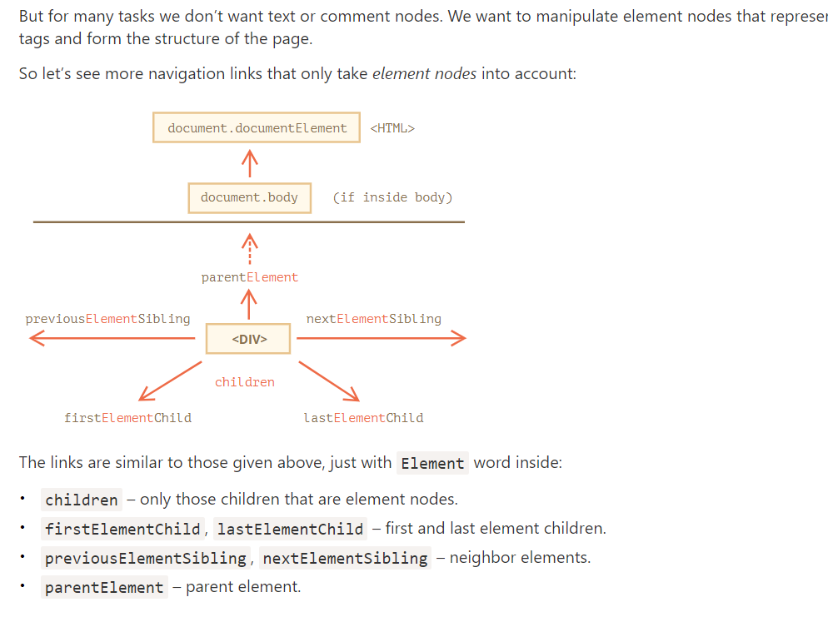
The parentElement property returns the “element” parent, while parentNode returns “any node” parent. These properties are usually the same: they both get the parent.
With the one exception of document.documentElement:
alert( document.documentElement.parentNode ); // document
alert( document.documentElement.parentElement ); // null
The reason is that the root node document.documentElement (<html>) has document as its parent. But document is not an element node, so parentNode returns it and parentElement does not.
This detail may be useful when we want to travel up from an arbitrary element elem to <html>, but not to the document:
while(elem = elem.parentElement) { // go up till <html>
alert( elem );
}

Certain types of DOM elements may provide additional properties, specific to their type, for convenience.
Tables are a great example of that, and represent a particularly important case:
The <table> element supports (in addition to the given above) these properties:
- table.rows – the collection of <tr> elements of the table.
- table.caption/tHead/tFoot – references to elements <caption>, <thead>, <tfoot>.
- table.tBodies – the collection of <tbody> elements (can be many according to the standard, but there will always be at least one – even if it is not in the source HTML, the browser will put it in the DOM).
<thead>, <tfoot>, <tbody> elements provide the rows property:
- tbody.rows – the collection of <tr> inside.
<tr>:
- tr.cells – the collection of <td> and <th> cells inside the given <tr>.
- tr.sectionRowIndex – the position (index) of the given <tr> inside the enclosing <thead>/<tbody>/<tfoot>.
- tr.rowIndex – the number of the <tr> in the table as a whole (including all table rows).
<td> and <th>:
- td.cellIndex – the number of the cell inside the enclosing <tr>.
An example of usage:
<table id="table">
<tr>
<td>one</td><td>two</td>
</tr>
<tr>
<td>three</td><td>four</td>
</tr>
</table>

<script>
// get td with "two" (first row, second column)
let td = table.rows[0].cells[1];
td.style.backgroundColor = "red"; // highlight it
</script>
The specification: tabular data.
There are also additional navigation properties for HTML forms. We’ll look at them later when we start working with forms.

DOM navigation properties are great when elements are close to each other. What if they are not? How to get an arbitrary element of the page?
There are additional searching methods for that
If an element has the id attribute, we can get the element using the method document.getElementById(id), no matter where it is.
<div id="elem">
Also, there’s a global variable named by id that references the element:

<div id="elem">
<div id="elem-content">Element</div>
</div>

<script>
// elem is a reference to DOM-element with id="elem"
elem.style.background = 'red';

// id="elem-content" has a hyphen inside, so it can't be a variable name
// ...but we can access it using square brackets: window['elem-content']
</script>
…That’s unless we declare a JavaScript variable with the same name, then it takes precedence:
<div id="elem"></div>

<script>
let elem = 5; // now elem is 5, not a reference to <div id="elem">

alert(elem); // 5
</script>

Please don’t use id-named global variables to access elements
There may be naming conflicts. Also, when one reads JS code and doesn’t have HTML in view, it’s not obvious where the variable comes from.
In real life document.getElementById is the preferred method.
Only document.getElementById, not anyElem.getElementById
The method getElementById that can be called only on document object. It looks for the given id in the whole document.

By far, the most versatile method, elem.querySelectorAll(css) returns all elements inside elem matching the given CSS selector.
Pseudo-classes in the CSS selector like :hover and :active are also supported. For instance, document.querySelectorAll(':hover') will return the collection with elements that the pointer is over now (in nesting order: from the outermost <html> to the most nested one).

The call to elem.querySelector(css) returns the first element for the given CSS selector.
In other words, the result is the same as elem.querySelectorAll(css)[0], but the latter is looking for all elements and picking one, while elem.querySelector just looks for one. So it’s faster and also shorter to write.
The elem.matches(css) does not look for anything, it merely checks if elem matches the given CSS-selector. It returns true or false.
The method comes in handy when we are iterating over elements (like in an array or something) and trying to filter out those that interest us.
The method elem.closest(css) looks the nearest ancestor that matches the CSS-selector. The elem itself is also included in the search.
In other words, the method closest goes up from the element and checks each of parents. If it matches the selector, then the search stops, and the ancestor is returned.

Today, they are mostly history, as querySelector is more powerful and shorter to write.
So here we cover them mainly for completeness, while you can still find them in the old scripts.
- elem.getElementsByTagName(tag) looks for elements with the given tag and returns the collection of them. The tag parameter can also be a star "*" for “any tags”.
- elem.getElementsByClassName(className) returns elements that have the given CSS class.
- document.getElementsByName(name) returns elements with the given name attribute, document-wide. Very rarely used.For instance:
// get all divs in the document
let divs = document.getElementsByTagName('div');

The "s" letter is absent in getElementById, because it returns a single element. But getElementsByTagName returns a collection of elements, so there’s "s" inside.

All methods "getElementsBy*" return a live collection. Such collections always reflect the current state of the document and “auto-update” when it changes.
In contrast, querySelectorAll returns a static collection. It’s like a fixed array of elements.

<div>First div</div>

<script>
let divs = document.getElementsByTagName('div');
alert(divs.length); // 1
</script>

<div>Second div</div>

<script>
alert(divs.length); // 2
</script>

Different DOM nodes may have different properties. For instance, an element node corresponding to tag <a> has link-related properties, and the one corresponding to <input> has input-related properties and so on. Text nodes are not the same as element nodes. But there are also common properties and methods between all of them, because all classes of DOM nodes form a single hierarchy.
Each DOM node belongs to the corresponding built-in class.
The root of the hierarchy is EventTarget, that is inherited by Node, and other DOM nodes inherit from it.
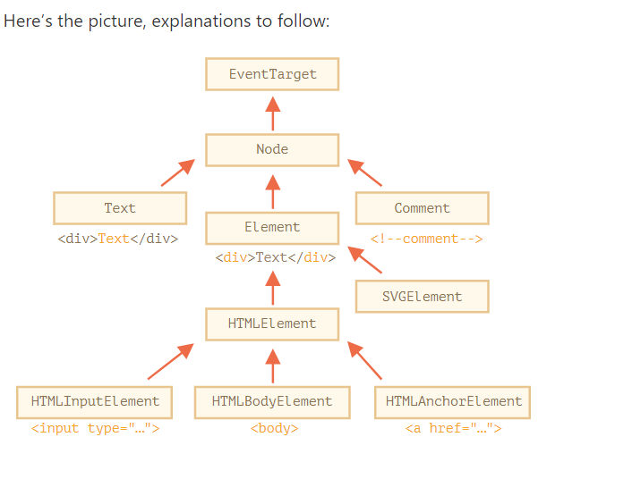

The classes are:
- EventTarget – is the root “abstract” class. Objects of that class are never created. It serves as a base, so that all DOM nodes support so-called “events”, we’ll study them later.
- Node – is also an “abstract” class, serving as a base for DOM nodes. It provides the core tree functionality: parentNode, nextSibling, childNodes and so on (they are getters). Objects of Node class are never created. But there are concrete node classes that inherit from it, namely: Text for text nodes, Element for element nodes and more exotic ones like Comment for comment nodes.
- Element – is a base class for DOM elements. It provides element-level navigation like nextElementSibling, children and searching methods like getElementsByTagName, querySelector. A browser supports not only HTML, but also XML and SVG. The Element class serves as a base for more specific classes: SVGElement, XMLElement and HTMLElement.
- HTMLElement – is finally the basic class for all HTML elements. It is inherited by concrete HTML elements:
  - HTMLInputElement – the class for <input> elements,
  - HTMLBodyElement – the class for <body> elements,
  - HTMLAnchorElement – the class for <a> elements,
  - …and so on, each tag has its own class that may provide specific properties and methods.
So, the full set of properties and methods of a given node comes as the result of the inheritance.
For example, let’s consider the DOM object for an <input> element. It belongs to HTMLInputElement class.
It gets properties and methods as a superposition of (listed in inheritance order):
- HTMLInputElement – this class provides input-specific properties,
- HTMLElement – it provides common HTML element methods (and getters/setters),
- Element – provides generic element methods,
- Node – provides common DOM node properties,
- EventTarget – gives the support for events (to be covered),
- …and finally it inherits from Object, so “plain object” methods like hasOwnProperty are also available.
To see the DOM node class name, we can recall that an object usually has the constructor property. It references the class constructor, and constructor.name is its name:
alert( document.body.constructor.name ); // HTMLBodyElement
…Or we can just toString it:
alert( document.body ); // [object HTMLBodyElement]
We also can use instanceof to check the inheritance:
As we can see, DOM nodes are regular JavaScript objects. They use prototype-based classes for inheritance.
That’s also easy to see by outputting an element with console.dir(elem) in a browser. There in the console you can see HTMLElement.prototype, Element.prototype and so on.
console.dir(elem) versus console.log(elem)
Most browsers support two commands in their developer tools: console.log and console.dir. They output their arguments to the console. For JavaScript objects these commands usually do the same.
But for DOM elements they are different:
- console.log(elem) shows the element DOM tree.
- console.dir(elem) shows the element as a DOM object, good to explore its properties.

In the specification, DOM classes aren’t described by using JavaScript, but a special Interface description language (IDL), that is usually easy to understand.
In IDL all properties are prepended with their types. For instance, DOMString, boolean and so on.
Here’s an excerpt from it, with comments:

// Define HTMLInputElement
// The colon ":" means that HTMLInputElement inherits from HTMLElement
interface HTMLInputElement: HTMLElement {
// here go properties and methods of <input> elements

// "DOMString" means that the value of a property is a string
attribute DOMString accept;
attribute DOMString alt;
attribute DOMString autocomplete;
attribute DOMString value;

// boolean value property (true/false)
attribute boolean autofocus;
...
// now the method: "void" means that the method returns no value
void select();
...
}

The nodeType property provides one more, “old-fashioned” way to get the “type” of a DOM node.
It has a numeric value:
- elem.nodeType == 1 for element nodes,
- elem.nodeType == 3 for text nodes,
- elem.nodeType == 9 for the document object,
°,,,,,ect

In modern scripts, we can use instanceof and other class-based tests to see the node type, but sometimes nodeType may be simpler.

Given a DOM node, we can read its tag name from nodeName or tagName properties:
the difference is reflected in their names, but is indeed a bit subtle.
- The tagName property exists only for Element nodes.
- The nodeName is defined for any Node:
  - for elements it means the same as tagName.
  - for other node types (text, comment, etc.) it has a string with the node type.
The browser has two modes of processing documents: HTML and XML. Usually the HTML-mode is used for webpages. XML-mode is enabled when the browser receives an XML-document with the header: Content-Type: application/xml+xhtml.
The tag name is always uppercase except in XML mode
The browser has two modes of processing documents: HTML and XML. Usually the HTML-mode is used for webpages. XML-mode is enabled when the browser receives an XML-document with the header: Content-Type: application/xml+xhtml.
In HTML mode tagName/nodeName is always uppercased: it’s BODY either for <body> or <BoDy>.
In XML mode the case is kept “as is”. Nowadays XML mode is rarely used.

The innerHTML property allows to get the HTML inside the element as a string.
We can also modify it. So it’s one of the most powerful ways to change the page.
The example shows the contents of document.body and then replaces it completely:
document.body.innerHTML = 'The new BODY!'; // replace it
We can try to insert invalid HTML, the browser will fix our errors
If innerHTML inserts a <script> tag into the document – it becomes a part of HTML, but doesn’t execute.
We can append HTML to an element by using elem.innerHTML+="more html".
But we should be very careful about doing it, because what’s going on is not an addition, but a full overwrite.
In other words, innerHTML+= does this:
- The old contents is removed.
- The new innerHTML is written instead (a concatenation of the old and the new one).
As the content is “zeroed-out” and rewritten from the scratch, all images and other resources will be reloaded.
(reload all ressource : image , gif ,,,,)
There are other side-effects as well. For instance, if the existing text was selected with the mouse, then most browsers will remove the selection upon rewriting innerHTML. And if there was an <input> with a text entered by the visitor, then the text will be removed. And so on.

Luckily, there are other ways to add HTML besides innerHTML, and we’ll study them soon.

The outerHTML property contains the full HTML of the element. That’s like innerHTML plus the element itself.

Beware: unlike innerHTML, writing to outerHTML does not change the element. Instead, it replaces it in the DOM.

<div>Hello, world!</div>

<script>
let div = document.querySelector('div');

// replace div.outerHTML with <p>...</p>
div.outerHTML = '<p>A new element</p>'; // (*)

// Wow! 'div' is still the same!
alert(div.outerHTML); // <div>Hello, world!</div> (**)
</script>

The outerHTML assignment does not modify the DOM element (the object referenced by, in this case, the variable ‘div’), but removes it from the DOM and inserts the new HTML in its place.

div still has its old value. The new HTML wasn’t saved to any variable. We can get references to the new elements by querying the DOM.

The innerHTML property is only valid for element nodes.
Other node types, such as text nodes, have their counterpart: nodeValue and data properties. These two are almost the same for practical use, there are only minor specification differences.
An example of reading the content of a text node alert(text.data); // Hello
The textContent provides access to the text inside the element: only text, minus all <tags>.
<div id="news">
<h1>Headline!</h1>
<p>Martians attack people!</p>
</div>

<script>
// Headline! Martians attack people!
alert(news.textContent);
</script>

Writing to textContent is much more useful, because it allows to write text the “safe way”.
Let’s say we have an arbitrary string, for instance entered by a user, and want to show it.
- With innerHTML we’ll have it inserted “as HTML”, with all HTML tags. (insertion code)
- With textContent we’ll have it inserted “as text”, all symbols are treated literally.
The “hidden” attribute and the DOM property specifies whether the element is visible or not.
We can use it in HTML or assign using JavaScript, like this:
<div>Both divs below are hidden</div>

<div hidden>With the attribute "hidden"</div>

<div id="elem">JavaScript assigned the property "hidden"</div>

<script>
elem.hidden = true;
</script>
Technically, hidden works the same as style="display:none". But it’s shorter to write.
Here’s a blinking element:
<div id="elem">A blinking element</div>

<script>
setInterval(() => elem.hidden = !elem.hidden, 1000);
</script>

DOM elements also have additional properties, in particular those that depend on the class:
- value – the value for <input>, <select> and <textarea> (HTMLInputElement, HTMLSelectElement…).
- href – the “href” for <a href="..."> (HTMLAnchorElement).
- id – the value of “id” attribute, for all elements (HTMLElement).
- …and much more…
For instance:
<input type="text" id="elem" value="value">

<script>
alert(elem.type); // "text"
alert(elem.id); // "elem"
alert(elem.value); // value
</script>

Or if we’d like to get them fast or are interested in a concrete browser specification – we can always output the element using console.dir(elem) and read the properties. Or explore “DOM properties” in the Elements tab of the browser developer tools.

When the browser loads the page, it “reads” (another word: “parses”) the HTML and generates DOM objects from it. For element nodes, most standard HTML attributes automatically become properties of DOM objects.
For instance, if the tag is <body id="page">, then the DOM object has body.id="page".
We’ve already seen built-in DOM properties. There are a lot. But technically no one limits us, and if there aren’t enough, we can add our own.
DOM nodes are regular JavaScript objects. We can alter them.
For instance, let’s create a new property in document.body:
document.body.myData = {
name: 'Caesar',
title: 'Imperator'
};
We can add a method as well:

document.body.sayTagName = function() {
alert(this.tagName);
};
We can also modify built-in prototypes like Element.prototype and add new methods to all elements:

Element.prototype.sayHi = function() {
alert(`Hello, I'm ${this.tagName}`);
};

When an element has id or another standard attribute, the corresponding property gets created. But that doesn’t happen if the attribute is non-standar
So, if an attribute is non-standard, there won’t be a DOM-property for it. Is there a way to access such attributes?
Sure. All attributes are accessible by using the following methods:
- elem.hasAttribute(name) – checks for existence.
- elem.getAttribute(name) – gets the value.
- elem.setAttribute(name, value) – sets the value.
- elem.removeAttribute(name) – removes the attribute.
Also one can read all attributes using elem.attributes: a collection of objects that belong to a built-in Attr class, with name and value properties.
Here’s a demo of reading a non-standard property:

<body something="non-standard">
<script>
alert(document.body.getAttribute('something')); // non-standard
</script>
</body>

attribute names are case-insensitive.
We can assign anything to an attribute, but it becomes a string. So here we have "123" as the value.
All attributes including ones that we set are visible in outerHTML.
The attributes collection is iterable and has all the attributes of the element (standard and non-standard) as objects with name and value properties.
When a standard attribute changes, the corresponding property is auto-updated, and (with some exceptions) vice versa.
<input>

<script>
let input = document.querySelector('input');

// attribute => property
input.setAttribute('id', 'id');
alert(input.id); // id (updated)

// property => attribute
input.id = 'newId';
alert(input.getAttribute('id')); // newId (updated)
</script>

But there are exclusions, for instance input.value synchronizes only from attribute → to property, but not
DOM properties are not always strings. For instance, the input.checked property (for checkboxes) is a boolean
There are other examples. The style attribute is a string, but the style property is an object
Most properties are strings though.

Quite rarely, even if a DOM property type is a string, it may differ from the attribute. For instance, the href DOM property is always a full URL, even if the attribute contains a relative URL or just a #hash.

Sometimes non-standard attributes are used to pass custom data from HTML to JavaScript, or to “mark” HTML-elements for JavaScript.
Like this:

<!-- mark the div to show "name" here -->
<div show-info="name"></div>
<!-- and age here -->
<div show-info="age"></div>

<script>
// the code finds an element with the mark and shows what's requested
let user = {
name: "Pete",
age: 25
};

for(let div of document.querySelectorAll('[show-info]')) {
// insert the corresponding info into the field
let field = div.getAttribute('show-info');
div.innerHTML = user[field]; // first Pete into "name", then 25 into "age"
}
</script>
Also they can be used to style an element.
For instance, here for the order state the attribute order-state is used:
<style>
/* styles rely on the custom attribute "order-state" */
.order[order-state="new"] {
color: green;
}

.order[order-state="pending"] {
color: blue;
}

.order[order-state="canceled"] {
color: red;
}
</style>

<div class="order" order-state="new">
A new order.
</div>

<div class="order" order-state="pending">
A pending order.
</div>

<div class="order" order-state="canceled">
A canceled order.
</div>
Why would using an attribute be preferable to having classes like .order-state-new, .order-state-pending, order-state-canceled?
Because an attribute is more convenient to manage. The state can be changed as easy as:
// a bit simpler than removing old/adding a new class
div.setAttribute('order-state', 'canceled');
But there may be a possible problem with custom attributes. What if we use a non-standard attribute for our purposes and later the standard introduces it and makes it do something? The HTML language is alive, it grows, and more attributes appear to suit the needs of developers. There may be unexpected effects in such case.
To avoid conflicts, there exist data-* attributes.
All attributes starting with “data-” are reserved for programmers’ use. They are available in the dataset property.
For instance, if an elem has an attribute named "data-about", it’s available as elem.dataset.about.
Like this:
<body data-about="Elephants">
<script>
alert(document.body.dataset.about); // Elephants
</script>
Multiword attributes like data-order-state become camel-cased: dataset.orderState.
Here’s a rewritten “order state” example:
<style>
.order[data-order-state="new"] {
color: green;
}

.order[data-order-state="pending"] {
color: blue;
}

.order[data-order-state="canceled"] {
color: red;
}
</style>

<div id="order" class="order" data-order-state="new">
A new order.
</div>

<script>
// read
alert(order.dataset.orderState); // new

// modify
order.dataset.orderState = "pending"; // (*)
</script>
Using data-* attributes is a valid, safe way to pass custom data.
Please note that we can not only read, but also modify data-attributes. Then CSS updates the view accordingly: in the example above the last line (*) changes the color to blue.

DOM modification is the key to creating “live” pages.
Here we’ll see how to create new elements “on the fly” and modify the existing page content.
To create DOM nodes, there are two methods:
document.createElement(tag)
Creates a new element node with the given tag:
let div = document.createElement('div');
document.createTextNode(text)
Creates a new text node with the given text:
let textNode = document.createTextNode('Here I am');
In our case the message is a div with alert class and the HTML in it:
let div = document.createElement('div');
div.className = "alert";
div.innerHTML = "<strong>Hi there!</strong> You've read an important message.";

We created the element, but as of now it’s only in a variable. We can’t see the element on the page, as it’s not yet a part of the document.

Insertion methods
To make the div show up, we need to insert it somewhere into document. For instance, in document.body.
There’s a special method append for that: document.body.append(div).
This set of methods provides more ways to insert:
- node.append(...nodes or strings) – append nodes or strings at the end of node,
- node.prepend(...nodes or strings) – insert nodes or strings at the beginning of node,
- node.before(...nodes or strings) –- insert nodes or strings before node,
- node.after(...nodes or strings) –- insert nodes or strings after node,
- node.replaceWith(...nodes or strings) –- replaces node with the given nodes or strings.
But what if we want to insert HTML “as html”, with all tags and stuff working, like elem.innerHTML?

insertAdjacentHTML/Text/Element
For that we can use another, pretty versatile method: elem.insertAdjacentHTML(where, html).
The first parameter is a code word, specifying where to insert relative to elem. Must be one of the following:
- "beforebegin" – insert html immediately before elem,
- "afterbegin" – insert html into elem, at the beginning,
- "beforeend" – insert html into elem, at the end,
- "afterend" – insert html immediately after elem.
The second parameter is an HTML string, that is inserted “as HTML”.
The method has two brothers:
- elem.insertAdjacentText(where, text) – the same syntax, but a string of text is inserted “as text” instead of HTML,
- elem.insertAdjacentElement(where, elem) – the same syntax, but inserts an element.
They exist mainly to make the syntax “uniform”. In practice, only insertAdjacentHTML is used most of the time. Because for elements and text, we have methods append/prepend/before/after – they are shorter to write and can insert nodes/text pieces.

Node removal
To remove a node, there’s a method node.remove().
Please note: if we want to move an element to another place – there’s no need to remove it from the old one.
All insertion methods automatically remove the node from the old place.
We could make a function and put the code there. But the alternative way would be to clone the existing div and modify the text inside it (if needed).
Sometimes when we have a big element, that may be faster and simpler.
- The call elem.cloneNode(true) creates a “deep” clone of the element – with all attributes and subelements. If we call elem.cloneNode(false), then the clone is made without child elements.
An example of copying the message:

<style>
.alert {
padding: 15px;
border: 1px solid #d6e9c6;
border-radius: 4px;
color: #3c763d;
background-color: #dff0d8;
}
</style>

<div class="alert" id="div">
<strong>Hi there!</strong> You've read an important message.
</div>

<script>
let div2 = div.cloneNode(true); // clone the message
div2.querySelector('strong').innerHTML = 'Bye there!'; // change the clone

div.after(div2); // show the clone after the existing div
</script>

DocumentFragment is a special DOM node that serves as a wrapper to pass around lists of nodes.
We can append other nodes to it, but when we insert it somewhere, then its content is inserted instead.
For example, getListContent below generates a fragment with <li> items, that are later inserted into <ul>:

<ul id="ul"></ul>

<script>
function getListContent() {
let fragment = new DocumentFragment();

for(let i=1; i<=3; i++) {
let li = document.createElement('li');
li.append(i);
fragment.append(li);
}

return fragment;
}

ul.append(getListContent()); // (*)
</script>
Please note, at the last line (*) we append DocumentFragment, but it “blends in”, so the resulting structure will be:
<ul>
<li>1</li>
<li>2</li>
<li>3</li>
</ul>

PAS COMRPIS
DocumentFragment is rarely used explicitly. Why append to a special kind of node, if we can return an array of nodes instead? Rewritten example:

<ul id="ul"></ul>

<script>
function getListContent() {
let result = [];

for(let i=1; i<=3; i++) {
let li = document.createElement('li');
li.append(i);
result.push(li);
}

return result;
}

ul.append(...getListContent()); // append + "..." operator = friends!
</script>

There are also “old school” DOM manipulation methods, existing for historical reasons.
These methods come from really ancient times. Nowadays, there’s no reason to use them, as modern methods, such as append, prepend, before, after, remove, replaceWith, are more flexible.
The only reason we list these methods here is that you can find them in many old scripts:
parentElem.appendChild(node)
Appends node as the last child of parentElem.
parentElem.insertBefore(node, nextSibling)
Inserts node before nextSibling into parentElem.
o insert newLi as the first element, we can do it like this:
list.insertBefore(newLi, list.firstChild);
parentElem.replaceChild(node, oldChild)
Replaces oldChild with node among children of parentElem.
parentElem.removeChild(node)
Removes node from parentElem (assuming node is its child).
All these methods return the inserted/removed node. In other words, parentElem.appendChild(node) returns node. But usually the returned value is not used, we just run the method. *There’s one more, very ancient method of adding something to a web-page: document.write.
The syntax:

<p>Somewhere in the page...</p>
<script>
document.write('<b>Hello from JS</b>');
</script>
<p>The end</p>
The call to document.write(html) writes the html into page “right here and now”. The html string can be dynamically generated, so it’s kind of flexible. We can use JavaScript to create a full-fledged webpage and write it.
The method comes from times when there was no DOM, no standards… Really old times. It still lives, because there are scripts using it.
In modern scripts we can rarely see it, because of the following important limitation:
The call to document.write only works while the page is loading.
If we call it afterwards, the existing document content is erased.
For instance:
<p>After one second the contents of this page will be replaced...</p>
<script>
// document.write after 1 second
// that's after the page loaded, so it erases the existing content
setTimeout(() => document.write('<b>...By this.</b>'), 1000);
</script>
So it’s kind of unusable at “after loaded” stage, unlike other DOM methods we covered above.
That’s the downside.
There’s an upside also. Technically, when document.write is called while the browser is reading (“parsing”) incoming HTML, and it writes something, the browser consumes it just as if it were initially there, in the HTML text.
So it works blazingly fast, because there’s no DOM modification involved. It writes directly into the page text, while the DOM is not yet built.
So if we need to add a lot of text into HTML dynamically, and we’re at page loading phase, and the speed matters, it may help. But in practice these requirements rarely come together. And usually we can see this method in scripts just because they are old.
There are generally two ways to style an element:
- Create a class in CSS and add it: <div class="...">
- Write properties directly into style: <div style="...">.
JavaScript can modify both classes and style properties.
We should always prefer CSS classes to style. The latter should only be used if classes “can’t handle it”.
For example, style is acceptable if we calculate coordinates of an element dynamically and want to set them from JavaScript, like this:
let top = /* complex calculations */;
let left = /* complex calculations */;

elem.style.left = left; // e.g '123px', calculated at run-time
elem.style.top = top; // e.g '456px'
For other cases, like making the text red, adding a background icon – describe that in CSS and then add the class (JavaScript can do that). That’s more flexible and easier to support.
In the ancient time, there was a limitation in JavaScript: a reserved word like "class" could not be an object property. That limitation does not exist now, but at that time it was impossible to have a "class" property, like elem.class.
So for classes the similar-looking property "className" was introduced: the elem.className corresponds to the "class" attribute.

For instance:
<body class="main page">
<script>
alert(document.body.className); // main page
</script>
</body>

If we assign something to elem.className, it replaces the whole string of classes.
There’s another property for that: elem.classList.
The elem.classList is a special object with methods to add/remove/toggle a single class.
For instance:

<body class="main page">
<script>
// add a class
document.body.classList.add('article');

alert(document.body.className); // main page article
</script>
</body>
So we can operate both on the full class string using className or on individual classes using classList. What we choose depends on our needs.
Methods of classList:
- elem.classList.add/remove("class") – adds/removes the class.
- elem.classList.toggle("class") – adds the class if it doesn’t exist, otherwise removes it.
- elem.classList.contains("class") – checks for the given class, returns true/false.
Besides, classList is iterable, so we can list all classes with for..of, like this:
<body class="main page">
<script>
for (let name of document.body.classList) {
alert(name); // main, and then page
}
</script>
</body>
The property elem.style is an object that corresponds to what’s written in the "style" attribute. Setting elem.style.width="100px" works the same as if we had in the attribute style a string width:100px.
For multi-word property the camelCase is used:
background-color => elem.style.backgroundColor
z-index => elem.style.zIndex
border-left-width => elem.style.borderLeftWidth
Browser-prefixed properties like -moz-border-radius, -webkit-border-radius also follow the same rule: a dash means upper case.

// if we run this code, the <body> will blink
document.body.style.display = "none"; // hide

setTimeout(() => document.body.style.display = "", 1000); // back to normal
If we set style.display to an empty string, then the browser applies CSS classes and its built-in styles normally, as if there were no such style.display property at all.
Normally, we use style.* to assign individual style properties. We can’t set the full style like div.style="color: red; width: 100px", because div.style is an object, and it’s read-only.
To set the full style as a string, there’s a special property style.cssText:
<div id="div">Button</div>

<script>
// we can set special style flags like "important" here
div.style.cssText=`color: red !important;
background-color: yellow;
width: 100px;
text-align: center;
`;

alert(div.style.cssText);
</script>
This property is rarely used, because such assignment removes all existing styles: it does not add, but replaces them.
The style property operates only on the value of the "style" attribute, without any CSS cascade.
So we can’t read anything that comes from CSS classes using elem.style.
There’s another method for that: getComputedStyle.
The syntax is:
getComputedStyle(element, [pseudo])
element
Element to read the value for.
pseudo
A pseudo-element if required, for instance ::before. An empty string or no argument means the element itself.
The result is an object with styles, like elem.style, but now with respect to all CSS classes.
For instance:
<head>
<style> body { color: red; margin: 5px } </style>
</head>
<body>

<script>
let computedStyle = getComputedStyle(document.body);

// now we can read the margin and the color from it

alert( computedStyle.marginTop ); // 5px
alert( computedStyle.color ); // rgb(255, 0, 0)
</script>

</body>
*There are two concepts in CSS:
- A computed style value is the value after all CSS rules and CSS inheritance is applied, as the result of the CSS cascade. It can look like height:1em or font-size:125%.
- A resolved style value is the one finally applied to the element. Values like 1em or 125% are relative. The browser takes the computed value and makes all units fixed and absolute, for instance: height:20px or font-size:16px. For geometry properties resolved values may have a floating point, like width:50.5px.
A long time ago getComputedStyle was created to get computed values, but it turned out that resolved values are much more convenient, and the standard changed.
So nowadays getComputedStyle actually returns the resolved value of the property, usually in px for geometry.
Visited links may be colored using :visited CSS pseudoclass.
But getComputedStyle does not give access to that color, because otherwise an arbitrary page could find out whether the user visited a link by creating it on the page and checking the styles.
JavaScript may not see the styles applied by :visited. And also, there’s a limitation in CSS that forbids applying geometry-changing styles in :visited. That’s to guarantee that there’s no side way for an evil page to test if a link was visited and hence to break the privacy.

An event is a signal that something has happened. All DOM nodes generate such signals (but events are not limited to DOM).
Mouse events:
- click – when the mouse clicks on an element (touchscreen devices generate it on a tap).
- contextmenu – when the mouse right-clicks on an element.
- mouseover / mouseout – when the mouse cursor comes over / leaves an element.
- mousedown / mouseup – when the mouse button is pressed / released over an element.
- mousemove – when the mouse is moved.
Keyboard events:
- keydown and keyup – when a keyboard key is pressed and released.
Form element events:
- submit – when the visitor submits a <form>.
- focus – when the visitor focuses on an element, e.g. on an <input>.
Document events:
- DOMContentLoaded – when the HTML is loaded and processed, DOM is fully built.
CSS events:
- transitionend – when a CSS-animation finishes.
To react on events we can assign a handler – a function that runs in case of an event.
A handler can be set in HTML with an attribute named on<event>.
For instance, to assign a click handler for an input, we can use onclick, like here:
<input value="Click me" onclick="alert('Click!')" type="button">
On mouse click, the code inside onclick runs.
Please note that inside onclick we use single quotes, because the attribute itself is in double quotes
An HTML-attribute is not a convenient place to write a lot of code, so we’d better create a JavaScript function and call it there.
Here a click runs the function countRabbits():
<script>
function countRabbits() {
for(let i=1; i<=3; i++) {
alert("Rabbit number " + i);
}
}
</script>

<input type="button" onclick="countRabbits()" value="Count rabbits!">

HTML attribute names are not case-sensitive, so ONCLICK
We can assign a handler using a DOM property on<event>.
If the handler is assigned using an HTML-attribute then the browser reads it, creates a new function from the attribute content and writes it to the DOM property.
These two code pieces work the same:
- Only HTML:
<input type="button" onclick="alert('Click!')" value="Button">

- HTML + JS:

<input type="button" id="button" value="Button">
<script>
button.onclick = function() {
alert('Click!');
};
</script>

In the first example, the HTML attribute is used to initialize the button.onclick, while in the second example – the script, that’s all the difference.
As there’s only one onclick property, we can’t assign more than one event handler.
To remove a handler – assign elem.onclick = null.

The value of this inside a handler is the element. The one which has the handler on it.
In the code below button shows its contents using this.innerHTML:
<button onclick="alert(this.innerHTML)">Click me</button>

If you’re starting to work with events – please note some subtleties.
We can set an existing function as a handler:
function sayThanks() {
alert('Thanks!');
}

elem.onclick = sayThanks;
But be careful: the function should be assigned as sayThanks, not sayThanks().
Sinon function call donc prend result et assign a event
…On the other hand, in the markup we do need the parentheses:
<input type="button" id="button" onclick="sayThanks()">

The difference is easy to explain. When the browser reads the attribute, it creates a handler function with body from the attribute content.
So the markup generates this property:

button.onclick = function() {
sayThanks(); // <-- the attribute content goes here
};

Don’t use setAttribute for handlers.
Such a call won’t work:
// a click on <body> will generate errors,
// because attributes are always strings, function becomes a string
document.body.setAttribute('onclick', function() { alert(1) });
DOM-property case matters.
Assign a handler to elem.onclick, not elem.ONCLICK, because DOM properties are case-sensitive.
special methods addEventListener and removeEventListener. They are free of such a problem.
The syntax to add a handler:
element.addEventListener(event, handler, [options]);
event
Event name, e.g. "click".
handler
The handler function.
options
An additional optional object with properties:
- once: if true, then the listener is automatically removed after it triggers.
- capture: the phase where to handle the event, to be covered later in the chapter Bubbling and capturing. For historical reasons, options can also be false/true, that’s the same as {capture: false/true}.
- passive: if true, then the handler will not call preventDefault(), we’ll explain that later in Browser default actions.
To remove the handler, use removeEventListener:
element.removeEventListener(event, handler, [options]);

To remove a handler we should pass exactly the same function as was assigned.
Please note – if we don’t store the function in a variable, then we can’t remove it. There’s no way to “read back” handlers assigned by addEventListener.

elem.onclick = () => alert("Hello");
elem.addEventListener("click", handler1); // Thanks!
elem.addEventListener("click", handler2); // Thanks again!
</script>
As we can see in the example above, we can set handlers both using a DOM-property and addEventListener.
There exist events that can’t be assigned via a DOM-property. Only with addEventListener.
For instance, the DOMContentLoaded event, that triggers when the document is loaded and DOM is built.
// will never run
document.onDOMContentLoaded = function() {
alert("DOM built");
};
// this way it works
document.addEventListener("DOMContentLoaded", function() {
alert("DOM built");
});
So addEventListener is more universal. Although, such events are an exception rather than the rule.
When an event happens, the browser creates an event object, puts details into it and passes it as an argument to the handler.
Here’s an example of getting pointer coordinates from the event object:

<input type="button" value="Click me" id="elem">

<script>
elem.onclick = function(event) {
// show event type, element and coordinates of the click
alert(event.type + " at " + event.currentTarget);
alert("Coordinates: " + event.clientX + ":" + event.clientY);
};
</script>
Some properties of event object:
event.type
Event type, here it’s "click".
event.currentTarget
Element that handled the event. That’s exactly the same as this, unless the handler is an arrow function, or its this is bound to something else, then we can get the element from event.currentTarget.
event.clientX / event.clientY
Window-relative coordinates of the cursor, for pointer events.
There are more properties. Many of them depend on the event type: keyboard events have one set of properties, pointer events – another one, we’ll study them later when we come to different events in details.
If we assign a handler in HTML, we can also use the event object, like this:
<input type="button" onclick="alert(event.type)" value="Event type">

That’s possible because when the browser reads the attribute, it creates a handler like this: function(event) { alert(event.type) }. That is: its first argument is called "event", and the body is taken from the attribute.

We can assign not just a function, but an object as an event handler using addEventListener. When an event occurs, its handleEvent method is called.
For instance:
<button id="elem">Click me</button>

<script>
let obj = {
handleEvent(event) {
alert(event.type + " at " + event.currentTarget);
}
};

elem.addEventListener('click', obj);
</script>
As we can see, when addEventListener receives an object as the handler, it calls obj.handleEvent(event) in case of an event.
We could also use a class for that:

<button id="elem">Click me</button>

<script>
class Menu {
handleEvent(event) {
switch(event.type) {
case 'mousedown':
elem.innerHTML = "Mouse button pressed";
break;
case 'mouseup':
elem.innerHTML += "...and released.";
break;
}
}
}

let menu = new Menu();
elem.addEventListener('mousedown', menu);
elem.addEventListener('mouseup', menu);
</script>
Here the same object handles both events. Please note that we need to explicitly setup the events to listen using addEventListener. The menu object only gets mousedown and mouseup here, not any other types of events.
The method handleEvent does not have to do all the job by itself. It can call other event-specific methods instead, like this:
<button id="elem">Click me</button>

<script>
class Menu {
handleEvent(event) {
// mousedown -> onMousedown
let method = 'on' + event.type[0].toUpperCase() + event.type.slice(1);
this[method](event);
}

onMousedown() {
elem.innerHTML = "Mouse button pressed";
}

onMouseup() {
elem.innerHTML += "...and released.";
}
}

let menu = new Menu();
elem.addEventListener('mousedown', menu);
elem.addEventListener('mouseup', menu);
</script>

The bubbling principle is simple.
When an event happens on an element, it first runs the handlers on it, then on its parent, then all the way up on other ancestors.
The process is called “bubbling”, because events “bubble” from the inner element up through parents like a bubble in the water.
The key word in this phrase is “almost”.
For instance, a focus event does not bubble. There are other examples too, we’ll meet them. But still it’s an exception, rather than a rule, most events do bubble.
The most deeply nested element that caused the event is called a target element, accessible as event.target.
Note the differences from this (=event.currentTarget):
- event.target – is the “target” element that initiated the event, it doesn’t change through the bubbling process.
- this – is the “current” element, the one that has a currently running handler on it.
A bubbling event goes from the target element straight up. Normally it goes upwards till <html>, and then to document object, and some events even reach window, calling all handlers on the path.
But any handler may decide that the event has been fully processed and stop the bubbling.
The method for it is event.stopPropagation().
For instance, here body.onclick doesn’t work if you click on <button>:
<body onclick="alert(`the bubbling doesn't reach here`)">
<button onclick="event.stopPropagation()">Click me</button>
</body>

If an element has multiple event handlers on a single event, then even if one of them stops the bubbling, the other ones still execute.
In other words, event.stopPropagation() stops the move upwards, but on the current element all other handlers will run.
To stop the bubbling and prevent handlers on the current element from running, there’s a method event.stopImmediatePropagation(). After it no other handlers execute.

Bubbling is convenient. Don’t stop it without a real need: obvious and architecturally well thought out.
Sometimes event.stopPropagation() creates hidden pitfalls that later may become problems.
For instance:
- We create a nested menu. Each submenu handles clicks on its elements and calls stopPropagation so that the outer menu won’t trigger.
- Later we decide to catch clicks on the whole window, to track users’ behavior (where people click). Some analytic systems do that. Usually the code uses document.addEventListener('click'…) to catch all clicks.
- Our analytic won’t work over the area where clicks are stopped by stopPropagation. Sadly, we’ve got a “dead zone”.
There’s usually no real need to prevent the bubbling. A task that seemingly requires that may be solved by other means. One of them is to use custom events, we’ll cover them later. Also we can write our data into the event object in one handler and read it in another one, so we can pass to handlers on parents information about the processing below.
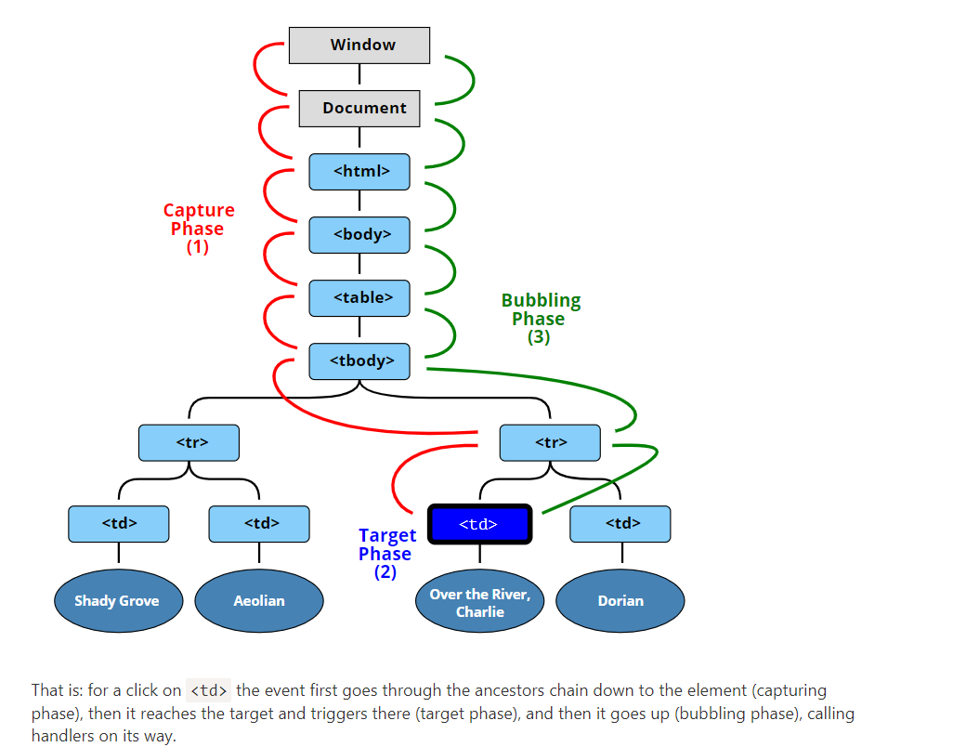
Before we only talked about bubbling, because the capturing phase is rarely used. Normally it is invisible to us.
To catch an event on the capturing phase, we need to set the handler capture option to true:
elem.addEventListener(..., {capture: true})
// or, just "true" is an alias to {capture: true}
elem.addEventListener(..., true)
There are two possible values of the capture option:
- If it’s false (default), then the handler is set on the bubbling phase.
- If it’s true, then the handler is set on the capturing phase.
PAS COMPRIS :
Note that while formally there are 3 phases, the 2nd phase (“target phase”: the event reached the element) is not handled separately: handlers on both capturing and bubbling phases trigger at that phase.
There’s a property event.eventPhase that tells us the number of the phase on which the event was caught.
If we addEventListener(..., true), then we should mention the same phase in removeEventListener(..., true) to correctly remove the handler.
If we have multiple event handlers on the same phase, assigned to the same element with addEventListener, they run in the same order as they are created:

Many events automatically lead to certain actions performed by the browser.
For instance:
- A click on a link – initiates navigation to its URL.
- A click on a form submit button – initiates its submission to the server.
- Pressing a mouse button over a text and moving it – selects the text.
If we handle an event in JavaScript, we may not want the corresponding browser action to happen, and want to implement another behavior instead.
There are two ways to tell the browser we don’t want it to act:
- The main way is to use the event object. There’s a method event.preventDefault().
- If the handler is assigned using on<event> (not by addEventListener), then returning false also works the same.
In this HTML a click on a link doesn’t lead to navigation, browser doesn’t do anything:
<a href="/" onclick="return false">Click here</a>
or
<a href="/" onclick="event.preventDefault()">here</a>

The value returned by an event handler is usually ignored.
The only exception is return false from a handler assigned using on<event>.
Certain events flow one into another. If we prevent the first event, there will be no second.
For instance, mousedown on an <input> field leads to focusing in it, and the focus event. If we prevent the mousedown event, there’s no focus.
<input value="Focus works" onfocus="this.value=''">
<input onmousedown="return false" onfocus="this.value=''" value="Click me">

That’s because the browser action is canceled on mousedown. The focusing is still possible if we use another way to enter the input. For instance, the Tab key to switch from the 1st input into the 2nd. But not with the mouse click any more.
The optional passive: true option of addEventListener signals the browser that the handler is not going to call preventDefault().
There are some events like touchmove on mobile devices (when the user moves their finger across the screen), that cause scrolling by default, but that scrolling can be prevented using preventDefault() in the handler.
The passive: true options tells the browser that the handler is not going to cancel scrolling. Then browser scrolls immediately providing a maximally fluent experience, and the event is handled by the way.
For some browsers (Firefox, Chrome), passive is true by default for touchstart and touchmove events.
The property event.defaultPrevented is true if the default action was prevented, and false otherwise.
Stop bubbling :
Sometimes we can use event.defaultPrevented instead, to signal other event handlers that the event was handled.

An alternative solution would be to check in the document handler if the default action was prevented? If it is so, then the event was handled, and we don’t need to react on it.

<p>Right-click for the document menu (added a check for event.defaultPrevented)</p>
<button id="elem">Right-click for the button menu</button>

<script>
elem.oncontextmenu = function(event) {
event.preventDefault();
alert("Button context menu");
};

document.oncontextmenu = function(event) {
if (event.defaultPrevented) return;

event.preventDefault();
alert("Document context menu");
};
</script>

We can generate not only completely new events, that we invent for our own purposes, but also built-in ones, such as click, mousedown etc. That may be helpful for automated testing.

Event constructor
Build-in event classes form a hierarchy, similar to DOM element classes. The root is the built-in Event class.
We can create Event objects like this:
let event = new Event(type[, options]);
Arguments:
- type – event type, a string like "click" or our own like "my-event".
- options – the object with two optional properties:
  - bubbles: true/false – if true, then the event bubbles.
  - cancelable: true/false – if true, then the “default action” may be prevented. Later we’ll see what it means for custom events.
By default both are false: {bubbles: false, cancelable: false}.

dispatchEvent
After an event object is created, we should “run” it on an element using the call elem.dispatchEvent(event).
There is a way to tell a “real” user event from a script-generated one.
The property event.isTrusted is true for events that come from real user actions and false for script-generated events.

We can create a bubbling event with the name "hello" and catch it on document.
All we need is to set bubbles to true:
Here’s a short list of classes for UI Events from the UI Event specification:
- UIEvent
- FocusEvent
- MouseEvent
- WheelEvent
- KeyboardEvent
- …
We should use them instead of new Event if we want to create such events. For instance, new MouseEvent("click").
The right constructor allows to specify standard properties for that type of event.
Like clientX/clientY for a mouse event:

let event = new MouseEvent("click", {
bubbles: true,
cancelable: true,
clientX: 100,
clientY: 100
});

alert(event.clientX); // 100
Please note: the generic Event constructor does not allow that.

For our own, completely new events types like "hello" we should use new CustomEvent. Technically CustomEvent is the same as Event, with one exception.
For our own, completely new events types like "hello" we should use new CustomEvent. Technically CustomEvent is the same as Event, with one exception.
In the second argument (object) we can add an additional property detail for any custom information that we want to pass with the event.

For instance:
<h1 id="elem">Hello for John!</h1>

<script>
// additional details come with the event to the handler
elem.addEventListener("hello", function(event) {
alert(event.detail.name);
});

elem.dispatchEvent(new CustomEvent("hello", {
detail: { name: "John" }
}));
</script>
The detail property can have any data. Technically we could live without, because we can assign any properties into a regular new Event object after its creation. But CustomEvent provides the special detail field for it to evade conflicts with other event properties.
or new, custom events, there are definitely no default browser actions, but a code that dispatches such event may have its own plans what to do after triggering the event.
By calling event.preventDefault(), an event handler may send a signal that those actions should be canceled.
In that case the call to elem.dispatchEvent(event) returns false. And the code that dispatched it knows that it shouldn’t continue.
<button onclick="hide()">Hide()</button>

<script>
// hide() will be called automatically in 2 seconds
function hide() {
let event = new CustomEvent("hide", {
cancelable: true // without that flag preventDefault doesn't work
});
if (!rabbit.dispatchEvent(event)) {
alert('The action was prevented by a handler');
} else {
rabbit.hidden = true;
}
}

rabbit.addEventListener('hide', function(event) {
if (confirm("Call preventDefault?")) {
event.preventDefault();
}
});
</script>

Please note: the event must have the flag cancelable: true, otherwise the call event.preventDefault() is ignored.

Usually events are processed in a queue. That is: if the browser is processing onclick and a new event occurs, e.g. mouse moved, then it’s handing is queued up, corresponding mousemove handlers will be called after onclick processing is finished.

The notable exception is when one event is initiated from within another one, e.g. using dispatchEvent. Such events are processed immediately: the new event handlers are called, and then the current event handling is resumed.
For instance, in the code below the menu-open event is triggered during the onclick.
It’s processed immediately, without waiting for onlick handler to end
That’s not only about dispatchEvent, there are other cases. If an event handler calls methods that trigger to other events – they are too processed synchronously, in a nested fashion.
Let’s say we don’t like it. We’d want onclick to be fully processed first, independently from menu-open or any other nested events.

It’s processed immediately, without waiting for onlick handler to end:
<button id="menu">Menu (click me)</button>

<script>
menu.onclick = function() {
alert(1);

menu.dispatchEvent(new CustomEvent("menu-open", {
bubbles: true
}));

alert(2);
};

// triggers between 1 and 2
document.addEventListener('menu-open', () => alert('nested'));
</script>
The output order is: 1 → nested → 2.
Then we can either put the dispatchEvent (or another event-triggering call) at the end of onclick or, maybe better, wrap it in the zero-delay setTimeout:
<button id="menu">Menu (click me)</button>

<script>
menu.onclick = function() {
alert(1);

setTimeout(() => menu.dispatchEvent(new CustomEvent("menu-open", {
bubbles: true
})));

alert(2);
};

document.addEventListener('menu-open', () => alert('nested'));
</script>
Now dispatchEvent runs asynchronously after the current code execution is finished, including mouse.onclick, so event handlers are totally separate.
The output order becomes: 1 → 2 → nested.

The lifecycle of an HTML page has three important events:
- DOMContentLoaded – the browser fully loaded HTML, and the DOM tree is built, but external resources like pictures <img> and stylesheets may be not yet loaded.
- load – not only HTML is loaded, but also all the external resources: images, styles etc.
- beforeunload/unload – the user is leaving the page.
Each event may be useful:
- DOMContentLoaded event – DOM is ready, so the handler can lookup DOM nodes, initialize the interface.
- load event – external resources are loaded, so styles are applied, image sizes are known etc.
- beforeunload event – the user is leaving: we can check if the user saved the changes and ask them whether they really want to leave.
- unload – the user almost left, but we still can initiate some operations, such as sending out statistics.
The DOMContentLoaded event happens on the document object.
We must use addEventListener to catch it:
document.addEventListener("DOMContentLoaded", ready);
// not "document.onDOMContentLoaded = ..."
For instance:
<script>
function ready() {
alert('DOM is ready');

// image is not yet loaded (unless was cached), so the size is 0x0
alert(`Image size: ${img.offsetWidth}x${img.offsetHeight}`);
}

document.addEventListener("DOMContentLoaded", ready);
</script>

<img id="img" src="https://en.js.cx/clipart/train.gif?speed=1&cache=0">
In the example the DOMContentLoaded handler runs when the document is loaded, so it can see all the elements, including <img> below.
But it doesn’t wait for the image to load.
So alert shows zero sizes.When the browser processes an HTML-document and comes across a <script> tag, it needs to execute before continuing building the DOM. That’s a precaution, as scripts may want to modify DOM, and even document.write into it, so DOMContentLoaded has to wait.

Scripts that don’t block DOMContentLoaded
There are two exceptions from this rule:
- Scripts with the async attribute, that we’ll cover a bit later, don’t block DOMContentLoaded.
- Scripts that are generated dynamically with document.createElement('script') and then added to the webpage also don’t block this event.
External style sheets don’t affect DOM, so DOMContentLoaded does not wait for them.
But there’s a pitfall. If we have a script after the style, then that script must wait until the stylesheet loads:
<link type="text/css" rel="stylesheet" href="style.css">
<script>
// the script doesn't not execute until the stylesheet is loaded
alert(getComputedStyle(document.body).marginTop);
</script>
The reason for this is that the script may want to get coordinates and other style-dependent properties of elements, like in the example above. Naturally, it has to wait for styles to load.
Firefox, Chrome and Opera autofill forms on DOMContentLoaded.
For instance, if the page has a form with login and password, and the browser remembered the values, then on DOMContentLoaded it may try to autofill them (if approved by the user).
So if DOMContentLoaded is postponed by long-loading scripts, then autofill also awaits
The load event on the window object triggers when the whole page is loaded including styles, images and other resources. This event is available via the onload property.
When a visitor leaves the page, the unload event triggers on window. We can do something there that doesn’t involve a delay, like closing related popup windows.
The notable exception is sending analytics.
There exists a special navigator.sendBeacon(url, data) method for such needs, described in the specification https://w3c.github.io/beacon/.
It sends the data in background. The transition to another page is not delayed: the browser leaves the page, but still performs sendBeacon.
Here’s how to use it:
let analyticsData = { /* object with gathered data */ };

window.addEventListener("unload", function() {
navigator.sendBeacon("/analytics", JSON.stringify(analyticsData));
};
- The request is sent as POST.
- We can send not only a string, but also forms and other formats, as described in the chapter Fetch, but usually it’s a stringified object.
- The data is limited by 64kb.
When the sendBeacon request is finished, the browser probably has already left the document, so there’s no way to get server response (which is usually empty for analytics).
There’s also a keepalive flag for doing such “after-page-left” requests in fetch method for generic network requests. You can find more information in the chapter Fetch API.
If we want to cancel the transition to another page, we can’t do it here. But we can use another event – onbeforeunload.
If a visitor initiated navigation away from the page or tries to close the window, the beforeunload handler asks for additional confirmation.
If we cancel the event, the browser may ask the visitor if they are sure.
window.onbeforeunload = function() {
return false;
};
For historical reasons, returning a non-empty string also counts as canceling the event. Some time ago browsers used to show it as a message, but as the modern specification says, they shouldn’t.
Here’s an example:
window.onbeforeunload = function() {
return "There are unsaved changes. Leave now?";
};
The behavior was changed, because some webmasters abused this event handler by showing misleading and annoying messages. So right now old browsers still may show it as a message, but aside of that – there’s no way to customize the message shown to the user.
What happens if we set the DOMContentLoaded handler after the document is loaded?
Naturally, it never runs.
There are cases when we are not sure whether the document is ready or not. We’d like our function to execute when the DOM is loaded, be it now or later.
The document.readyState property tells us about the current loading state.
There are 3 possible values:
- "loading" – the document is loading.
- "interactive" – the document was fully read.
- "complete" – the document was fully read and all resources (like images) are loaded too.
So we can check document.readyState and setup a handler or execute the code immediately if it’s ready.
There’s also the readystatechange event that triggers when the state changes, so we can print all these states like this:
// current state
console.log(document.readyState);

// print state changes
document.addEventListener('readystatechange', () => console.log(document.readyState));
The readystatechange event is an alternative mechanics of tracking the document loading state, it appeared long ago. Nowadays, it is rarely used.
Let’s see the full events flow for the completeness.
Here’s a document with <iframe>, <img> and handlers that log events:
<script>
log('initial readyState:' + document.readyState);

document.addEventListener('readystatechange', () => log('readyState:' + document.readyState));
document.addEventListener('DOMContentLoaded', () => log('DOMContentLoaded'));

window.onload = () => log('window onload');
</script>

<iframe src="iframe.html" onload="log('iframe onload')"></iframe>

<img src="http://en.js.cx/clipart/train.gif" id="img">
<script>
img.onload = () => log('img onload');
</script>
The working example is in the sandbox.
The typical output:
- [1] initial readyState:loading
- [2] readyState:interactive
- [2] DOMContentLoaded
- [3] iframe onload
- [4] img onload
- [4] readyState:complete
- [4] window onload
The numbers in square brackets denote the approximate time of when it happens. Events labeled with the same digit happen approximately at the same time (± a few ms).
- document.readyState becomes interactive right before DOMContentLoaded. These two things actually mean the same.
- document.readyState becomes complete when all resources (iframe and img) are loaded. Here we can see that it happens in about the same time as img.onload (img is the last resource) and window.onload. Switching to complete state means the same as window.onload. The difference is that window.onload always works after all other load handlers.
In modern websites, scripts are often “heavier” than HTML: their download size is larger, and processing time is also longer.
When the browser loads HTML and comes across a <script>...</script> tag, it can’t continue building the DOM. It must execute the script right now.
The same happens for external scripts <script src="..."></script>: the browser must wait until the script downloads, execute it, and only after process the rest of the page.
That leads to two important issues:
- Scripts can’t see DOM elements below them, so they can’t add handlers etc.
- If there’s a bulky script at the top of the page, it “blocks the page”. Users can’t see the page content till it downloads and runs:
The defer attribute tells the browser that it should go on working with the page, and load the script “in background”, then run the script when it loads.
- Scripts with defer never block the page.
- Scripts with defer always execute when the DOM is ready, but before DOMContentLoaded event.

Here’s the same example as above, but with defer:
<p>...content before scripts...</p>

<script>
document.addEventListener('DOMContentLoaded', () => alert("DOM ready after defer!")); // (2)
</script>

<script defer src="https://javascript.info/article/script-async-defer/long.js?speed=1"></script>

<p>...content after scripts...</p>
- The page content shows up immediately.
- DOMContentLoaded waits for the deferred script. It only triggers when the script (2) is downloaded and executed.
Deferred scripts keep their relative order, just like regular scripts.
So, if we have a long script first, and then a smaller one, then the latter one waits.
<script defer src="https://javascript.info/article/script-async-defer/long.js"></script>
<script defer src="https://javascript.info/article/script-async-defer/small.js"></script>
The small script downloads first, runs second
Browsers scan the page for scripts and download them in parallel, to improve performance. So in the example above both scripts download in parallel. The small.js probably makes it first.
But the specification requires scripts to execute in the document order, so it waits for long.js to execute.
The defer attribute is only for external scripts
The defer attribute is ignored if the <script> tag has no src.
The async attribute means that a script is completely independent:
- The page doesn’t wait for async scripts, the contents are processed and displayed.
- DOMContentLoaded and async scripts don’t wait for each other:
  - DOMContentLoaded may happen both before an async script (if an async script finishes loading after the page is complete)
  - …or after an async script (if an async script is short or was in HTTP-cache)
- Other scripts don’t wait for async scripts, and async scripts don’t wait for them.
So, if we have several async scripts, they may execute in any order. Whatever loads first – runs first:
<p>...content before scripts...</p>

<script>
document.addEventListener('DOMContentLoaded', () => alert("DOM ready!"));
</script>

<script async src="https://javascript.info/article/script-async-defer/long.js"></script>
<script async src="https://javascript.info/article/script-async-defer/small.js"></script>

<p>...content after scripts...</p>
- The page content shows up immediately: async doesn’t block it.
- DOMContentLoaded may happen both before and after async, no guarantees here.
- Async scripts don’t wait for each other. A smaller script small.js goes second, but probably loads before long.js, so runs first. That’s called a “load-first” order.
Async scripts are great when we integrate an independent third-party script into the page: counters, ads and so on, as they don’t depend on our scripts, and our scripts shouldn’t wait for them:
<!-- Google Analytics is usually added like this -->
<script async src="https://google-analytics.com/analytics.js"></script>
- We can also add a script dynamically using JavaScript:
let script = document.createElement('script');
script.src = "/article/script-async-defer/long.js";
document.body.append(script); // (*)
The script starts loading as soon as it’s appended to the document (*).
Dynamic scripts behave as “async” by default.
That is:
- They don’t wait for anything, nothing waits for them.
- The script that loads first – runs first (“load-first” order).

let script = document.createElement('script');
script.src = "/article/script-async-defer/long.js";

script.async = false;

document.body.append(script);
For example, here we add two scripts. Without script.async=false they would execute in load-first order (the small.js probably first). But with that flag the order is “as in the document”:
function loadScript(src) {
let script = document.createElement('script');
script.src = src;
script.async = false;
document.body.append(script);
}

// long.js runs first because of async=false
loadScript("/article/script-async-defer/long.js");
loadScript("/article/script-async-defer/small.js");
The browser allows us to track the loading of external resources – scripts, iframes, pictures and so on.
There are two events for it:
- onload – successful load,
- onerror – an error occurred.
Let’s say we need to load a third-party script and call a function that resides there.
We can load it dynamically, like this:
let script = document.createElement('script');
script.src = "my.js";

document.head.append(script);
…But how to run the function that is declared inside that script? We need to wait until the script loads, and only then we can call it.
Please note:
For our own scripts we could use JavaScript modules here, but they are not widely adopted by third-party libraries.

script.onload
The main helper is the load event. It triggers after the script was loaded and executed.
For instance:

let script = document.createElement('script');

// can load any script, from any domain
script.src = "https://cdnjs.cloudflare.com/ajax/libs/lodash.js/4.3.0/lodash.js"
document.head.append(script);

script.onload = function() {
// the script creates a helper function "_"
alert(_); // the function is available
};
So in onload we can use script variables, run functions etc.

script.onerror
Errors that occur during the loading of the script can be tracked in an error event.
For instance, let’s request a script that doesn’t exist:

let script = document.createElement('script');
script.src = "https://example.com/404.js"; // no such script
document.head.append(script);

script.onerror = function() {
alert("Error loading " + this.src); // Error loading https://example.com/404.js
};
Please note that we can’t get HTTP error details here. We don’t know if it was an error 404 or 500 or something else. Just that the loading failed.
Important:
Events onload/onerror track only the loading itself.
Errors that may occur during script processing and execution are out of scope for these events. That is: if a script loaded successfully, then onload triggers, even if it has programming errors in it. To track script errors, one can use window.onerror global handler.

Other resources
The load and error events also work for other resources, basically for any resource that has an external src.
For example:
let img = document.createElement('img');
img.src = "https://js.cx/clipart/train.gif"; // (*)

img.onload = function() {
alert(`Image loaded, size ${img.width}x${img.height}`);
};

img.onerror = function() {
alert("Error occurred while loading image");
};
There are some notes though:
- Most resources start loading when they are added to the document. But <img> is an exception. It starts loading when it gets a src (*).
- For <iframe>, the iframe.onload event triggers when the iframe loading finished, both for successful load and in case of an error.
That’s for historical reasons.
Or, to be more precise, one origin (domain/port/protocol triplet) can’t access the content from another one. So even if we have a subdomain, or just another port, these are different origins with no access to each other.
This rule also affects resources from other domains.
If we’re using a script from another domain, and there’s an error in it, we can’t get error details.
For example, let’s take a script error.js that consists of a single (bad) function call:
// 📁 error.js
noSuchFunction();
Now load it from the same site where it’s located:
<script>
window.onerror = function(message, url, line, col, errorObj) {
alert(`${message}\n${url}, ${line}:${col}`);
};
</script>
<script src="/article/onload-onerror/crossorigin/error.js"></script>
We can see a good error report, like this:
Uncaught ReferenceError: noSuchFunction is not defined
https://javascript.info/article/onload-onerror/crossorigin/error.js, 1:1
Now let’s load the same script from another domain:
<script>
window.onerror = function(message, url, line, col, errorObj) {
alert(`${message}\n${url}, ${line}:${col}`);
};
</script>
<script src="https://cors.javascript.info/article/onload-onerror/crossorigin/error.js"></script>
The report is different, like this:
Script error.
, 0:0
Details may vary depending on the browser, but the idea is the same: any information about the internals of a script, including error stack traces, is hidden. Exactly because it’s from another domain.
Why do we need error details?
There are many services (and we can build our own) that listen for global errors using window.onerror, save errors and provide an interface to access and analyze them. That’s great, as we can see real errors, triggered by our users. But if a script comes from another origin, then there’s not much information about errors in it, as we’ve just seen.
Similar cross-origin policy (CORS) is enforced for other types of resources as well.
To allow cross-origin access, the <script> tag needs to have the crossorigin attribute, plus the remote server must provide special headers.
There are three levels of cross-origin access:
- No crossorigin attribute – access prohibited.
- crossorigin="anonymous" – access allowed if the server responds with the header Access-Control-Allow-Origin with * or our origin. Browser does not send authorization information and cookies to remote server.
- crossorigin="use-credentials" – access allowed if the server sends back the header Access-Control-Allow-Origin with our origin and Access-Control-Allow-Credentials: true. Browser sends authorization information and cookies to remote server.
Please note:
You can read more about cross-origin access in the chapter Fetch: Cross-Origin Requests. It describes the fetch method for network requests, but the policy is exactly the same.
Such thing as “cookies” is out of our current scope, but you can read about them in the chapter Cookies, document.cookie.
In our case, we didn’t have any crossorigin attribute. So the cross-origin access was prohibited. Let’s add it.
We can choose between "anonymous" (no cookies sent, one server-side header needed) and "use-credentials" (sends cookies too, two server-side headers needed).
If we don’t care about cookies, then "anonymous" is the way to go:

<script>
window.onerror = function(message, url, line, col, errorObj) {
alert(`${message}\n${url}, ${line}:${col}`);
};
</script>
<script crossorigin="anonymous" src="https://cors.javascript.info/article/onload-onerror/crossorigin/error.js"></script>
Now, assuming that the server provides an Access-Control-Allow-Origin header, everything’s fine. We have the full error report.
MutationObserver is a built-in object that observes a DOM element and fires a callback in case of changes. Syntax
MutationObserver is easy to use.
First, we create an observer with a callback-function:
let observer = new MutationObserver(callback);
And then attach it to a DOM node:
observer.observe(node, config);
config is an object with boolean options “what kind of changes to react on”:
- childList – changes in the direct children of node,
- subtree – in all descendants of node,
- attributes – attributes of node,
- attributeFilter – an array of attribute names, to observe only selected ones.
- characterData – whether to observe node.data (text content),
Few other options:
- attributeOldValue – if true, pass both the old and the new value of attribute to callback (see below), otherwise only the new one (needs attributes option),
- characterDataOldValue – if true, pass both the old and the new value of node.data to callback (see below), otherwise only the new one (needs characterData option).
Then after any changes, the callback is executed: changes are passed in the first argument as a list of MutationRecord objects, and the observer itself as the second argument.
MutationRecord objects have properties:
- type – mutation type, one of
  - "attributes": attribute modified
  - "characterData": data modified, used for text nodes,
  - "childList": child elements added/removed,
- target – where the change occurred: an element for "attributes", or text node for "characterData", or an element for a "childList" mutation,
- addedNodes/removedNodes – nodes that were added/removed,
- previousSibling/nextSibling – the previous and next sibling to added/removed nodes,
- attributeName/attributeNamespace – the name/namespace (for XML) of the changed attribute,
- oldValue – the previous value, only for attribute or text changes, if the corresponding option is set attributeOldValue/characterDataOldValue.
For example, here’s a <div> with a contentEditable attribute. That attribute allows us to focus on it and edit.
<div contentEditable id="elem">Click and <b>edit</b>, please</div>

<script>
let observer = new MutationObserver(mutationRecords => {
console.log(mutationRecords); // console.log(the changes)
});

// observe everything except attributes
observer.observe(elem, {
childList: true, // observe direct children
subtree: true, // and lower descendants too
characterDataOldValue: true // pass old data to callback
});
</script>
If we run this code in the browser, then focus on the given <div> and change the text inside <b>edit</b>, console.log will show one mutation:
mutationRecords = [{
type: "characterData",
oldValue: "edit",
target: <text node>,
// other properties empty
}];
If we make more complex editing operations, e.g. remove the <b>edit</b>, the mutation event may contain multiple mutation records:
mutationRecords = [{
type: "childList",
target: <div#elem>,
removedNodes: [<b>],
nextSibling: <text node>,
previousSibling: <text node>
// other properties empty
}, {
type: "characterData"
target: <text node>
// ...mutation details depend on how the browser handles such removal
// it may coalesce two adjacent text nodes "edit " and ", please" into one node
// or it may leave them separate text nodes
}];
So, MutationObserver allows to react on any changes within DOM subtree.
Imagine the situation when you need to add a third-party script that contains useful functionality, but also does something unwanted, e.g. shows ads <div class="ads">Unwanted ads</div>.
Naturally, the third-party script provides no mechanisms to remove it.
Using MutationObserver, we can detect when the unwanted element appears in our DOM and remove it.
There’s a method to stop observing the node:
- observer.disconnect() – stops the observation.
When we stop the observing, it might be possible that some changes were not processed by the observer yet.
- observer.takeRecords() – gets a list of unprocessed mutation records, those that happened, but the callback did not handle them.
These methods can be used together, like this:
// we'd like to stop tracking changes
observer.disconnect();

// handle unprocessed some mutations
let mutationRecords = observer.takeRecords();
...
Garbage collection interaction
Observers use weak references to nodes internally. That is: if a node is removed from DOM, and becomes unreachable, then it becomes garbage collected.
The mere fact that a DOM node is observed doesn’t prevent the garbage collection.
The basic concept of selection is Range: basically, a pair of “boundary points”: range start and range end.
Each point represented as a parent DOM node with the relative offset from its start. If the parent node is an element node, then the offset is a child number, for a text node it’s the position in the text. Examples to follow.
Let’s select something.
First, we can create a range (the constructor has no parameters):
let range = new Range();
Then we can set the selection boundaries using range.setStart(node, offset) and range.setEnd(node, offset).
For example, consider this fragment of HTML:
<p id="p">Example: <i>italic</i> and <b>bold</b></p>
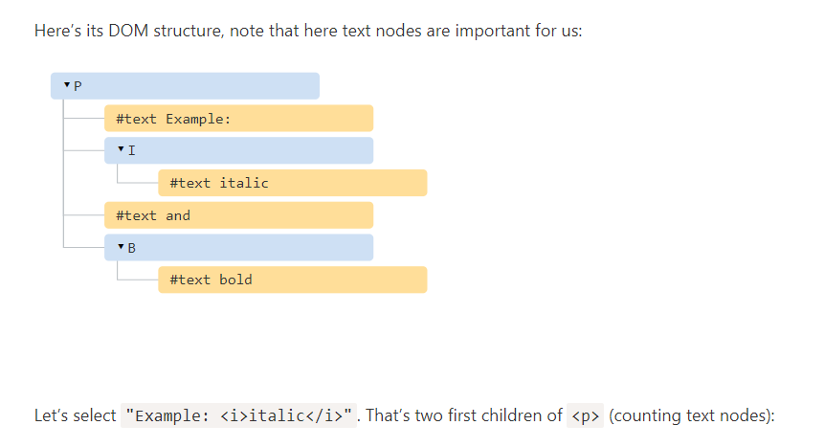

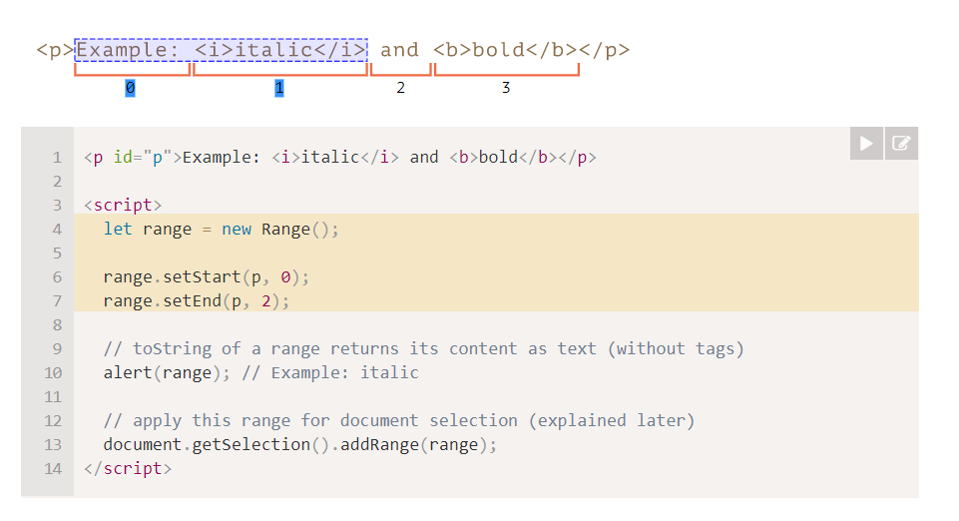
range.setStart(p, 0) – sets the start at the 0th child of <p> (that’s the text node "Example: ").
- range.setEnd(p, 2) – spans the range up to (but not including) 2nd child of <p> (that’s the text node " and ", but as the end is not included, so the last selected node is <i>).

Here’s a more flexible test stand where you try more variants:

<p id="p">Example: <i>italic</i> and <b>bold</b></p>

From <input id="start" type="number" value=1> – To <input id="end" type="number" value=4>
<button id="button">Click to select</button>
<script>
button.onclick = () => {
let range = new Range();

range.setStart(p, start.value);
range.setEnd(p, end.value);

// apply the selection, explained later
document.getSelection().removeAllRanges();
document.getSelection().addRange(range);
};
</script>
We don’t have to use the same node in setStart and setEnd. A range may span across many unrelated nodes. It’s only important that the end is after the start.
We need to create a range, that:
- starts from position 2 in <p> first child (taking all but two first letters of "Example: ")
- ends at the position 3 in <b> first child (taking first three letters of “bold”, but no more):
<p id="p">Example: <i>italic</i> and <b>bold</b></p>

<script>
let range = new Range();

range.setStart(p.firstChild, 2);
range.setEnd(p.querySelector('b').firstChild, 3);

alert(range); // ample: italic and bol

// use this range for selection (explained later)
window.getSelection().addRange(range);
</script>
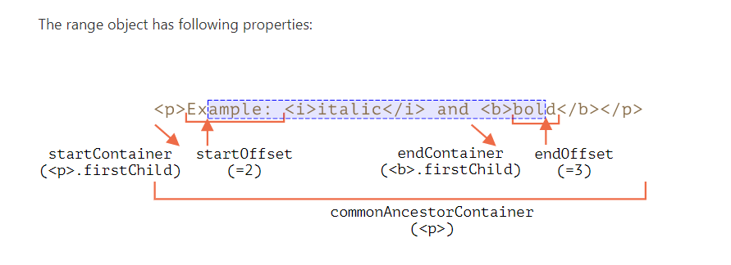
startContainer, startOffset – node and offset of the start,
  - in the example above: first text node inside <p> and 2.
- endContainer, endOffset – node and offset of the end,
  - in the example above: first text node inside <b> and 3.
- collapsed – boolean, true if the range starts and ends on the same point (so there’s no content inside the range),
  - in the example above: false
- commonAncestorContainer – the nearest common ancestor of all nodes within the range,
  - in the example above: <p>

Range methods
There are many convenience methods to manipulate ranges.
Set range start:
- setStart(node, offset) set start at: position offset in node
- setStartBefore(node) set start at: right before node
- setStartAfter(node) set start at: right after node
Set range end (similar methods):
- setEnd(node, offset) set end at: position offset in node
- setEndBefore(node) set end at: right before node
- setEndAfter(node) set end at: right after node
As it was demonstrated, node can be both a text or element node: for text nodes offset skips that many of characters, while for element nodes that many child nodes.
Others:
- selectNode(node) set range to select the whole node
- selectNodeContents(node) set range to select the whole node contents
- collapse(toStart) if toStart=true set end=start, otherwise set start=end, thus collapsing the range
- cloneRange() creates a new range with the same start/end
To manipulate the content within the range:
- deleteContents() – remove range content from the document
- extractContents() – remove range content from the document and return as DocumentFragment
- cloneContents() – clone range content and return as DocumentFragment
- insertNode(node) – insert node into the document at the beginning of the range
- surroundContents(node) – wrap node around range content. For this to work, the range must contain both opening and closing tags for all elements inside it: no partial ranges like <i>abc.
Range is a generic object for managing selection ranges. We may create such objects, pass them around – they do not visually select anything on their own.
The document selection is represented by Selection object, that can be obtained as window.getSelection() or document.getSelection().
A selection may include zero or more ranges. At least, the Selection API specification says so. In practice though, only Firefox allows to select multiple ranges in the document by using Ctrl+click (Cmd+click for Mac).
Other browsers support at maximum 1 range. As we’ll see, some of Selection methods imply that there may be many ranges, but again, in all browsers except Firefox, there’s at maximum 1.
Similar to a range, a selection has a start, called “anchor”, and the end, called “focus”.
The main selection properties are:
- anchorNode – the node where the selection starts,
- anchorOffset – the offset in anchorNode where the selection starts,
- focusNode – the node where the selection ends,
- focusOffset – the offset in focusNode where the selection ends,
- isCollapsed – true if selection selects nothing (empty range), or doesn’t exist.
- rangeCount – count of ranges in the selection, maximum 1 in all browsers except Firefox.
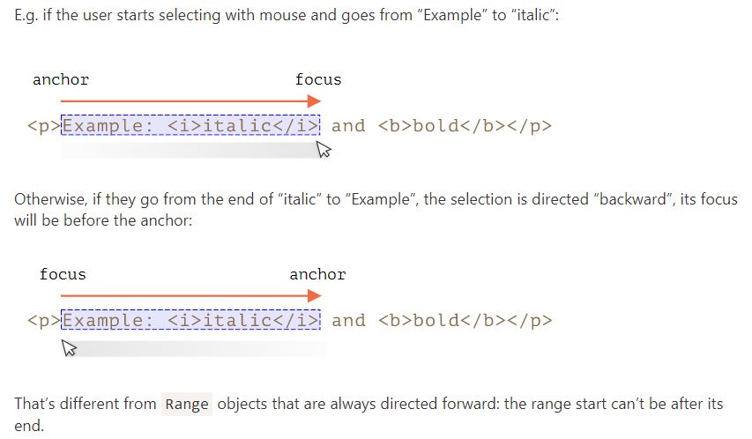
There are events on to keep track of selection:
- elem.onselectstart – when a selection starts on elem, e.g. the user starts moving mouse with pressed button.
  - Preventing the default action makes the selection not start.
- document.onselectionchange – whenever a selection changes.
  - Please note: this handler can be set only on document.
Selection methods to add/remove ranges:
- getRangeAt(i) – get i-th range, starting from 0. In all browsers except firefox, only 0 is used.
- addRange(range) – add range to selection. All browsers except Firefox ignore the call, if the selection already has an associated range.
- removeRange(range) – remove range from the selection.
- removeAllRanges() – remove all ranges.
- empty() – alias to removeAllRanges.
Also, there are convenience methods to manipulate the selection range directly, without Range:
- collapse(node, offset) – replace selected range with a new one that starts and ends at the given node, at position offset.
- setPosition(node, offset) – alias to collapse.
- collapseToStart() – collapse (replace with an empty range) to selection start,
- collapseToEnd() – collapse to selection end,
- extend(node, offset) – move focus of the selection to the given node, position offset,
- setBaseAndExtent(anchorNode, anchorOffset, focusNode, focusOffset) – replace selection range with the given start anchorNode/anchorOffset and end focusNode/focusOffset. All content in-between them is selected.
- selectAllChildren(node) – select all children of the node.
- deleteFromDocument() – remove selected content from the document.
- containsNode(node, allowPartialContainment = false) – checks whether the selection contains node (partially if the second argument is true)
So, for many tasks we can call Selection methods, no need to access the underlying Range object.

