Project Phase-I Report
SAGE
Service-Agent Graph Ecosystem
AI-Driven Cloud Service Marketplace for Autonomous Microservice Composition and Optimization using Multi-Agent Artificial Intelligence
BCSE355L — Cloud Architecture Design
Prepared by: Divik Bhaskar
Individual Project (Solo)
Course Instructor: Dr. Priya V
Submission Deadline: 30 July 2026

Table of Contents
Table of Contents 1
Abstract 1
Literature Survey 1
Individual Research Gap Analysis 1
Project Objectives 1
Novelty Summary 1
Proposed Architecture 1
Diagram 1 — AWS Cloud Architecture 1
Diagram 2 — Complete System Architecture / Workflow 1
Dataset Details 1
AWS Services Planning 1
Future Work: Architectural Extensions 1
Feasibility Check 1
Novelty / Prior-Art Check 1
GitHub Guidelines 1
Repository Naming 1
Repository Structure 1
Branch Model (Individual Project) 1
Expected GitHub Activity (Solo Equivalent) 1
Contribution Matrix 1

Abstract
Modern cloud computing offers thousands of independent microservices, but selecting and combining the right ones into a working pipeline remains a largely manual, expertise-dependent process. Developers must individually evaluate services on cost, performance, and reliability, then hand-wire integrations: a slow, error-prone workflow that does not scale as the number of available services grows.
Existing multi-agent AI frameworks such as AutoGen, CrewAI, and LangGraph attempt to automate parts of this coordination problem, but suffer from well-documented limitations: they pass entire conversation histories between agents, inflating token costs and increasing hallucination risk (“context bloat”); they offer poor visibility into which agent made a given decision (“black-box” observability); they are heavily Python-centric, complicating integration into modern TypeScript/JavaScript web stacks; and they lack deterministic safeguards against agents entering unproductive, repeating loops.
This project presents SAGE (Service-Agent Graph Ecosystem), an AI-driven cloud service marketplace that autonomously composes and optimizes microservice pipelines using a coordinated team of specialized AI agents. A user describes a desired capability in natural language. An Intent Agent structures this into a formal request; a Broker Agent retrieves matching services via semantic and metadata search; a Negotiator Agent deterministically selects the optimal composition on cost and performance; a Reviewer Agent validates the composition against constraints with a bounded retry limit; and an Explainer Agent produces a transparent, human-readable rationale for the final choice. SAGE addresses the four framework limitations above through strictly-typed scoped payloads instead of full conversation history, a built-in observability dashboard for step-by-step decision tracing, a TypeScript-first architecture shared across frontend and backend, and deterministic retry limits with human-in-the-loop escalation.
The system is built entirely on Amazon Web Services, using Amazon Bedrock for LLM inference, AWS Lambda and EC2 for compute and orchestration, DynamoDB and CloudTrail for auditability, API Gateway for request routing, Amazon SNS for oversight notifications, and IAM/SSM Parameter Store for secure, credential-free access control, all within a student AWS credit allowance.

Literature Survey
As this is an individual project, all fifteen papers listed below were surveyed independently by the author. Full method-by-method analysis, including dataset details, advantages, limitations, and a personally reasoned research gap for each paper, is provided in the companion document, “SAGE — Literature Survey: Detailed Paper Analysis.” The table below summarizes all fifteen.
# | Paper (short title) | Venue / Year | Method | Key Limitation
1 | LLM-Based Multi-Agent Orchestration Survey | MDPI Future Internet, 2026 | Taxonomy of 6 frameworks across topologies | No unified cost/observability benchmark across frameworks
2 | ACO-based Service Composition in Multi-Cloud | J. Cloud Computing (Springer), 2024 | Ant Colony Optimization + GA mutation for QoS | Not validated against LLM-driven, semantic requests
3 | AI Strategy for Microservices in 6G (RL) | Neural Comput. & Applic. (Springer), 2024 | Reinforcement learning for edge/cloud tier selection | Domain-specific to 6G; no natural-language interface
4 | AI Techniques in Microservices Life-Cycle | Computing (Springer), 2025 | Systematic mapping study, 69 papers | Surveys existing AI use; proposes no new architecture
5 | Designing Microservices Using AI (SLR) | MDPI Software, 2025 | Systematic literature review 2018–2024 | Focus is design-time decomposition, not runtime composition
6 | Semantic Search for Models via Vector Embeddings | MDPI Future Internet, 2026 | Sentence-BERT embeddings + RAG in microservices | Applied to system-dynamics models, not service catalogs
7 | Semantic-Based Cognitive Service Discovery | IEEE Xplore Conf., 2023 | Semantic/cognitive matching in multi-cloud | No cost-aware negotiation layer after discovery
8 | Prompt Injection Attacks on LLMs: A Survey | CMC – Tech Science Press, 2026 | Systematic review of 128 studies (2022–2025) | Defenses evaluated in isolation, not within agent pipelines
9 | TRiSM for Agentic AI | ScienceDirect (Elsevier), 2026 | Trust/Risk/Security Management framework for MAS | Framework-level; lacks a concrete reference implementation
10 | ML-Based Cloud Resource Allocation: Review | Frontiers in Computer Science, 2025 | Comparative review of RL/DL allocation algorithms | Focuses on infrastructure allocation, not service selection
11 | Framework for Migrating to Zero Trust Architecture | IEEE Access, 2023 | Migration framework for ZTA adoption | General-purpose; not specific to multi-agent AI workloads
12 | Performance-Based Trustworthy Edge-Cloud Continuum | IEEE Access, 2024 | Trust-scoring across edge-cloud continuum | Trust model is infrastructure-level, not decision-level
13 | User-Priorities Negotiating Agents for Cloud Services | IEEE Access, 2023 | Three-phase recommendation + negotiation agents | Negotiation is rule-based; no LLM-based explainability
14 | Comparing Cost/Performance: EC2 vs Lambda | Springer CCIS (SDSC 2023), 2024 | Empirical benchmarking of EC2 vs Lambda | Single-workload benchmark; not multi-agent orchestration
15 | SLR of Retrieval-Augmented Generation | MDPI Big Data & Cogn. Comput., 2025 | PRISMA review of RAG techniques/metrics | RAG evaluated for QA tasks, not service-catalog retrieval

Individual Research Gap Analysis
Reviewing all fifteen papers reveals a consistent, cross-cutting gap. The cloud-computing literature (papers 2–7, 10–14) offers strong, individually validated techniques for service composition, semantic discovery, resource allocation, and cost-aware negotiation, but almost none of it is designed with a modern LLM-based multi-agent reasoning layer in mind. The AI-agent literature (papers 1, 8, 9, 15), by contrast, documents real weaknesses in current multi-agent frameworks: context bloat, prompt-injection exposure, weak trust and observability tooling, and unreliable retrieval grounding. That literature is rarely tested against a concrete cloud-marketplace use case.
SAGE's research gap, and its response to it, can be summarized as follows: no existing system combines (a) classical QoS-aware, cost-optimal service composition techniques (papers 2, 3, 13) with (b) a disciplined, scoped-payload multi-agent LLM architecture (paper 1) that explicitly defends against the documented framework weaknesses (papers 8, 9, 15), while (c) remaining deployable within a real, metered cloud environment at a validated, benchmarked cost (paper 14). This is not a claim that any single component of SAGE is unprecedented. Rather, the novelty is in the disciplined integration of these separately studied techniques into one coherent, secure, and explainable system, detailed further in the Novelty Summary below.

Project Objectives
- Develop a multi-agent AI system that autonomously composes cloud microservice pipelines from a natural-language request.
- Reduce manual service-selection effort by combining semantic (vector) search with deterministic, cost/uptime-based negotiation logic.
- Ensure every autonomous decision is explainable, producing a plain-language rationale alongside the final composition.
- Guarantee an immutable, queryable audit trail of every agent decision using DynamoDB and CloudTrail.
- Enforce security by design: input sanitization against prompt injection, least-privilege IAM roles, and zero standing production credentials for any agent.
- Prevent uncontrolled agent loops through deterministic retry limits with human-in-the-loop escalation, verified through failure-injection testing.

Novelty Summary
SAGE differs from existing multi-agent and cloud-composition work in several concrete, verifiable ways:
- New feature: a Reviewer Agent with a hard max-retries circuit breaker that escalates to a Human-in-the-Loop node and an SNS alert, rather than looping indefinitely. This addresses a documented failure mode in current LLM multi-agent frameworks.
- Better algorithm: cost/uptime composition selection is solved with deterministic scoring and dependency resolution, not a repeated LLM call. This reduces both cost and hallucination risk while keeping the decision auditable and reproducible.
- Better architecture: a TypeScript-first, scoped-JSON-payload orchestration design shared across frontend and backend, avoiding both the Python-centric tooling gap and the context-bloat problem documented in current frameworks.
- Better AWS integration: the entire agent pipeline runs as isolated, per-agent AWS Lambda invocations orchestrated by an EC2-hosted conductor, with LLM inference via Amazon Bedrock. This avoids third-party LLM subscriptions entirely.
- Better security: an explicit Input Guard layer defends against prompt injection before any LLM-facing agent runs, combined with least-privilege IAM roles and zero standing production credentials for agents.
- Better automation with accountability: every agent decision is logged to an immutable DynamoDB audit table and surfaced through a graph-based observability dashboard, enabling “time-travel debugging” of any past request.

Proposed Architecture

Diagram 1 — AWS Cloud Architecture
This diagram shows how AWS services interact to support SAGE's data flow, storage, processing, authentication, notifications, and monitoring requirements.
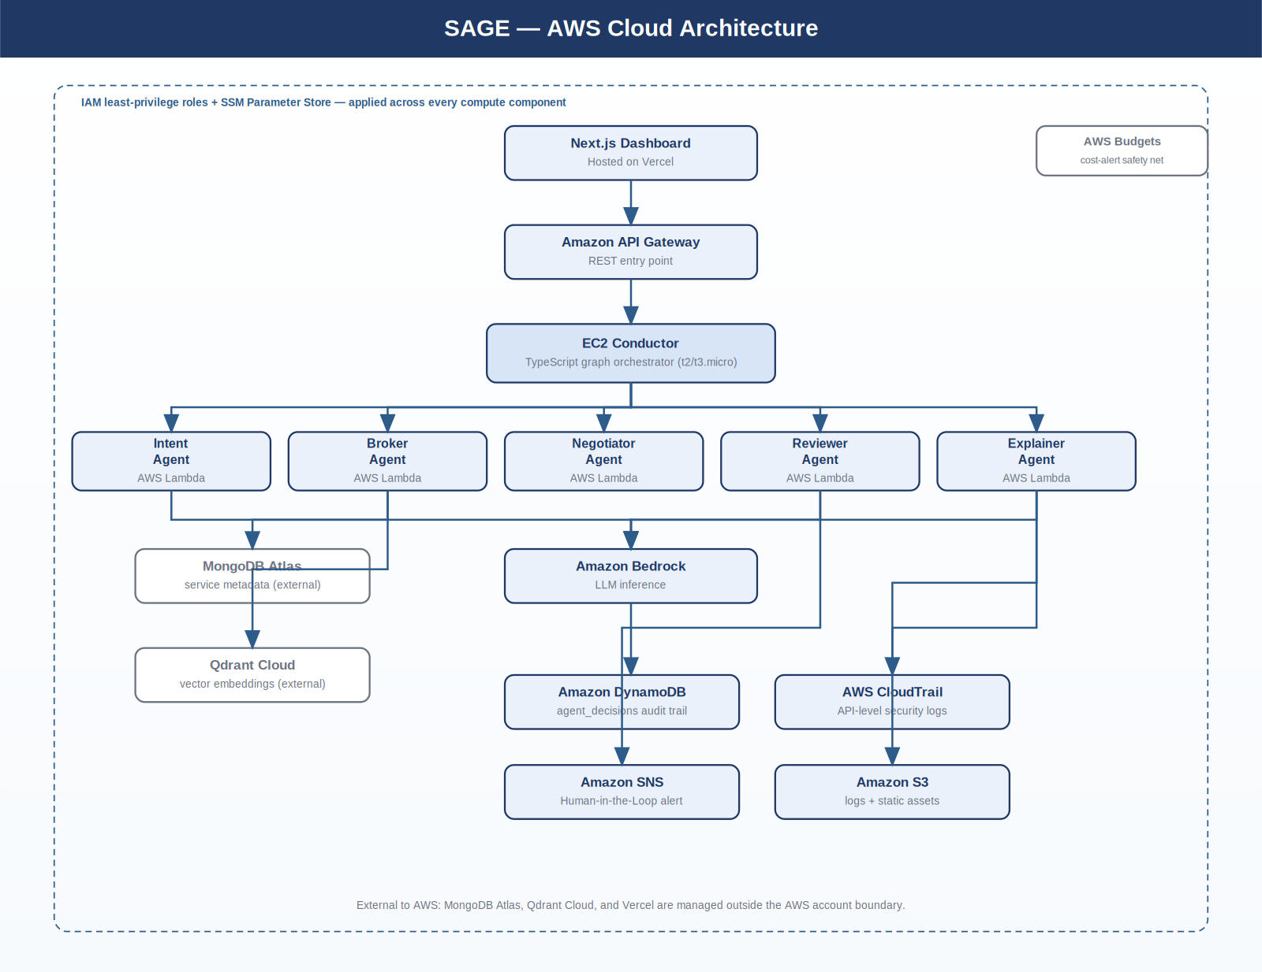

Diagram 2 — Complete System Architecture / Workflow
This diagram shows the end-to-end workflow: a user request flows through the dashboard and API layer into the Conductor, which sequences the five specialized agents, integrates external data services, and returns an explained, auditable composition blueprint.
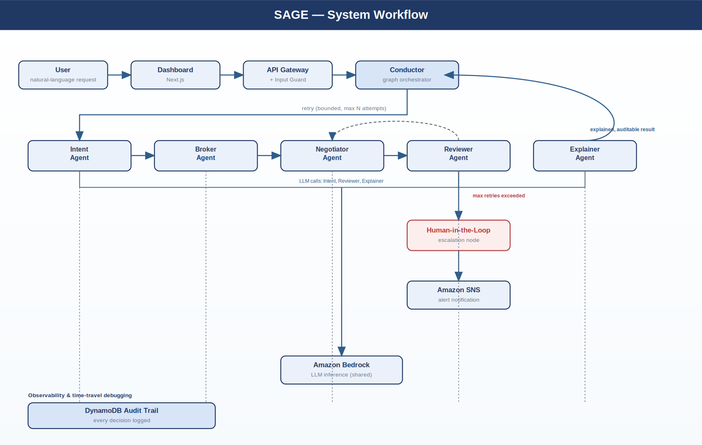

Dataset Details
SAGE does not use a public machine-learning training dataset, since it is not a predictive model but an orchestration and decision system operating over a service catalog. The catalog itself is treated as the project's core dataset:
Field | Detail
Dataset Name | SAGE Mock Microservice Catalog
Source | Self-generated by the author (no public dataset exists at this composition granularity; this absence is itself part of the identified research gap)
URL | Maintained within the project's own GitHub repository under /dataset/
Size | Approx. 50–100 mock service entries (target for Phase-II)
Number of Records | One record per mock microservice
Number of Features | 7–9 fields per record: service ID, name, capability description, price, uptime, latency, endpoint, category, (optional) vendor tag
Data Type | Hybrid: structured numeric/categorical fields (price, uptime, latency) plus unstructured text (capability description) later embedded as vectors
License | Original, self-created content; no third-party license restrictions
Purpose | Provides the searchable catalog the Broker Agent queries via MongoDB Atlas (metadata) and Qdrant Cloud (semantic embeddings), and the candidate pool the Negotiator Agent scores
Preprocessing Required | Text descriptions are embedded into vectors for semantic search; numeric fields (price, uptime, latency) are normalized before being used in the Negotiator Agent's scoring formula

AWS Services Planning
AWS Service | Purpose in SAGE
Amazon EC2 (t2/t3.micro) | Hosts the Node.js/TypeScript Conductor (graph orchestrator)
AWS Lambda | Runs each agent (Intent, Broker, Negotiator, Reviewer, Explainer) as an isolated invocation, plus the Input Guard and deployment glue
Amazon API Gateway | Provides the REST entry point from the Next.js dashboard into the backend
Amazon Bedrock | Supplies LLM inference for the Intent, Reviewer, and Explainer agents
Amazon DynamoDB | Stores the agent_decisions audit trail (immutable, queryable decision log)
AWS CloudTrail | Logs all infrastructure-level AWS API calls for security monitoring
AWS IAM | Provides least-privilege roles for EC2 and every Lambda; no agent holds standing credentials
AWS SSM Parameter Store | Stores MongoDB Atlas and Qdrant Cloud credentials securely (Standard tier, no per-secret cost)
Amazon SNS | Sends a notification/alert when the Human-in-the-Loop node is triggered
Amazon S3 | Stores logs and static assets
AWS Budgets | Provides a cost-alert safety net against the AWS Student credit allowance
MongoDB Atlas (external) | Stores structured service metadata: price, uptime, endpoint
Qdrant Cloud (external) | Stores vector embeddings of service capability descriptions for semantic search
Vercel (external) | Hosts the Next.js frontend dashboard

Future Work: Architectural Extensions
Beyond the Phase-I scope, a possible extension to SAGE's Broker Agent involves separating hard eligibility constraints, such as compliance rules governing which service providers are permissible, from the semantic search performed by the AI agent. In this design, a rule-based, non-AI gateway module would extract compliance constraints from an incoming request before any portion of the request reaches the LLM-based agent, and the constraints would be carried alongside the request in an encrypted form that the agent cannot read. The intent is to reduce the risk of an AI agent inadvertently exposing or reasoning incorrectly about sensitive eligibility rules, while still allowing it to freely perform semantic matching over service capabilities.
This section records two preliminary checks on that concept: technical feasibility within the project's existing constraints, and how it relates to prior work. Both are included for completeness and to inform later project planning; neither constitutes a claim that this extension has been implemented in the current system.

Feasibility Check
The core building blocks of this concept map reasonably well onto services already planned for SAGE:
- The rule-based extraction step is a deterministic parsing function. It requires no new infrastructure beyond an additional Lambda function or a pre-processing step inside the existing Input Guard layer.
- Encrypting extracted constraints into a token is achievable with standard, low-cost primitives, for example AWS KMS or application-level encryption using a key held in SSM Parameter Store, well within the AWS Student credit allowance.
- Restricting the semantic search step to operate only on capability descriptions, without the encrypted constraints, fits naturally into the Broker Agent's existing MongoDB Atlas / Qdrant Cloud query flow, with no architectural conflict.
- A hardware-isolated execution environment, such as a Trusted Execution Environment, for unlocking and validating constraints was also considered as a further hardening step. This is assessed as not feasible within the current project: it requires specialized EC2 instance types and meaningfully more operational complexity than the Student credit allowance and Phase-I/II timeline support. It is noted here only as a longer-term, out-of-scope possibility.
Overall assessment: the gateway-and-masking portion of this concept is feasible as a Phase-II stretch goal. The hardware-isolation portion is not feasible under current project constraints and is excluded from planned work.

Novelty / Prior-Art Check
This is a preliminary, non-exhaustive check based on the literature already surveyed for this project (see Literature Survey and Research Gap Analysis above), not a formal prior-art search. It is intended to flag what would need independent verification before any further action is taken:
- The surveyed AI-agent literature (papers 1, 8, 9, 15) documents general weaknesses in multi-agent frameworks, including prompt-injection exposure and weak trust/observability tooling, but none of the surveyed papers describe a deterministic, non-AI gateway that structurally withholds specific constraint data from an LLM-based agent prior to a semantic search step.
- The surveyed cloud-composition literature (papers 2, 3, 7, 11, 12, 13) addresses service discovery, negotiation, and trust scoring, but treats constraint handling as part of the same pipeline the AI operates within, rather than as a structurally separated, non-AI-visible step.
- This suggests one specific combination is not directly addressed within this project's literature survey: deterministic constraint extraction plus encrypted masking, applied ahead of an AI-driven semantic search step. This is not evidence of novelty in a legal sense; a proper novelty and prior-art determination requires a dedicated patent/prior-art search covering issued patents and non-academic technical disclosures, which falls outside the scope of this academic literature survey.
- Any further evaluation of this concept's novelty should be treated as a separate, dedicated exercise from this course deliverable.

GitHub Guidelines
As an individual project, the branch-per-teammate model in the course template is simplified accordingly, while preserving the same repository structure and commit discipline expected of a team submission.

Repository Naming
SAGE_Cloud_Project_2026

Repository Structure

SAGE_Cloud_Project_2026/

├── README.md

├── LICENSE

├── .gitignore

├── docs/

│ ├── Project_Report.docx

│ ├── Literature_Survey.docx

│ ├── Research_Gap.docx

│ ├── Objectives.docx

│ └── Novelty.docx

├── architecture/

│ ├── AWS_Architecture.png

│ └── System_Architecture.png

├── dataset/

│ ├── raw/

│ ├── processed/

│ └── dataset_description.pdf

├── src/

│ ├── apps/

│ │ └── dashboard/

│ ├── services/

│ │ └── conductor/

│ ├── agents/

│ │ ├── intent/

│ │ ├── broker/

│ │ ├── negotiator/

│ │ ├── reviewer/

│ │ └── explainer/

│ └── packages/

│ ├── shared-types/

│ └── compliance-gateway/

├── package.json → npm workspaces root

└── results/Branch Model (Individual Project)
main → develop → feature/sage-solo. All work is committed to the feature/sage-solo branch, merged into develop via self-reviewed pull requests, then merged into main at each milestone and tagged, for example v1.0-Phase1.

Expected GitHub Activity (Solo Equivalent)
- 20–30+ meaningful commits across the Phase-I period
- At least 2 pull requests (feature → develop → main)
- Regular weekly commits with continuous documentation updates

Contribution Matrix
Activity | Contributor
Literature Survey (all 15 papers) | Divik Bhaskar
Research Gap Analysis (all 15 papers) | Divik Bhaskar
Frontend Development | Divik Bhaskar
Backend Development | Divik Bhaskar
Database Integration | Divik Bhaskar
AWS Cloud Services | Divik Bhaskar
AI / Multi-Agent System | Divik Bhaskar
Testing | Divik Bhaskar
Documentation | Divik Bhaskar
Presentation | Divik Bhaskar
GitHub Commits | Divik Bhaskar

