How to forward calls from indoor station to main station via SIP server

Preparation
- Door station
- Indoor station
- SIP server DS-KS6160

Background
In a residential community , there are multiple buildings. Each building entrance is equipped with a door station, each household has an indoor station, and the security guard station at the main gate is equipped with a main station. When a guest calls from the door station and the indoor station is not answered, it is desired that the call can be directly transferred to the main station.

Steps
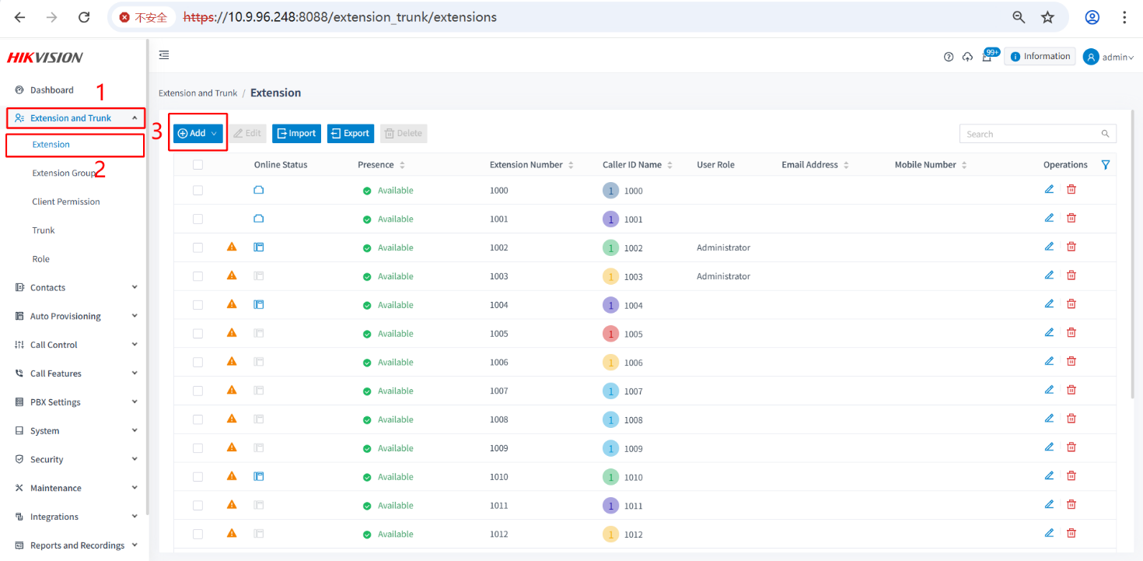
- Register the indoor station, door station, and main station to the SIP server, ensuring that the SIP numbers are not duplicated. After registering all devices, apply the changes; otherwise, registration may fail.
- Configure the call numbers in the door station web interface: First, set the call room numbers for each room in each building, then add SIP1 (the SIP number of the main station) to enable the functionality.
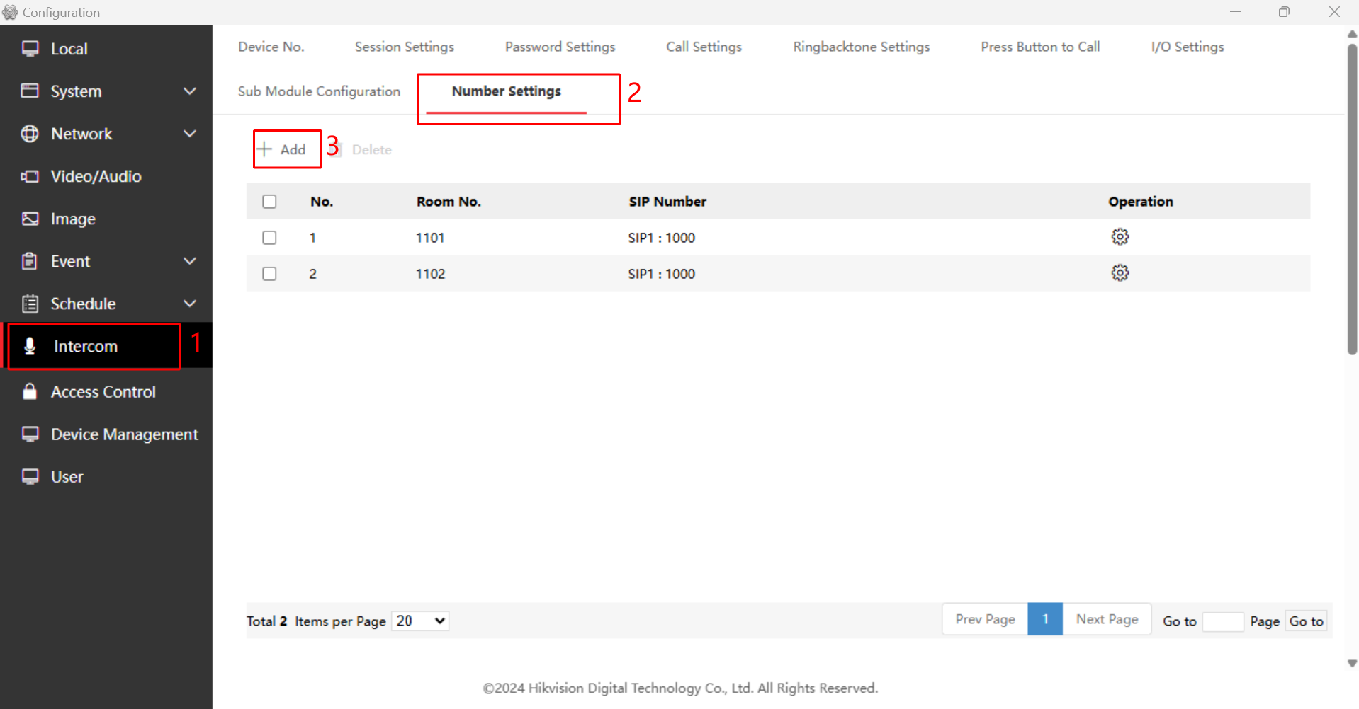
Note:the Room No Depending on the room number entered when the door station calls the indoor station, SIP Number:1000 is the SIP number of the main station, and it can be set on-site as needed.

