Alarm and Audio Interface Using Method
1. Alarm output
Model one: electrical level value output
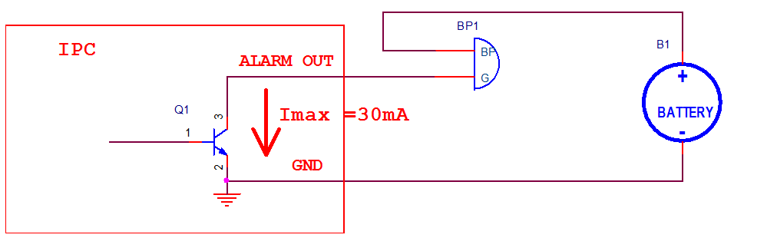
Connection one for model one: to directly drive weak load, such as LED, buzzer, etc.

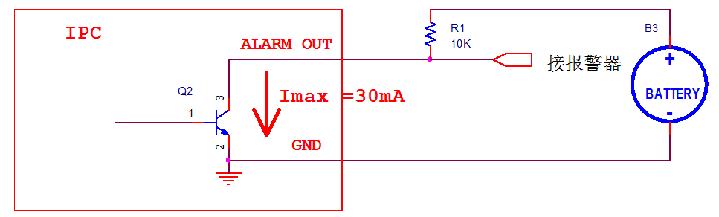
Connection two for model one: output electrical level after pulling up resistor

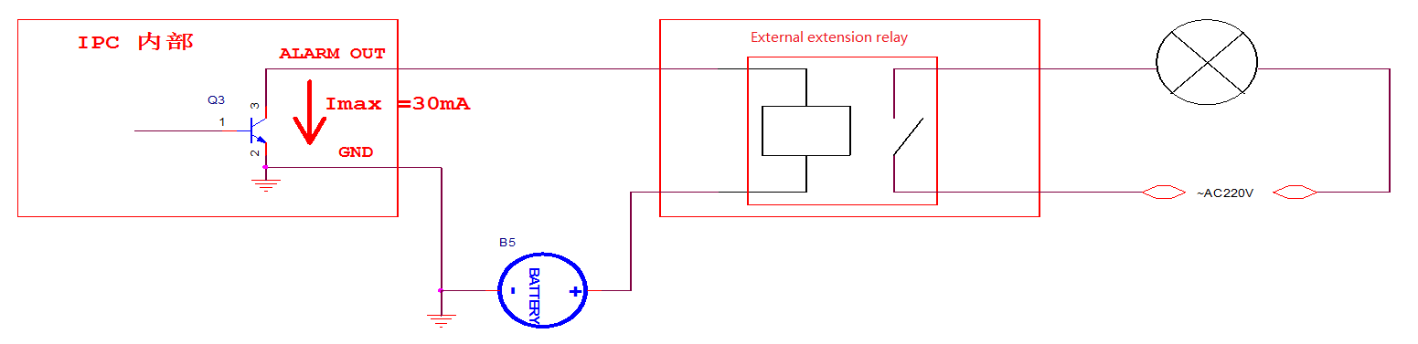
Connection three for model one: connection method for external extension relay

Corresponding models: all 1, 2, 3 series
Main point:
1. Do not make an inversely connection for the polarity of BP1 and battery.
2. Battery voltage should be no more than 12V; pull-up resistor should be no less than 4.7K.
3. The output should cooperatively use with GND. GND must connect to the distal battery
cathode.

Model two: switching value output

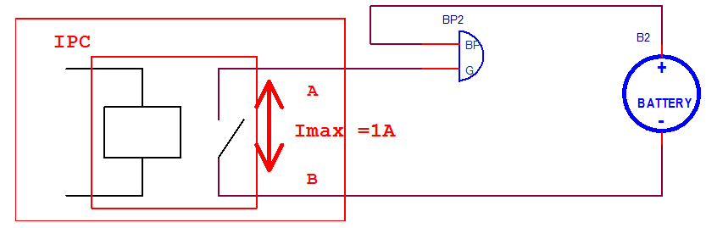
Connection one for model two: be able to drive 1A maximum current

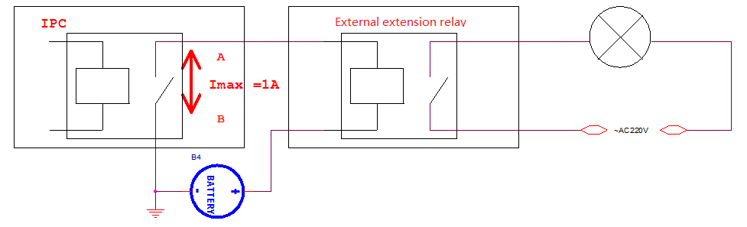
Connection two for model two: connection method for external extension relay

Corresponding models: 4, 5, 6 series
Main point:
1. The internal IPC is equivalent to a switch, no polarity.
2. Max. Load current is 1A, Max. Battery voltage is DC30V.
3. A, B completely hung up, no connection to the earth.

2. Alarm input
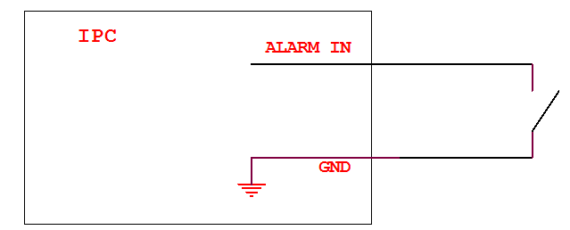
Alarm input connection method

Corresponding models: 1, 2, 3, 4, 5, 6 series
Main point:
1. Short circuit the Alarm in and GND to trigger alarm.

Audio input, output parameters
Line-In:
Impedance: 10KΩ
Frequency response range: 20Hz ~ 20 KHz
Input range: Max. 2Vpp
Using suggestion: 1. generally do not use external microphone which may introduce noise. 2.
possible to use external sound pick-up or input audio source directly to device.

Line-Out
Impedance: 600Ω
Frequency response range: 20Hz ~ 20 KHz
Drive capability:
1. output power: 20mW@16Ω, it means it Only can drive the headset which more than 16Ω impedance, or directly connect to input terminal of powered speaker.
2. Unable to drive the Speaker which is less than 8Ω.

