# Personal Websites of Five Astronomers

## 1. Chanda Prescod-Weinstein

Website: https://chanda.science/

### Likes:

- Clean and minimalistic design makes it easy to navigate.  
- Highlights her research and outreach work clearly.  
- Provides links to her publications and media appearances.  
- Personal touch with photos and blog entries.

### Dislikes:

- Some sections are too brief and lack detailed explanations.  
- Could include more visuals or interactive elements.

## 2. Emily Lakdawalla

Website: https://www.lakdawalla.com/emily/

### Likes:

- Well-organized layout with clear sections.  
- Detailed descriptions of her planetary exploration work.  
- Includes personal projects and publications.  
- Easy access to her social media and blogs.

### Dislikes:

- The homepage feels slightly text-heavy.  
- Limited use of graphics to showcase her work visually.

## 3. Sara Seager

Website: https://www.saraseager.com/

### Likes:

- Professional, elegant design with an intuitive structure.  
- Highlights her research, discoveries, and awards.  
- Includes videos and media coverage, making the content engaging.  
- Links to recent talks and news updates.

### Dislikes:

- Some sections require external links for detailed information.  
- Limited interactivity on the homepage.

## 4. Brian Greene

Website: https://www.briangreene.org/

### Likes:

- Beautifully designed and visually appealing.  
- Contains videos, books, and lectures, making it dynamic.  
- Easy navigation between projects and outreach content.  
- Personal branding is clear and professional.

### Dislikes:

- Some sections load slower due to high-resolution media.  
- Could include more updates on his latest research activities.

## 5. Mike Brown

Website: https://mikebrown.caltech.edu/

### Likes:

- Simple yet effective design with a personal tone.  
- Includes a blog with insights about planetary discoveries.  
- Shares educational resources and project updates.  
- Easy to access his research and publications.

### Dislikes:

- Overall visual design could be more modern.  
- Limited use of interactive elements or images.

metin, ekran görüntüsü, web sitesi, yazılım içeren bir resim

Yapay zeka tarafından oluşturulmuş içerik yanlış olabilir.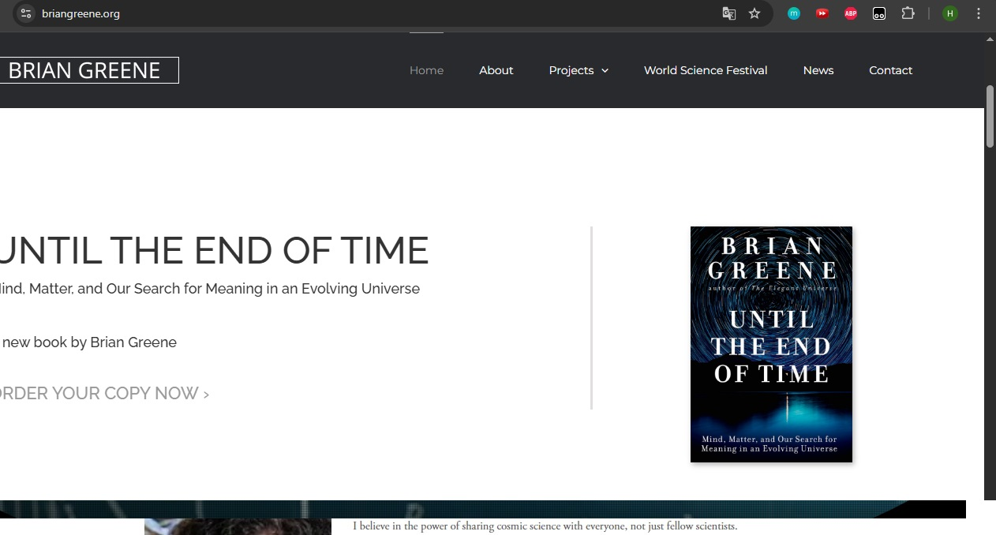metin, ekran görüntüsü, ay, multimedya yazılımı içeren bir resim

Yapay zeka tarafından oluşturulmuş içerik yanlış olabilir.metin, ekran görüntüsü, yazılım, multimedya yazılımı içeren bir resim

Yapay zeka tarafından oluşturulmuş içerik yanlış olabilir.metin, bilgisayar, ekran görüntüsü, web sitesi içeren bir resim

Yapay zeka tarafından oluşturulmuş içerik yanlış olabilir.